Supplementary information
Aqueous benzene, toluene, ethylbenzene and xylene (BTEX) removal using core-shell structure activated carbon ball as a permeable reactive barrier material

Eunji Myung¹, Hyunsoo Kim², Nagchoul Choi³ and Kanghee Cho³

¹ Institutes of Green Bio Science and Technology, Seoul National University, Gangwon-do 25354, Republic of Korea
² Department of Energy and Resource Engineering, Chosun University, Gwangju 61452, Republic of Korea
³ Research Institute of Agriculture and Life Sciences, Seoul National University, Seoul 08826, Republic of Korea

* Corresponding authors: Kanghee Cho
E-mail; kanghee1226@snu.ac.kr

- Data analysis
The following equations were adopted for the determination of the coefficient ($R^{2}$), chi-square coefficient ($χ^{2}$), and the sum of the squared error (SSE) to estimate the adsorption data and verify their fitness to the model:
$R^{2}=\frac{\sum_{i=1}^{m}{(y_{c}-\overline{y_{e}})_{i}^{2}}}{\sum_{i=1}^{m}{(y_{c}-\overline{y_{e}})_{i}^{2}+\sum_{i=1}^{m}{(y_{c}-y_{e})_{i}^{2}}}}$ (1)
$χ^{2}=\sum_{i=1}^{m}{{\left[\frac{(y_{e}-y_{c})^{2}}{y_{c}}\right]}_{i}}$ (2)
$SAE=\sum_{i=1}^{n}{{\left|y_{c}-y_{e}\right|}_{i}}$ (3)
where $y_{c}$ is the removal capacity calculated from the model, $y_{e}$ is the removal capacity measured in the experiment, and $\overline{y_{e}}$ is the average measured removal capacity.
- Column data analysis
The data obtained from the fixed-bed column adsorption system were plotted in breakthrough curves in the form of $C_{t}/C_{0}$ versus time. In this study, a $C_{t}/C_{0}$ value of 0.1 was point as break point. The following parameters were calculated using the equations below to evaluate the performance of the fixed bed column; absorption capacity in saturated state (q_{e}), and removal efficiency in saturated state (Re)
$$q_{e}=\frac{Q}{M}\int_{t=0}^{t=t_{s}}{(C_{0}-C_{t})dt}$$ |  | (4)
 | $$Re=\frac{q_{e}M}{C_{0}Qt_{s}}$$ | (5)
where $q_{e}$(mg/g) is the accumulative adsorption amount till time t (min), M (g) is the adsorbent mass, breakthrough state (t_{s}) and Q (mL/min) is the flow rate of the influent solution.
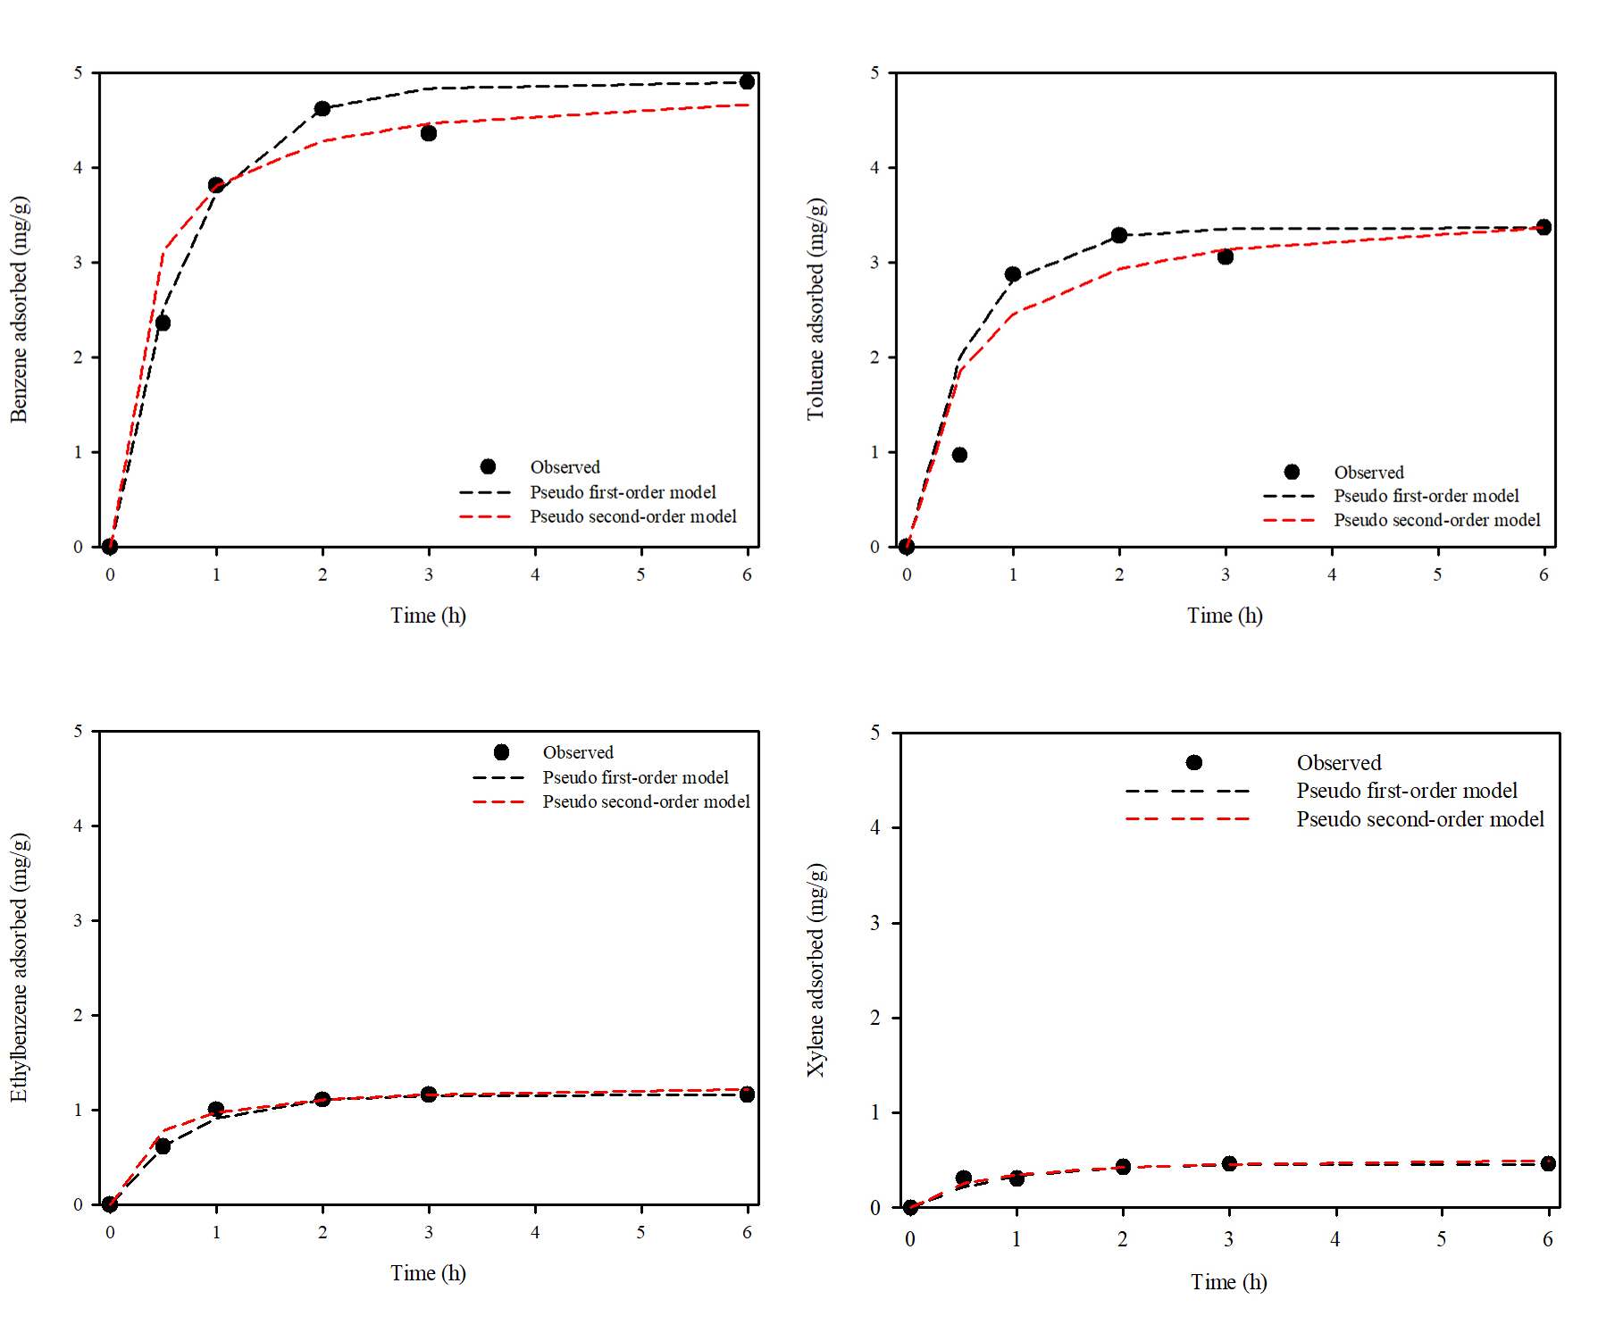
Fig. S1 Kinetics for the adsorption of BTEX by AC30.

Table S1. Kinetic model parameters obtained from model fitting to experimental data.
Material | Pseudo first-order model |  |  | Pseudo second-order model
 | q_{e} | k₁ | R² | q_{e} | k₂ | R²
 | (mg/g) | (1/h) | R² | (mg/g) | (g/mg/h) | R²
Benzene | 4.90 | 1.44 | 0.95 | 4.88 | 0.73 | 0.94
Toluene | 3.37 | 1.82 | 0.93 | 3.63 | 0.57 | 0.81
Ethylbenzene | 1.16 | 1.54 | 0.97 | 1.28 | 2.45 | 0.92
Xylene | 0.46 | 1.30 | 0.82 | 0.54 | 3.45 | 0.84

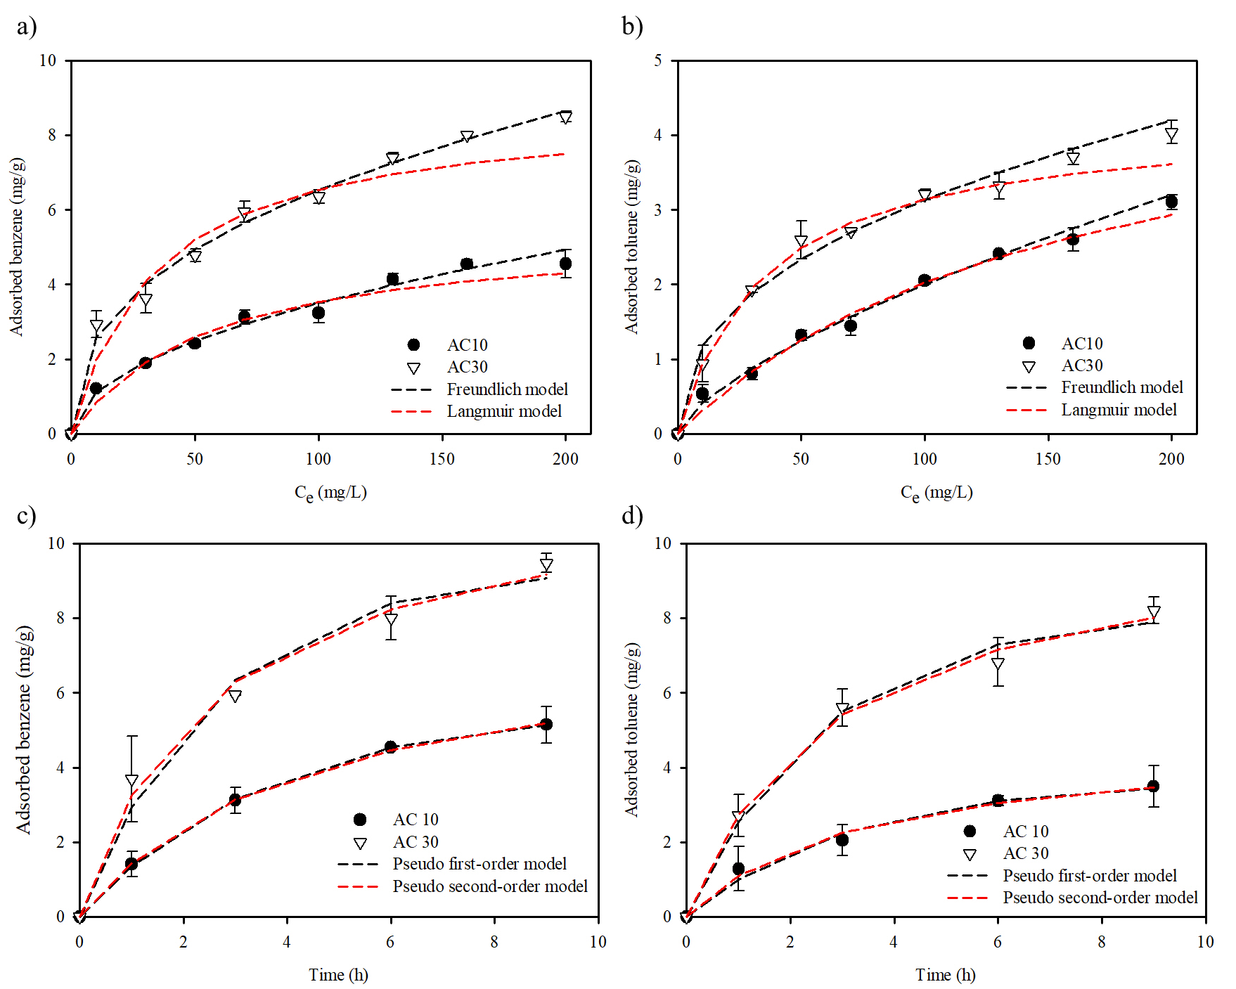
Fig. S2 Comparison of (a-b) equilibrium (Langmuir and Freundlich) and (c-d) kinetics (PFO and PSO) for the adsorption of benzene and toluene by AC10 and AC30.

Table S2. Fixed-bed column experimental conditions.
Column diameter (cm) | Bed depth (cm) | Pore volume (ml)
2.5 | 10 | 20.62
Mass of adsorbent (g) | Flow rate (mL/min) | Initial concentration (mg/L)
43.09 | 0.5, 1.0, 5.0 | 200

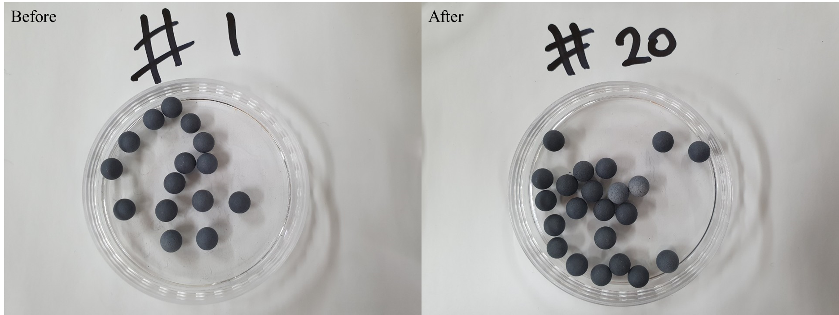
Fig. S3 Digital images of AC30 after 20 cycles of adsorption/desorption of benzene using microwave.

