TEACHER SURVEY
Q1 In what locations do students congregate during lunch hours? Select all that apply.
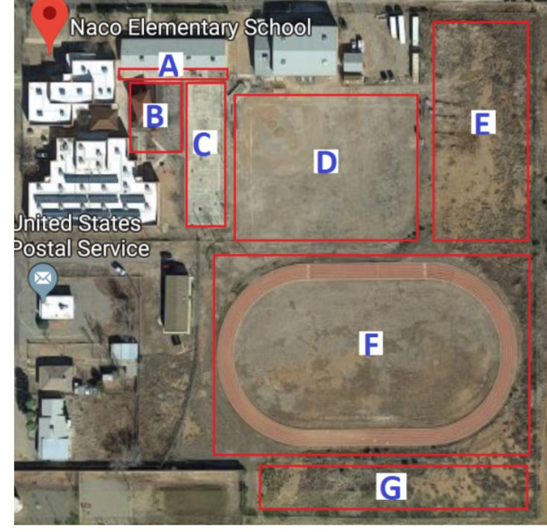
- Location A (1)
- Location B (2)
- Location C (3)
- Location D (4)
- Location E (5)
- Location F (6)
- Location G (7)

Q2 In what locations do students congregate before and after school? Select all that apply.​​​​​​​ ​​​​​​​
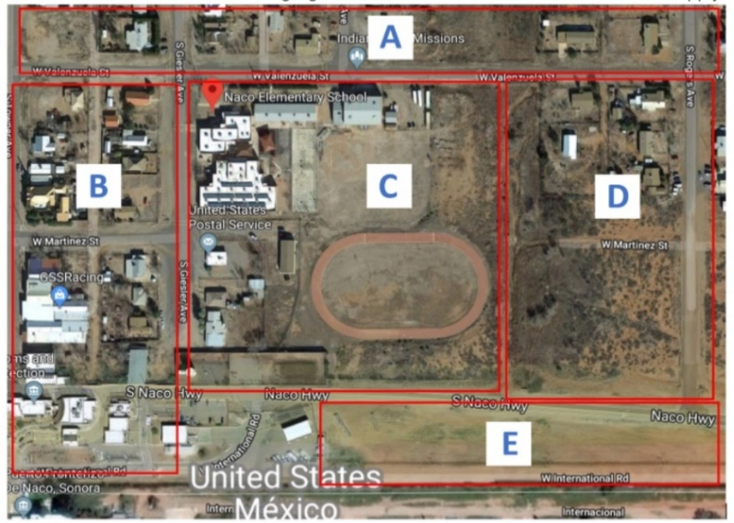
- Location A (1)
- Location B (2)
- Location C (3)
- Location D (4)
- Location E (5)

Q3 Are any physical activities conducted outside?
- Yes (1)
- No (2)

Display This Question:
If Are any physical activities conducted outside? = Yes

Q4 Please select the physical activities conducted outside and their location. Refer to the image for location. You may select more than one location for each activity. ​​​​​​​
 | Location A (1) | Location B (2) | Location C (3) | Location D (4) | Location E (5) | Location F (6) | Location G (7)
Walking (1)
Running (2)
Sport team games (i.e. soccer, volleyball) (3)
Imaginative play (4)
Other (5)

Q5 Are any passive (resting) activities conducted outside?
- Yes (1)
- No (2)
- No (3)

Display This Question:
If Are any passive (resting) activities conducted outside? = Yes

Q6 Please select the passive activities conducted outside and their location. Refer to the image for location. You may select more than one location for each activity.
 | Location A (1) | Location B (2) | Location C (3) | Location D (4) | Location E (5) | Location F (6) | Location G (7)
Reading (1)
Listening to music; chatting (2)
Drawing; coloring; painting (3)
Imaginative play (4)

Q7 Do you think you take any actions to avoid tracking soil into your classroom?
- Yes (1)
- No (2)
- I am not sure (3)

Display This Question:
If Do you think you take any actions to avoid tracking soil into your classroom? = Yes

Q8 Please explain how you avoid tracking soil into your classroom.
________________________________________________________________

Q9 How often do you observe the following behavior collectively for your class?
 | Never  (0 events per hour) (1) | Seldom  (0-15 events per hour) (2) | Sometimes  (16-30 events per hour) (3) | Often  (31-50 events per hour) (4) | Always  (51+ events per hour) (5)
Mouth or tongue contact with hands? (1)
Mouth or tongue contact with toys? (2)
Mouth or tongue contact with natural objects (i.e. rocks, plants, soil)? (3)
Mouth and tongue contact with surfaces (i.e. hand rails, tables) (4)

Q10 In the past year, have you been aware when a sewage overflow event occurs in proximity to Naco Elementary?
- Yes (1)
- Sometimes (2)
- No (3)

Display This Question:
If In the past year, have you been aware when a sewage overflow event occurs in proximity to Naco El... = Yes
Or In the past year, have you been aware when a sewage overflow event occurs in proximity to Naco El... = Sometimes

Q11 How did you find out a sewage overflow event was occurring? Select all that apply.
- County Public Announcement (1)
- School Announcement (2)
- Media (3)
- Word of Mouth (4)
- Self (5)
- I found out AFTER it had happened (6)

Display This Question:
If In the past year, have you been aware when a sewage overflow event occurs in proximity to Naco El... = Yes
Or In the past year, have you been aware when a sewage overflow event occurs in proximity to Naco El... = Sometimes

Q12 What observations have you noticed during the time of a sewage overflow event? (visual observations, smells, response actions taken by school, government, or community members) Please be as detailed as possible.
________________________________________________________________
________________________________________________________________
________________________________________________________________
________________________________________________________________
________________________________________________________________

Q13 What are your concerns during these events?
________________________________________________________________
________________________________________________________________
________________________________________________________________
________________________________________________________________
________________________________________________________________

Q14 How would you like to receive risk communication information? Select all that apply.
- Email (1)
- Phone Call (2)
- Text Message (3)
- Brochures/Flyers (4)

End of Block: Default Question Block

