Micro-crystalline Evolution and Enhanced Mechanical Properties of Continuous BN Fibers
Xueli Qi^{a,b}, Weichen Ding^{b}, Haonan Xu^{b}, Yujiao Wang^{b}, Zhiqiang Cheng^{b}, Meng Zhang^{c,*}, Zhihao Wang^{d,*}, Jianyao Yao^{a,*}
ª College of Aerospace Engineering, Chongqing University, Chongqing 400044, PR China
^{b} Shandong Industrial Ceramic Research & Degisn insitute Co.Ltd., Zibo 255000, PR China
^{c} College of Materials Science and Engineering, Qingdao University of Science and Technology, Qingdao, Shandong province, 266042, China.
^{d} School of Material Science and Engineering, Qilu University of Technology (Shandong Academy of Sciences), Jinan 250353, PR China

E-mail addresses: mengzhang@qust.edu.cn (M. Zhang), wangzhihao0805@126.com (Z. Wang), yaojianyao@cqu.edu.cn (J. Yao)

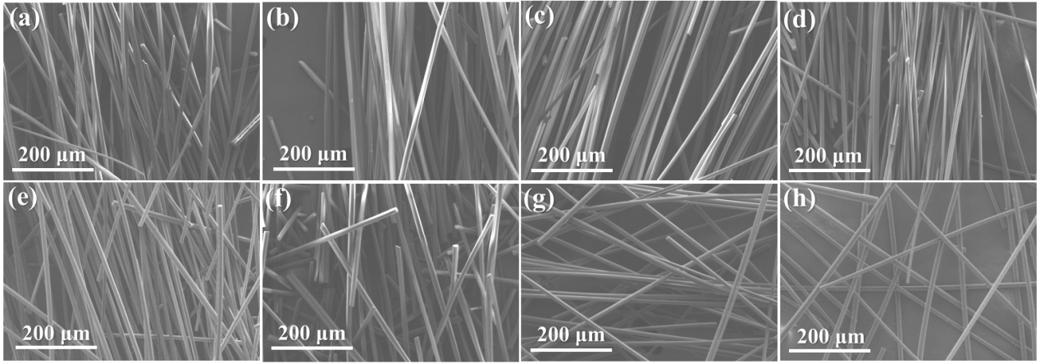
Figure S1 Low magnification SEM images of BNO samples (a) BNO-250, (b) BNO-300, (c) BNO-350, (d) BNO-400, (e) BNO-500, (f) BNO-600, (g) BNO-800, (h) BNO-1000;

Table S1 Reaction thermodynamic data of BNO samples at different calcination temperatures
T K | ∆H kcal | ∆G kcal | K | Log(K)
523.000 | 33.194 | 13.590 | 2.092E-006 | -5.679
573.000 | 33.119 | 11.719 | 3.387E-005 | -4.470
623.000 | 33.018 | 9.856 | 3.485E-004 | -3.458
673.000 | 32.890 | 8.002 | 2.519E-003 | -2.599
773.000 | 26.404 | 4.742 | 4.562E-002 | -1.341
873.000 | 25.549 | 1.994 | 3.169E-001 | -0.499
1073.000 | 24.081 | -3.239 | 4.569E+000 | 0.660
1273.000 | 22.791 | -8.217 | 2.575E+001 | 1.411

Table S2 Crystal structure parameters of the samples obtained at 1000℃
2θ₍₀₀₂₎ (º) | d₍₀₀₂₎ (nm) | L_{c(002)} (nm) | L_{a(10)} (nm) | η (%)
25.32 | 0.352 | 0.935 | 1.932 | 57.66
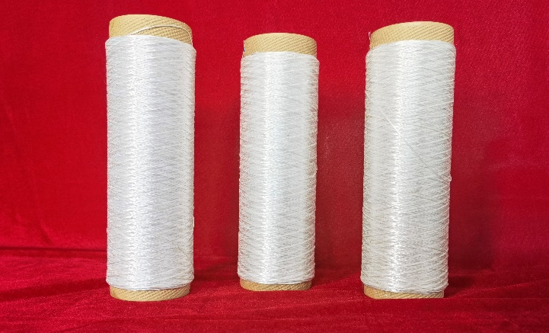
Figure S2 Macro picture of the prepared continuous BN fiber

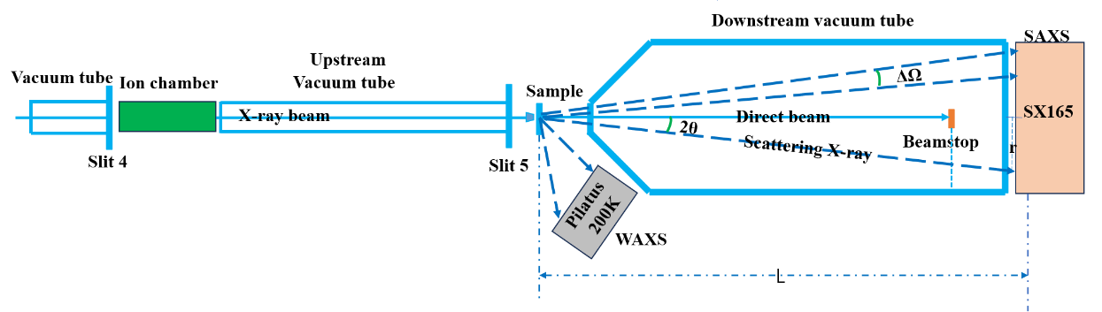
Figure S3 Schematic diagram of the working principle of SAXS characterization

Table S3 Average sizes parameters of B₂O₃ precursor fiber, BNO-1000 sample, and BN fibers obtained at various temperatures
Sample | Average length c (nm) | Average length a (nm) | Ratio c/a | Q₀/Q₉₀
B₂O₃ | 65.85 | 59.47 | 1.11 | 0.64
BNO-1000 | 72.33 | 53.18 | 1.36 | 0.59
BN | 101.35 | 28.63 | 3.54 | 0.43

Table S4 Mechanical properties of BN fibers obtained at various temperatures
Sample | F (cN) | ε (%) | D (μm) | R (MPa) | E (GPa)
1000℃ | 1.29 | 0.015 | 6.48 | 391.91 | 33.59
1850℃ | 2.8 | 0.022 | 6.326 | 890.9 | 40.8

