Supplemental Figures
Figure S1: Co-occurring alterations in patients with a bTMB ≥10mut/Mb and (A) MSI-Detected or (B) MSI-Not Detected.
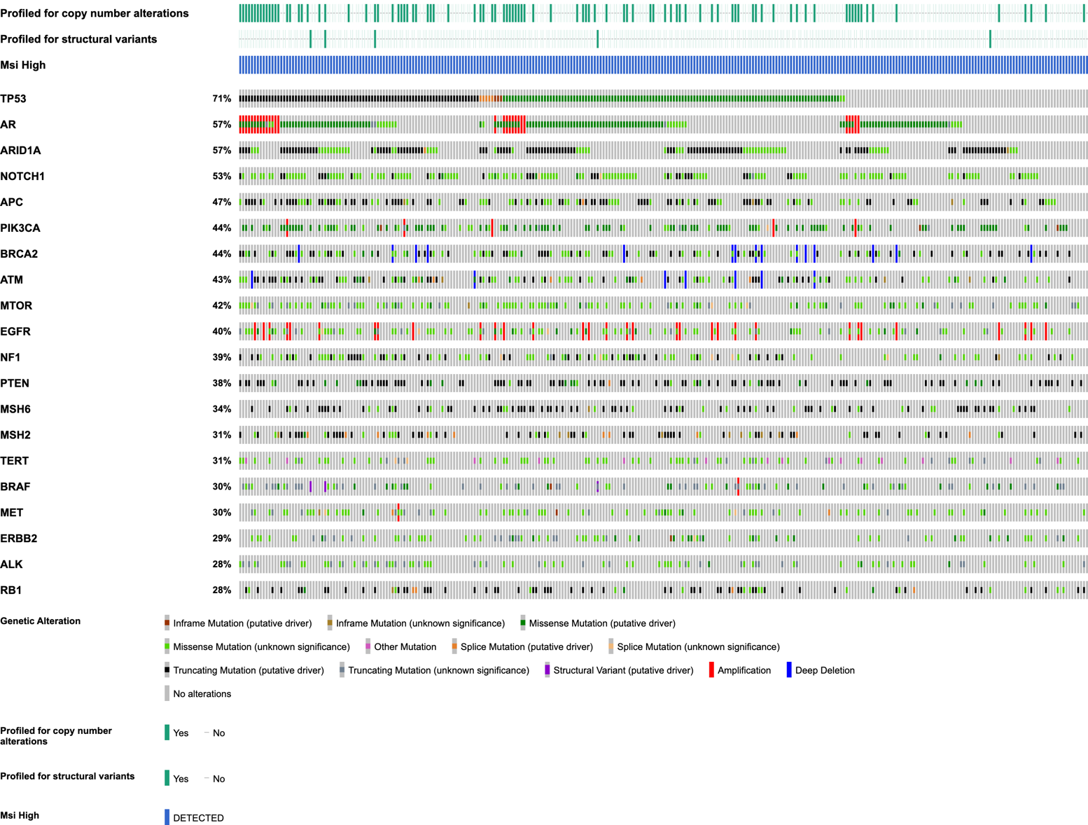
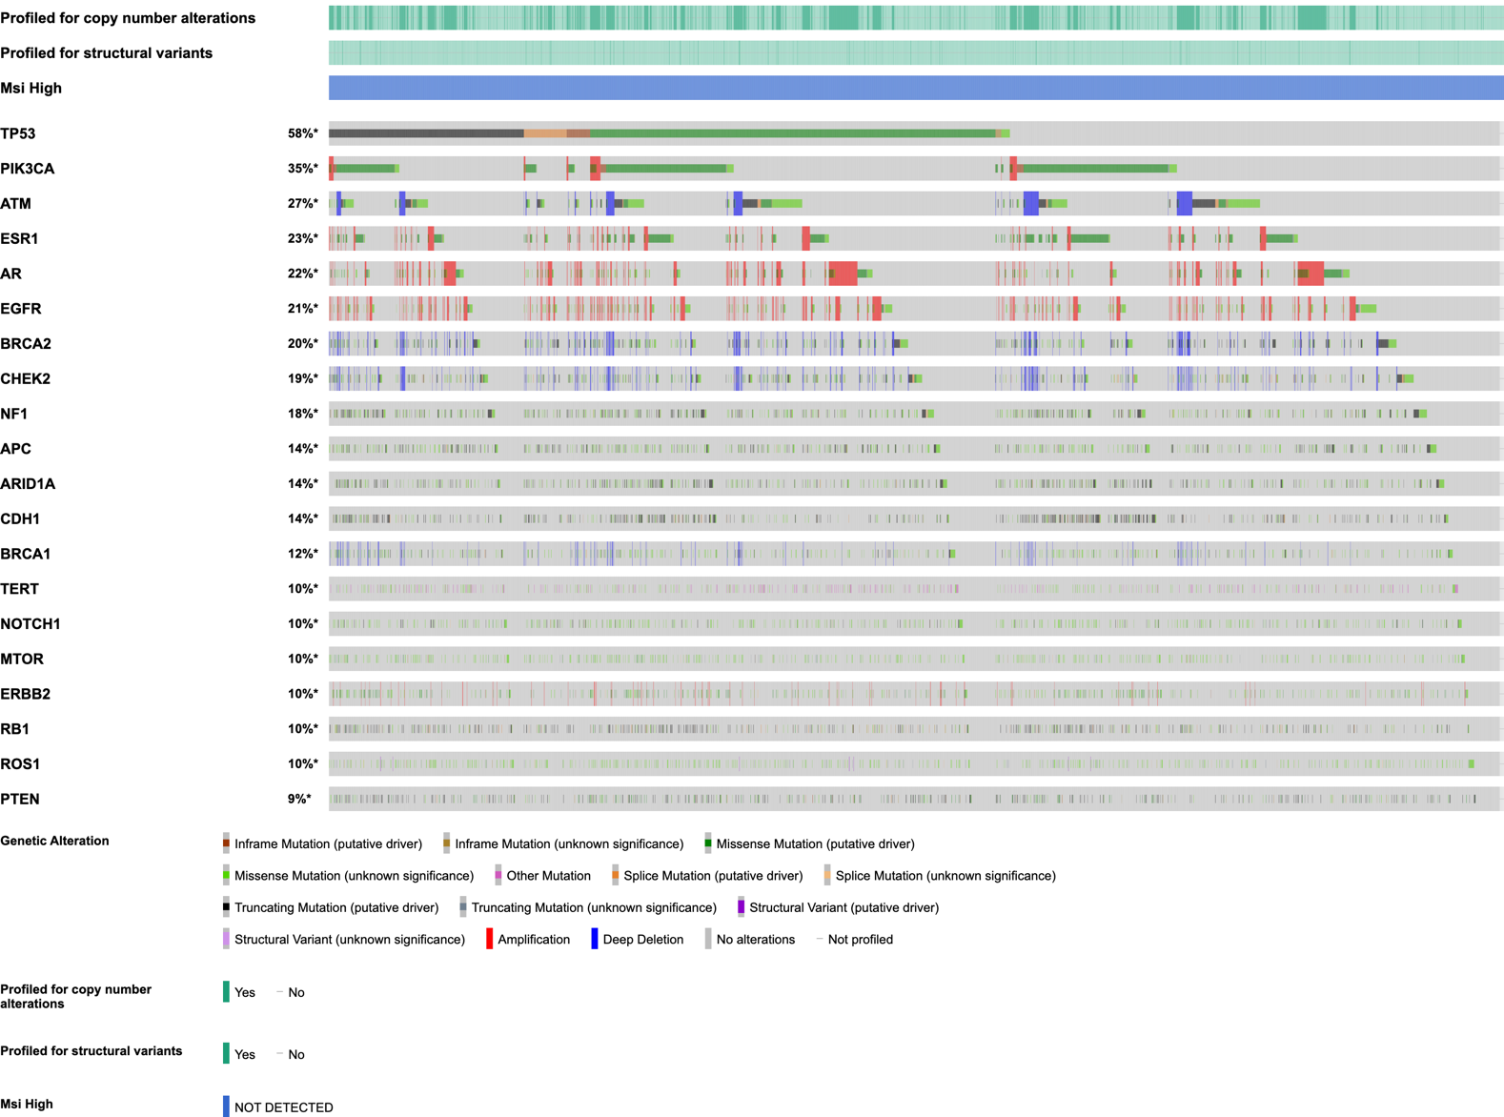

Figure S2: Co-occurring alterations in patients with a bTMB ≥16mut/Mb and (A) MSI-Detected or (B) MSI-Not Detected.
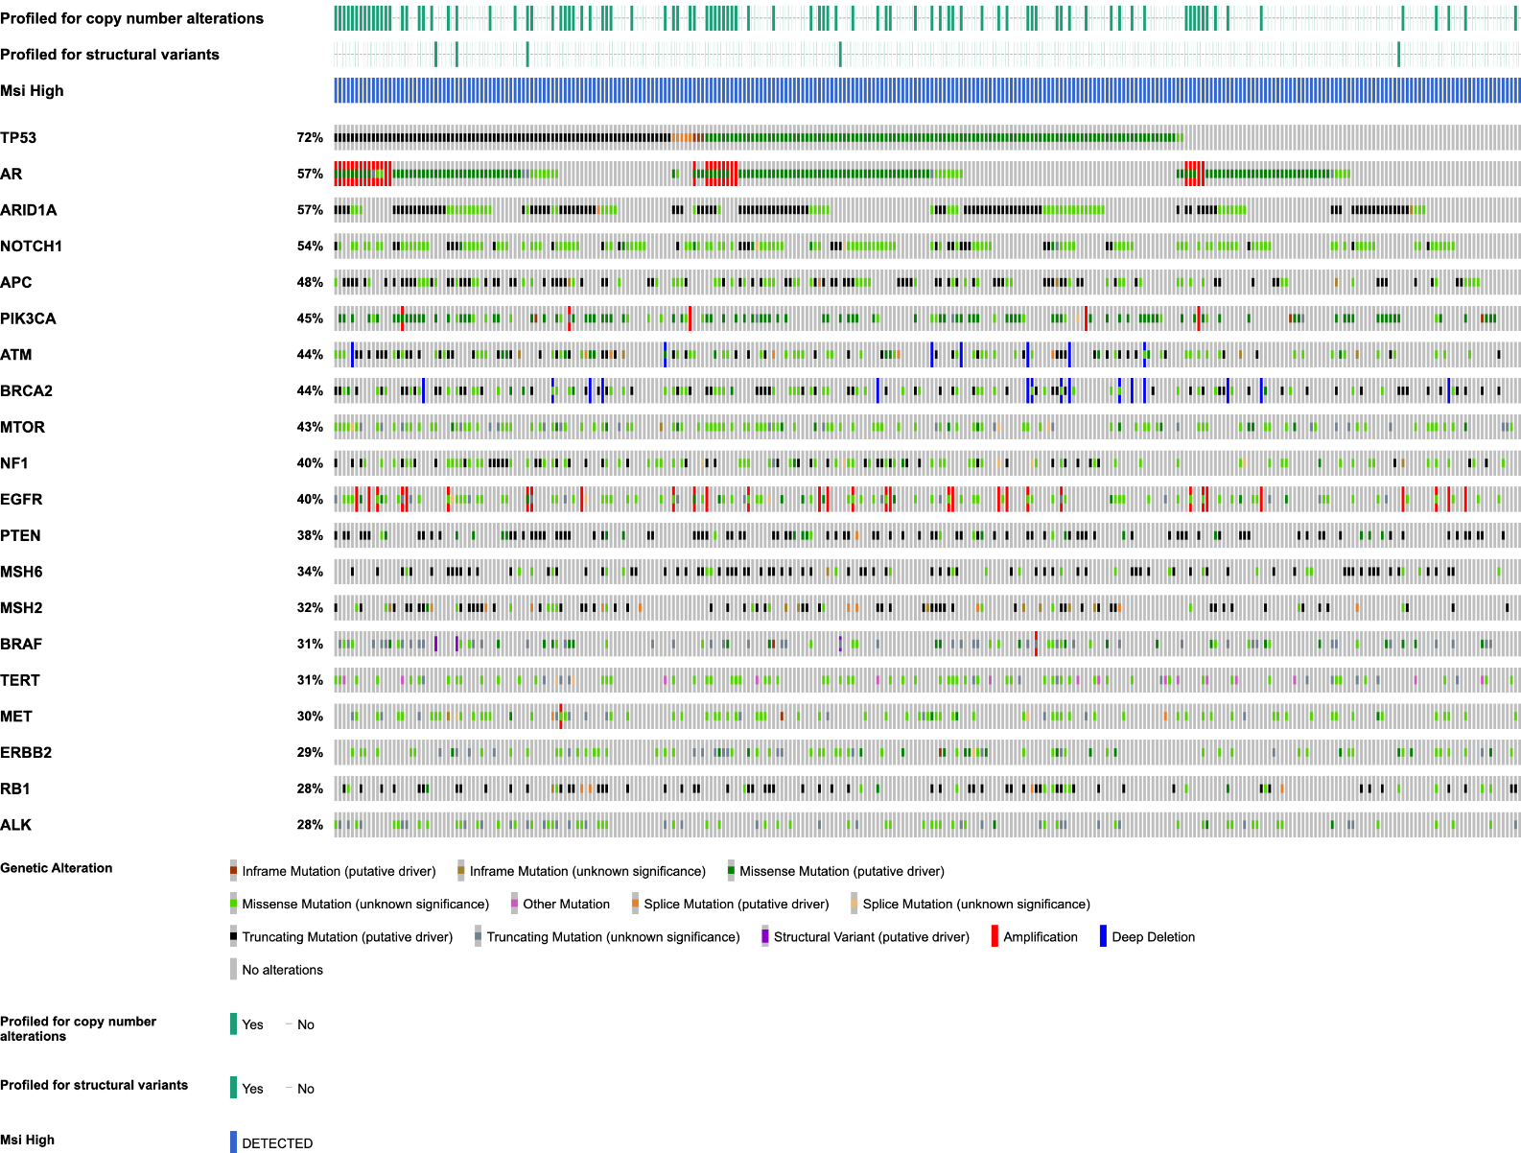
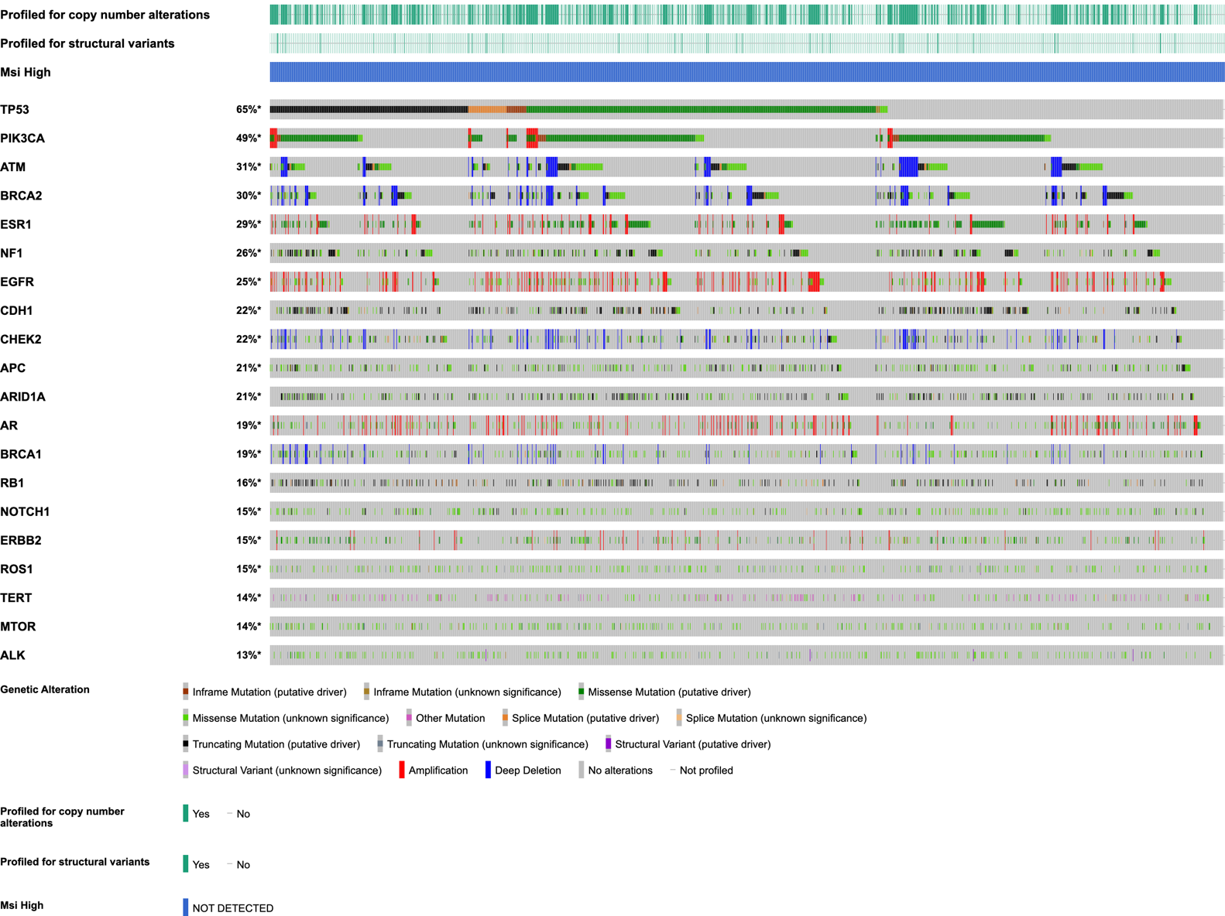

Figure S3: Genomic Landscape in cohort of breast cancer with bTMB ≥10 (A) and bTMB ≥16 (B); prostate cancer in with bTMB ≥10 (C) and bTMB ≥16 (D). Patients with MSI-Detected have been removed.
A

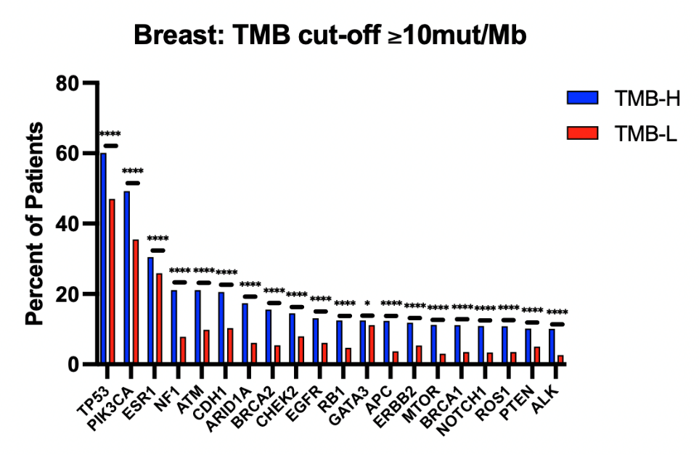
B
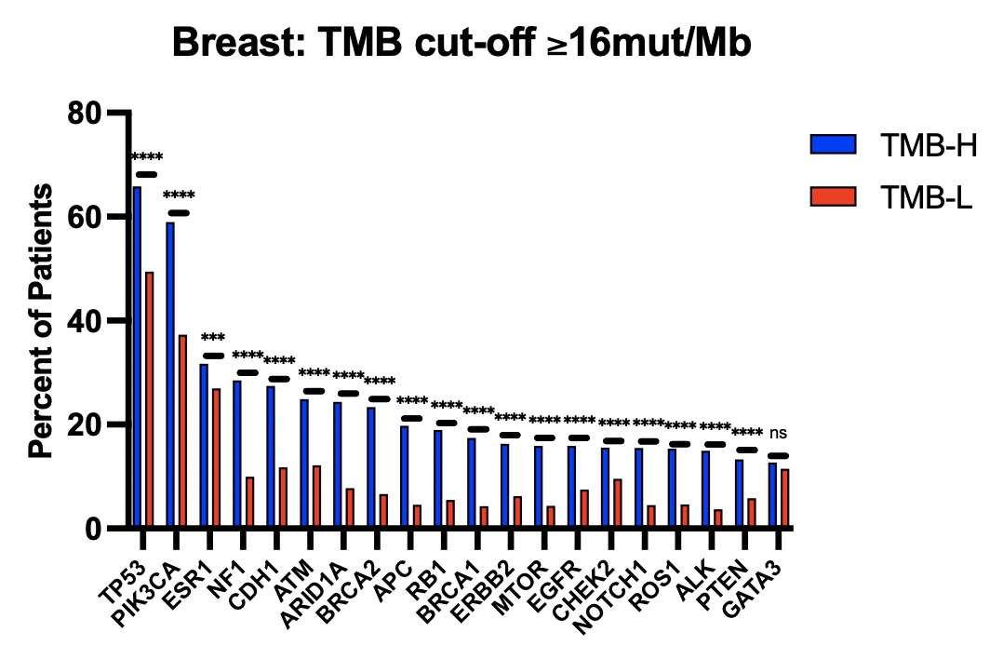

C
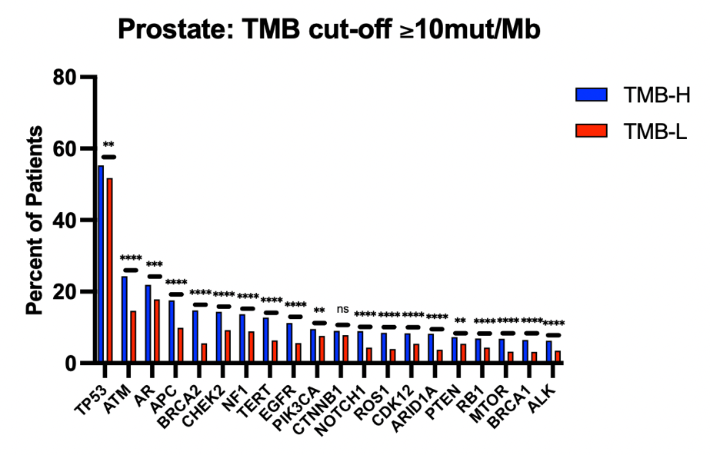
D
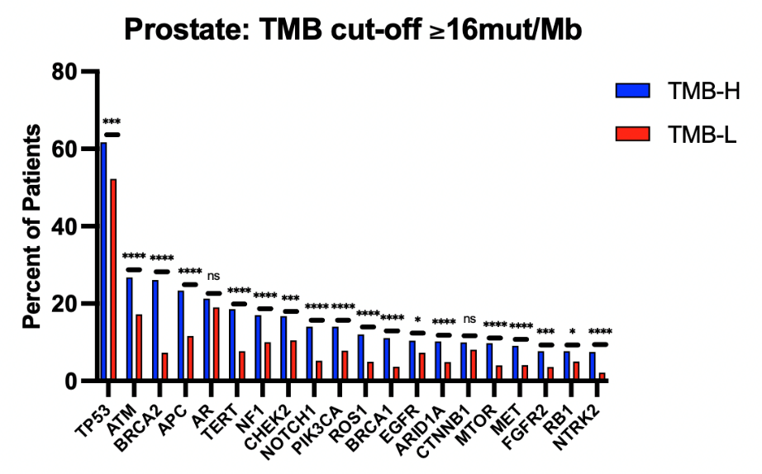

Table S1: HRR genes by bTMB-H cutoffs and MSI status in patients with prostate cancer: bTMB-16 vs bTMB-10 groups.

HRR Genes | bTMB-10 | bTMB-16 | p Value | bTMB-10 MSI-Detected | bTMB-10 MSI- Not Detected | p Value | bTMB-16 MSI-Detected | bTMB-16 MSI- Not Detected | p Value
ATM | 26.26% | 32.53% | 0.0018 | 43.17% | 24.28% | ≤0.0001 | 43.95% | 26.76% | ≤0.0001
BRCA1 | 8.25% | 15.36% | ≤0.0001 | 23.35% | 6.48% | ≤0.0001 | 23.77% | 11.11% | ≤0.0001
BRCA2 | 17.46% | 31.02% | ≤0.0001 | 40.53% | 14.76% | ≤0.0001 | 40.81% | 26.08% | ≤0.0001
CDK12 | 10.09% | 13.25% | 0.0267 | 24.67% | 8.38% | ≤0.0001 | 25.11% | 7.26% | ≤0.0001
CHEK2 | 14.42% | 16.27% | 0.2616 | 14.98% | 14.35% | 0.432 | 15.25% | 16.78% | 0.349
PALB2 | 5.02% | 11.14% | ≤0.0001 | 20.7% | 3.19% | ≤0.0001 | 21.08% | 6.12% | ≤0.0001
RAD51D | 1.38% | 3.31% | 0.0025 | 5.29% | 0.93% | ≤0.0001 | 5.38% | 2.27% | 0.0323

