Supplementary Information

Tailoring sub-nanochannels of palygorskite-derived membranes for desalination and selective lithium-ion transport
Liping Zhen^{1, 2, 3#}, Genping Meng^{1#}, Xisheng Zhao^{2,4}, Dina Sun¹, Yonghui Chen³, Shuai Wei¹, Yuhui Yin¹, Xinyue Li¹, Guowen Hu¹, Hua Li¹, Aiqin Wang⁵, and Baodui Wang^{1, 2}
¹College of Chemistry and Chemical Engineering, Lanzhou University, Gansu, Lanzhou, 730000. P. R. China.
²College of Earth and Environmental Sciences, Lanzhou University, Gansu, Lanzhou, 730000, P. R. China.
³Advanced Energy Science and Technology Guangdong Laboratory, Guangdong, Huizhou, 516000. P. R. China.
⁴Baotou Iron and Steel (Group) Co. Ltd., Baotou, 014010, P. R. China.
⁵Key Laboratory of Clay Mineral Applied Research of Gansu Province, Lanzhou Institute of Chemical Physics, Chinese Academy of Sciences, Lanzhou, Gansu 730000, China.
#These authors contributed equally to this work.
Email: aqwang@licp.cas.cn; wangbd@lzu.edu.cn

Supplementary Information
1. Supplementary Methods 3
2. Supplementary Figures
Figure S1 | Photographs of K control coater and the large-area PCH-7 membrane 7
Figure S2 | Photos of molds and membranes 8
Figure S3 | d-spacing of PAL nanorods in membrane calculated from Digital Micrograph 9
Figure S4 | TEM characterizations of the PCH-7 membrane 10
Figure S5 | AFM images of PCH membranes 11
Figure S6 | Pore size modulation of PAL nanorods 12
Figure S7 | XRD pattern of CMC chains 13
Figure S8 | XPS high-resolution scans for Mg 2p 14
Figure S9 | DFT simulation illustration of thePAL-CMC model system 15
Figure S10 | Zeta potential of the PCH membranes 16
Figure S11 | A commercial RO cross-flow filtration system 17
Figure S12 | Stability of the PAL nanorod membrane and PCH membrane in water 18
Figure S13 | The characteristics of the organic dyes used in this work 19
Figure S14 | Dye rejection performance of the PCH-7 membrane 20
Figure S15 | Antifouling performance of PCH-7 membrane 21
3. Supplementary Tables
Table S1 | The CMC content in PCH membranes 22
Table S2 | The species of oxygen-containing functional groups and their corresponding binding energy obtained by peak fitting to O 1s 23
Table S3 | Some reported nanofiltration membranes as well as corresponding membrane parameters 24
Table S4 | The antifouling indexes of the PCH-7 membrane for BSA feed solutions 25
4. References 26

- Supplementary Methods
Materials and Chemicals. Palygorskite (PAL)was supplied by Lanzhou Institute of Chemical Physics, Chinese Academy of Sciences. Commercially available Polyethersulfone (PES) ultrafiltration membranes (mean pore size: 0.22 μm) used as the substrate were purchased from Dongguan Pinggen Experimental Equipment Co. Ltd. (Guangdong, China). Oxalic acid (H₂C₂O₄) was obtained from Shanghai Macklin Biochemical Technology Co., Ltd. Hydrochloric acid (HCl) was provided by Lianlong Bohua Pharmaceutical & Chemical Co., Ltd. Sodium Carboxymethyl cellulose (CMC) and the four types of salts containing sodium chloride (NaCl), calcium chloride (CaCl₂) sodium sulfate (Na₂SO₄), lithium chloride (LiCl) magnesium chloride (MgCl₂) and magnesium sulfate (MgSO₄) were acquired from Kelong chemical reagent Co. Ltd. (Chengdu, China). Congo red (GR), Rhodamine 6G (Rh6G), Methyl blue (MB), and Crystal violet (CV) were provided by Dingguo Biological Technology Co. Ltd. (Beijing, China). Unless specified, deionized (DI) water was used throughout this work. All chemicals were used as received without any further purification.
Membrane Characterization. The morphologies of the PAL, the substrate MCE membrane, and the PCH membranes were characterized via a field emission scanning electron microscope at 10 kV (FESEM, Apreo S, Thermo Fisher). The chemical composition was obtained by energy-dispersive spectrometry (EDS). The transmission electron microscope (TEM, Tecnai F30, FEI) was used for measuring the structural performance of PAL. The crystallization property of the PAL and PCH membrane was measured by Rigaku D/Max-2400 Powder X-ray diffractometer (XRD) that works under 40 kV and 30 mA with a diffraction angle from 5⁰ to 90⁰ in a fixed time mode and step interval of about 0.167°. The superficial properties of PCH membranes, including chemical ingredient, coordination, hydrophilicity, and zeta potential, were recorded by Fourier transform infrared (FTIR, Nicolet 560) spectrometer, X-ray Photoelectron Spectroscopy (XPS, PHI-5702 multifunctional spectrometer with AlKa radiation), contact angle goniometer (JC2000C, China), and Sur PASS Electrokinetic Analyzer (Anton Paar KG, Austria), respectively. Room temperature UV-visible absorption spectroscopy was conducted to obtain the concentration of dyes on an Agilent Cary 5000 UV-Vis-NIR Spectrophotometer across the range of 200-800 nm. The concentration of metal ions was quantitatively analyzed by inductively coupled plasma atomic emission spectrometry (ICP-OES). The concentration of heavy metal ions was quantitatively analyzed by inductively coupled plasma mass spectrometry (ICP-MS). All the solid-state NMR experiments were performed on a 400 MHz spectrometer equipped with a MAS probe (AVANCE NEO, Bruker, Germany). The ²⁷Al MAS NMR spectra of the PAL and PCH-7 membrane were recorded.
Purification of PAL nanorods. The palygorskite (PAL) was purified via sedimentation methodology, and the obtained purified PAL was marked as PAL nanorods. In a typical procedure, 1.0 g PAL was suspended in 100 mL of ID water and ultrasound at 25 °C for 2 h. After that, the mixture was collected via centrifugation at 4000 rpm for 5 min, and washed with DI water three times. Finally, the samples were dried at 50 °C.
Ion imprinting treatment of PAL nanorods. A series of ion-imprinted PAL nanorods were performed as follows: 1.0 g PAL nanorods were immersed in 25 ml H₂C₂O₄/HCl solution with various concentrations (0.2, 0.5, and 1.0 mol/L) at 20 ℃ for 0.5 h under mechanical stirring at 1250 rpm, and then washed with distilled water for many times until the supernatant was free of Cl⁻ (determined by AgNO₃ solution). The resulting sample was dried at 100 °C. The obtained ion-imprinted PAL nanorods were marked as P_{β}AL nanorods (where β corresponds to H₂C₂O₄/HCl solution concentration).
Preparation of PCH-α and P_{β}CH-α membranes. The PCH-α (α = 3 to 9, where α represents the increasing CMC content) membranes were fabricated by a coordination self-assembly method. Briefly, the mixtures of PAL or P_{β}AL nanorods and CMC chains (a total of 0.5 g) were evenly dispersed into 100 mL with water, followed by stir at 45 °C for 12 h in a water bath. It was subsequently concentrated to ~10 ml by a decompression distillation process. The resulting slurry was coated with a Mayer rod to fabricate freestanding Palygorskite-derived hybrid (PCH) membranes for water desalination and purification performance evaluation. Meanwhile, to be exfoliated easily from the substrate membrane, the as-prepared PCH membranes were dried at 60 °C for 2 hours. The CMC content of the membrane varied in mass percent between 0.09% and 0.03% (presented as PCH-α, where α corresponds to 100 times the CMC percentage). For example, PCH-7 represented the membrane with the addition of 7 wt % of CMC chains.
Membrane Filtration Performance. The permeation and separation performances of the synthesized PCH-α (α = 3 to 9) membranes were evaluated using a lab-scale crossflow filtration system at room temperature. In detail, membranes were loaded in a dead-end and crossflow filtration cell which have effective areas of 3.14 cm², respectively. The membranes were pre-compacted and washed with DI water for at least 0.5 h at a constant pressure of 6.0 bar. Continuous filtration of 30 min was needed before the water permeability or the solute rejection was determined. The rejection was researched with different concentrations of the aqueous solution of inorganic salts and dye respectively.
The water permeance (P_{w}, L m⁻² h⁻¹ bar⁻¹) and solute rejection (R) was defined as:
$$P_{w}= \frac{V}{S × ∆t × ∆P}$$
$$R=(1- \frac{C_{a}}{C_{b}})$$
$$S_{{Mg}^{2+}/{Li}^{+}}=(\frac{C_{b {Mg}^{2+}} /{ C}_{b {Li}^{+}} }{C_{a {Mg}^{2+}} /{ C}_{a {Li}^{+}}})$$
where V (L), S (m²), ΔP (bar) and Δt were the volume of infiltration, the effective membrane area, working pressure and the permeance time, respectively. And C_{b} (mg/L) and C_{a} (mg/L) were the concentrations of before and after purification.
Antifouling experiments. The antifouling feature of the PCH membranes was evaluated by a filtration measurement using BSA as the representative foulant. Before the measurements, all the membranes were pretreated at 0.8 bar for 0.5 h by deionized (DI) water until the permeance reached a stable value. In detail, the DI water permeation (P_{w1}) of the membrane was tested first at 0.8 bar. Subsequently, the DI water was replaced by a foulant aqueous solution (0.1 wt.%). The fouling test was carried out for 5 h and the permeation (P_{f}) was recorded again. Then the fouled membrane was cleaned with DI water for 1 h. At last, the filtration cell was refilled with the DI water to obtain water permeation (P_{w2}). After antifouling tests, four parameters including total flux decline ratio (DR_{t}), irreversible flux decline ratio (DR_{ir}), reversible flux decline ratio (DR_{r}), and flux recovery ratio (FRR) were introduced to evaluate the antifouling features of the membrane and were calculated with the equations below.
$${DR}_{t}=1- \frac{P_{f}}{P_{w1}}$$
$${DR}_{it}=1- \frac{P_{w2}}{P_{w1}}$$
$${DR}_{r}= \frac{P_{w2}- P_{f}}{P_{w1}}$$
$$FRR= \frac{P_{w2}}{P_{w1}}$$
The higher FRR and lower DR_{t} values indicate the better antifouling property of the membrane.
Density functional theory simulations. We have employed the first principles to perform all density functional theory (DFT) calculations within the generalized gradient approximation (GGA) using the Perdew-Burke-Ernzerhof (PBE) formulation. The projected augmented wave (PAW) potentials were chosen to describe the ionic cores and take valence electrons into account using a plane wave basis set with a kinetic energy cutoff of 520 eV. Partial occupancies of the Kohn−Sham orbitals were allowed using the Gaussian smearing method with a width of 0.05 eV. The electronic energy was considered self-consistent when the energy change was smaller than 10⁻⁵ eV. A geometry optimization was considered convergent when the energy change was smaller than 0.05 eV Å⁻¹. The vacuum spacing in a direction perpendicular to the plane of the structure is 18 Å for the surfaces. The Brillouin zone integration is performed using 2×2×1 Monkhorst-Pack k-point sampling for a structure. Finally, the adsorption energies (E_{ads}) were calculated as E_{ads}= E_{ad/sub} -E_{ad} -E_{sub}, where E_{ad/sub}, E_{ad}, and E_{sub} are the total energies of the optimized adsorbate/substrate system, the adsorbate in the structure, and the clean substrate, respectively. The free energy was calculated using the equation:
G=E_{ads} + ZPE - TS
where G, E_{ads}, ZPE, and TS are the free energy, total energy from DFT calculations, zero point energy, and entropic contributions, respectively.
Langevin dynamics simulations. Ab initio molecular dynamics (AIMD) simulation was carried out to study structures with H₂O. respectively. During geometry optimization, the cut-off energy was set as 450eV for structures, respectively. The Brillouin zone was sampled by a Monkhorst-Pack (MP) k-point grid of 1× 1 × 1 for geometry optimizations. The PBE-D3 dispersion term was introduced to correct the van der Waals interactions. The conjugated gradient method was applied with a smearing width of 0.15 eV, and the convergence criteria for the energy and force were 10-4 eV/cell and 0.05 eV/Å, respectively. AIMD simulations were run for 100 ps as equilibration with time steps of 1 fs, performing a constant temperature of 300 K in the Nosé -Hoover isokinetic ensemble. Grimme’s DFT-D3 methodology was used to describe the dispersion interactions. Finally, the binding energies (E_{b}) were calculated as E_{b}= E_{ad/sub} -E_{ad} -E_{sub}, where E_{ad/sub}, E_{ad}, and E_{sub} are the total energies of the optimized adsorbate/substrate system, the adsorbate in the structure, and the clean substrate, respectively.

2. Supplementary Figures
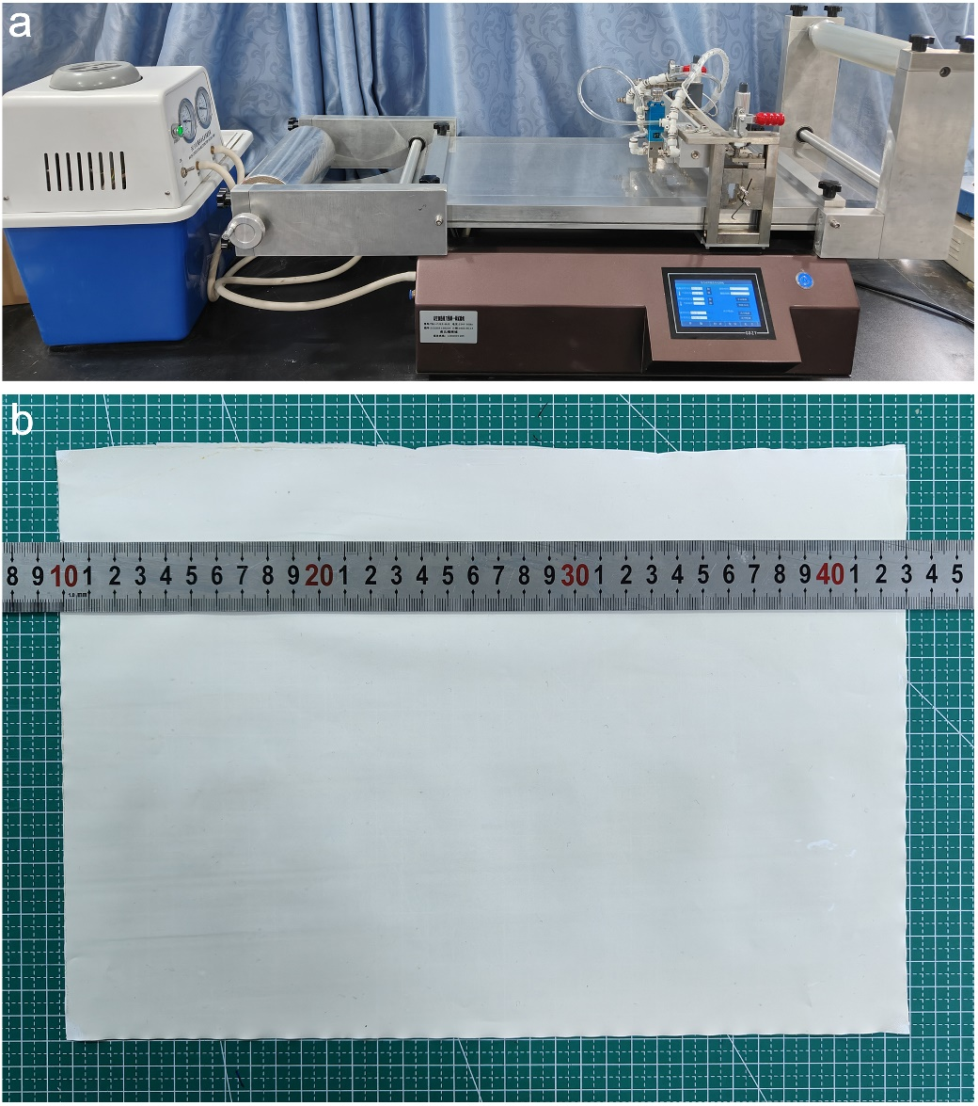
Figure S1 Photographs of (a) K control coater and (b) the large-area PCH-7 membrane.

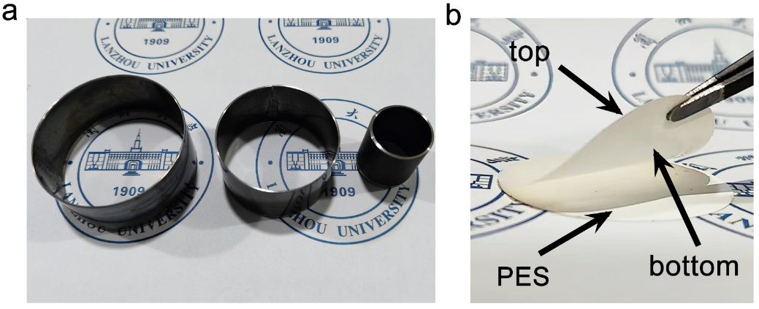
Figure S2 Photos of molds and membranes. (a) Molds for cutting large-area membrane, (b) Exfoliation process of the PCH membrane from the PES substrate. A circular membrane was obtained by cutting the large-area membrane with a mold.

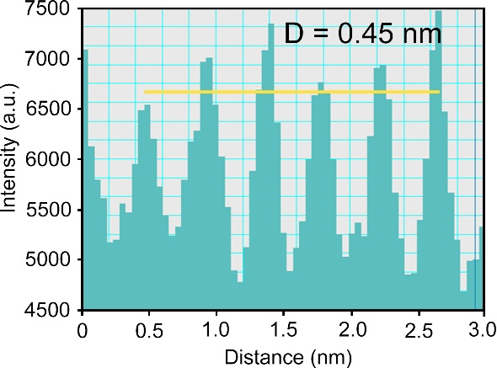
Figure S3 d-spacing of PAL nanorods in membrane calculated from DigitalMicrograph.

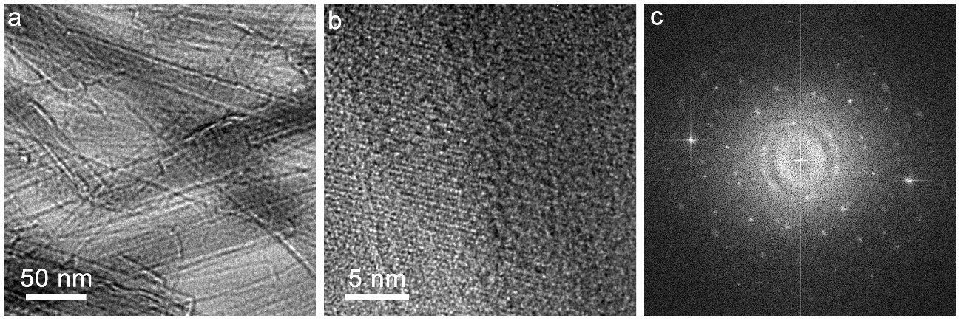
Figure S4 TEM characterizations of the PCH-7 membrane. (a) and (b) TEM images with different magnifications. The HRTEM image of the lattice spacing of the PAL nanorod in the PCH-7 assembly. (c) The electron diffraction pattern of PAL nanorods in the PCH-7 membrane. It reveals the high crystallinity of the PAL nanorods.

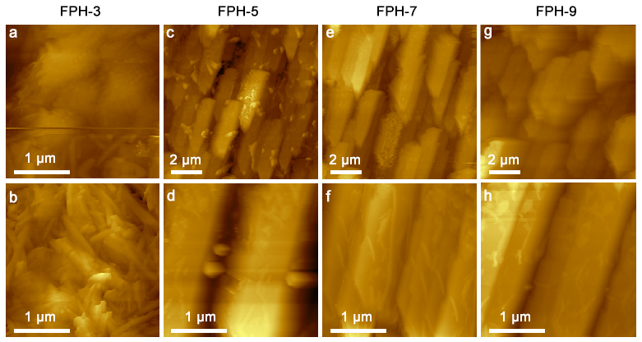
Figure S5 AFM images of PCH membranes.

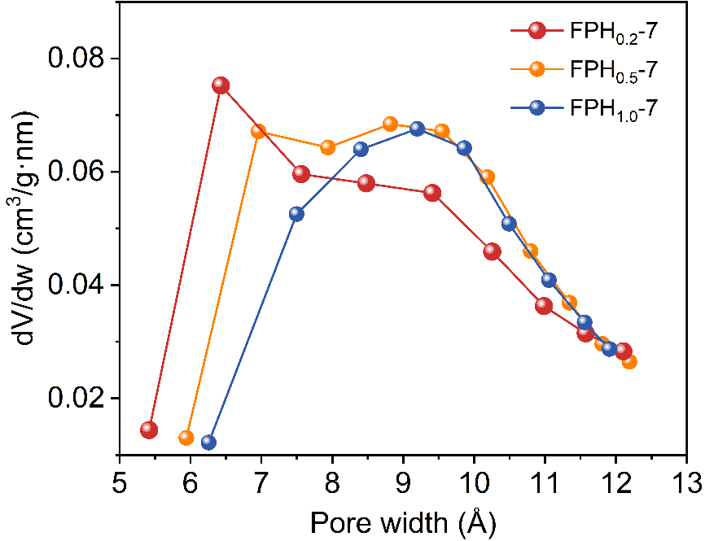
Figure S6 Pore size modulation of PAL nanorods using the ion-imprinting technique.

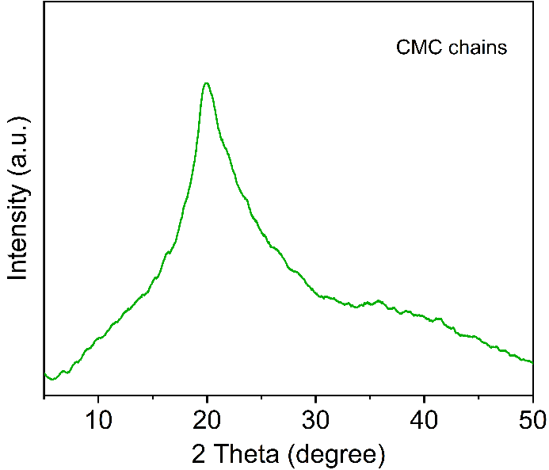
Figure S7 XRD pattern of CMC chains.

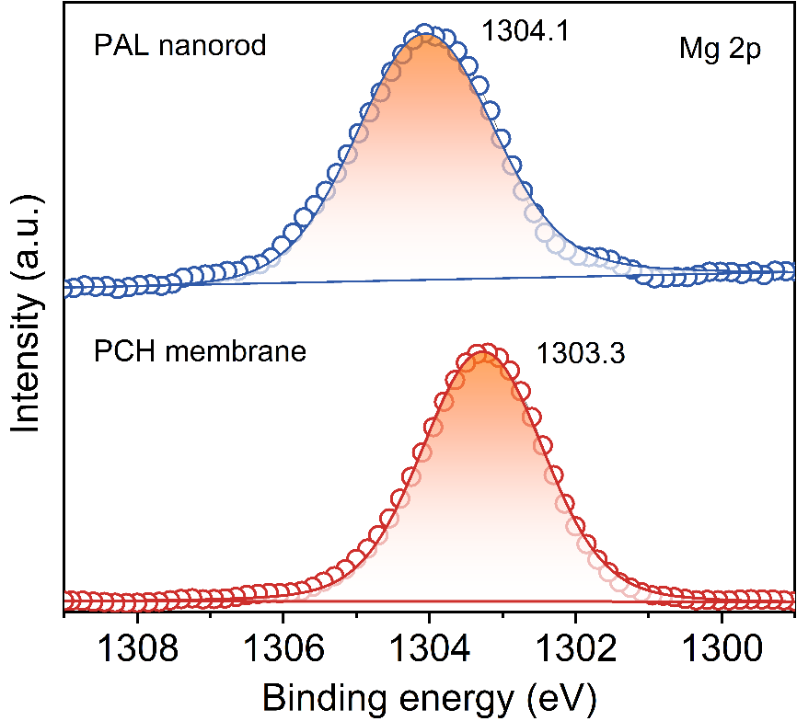
Figure S8 XPS high-resolution scans for Mg 2p.

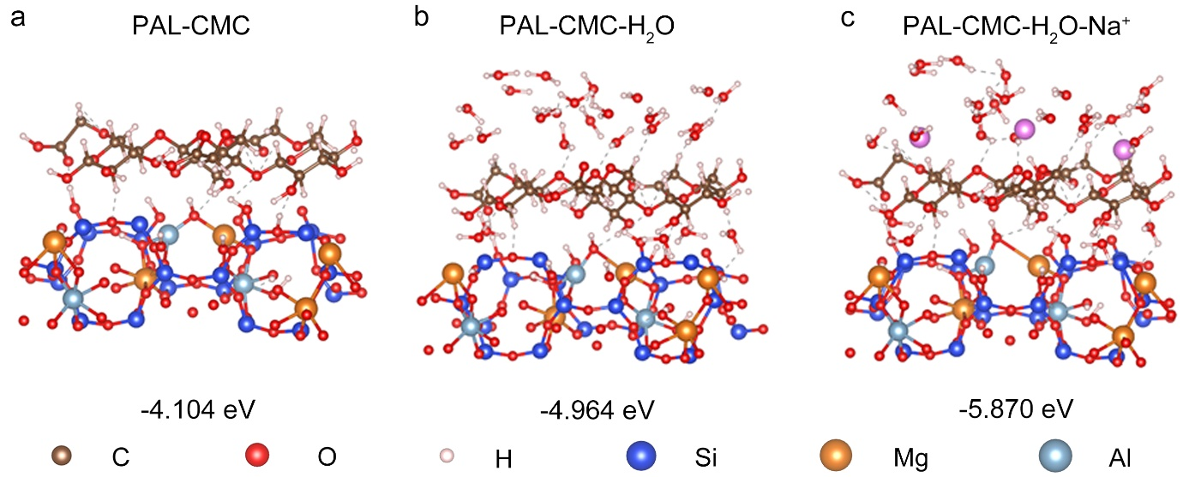
Figure S9 Energy-optimized geometry of bonding between a PAL nanorod and a CMC chain by theoretical calculation with DFT. The interaction between a PAL nanorod and a CMC chain under different conditions: (a) in a dry state, (b) in pure water, and (c) in water under the presence of Na⁺. The gray dotted line represents hydrogen bonding interactions formed between PAL and the CMC chain.

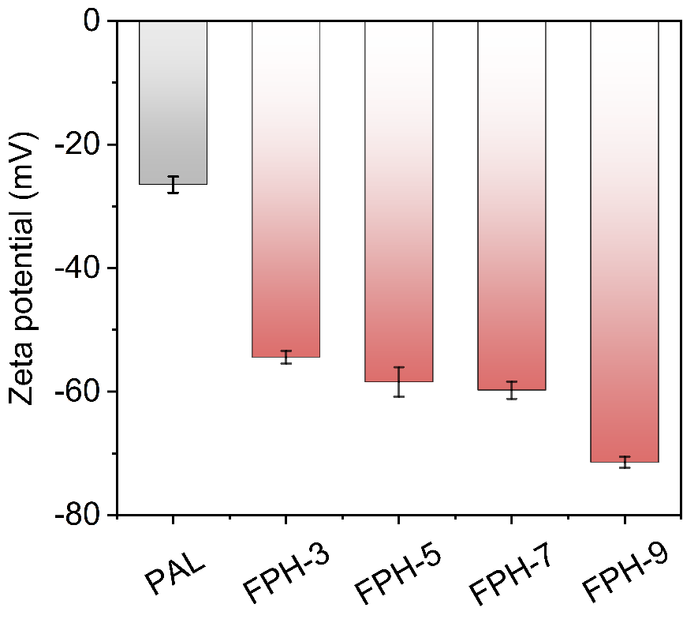
Figure S10 Zeta potential of the PCH membranes.

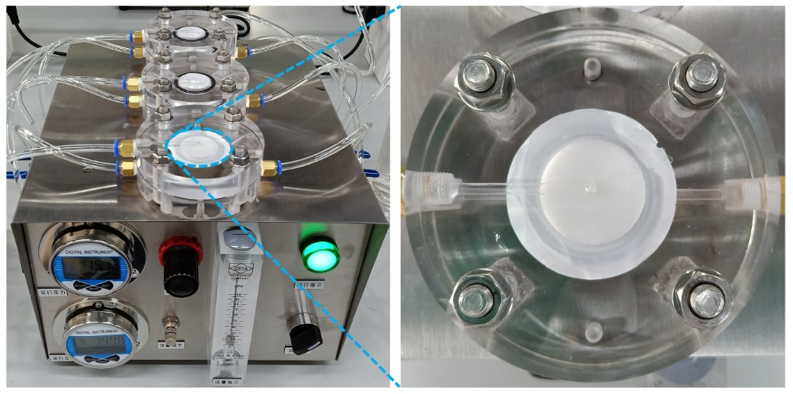
Figure S11 A commercial RO cross-flow filtration system.

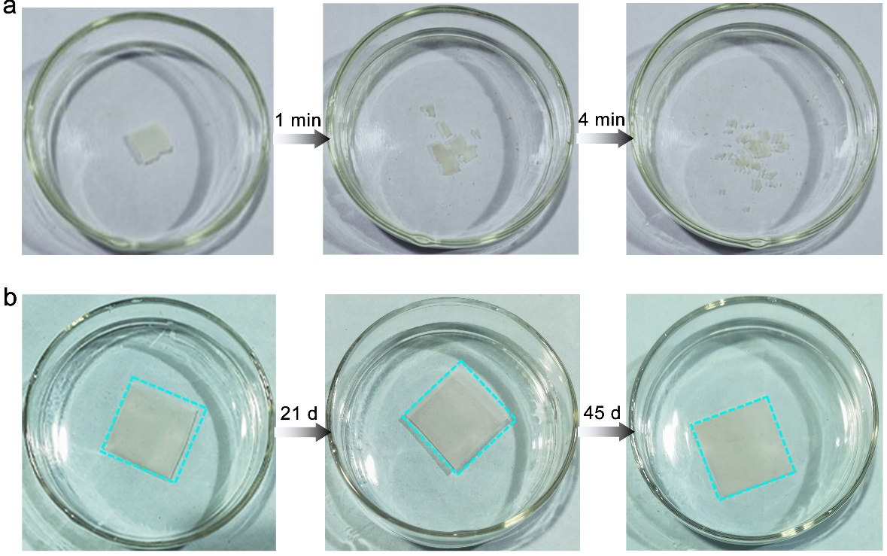
Figure S12 Stability of the PAL nanorod membrane (a) and (b) PCH membrane in water. In the absence of CMC, the bare PAL nanorod membrane readily disintegrates in water within 4 min. In contrast, the PCH membrane retains structural integrity even if soaked in water for 45 days due to the strong interactions between PAL nanorods and CMC chains.

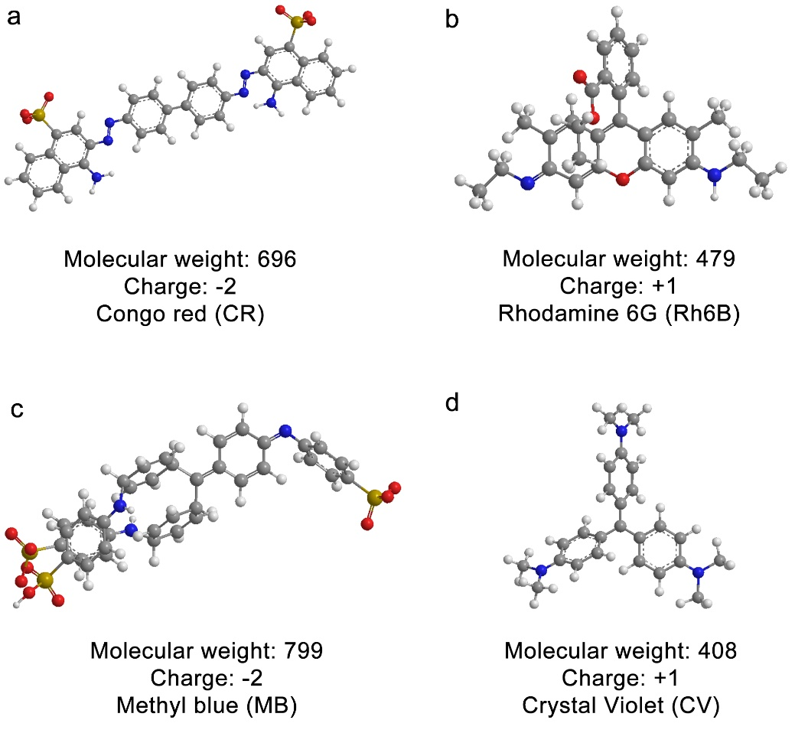
Figure S13 The characteristics of the organic dyes used in this work.

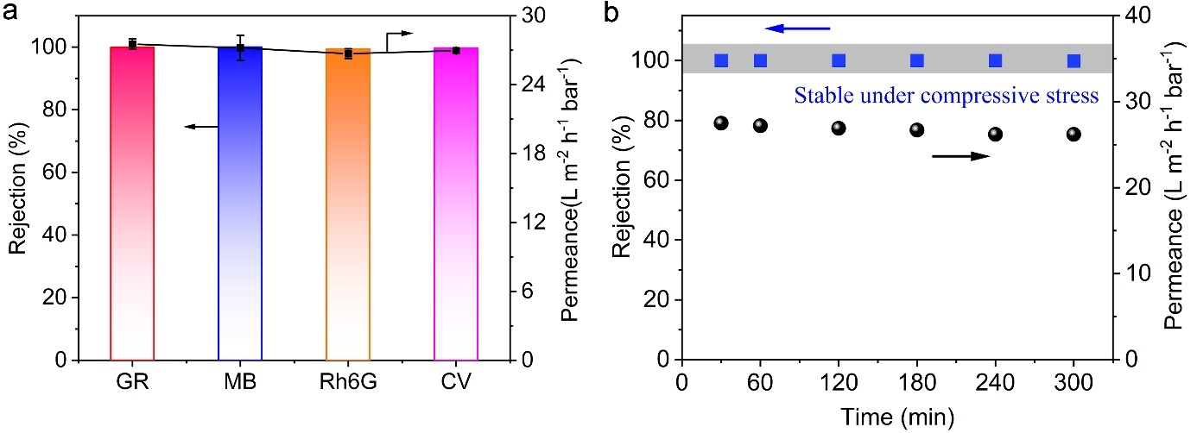
Figure S14 Dye rejection performance of the PCH-7 membrane. (a) Permeability and selectivity of the PCH-7 membrane for the nanofiltration of different dye solutions (dye concentration: 20 ppm; applied pressure: 6.0 bar). b) Long-term stability of the PCH-7 membrane for rejecting MB.

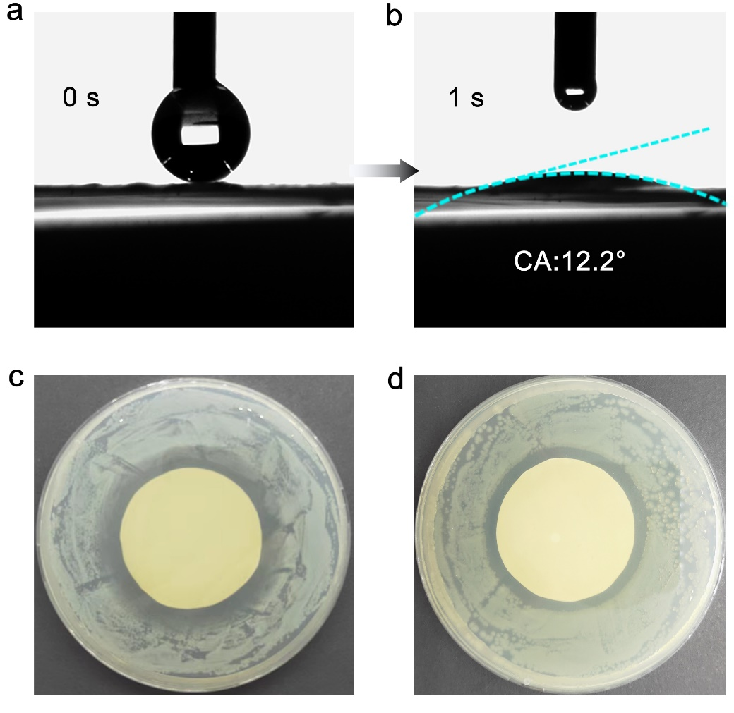
Figure S16 Antifouling performance of PCH-7 membrane. a, b) The Surface wettability of the PCH-7 membrane. c, d) The inhibition zone of PCH-7 membrane against S. aureus and E.coli.

Table S1 The CMC content in PCH membranes.
Membrane | PAL content (wt%) | CMC content (wt%)
PCH-3 | 97 | 3
PCH-5 | 95 | 5
PCH-7 | 93 | 7
PCH-9 | 91 | 9

Table S2 The species of oxygen-containing functional groups and their corresponding binding energy obtained by peak fitting to O 1s.
 | Functional groups | Binding energy（eV）
CMC chains | C-O-C | 533.4
CMC chains | O=C-O | 532.7
PCH membrane | Si-O-Mg | 530.5
PCH membrane | Si-O-Al | 531.0
PCH membrane | Si-O-Si | 531.6
PCH membrane | Si-OH | 532.4
PCH membrane | C-O-C | 534.2
PCH membrane | O=C-O | 535.8

Table S3 Some reported nanofiltration membranes as well as corresponding membrane parameters.
Membrane | Feed  solution | Salt  rejection  (%) | Saltwater Hydraulic  Permeability  (L m⁻² h⁻¹ bar⁻¹) | Reference
PSBMA@MoS₂ | 1000 ppm  Na₂SO₄ | 94.8 | 7.8 | ^{[1]}
PA-ATP(n)/PES | 1000 ppm  Na₂SO₄ | 92 | ~23 | ^{[2]}
GO/MoS₂ | 0.01M Na₂SO₄ | 65.2 | 10.2 | ^{[3]}
rGO membrane | 0.01M Na₂SO₄ | 90 | <0.5 | ^{[4]}
MOF-303 membrane | 0.10 wt % Na₂SO₄ | 100 | 0.0396 | ^{[5]}
PA/GO membrane | 1000 ppm  Na₂SO₄ | 94.8 | 15.5 | ^{[6]}
ZIF-8/TA-PES | 2000 ppm  Na₂SO₄ | 92.2 | 3.6 | ^{[7]}
NF270 | 1000 ppm  Na₂SO₄ | 96.1 | 10.3 | ^{[8]}
PCH membrane | 2000 ppm  Na₂SO₄ | 97.3 | 26.4 | This work
Traditional PA | 2000 ppm  NaCl | 33.7 | 7.1 | ^{[9]}
Asymmetric PA | 2000 ppm  NaCl | 41.1 | 30.6 | ^{[9]}
PDA-2h-PA | 2000 ppm  NaCl | 99.4 | 1.46 | ^{[10]}
PA-ATP(n)/PES | 1000 ppm  NaCl | 14.7 | ~23 | ^{[2]}
ZIF-8/TA-PES | 2000 ppm  NaCl | 64.7 | ~2 | ^{[7]}
ZIF-8/(TA-Zn²⁺)n/PES | 2000 ppm  NaCl | 55.2 | 5.1 | ^{[11]}
GO/FLG | 0.2% NaCl | 85 | 0.46 | ^{[12]}
NF270 | 1000 ppm  NaCl | 25.9 | 13.8 | ^{[8]}
NF90 | 1000 ppm  NaCl | 80.3 | 8.7 | ^{[8]}
CPF membrane | 584 ppm  NaCl | 83.0 | 9.5 | ^{[13]}
PCH membrane | 2000 ppm NaCl | 86.2 | 27.7 | This work

Table S4 The antifouling indexes (DR_{t}, DR_{r}, DR_{ir,} and FRR) of the PCH-7 membrane for BSA feed solutions.
Antifouling Indexes | PCH-7 membrane
FRR | 94.6
DR_{t} | 18.5
DR_{r} | 13.1
DR_{ir} | 5.4

References

[1] X. Liang, et al. Zwitterionic functionalized MoS₂ nanosheets for a novel composite membrane with effective salt/dye separation performance. J. Membr. Sci., 573: 270-279 (2019).
[2] M. Wu, et al. Fabrication of composite nanofiltration membrane by incorporating attapulgite nanorods during interfacial polymerization for high water flux and antifouling property. J. Membr. Sci., 544: 79-87 (2017).
[3] P. Zhang, et al. Novel “loose” GO/ MoS₂ composites membranes with enhanced permeability for effective salts and dyes rejection at low pressure. J. Membr. Sci. 574: 112-123 (2019).
[4] Z. Wang, et al. Graphene oxide nanofiltration membranes for desalination under realistic conditions. Nat. Sustain. 4(5): 402-408 (2021).
[5] M. Jian, et al. Ultrathin water-stable metal-organic framework membranes for ion separation. Sci. Adv. 6: eaay3998 (2020).
[6] X. Wei, et al. Preparation of graphene oxide/polyamide composite nanofiltration membranes for enhancing stability and separation efficiency. J Appl Polym Sci, 138(40), (2021).
[7] Y. Xu, et al. Plant polyphenol intermediated metal-organic framework (MOF) membranes for efficient desalination. J. Membr. Sci., 618, (2021).
[8] Y. Li, et al. Fabrication of composite polyamide/kevlar aramid nanofiber nanofiltration membranes with high permselectivity in water desalination. J. Membr. Sci., 592, (2019)
[9] B. Yuan, et al. Asymmetric polyamide nanofilms with highly ordered nanovoids for water purification. Nat. Commun., 11(1), (2020).
[10] X. Song, et al. Constructing semi-oriented single-walled carbon nanotubes artificial water channels for realized efficient desalination of nanocomposite ro membranes. J. Membr. Sci., 663, (2022).
[11] Y. Xiao, et al. Metal-phenolic network as precursor for fabrication of metal-organic framework (MOF) nanofiltration membrane for efficient desalination. J. Membr. Sci., 624, (2021).
[12] A. Morelos-Gomez, et al. Effective NaCl and dye rejection of hybrid graphene oxide/graphene layered membranes. Nat. Nanotechnol. 12(11): 1083-1088 (2017).
[13] J. Shen, et al. Fast water transport and molecular sieving throughultrathin ordered conjugated-polymer-framework membranes. Nat. Nanotechnol. 21: 1183-1190 (2022).

