Supplementary Figures and Tables
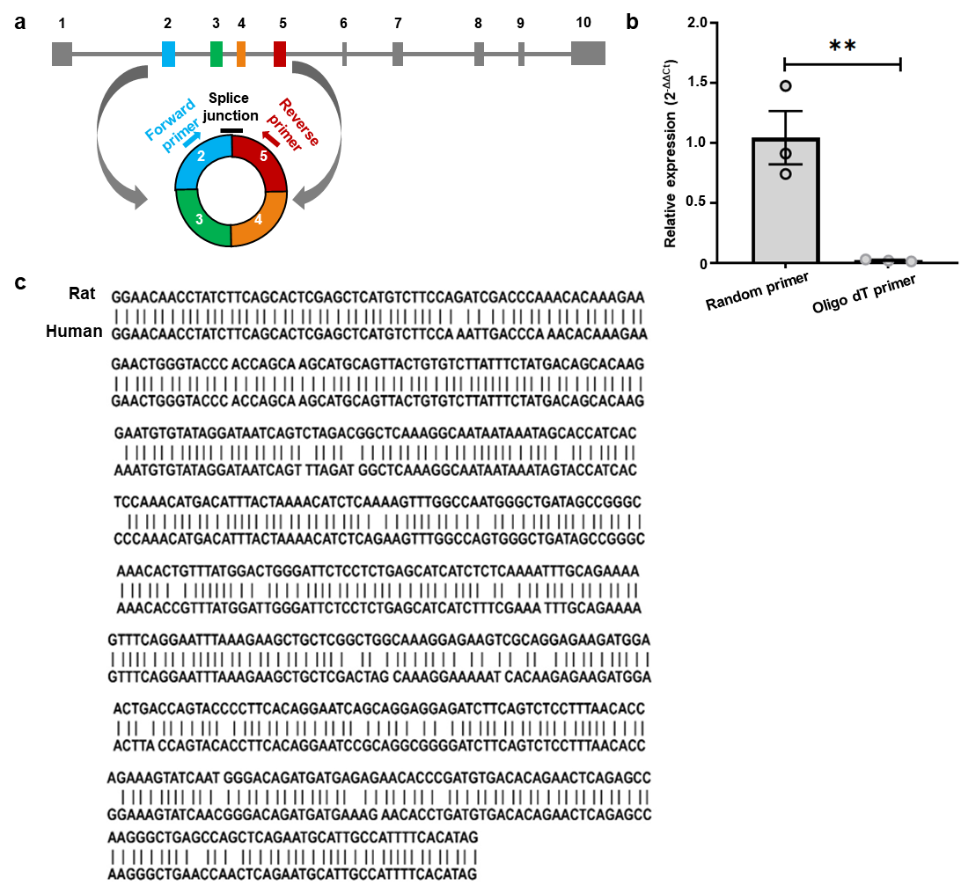Supplementary Fig. 1: The construction and conservation of circHomer1.
a, Schematic representation of circRNA biogenesis and detection for rat circHomer1. CircHomer1 is generated from exons 2 to 5 of Homer1 following backsplicing and covalent joining between exon 5 and exon 2 of the longest Homer1 isoform. The location for shRNAs and probes for circHomer1-specific knockdown and detection, respectively, are shown. b, Poly-A selection depletes circHomer1 expression. Unpaired t test, t = 4.605, df = 4, P = 0.010. c, Comparison of human and rat mature circHomer1 sequences. Results from NCBI blast alignment of the mature circHomer1 sequences for human and rat (94% sequence conservation). Error bars indicate SEM, **P < 0.01
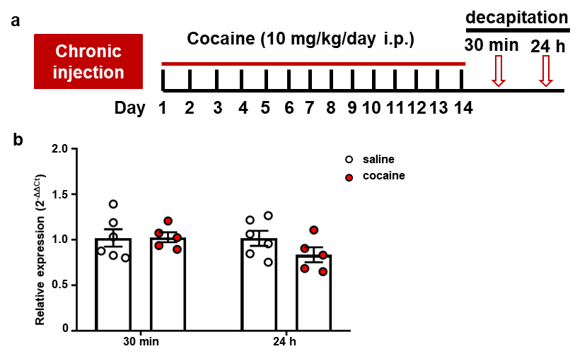Supplementary Fig. 2: The total Homer1 expression after repeated cocaine exposure.
a, Timeline of the experiment. The rats were injected intraperitoneally with cocaine for 14 days and were decapitated to detect the expression of total Homer1 mRNA at 30 min and 24 h after the last cocaine injection. b, The expression of Homer1 in PrL at 30 min and 24 h after the last cocaine injection. Unpaired t test, 30 min: t = 0.062, df = 9, P = 0.952; 24h: t = 1.537, df = 9, P = 0.159. Error bars indicate SEM.
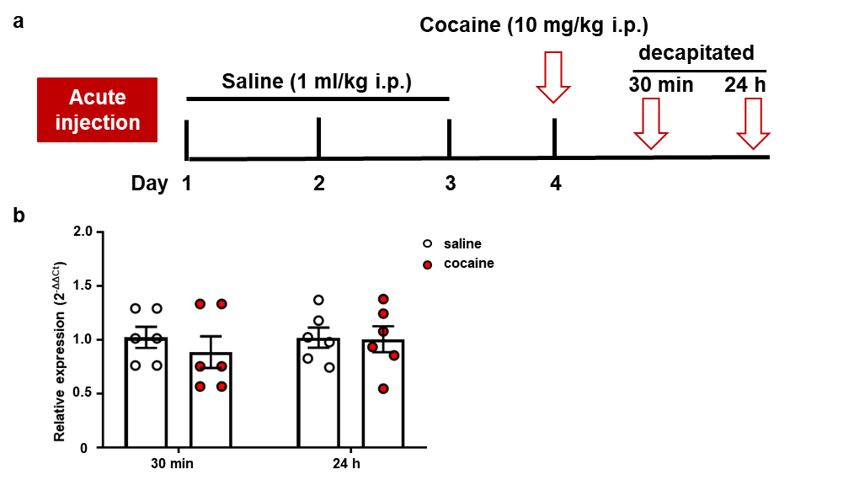Supplementary Fig. 3: The expression of circHomer1 after acute cocaine treatment.
a, Timeline of the experiment. The rats were injected intraperitoneally with saline (1 ml/kg) for 3 days to adapt the experimenter’s operation and were decapitated to detect the expression of circHomer1 at 30 min and 24 h after the acute cocaine injection. b, The expression of circHomer1 in PrL at 30 min and 24 h after acute cocaine treatment. Unpaired t test, 30 min: t = 0.785, df = 10, P = 0.451; 24h: t = 0.093, df = 10, P = 0.928. Error bars indicate SEM.
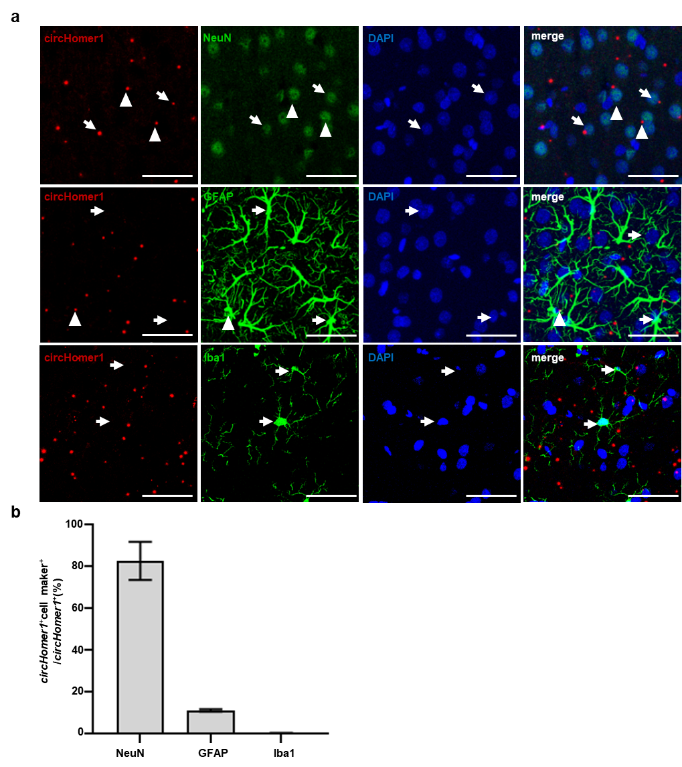Supplementary Fig. 4: CircHomer1 is mainly expressed in neurons.
a, Illustration of circHomer1-expressing cell types in the PrL of native rats. White arrows indicate positive staining of biomarkers for cell types (green indicates NEUN, GFAP, and Iba-1); white triangles indicate co-localization with circHomer1 (red) and biomarkers (green). Scale bars, 50 μm. b, Ratio of circHomer1 and cell markers double-positive cells among circHomer1-positive cells. n = 4. Error bars indicate SEM.
Supplementary Table 1: The information of all including samples
ID | Clinical Diagnosis | Age | Race | Cause of Death
1 | Unaffected Control | 29 | Black | multiple gunshot wounds
3 | Unaffected Control | 23 | White | acute coronary thrombosis - LAD: coronary atherosclerosis
4 | Unaffected Control | 21 | Black | gunshot wound to chest
5 | Unaffected Control | 45 | White | acute coronary thrombosis, atherosclerotic heart disease
6 | Unaffected Control | 21 | Black | gunshot wound to chest
7 | Unaffected Control | 26 | Black | gunshot wounds of chest
8 | Unaffected Control | 46 | White | idiopathic dilated cardiomyopathy
9 | Unaffected Control | 48 | White | cardiac arrest
11 | Unaffected Control | 22 | Black | gunshot wound to chest
12 | Unaffected Control | 35 | White | blunt force craniocerebral trauma
13 | Unaffected Control | 47 | White | cardiomegaly with left ventricular hypertrophy
14 | Unaffected Control | 29 | Black | pulmonary thromboembolus, deep vein phlebothrombosis, arteriosclerotic cardiovascular disease
21 | Cocaine intoxication death | 27 | White | cocaine intoxication
22 | Cocaine intoxication death | 29 | White | cocaine intoxication
23 | Cocaine intoxication death | 35 | White | cocaine intoxication
24 | Cocaine intoxication death | 31 | White | cocaine intoxication
25 | Cocaine intoxication death | 23 | White | cocaine intoxication
26 | Cocaine intoxication death | 29 | White | acute cocaine toxicity
27 | Cocaine intoxication death | 38 | White | atherosclerotic coronary artery disease; chronic cocaine abuse
28 | Cocaine intoxication death | 36 | White | acute cocaine toxicity
29 | Cocaine intoxication death | 30 | Black | cocaine intoxication
30 | Cocaine intoxication death | 33 | Black | Massive pulmonary emboli;chronic cocaine abuse
31 | Cocaine intoxication death | 45 | White | cocaine intoxication
32 | Cocaine intoxication death | 44 | Black | cocaine toxicity; cerebrovascular accident
33 | Cocaine intoxication death | 34 | White | acute cocaine overdose; hypertensive cardiac disease
34 | Cocaine intoxication death | 28 | White | acute cocaine toxicity
35 | Cocaine intoxication death | 35 | White | cocaine toxicity
36 | Cocaine intoxication death | 21 | Black | cocaine intoxication

