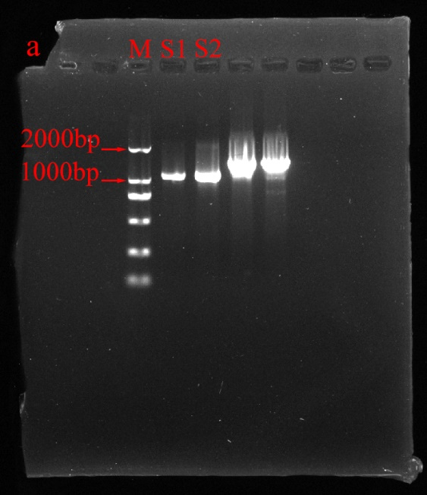
Figure S1. The original gels of figure 1.

