Table 1 Clinical features and follow up times of cases
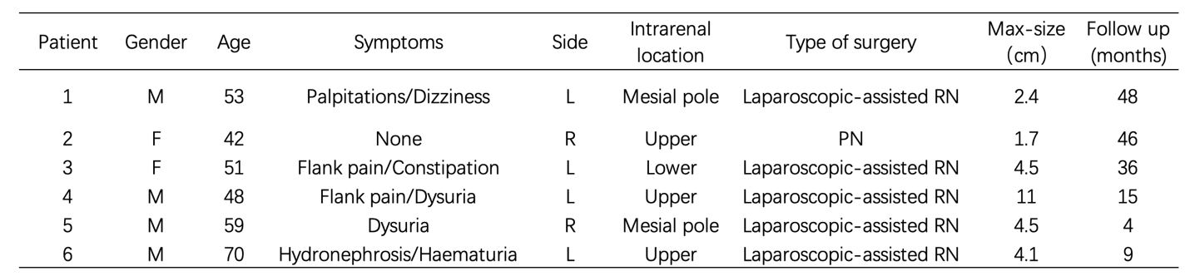
PN: partial nephrectomy；RN: Radical nephrectomy；M: male; F: female; R: right; L:left;

Table 2 Pathologic features of cases
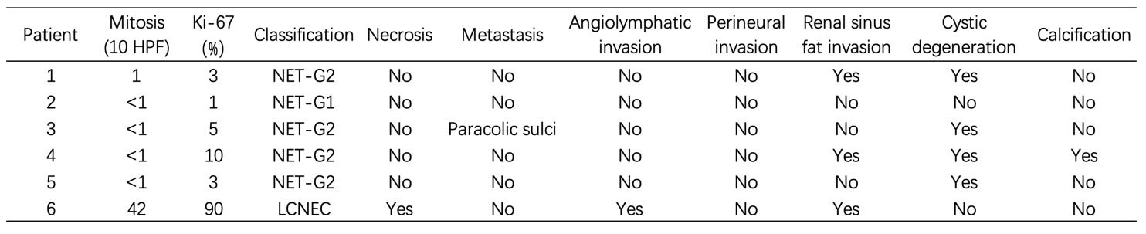
Table 3 Immunohistochemical features of the patients
