Effects of exercise on depression in postmenopausal women: a pairwise and network meta-analysis of randomized controlled trials
Content
Supplemental Material 1 Search Strategy 2
Supplemental Material 2 The Classifications of Exercise Interventions 5
Supplemental Material 3 Description of Studies Excluded at Full Text Stage 6
Supplemental Material 4 Study Characteristics 11
Supplemental Material 5 The Analysis for Primary Outcomes 16
5.1 Funnel Plot of Exercise Effects on Depression in pairwise meta-analysis 16
5.2 The Results of the Sensitivity Analysis of Pairwise Meta-analysis 16
5.3 Local Inconsistency Test for Network Meta-analysis 18
5.4 The Depression Rankings for Different Types of Exercise. 18
Supplemental Material 6 The Analysis for Anxiety 19
6.1 Pairwise Meta-analysis for Anxiety 19
6.2 Network Meta-analysis for Anxiety 20

Supplemental Material 1 Search Strategy
Table 1 Search strategy in Pubmed
Step | Search strategy
#1 | "postmenopause"[mh] OR “post menopausal period”[tiab] OR postmenopausal[tiab] OR “Post Menopause”[tiab] OR “Senior woman”[tiab] OR “Elderly woman”[tiab] OR “Older woman”[tiab] 77347
#2 | "exercise"[mh] OR exercises[tiab] OR “physical activity”[tiab] OR “aerobic exercise”[tiab] OR sport*[tiab] OR walk*[tiab] OR swim*[tiab] OR yoga[tiab] OR qigong[tiab] OR baduanjin[tiab] OR pilate[tiab] OR taichi[tiab] OR resistance[tiab] OR training[tiab] 2020893
#3 | "depression"[mh] OR depress*[tiab] 614,375
#4 | "randomized controlled trial"[pt] OR "controlled clinical trial"[pt] OR "randomized controlled trials as topic"[mh] OR "clinical trials as topic"[mh] OR "controlled clinical trials as topic"[mh] OR "clinical trial"[pt] OR "random allocation"[mh] OR randomized[tiab] OR randomised[tiab] OR randomization[tiab] OR randomly allocated[tiab] OR RCT[tiab] OR clinical trial*[tiab] OR clinical stud*[tiab] 2,081,133
#5 | #1 AND #2 AND #3 AND #4 64

Table 2 Search strategy in Embase
Step | Search strategy
#1 | ‘postmenopause’/exp OR ‘post menopausal’:ab,ti OR postmenopausal:ab,ti OR ‘Senior woman’:ab,ti OR ‘Elderly woman’:ab,ti OR ‘Older woman’:ab,ti 130,203
#2 | ‘exercise’/exp OR exercises:ab,ti OR ‘physical activity’:ab,ti OR sport*:ab,ti OR ‘aerobic exercise’:ab,ti OR walk*:ab,ti OR qigong:ab,ti OR swim*:ab,ti OR yoga:ab,ti OR baduanjin:ab,ti OR pilate:ab,ti OR taichi:ab,ti OR resistance:ab,ti OR training:ab,ti 2,695,556
#3 | ‘depression’/exp OR depress*:ab,ti 1,012,471
#4 | 'randomized controlled trial'/exp OR randomized:ab,ti OR randomised:ab,ti OR randomization:ab,ti OR randomly:ab,ti OR RCT:ab,ti OR 'controlled clinical trial'/exp OR 'controlled clinical':ab,ti 1,972,600
#5 | #1 AND #2 AND #5 141
#6 | #1 AND #2 AND #5 AND ([article]/lim) 84

Table 3 Search strategy in The Cochrane Library
Step | Search strategy
#1 | MeSH descriptor: [postmenopause] explode all trees 6,099
#2 | (postmenopause OR postmenopausal OR “post menopausal” OR Senior woman OR Elderly woman OR Older woman):ti,ab,kw 25,647
#3 | MeSH descriptor: [exercise] explode all trees 38,461
#4 | (exercise* OR “physical activity” OR “aerobic exercise” OR sport* OR walk* OR swim* OR yoga OR qigong OR baduanjin OR pilate OR taichi OR resistance OR training):ti,ab,kw 314,383
#5 | MeSH descriptor: [depression] explode all trees 105,473
#6 | (depression OR depressive):ti,ab,kw 109,195
#7 | #1 OR #2 26,157
#8 | #3 OR #4 317,319
#9 | #5 OR #6 146,186
#10 | #7 AND #8 AND #9 ([trial]/lim) 529

Table 4 Search strategy in Web of Science
Step | Search strategy
#1 | TS=("postmenopause" OR “post menopausal period” OR postmenopausal OR “Post Menopause” OR “Senior woman” OR “Elderly woman” OR “Older woman”) 136,880
#2 | TS=("exercise" OR exercises OR “physical activity” OR “aerobic exercise” OR sport* OR walk* OR swim* OR yoga OR qigong OR baduanjin OR pilate OR taichi OR resistance OR training) 6,195,675
#3 | TS=(depression OR depressive) 1,037,732
#4 | TS=("randomized controlled trial" OR "controlled clinical trial" OR "clinical trial" OR "random allocation" OR randomized OR randomised OR randomization OR RCT) 1,769,072
#5 | #1 AND #2 AND #3 AND #4 236
#6 | #1 AND #2 AND #3 AND #4 NOT Review Article (Exclude – Document Types) 192
Table 5 Search strategy in EBSCOhost
Step | Search strategy
#1 | AB=("postmenopause" OR “post menopausal period” OR postmenopausal OR “Post Menopause” OR Senior woman OR Elderly woman OR Older woman)
#2 | AB=("exercise" OR exercises OR “physical activity” OR “aerobic exercise” OR sport* OR walk* OR swim* OR yoga OR qigong OR baduanjin OR pilate OR taichi OR resistance OR training)
#3 | AB=(depression OR depressive)
#4 | AB=("randomized controlled trial" OR "controlled clinical trial" OR "clinical trial" OR "random allocation" OR randomized OR randomised OR randomization OR RCT)
#5 | #1 AND #2 AND #3 AND #4 138
Note: SPORTDiscus, PsycINFO and CINAHL Plus are all accessible through EBSCOhost for searching.

Table 6 Search strategy in CNKI
#1 | 运动 + 锻炼 + 抗阻 + 八段锦 + 气功 + 六字诀 + 瑜伽 + 太极 + 步行 + 游泳 + 普拉提 1,978,793
#2 | 绝经后 + 老年女性 34,965
#3 | 抑郁 173,822
#4 | #1 AND #2 AND #3 83

Supplemental Material 2 The Classifications of Exercise Interventions
Table 7 The classifications of exercise interventions
Types | Define
Aerobic exercise | Aerobic exercise aiming to improve cardiovascular fitness including walking, running, swimming or cycling.
Resistance training | A type of strength-building exercise program that requires the body muscle to exert a force against some form of resistance, such as weight, stretch bands, water, or immovable objects. Resistance exercise is a combination of static and dynamic contractions involving shortening and lengthening of skeletal muscles.
Stretching exercise | Stretching exercises are physical activities that aim to increase the flexibility of muscles and joints, which can enhance overall movement and decrease the risk of injuries. There are vaious types of stretching technigues including active, passive (relaxed).static, dynamic (gentle), ballistic (forced), isometric, and others.
Mind-body  exercise | Mind-body exercise, aiming to improve participants’ mind-body coordination and awareness by practicing a series of controlled movements and focusing on interactions among the brain, body, mind, and behavior, such as Tachi, yoga, Qigong, pilates, baduanjin and dance.
Concurrent training | Also known as concurrent aerobic and strength training, this refers to aerobic exercise and resistance training during the same period of time.

Supplemental Material 3 Description of Studies Excluded at Full Text Stage
Table 8 Description of Studies Excluded at Full Text Stage
Author | Title | Reason for exclusion
Actrn 2005 | The health-related benefits of country line dancing in community-dwelling older women with functional impairment: a double-blind placebo controlled clinical trial | Not RCT
Ades 2005 | Resistance training increases total daily energy expenditure in disabled older women with coronary heart disease | Lack of extractable outcomes
Aiello 2004 | Effect of a yearlong, moderate-intensity exercise intervention on the occurrence and severity of menopause symptoms in postmenopausal women | Lack of extractable outcomes
Alves 2013 | Creatine Supplementation Associated or Not with Strength Training upon Emotional and Cognitive Measures in Older Women: A Randomized Double-Blind Study | Lack of extractable outcomes
Audette 2006 | Tai Chi versus brisk walking in elderly women | Lack of extractable outcomes
Bashir 2022 | Effects of Aerobic Exercises on Postmenopausal Depression: Randomized Controlled Trial | Ineligible participants
Battaglia 2016 | Effects of an adapted physical activity program on psychophysical health in elderly women | Lack of extractable outcomes
Bravo 1996 | Impact of a 12-Month Exercise Program on the Physical and Psychological Health of Osteopenic Women | Lack of extractable outcomes
Devereux 2005 | Effects of a water-based program on women 65 years and over: A randomised controlled trial | Lack of extractable outcomes
Elavsky 2007 | Physical Activity and Mental Health Outcomes During Menopause: A Randomized Controlled Trial | Ineligible participants
Eskiyurt 2019 | HE ROLE OF SUPERVISED EXERCISES ON QUAL ITY OF LIFE AND DEPRESSIVE SYMPTOMS IN  POSTMENOPAUSAL WOMEN | Not RCT
Esmaeilzadeh 2013 | Effects of High-impact Exercises on Bone Mineral Density, Bone Turnover Marker, Quality of Life and Depressive Symptoms in Postmenopausal Women: A Randomized Controlled Trial. | Not RCT
Eyigor 2009 | A randomized controlled trial of Turkish folklore dance on the physical performance, balance, depression and quality of life in older women | Lack of extractable outcomes
R. B. R. g27zn 2012 | Effect of the physical training in community-dwelling older women: randomized clinical assay | Full-text no available
Gary2004 | Home-based exercise improves functional performance and quality of life in women with diastolic heart failure | Lack of extractable outcomes
Hanachi 2007 | The Effect of Soymilk on Alkaline Phosphatase, Total Antioxidant Levels, and Vasomotor Symptoms in Menopause Women | Inappropriate intervention
Hansen 2023 | The effect of aerobic exercise training on asthma control in postmenopausal women (ATOM): a randomized controlled pilot study | Lack of extractable outcomes
Huang 2023 | THE LESSENING INCONTINENCE WITH LOW-IMPACT ACTIVITY (LILA) TRIAL: a MULTISITE RANDOMIZED TRIAL OF A PELVIC YOGA VERSUS PHYSICAL CONDITIONING PROGRAM IN MIDLIFE AND OLDER WOMEN WITH URINARY INCONTINENCE | Full-text no available
Irct2012112810493N 2013 | Pilates exercise and its effect on falls in elderly women | Full-text no available
Irct2014020616501N 2014 | Walking with pedometer, Depression, General health in postmenopausal women | Full-text no available
Irct2014042017344N 2014 | Pilates exercise and acupressure effect on anxiety and sleep quality in postmenopausal women | Full-text no available
Irct2015020420955N 2015 | The effect of Tai chi chuan on Depression and Anxiety level among elderly women | Full-text no available
Irct2015072923408N 2016 | Effect of Tai Chi Exercise on the Stress of Elderly Women  With Hypertension | Not RCT
Irct2015122425685N 2016 | The effect of self management program on elderly women with rheumatoid arthritis | Full-text no available
Irct20200222046579N 2020 | The effect of physical activity training program on depression and anxiety in Postmenopausal Women | Full-text no available
Jin 2019 | A Long-Term Exercise Intervention Reduces Depressive Symptoms in Older  Korean Women | Not RCT
Jorge 2016 | Hatha Yoga practice decreases menopause symptoms and improves quality of life: A randomized controlled trial | Lack of extractable outcomes
Khalili 2022 | The effect of group walking program on social physique anxiety and the risk of eating disorders in aged women: A Randomized Clinical Trial study | Full-text no available
Kline 2016 | Doseeresponse effects of exercise training on the subjective sleep quality of postmenopausal women: exploratory analyses of a randomised controlled trial | Lack of extractable outcomes
Lee 2011 | Effects of exercise therapy on cardiac health after menopause: From clinical to bench evidence | Not RCT
Lee 2021 | Effects of 16 Weeks of Taekwondo Training on the Cerebral Blood Flow Velocity, Circulating Neurotransmitters, and Subjective Well-Being of Obese Postmenopausal Women | Lack of extractable outcomes
iposcki 2019 | Influence of a Pilates exercise program on the quality of life of sedentary elderly people: A randomized clinical trial | Lack of extractable outcomes
Macfarlane 2005 | EFFECTS OF TAI CHI ON THE PHYSICAL AND PSYCHOLOGICAL WELL-BEING OF CHINESE OLDER WOMEN | Full-text no available
Marcu 2015 | ROLE OF PHYSICAL EXERCICE PROGRAM IN PATIENTS WITH OSTEOPOROSIS | Not RCT
Martin 2009 | Exercise Dose and Quality of Life A Randomized Controlled Trial | Lack of extractable outcomes
Mason 2019 | Eating behaviors and weight loss outcomes in a 12-month randomized trial of diet and/ or exercise intervention in postmenopausal women | Lack of extractable outcomes
Moilanen 2012 | Effect of aerobic training on menopausal symptomsVa randomized controlled trial | Ineligible participants
Mokhtari 2013 | Effect of Pilates training on some psychological and social factors related to falling in elderly women | Lack of extractable outcomes
Moreau 1999 | The eff The effects of walking v ects of walking volume on blood pr olume on blood pressure in hyper e in hypertensive postmenopausal women | Not RCT
Moriyama 2008 | A randomized, placebo-controlled trial of the effects of physical exercises and estrogen therapy on health-related quality of life in postmenopausal women | Lack of extractable outcomes
Nct 2023 | Clinical Pilates and Aerobic Exercise in Menopause | Full-text no available
Nct 2023 | Effects of Progressive Resistance Training Vasomotor Symptoms in Post Menopausal Women | Full-text no available
Nct 2023 | The Effect of Laughter Yoga on Self-Care, Quality of Life and Stress Level in Menopause | Full-text no available
Nikkhah 2015 | The effect of walking with pedometer on general health of postmenopausal women | Lack of extractable outcomes
Pactr 2019 | Effect of Aerobic Exercise on Plasma Oxytocin in Depressed Post-menopausal Women: a Randomized Controlled Trial | Full-text no available
Pirzadeh 2017 | The effect of exercise on menopausal symptoms in postmenopausal women | Not RCT
Prieto 2015 | RELEVANCIA DE UN PROGRAMA DE EQUILIBRIO EN LA CALIDAD DE VIDA RELACIONADA CON LA SALUD DE MUJERES ADULTAS MAYORES OBESAS | Lack of extractable outcomes
Rashidi 2013 | The effect of eight weeks of aerobic exercise on depression in postmenopausal women | Lack of extractable outcomes
Ravari 2021 | The effect of Pilates exercise on the happiness and depression of elderly women: a clinical trial study | Full-text no available
Roghani 2012 | The effect of 6-week submaximal training with and without external loading on cardiovascular fitness, balance, cortisol, and lipid profiles in osteoporotic postmenopausal women | Lack of extractable outcomes
Salehi 2016 | Effects of 8-weeks combined training (strength and endurance) on serum levels of AGRP, GH and changes in appetite and body mass in postmenopausal women | Lack of extractable outcomes
Shen 2010 | Green tea polyphenols supplementation and Tai Chi exercise for postmenopausal osteopenic women: safety and quality of life report | Lack of extractable outcomes
Son 2006 | The Effect of the Walking Exercise on Physiological index, Physical Fitness, Self Esteem, Depression and Life Satisfaction in the Institutionalized Elderly Women | Lack of extractable outcomes
Susanti 2022 | Effects of yoga on menopausal symptoms and sleep quality across menopause statuses: A randomized controlled trial | Ineligible participants
Vedovelli 2017 | Multimodal physical activity increases brain-derived neurotrophic factor levels and improves cognition in institutionalized older women | Not RCT
Velez-Toral 2017 | Improvements in health-related quality of life, cardio-metabolic health and fitness in postmenopausal women after an exercise plus health promotion intervention: a randomized controlled trial | Lack of extractable outcomes
Xi 2017 | Effect of health education combining diet and exercise supervision in Chinese women with perimenopausal symptoms: a randomized controlled trial | Ineligible participants
Yu 2015 | Effects of a Physical Activity Program using Exergame with Elderly Women | Lack of extractable outcomes
asbury2006 | The importance of continued exercise participation in quality of life and psychological well-being in previously inactive postmenopausal women: a pilot study | Lack of proper control
Blain2017 | EFFECT OF A 6-MONTH BRISK WALKING PROGRAM ON WALKING ENDURANCE IN SEDENTARY AND PHYSICALLY DECONDITIONED WOMEN AGED 60 OR OLDER: A RANDOMIZED TRIAL | Not RCT
Lin 2009 | 运动处方干预对老年女性身心健康的影响 | Not RCT
Wang 2016 | 广场舞对老年女性生活质量的影响 | Lack of extractable outcomes
Ruan 2015 | 规律性瑜伽运动对老年女性生活质量及健康体能的影响 | Lack of extractable outcomes
Zheng 2021 | 简化太极拳锻炼对改善老年女性生活质量的作用（Influence of simplified Taijiquan exercise on improving life quality of old women） | Not RCT
Mo 2016 | 健身气功·太极养生杖锻炼对老年女性心境状态与心理健康的影响 | Lack of extractable outcomes
Song 2022 | 太极运动对老年女性膝OA患者运动功能和生活质量的作用 | Lack of proper control

Supplemental Material 4 Study Characteristics
Table 8 Study characteristics
Study |  | Participants |  |  | Interventions |  |  |  | Outcome  Measured
Author (year) | Country | Sample size (drop) | Age (SD) | Health  Status | Intervention Program | Duration | Frequency | Length | Outcome  Measured
Abedi2015 | Iran | EG：53;9.4%  CG:53;7.5% | EG: 52.4±3.8  CG: 53±4.1 | mild to moderate depression | EG:pedometer-based walking  CG:usual care | NR | NR | 12wk | HADS
Afonso 2012 | Brazil | EG1: 21;33.3%  EG2:24;37.4%  CG：16;6.2% | ALL:50-65 | insomnia | EG1: passive stretching  EG2:yoga  CG:usual care | 1 hour/day | 2 days/wk | 16wk | BDI、BAI
Aibar-Almazán 2019 | Spain | EG:55;0%  CG:55;5.4% | EG:69.98±7.83  CG:66.79±10.14 | healthy | EG: Pilates-based exercise CG:usual care | 1 hour/day | 2 days/wk | 12wk | HADS
Alves 2013 | Brazil | EG:14;28.6%  CG:14;14.3% | EG:63.9±3.8  CG:67.3±5.6 | healthy | EG: supervised strength training  CG: placebo supplementation | 40minutes/day | 2 days/wk | 24 wk | GDS
Pinheiro 2020 | Brazil | EG:20;50%  CG:20;45% | EG:79±7.66  CG:81.7±5.95 | sarcopenia | EG:supervised progressive resistance training  CG:usual care | NR | 2 days/wk | 12wk | GDS
Bernard 2015 | France | EG:61;13.1%  CG:60;8.3% | EG:65.46±4.37  CG:65.5±4.03 | healthy | EG:supervised and home-based walking  CG:usual care | 40 minutes/day | 3 days/wk | 24wk | BDI
Bowen 2006 | USA | EG1:86;0%  EG2:87;1.1% | ALL:50-75 | Sedentary healthy | EG:home-based aerobic exercise  CG:stretching training | 45 minutes/day | 5 days/wk | 12months | BSI
Carcelén-Fraile 2022 | Spain | EG:63;9.5%  CG:62;3.2% | EG:69.70±6.15  CG:69.75±6.76 | healthy | EG:Qigong  CG:usual care | 1 hour/day | 2 days/wk | 12wk | HADS
Curi 2018 | Brazil | EG:33;6.0%  CG:31;3.2% | EG:64.25±0.14  CG:63.75±0.08 | healthy | EG:supervised Pilates  CG:usual care | 1hour/day | 2 days/wk | 16wk | GHQ-12
Farzane 2022 | Iran | EG:21;28.6%  CG:17;29.4% | EG:61.47±1.55 CG:62.00±1.4 | healthy | EG:Pilates  CG: usual care | 75minutes/day | 3 days/wk | 8wk | HADS
Gary 2007 | Atlanta | EG:13;0%  CG:10;0% | ALL:68±12 | Diastolic Heart Failure | EG: home-based walking  CG: health education | NR | 3 days/wk | 12wk | GDS
Gusi 2008 | Spain | EG:64;14.1%  CG:63;19.0% | EG:71±5  CG:74±6 | moderate depression or overweight | EG:supervised walking-based exercise  CG:routine care and a recom-mendation of physical activity | 50minutes/day | 3 days/wk | 24wk | GDS/STAI
Hu 2017 | China | EG:46;13.0%  CG:45;11.1% | EG:52.60±4.12  CG:54.15±2.32 | healthy | EG: supervised walking  CG: usual care | 1 hour/day | 3 days/wk | 16wk | BDI
Imayama 2011 | USA | EG:117;0.9%  CG:87;8.0% | EG:58.1±5.0  CG:57.4±4.4 | overweight/obese | EG:supervised aerobic exercise  CG:usual care | 45 minutes | 5 days/wk | 48wk | BSI-18
Innes 2012 | USA | EG:10;0%  CG:10;0% | EG:58.40±6.32  CG:58.90±9.11 | overweight/restless legs syndrome | EG:yoga  CG:educational film | 90-minutes/day | 2 days/wk | 8wk | POMS
Kim 2019 | Korea | EG:12;8.3%  CG:13;23.1% | EG:76.10±3.85  CG:76.40±3.27 | healthy | EG:strength training  CG:usual care | 50-80minutes/day | 3 days/wk | 24wk | SGDS-K
Sen2019 | Turkey | EG:19;15.8%  CG:20;10% | EG:53.1±4.4 CG:54.5±6.0 | osteoporosis | EG:supervised whole-body vibration or aerobic exercises  CG: usual care | 20-60minutes/day | 3 days/wk | 24wk | BDI
Pereira 2013 | Brazil | EG1:229;21.0%  EG2:222;24.8% | EG1:71.03±4.8  EG2:70.33±4.5 | inactive | EG1: supervised strengthening  EG2: aerobic exercise | 1 hour/day | 3 days/wk | 10wk | GDS
Shahidi 2011 | Iran | EG1:23;13.0%  EG2:23;13.0% CG:24;16.7% | CG: 68.4±6.3 EG1:65.5±4.8 EG2:65.7±4.2 | depressed | EG1: Laughter Yoga  EG2: exercise therapy  CG:usual care | EG1:NR  EG2:30minutes/day | NR | NR | GDS
Song 2022 | China | EG:20;0%  CG:20;0% | EG:64.15±8.56  CG:64.15±8.56 | knee osteoarthritis | EG:Tai Chi  CG:wellness education | 60minutes/day | 3 days/wk | 12 wk | SDS/SAS
Soori 2022 | Iran | EG1:25; 0% EG2:25;0%  CG:25;0% | EG1:62.48±2.87 EG2:62.66±1.68  CG:63.80±3.35 | inactive | EG1: aerobic exercise  EG2: Pilates  CG:usual care | 40 minutes/day | EG1:3 days/wk  EG2:NR | 3wk | GHQ
Tsutsumi 1998 | Japan | EG1:12;0% EG2:12;0%  CG:12;0% | ALL:68.5±6.1 | sedentary | EG1:high intensity strength training  EG2:moderate intensity strength training  CG:usual care | NR | 3 days/wk | 12wk | STAI
Gutiérrez 2012 | Spain | EG:30;10%  CG:30;0% | ALL:60-70 | suffered mood problem | EG:aerobic exercise and strength training  CG:usual care | 50-60 minutes/day | 3day/wk | 24wk | GDS/HRSA
Williams 1997 | Malaysia | EG :94;24.5%  CG:93;16.1% | EG :71.8±5.6  CG:71.6±5.2 | Osteoarathritis;High blood pressure;Heart disease | EG:aerobic exercises and strengthening exercises  CG:usual care | 1 hour/day | 2 days/wk | 42wk | DASS
Ma2016 | China | EG:40;5%  CG:40;0% | EG:60.9±5.1  CG:60.2±4.1 | healthy | EG:Qigong  CG:usual care | 1 hour/day | 3 days/wk | 20wk | POMS/SAS
Song 2022 | China | EG:20;0%  CG:20;0% | EG:64.05±6.63  CG:64.15±8.56 | Knee osteoarthritis | EG: Tai Chi  CG: health education | 60minutes/day | 3 days/wk | 12wk | SDS/SAS
Liu 2016 | China | EG:32;3.1%  CG:32;3.1% | EG:66.3±2.7  CG:65.8±3.2 | healthy | EG: Tai Chi  CG: usual care | 60minutes/day | 5 days/wk | 16 wk | POMS/SCL-90
Agil2010 | Turkey | EG1:21;14.3% EG2:21;14.3% | EG1:52.4±4.7  EG2:52.6±3.5 | healthy | EG1: supervised aerobic exercise  EG2: supervised resistance exercise | EG1:40-45minutes/day  EG2:NR | 3days/wk | 8wk | BDI/SCL-90
Blumenthal1991 | USA | CG:18:NR  EG1:16;NR EG2:17;NR | ALL:67.7±5.1 | sedentary | EG1: aerobic exercise  EG2: yoga  CG: usual care | 1 hour | EG1: 3 days/wk  EG2: 2 days/wk | 14 months | CES-D/STAI
Note: SD: standard deviation; EG: exercise group; CG: control group; NR: not report; HADS: Hospital Anxiety and Depression Scale; BDI: Beck Depression Inventory; BAI: Beck Anxiety Inventory; GDS: Geriatric Depression Scale; CES-D: Center for Epidemiologic Studies Depression Scale; STAI: State-Trait Anxiety Inventory; SCL-90: Symptom Checklist-90; POMS: Profile of Mood States; SDS: Self-Rating Depression Scale; SAS: Self-Rating Anxiety Scale; HRSA: Hamilton Rating Scale for Anxiety; DASS: Depression Anxiety Stress Scales; GHQ: General Health Questionnaire.

Supplemental Material 5 The Analysis for Primary Outcomes

5.1 Funnel Plot of Exercise Effects on Depression in Pairwise Meta-analysis
Figure 1 Funnel Plot of Exercise Effects on Depression Levels in Postmenopausal Women

5.2 The Results of the Sensitivity Analysis of Pairwise Meta-analysis
Sensitivity Analysis 1: leave-one-out approach
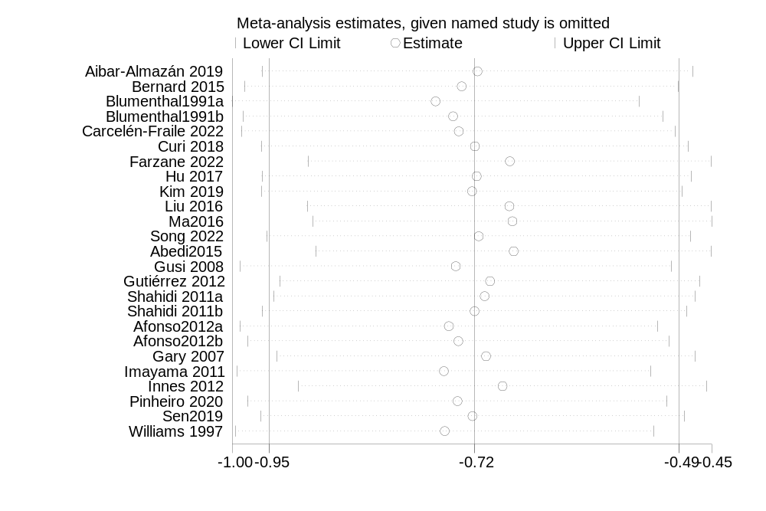
Figure 2 The results of leave-one-out approach
Sensitivity Analysis 2: Excluding Studies Using Health Education as Control
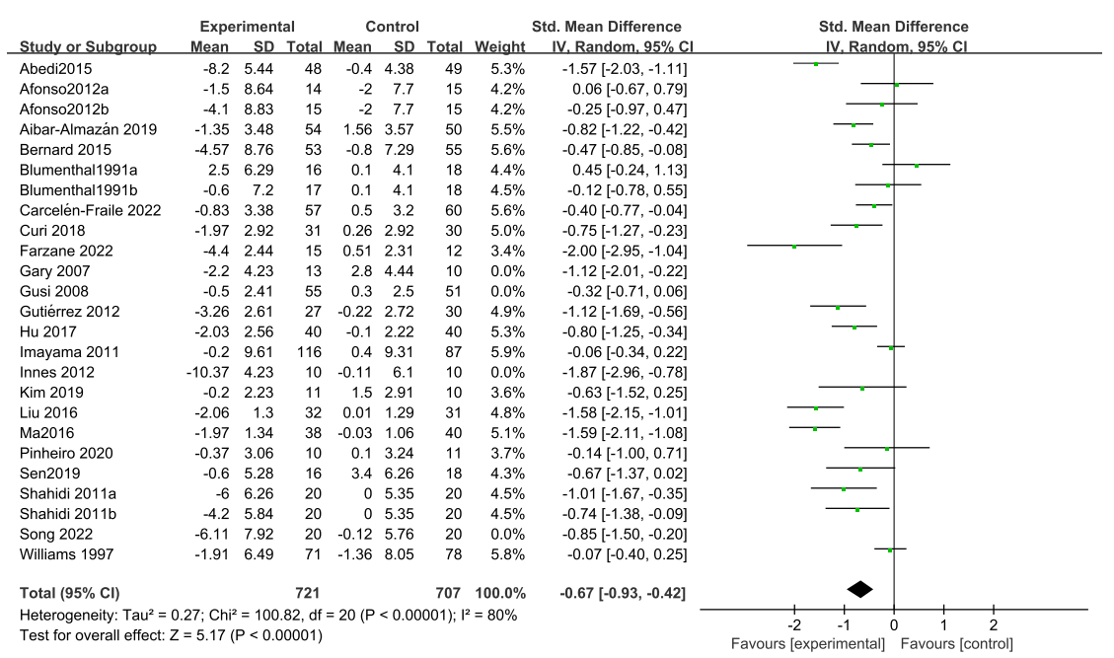
Figure 3 The results of Excluding Studies Using Health Education as Control

5.3 Local Inconsistency Test for Network Meta-analysis
Figure 4 Local inconsistency in depression

5.4 The Depression Rankings for Different Types of Exercise.
Table 9 Comparative Efficacy of Exercise Interventions for Depression
Exercise | SUCRA (%) | PrBest (%) | Mean rank
Control | 4.4 | 0.0 | 5.8
Stretching exercise | 41.6 | 5.1 | 3.9
Aerobic exercise | 57.4 | 0.8 | 3.1
Resistance training | 48.5 | 5.1 | 3.6
Mind-body exercise | 94.7 | 77.6 | 1.3
Concurrent training | 53.3 | 11.4 | 3.3

Supplemental Material 6 The Analysis for Anxiety

6.1 Pairwise Meta-analysis for Anxiety

Forest plot：
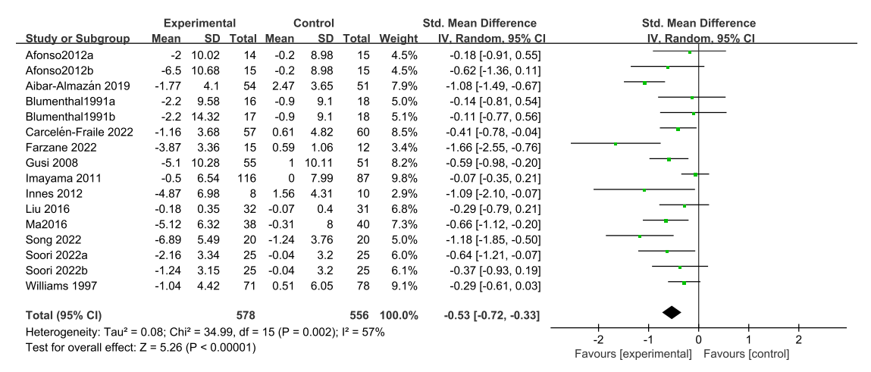
Figure 5 Forest plot of the effects of exercise training on anxiety.

Publication bias test A (Begg’s and Egger’s test)：
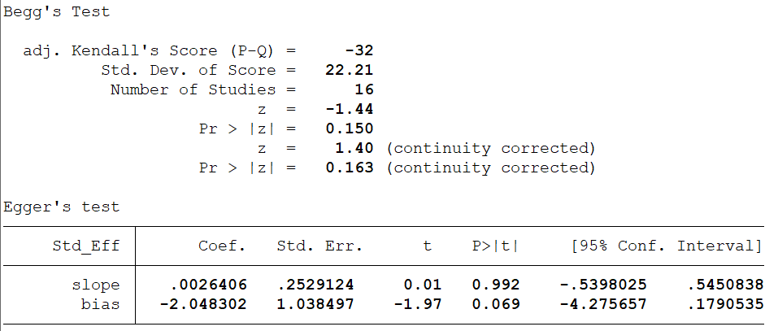
Figure 6 The results of Begg’s and Egger’s test

Publication bias test B (Funnel Plot)
Figure 7 Funnel Plot of Exercise Effects on Anxiety Levels in Postmenopausal Women

6.2 Network Meta-analysis for Anxiety

Figure 8. Network plot of comparisons for anxiety in the NMA.
Figure 9. Predictive interval plot for the anxiety network. CON, control; SE, stretching exercise; AE, aerobic exercise; RT, resistance training; MBE, mind-body exercise; CT, concurrent training.
Figure 10 Local inconsistency in anxiety
Figure 11. Cumulative ranking probability plots for anxiety. CON, control; SE, stretching exercise; AE, aerobic exercise; RT, resistance training; MBE, mind-body exercise; CT, concurrent training

Table 10 Comparative Efficacy of Exercise Interventions for Anxiety
Exercise | SUCRA (%) | PrBest (%) | Mean rank
Control | 15.0 | 0.0 | 5.2
Stretching exercise | 43.1 | 2.5 | 3.8
Aerobic exercise | 59.8 | 0.8 | 3.0
Resistance training | 34.7 | 8.5 | 4.3
Mind-body exercise | 95.4 | 79.9 | 1.2
Concurrent training | 52.1 | 8.3 | 3.4

