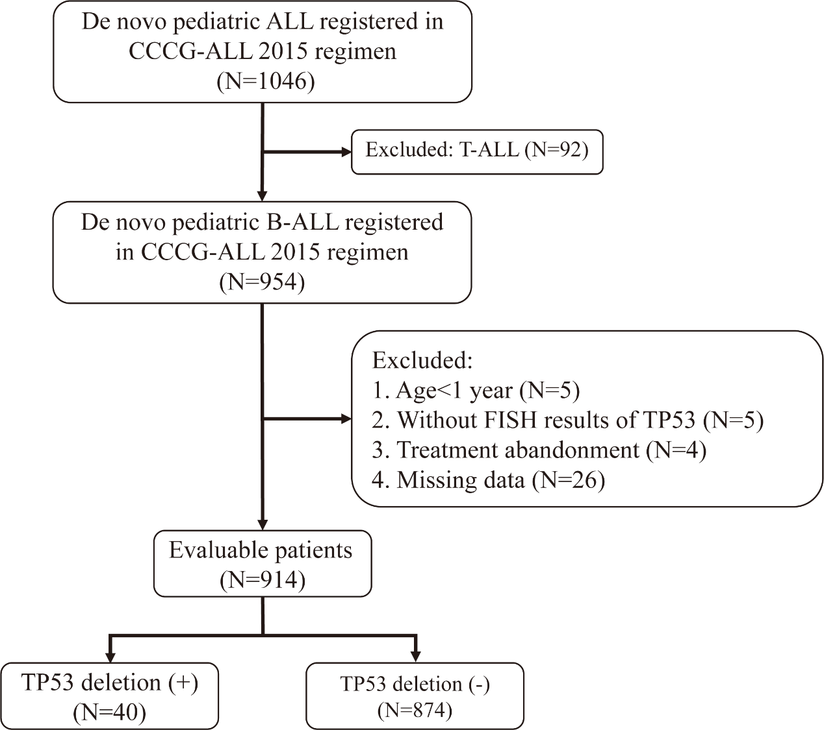
Figure S1. Flow diagram summarizing the reasons for exclusion and the number of patients with or without TP53 deletion.
Abbreviations: ALL, acute lymphoblastic leukemia. CCCG-ALL-2015, Chinese Children’s Cancer Group ALL-2015 protocol.

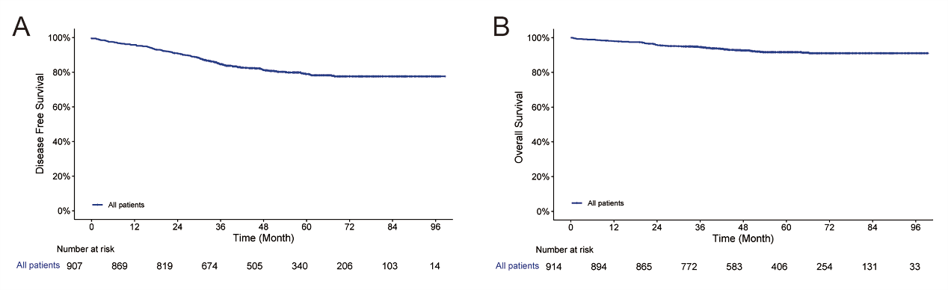
Figure S2. (A) The 5-year disease-free survival (DFS) of the whole cohort. (B) The 5-year overall survival (OS) of the whole cohort.

Table S1. The polymerase chain reaction panel including 56 common fusion genes.
PML::RARA(L) | RUNX1::RUNX1T1 | CBFβ::MYH11 | MLL::AF9 | MLL::AF4 | MLL::ENL | MLL::AF10
MLL::SEPT6/9 | MLL::ELL | MLL::AF17 | MLL::AF1q | MLL::AF1p | MLL::AF6 | NPM::RARA
PLZF::RARA | RUNX1::MDS1/EVI1 | RUNX1::MTG16 | ETV6::ABL | ETV6::JAK2 | ETV6::RUNX1 | ETV6::PDGFRB
TCF3::PBX1 | TCF3::HLF | SIL::TAL1 | EFIP1L1::PDGFRA | DEK::CAN | NPM::MLF1 | STAT5b::RARA
ETV6::PDGFRA | NUP98::HOXA13 | NUP98::HOXC11 | NUP98::HOXD13 | NUP98::HOXA9 | NUP98::HOXA11 | NUP98::PMX1
MLL::AFX | FIP1L1::RARA | PRKAR1A::RARA | NUMA1::RARA | SET::CAN | TLS::ERG | CALM::AF10
MLL::AF5 | BCR::PDGFRA | KIF5B::PDGFRA | STRN::PDGFRA | CDK5RAP2::PDGFRA | HOX11L2 | HLXB9::ETV6
HOX11 | PML::RaRa(S) | PML::RaRa(V) | WT1 | BCR::ABLP190 | BCR::ABL(no P190)

Table S2. Univariate analysis for DFS and OS.
 | Univariate analysis
 | DFS |  |  |  | OS
Parameter | HR | 95%CI | P value |  | HR | 95%CI | P value
Age (≥10 y) | 1.86 | 1.33-2.62 | <0.001 |  | 2.44 | 1.48-4.03 | 0.001
Male | 1.17 | 0.87-1.59 | 0.303 |  | 1.24 | 0.76-2.01 | 0.393
WBC>50*10⁹/L | 3.47 | 2.56-4.72 | <0.001 |  | 4.54 | 2.84-7.24 | <0.001
Bone marrow blasts | 1.01 | 1.00-1.02 | 0.282 |  | 1.02 | 1.00-1.04 | 0.095
CNS involvement* | 1.71 | 1.09-2.67 | 0.019 |  | 2.13 | 1.12-4.06 | 0.021
Hyperdiploid | 0.94 | 0.56-1.57 | 0.802 |  | 1.20 | 0.57-2.50 | 0.633
Hypodiploid | 0.75 | 0.11-5.34 | 0.773 |  | — | — | —
ETV6::RUNX1 | 0.39 | 0.25-0.61 | <0.001 |  | 0.32 | 0.15-0.69 | 0.004
BCR::ABL1 | 2.73 | 1.79-4.17 | <0.001 |  | 1.94 | 0.93-4.04 | 0.079
TCF3::PBX1 | 0.90 | 0.44-1.82 | 0.766 |  | 1.45 | 0.58-3.60 | 0.425
MLLr | 7.80 | 4.07-15.70 | <0.001 |  | 10.24 | 4.41-23.79 | <0.001
TP53^{del} | 2.62 | 1.57-4.37 | <0.001 |  | 2.53 | 1.16-5.53 | 0.020
D19 MRD positive | 1.87 | 1.36-2.56 | <0.001 |  | 2.39 | 1.48-3.87 | <0.001
D46 MRD positive | 3.54 | 2.62-4.78 | <0.001 |  | 4.12 | 2.52-6.74 | <0.001
*CNS involvement: central nervous system involvement, including CNS3, CNS2 or traumatic lumbar puncture.
Abbreviations: DFS, disease-free survival. OS, overall survival. y, year. WBC, white blood cell count.
MLLr, MLL rearrangement. TP53^{del}, TP53 deletion. MRD, minimal residual disease.

