Graphical abstract
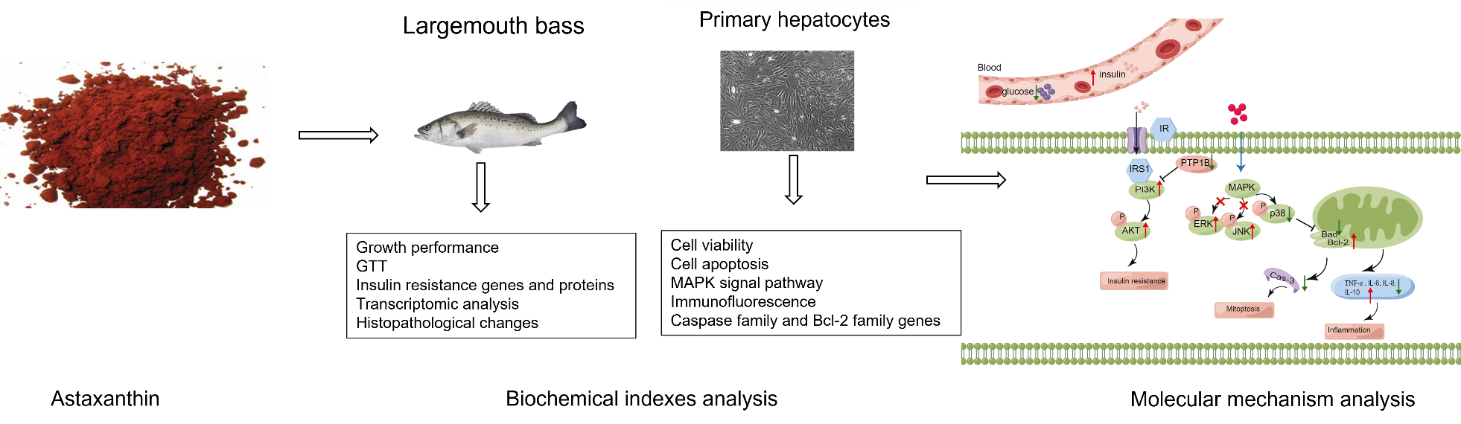
Notes: this picture is drawn by Figdraw

