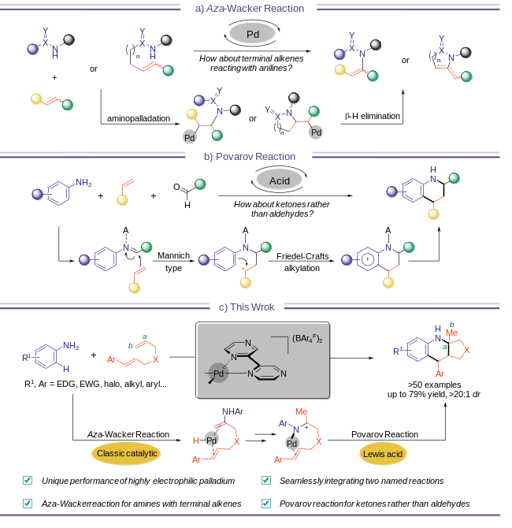
Scheme 1. a) Aza-Wacker reaction and its mechanism. b) Povarov reaction and its step-wise mechanism. c) palladium catalyzed aza-Wacker/Povarov reaction of anilines with 1,6-dienes to synthesize hexahydro-cyclopenta[b]quinolines.

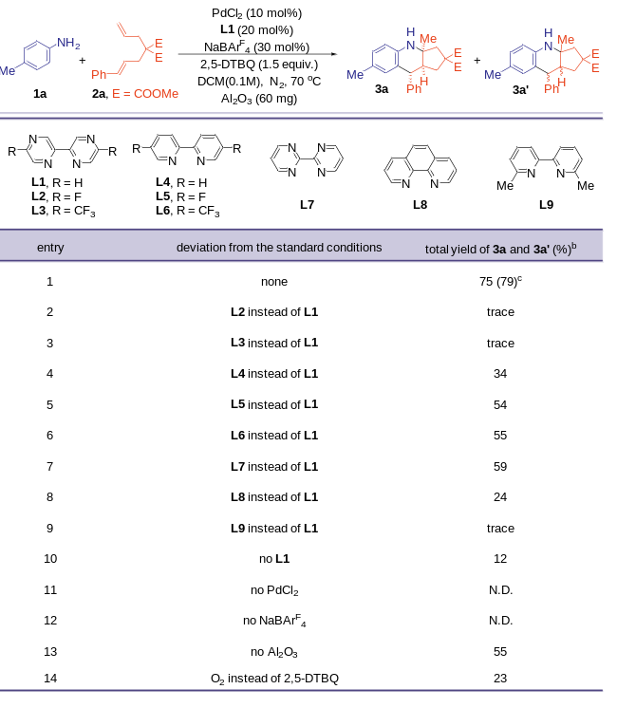
Scheme 2. Optimization of the Reaction Conditions. ªReaction conditions: 1a (0.2 mmol), 2a (0.2 mmol), PdCl₂(10 mol%), L1 (20 mol%), NaBAr^{F}₄ (30 mol%), 2,5-DTBQ (1.5 equiv.), and Al₂O₃ (60 mg) in DCM (0.1M) at 70 ºC under N₂ atmosphere for 72 h. ^{b}Yield was determined by ¹H NMR of the crude product using CH₂Br₂ as internal standard. ^{c}Isolated yield. Ar^{F} = 3,5-(CF₃)₂C₆H₃. 2,5-DTBQ = 2,5-di-tert-butylcyclohexa-2,5-diene-1,4-dione.

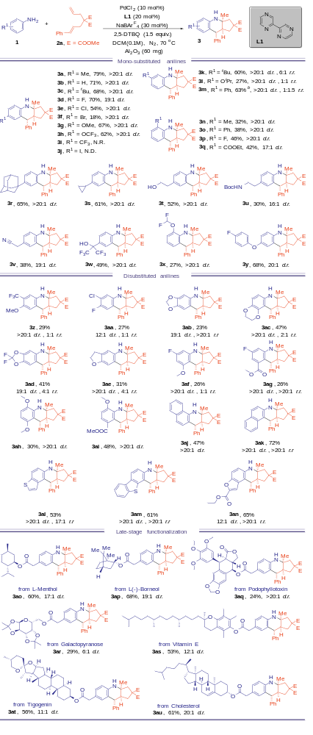
Scheme 3. Scope of the anilines. ªStandard reaction conditions: 1 (0.2 mmol), 2a (0.2 mmol), PdCl₂(10 mol%), L1 (20 mol%), NaBAr^{F}₄ (30 mol%), 2,5-DTBQ (1.5 equiv.), and Al₂O₃ (60 mg) in DCM (0.1M) at 70 ºC under N₂ atmosphere for 72 h. Yields refer to isolated yields of 3. Diastereoisomer rate (d.r.) and regioselectivity rate (r.r.) were determined by ¹H NMR. ^{b}Regioselective product mixture, overall isolated yield. Ar^{F} = 3,5-(CF₃)₂C₆H₃.
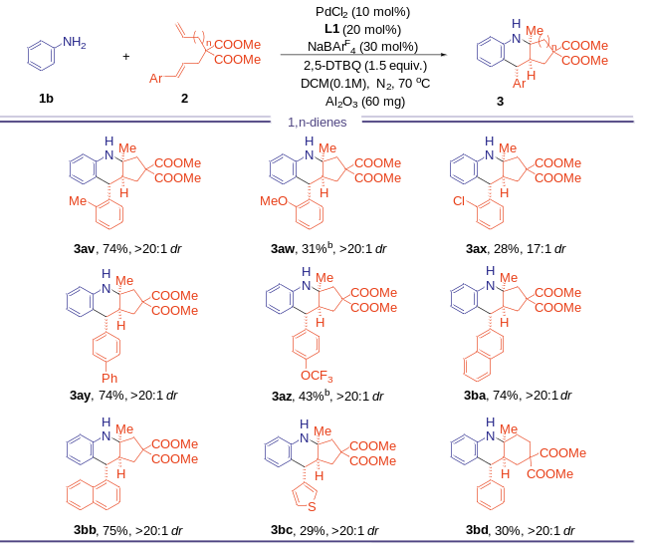
Scheme 4. Scope of the 1,n- Dienes. ªStandard reaction conditions: 1b (0.2 mmol), 2 (0.2 mmol), PdCl₂(10 mol%), L1 (20 mol%), NaBAr^{F}₄ (30 mol%), 2,5-DTBQ (1.5 equiv.), and Al₂O₃ (60 mg) in DCM (0.1M) at 70 ºC under N₂ atmosphere for 72 h. Yields refer to isolated yields of 3. Diastereoisomer rate (d.r.) and regioselectivity rate (r.r.) were determined by ¹H NMR. ^{b}at 80 ºC. Ar^{F} = 3,5-(CF₃)₂C₆H₃.

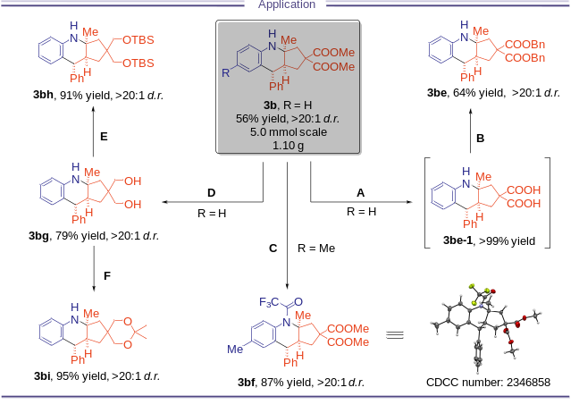
Scheme 5. Synthetic Applications. A: LiOH, MeOH/THF/H₂O=1:1:1, 50 ºC, then HCl. B: BnBr, DBU, MeCN, rt. C: (CF₃CO)₂O, Et₃N, DCM, 0 ºC to rt. D: LiAlH₄, THF, 0 ºC to rt. E: TBSCl, imidazole, DCM, rt. F: 2,2-dimethoxypropane, TsOH, THF, rt (See Chapter 7.3 of SI for more details).

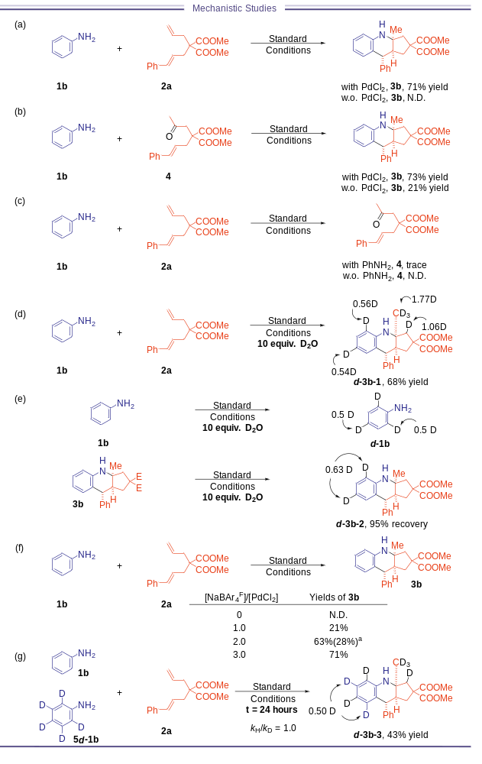
Scheme 6. Mechanistic Studies. ªPdCl₂(5 mol%), L1 (20 mol%), NaBAr^{F}₄ (10 mol%)

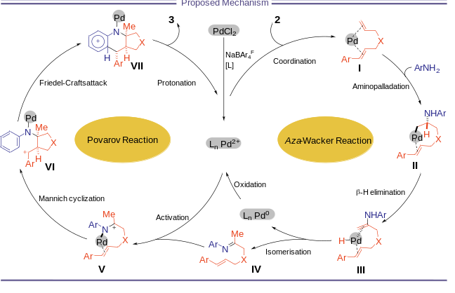
Scheme 7. Proposed Mechanism.

