Figure legend for supplementary materials
Figure S1 Differentially expressed genes (DEGs) volcano maps of T30_vs_CK, T35_vs_CK, and T40_vs_CK comparing groups, respectively. Each point that arises in the differential expression volcano maps denotes a gene. The x-axis indicates the logarithm for the fold change of the discrepancy expression of a gene in two samples. Y-axis indicates the negative logarithm of significantly statistical level value for differentially expressed genes. The green dots indicate down-regulated discrepantly expressed genes, and the red dots up-regulated discrepantly expressed genes, the black dots no differentially expressed genes
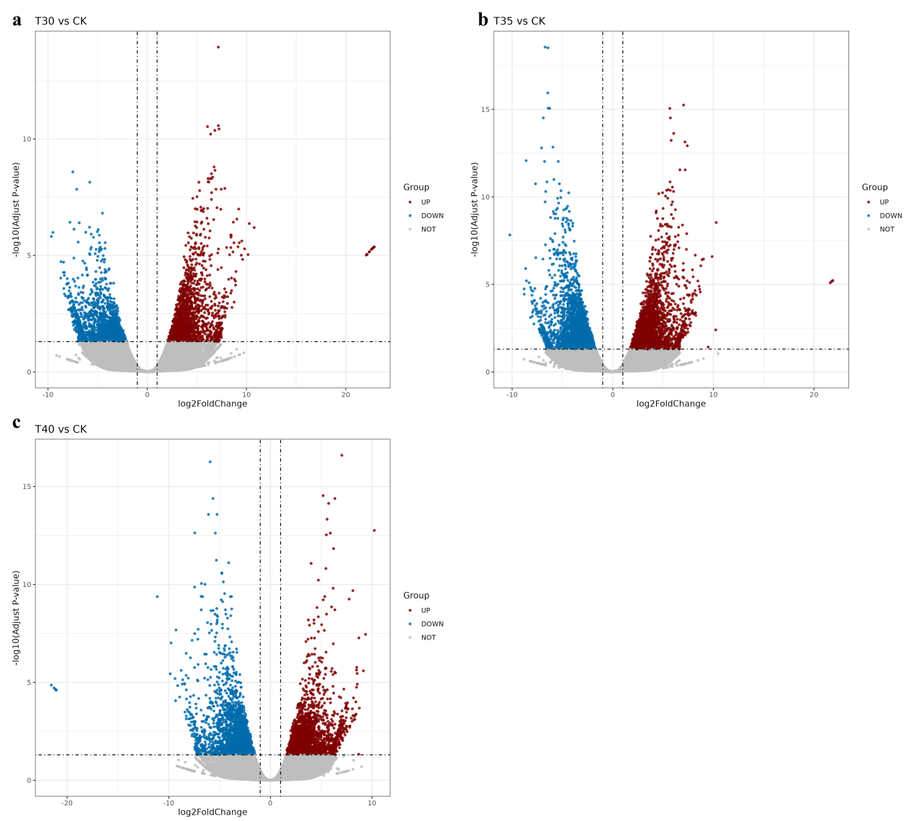

Figure S2 GO enrichment analysis of DEGs that were specifically expressed in response to T30 T35 and T40 tress in Medicago sativa L..
The area of the dot represents the number of genes, and the color represents padj. (a) GO enrichment analysis of DEGs that were specifically expressed in response to T30 stress in Medicago sativa L. (b) GO enrichment analysis of DEGs that were specifically expressed in response to T35 stress in Medicago sativa L.(c) GO enrichment analysis of DEGs that were specifically expressed in response to T40 stress in Medicago sativa L.

Figure S3 Volcano plots of significantly changed metabolites of positive ion mode in CK_vs_T30 (a), CK_vs_T35(b), and CK_vs_T40 (c) compare groups, and of negative ion mode in CK_vs_T30 (d), CK_vs_T35 (e), and CK_vs_T40 (f) compare groups, respectively. Red pixel dots denote significantly changed (upregulated or downregulated) metabolites, and black pixel dots denote insignificantly changed metabolites. The x-axis indicates the log₂ (fold-change, FC) of each metabolite. The y-axis represents -log₁₀ (p-value) relative to the corresponding control (CK).
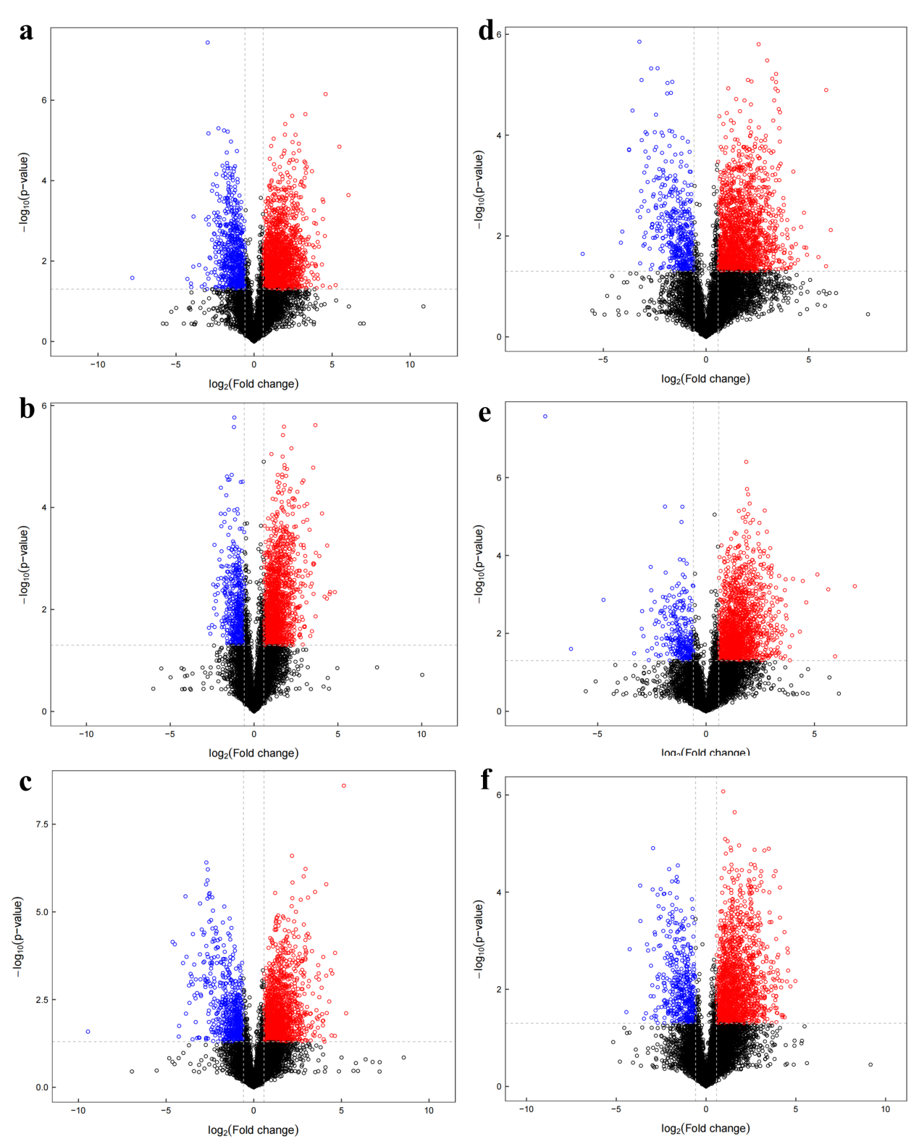

Table legend
Table S1. Summary of sequencing data quality
Sample | Raw reads | Clean reads | Error (%) | Q20(%) | Q30(%) | GC (%)
CK1 | 45013854 | 44677628 | 0.04 | 97.88 | 94.27 | 44.16
CK2 | 47375690 | 47112542 | 0.04 | 98.11 | 94.78 | 43.36
CK3 | 51949840 | 51593288 | 0.04 | 97.95 | 94.43 | 43.29
T30-1 | 92038004 | 91562804 | 0.04 | 98.54 | 95.93 | 46.24
T30-2 | 52212992 | 51946032 | 0.04 | 98.9 | 96.86 | 47.83
T30-3 | 85556062 | 85038274 | 0.04 | 98.37 | 95.49 | 46.73
T35-1 | 51337548 | 51028132 | 0.04 | 98.78 | 96.56 | 46.79
T35-2 | 60883348 | 60512282 | 0.04 | 98.18 | 94.98 | 44.05
T35-3 | 42864196 | 42637952 | 0.04 | 98.46 | 95.74 | 44.96
T40-1 | 66668714 | 66220592 | 0.04 | 97.86 | 94.14 | 43.87
T40-2 | 68934594 | 68501758 | 0.04 | 97.82 | 94.01 | 43.51
T40-3 | 64372214 | 63915926 | 0.04 | 97.85 | 94.1 | 43.72
average value | 60767254.67 | 60395600.83 | 0.04 | 98.23 | 95.11 | 44.88

Table S2. Summary for metabolites
SuperClass | percent | Freq
Lipids and lipid-like molecules | 22.678 | 481
Organic acids and derivatives | 20.226 | 429
Organoheterocyclic compounds | 13.201 | 280
Benzenoids | 12.824 | 272
Undefined | 11.315 | 240
Phenylpropanoids and polyketides | 7.544 | 160
Organic oxygen compounds | 7.261 | 154
Organic nitrogen compounds | 1.839 | 39
Nucleosides, nucleotides, and analogues | 1.509 | 32
Alkaloids and derivatives | 0.707 | 15
Lignans, neolignans and related compounds | 0.471 | 10
Homogeneous non-metal compounds | 0.141 | 3
Organometallic compounds | 0.094 | 2
Organosulfur compounds | 0.094 | 2
Hydrocarbon derivatives | 0.047 | 1
Organophosphorus compounds | 0.047 | 1
Table S3 Different metabolites in T30_vs_CK compare group participated in KEGG pathways.
Map_Name(11) | Test | p.value | richFactor
ABC transporters | 12 | 0.00014903 | 0.087591241
Citrate cycle (TCA cycle) | 4 | 0.001346639 | 0.2
Plant hormone signal transduction | 3 | 0.002881358 | 0.25
Glyoxylate and dicarboxylate metabolism | 5 | 0.019085761 | 0.080645161
cAMP signaling pathway | 3 | 0.023749908 | 0.12
Phenylpropanoid biosynthesis | 5 | 0.027306789 | 0.073529412
Alanine, aspartate and glutamate metabolism | 3 | 0.032040032 | 0.107142857
Glycine, serine and threonine metabolism | 4 | 0.035905465 | 0.08
Pantothenate and CoA biosynthesis | 3 | 0.038300384 | 0.1
beta-Alanine metabolism | 3 | 0.045136554 | 0.09375
Arginine and proline metabolism | 5 | 0.045431774 | 0.064102564

Table S4 Different metabolites in T35_vs_CKcompare group participated in KEGG pathways.
Map_Name(23) | test | p.value | richFactor
Plant hormone signal transduction | 3 | 0.002310858 | 0.25
Citrate cycle (TCA cycle) | 3 | 0.010455023 | 0.15
ABC transporters | 8 | 0.013977265 | 0.058394161
Glyoxylate and dicarboxylate metabolism | 4 | 0.05516615 | 0.064516129
Vitamin digestion and absorption | 3 | 0.061027837 | 0.076923077
Glycine, serine and threonine metabolism | 3 | 0.109292076 | 0.06
cAMP signaling pathway | 2 | 0.113583932 | 0.08
Glycerophospholipid metabolism | 3 | 0.119291876 | 0.057692308
Alanine, aspartate and glutamate metabolism | 2 | 0.136951834 | 0.071428571
beta-Alanine metabolism | 2 | 0.169531772 | 0.0625
Furfural degradation | 1 | 0.209526619 | 0.1
D-Arginine and D-ornithine metabolism | 1 | 0.227912842 | 0.090909091
Galactose metabolism | 2 | 0.2896315 | 0.043478261
Protein digestion and absorption | 2 | 0.298284044 | 0.042553191
Oxidative phosphorylation | 1 | 0.313666226 | 0.0625
Ascorbate and aldarate metabolism | 2 | 0.315537789 | 0.040816327
Pentose and glucuronate interconversions | 2 | 0.366629676 | 0.036363636
Valine, leucine and isoleucine biosynthesis | 1 | 0.418060114 | 0.043478261
Cysteine and methionine metabolism | 2 | 0.432324756 | 0.031746032
Carbohydrate digestion and absorption | 1 | 0.470467836 | 0.037037037
Phenylpropanoid biosynthesis | 2 | 0.471529571 | 0.029411765
Mineral absorption | 1 | 0.494886633 | 0.034482759
Carbon metabolism | 3 | 0.496751229 | 0.026315789

Map_Name(16) | Test | p.value | richFactor
Alanine, aspartate and glutamate metabolism | 7 | 1.20596E-05 | 0.25
Protein digestion and absorption | 8 | 5.73158E-05 | 0.170212766
Mineral absorption | 6 | 0.000162994 | 0.206896552
ABC transporters | 13 | 0.0001798 | 0.094890511
Biosynthesis of amino acids | 12 | 0.000357881 | 0.09375
Aminoacyl-tRNA biosynthesis | 7 | 0.000750151 | 0.134615385
Pantothenate and CoA biosynthesis | 5 | 0.001648959 | 0.166666667
Glyoxylate and dicarboxylate metabolism | 7 | 0.002153576 | 0.112903226
Citrate cycle (TCA cycle) | 4 | 0.002445444 | 0.2
Glycine, serine and threonine metabolism | 6 | 0.003267374 | 0.12
Carbon metabolism | 9 | 0.006243681 | 0.078947368
Cysteine and methionine metabolism | 6 | 0.010203173 | 0.095238095
Galactose metabolism | 5 | 0.010857817 | 0.108695652
Glutathione metabolism | 4 | 0.024712254 | 0.105263158
Arginine biosynthesis | 3 | 0.028945497 | 0.130434783
Plant hormone signal transduction | 2 | 0.047007392 | 0.166666667
Table S5 Different metabolites in T40_vs_CK compare group participated in KEGG pathways.
Table S6 Candidate gene primer design
Gene name | Primer | Sequence (5’-3’)
MS. gene08315 | Forward primer | CCTCGGCAACCGTTAGATTAT
MS. gene08315 | Reverse primer | GTGGTGGAGACACAAGAGAAA
MS. gene59331 | Forward primer | CTTCGTTCCCGAGTCCAATAC
MS. gene59331 | Reverse primer | CGGATGAATGGTAGGAGAAAGG
MS. gene89156 | Forward primer | GAGGAATTTCGGGCTCCTTTA
MS. gene89156 | Reverse primer | GCCTACGAATGCAACTGAGA
MS. gene54468 | Forward primer | GCATCAGGGTAAGCAGCAATA
MS. gene54468 | Reverse primer | GAACCACAAGTCACCAGGATAC
MS. gene73493 | Forward primer | TCAAAGGGCTGAAGAACCTTATC
MS. gene73493 | Reverse primer | CGGGTGAGTGTGGTTTCATT
MS. gene92218 | Forward primer | GCATCAGGGTAAGCAGCAATA
MS. gene92218 | Reverse primer | GAACCACAAGTCACCAGGATAC
MS. gene54467 | Forward primer | GGACAAAGGCATCAGGGTAA
MS. gene54467 | Reverse primer | ACGGACGTTACTGGACAATG
MS. gene80967 | Forward primer | GAACGTTGTCGTATCCGATGAT
MS. gene80967 | Reverse primer | GTGGAAGTTGCCTTTGTTTGG
MS. gene76907 | Forward primer | GCAACCCATCCCTTCCTTAT
MS. gene76907 | Reverse primer | TTTAGGTGTGGCCTCCTATTG
MsActin | Forward primer | ACTGGAATGGTGAAGGCTGG
MsActin | Reverse primer | TGACAATACCGTGCTCAATGG

