Supplementary material text

Biopsy procedure technique

All biopsies were carried out in a CT scanner (SOMATOM Definition Edge, Siemens Healthineers, Erlangen, DE) with a 78 cm gantry. Procedures were performed under conscious sedation by an attending interventional radiologist with 6 years of experience in biopsy procedures, including >40 robotic interventional cases (XX). Two participants were repositioned during procedures to safely access different target regions (freehand guidance only).

Planning CT images were acquired in the axial plane using 3 mm slice thickness and 1 mm slice interval, 75 seconds after administration of intravenous Omnipaque contrast 300 at 1 mL/kg, maximum volume 96 mLs, minimum flow rate 2 mLs/second. The MRI including annotated target regions was displayed in the scanner. Biopsy paths were then defined using ‘cognitive’ MRI/CT fusion guided by anatomical landmark cues visible on both the previously acquired MRI and planning CT. The scanner console software was used for planning freehand procedures, and the robotic workstation software was used for planning robotic procedures.

A wide sterile field was prepared around the target tumor, and 1% lidocaine infiltrated each entry site. Biopsy of each target region was attempted using 15G coaxial needles (Argon Tru Core II, TX, USA). Needles were inserted with robotic or freehand guidance either “sequentially” (one needle present within the tumor at a time) or “simultaneously” (multiple needles present within the tumor) and manipulated until their position was judged as satisfactory by the operator for sampling of the target region. 16G semiautomatic spring-loaded biopsy needles were half deployed to expose their side notches, and a volumetric control CT was acquired for later analysis. After taking multiple biopsy cores from each region and placing specimens in separate sample pots (one pot per region), a hemostatic plug with a tantalum-coated tip (Hunter Biopsy Sealing device, Teleflex, Morrisville, NC) was inserted through each coaxial needle for hemostasis and to further mark the position of biopsy sites. A final unenhanced CT was carried out to assess for complications. For the participants who were repositioned to safely access different target regions, this was carried out in the same position as the MRI acquisition for accurate CT/MRI fusion and quantitative imaging metric extraction. Vital signs were monitored for four hours following procedures.

For freehand procedures, planned needle paths were defined and saved on the CT workstation. Needle manipulations were monitored using low-dose ‘sequential’ acquisitions with 2.4 mm slice thickness and 1.2 mm slice interval.

Robotic procedures were carried out using a CE-marked, FDA-approved stereotactic device (MAXIO version 2, Perfint Pvt, Chennai, IN), described in detail previously (BLINDED REF). The device assumes no respiratory variation, which is why we performed and reviewed cine MRI to ensure minimal tumor excursion (<1 cm), i.e., safety without a respiratory control apparatus. The device was switched on, docked, and calibrated. DICOM images were sent from the scanner to the integrated planning workstation on which needle paths were defined (for regions A, B and C). After the robotic arm was positioned, the coaxial needle was inserted manually through needle guides clamped by the end effector grippers to reach the target. This process was repeated for the other two regions. Example images are shown in Suppmenetal Figure 1.

Evolution of biopsy technique

The first four procedures were performed using freehand guidance to better resemble conventional technique and maintain procedural familiarity/safety. Two more freehand procedures were also attempted in the middle and at the end of the study (Cases 7 and 12) to ensure that our preference robotic procedures were not related to the use of the immobilization mattress or increasing familiarity with ‘smart’ biopsy procedures. The vacuum immobilization mattress was consistently used from the fifth case onward and subjectively improved the experience for both operators and participants by reducing anxiety about participant movement. The scan and biopsy position was supine in five cases, prone in four cases, a mix of supine/prone and supine/lateral in one case each (freehand cases), and left side up oblique in one participant. The first two cases were performed with sequential biopsies. From the third case onwards, we ascertained that participants could tolerate multiple indwelling light coaxial/biopsy needles such that this approach was used where possible, although sometimes limited by needle stability. A summary table is shown in Supplementary Table 2.

Specimen processing, analysis and extraction of histological metrics

Biopsy specimens were formalin fixed and paraffin embedded, and consecutive 4 μm sections were stained with hematoxylin and eosin (H&E) or subjected to immunohistochemistry with MIB-1 to assess the Ki-67 proliferation index using a DAKO link automated stainer (Agilent, CA, USA). Sections were deparaffinized with xylene and rehydrated with graded ethanol. Digital microscopy images were captured at x40 resolution using Nanozoomer-XR (Hamamatsu Photonics, Japan). Slides from each region were interpreted together by an experienced attending sarcoma histopathologist (KT) with all clinical information available as per standard care, blind to imaging appearances. H&E slides were assessed to confirm viable tumor content. The nuclear to stromal ratio was assessed as a ratio of tumor nuclei to surrounding stroma and converted into a fraction, and the proportion of Ki-67-positive cells was determined semiquantitatively as the percentage of total tumor cells (%Ki-67) displaying brown diaminobenzidine (DAB) staining 31.

Supplementary Table 1. Acquisition details for multiparametric MRI.
 | DWI | Dixon | Pre and post Gd T1-weighted imaging | Cine MRI
Purpose | Region selection and calculation of Apparent Diffusion Coefficient map | Region selection and calculation of Fat Fraction map | Region selection and calculation of Enhancement Fraction map | Assessment of tumor excursion
Sequence | Single shot diffusion weighted-EPI | 3D Gradient Echo | 3D Gradient Echo | TRUE FISP
Slice orientation | Axial | Axial | Axial | Sagittal
PE direction | AP | AP (in-plane) | AP (in-plane) | AP
FOV, mm x mm | 430 x 290 | 430 x 323 | 430 x 323 | 380 x 380
Acquisition matrix | 160 x 108 | 256 x 192 | 256 x 192 | 256 x 256
Slice thickness, mm | 5 | 5 | 5 | 10
Slice gap | 0 | 0 | 0 | 0
Number of slices | 40 per station  (>1 station if  necessary to cover  tumor) | 40 per slab | 40 per slab | 10 per station
Echo time (TE), ms | 65 | 2.39 and 4.77 | 1.06 | 1.67
Repetition time (TR), ms | 9200 | 7.5 | 3.8 | 423
Flip angle, ° | 90 | 3 | 17 | 60
Bandwidth, Hz/pixel | 1954 | 290 | 610 | 1302
Number of signal averages | 4 for b = 50  s/mm² and b = 600  s/mm²,  5 for b = 900 s/mm² | 1 | 1 | 1
Acceleration | GRAPPA,  reduction factor 2 | CAIPIRINHA,  acceleration  factor 2x2 | None | GRAPPA, acceleration factor 3
Fat suppression | SPAIR | None | None | None
Breathing instructions | Free breathing | Breath hold | Breath hold | Free breathing
Diffusion weighting, s/mm² | 50, 600, 900 | N/A | N/A | N/A
Diffusion encoding scheme | Three-scan trace | N/A | N/A | N/A
Acquisition time | 6 mins 28 sec per  station | 16 seconds per  station | 22 seconds per station. Acquired before and 4 min after injection of Dotarem, 0.2 mL/kg body weight using a power injector) | 1 min 52 sec

Supplementary Table 2. Procedural modifications
Participant number | Technique | Vacuum mattress | Interval | Position | MNN
1 | Freehand | No | 0 | Supine | 1
2 | Freehand | No | 0 | Supine and prone | 1
3 | Freehand | No | 3 | Supine | 2
4 | Freehand | No | 0 | Supine | 2
5 | Robotic | Yes | 3 | Supine | 3
6 | Robotic | Yes | 7 | Supine | 3
7 | Freehand | Yes | 3 | Supine and lateral | 1
8 | Robotic | Yes | 0 | Prone | 3
9 | Robotic | Yes | 0 | Left up oblique | 3
10 | Robotic | Yes | 0 | Prone | 3
11 | Robotic | Yes | 0 | Prone | 3
12 | Freehand | Yes | 0 | Prone | 3
N.B. Cases are arranged in chronological order. The interval denotes days between MRI and biopsy. MNN (maximum number of needles) = maximum number of needles simultaneously present within the target tumor during biopsy, i.e., 1 = biopsy performed with sequential needle insertions, 2 or 3 simultaneously.

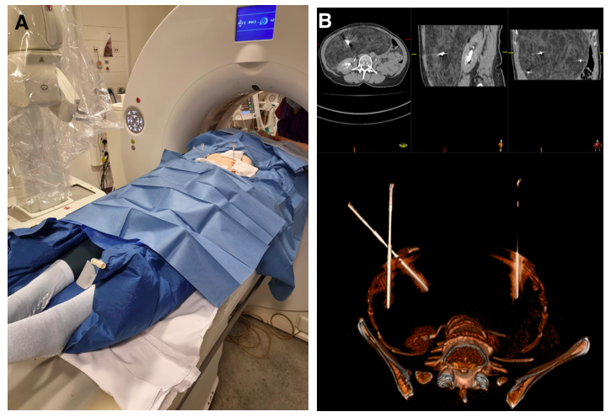
Supplementary Figure 1. Example of a robotic-assisted ‘Smart’ biopsy procedure in a 66-year-old woman with well-differentiated liposarcoma. A: Photograph of the device and the participant within a vacuum immobilization mattress on the CT table. Three simultaneous biopsy needles in situ. B: Volume-rendered CT image with multiplanar reconstructions of the same participant, showing the three simultaneously positioned needles accessing the three target regions.

Supplementary Figure 2. Flow diagram of the study methods. Immobilization steps (marked with asterisks) applied from the fifth participant onwards. Steps carried out in the MRI department are displayed in green. Steps carried out in the CT scanner/interventional radiology department are displayed in blue. Steps in the pathology department are displayed in yellow. Analytical steps are displayed in red. NSR = nuclear-to-stromal ratio. ADC = apparent diffusion coefficient.

