Antioxidant Potential of Calophyllum canum P. F. Stevens: Xanthones, Phenolics, and Radical Scavenging Activity
Mas Atikah Lizazman, Vivien Jong Yi Mian*
Faculty of Applied Sciences, Universiti Teknologi MARA, Kota Samarahan, Sarawak, Malaysia
*E-mail: vivien@uitm.edu.my

Abstract
The isolation and purification of the ethyl acetate of C. canum stem bark have yielded a new α,β-unsaturated δ-lactone compound, canumolactone (8), along with known xanthones, 1-hydroxy-7-methoxyxanthone (1), caloxanthone C (2), trapezifolixanthone (3), ananixanthone (4), euxanthone (5), gentisin (6), 2-hydroxyxanthone (7), and α-mangostin (9). In this study on C. canum extracts, the total phenolic content (TPC), total flavonoid content (TFC), and radical scavenging activity (RSA) were investigated to assess the antioxidant potential. The extraction of C. canum stem bark yielded various crude extracts, with the ethyl acetate extract showing the highest RSA (97.14 ± 0.24 %) and TPC (277.33 ± 9.65 mg GAE/g extract). The TFC values varied across extracts, with the dichloromethane extract displaying the highest TFC (117.96 ± 3.35 mg QE/g extract). A strong positive correlation was observed between TPC and RSA, indicating the significant role of phenolic compounds in the antioxidant activity of the extracts. Conversely, the relationship between TFC and RSA was weak, suggesting a minor contribution of flavonoids to the antioxidant potential of the extracts. These findings highlight the importance of phenolic compounds in determining the antioxidant activity of C. canum extracts.

Keywords
Calophyllum canum, extract, canumolactone, xanthone, TPC, TFC, DPPH.

3. Experimental
3.1 General experimental procedure
The AR grade solvent (n-hexane, dichloromethane, chloroform, ethyl acetate, and methanol) were used for the extraction, isolation, and purification. Gravity column chromatography was performed using silica gel Merck 60 (1.09385.1000), the gel filtration chromatography was performed using Sephadex LH-20 (Sigma Aldrich) as the stationary phase. TLC was conducted on TLC silica gel Merck 60 F254 (1.05554.0001) aluminium sheets. The radial chromatography plate was prepared using silica gel Merck 60 PF254 (1.07749.1000) containing gypsum in 0.5 mm, 1.0 mm, and 2.0 mm thickness. Spots and bands on the TLC and radial chromatography plate were visualized under UV light at 254 nm and 366 nm. 1D and 2D NMR spectral analyses were carried out using Bruker 400 spectrometer which run at 400 MHz (¹H NMR) and 100 MHz (¹³C NMR) with tetramethylsilane (TMS) as the internal standard.
3.2 Plant material
The stem bark of C. canum was collected from Semenggok, Sarawak, Malaysia and identified by a plant taxonomist, Mr. Tinjan anak Kuda from the Forest Department Sarawak. The herbarium voucher specimen (UITM 3007) was deposited at the herbarium Universiti Teknologi MARA Kota Samarahan, Sarawak. The stem bark was air-dried before being ground with conventional mill.
3.3 Extraction and isolation of C. canum stem bark
The ground stem bark (1.0 kg) was extracted with n-hexane for 72 hours using cold maceration technique for three times. The extract was filtered with Whatman No. 1 filter paper and concentrated under reduced pressure using a BUCHI model R-215 rotary evaporator to yield the crude extract. The crude extract was kept in a dry place until further use. The powdered stem bark was air-dried before being introduced to other solvents. The steps were sequentially repeated with other solvents of increasing polarity; dichloromethane, chloroform, ethyl acetate, and methanol. The ethyl acetate extract underwent a combination of chromatography techniques, including gravity column chromatography, gel filtration chromatography, and radial chromatography, for isolation and purification processes.
The ethyl acetate extract of C. canum underwent chromatography on silica gel gravity column chromatography, employing gradient elution of n-hexane to ethyl acetate at varying ratios (100% n-hexane to 100% ethyl acetate), producing a total of 21 fractions. Fractions 1 and 2 were combined and subjected to gel filtration chromatography with Sephadex LH-20 as the stationary phase, eluted with 100% methanol, resulting in the isolation of 17 fractions labelled from A to Q. Subfractions L-O were further combined and purified with radial chromatography (2.0 mm thickness) using a n-hexane to ethyl acetate ratio of 95:5, leading to the isolation of compounds 1 and 2.
Next, compounds fractions 3-4 were chromatographed on silica gel column using a mobile phase of n-hexane to ethyl acetate (100% n-hexane to 3:7 n-hexane to ethyl acetate ratio), resulting in 8 subfractions labelled from A to H. The subfractions A-B were isolated using Sephadex- LH20 with 100% methanol as the eluent, yielding subfractions 1-14. The back subfractions 11-13 was further purified using radial chromatography (1.0 mm thickness) with a n-hexane to ethyl acetate ratio of 8:2, leading to the acquisition of compounds 3 and 4. Subfractions C from fractions 3-4 underwent separation based on molecule size through Sephadex LH-20 chromatography using 100% methanol as the eluent, resulting in 12 fractions. Subfractions 4-7 and 8-11 were purified using the same n-hexane to ethyl acetate solvent system (8:2 to 1:1) on radial chromatography, yielding compounds 5 and 6 respectively. Subfraction D was then subjected to gel filtration chromatography with 100% methanol as the eluent, producing 11 subfractions. Subfractions 4-7 were characterized as compound 7, while subfractions 8-11 were further purified to obtain compounds 8 and 9. The isolation work of the ethyl acetate extract of C. canum is summarized as in Figure S1.
3.4 Spectral data
3.4.1 l-hydroxy-7-methoxyxanthone (1)
Pale yellow needle crystal. ¹H NMR (400 MHz, acetone-d₆): 12.69 (s, 1-OH), 7.72 (1H, t, J = 8.4 Hz, H-3), 7.62 (1H, d, J = 3.1 Hz, H-8), 7.59 (1H, d, J = 9.1 Hz, H-5), 7.50 (1H, dd, J = 3.1 Hz, 9.2 Hz, H-6), 7.02 (1H, dd, J = 1.0 Hz, 8.4 Hz, H-4), 6.79 (1H, dd, J = 1.0 Hz, 8.2 Hz, H-2), 3.96 (s, 7a-OCH₃). ¹³C NMR (100 MHz, acetone-d₆): 182.9 (C-9), 162.7 (C-1), 157.3 (C-7), 157.2 (C-4a), 151.9 (C-5a), 137.9 (C-3), 126.5 (C-6), 121.6 (C-8a), 120.4 (C-5), 110.8 (C-2), 109.2 (C-9a), 107.9 (C-4), 106.1 (C-8), 56.3 (C-7a). The ¹H and ¹³C NMR spectral data are similar with literature (Charoensup et al. 2022).
3.4.2 Caloxanthone C (2)
C-1
Yellow needle crystal. ¹H NMR (400 MHz, acetone-d₆): 13.72 (s, 1-OH), 8.82 (s, 5-OH), 7.67 (1H, dd, J = 1.5 Hz, 7.9 Hz, H-8), 7.38 (1H, dd, J = 1.5 Hz, 7.9 Hz, H-6), 7.24 (1H, t, J = 7.9 Hz, H-7), 6.73 (1H, d, J = 9.9 Hz, H-1′), 6.52 (1H, dd, J = 10.6 Hz, 17.5 Hz, H-2′′), 5.76 (1H, d, J = 9.9 Hz, H-2′), 5.05 (1H, dd, J = 1.2 Hz, 17.5 Hz, H-3′′), 4.90 (1H, dd, J = 1.2 Hz, 10.6 Hz, H-3′′), 1.76 (6H, s, H-4′′ & H-5′′), 1.52 (6H, s, H-4′ & H-5′). ¹³C NMR (100 MHz, acetone-d₆): 182.4 (C-9), 160.2 (C-3), 157.2 (C-1), 155.9 (C-4a), 152.6 (C-2′′), 147.3 (C-5), 146.0 (C-5a), 128.6 (C-2′), 124.9 (C-7), 121.8 (C-8a), 120.9 (C-6), 116.3 (C-1’), 116.0 (C-8), 114.4 (C-4), 107.6 (C-3′′), 105.8 (C-2), 104.4 (C-9a), 79.3 (C-3′), 41.9 (C-1′′), 30.0 (C-4′′ & C-5′′). 28.1 (C-4′ & C-5′), The ¹H and ¹³C NMR spectral data are similar with literature (Lizazman et al. 2023).
3.4.3 Trapezifolixanthone (3)
Yellow needle crystals. ¹H NMR (400 MHz, CDCl₃): 13.11 (s, 1-OH), 7.76 (1H, dd, J = 1.2 Hz, 7.7 Hz, H-8), 7.30 (1H, dd, J = 1.2 Hz, 7.7 Hz, H-6), 7.26 (1H, d, J = 7.7 Hz, H-7), 6.77 (1H, d, J = 10.0 Hz, H-10), 6.06 (s, 5-OH), 5.63 (1H, d, J = 10.0 Hz, H-11), 5.25 (1H, t, J = 7.0 Hz, H-2′), 3.52 (2H, d, J = 7.0 Hz, H-1′), 1.88 (3H, s, H-5′), 1.73 (3H, s, H-4′), 1.50 (6H, s, H-13 & H-14). ¹³C NMR (100 MHz, CDCl₃): 181.1 (C-9), 158.3 (C-3), 156.0 (C-1), 153.7 (C-4a), 144.6 (C-5), 144.4 (C-5a), 131.6 (C-3′), 127.5 (C-11), 123.9 (C-7), 122.7 (C-2′), 120.9 (C-8a), 119.7 (C-6), 116.7 (C-8), 115.7 (C-10), 107.1 (C-4), 104.7 (C-2), 103.4 (C-9a), 78.3 (C-12), 28.3 (C-13 & C-14), 25.7 (C-4′), 21.7 (C-1′), 17.9 (C-5′). The ¹H and ¹³C NMR spectral data are similar with literature (Lizazman et al. 2022).

3.4.4 Ananixanthone (4)
Yellow needle crystal. ¹H NMR (400 MHz, acetone-d₆): 13.45 (s, 1-OH), 9.21 (s, 5-OH), 7.72 (1H, dd, J = 1.7 Hz, 7.9 Hz, H-8), 7.40 (1H, dd, J = 1.7 Hz, 7.9 Hz, H-6), 7.31 (1H, t, J = 7.9 Hz, H-7), 7.09 (1H, d, J = 10.0 Hz, H-10), 5.79 (1H, d, J = 10.0 Hz, H-11), 5.27 (1H, t, J = 7.5 Hz, H-2′), 3.37 (2H, d, J = 7.5 Hz, H-1′), 1.83 (3H, s, H-5′), 1.68 (3H, s, H-4′), 1.52 (6H, s, H-13 & H-14). ¹³C NMR (100 MHz, acetone-d₆): 181.1 (C-9), 160.2 (C-1), 158.4 (C-3), 149.9 (C-4a), 146.1 (C-5), 145.2 (C-5a), 130.9 (C-3′), 127.1 (C-11), 124.1 (C-7), 122.1 (C-2′), 121.3 (C-8a), 120.9 (C-6), 115.6 (C-8), 115.2 (C-10), 111.3 (C-2), 102.9 (C-9a), 101.1 (C-4), 78.2 (C-12), 27.5 (C-13 & C-14), 25.0 (C-4′), 20.9 (C-1′), 17.2 (C-5′). The ¹H and ¹³C NMR spectral data are similar with literature (Karunakaran et al. 2020).
3.4.5 Euxanthone (5)
Yellow crystal. ¹H NMR (400 MHz, acetone-d₆): 12.74 (s, 1-OH), 9.15 (s, 7-OH), 7.71 (1H, t, J = 8.3 Hz, H-3), 7.62 (1H, d, J = 3.0 Hz, H-8), 7.54 (1H, d, J = 9.0 Hz, H-5), 7.45 (1H, dd, J = 3.0 Hz, 9.2 Hz, H-6), 7.02 (1H, dd, J = 1.0 Hz, 8.5 Hz, H-4), 6.78 (1H, dd, J = 1.0 Hz, 8.5 Hz, H-2). ¹³C NMR (100 MHz, acetone-d₆): 182.1 (C-9), 161.9 (C-1), 156.5 (C-4a), 154.2 (C-7), 150.2 (C-5a), 137.0 (C-3), 125.3 (C-6), 121.0 (C-8a), 119.4 (C-5), 109.7 (C-8), 108.3 (C-2), 108.3 (C-9a), 106.9 (C-4). The ¹H and ¹³C NMR spectral data are similar with literature (Lim et al. 2019).
3.4.6 Gentisin (6)
Yellow crystal. ¹H NMR (400 MHz, acetone-d₆): 12.94 (s, 1-OH), 9.08 (s, 7-OH), 7.58 (1H, d, J = 3.0 Hz, H-8), 7.46 (1H, d, J = 9.0 Hz, H-5), 7.37 (1H, dd, J = 3.0 Hz, 9.0 Hz, H-6), 6.53 (1H, d, J = 2.2 Hz, H-4), 6.33 (1H, d, J = 2.3 Hz, H-2), 3.95 (s, 3a-OCH₃). ¹³C NMR (100 MHz, acetone-d₆): 181.5 (C-9), 167.9 (C-3), 164.3 (C-1), 158.9 (C-4a), 155.0 (C-7), 150.9 (C-5a), 125.4 (C-6), 121.9 (C-8a), 119.9 (C-5), 109.3 (C-8), 104.1 (C-9a), 97.7 (C-2), 93.1 (C-4), 56.5 (C-3a). The ¹H and ¹³C NMR spectral data are similar with literature (Zheng et al. 2014).
3.4.7 2-Hydroxyxanthone (7)
Yellow crystal. ¹H NMR (400 MHz, acetone-d₆): 9.00 (s, 2-OH), 8.25 (1H, dd, J = 1.4 Hz, 8.0 Hz, H-8), 7.84 (1H, td, J = 1.7 Hz, 8.5 Hz, H-6), 7.64 (1H, d, J = 3.0 Hz, H-1), 7.58 (1H, d, J = 8.5 Hz, H-5), 7.52 (1H, d, J = 9.0 Hz, H-4), 7.45 (1H, td, J = 1.0 Hz, 8.0 Hz, H-7), 7.38 (1H, dd, J = 3.0 Hz, 9.0 Hz, H-3). ¹³C NMR (100 MHz, acetone-d₆): 176.9 (C-9), 157.1 (C-5a), 154.9 (C-2), 150.9 (C-4a), 135.7 (C-6), 127.0 (C-8), 125.1 (C-3), 124.6 (C-7), 123.2 (C-9a), 122.0 (C-8a), 120.3C-4), 118.9 (C-5), 109.9 (C-1). The ¹H and ¹³C NMR spectral data are similar with literature (Amanatie et al. 2017).

3.4.8 Canumolactone (8)
Yellowish orange gum. ¹H NMR (400 MHz, acetone-d₆): 7.75 (1H, dd, J = 3.3 Hz, 5.8 Hz, H-3), 7.65 (1H, dd, J = 3.3 Hz, 5.8 Hz, H-4), 4.21 (2H, m, H-6), 1.70 (1H, m, H-5), 1.44 (2H, m, H-3′), 1.39 (2H, m, H-2′), 1.35 (2H, m, H-5′), 1.33 (2H, m, H-6′), 0.94 (3H, t, H-4′), 0.91 (3H, t, H-7′). ¹³C NMR (100 MHz, acetone-d₆): 168.0 (C-2), 133.5 (C-1′), 132.0 (C-4), 129.6 (C-3), 68.4 (C-6), 39.7 (C-5), 31.2 (C-2′), 29.7 (C-5′), 24.5 (C-3′), 23.6 (C-6′), 14.3 (C-7′), 11.3 (C-4′).
3.4.9 α-Mangostin (9)
Yellow crystal. ¹H NMR (400 MHz, acetone-d₆): 13.80 (s, 1-OH), 6.83 (1H, s, H-5), 6.40 (1H, s, H-4), 5.28 (1H, t, J = 7.0 Hz, H-2′), 5.28 (1H, t, J = 6.5 Hz, H-2″), 4.13 (2H, d, J = 6.5 Hz, H-1″), 3.80 (s, 7a-OCH₃), 3.35 (2H, d, J = 7.2 Hz, H-1′), 1.83 (3H, s, H-4″), 1.79 (3H, s, H-4′), 1.65 (3H, s, H-5′), 1.65 (3H, s, H-5″). ¹³C NMR (100 MHz, acetone-d₆): 182.9 (C-9), 163.0 (C-3), 161.7 (C-1), 157.5 (C-6), 156.3 (C-5a), 155.7 (C-4a), 144.5 (C-7), 138.1 (C-8), 131.4 (C-3′), 131.4 (C-3″), 124.8 (C-2″), 123.5 (C-2′), 111.9 (C-8a), 111.1 (C-2), 103.6 (C-9a), 102.7 (C-5), 93.2 (C-4), 61.3 (C-7a), 27.9 (C-1″), 25.9 (C-5′), 25.9 (C-5″), 21.9 (C-1′),18.3 (C-4″), 17.9 (C-4′). The ¹H and ¹³C NMR spectral data are similar with literature (Morelli et al. 2015; Abate et al. 2022).
3.6 Preparation of stock solution
The standard stock solution of the C. canum extracts was prepared by accurately weighing 10 mg of the extract, which was then dissolved in 10 mL of methanol to afford a concentration of 1000 μg/mL. A similar procedure was followed with gallic acid and quercetin to yield solutions with a concentration of 1000 μg/mL.
3.7 Antioxidant assay
The antioxidant activity of the extracts was determined using the 2,2-diphenyl-1-picrylhydrazyl (DPPH) radical scavenging assay (Trinh et al. 2014), with adjustments made according to the number of extracts. The experiment was conducted in triplicate. From the stock solution, 0.2 mL of the extract was diluted in 4.8 mL of methanol to achieve a concentration of 40 μg/mL. A quantity of 19.7 mg of DPPH was dissolve in 1L of methanol to prepare a concentration of 0.05 mM.
One mL of methanolic extracts or standard was added to 3 mL of methanolic DPPH, which was then vigorously shaken. A blank was prepared by utilizing 4 mL of 100% methanol. A control was prepared by mixing 1 mL of methanol to 3 ml of methanolic DPPH, which was promptly measured upon preparation. The absorbance was measured at 517 nm after an hour incubation at room temperature (25 ℃). The radical scavenging activity of DPPH was calculated using the following formula:
DPPH radical scavenging activity (%) = $\frac{Absorbance of control – Absorbance of sample}{Absorbance of control} ×100$

3.8 Total phenolic content
The total phenolic content of the extracts was determined using the Folin-Ciocalteu (FC) method (Naves et al. 2019), with adjustments made according to the number of extracts. The experiment was conducted in triplicate. From the stock solution, 0.3 mL of the extract was diluted in 2.7 mL of methanol to achieve a concentration of 100 μg/mL. For the standard, six concentrations of gallic acid (10 - 100 μg/mL) were prepared using the serial dilution method. A 10% (v/v) solution of FC reagent was prepared by diluting 6 mL of reagent in 54 mL of distilled water for this experiment. Two grams of Na₂CO₃ were dissolve in 50 mL of distilled water to prepare 4% (w/v) concentration.
A volume of 2.5 mL of FC solution was added to 0.5 mL of methanolic extracts or standards, followed by the addition of 2 mL of Na₂CO₃ solution after one minute. A blank was prepared by mixing 0.5 mL of methanol with 2.5 mL of FC solution and 2 mL of Na₂CO₃ solution. The absorbance was measured at 750 nm after a 2-hour incubation at room temperature (25 ℃) and compared with gallic acid equivalents (mg GAE/ g extract).
3.9 Total flavonoid content
The total flavonoid content of the extracts was determined using the aluminium chloride calorimetric method (Sakai et al. 2022), with adjustments made according to the number of extracts. The experiment was conducted in triplicate. The methanolic extracts were directly utilized from the stock solution as prepared in section 3.6. For the standard, six concentrations of quercetin (10 - 100 μg/mL) were prepared using the serial dilution method. A 2% (w/v) methanolic solution of AlCl₃.6H₂O was prepared by dissolving 1 g of AlCl₃.6H₂O in 50 mL of methanol for this experiment.
A volume of 2 mL of methanolic AlCl₃.6H₂O was added to 2 mL of methanolic extracts or standards. A blank was prepared by mixing 2 mL of methanol with 2 mL of methanolic AlCl₃.6H₂O. The absorbance was measured at 425 nm after an hour incubation at room temperature (25 ℃) and compared with quercetin equivalents (mg QE/ g extract).
3.10 Statistical analysis
The results obtained from the phytochemical analysis and radical scavenging activity were presented as mean ± standard deviation of triplicate independent analyses using Microsoft Excel 365. Meanwhile, the relationship between phytochemical analysis and antioxidant activity was determined using Pearson correlation. The significance level was set at p < 0.05.

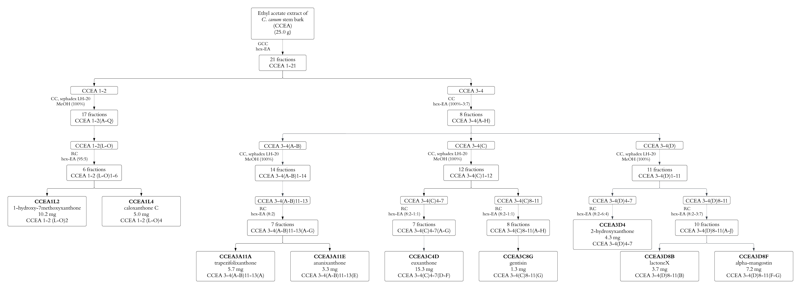
Figure S1. The isolation work of the ethyl acetate extract of C. canum.

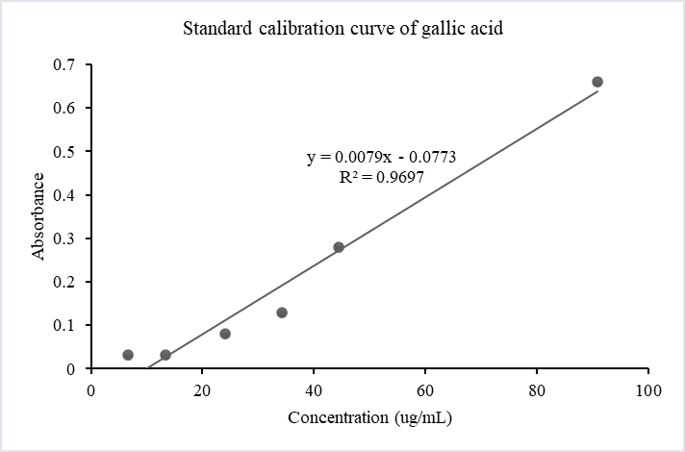
Figure S2. Standard calibration curve of gallic acid.

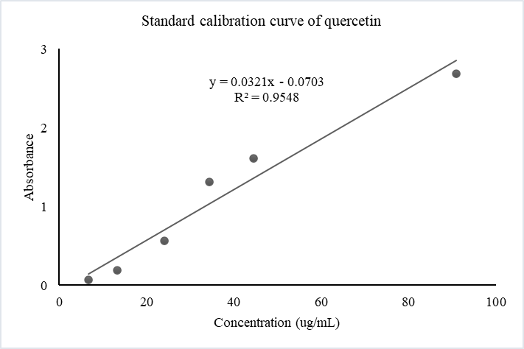
Figure S3. Standard calibration curve of quercetin.

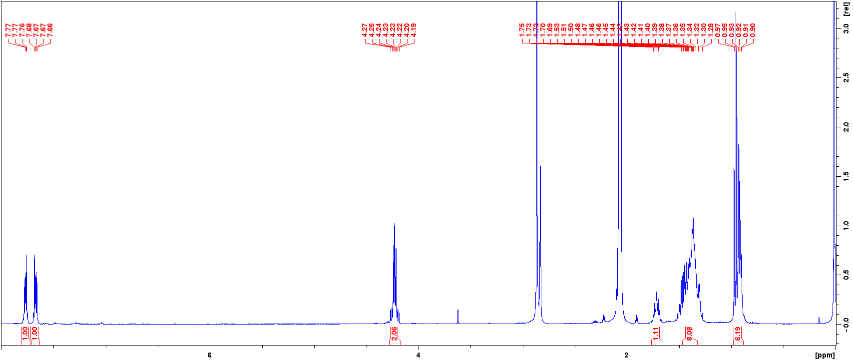
Figure S4. 1D (¹H) NMR spectrum (400 MHz, acetone-d₆) of canumolactone (8).

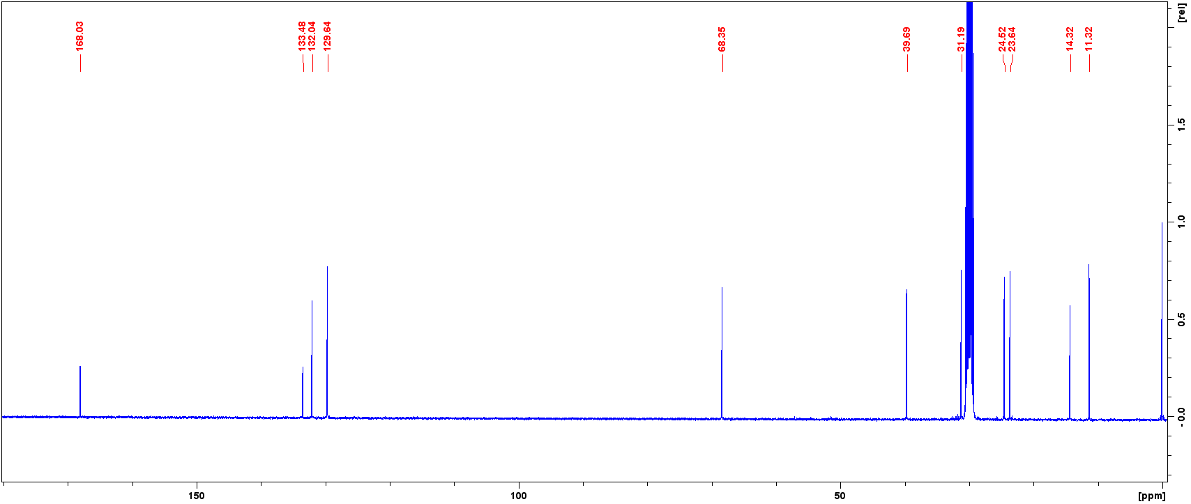
Figure S5. 1D (¹³C) NMR spectrum (100 MHz, acetone-d₆) of canumolactone (8).

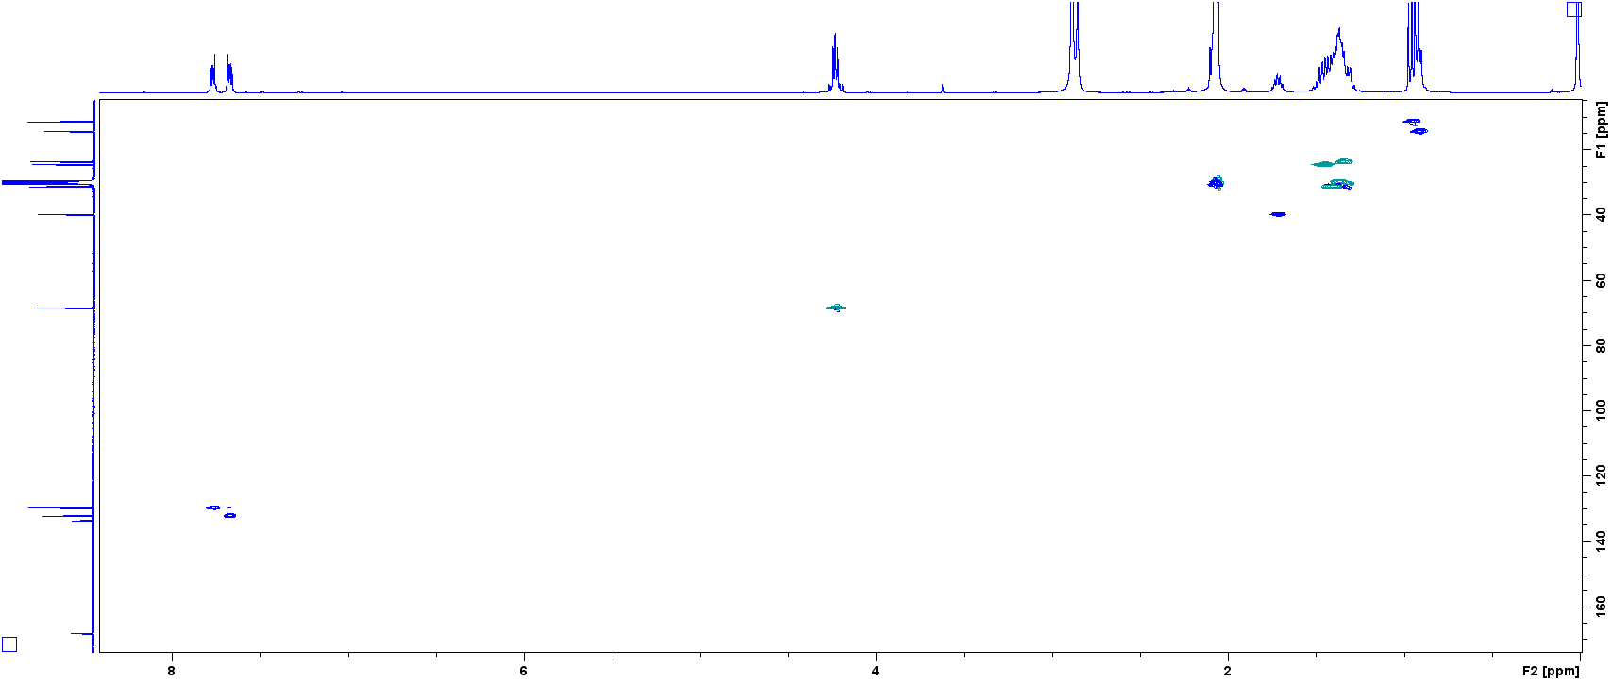
Figure S6. 2D (HSQC) NMR spectrum (400 MHz, acetone-d₆) of canumolactone (8).

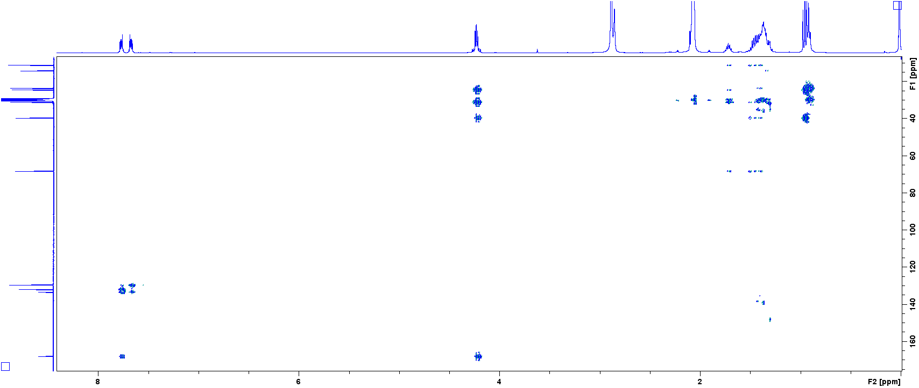
Figure S7. 2D (HMBC) NMR spectrum (400 MHz, acetone-d₆) of canumolactone (8).

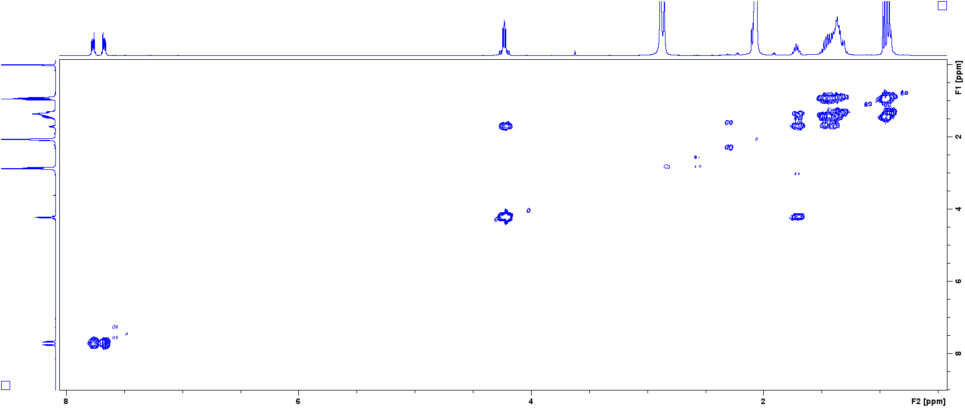
Figure S8. 2D (COSY) NMR spectrum (400 MHz, acetone-d₆) of canumolactone (8).

