Supporting information for
Conveyor CVD to high-quality and productivity of large-area graphene and its potentiality
Dong Yun Lee¹, Jungtae Nam¹, Gil Yong Lee¹, Imbok Lee¹, A-Rang Jang^{2, *}, and Keun Soo Kim^{1, *}
¹ Department of Physics and Graphene Research Institute, Sejong University, Seoul, 05006, Republic of Korea
² Division of Electrical, Electronic and Control Engineering, Kongju National University, Cheonan-si, Chungcheongnam-do, 31080, Republic of Korea
* indicates the corresponding author

* Corresponding author: Keun Soo Kim¹, A-Rang Jang²
Tel.: +82-02-3408-39881, +82-041-521-91872
E-mail address: kskim2676@sejong.ac.kr¹, arjang@kongju.ac.kr²
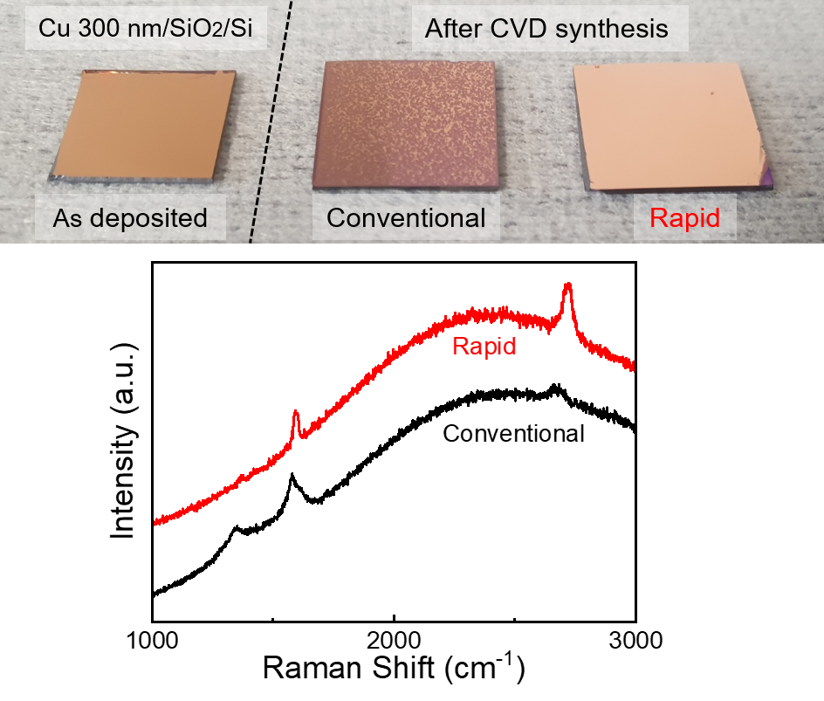
Figure S1. Comparison of photograph images for thermally deposited copper film(300 nm) on SiO₂/Si substrate and conventional/rapid synthesis of graphene on it and their Raman spectra.

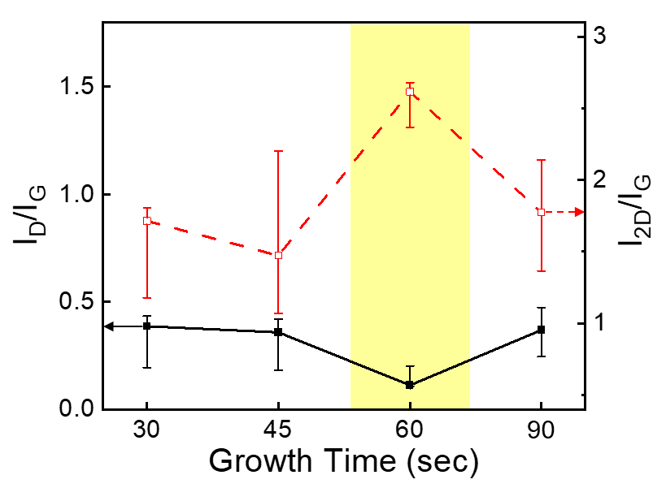
Figure S2. Raman peak ratio of pristine graphene synthesized at 900 ℃ by growth time. Compared to 60 sec data, 30, 45 and 90 sec data have larger D peak and smaller 2D peak, and bigger error bars indicate that the properties of each graphene are non-uniform.

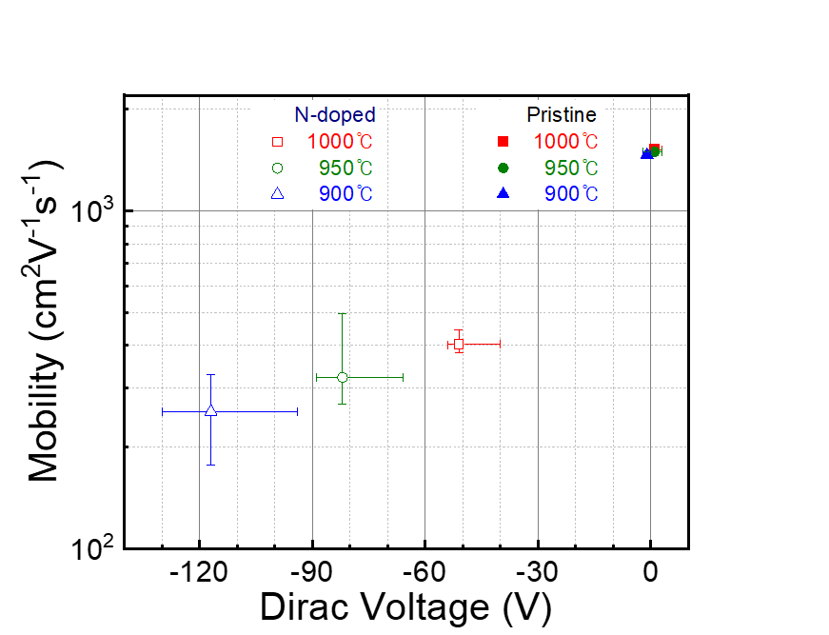
Figure S3. Correlation between Dirac Voltage and mobility of the graphene by growth temperature and doping.
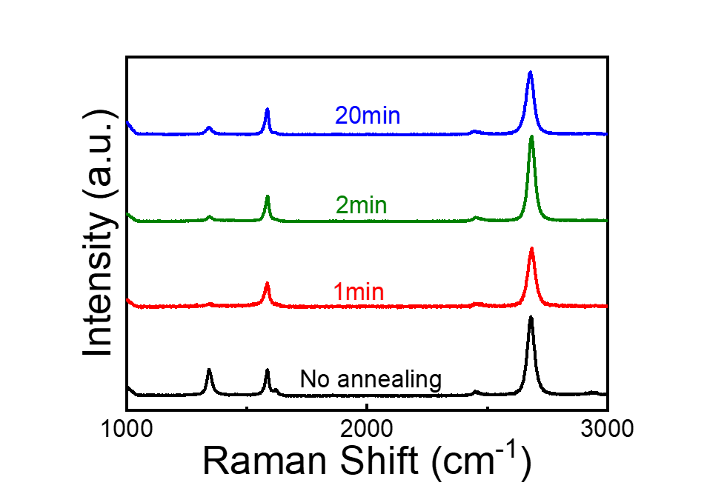
Figure S4. Annealing time dependence Raman spectra of pristine graphene at 1000 ℃.

