Supplementary Figures and Tables
Fig. S1 Rhizosphere soil properties and fine root traits after organic mulching. Values are means ± the standard error (n = 5). SOC: soil organic carbon; DOC: dissolved organic carbon; MBC: microbial biomass carbon; TN: total nitrogen; MBN: microbial biomass nitrogen; TP: total phosphorus; IA: invertase activity; UA: urease activity; PA: peroxidase activity; DA: dehydrogenase activity; SRL: specific root length; SSA: specific surface area; RTD: root tissue density; FRB: fine root biomass; FRC: fine root carbon concentration; FRN: fine root nitrogen concentration; FRP: fine root phosphorus concentration; OM0: no mulch; OM5: 5 cm mulch; OM10: 10 cm mulch; OM20: 20 cm mulch.
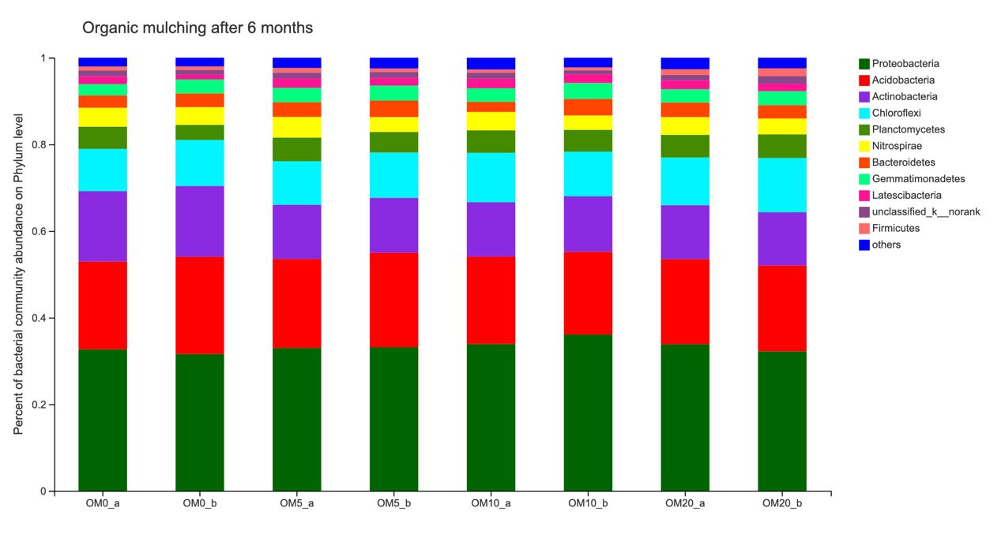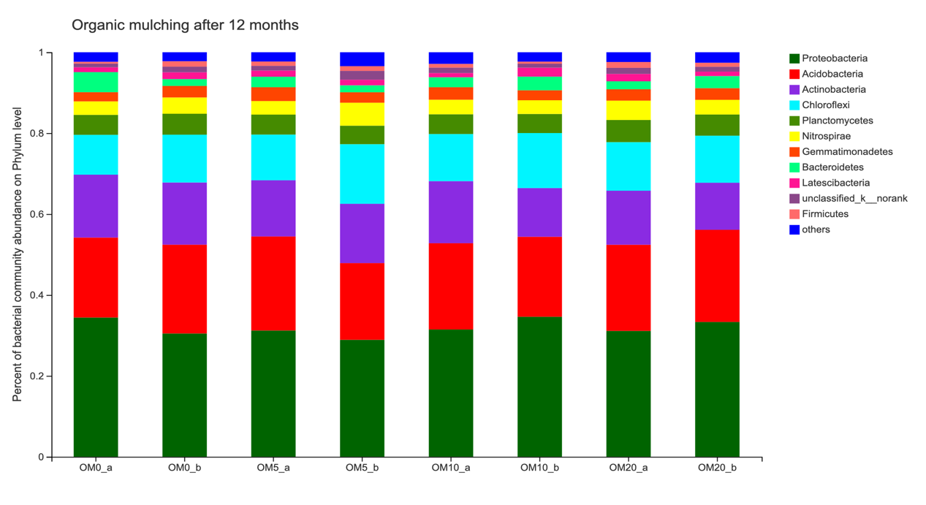
Fig. S2 Relative abundance of rhizosphere bacterial community on Phylum level. The classifications with less than 0.01 abundance are gathered into the category “others”. a: topsoil, b: subsoil.
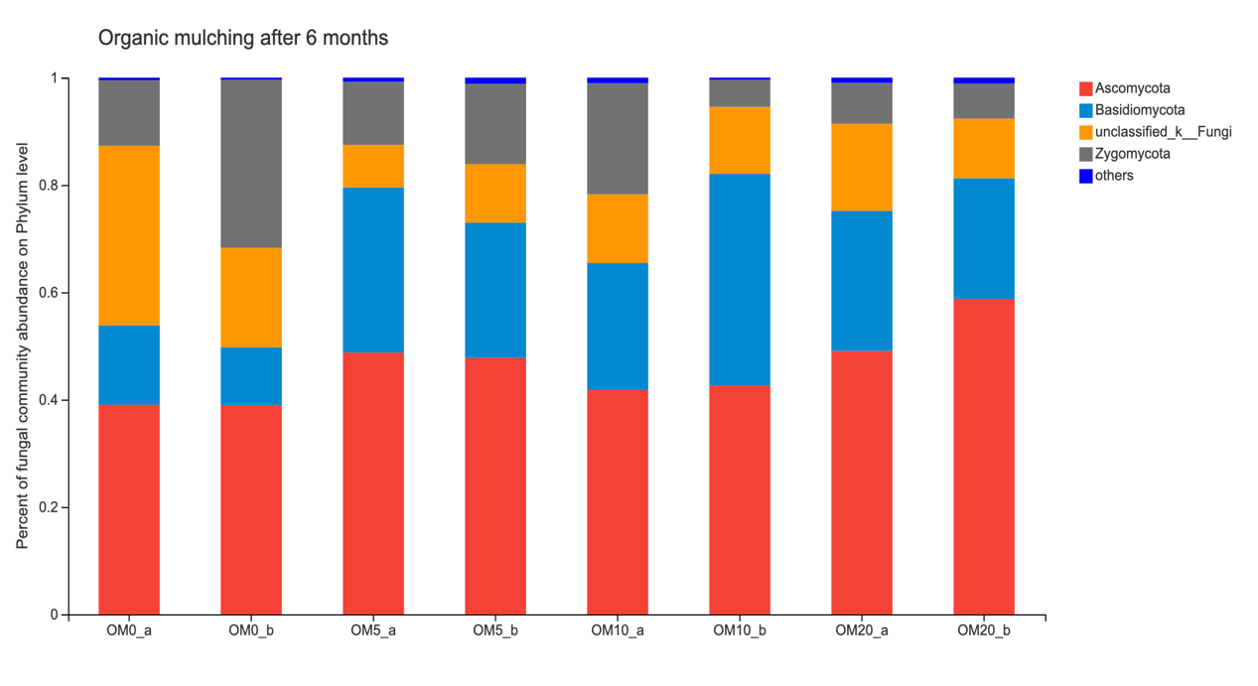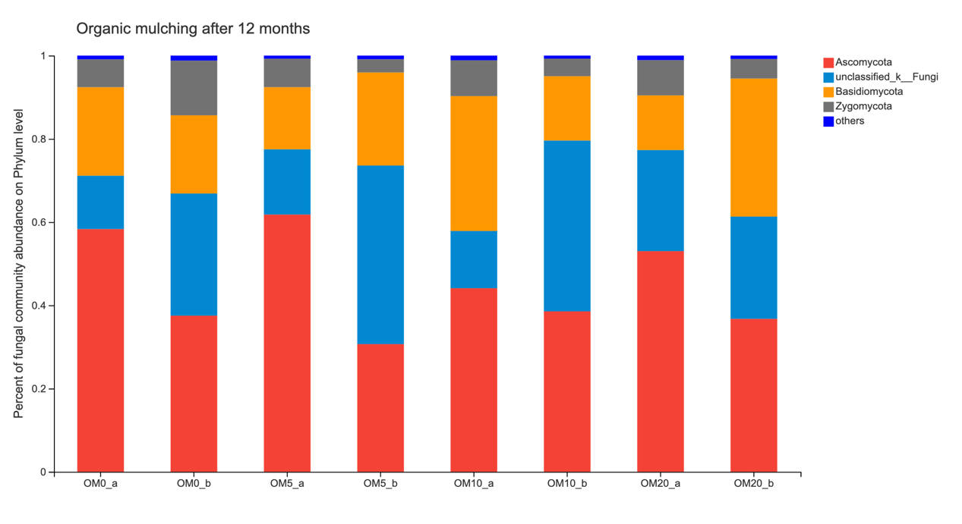
Fig. S3 Relative abundance of rhizosphere fungal community on Phylum level. The classifications with less than 0.01 abundance are gathered into the category “others”. a: topsoil, b: subsoil.

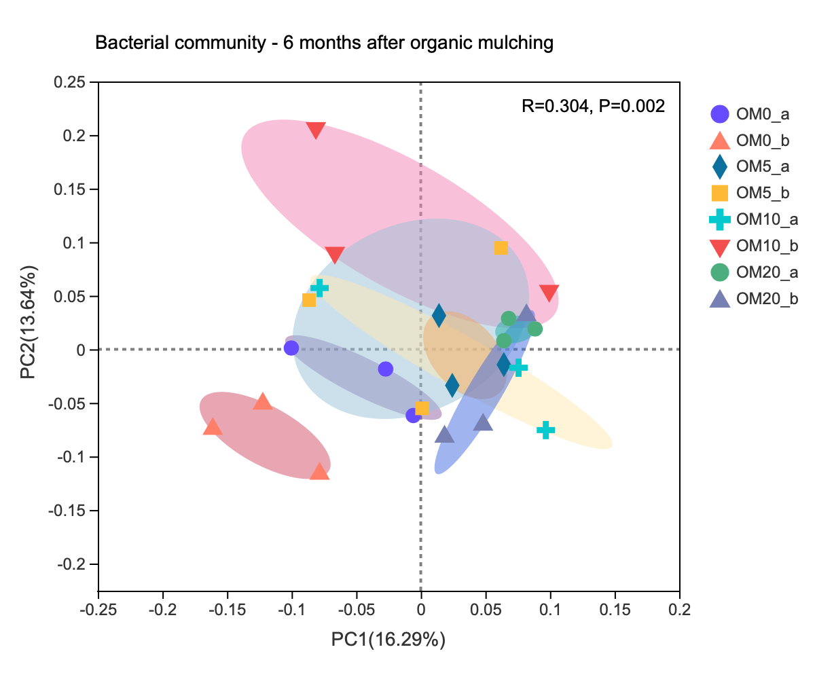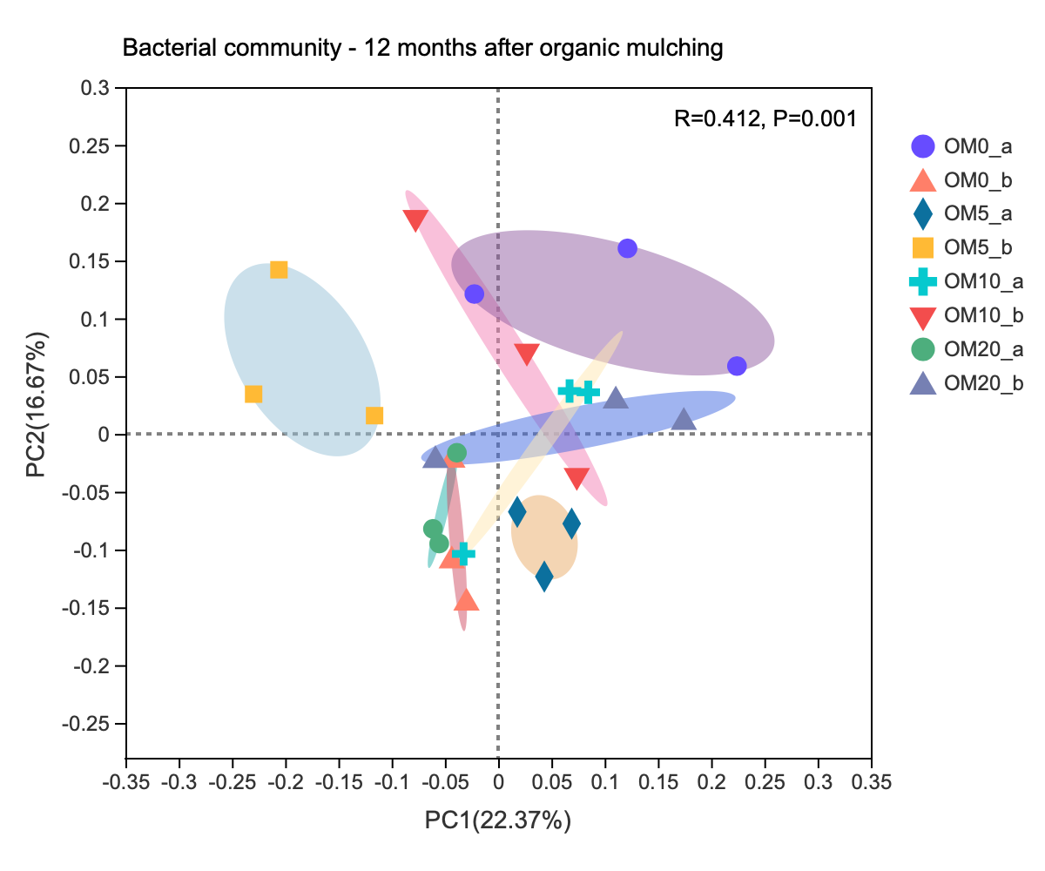
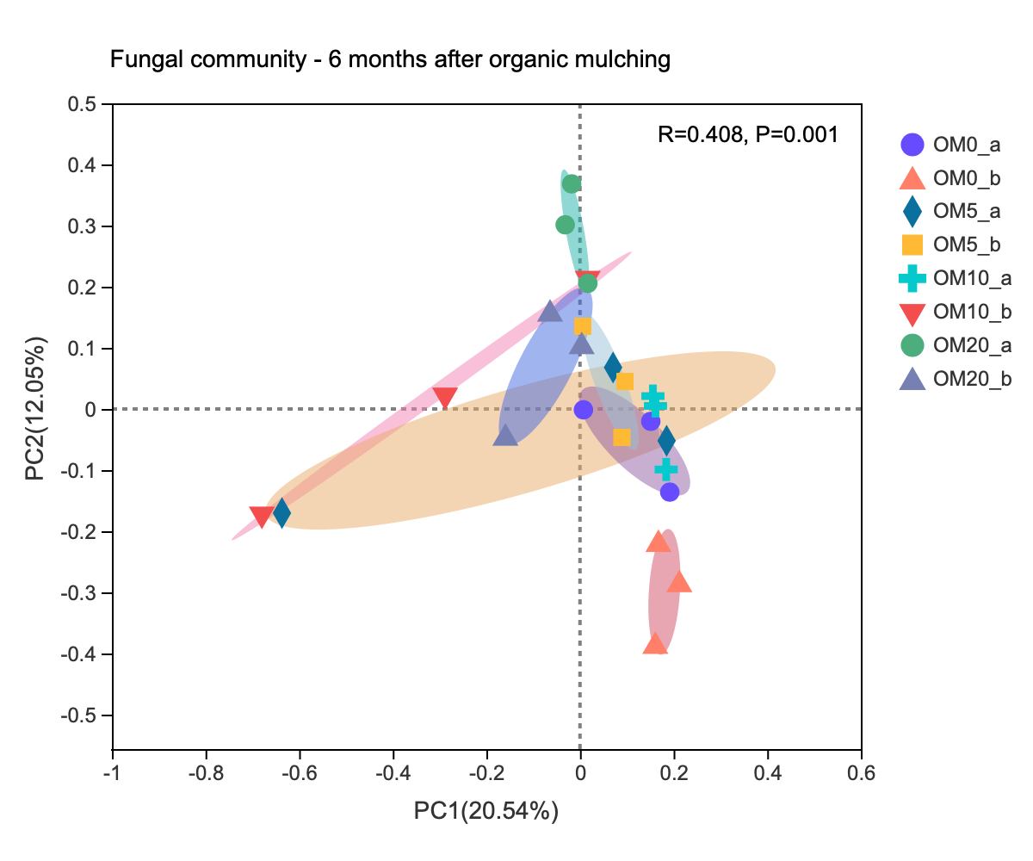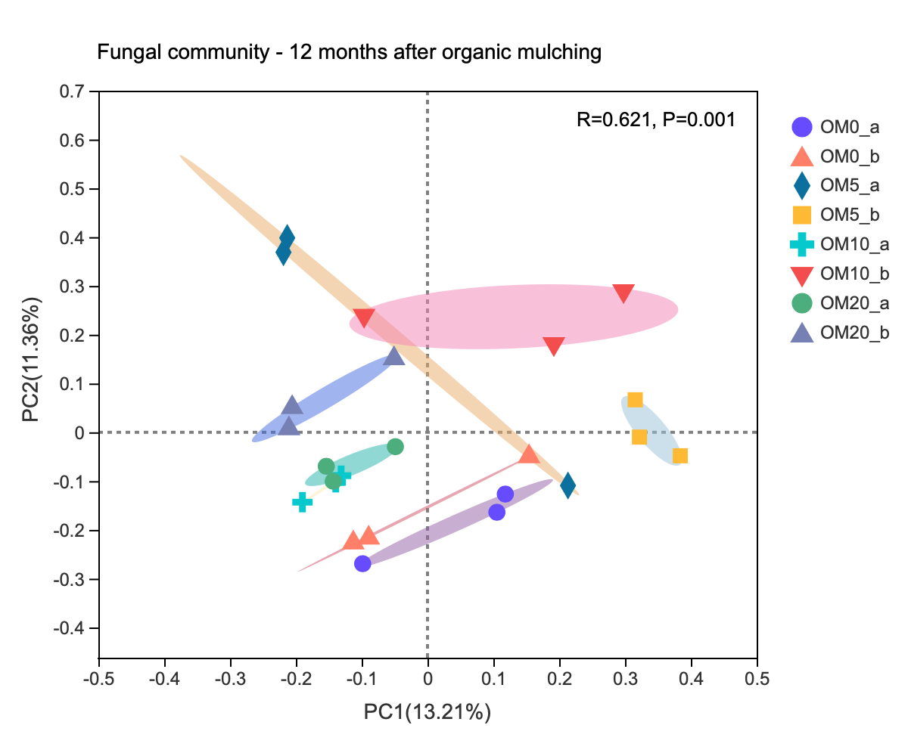
Fig. S4 Principal components analysis (PCoA) of rhizosphere bacterial and fungal community on OTU level under different organic mulching. a: topsoil, b: subsoil.

Table S1 Non-metric multidimensional scaling (NMDS) of rhizosphere microbial community composition and its influencing factors
 | 6 months after organic mulching |  |  |  |  | 12 months after organic mulching
Bacteria | NMDS1 | NMDS2 | r² | Pr(>r) | NMDS1 |  | NMDS2 | r² | Pr(>r)
W | -0.65 | 0.76 | 0.10 | 0.31 | -0.07 |  | 1.00 | 0.01 | 0.88
pH | 0.67 | 0.74 | 0.23 | 0.08 | -0.17 |  | -0.98 | 0.20 | 0.11
SOC | 0.68 | 0.73 | 0.07 | 0.42 | 1.00 |  | 0.05 | 0.00 | 0.99
DOC | 0.66 | 0.75 | 0.08 | 0.42 | 0.62 |  | -0.78 | 0.22 | 0.06
MBC | -0.10 | 0.99 | 0.06 | 0.47 | 0.98 |  | -0.18 | 0.07 | 0.46
TN | 0.18 | 0.98 | 0.12 | 0.28 | 0.86 |  | 0.51 | 0.04 | 0.63
AN | 0.81 | -0.58 | 0.04 | 0.68 | 0.11 |  | -0.99 | 0.01 | 0.95
NN | 0.87 | 0.48 | 0.01 | 0.89 | 0.36 |  | 0.93 | 0.02 | 0.79
MBN | 0.21 | 0.98 | 0.03 | 0.73 | 0.83 |  | 0.57 | 0.08 | 0.43
TP | -0.81 | 0.58 | 0.17 | 0.15 | -0.61 |  | -0.79 | 0.04 | 0.66
IA | 0.14 | -0.99 | 0.14 | 0.21 | -0.40 |  | 0.92 | 0.05 | 0.57
UA | 0.74 | -0.67 | 0.15 | 0.18 | 0.49 |  | -0.87 | 0.04 | 0.60
PA | -0.26 | 0.96 | 0.05 | 0.57 | 0.10 |  | -1.00 | 0.06 | 0.50
DA | 0.58 | -0.82 | 0.05 | 0.56 | 0.32 |  | 0.95 | 0.15 | 0.18
SRL | -0.83 | 0.55 | 0.00 | 0.99 | 0.90 |  | -0.43 | 0.23 | 0.06
SSA | -0.65 | -0.76 | 0.01 | 0.89 | 1.00 |  | 0.01 | 0.07 | 0.40
RTD | 0.14 | 0.99 | 0.10 | 0.32 | -0.52 |  | 0.85 | 0.11 | 0.32
FRB | -0.15 | 0.99 | 0.06 | 0.53 | -0.09 |  | 1.00 | 0.04 | 0.67
FRC | -0.76 | 0.65 | 0.02 | 0.83 | -0.48 |  | 0.88 | 0.05 | 0.58
FRN | 0.54 | 0.84 | 0.09 | 0.39 | 0.69 |  | -0.72 | 0.16 | 0.14
FRP | 0.21 | 0.98 | 0.33 | 0.02* | 0.16 |  | -0.99 | 0.04 | 0.63
Fungi | NMDS1 | NMDS2 | r² | Pr(>r) | NMDS1 |  | NMDS2 | r² | Pr(>r)
W | 0.03 | 1.00 | 0.19 | 0.12 | 0.26 |  | 0.96 | 0.10 | 0.31
pH | 0.23 | -0.97 | 0.02 | 0.82 | -0.62 |  | -0.78 | 0.15 | 0.18
SOC | -1.00 | -0.01 | 0.07 | 0.51 | -0.98 |  | -0.22 | 0.01 | 0.92
DOC | 0.23 | 0.97 | 0.20 | 0.09 | 0.81 |  | -0.59 | 0.02 | 0.85
MBC | 0.22 | 0.98 | 0.15 | 0.19 | -0.06 |  | -1.00 | 0.07 | 0.50
TN | -0.31 | 0.95 | 0.13 | 0.22 | 0.98 |  | 0.21 | 0.05 | 0.57
AN | -0.25 | 0.97 | 0.17 | 0.16 | -0.86 |  | -0.51 | 0.07 | 0.48
NN | -0.10 | 0.99 | 0.18 | 0.14 | -0.93 |  | -0.36 | 0.00 | 0.97
MBN | 0.26 | 0.97 | 0.08 | 0.40 | 0.97 |  | 0.24 | 0.08 | 0.43
TP | 0.68 | -0.73 | 0.09 | 0.35 | -0.94 |  | 0.34 | 0.05 | 0.58
IA | -0.52 | 0.85 | 0.07 | 0.48 | 0.72 |  | -0.70 | 0.00 | 0.99
UA | -0.92 | -0.39 | 0.33 | 0.02* | -0.38 |  | -0.92 | 0.00 | 0.95
PA | 0.45 | -0.89 | 0.18 | 0.13 | -0.78 |  | -0.63 | 0.19 | 0.11
DA | -0.79 | 0.61 | 0.30 | 0.04* | 0.92 |  | 0.39 | 0.00 | 0.95
SRL | -0.75 | 0.67 | 0.26 | 0.04* | 0.89 |  | -0.46 | 0.08 | 0.42
SSA | -0.90 | 0.43 | 0.19 | 0.11 | 0.95 |  | 0.32 | 0.08 | 0.39
RTD | 0.59 | 0.81 | 0.00 | 1.00 | -0.73 |  | 0.68 | 0.02 | 0.81
FRB | 0.40 | 0.92 | 0.22 | 0.08 | 0.28 |  | 0.96 | 0.01 | 0.88
FRC | 0.72 | -0.69 | 0.19 | 0.13 | -0.36 |  | 0.93 | 0.02 | 0.77
FRN | -0.13 | 0.99 | 0.28 | 0.03* | -0.09 |  | -1.00 | 0.04 | 0.64
FRP | 0.97 | 0.24 | 0.11 | 0.32 | -0.80 |  | -0.59 | 0.05 | 0.59
Note: * P < 0.05. T: temperature; W: water content; SOC: soil organic carbon; DOC: dissolved organic carbon; MBC: microbial biomass carbon; TN: total nitrogen; AN: ammonium; NN: nitrate; MBN: microbial biomass nitrogen; TP: total phosphorus; IA: invertase activity; UA: urease activity; PA: peroxidase activity; DA: dehydrogenase activity; SRL: specific root length; SSA: specific surface area; RTD: root tissue density; FRB: fine root biomass; FRC: fine root carbon concentration; FRN: fine root nitrogen concentration; FRP: fine root phosphorus concentration.

