Environmental Quality and Mental Health of Residents in Selected Areas of Dhaka City



Thesis for the partial fulfillment of the Bachelor's Degree in Environmental Science & Management

18th December, 2022
Submitted by-

Reeju Francis Leonard Gomes
Student ID: 1910121
Semester: Autumn 2022

BSc. in Environmental Science
Department of Environmental Science and Management (DESM)
School of Environment and Life Sciences (SELS)

Independent University, Bangladesh (IUB)



Prepared By:
Reeju Francis Leonard Gomes
Student ID#1910121
BSc. in Environmental Science
Department of Environmental Science and Management (DESM)
School of Environment and Life Sciences (SELS)
Independent University, Bangladesh (IUB)
E-mail: 1910121@iub.edu.bd

Supervised By:

Md. Ekhtekharul Islam
Senior lecturer
Department of Environmental Science and Management (DESM)
Independent University, Bangladesh (IUB)
E-mail: ekhtekhar@iub.edu.bd

Zahirul Islam
Senior Project Associate at ARCED Foundation
  M |  | +880 1688 831919
   | W |  | www.arced.foundation

E |  | zahirul.islam@arced.foundation

A |  | ​House # 463 | Level # 5 | Road # 7 | Avenue # 5

A |  | ​Mirpur-DOHS | Dhaka-1216 | Bangladesh

Submitted on: 18th December, 2022
Presentation Date: 18th December, 2022

Acknowledgement

After the completion of this thesis, I would like to express my gratitude to my academic supervisor, Md. Ekhtekharul Islam Senior lecturer Department of Environmental Science and Management (DESM), Independent University, Bangladesh (IUB) for guiding me in this Research Project and for supporting me throughout the entire course of time. Special gratitude to Mr. Zahirul Islam, Project Associate, Arced Foundation, for his immense help with data management and working in the backend of the data analysis.

I would also like to thank all the faculty members from the Department of Environmental Science & Management (DESM), and Ms. Raiyana Rahman and Ms. Refat Ara Jerin from the Department of Media & Communication for helping me reach my target number of responses by sharing my online survey form and always extending their support and cooperation in every possible way. I am also grateful to all my close family & friends for their support and encouragement throughout the preparation of this research work. Special thanks to all of the participants for trusting me with their responses and taking part in the survey without which this research would not be possible in the first place.

Last but not the least, my deepest gratitude to Independent University, Bangladesh (IUB) for having the provision of a thesis that supports the students from every department to get the opportunity to learn through practical experience about the real working world.

Abstract

Poor environmental quality not only adversely affects animals and humans physically but affect human beings mentally. This study focuses on establishing a relationship between environmental quality and mental health in Dhaka by comparing two selected areas, Farmgate and Bashundhara Residential Area. Residential Environmental Assessment Tool (REAT 2.0) and General Health Questionnaire (GHQ-12) was used to assess the environmental and mental health quality. A total of 503 responses were collected through both online and offline methods which were analyzed using Stata 17.0 version. The findings of this study include establishing a relationship and correlation between poor environmental quality and mental health in Dhaka among the two areas, determining the environmental factors which affect the mental health the most, and also determining the mental health aspect that are most affected due to a poor environmental quality. Cronbach’s alpha analysis test score was 0.83 which means that the questionnaire is very reliable and has high internal consistency.
Keywords: Environmental quality, mental health, Stata, REAT 2.0, GHQ-12

Table of contents
Acknowledgement 2
Abstract 3
Table of contents 4
Chapter 1 - Introduction 5
1.1 Importance of this study 6
1.2 Objectives of this study 7
Chapter 2 - Research Background 7
Chapter 3 - Materials & Methodology 9
3.1 Study Area 9
3.2 Study population and data 12
3.3 Indicators of mental health 13
3.4 Indicators of environmental quality 15
3.5 Ethical Considerations 21
3.6 Statistical Analysis 21
Chapter 4 - Results & Discussion 22
4.1 Characteristics of sample 22
4.2 Residential Environmental Assessment Tool (REAT 2.0) 23
4.3 General Health Questionnaire (GHQ-12) 25
4.4 Residential environment quality and general mental health quality 26
4.5 Major environmental factors affecting mental health wellbeing 31
4.6 Mental health aspects affected by environmental quality 32
Chapter 5 - Limitations of the study 31
Chapter 6 - Conclusion 32
References 31

Chapter 1 - Introduction
Bangladesh has been known for being a country of natural beauty for instance, biodiversity, the fertile lands, the rivers, and many other natural environmental qualities (Bangladesh: A Country of Natural Beauty, n.d.). However, due to lack of proper management and planning, people living within the city do not get a chance to experience and connect with nature for various reasons. It could be due to the robotic life people are forced to live to survive in the city or the lack of proper management during urbanization. It is well known and the trend is very clear how urbanization in Dhaka is improving when the city is branching out, for example when Old Dhaka is compared with Uttara.

Overpopulation in Bangladesh is a major issue. The population of Dhaka in 2022 is 22,478,000 (Dhaka, Bangladesh Metro Area Population 1950-2022, n.d.). In addition, the population density of Dhaka city is 30,093 residents per square kilometer (Statista, 2022). With issues such as lack of space with the city and the extreme urge to expand the city and develop the outskirts of the city, lack of urban planning with the city is very evident due to the congested buildings. The housing sector is under direct stress as a result of the population's rapid growth. The poor move from central areas to urban fringe areas in subpar homes and construct their homes in government and private undeveloped land and roadside spaces, creating slums and squatter settlements because they cannot afford the average rent of the houses. Slums and squatter settlements have extremely high population densities, which leads to environmental issues (Hasan, 2022). Inadequate leisure facilities are lacking in Dhaka as a result of congestion and a lack of available space. The absence of public spaces and recreational amenities substantially lowers the quality of life in Dhaka, with the exception of a few limited parks and recreation facilities. Lack of recreational opportunities has serious and far-reaching effects, especially on youngsters who must deal with their pent-up energy (Rahaman, 2022).

While studying about environment and environmental science, much of the importance is usually given to the impacts of anthropogenic activities on the environment and the impact of the environment such as climate change on humans and other organisms. It is a growing concern for people that the environment can affect the mental health of people. In the early days, before the 1960s, there was little environmental awareness and only a few isolated international environmental regulatory initiatives (International Environmental Law: History and Milestones, 2020). It was not until the 1970s that Bangladesh started focusing on environmental laws too where they added the Water Pollution Control Ordinance, 1970. With time as people became more and more aware, laws became more defined and stricter regarding the environment. However, while to this day the impact of mental health due to the environment where we live is often underestimated and ignored, there is growing attention in the idea that neighborhood elements in addition to residents' characteristics may have an impact on mental health (Thomas et al., 2007)

The hypothesis that housing quality affects mental health has proved difficult to evaluate scientifically (Evans, 2003). Despite the fact that humans devote more than 90% of their time indoors, ambient environmental conditions and health are better understood than the built environment and health. There are two main ways that the built environment influences mental health. Firstly, the built environment's qualities can have a direct impact on mental health. For example, housing, crowding, noise, indoor air quality, and light are environmental factors that have an immediate impact on mental health. Secondly, the built environment can also have an indirect effect on mental health through changing psychosocial processes that are known to have negative effects on mental health. For instance, greater residential congestion hinders the emergence of socially supportive bonds among family members (Evans, 2003).

1.1 Importance of this study
People spend more time at home than in any other environment, which gives this idea both relevance and significance. Therefore, home quality should be a top research candidate if the physical environment might affect mental health (Evans, 2003). If a correlation can be established, it would mean that people should be more careful and take better action on keeping their environmental quality good. It would also mean that parents raising their children or soon-to-be parents should consider evaluating the impact of the environmental quality on their children as well because mental health is a serious issue to consider. Architects and city planners could use this knowledge to plan better, more modern, environmentally friendly and people friendly cities. Finally, research on this topic is quite limited in Bangladesh making it one of the few studies to be done here in Bangladesh. This research sheds light on a topic which is not only important but rarely studied. Finally, this research uses and combines two sets of questionnaires which has never been done in the context of Bangladesh. This means that future research in similar topics in Bangladesh or neighboring countries could use this reliable set of surveys for studying and conducting research.

1.2 Objectives of this study
This report has been focused and narrowed down on the impacts of residential environmental quality of the residents on mental health in some selected areas of Dhaka City. The research objectives include finding
- a correlation between the quality of the environment and the mental health of the residents of those areas,
- a relationship of high significance between environmental quality and mental health,
- the most significant factor(s) of environmental quality that adversely affect mental health the most,
- different components of mental health severely affected
Therefore, the hypothesis is as follows.

I hypothesize that there is a significant correlation between environmental quality in a residential area (Farmgate and Bashundhara Residential Area) and the residents’ mental health of that particular area(s).

The purpose of this report is to qualitatively and quantitatively explain the findings from the survey, and relate with similar studies which were conducted here in Bangladesh and other countries, too. Finally, this report mentions some of the limitations which were faced while conducting this research. These limitations should be kept in mind before conducting similar research in the future in Bangladesh or other countries.

Chapter 2 - Research Background
Plenty of studies have shown that the environment does have an adverse impact on the mental health of people. A person’s mental health can be affected due to many reasons and it is suggested that as more research is being conducted, keeping mental health in focus, it has become clearer that mental health can be affected due to a combination of several factors such as biological, psychological and environmental (Causes of Mental Illness, 2003). It has also been found that along with climate change and environmental factors, environmental disasters such as contamination in drinking water, flooding, and drought, for example, affect mental health negatively, and some common effects of which are depression, anxiety and posttraumatic stress disorder (PTSD) (Reuben et al., 2022).

A well-written article by Lindberg (2022) says that one's mental health can be impacted by a variety of factors, including their home, city, and state of residence, as well as the local climate, social environment, and workplace. The physical and emotional health may be significantly impacted by these places since one spends a lot of time in. According to an editorial written by Helbich (2018), which analyzed 10 manuscripts, it said that some of the papers support the implication that the environment can affect people’s mental health directly or indirectly. As more researches and studies are being done, there is now growing evidence of a link between certain air pollutants and mental illnesses such as depression, dementia, anxiety and suicide (United Nations Environment Programme, n.d.). In addition, research now shows that high traffic-related air pollution can cause anxiety levels (Even Small Spikes in Air Pollution Can Threaten Children’s Mental Health, Research Suggests, 2021), and 12 year old children are more like (by a factor of three or four times) to have depression at 18 if they are exposed to polluted air specifically by NO₂ and PM_{2.5} (Roberts et al., 2019).

According to “Mental health and the environment: How European policies can better reflect environmental degradation’s impact on people’s mental health and well-being”, environmental degradation and pollution is a threat to mental health therefore, it automatically comes to a conclusion that nature can be a good factor for improving or having good mental health. Strong evidence also suggests a connection between noise pollution (especially that caused by traffic) and mental health issues, such as discomfort, poor sleep, cognitive decline, and worsening of psychiatric issues. Impact of noise is more significant to children as they are more vulnerable to this. Furthermore, this study also linked the adverse impact of mental health with climate change. Climate change furthermore has direct impacts on mental health (e.g., heat stress) and indirectly affects social support systems, cultural traditions, and environmental conditions (Filipova et al., 2020). According to a research by Clayton (2020), children are more affected by the stress brought on by the global crisis posed by climate change since they are more susceptible to its immediate consequences. This stress may result in psychological distress. They typically experience more severe reactions to harsh weather, such as PTSD, depression, sleep difficulties, etc., in part because of their increased reliance on adult family members and other social support systems that the event could disrupt.

Individuals may have improved mental health if they have access to more green space, better food options, cleaner air and water, and more economical health care (Reuben et al., 2022). Regardless of other risk factors such as level of urbanization, socioeconomic factors, parental history of mental illness, and parental age, a multi-decade nationwide study in Denmark found that children raised in neighborhoods with the least green space had a risk of developing a psychiatric disorder in adulthood of up to 55% greater than their peers raised in greener settings (Engemann 2019).

A study called “Housing Quality and Mental Health” mentions some of the reasons which make it challenging to carry out thorough, scientific research on housing quality and mental health. People first decide where to reside. This makes it challenging to separate the effect of housing quality from personal traits that can cause misleading connections between housing quality and mental health, such as socioeconomic status (SES) and initial levels of mental health. Second, the current metrics of housing quality were created from one of two perspectives: either to evaluate risks to the public's health or in terms of building rules or construction standards. Both of these viewpoints have intentionally ignored environmental factors that are conceptually important to mental health. The majority of the current housing quality parameters rely on respondents' self-reports of housing quality, which has fundamental conceptual flaws and makes relationships with self-report measures of mental health prone to mono method bias. Third, tools created to quantify nonclinical symptomatology are needed for the assessment of mental health in the general population. Prior studies on the relationship between home quality and mental health have mainly used subjective, author-generated measures of mental health or catastrophic indicators like psychiatric case openings (Evans, 2003).

Chapter 3 - Materials & Methodology

3.1 Study Area
For the purposes of this research, two areas within Dhaka city were chosen for comparison between environmental quality and mental health. The chosen areas are Farmgate (figure 1) and Bashundhara Residential Area (figure 2) as the study area. There are reasons for choosing these two areas specifically.

- Farmgate is known for being overcrowded and having poor urban planning. With almost 70 micrograms (mgs) of particulate matter (PM 2.5) per cubic meter, where the permissible limit of PM 2.5 is 15 mgs per cubic meter, the Tejgaon industrial zone, which is next to Farmgate and is seen in figure 3 below, has been reported to be the most polluted place (Alam, 2019)
- Feasibility and accessibility are important factors as well. Due to the advantage of having a lot of networks and access in Farmgate, it allowed to conveniently collect 250 responses within the short time frame. While there were other areas such as Old Dhaka to consider, it would not have been feasible to survey 250 respondents in that short period of time. This is because traveling back and forth to Old Dhaka would be time consuming and financially straining. Attempting to obtain 250 responses from Old Dhaka through online means would also be very difficult because of the lack of networking and access to Old Dhaka.
- Bashundhara Residential Area has a more structured planning, in my opinion. Additionally, a website of the Assure Group determines that a good location requires well-structured houses that keep a safe spacing from one another, lakes, gardens, and parks for adults and children to enjoy. One of the newest upscale neighborhoods in Dhaka, Bashundhara Residential, is highlighted on the same website. East of Baridhara, a residential neighborhood has developed immediately off the Kuril highway. In contrast to the regions mentioned above, Bashundhara is providing a full range of living options (Posh Areas in Dhaka, 2021).
- While two neighboring areas could have been selected, the environment quality between two adjacent areas is not expected to vary significantly. This meant that distant areas such as Bashundhara Residential Area would be a reasonable choice. However, in order to show a good comparison of mental health wellbeing between a poor environmental quality and good environmental quality, a strong contrast is preferable.
- Another reason for choosing Bashundhara Residential Area is that having a lot of network in that area allowed to obtain 250 responses within time. The faculties from Independent University, Bangladesh were requested to share the Google Form with students through Google Classroom. Reasons why other areas such as Uttara were not chosen were that Uttara was very far away which would mean that it would be costly and time-consuming studying that area.

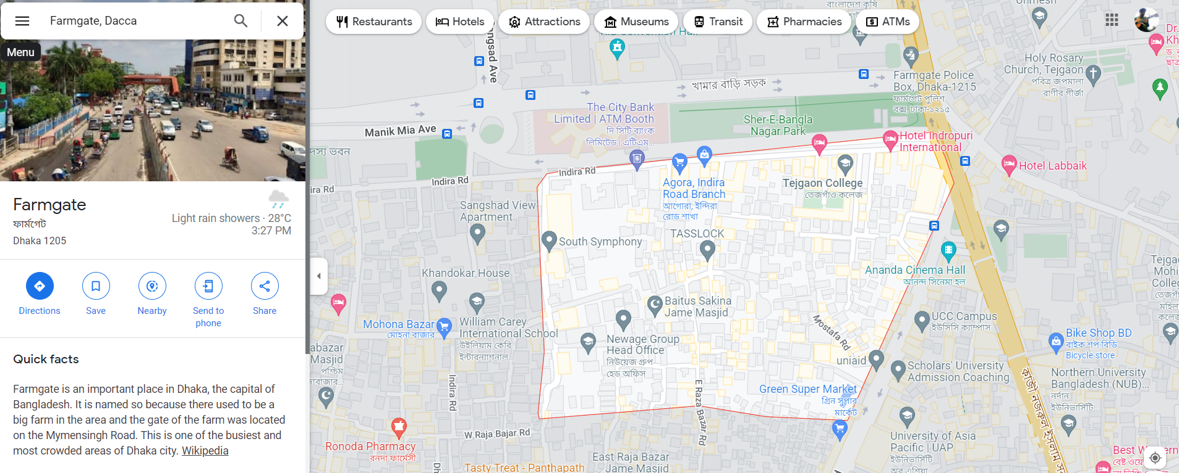
Figure 1: Farmgate

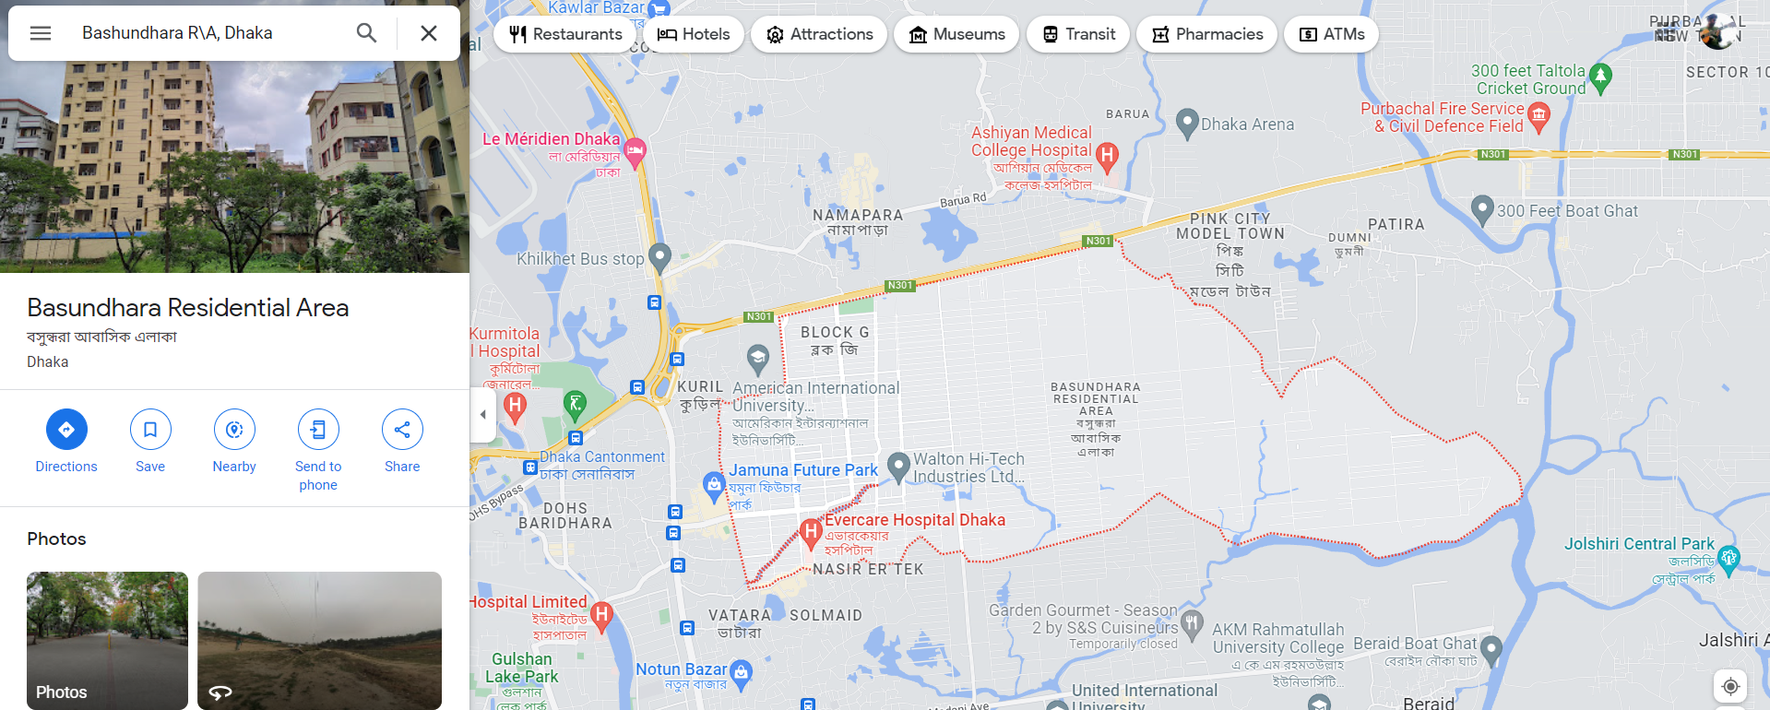
Figure 2: Bashundhara Residential Area

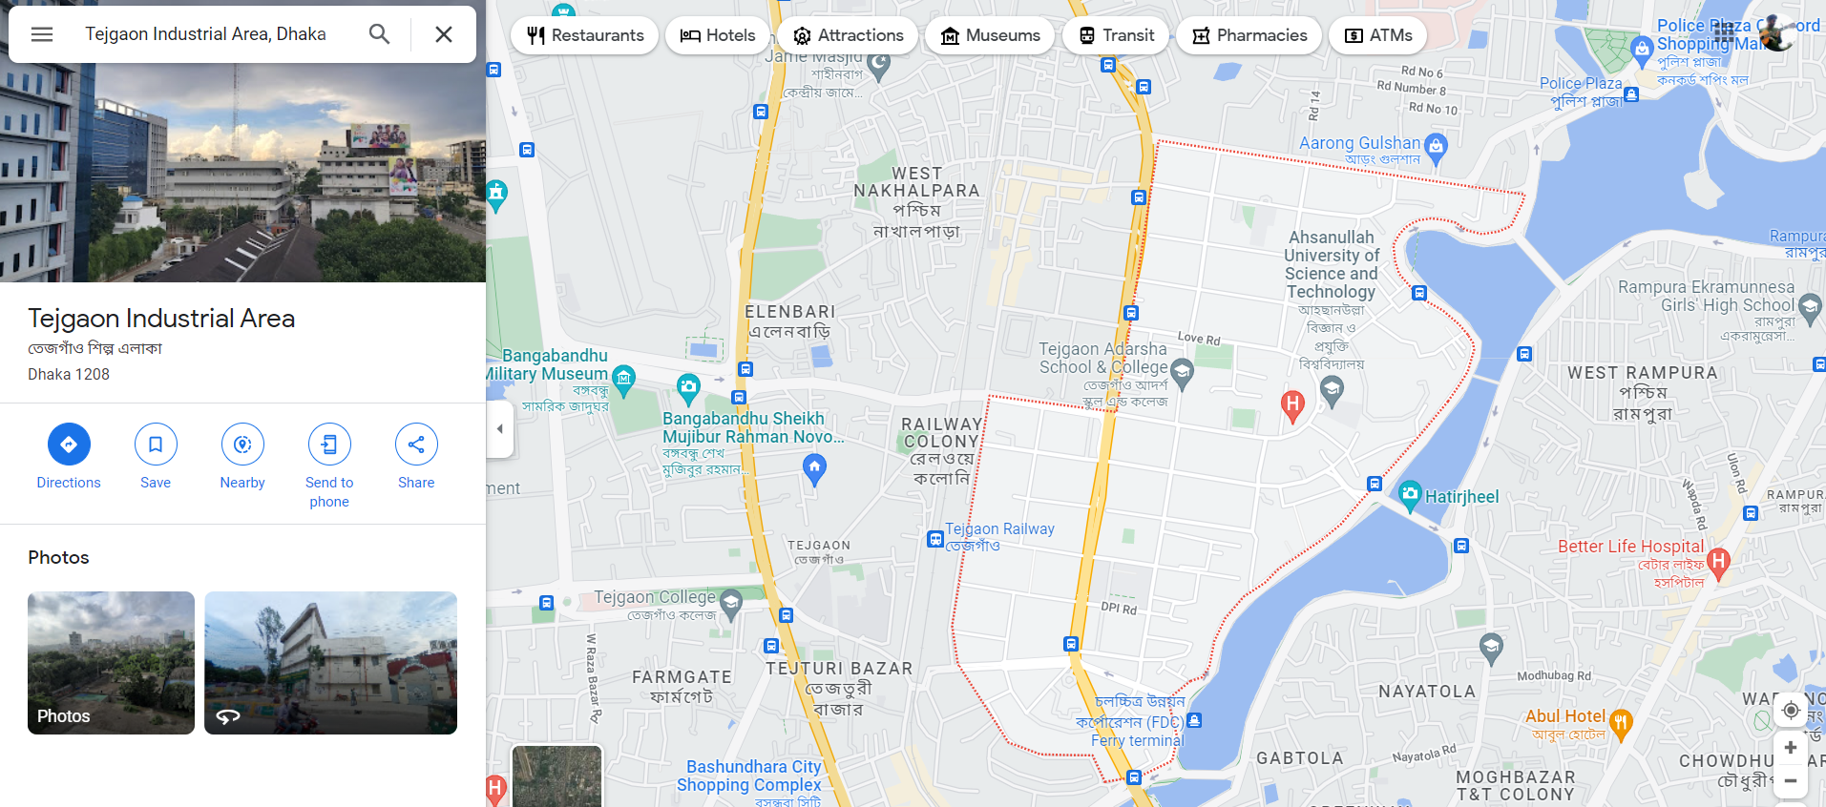
Figure 3: Tejgaon Industrial Area

Even though there were plenty of secondary data stating that the environmental quality of Farmgate was poor and the environmental quality of Bashundhara Residential Area was a lot better, determining the environmental quality of those two areas and obtaining primary data would make this study more reliable. Therefore, a survey was conducted in order to determine the environmental quality of Farmgate and Bashundhara Residential Area. This primary data helped increase the validity and credibility of area choice and findings which are explained later in this report.

3.2 Study population and data
The research topic focuses on a specific target population who are the residents of Farmgate and Bashundhara Residential Area. Since this is a quantitative study, the more responses that can be collected for both areas the better it would have been for the results of the study. However, due to certain limitations, it was decided to have 250 responses from each area separately totaling up to 500 responses collectively. While this response size does not represent the population size, it is a good number which gives a clear concept and correlation on whether or not there is a correlation between the environmental quality and mental health. The age group was preferred to be above 18 with no specific end age group. The reason for choosing this is that the respondents would have knowledge and are aware of the problems due to the environment. Furthermore, some questions in this questionnaire might have been too difficult for young children to answer. The target population was approached mostly through an online survey. They were provided with a google form link which consisted of the entire questionnaire. In order to reach a mass number of respondents, the google form link was shared in several social media groups such as Facebook. Furthermore, the link was also requested to be shared by the faculties with the students of Independent University, Bangladesh through Google Classroom. Even though students were expected to live all over Dhaka and not just specifically Farmgate and Bashundhara Residential Area, their responses were collected. However, as this research focuses only on Farmgate and Bashundhara Residential Area, responses from all other areas were discarded.

3.3 Indicators of mental health
In depth background study on this research topic has given light to the fact that there are different surveys and questionnaires that could be done in order to find the mental health status. For example, the WHO Quality of Life (WHOQOL-BREF) was created to examine domain-level profiles that evaluate quality of life (Health, 2022). Another mental health questionnaire which was used in a paper with similar research topic was The Symptom Checklist-90-R (SCL-90-R) which was designed to evaluate a broad range of psychological problems and symptoms of psychopathology. Aside from measuring the outcome of psychiatric treatments it is also used for research purposes ("Symptom Checklist 90 - Wikipedia", 2022). However, after discussing with the thesis supervisor we decided that the Short General Health Questionnaire (GHQ 12) would be the most suitable for this research. The figure below shows the set of questions in a typical GHQ 12. There are many reasons why this questionnaire was chosen. The reasons are as follows.
- It showed great reliability in other studies
- It was used in a very similar and good research paper called “Mental health and quality of residential environment”
- The mental health aspect of the survey was shared and consulted with a professor of the psychology department from East West University. The mental health questionnaire was only released to the respondents/public when I received the green signal from the professor as she said “The questionnaire part on mental health (GHQ-12) seems relevant to the topic as it is widely accepted.”
- The GHQ 12 is not too lengthy, which could affect the response rate as people do not like to spend a lot of time doing a survey, and yet contains the main proper set of questions which would provide data needed to find the correlation.

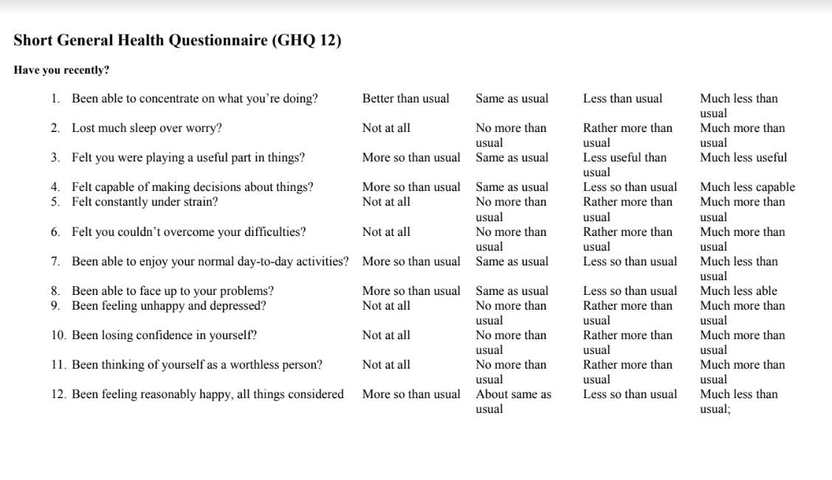
Figure 4: Short General Health Questionnaire (GHQ 12)

According to a Persian study, a sample of 300 Iranian seniors (60 and older) was chosen from areas in three Iranian cities that senior citizens were known to frequent. The GHQ-12 factor was evaluated using confirmatory factor analysis (CFA). By calculating the Spearman correlation coefficient and Cronbach's alpha, internal consistency and test-retest reliability were assessed. The 12-item General Health Questionnaire in Persian was proven to be valid and trustworthy for assessing general health in older populations who speak Persian, according to the study's findings (Namjoo et al., 2016). It was observed that the GHQ-12 exhibits appropriate reliability and validity for use in the Spanish population in a research of the internal consistency, external validity, and structure validity. The study's methodology included the administration of the instruments through voluntary participation over the course of one-hour sessions, and using the statistical tool SPSS, version 12.0 for data analysis (del P.S.L., M., & Dresch, V. (2008).

There are different types of GHQ questionnaire set. Aside from the GHQ-12, there are longer versions which consist of 28 and 30 sets of questionnaires and so, they are called GHQ-28 and GHQ-30 respectively. In a World Health organization study of psychological disorders in general health care where their objective was to compare the validity of the GHQ-12 with the GHQ-28 it was found that if investigators wish to use a screening instrument as a case detector, the shorter GHQ is remarkably robust and works as well as the longer instrument (Goldberg et al., 1997)

Finally, it was discovered that the 12-item General Health Questionnaire (GHQ-12) had a Cronbach's alpha of 0.9 in an Indian study whose aim was to examine the internal consistency, factor structure, and external validity of the GHQ-12 among older persons in India. As part of their methodology, the GHQ-12 survey was given to 9692 respondents from seven Indian states who were drawn from a community-based representative sample and were 60 years of age or older. The subjective well-being inventory (SUBI) and the GHQ-12 total score had a 0.58 correlation. In conclusion, the senior Indian population responds to the GHQ-12 with a sufficient level of confidence and reliability (Qin et al., 2018).

While the questionnaire would provide data regarding the mental health of the respondent, it would not ensure or it would fail to completely and confidently ensure that the mental health status represented is due to and only due to the environmental quality of the residential area. To ensure that the respondents exclude all other factors from mind, tiny changes in the questions were made keeping the context and the main theme of the question same, and a caption in the online survey was added which stated the following.

“This is the final part of the survey. To determine the mental health aspects, General Health Questionnaire (GHQ 12) is used in this survey. Please keep in mind about your surrounding/environment while answering the survey. Thank you!”

3.4 Indicators of environmental quality
There were multiple questionnaires to and surveys which would provide data about the environmental quality of an area. For example, a webpage called Fieldwork Studies Council provided two different sets of survey questions both of which quantitatively measure the quality of the environment. The questionnaires were titled “Urban Studies- An Environmental Quality Index” and “Environmental Quality- Area”. However, after plenty of background study, discussion and analysis, REAT 2.0 was found more appropriate for this research project. There are two reasons why this set of questionnaires was chosen. The reasons are as follows.
- It showed great reliability in several studies.
- It was used in a similar study and in a prominent research paper called “Mental health and quality of residential environment”. While the paper, Mental health and quality of residential environment, actually uses REAT 1.0, this paper uses a revised version of REAT called REAT 2.0.

The updated tool, known as REAT 2.0, was condensed from 30 to 18 questions, restructured according to four separate dimensions, and given a clear modular structure (Poortinga et al., 2016c). It now includes the four key dimensions (shown in figure 5) of
- neighborhood condition,
- natural surveillance, and
- natural elements
- and miscellaneous (urban form), which are assessed both on individual properties and at the road level.

The entire quality of the local environment is evaluated using three REAT 2.0 dimensions: neighborhood condition, natural surveillance, and natural elements. The fourth miscellaneous dimension includes a variety of urban form characteristics that are used to describe the neighborhoods being evaluated but are not directly included in the overall neighborhood quality evaluation (Jones et al., 2016).

Even though REAT 2.0 and GHQ-12 should have great reliability in other studies and other countries, these two questionnaires have never been combined into one set of questionnaires. Furthermore, changes had to be made in order to fit in the context of Dhaka, Bangladesh and this research topic. Therefore, it was very important to conduct a reliability and validity test and determine whether or not the new combined questionnaire would give reliable results. In order to find this reliability, Cronbach's alpha test was done and it showed very high reliability. The test score of Cronbach's alpha was 0.8251.

Table 1: Cronbach’s alpha test score
Item | Observations | Sign | Item-test correlation | Item-rest correlation | Average interitem covariance | alpha
Gender | 503 | - | 0.0826 | 0.0426 | 0.130734 | 0.8266
Age group | 503 | + | 0.1528 | 0.0872 | 0.129412 | 0.8272
Living status | 503 | + | 0.8763 | 0.7595 | 0.073362 | 0.8414
Living area | 503 | + | 0.8763 | 0.8667 | 0.120517 | 0.8128
Housing type | 503 | + | 0.5039 | 0.4738 | 0.125304 | 0.8194
Road type | 503 | + | 0.7356 | 0.7106 | 0.119745 | 0.8126
Road Layout | 503 | - | 0.3619 | 0.3361 | 0.128099 | 0.8225
Parked cars | 503 | - | 0.2247 | 0.1369 | 0.127317 | 0.8277
Recreational space | 503 | - | 0.6469 | 0.6232 | 0.123479 | 0.8169
Clear view of the whole street and houses | 503 | - | 0.3798 | 0.3458 | 0.126933 | 0.8216
Littered | 503 | + | 0.2776 | 0.2065 | 0.126315 | 0.8242
General condition of public spaces | 503 | + | 0.6792 | 0.6388 | 0.117313 | 0.811
Vandalism/graffiti | 503 | - | 0.6228 | 0.5687 | 0.116737 | 0.8118
Clear view of ground floor windows or doors from the stree | 503 | - | 0.4824 | 0.4517 | 0.125632 | 0.8198
Trees in front gardens | 503 | - | 0.5471 | 0.5134 | 0.123678 | 0.8177
Planted vegetation | 503 | - | 0.3227 | 0.2803 | 0.127089 | 0.8223
Properties maintained | 503 | - | 0.5158 | 0.4467 | 0.118932 | 0.816
Front gardens or spaces | 503 | - | 0.1469 | 0.0512 | 0.129692 | 0.8317
Air quality | 503 | + | 0.7438 | 0.6903 | 0.109088 | 0.8041
Water quality | 503 | + | 0.1684 | 0.0986 | 0.129025 | 0.8272
Noise quality | 503 | + | 0.4772 | 0.4206 | 0.121954 | 0.8177
Able to concentrate | 503 | - | 0.1187 | 0.0852 | 0.130351 | 0.8257
Lack of sleep | 503 | + | 0.5858 | 0.5611 | 0.124717 | 0.8184
Objective in life | 503 | - | 0.397 | 0.3637 | 0.126743 | 0.8213
Capable of making decisions | 503 | - | 0.4295 | 0.3976 | 0.126388 | 0.8208
Stress | 503 | + | 0.4908 | 0.4622 | 0.125829 | 0.82
Couldn't overcome difficulties | 503 | + | 0.4057 | 0.373 | 0.126679 | 0.8212
Enjoy normal day-to-day activities | 503 | - | 0.4583 | 0.4275 | 0.126057 | 0.8203
Tackle problems | 503 | - | 0.4543 | 0.4234 | 0.126112 | 0.8204
Feeling unhappy | 503 | + | 0.4965 | 0.467 | 0.125559 | 0.8197
Losing confidence | 503 | + | 0.418 | 0.3874 | 0.126755 | 0.8212
Feeling worthless | 503 | + | 0.3594 | 0.327 | 0.127421 | 0.8221
Feeling happy | 503 | - | 0.3916 | 0.3608 | 0.127125 | 0.8216
Test scale |  |  |  |  | 0.123336 | 0.8251

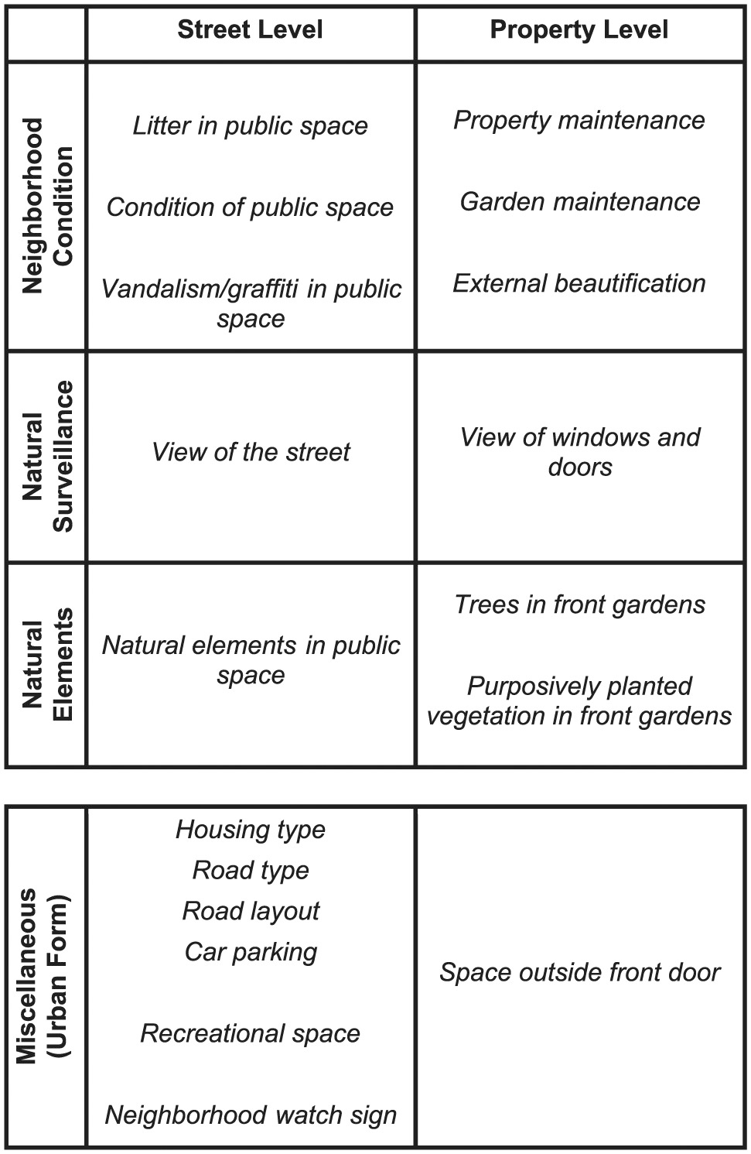
Figure 5: Structure of REAT 2.0

Depending on the goals of the project in which the instrument is utilized, different modules might be added or removed from the structure. The updated program also enables the calculation of individual component scores in addition to a neighborhood quality score overall. REAT 2.0 can be used outside of the UK as well. The modules may need to be checked, though, as some of the questions might not be as appropriate in another setting. The REAT 2.0 user also offers handbook step-by-step instructions on how to use the tool to perform an area's assessments. In addition to operational definitions, pictures of important concepts, and scoring scales to help fieldworkers assign appropriate categories, it also offers advice on managing fieldworkers and data collection procedures. It is advised that the user handbook be included in an auditor training program that includes practical fieldwork.

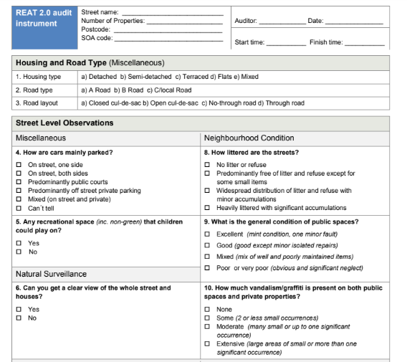
Figure 6: REAT 2.0 question-set sample

According to a study on the revised Residential Environment Assessment Tool, REAT 2.0 has high levels of inter-rater reliability. The questionnaire had high score in both Kappa coefficient and Spearman’s rank correlation of (k) ≥ 0.77 and ϱ) of ≥ 0.97 respectively. REAT 2.0 was also validated against residents’ own perceptions of the neighborhood through a neighborhood quality perceptions survey. This demonstrated the reliability and quality of the instrument's design. The REAT 2.0 tool may be used to evaluate areas that are undertaking housing improvements, whether or not planned regeneration is included. It would also be helpful to demonstrate the economic and social advantages of housing improvement work at the area level.

In a well-depth research, titled Neighborhood Quality and Attachment: Validation of the Revised Residential Environment Assessment Tool, the reliability and validity of REAT 2.0 were established. The findings of a thorough validation exercise of the REAT 2.0 were provided in this study utilizing a variety of various approaches and techniques, including comparisons with other neighborhood assessment tools, digital map analysis (DMAs), and a survey of neighborhood perceptions. According to the study, the REAT 2.0 is a valid and user-friendly tool for evaluating the general quality of neighborhood surroundings. It also discovered that indicators of neighborhood quality were easier to validate than characteristics of urban form (Poortinga et al., 2016c).

One final study which used REAT 2.0 was to assess the impact of a major housing improvement programme on the quality of the neighborhood environment in Carmarthenshire, Wales. This study remarked the use of REAT 2.0 as suitable for assessing areas undergoing housing improvements and would be useful to evidence the wider area level economic and social benefits of housing improvement work.

As mentioned by the official website “REAT | Residential Environment Assessment Tool data site” that it is also possible to use REAT 2.0 outside of the UK. However, the modules may need to be validated and modified as some of the questions could be less suitable in a different context. Therefore, several changes were made to the original REAT 2.0 questions. Some of the changes include
- adding new questions which were more relevant to the research topic and area (Dhaka, Bangladesh).
- Removing some questions which were completely irrelevant to the research topic (these findings would not aid in the research) and research area.
- Using easier terminologies so that participants answering the questions understand the words and are able to complete the survey independently online

Some other changes which were made are listed below.
- Removing and changing “a) Closed cul-de-sac b) Open cul-de-sac c) No-through road d) Through road” to “dead end” and “linear through road (open road)”
- Deleting “neighborhood watch” related question as it is irrelevant to Bangladesh
- Adding gender and age group
- Changing options of road type to main road and local road.

After the final draft of the questionnaire was set on Google Form, which includes both REAT 2.0 and GHQ-12, it was shared with a handful of people such as students from the Department of Environmental Science and Management, School of Business and Entrepreneurship, and also people with no affiliation with Independent University, Bangladesh. The responders were carefully selected keeping in mind that they do not have a preconceived notion of the study being conducted and from various backgrounds making the secondary perspective more valuable. The second perspective helped make sure the questions were written in easy to understand English. Any feedback provided was discussed with the supervisor and changes were made accordingly.

3.5 Ethical Considerations
As the following research involves the local community of the selected regions, several ethical and practical concerns were taken into consideration:
- Prior permission was taken before taking the questionnaire survey, the respondents were assured that their participation was voluntary and their identity would remain completely anonymous.
- The privacy of all the respondents were maintained, the data obtained from the survey would not be breached and would be utilized only for the sake of this research.
- To ensure full credibility, all secondary sources utilized for the comparative research have been structured and organized with references to their respective sources.

3.6 Statistical Analysis
All of the statistical analysis in this study was done using Stata version 17.0 for Windows. Statistical analysis such as simple linear regression was done to find the correlation between mental health and environmental quality. In addition, logistic regression, Pearson’s chi-square test and two sample t tests were done to find if there was a relationship between different dependent variables and independent variables or were the changes occurring due to chance.

Chapter 4 - Results & Discussion

4.1 Characteristics of sample
A total of 612 questionnaires were returned of which 109 responses were removed from the analysis as the respondents did not reside in either of the locations required in this study. The final sample size that was used in all of the analysis was 503. As per the table below, which consists of some primary information about the sample of this study, the gender gap between men and women were very small as 48.3% were females and 51.1% were males. Since the survey was shared with the help of the faculties, the major age group is seen to be 18-24 years (50.7%). There were 253 responses (50.3%) from Bashundhara R/A and 250 responses (49.7%) from Farmgate. Finally, it was also found through the survey that most of the residents (61.20%) resides in a multi-story apartment.

Table 2: Characteristics of the sample
Characteristics | Frequency (N=503) | Percent (%)
Gender
Prefer not to say | 3 | 0.6%
Female | 243 | 48.3%
Male | 257 | 51.1%
Age
18-24 yrs. | 255 | 50.7%
25-35 yrs. | 171 | 34.0%
36-45 yrs. | 53 | 10.5%
Above 45 yrs. | 23 | 4.6%
Prefer not to say | 1 | 0.2%
Respondent lives
Bashundhara Residential Area | 253 | 50.3%
Farmgate or nearby areas | 250 | 49.7%
Housing type
Multi-story apartment | 308 | 61.20%
Building with 2-4 housing units | 192 | 38.20%
Others | 3 | 0.60%

4.2 Residential Environmental Assessment Tool (REAT 2.0)
REAT 2.0 had a total of 18 questions which gave insight to a neighborhood’s condition. For example, the figure 7 below shows the response characteristic for the question “How littered are the streets?” to which majority of the Bashundhara residents replied “mostly free of litter”. However, we can see that people residing in Farmgate have a mix of both mostly free and widespread distribution of litter. This trend of response corresponds to figure 8 where majority of the Bashundhara residents have said they have a good condition of public space, but Farmgate’s majority responded to saying the “mixed” public space condition. Analyzing figure 8 and 9 gives a clearer idea about the general environmental and neighborhood quality in the two areas. According to figure 8 Bashundhara has the availability of recreational space where residents at Farmgate has responded to saying that they do not have that facility in their area. Finally, it is clearly seen from figure 10 that majority of the properties in Bashundhara R/A are maintained with minor faults whereas in Farmgate the majority responded saying the properties need repair.

Figure 7: Comparison of litter on the streets between Farmgate and Bashundhara

Figure 8: Comparison of general condition of public space

Figure 9: Comparison of the availability of recreational space

Figure 10: Maintenance of properties in Bashundhara and Farmgate

4.3 General Health Questionnaire (GHQ-12)
The mental health questionnaire has a set of 12 questions of which three findings are shown using graphs. Figure 11 represents the ability to concentrate in both areas. It was found more people (53.40%) were able to concentrate in Bashundhara R/A, and about 55.60% of the residents have responded saying they could not concentrate due to their environment. Another question from GHQ-12 was about the lack of sleep due to stress to which majority of the residents, 53.40%, in Bashundhara R/A have responded saying “no more than usual”. On the other hand, 44.00% responses (rather more than usual), the highest response in Farmgate, have said that they are unable to sleep due to stress from the environment. Furthermore, another 38.00% have chosen the option “much more than usual” meaning they were more affected. Reasoning behind these findings are explained later in this report.

Figure 11: Ability to concentrate in Bashundhara and Farmgate

Figure 12: Lack of sleep due to stress Bashundhara and Farmgate

Figure 13: Losing confidence in Bashundhara and Farmgate

4.4 Residential environment quality and general mental health quality
In order to find if there exists a relationship between the quality of the residential environment and the mental health, both chi-square tests and simple linear regression analysis were done. It was found that the environmental quality was statistically significantly associated with symptoms of common mental disorder. The results of both of the statistical analysis was same for both of the tests which was P> |t| 0.034 was found. This means that statistically there is a significant relationship between mental health and environmental quality. The positive coefficient in the coefficient column shows that as the value of the independent variable increases, the dependent variable also tends to increase. In other words, if the environmental quality degrades, mental health will be poor as well.

Table 3: Correlation between environmental quality and mental health
Env_score | Coefficient | Standard Error | t | P>t | [95% conf. | interval]
Mental_score | 0.1074654 | 0.0504802 | 2.13 | 0.034* | 0.0082864 | 0.2066444
_cons | 0.2566372 | 0.0444498 | 5.77 | 0.000 | 0.1693062 | 0.3439681
Note: * p < 0.05, ** p < 0.01, *** p < 0.001

In addition to finding a significance of the relationship between environmental quality and mental health, a correlation between the factors/variables of mental health and environmental quality was analyzed using the Strata software (table shown below). It was found that most of the variables were moderately correlated with poor environmental quality. The highest negative correlation (58.08%) was found corresponding with the ability to concentrate whereas the highest positive correlation (55.59%) corresponded with the lack of sleep due to stress.

There were six factors which had negative correlation and six positive correlation. The reason for this was the way those questions were constructed. The first question, for instance, phrased, "Have you recently been able to concentrate on what you are doing?". Since the two variables are negatively correlated, it is interpreted such that as environmental quality becomes worse, it will be harder to focus or concentrate. Therefore, they have answered no which serves as an explanation to why it is negatively correlated. The second question, "Have you recently had a lack of sleep due to stress?" found a positive correlation. Again, this indicates that deteriorating environmental quality will increase the likelihood of experiencing sleep deprivation brought on by stress, thus explaining the positive association. While the correlation between the different variables and environmental quality are not strong, there does exist a pattern in the way the questions were phrased. The six positively phrased questions and six negatively phrased questions in the GHQ-12 questionnaire. All of the six positively phrased questions such as “able to concentrate” had negative correlation and all of the six negatively phrased questions such as “had a lack of sleep due to stress” had positive correlation to poor environmental quality.

Table 4: Six positively and negatively phrased in GHQ-12
Positively phrased (Negative Correlation) | Negatively phrased (Positive Correlation)
1. Been able to concentrate on what you are doing | 2. Had a lack of sleep due to stress?
3. Felt like you do things that have purposes? | 5. Felt under constant stress?
4. Felt capable of making decisions about things? | 6. Felt you couldn’t overcome your difficulties?
7. Been able to enjoy your normal day-to-day activities? | 9. Been feeling unhappy and depressed?
8. Been able to tackle your problems? | 10. Been losing confidence in yourself?
12. Been feeling reasonably happy, all things considered | 11. Been thinking of yourself as a worthless person?

Figure 7: Six positively and negatively phrased in GHQ-12
 | env_score | Able to concentrate | Lost much sleep | Playing useful part | Capable of making decisions | Under stress | Could not overcome difficulties | Enjoy normal activities | Face up to problems | Feeling unhappy and depressed | Losing confidence | Thinking of self as worthless | Feeling reasonably happy
env_score | 1
Able to concentrate | -0.5808 | 1
Lost much sleep | 0.5559 | -0.6589 | 1
Playing useful part | -0.367 | 0.5997 | -0.4441 | 1
Capable of making decisions | -0.3744 | 0.5792 | -0.4002 | 0.6429 | 1
Under stress | 0.5319 | -0.6227 | 0.7235 | -0.4374 | -0.428 | 1
Could not overcome difficulties | 0.3728 | -0.4248 | 0.5254 | -0.3348 | -0.3692 | 0.6313 | 1
Enjoy normal activities | -0.4034 | 0.609 | -0.4573 | 0.5622 | 0.6337 | -0.4547 | -0.3606 | 1
Face up to problems | -0.3981 | 0.6112 | -0.4222 | 0.571 | 0.6381 | -0.4367 | -0.3618 | 0.6999 | 1
Feeling unhappy and depressed | 0.4979 | -0.5524 | 0.6396 | -0.4084 | -0.4112 | 0.6938 | 0.5778 | -0.4893 | -0.405 | 1
Losing confidence | 0.5475 | -0.5888 | 0.6558 | -0.4539 | -0.4501 | 0.6702 | 0.5831 | -0.4543 | -0.4358 | 0.7781 | 1
Thinking of self as worthless | 0.5123 | -0.5565 | 0.6085 | -0.4183 | -0.3957 | 0.6381 | 0.5394 | -0.4312 | -0.3923 | 0.7619 | 0.8367 | 1
Feeling reasonably happy | -0.5106 | 0.6689 | -0.5221 | 0.5514 | 0.6232 | -0.5451 | -0.3694 | 0.6377 | 0.6549 | -0.5296 | -0.556 | -0.527 | 1
Note: All numerical values in bold have negative correlation with poor environmental quality

4.5 Major environmental factors affecting mental health wellbeing
As it has been established that there is a relationship between poor environmental quality and poor mental health, it was analyzed to see which environmental factor affects mental health the most. It was found that noise, with P>z value of 0.000, had very high statistical significance with mental health. This means that noise was one of the major environmental causes to affect poor mental health among the respondents. The table 5 below shows a regression analysis between three qualities of the environment- water, air and noise, and their relationship with mental health.

Table 5: Major environmental factor responsible for negatively affecting mental health
Mental Score | Odds ratio | Standard Error | z | P>z | [95% conf. | interval]
Air quality | 1.031134 | 0.087157 | 0.36 | 0.717 | 0.8737091 | 1.216924
Water quality | 1.019341 | 0.118469 | 0.16 | 0.869 | 0.811693 | 1.280109
Noise quality | 1.63469 | 0.197669 | 4.06 | 0.000*** | 1.289755 | 2.071876
_cons | 0.439488 | 0.206256 | -1.75 | 0.080 | 0.175174 | 1.102615
Note: * p < 0.05, ** p < 0.01, *** p < 0.001

One explanation why the air quality did not show any statistical significance in the context of Dhaka, Bangladesh might be that indoor air quality tends to be cleaner than outdoor. This is because of the cars, construction work, dust and other reasons which are not present to that degree inside the house. In addition, water quality has a standard throughout the entire city as only one company, Dhaka Water Supply And Sewerage Authority, distributes water.

However, the statistically significant finding data was supported with several other studies and sources found online. The impact of noise pollution on a person's mental health, for instance, is increased if they believe they have little control over the level of noise in their area, according to a published online by Millar (2020. Noise and noise sensitivity are negatively associated with the mental health of children and adolescents, particularly in low-income groups (Lim et al., 2018). A Harvard study has found that noise pollution causes sleep disturbances; stress; mental health and cognition problems among many other physical problems (The Effects of Noise on Health, 2022). Some findings from a study by Porteous-Sebouhian (2021) showed that symptoms of noise pollution lead to poor sleep, increased stress and anxiety, lack of focus and concentration, sense of hopelessness and helplessness and even depression and exhaustion.

4.6 Mental health aspects affected by environmental quality
Statistical analysis was done between mental health and environmental quality. There seems to be a strong relationship with high significance between some of the factors of mental health from the 12 with the environmental quality. The table 6 below shows results of the analysis. The four variables or factors which were found significant are the ability to concentrate on activities (P-value 0.000), lack of sleep due to stress (P-value 0.005), losing confidence in oneself (P-value 0.032), and feeling reasonably happy (P-value 0.012).

Analyzing the coefficient column, it can be seen that the ability to concentrate (-0.118) on activities and feeling reasonably happy (-0.061) have negative coefficients which means that as the independent variable (environmental score) increases, the dependent variable tends to decrease. In other words, as the environmental quality gets worse, these two factors or variables become more prominent and take place. Findings about the impact on concentration due to the environment are consistent with the research results of another study called “Effects of environment and posture on the concentration and achievement of students in mobile learning”. In addition, the environment was found to have a significant impact on M-learning concentration in a study, and a loud and noisy atmosphere made it harder for students to focus (Yang et al., 2020). A study that discovered there is evidence in psychology to support the idea that being exposed to green, natural areas enhances mental well-being also revealed that feeling moderately happy is adversely affected by the poor environmental quality. Healthy green environment has seen to decrease stress and increase positive feelings (releasing “happy hormones” such as oxytocin), cognitive recovery, and have beneficial effects on self-regulation (Krekel & MacKerron, 2020).

On the other hand, lack of sleep due to stress (0.073) and losing confidence (0.071) in oneself has positive coefficients which means that as the environmental quality gets worse, these two factors or variables also reduce. While it is understandable why sleep disturbances can be caused due to noise, research has found that excessive noise when sleeping—whether it comes from traffic or neighbors—can reduce the quality of one's sleep, increase disturbance which results in waking up more frequently during the night, and even trigger the release of stress hormones (Pacheco & Rehman, 2022).

While it may be difficult to address why or how a person’s confidence is directly affected by the natural environment, different sources have mentioned that lack of confidence could occur indirectly and through a combination of other factors. An online article has said that spending time in nature can also help boost self-esteem or confidence because being in
green environments can increase happy hormones such as serotonin, dopamine endorphins, and oxytocin that elevate our mood and help us feel better about ourselves (Okafor, 2022).

Table 6: Mental health factor most affected by poor environmental quality
Environmental Score | Coefficient | Standard Error | t | P>t | [95% conf. | interval]
Able to concentrate | -0.11771 | 0.026678 | -4.41 | 0.000*** | -0.1701299 | -0.0653
Lost much sleep | 0.072647 | 0.025764 | 2.82 | 0.005** | 0.0220244 | 0.123269
Playing useful part | 0.026913 | 0.027548 | 0.98 | 0.329 | -0.0272129 | 0.081039
Capable of making decisions | 0.00597 | 0.029683 | 0.2 | 0.841 | -0.0523525 | 0.064292
Under stress | 0.039304 | 0.027084 | 1.45 | 0.147 | -0.01391 | 0.092519
Could not overcome difficulties | -0.01163 | 0.023875 | -0.49 | 0.626 | -0.0585371 | 0.035284
Enjoy normal activities | 0.004247 | 0.029844 | 0.14 | 0.887 | -0.0543909 | 0.062885
Face up to problems | -0.00356 | 0.02924 | -0.12 | 0.903 | -0.0610132 | 0.053891
Feeling unhappy and depressed | -0.00021 | 0.030328 | -0.01 | 0.995 | -0.0597937 | 0.059382
Losing confidence | 0.070685 | 0.032899 | 2.15 | 0.032* | 0.0060451 | 0.135325
Thinking of self as worthless | 0.026136 | 0.030826 | 0.85 | 0.397 | -0.0344313 | 0.086703
Feeling reasonably happy | -0.06073 | 0.024024 | -2.53 | 0.012* | -0.1079363 | -0.01353
_cons | 0.242729 | 0.076998 | 3.15 | 0.002 | 0.0914428 | 0.394016
Note: * p < 0.05, ** p < 0.01, *** p < 0.001

Chapter 5 - Limitations of the study
Every research has its limitations and it is important to acknowledge them so that people can learn from the limitations and make sure to take those into consideration for further research projects. The limitations of this study are listed below.
- Due to lack of funding, manpower, and time, adequate face to face interviews and surveys could not be conducted which might have allowed better quality surveys.
- Online surveys can also lose value as people may put random answers in the form contaminating the results.
- Studying and analyzing more areas would give more reliable and accurate results for comparison.
- More responses from both of the areas would have given more reliable results

Chapter 6 - Conclusion
According to some prominent research, it has been found that environment does affect mental health. This study was successful in achieving all of the research objectives. The findings of this study have shown that there is a strong significance (P >|t| 0.034) between poor environmental quality and mental health. It also goes further and shows the different aspects of mental health that are affected most due to poor environmental quality which are the ability to concentrate on activities, lack of sleep due to stress, losing confidence in oneself, and feeling reasonably happy, and the component of environmental quality that affects mental health the most which is noise. All of the mental health components were found to show mild correlation both positively and negatively. Therefore, it is important that more research in this topic should be carried and solution needs to be studied as well as applied practically to tackle this issue.

References
- Alam, D. (2019). The dark side of Dhaka’s urbanisation. The Daily Star. Retrieved September 26, 2022, from
https://www.thedailystar.net/supplements/28th-anniversary-supplements/avoiding-urban-nightmare-time-get-planning-right/news/the-dark-side-dhakas-urbanisation-1703425
- Bangladesh: A country of natural beauty. (n.d.). Retrieved September 12, 2022, from http://www.cs.loyola.edu/%7Eraunak/homeland.html
- Causes of Mental Illness. (2003, February 7). WebMD. Retrieved October 3, 2022, from https://www.webmd.com/mental-health/mental-health-causes-mental-illness#:%7E:text=Mental%20illness%20itself%20occurs%20from,an%20inherited%20susceptibility%20to%20it.
- Clayton, S. (2020). Climate anxiety: Psychological responses to climate change. Journal of anxiety disorders, 74, 102263.
- del Pilar Sánchez-López, M., & Dresch, V. (2008). The 12-Item General Health Questionnaire (GHQ-12): reliability, external validity and factor structure in the Spanish population. Psicothema, 20(4), 839-843.
- Dhaka, Bangladesh Metro Area Population 1950-2022. (n.d.). MacroTrends. Retrieved September 12, 2022, from
https://www.macrotrends.net/cities/20119/dhaka/population#:%7E:text=The%20current%20metro%20area%20population,a%203.56%25%20increase%20from%202019.
- Engemann, K., Pedersen, C. B., Arge, L., Tsirogiannis, C., Mortensen, P. B., & Svenning, J. C. (2019). Residential green space in childhood is associated with lower risk of psychiatric disorders from adolescence into adulthood. Proceedings of the national academy of sciences, 116(11), 5188-5193.
- Evans, G. W. (2003). The built environment and mental health. Journal of urban health, 80(4), 536-555.
- Even Small Spikes in Air Pollution Can Threaten Children’s Mental Health, Research Suggests. (2021, December 8). EcoWatch. Retrieved October 8, 2022, from https://www.ecowatch.com/air-pollution-childrens-mental-health-2640650546.html
- Filipova, T., Kopsieker, L., Gerritsen, E., Bodin, E., Brzezinski, B., & Ramirez-Rubio, O. (2020). Mental Health and the Environment: How European Policies Can Better Reflect the Impact of Environmental Degradation on People’s Mental Health and Well-Being. Barcelona: European Environmental Policy (IEEP) & Barcelona Institute for Global Health (ISGlobal).
- Goldberg, D. P., Gater, R., Sartorius, N., Ustun, T. B., Piccinelli, M., Gureje, O., & Rutter, C. (1997). The validity of two versions of the GHQ in the WHO study of mental illness in general health care. Psychological medicine, 27(1), 191-197.
- Hasan, M. R. (2022, January 27). Urban planning in Bangladesh: Challenges and opportunities. The Business Standard. Retrieved September 12, 2022, from https://www.tbsnews.net/supplement/urban-planning-bangladesh-challenges-and-opportunities-362911
- Health, G. (2022). Quality of Life | WHOQOL-BREF - Greenspace Mental Health Knowledge Base. Retrieved 26 September 2022, from https://help.greenspacehealth.com/article/105-quality-of-life-whoqol-bref
- Helbich M. (2018). Mental Health and Environmental Exposures: An Editorial. International journal of environmental research and public health, 15(10), 2207. https://doi.org/10.3390/ijerph15102207
- Krekel, C., & MacKerron, G. (2020). How Environmental Quality Affects Our Happiness | The World Happiness Report. World Happiness Report. Retrieved December 12, 2022, from https://worldhappiness.report/ed/2020/how-environmental-quality-affects-our-happiness/
- International Environmental Law: History and milestones. (2020, March 29). Interamerican Association for Environmental Defense (AIDA). Retrieved September 12, 2022, from https://aida-americas.org/en/blog/international-environmental-law-history-and-milestones
- Jones, N., Poortinga, W., Lannon, S. C., & Calve, T. (2016). The effect of a housing intervention on the quality of the neighbourhood environment.
- Lindberg, S. (2022). How Your Environment Affects Your Mental Health. Retrieved 2 October 2022, from
https://www.verywellmind.com/how-your-environment-affects-your-mental-health-5093687
- Lim, J., Kweon, K., Kim, H. W., Cho, S. W., Park, J., & Sim, C. S. (2018). Negative impact of noise and noise sensitivity on mental health in childhood. Noise & health, 20(96), 199–211. https://doi.org/10.4103/nah.NAH_9_18
- Millar, H. (2020, December 22). What are the health effects of noise pollution? Medical News Today. Retrieved December 13, 2022, from https://www.medicalnewstoday.com/articles/noise-pollution-health-effects
- Namjoo, S., Shaghaghi, A., Sarbaksh, P., Allahverdipour, H., & Pakpour, A. H. (2017). Psychometric properties of the General Health Questionnaire (GHQ-12) to
be applied for the Iranian elder population. Aging & mental health, 21(10), 1047-1051.
- Okafor, J. (2022, October 24). How Nature Benefits Mental Health. TRVST. Retrieved December 12, 2022, from https://www.trvst.world/mind-body/how-nature-benefits-mental-health/
- Pacheco, D., & Rehman, Dr. A. (2022). The Bedroom Environment. Sleep Foundation. Retrieved December 12, 2022, from https://worldsleepday.org/environmental-sleep-factors
- Poortinga, W., Calve, T., Jones, N., Lannon, S., Rees, T., Rodgers, S. E., ... & Johnson, R. (2017). Neighborhood quality and attachment: Validation of the revised residential environment assessment tool. Environment and behavior, 49(3), 255-282.
- Porteous-Sebouhian, B. (2021). Can noise pollution effect our mental health? Mental Health Today (MHT). Retrieved December 13, 2022, from https://www.mentalhealthtoday.co.uk/innovations/can-noise-pollution-affect-our-mental-health
- Posh Areas In Dhaka. (2021). Assure Group. Retrieved September 26, 2022, from https://www.assuregroupbd.com/media/blog/best-residential-area-to-stay-in-dhaka
- Qin, M., Vlachantoni, A., Evandrou, M., & Falkingham, J. (2018). General Health Questionnaire-12 reliability, factor structure, and external validity among older adults in India. Indian Journal of Psychiatry, 60(1), 56.
- Rahaman, M. (2022). Unplanned urbanisation and sustainable housing. Retrieved 1 October 2022, from
https://www.newagebd.net/article/163203/unplanned-urbanisation-and-sustainable-housing#:~:text=Due%20to%20unplanned%20urbanisation%2C%20our,accommodate%20the%20city's%20large%20population.
- REAT Audit Tool | Data Site. (n.d.). https://reat.cardiff.ac.uk/
- Reuben, A., Manczak, E. M., Cabrera, L. Y., Alegria, M., Bucher, M. L., Freeman, E. C., ... & Perry, M. J. (2022). The Interplay of Environmental Exposures and Mental Health: Setting an Agenda. Environmental health perspectives, 130(2), 025001.
- Roberts, S., Arseneault, L., Barratt, B., Beevers, S., Danese, A., Odgers, C. L., ... & Fisher, H. L. (2019). Exploration of NO2 and PM2. 5 air pollution and mental health problems using high-resolution data in London-based children from a UK longitudinal cohort study. Psychiatry research, 272, 8-17.
- Rodgers SE, Bailey R, Johnson R, et al. Health impact, and economic value, of meeting housing quality standards: a retrospective longitudinal data linkage study. Southampton (UK): NIHR Journals Library; 2018 Jun. (Public Health Research, No. 6.8.) Appendix 3, The revised Residential Environment Assessment Tool. Available from: https://www.ncbi.nlm.nih.gov/books/NBK508019/
- Statista. (2022, August 5). Cities with the highest population density globally 2022. Retrieved September 12, 2022, from
https://www.statista.com/statistics/1237290/cities-highest-population-density/#:%7E:text=Dhaka%20(Bangladesh)%20led%20the%20ranking,30%2C093%20residents%20per%20square%20kilometer.
- Symptom Checklist 90 - Wikipedia. (2022). Retrieved 26 September 2022, from https://en.wikipedia.org/wiki/Symptom_Checklist_90
- The Effects of Noise on Health. (2022). Harvard Medicine Magazine. Retrieved December 13, 2022, from
https://hms.harvard.edu/magazine/viral-world/effects-noise-health
- Thomas, H., Weaver, N., Patterson, J., Jones, P., Bell, T., Playle, R., ... & Araya, R. (2007). Mental health and quality of residential environment. The British Journal of Psychiatry, 191(6), 500-505.
- United Nations Environment Programme. (n.d.). Caring for the environment helps to care for your mental health. UNEP. Retrieved October 3, 2022, from https://www.unep.org/news-and-stories/story/caring-environment-helps-care-your-mental-health
- Yang, X., Zhao, X., Tian, X., & Xing, B. (2021). Effects of environment and posture on the concentration and achievement of students in mobile learning. Interactive Learning Environments, 29(3), 400-413.

