Supporting Materials
for

Comparative Efficacy of Citric acid/Tartaric acid/Malic acid Additive based Polyvinyl alcohol-Starch Composite Films

Aritra Das¹, Muktashree Saha², Manish Kumar Gupta², Latha Rangan², Ramagopal Uppaluri¹* and Chandan Das¹*
¹Department of Chemical Engineering, Indian Institute of Technology Guwahati, Assam, India, PIN 781039
²Department of Biosciences and Bioengineering, Indian Institute of Technology Guwahati, Assam, India, PIN 781039

*Correspondence to: Email: cdas@iitg.ac.in (C. Das), ramgopalu@iitg.ac.in (V.S.R.G. Uppaluri)
Phone: +91 361 258 2268/2260;
Fax: +91 361 258 2291

Table captions
Table No | Title
Table S1 | Influence of CA, TA and MA on the degree of crosslinking of organic acid based PVA-St composite films

Figure captions
Figure No | Title
Figure S1 | Influence of CA, TA and MA on the (a) solubility and (b) gel fraction characteristics of organic acid based PVA-St composite films.
Figure S2 | Photographs depicting antibacterial activity of organic acid based PVA-St composite films with respect to E. coli and (a) TA and (b) MA additives.
Figure S3 | Photographs depicting antibacterial activity of organic acid based PVA-St composite films with respect to L. monoocytogenes and (a) TA and (b) MA additives.

Table S1: Influence of CA, TA and MA on the degree of crosslinking of organic acid based PVA-St composite films
Formulation | Organic acid | Absorbance values of CO bands | Absorbance values of OH bands | Degree of crosslinking
EXP-%E | CA | 0.0806 | 0.1278 | 0.6308
EXP-%E | TA | 0.0917 | 0.241 | 0.3806
EXP-%E | MA | 0.1017 | 0.2175 | 0.4675
EXP+%E | CA | 0.1425 | 0.2022 | 0.7048
EXP+%E | TA | 0.1224 | 0.2241 | 0.5462
EXP+%E | MA | 0.1298 | 0.2203 | 0.5894
RSM-%E | CA | 0.1159 | 0.2286 | 0.5071
RSM-%E | TA | 0.1227 | 0.2192 | 0.56
RSM-%E | MA | 0.1253 | 0.212 | 0.591
RSM+%E | CA | 0.1449 | 0.2082 | 0.6961
RSM+%E | TA | 0.1428 | 0.2099 | 0.6804
RSM+%E | MA | 0.1501 | 0.2075 | 0.7232

Solubility and gel fraction characteristics
The solubility and GF characteristics of the organic acid based PVA composite film samples were determined using the same procedures outlined in our previous article (Das et al., 2019). Thereby solubility and GF were calculated using the expressions;
% | (1)
% | (2)
where represents the first dry weight of the hydrogel samples and represents the weight of the hydrogel samples measured after 37 ˚C drying of DI water-soaked samples.

Solubility and gel fraction measurements
Figure S1 (a) and (b) respectively depicted the PVA-St composite film solubility and GF trends with respect to variations in organic acid (CA, TA and MA) concentrations for four different case films being designated as EXP-%E, EXP+%E, RSM-%E and RSM+%E. It can be analysed, for the optimized PVA-St composite films and corresponding constituent concentration, the solubility characteristics varied as 66.01 ± 4.47 to 75.88 ± 4.34, 51.81 ± 2.25 to 74.88 ± 0.41 and 61.59 ± 1.21 to 82.72 ± 2.28 %, respectively, for CA, TA and MA. The corresponding variation in GF trends have been as 24.12 to 66.11, 25.12 to 48.19 and 17.28 to 38.41 % for CA, TA and MA based films respectively. To portray upon the enhancement or detrimental trends of solubility or GF with respect to the organic acid concentrations, the obtained trends have been inconclusive. This was possibly due to the intermolecular reaction between the polymer (PVA and St) and the additives (Gl and CA/TA/MA organic acid). However, among all organic acids, the MA based PVA-St composite film exhibited versatile solubility range data and indicates likely promising performance upon further exploration. The RSM-%E (5.46 w/w% PVA, 8.09 w/w% St, 22.77 wt% CA/TA/MA and 22.69 wt% Gl) formulations, where St concentration was again higher than PVA concentration in the film matrix (significant low solubility with p-value ≤0.05 in comparison to CA, with p-value ≤0.001 in comparison to MA). This may possibly due to the effective bonding of TA with St but not the PVA to thereby indicate lowest solubility of the TA based PVA-St composite film. For the RSM+%E (7.45 w/w% PVA, 6.96 w/w% St, 28.57 wt% CA/TA/MA and 18.38 wt% Gl) case, the CA based film possessed highest solubility or lowest GF (with a significance level of p ≤0.01, in comparison to both TA and MA). This was possibly due to its comparatively improvised plasticization characteristics that are being facilitated with the larger number of free –COOH groups in the matrix or blend at higher CA concentrations (Shi et al., 2008).
Figure S1: Influence of CA, TA and MA on the (a) solubility and (b) gel fraction characteristics of organic acid based PVA-St composite films.

Antibacterial effectiveness of PVA-St blend films
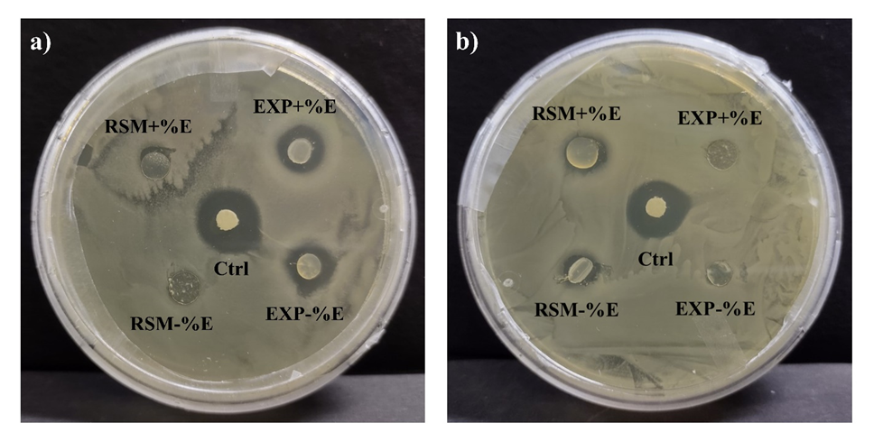
Figure S2: Photographs depicting antibacterial activity of organic acid based PVA-St composite films with respect to E. coli and (a) TA and (b) MA additives.
Figure S3: Photographs depicting antibacterial activity of organic acid based PVA-St composite films with respect to L. monoocytogenes and (a) TA and (b) MA additives.

