Development of a Loop-Mediated Isothermal Amplification Technique for Sex Detection in Cervidae Species
Journal name: Mammalian Biology
Author names: Orsolya Zorkóczyª, Adrienn Gyurcsó^{b}, László Ózsvári^{b}, Pál Lehotzky^{c}, Raveendranathanpillai Sanil^{d}, Petra Zenkeª*
ª Department of Animal Breeding and Genetics, University of Veterinary Medicine Budapest, Budapest, Hungary;
^{b} Department of Veterinary Forensics and Economics, University of Veterinary Medicine Budapest, Budapest, Hungary;
^{c} Hungarian Hunting National Chamber, Budapest, Hungary;
^{d} Molecular Biodiversity Lab, Department of Zoology, Government Arts College, Udhagmandalam 643002, The Nilgiris, Tamilnadu, India
*Corresponding author: Dr. Petra Zenke, Email: zenke.petra@univet.hu

Table S1. Available sequences of the sex-determining region Y (SRY) and Amelogenin X (AmelX) genes of the three targeted deer species (downloaded from the NCBI GenBank database) to identify conservative regions of similarity.

Marker/Species | Red deer | Fallow deer | Roe deer
AmelX | FJ946989.1  KJ542362.1  XM_043895580.1 | KJ542361.1 | KJ542360.1
SRY | DQ888692.1  GQ272385.1  GQ272386.1  EF100133.1  AY244497.1  AY244499.1  EF062527.1 | DQ888701.1 | DQ888700.1  EU402954.1  HG326979.1  KJ558346.1  MW800126.1

Table S2: Sequence homologies in different cervids in comparison with the corresponding gene segments of red deer (KJ542362 for AmelX and DQ888692 for SRY). n.d.: no data available in GenBank
Species | SRY homology (%) | AmelX homology (%)
Elk (Cervus canadensis) | 98.99-100 | 94.3-100
Texas white-tailed deer (Odocoileus virginianus texanus) | 97.46 | 99.48
Reindeer (Rangifer tarandus) | 97.97 | 93.26-99.48
Moose (Alces alces) | 98.99 | 93.2-99.45
Sika deer (Cervus nippon) | 100 | 93.75
Sangai (Rucervus eldii) | 99.49-100 | n.d.
Thorold’s deer (Cervus albirostris) | 100 | n.d.
Sambar deer (Rusa unicolor) | 99.49 | n.d.
Central Asian red deer (Cervus hanglu) | 99.49 | n.d.
Père David's deer (Elaphurus davidianus) | 99.49 | n.d.
Indian hog deer (Axis porcinus) | 99.49 | n.d.
Reeves's muntjac (Muntiacus reevesi) | 98.48 | n.d.
Hairy-fronted muntjac (Muntiacus crinifrons) | 98.48 | n.d.
Tufted deer (Elaphodus cephalophus) | 98.48 | n.d.
Mule deer (Odocoileus hemionus) | 97.46 | n.d.

Fig. S1. The optimization of different reaction times (♀: female sample, ♂: male sample, +: true positive, -: true negative, RC: reagent control).
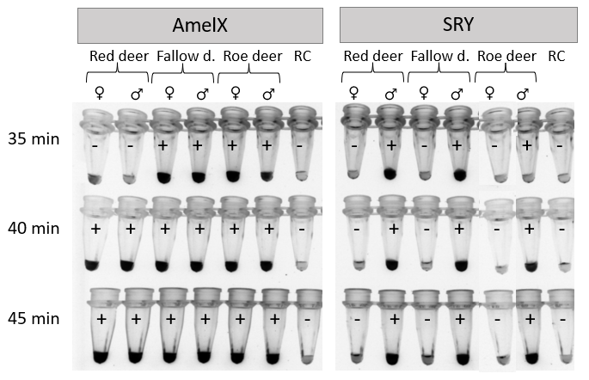
Fig. S2. Sensitivity of LAMP reactions using 1.0, 0.5, 0.25, 0.125, and 0.062 ng DNA (♀: female sample, ♂: male sample, +: true positive, -: true negative, RC: reagent control).
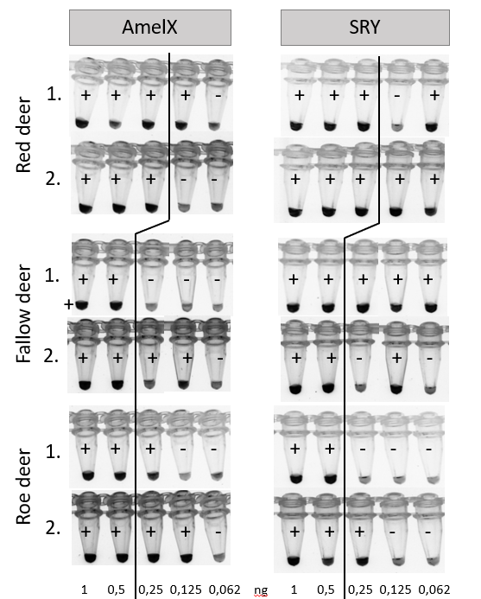

Fig. S3. Species specificity (♀: female sample, ♂: male sample, +: true positive, -: true negative).
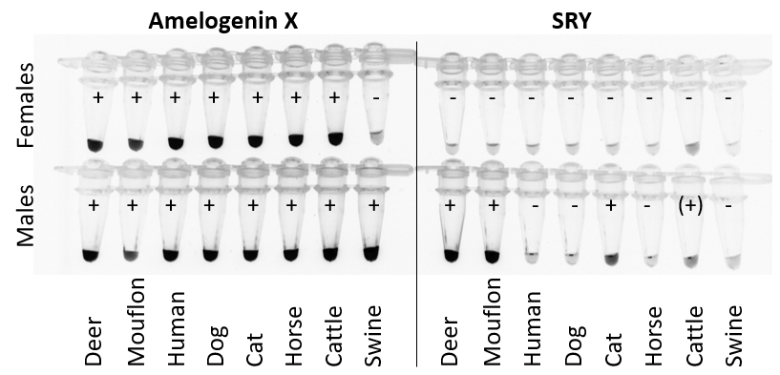

Fig. S4. Conventional PCR-based (A, ref: Zenke et al. 2022) and LAMP test (B) results for sex detection of three deer species from India. Sp: Spotted deer, Sa: Sambar deer, Ba: Barking deer, Fa: Fallow deer as a positive control, RC: reagent control, ♀: female sample, ♂: male sample, ?: samples with low DNA content and unclear results, -: no PCR product)
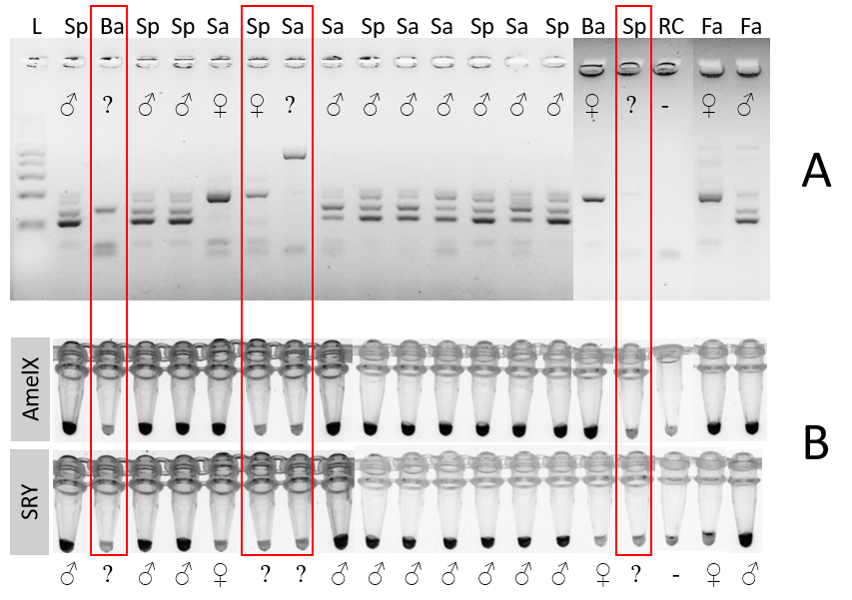

Reference
Zenke P, Zorkóczy OK, Lehotzky P, Ózsvári L, Pádár Z. 2022. Molecular sexing and species detection of antlered European hunting game for forensic purposes. Animals. 12(3):246.

