Supporting information for

The Role of miR-92b-3p in the Notch Signaling and Monitoring of Oral Squamous Cell Carcinoma

Yudan Piao¹, Seung-Nam Jung², Mi Ae Lim², Sicong Zheng¹, Chan Oh¹, Yan Li Jin¹, Shan Shen¹, Quoc Khanh Nguyen¹, Se-Hee Park¹, Young il Kim³, Jae Won Chang^{1,2}, Ho-Ryun Won^{1,2*,} Bon Seok Koo^{1,2*}

¹Department of Medical Science, Chungnam National University College of Medicine, Daejeon, Republic of Korea
²Department of Otolaryngology-Head and Neck Surgery, Chungnam National University College of Medicine, Daejeon, Republic of Korea
³Radiation Oncology, Chungnam National University Sejong Hospital, Daejeon, Republic of Korea.

* These authors contributed equally to this work as corresponding authors.

Correspondence Authors:
Bon Seok Koo MD, PhD.
Professor, Department of Otolaryngology-Head and Neck Surgery,
Chungnam National University College of Medicine,
266, Munhwa-ro, Jung-gu, Daejeon, 35015, Republic of Korea
Tel: +82-42-280-7690 Fax: +82-42-253-4059
E-mail: bskoo515@cnuh.co.kr

Ho-Ryun Won MD, PhD.
Professor, Department of Otolaryngology-Head and Neck Surgery,
Chungnam National University College of Medicine,
Chungnam National University Sejong Hospital
20, Bodeum 7-ro, Sejong, 30099, Republic of Korea
Tel: +82-44-995-4756 Fax: +82-44-995-5099
E-mail: hryun83@cnuh.co.kr

FIGURE S1

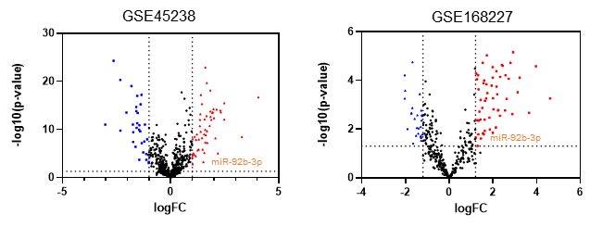

Volcano plots show that many miRNAs had significantly different expression levels between normal and OSCC patients. Red: up-regulation with a fold change of more than 2; blue: down-regulation with a fold change of more than −2 (p<0.05).

FIGURE S2
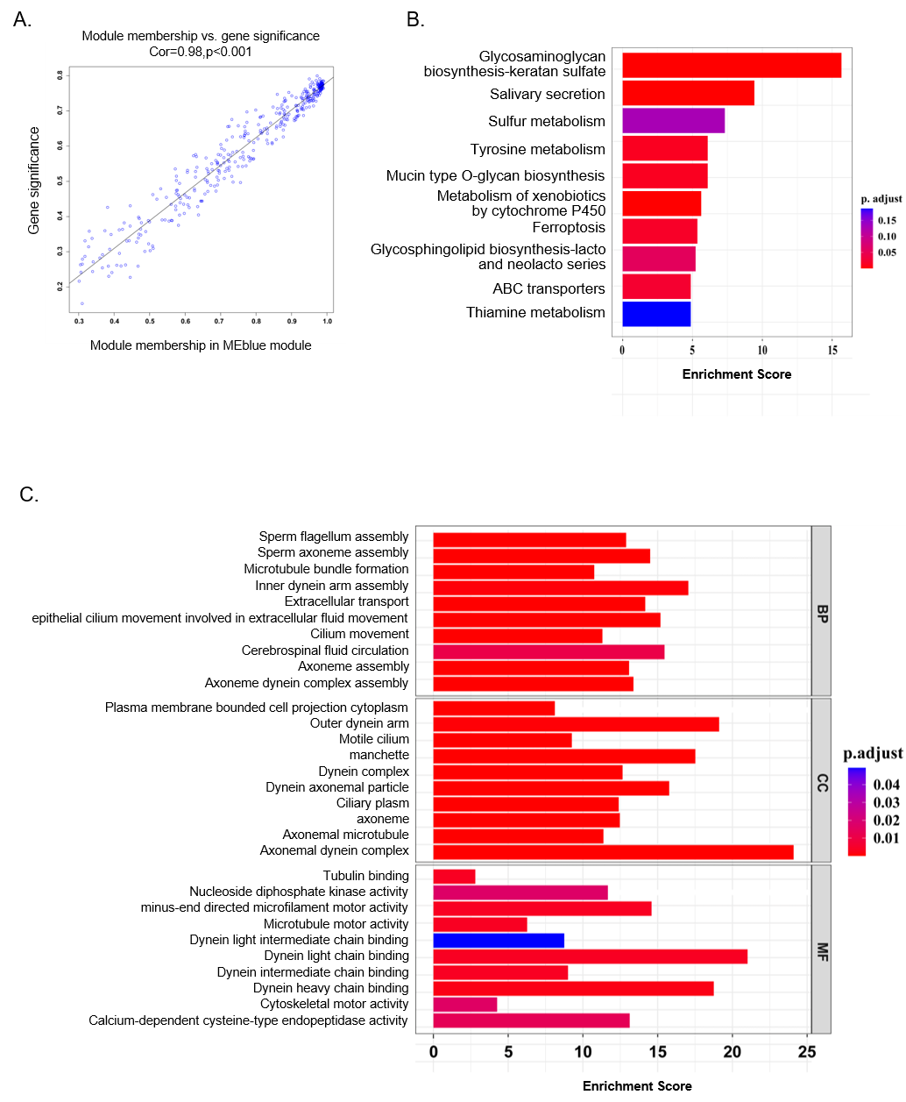

A. Scatter plots of correlations between genes in the “blue” module and the phenotype correlation of the genotype. KEGG(B) and GO (C) enrichment analyses of DEGs in the “blue” module.
FIGURE S3
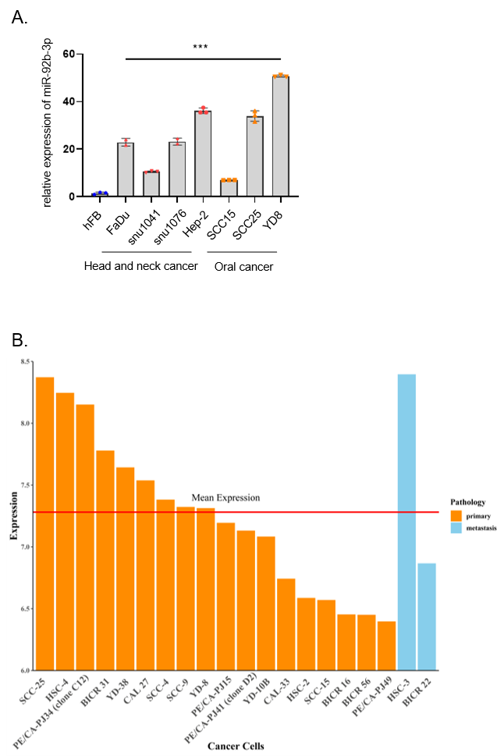

A. Comparison of miR-92b-3p expression levels in head and neck cancer cell lines to normal epithelial cells using qPCR. B. The histogram represents the expression level of miR-92b-3p in all the oral cancer cell lines, and the red solid line represents the mean expression of miR-92b-3p.
FIGURE S4
A. YD8 and SCC25 cell lines were transfected with miR-92b-3p mimic, inhibitor, or negative control, and cell proliferation was measured by WST-1 assay. B. Colony formation assays in OSCC cells transfected with miR-92b-3p mimic, inhibitor or negative control. Transwell assays measured the effect of miR-92b-3p on OSCC cell migration (C) and invasion (D). All n=3; bar, SEM; *p< 0.05; **p<0.01; ***p<0.001; Student’s test.
FIGURE S5
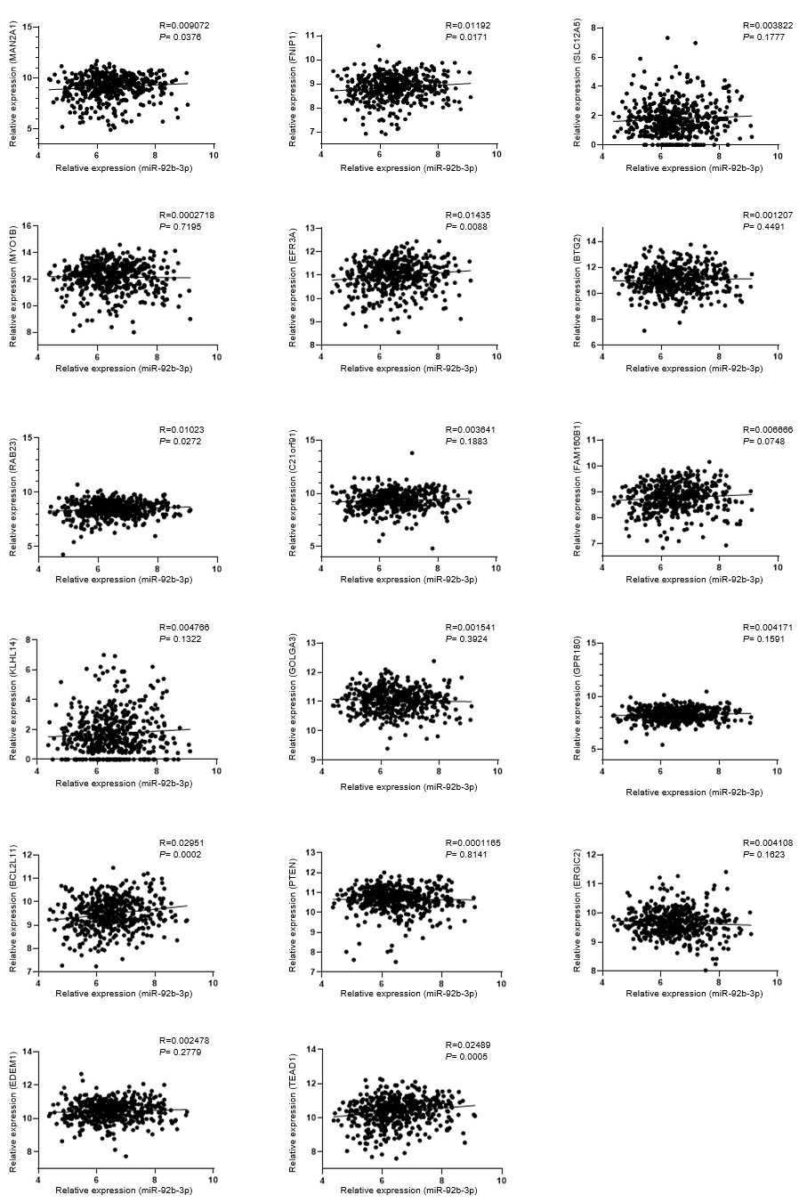
Spearman correlation analysis was used to analyze the association between miR-92b-3p levels and potential target genes in The Cancer Genome Atlas oral squamous cell carcinoma (OSCC) cohort.
FIGURE S6
A. B.
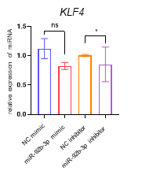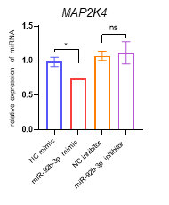
C. D.
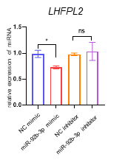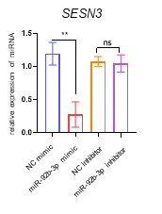
Quantitative polymerase chain reaction analysis of potential target gene expression levels in OSCC cells transfected with miR-92b-3p mimic, inhibitor, or negative control.

FIGURE S7
A. SCC25 and YD8 cell lines were transfected with ATXN1 or CPEB3 overexpression vector or negative control, cell proliferation was measured by WST-1 assay. B. Colony formation assay of SCC25 and YD8 cell lines were transfected with ATXN1 or CPEB3 overexpression vector or negative control. C. Transwell assays were used to assess the migration and invasion ability of OSCC cells transfected with ATXN1 or CPEB3 overexpression vector or negative control.
FIGURE S8
A
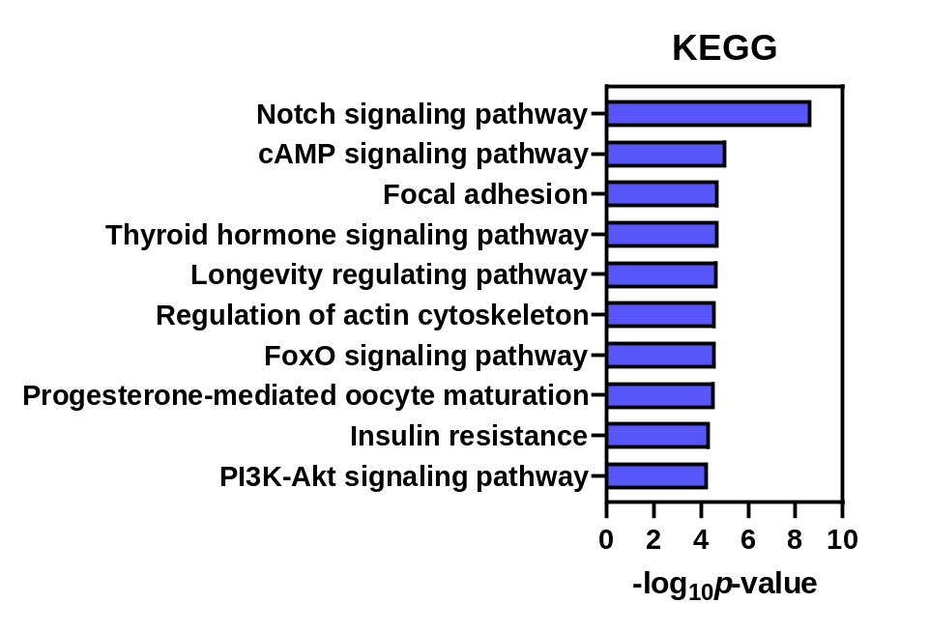
B
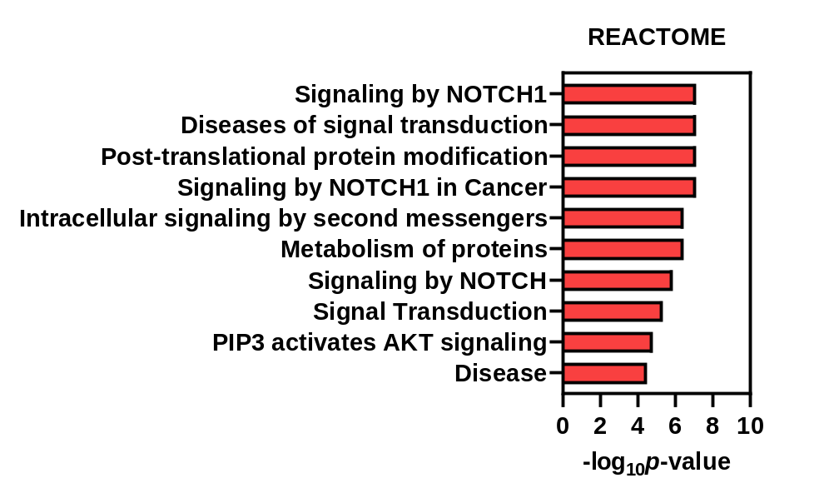
- B. All target genes with scores >0.9 for miR-92b-3p, as determined by TargetScan, were evaluated using the online tool David (https://david.ncifcrf.gov/). The bar graph displays KEGG, REACTOME (A), and Gene Ontology enrichment analyses (B).

FIGURE S9
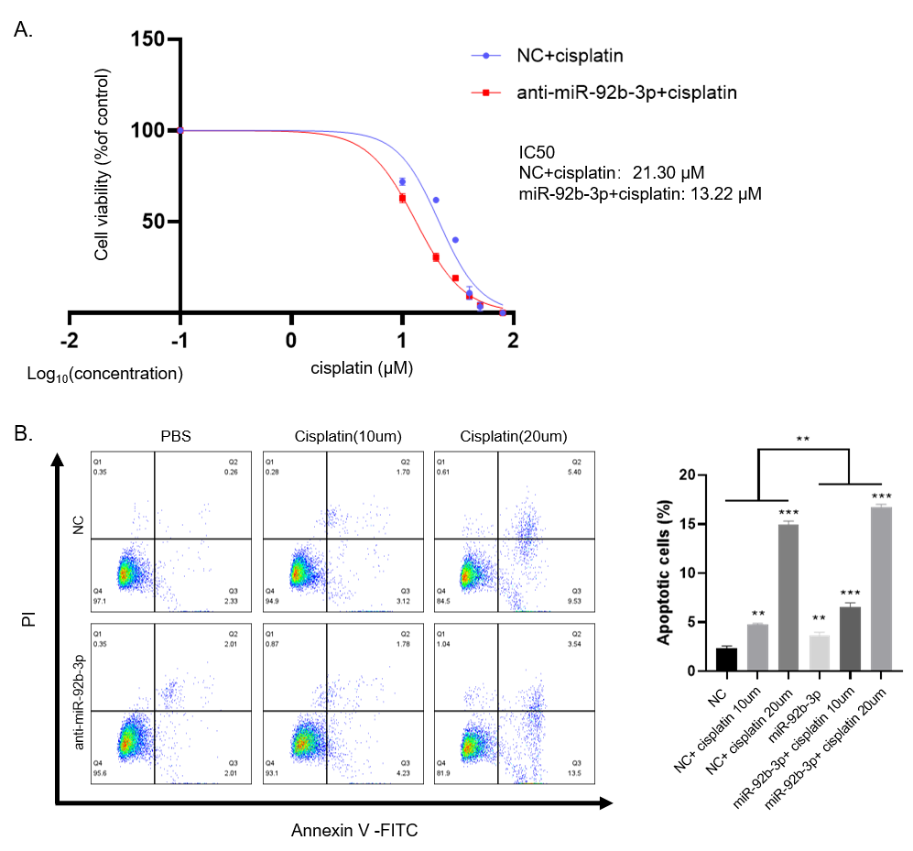

A. SCC25 cells lines were transfected with miR-92b-3p inhibitor or the negative control counterpart, and treated with gradient concentrations of cisplatin for 48 hours. Subsequently, cell survival curves and IC50 values for multiple cisplatin concentrations were determined using the WST-1 assay. All experiments were independently repeated three or more times, and values are presented as mean ± standard deviation. * p< 0.05, ** p< 0.01, *** p< 0.001. B. Flow cytometry was conducted to assess the apoptotic rate of SCC25 cells. Apoptosis was detected using an annexin-V apoptosis detection kit.
FIGURE S10

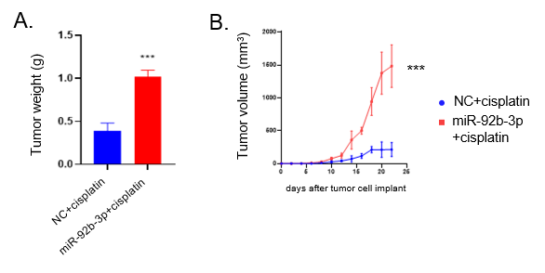

A-B. Tumor weight and volume changes after SCC25 cells with stable miR-92b-3p expression or negative control were injected into nude mice. Each group, n=5.

FIGURE S11
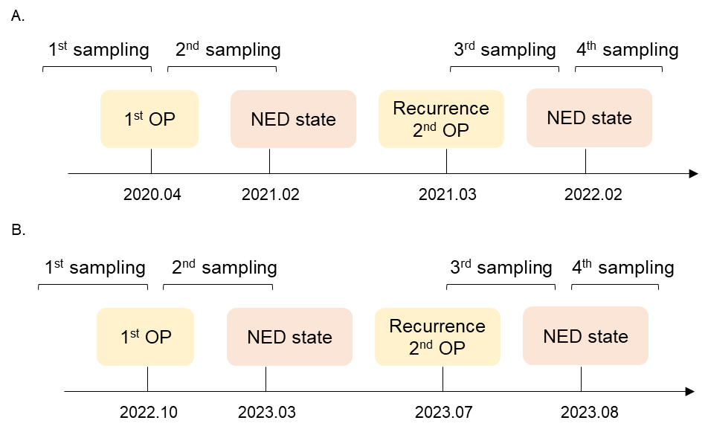

The clinical course of recurrent patients [case1(A) and case2(B)] with OSCC in CNUH cohort.

FIGURE S12.

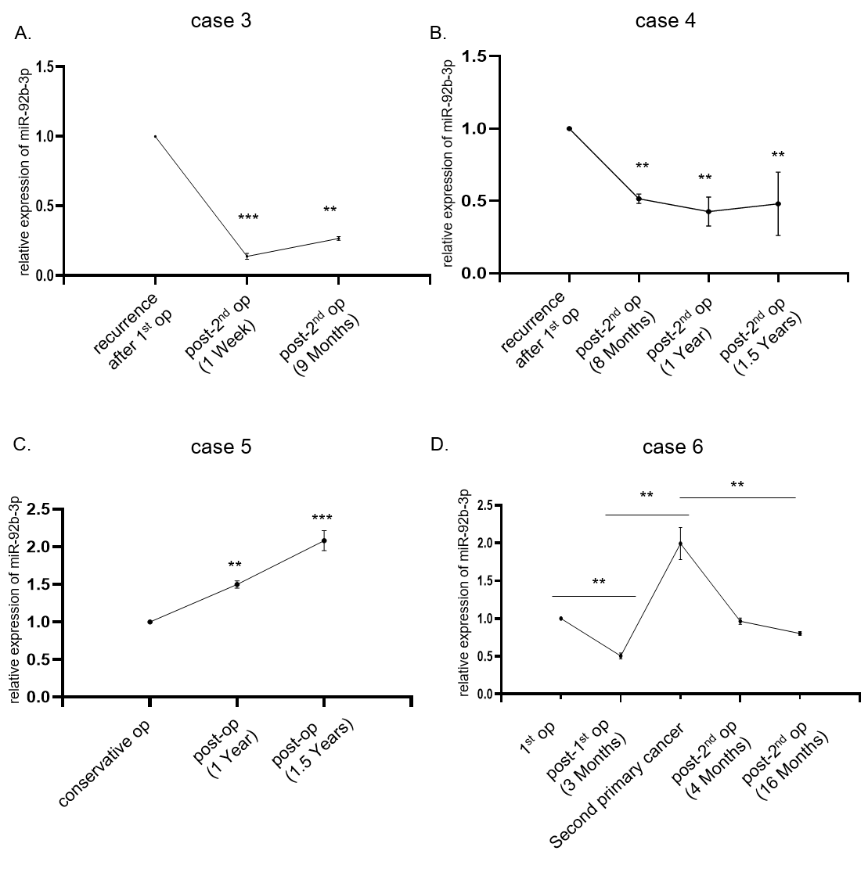

Dynamic changes in serum miR-92b-3p expression levels in patients with recurrent OSCC.

Table S1. The clinical information of patients with OSCC in CNUH cohort.
Characteristics | Total [n=67(%)]
Gender
Male | 24 (35.8%)
Female | 43 (64.2%)
Age
<65 | 28 (41.8%)
≥65 | 39 (58.2%)
Main subsite
Tongue | 49 (73.1%)
Buccal | 6 (9.0%)
RMT | 5 (7.5%)
Gingiva | 2 (3.0%)
FOM | 3 (4.5%)
Lip | 1 (1.5%)
Hard palate | 1 (1.5%)
Clinical T stage
T1 | 32 (47.8%)
T2 | 20 (29.9%)
T3 | 8 (11.9%)
T4 | 7 (10.4%)
Clinical N stage
N0 | 48 (71.6%)
N1 | 7 (10.4%)
N2 | 9 (13.4%)
N3 | 3 (4.5%)
RMT, retromolar trigone; FOM, floor of the mouth.
Table S2. The primer sequences used in real-time PCR
ID | Primer sequence (5’-3’)
miR-92b-3p | miRCURY LNA miRNA PCR Assay (Cat NO. 339306) (YP00204384)
ATXN1 | F AGATCGACTCCAGCACCGTAGA
 | R CTCTACCAAAACTTCAACGCTGAC
CPEB3 | F GATACGGACCCAGAGCTGAA
 | R CCTGGCACTCATCACACATC
Jagged2 | F GCTGCTACGACCTGGTCAATGA
 | R AGGTGTAGGCATCGCACTGGAA
Hes1 | F GGAAATGACAGTGAAGCACCTCC
 | R GAAGCGGGTCACCTCGTTCATG
Hey1 | F TGTCTGAGCTGAGAAGGCTGGT
 | R TTCAGGTGATCCACGGTCATCTG
Twist | F GCCAGGTACATCGACTTCCTCT
 | R TCCATCCTCCAGACCGAGAAGG
Oct4 | F CCTGAAGCAGAAGAGGATCACC
 | R AAAGCGGCAGATGGTCGTTTGG
Nanog | F CTCCAACATCCTGAACCTCAGC
 | R CGTCACACCATTGCTATTCTTCG
Klf4 | F CATCTCAAGGCACACCTGCGAA
 | R TCGGTCGCATTTTTGGCACTGG
Map2k4 | F CTGAGAACACACAGCATTGAGTC
 | R CACAAAAGAGCAGGATGAGGTC
Lhfpl2 | F GCATCTTCAATGTCTGTGGGCTG
 | R GTCCACAGTAGTCTATGGCCTTC
Sesn3 | F TTTGTGGTCCCTGGAGAAAC
 | R ATCGAGAGACATCGGCTGTT

Table S3. Antibodies.
ID | Product code | Information
ATXN1 | 21775 | 1:1000, Cell signalling Technology Inc., Danvers, MA, USA
CPEB3 | ab10883 | 1:1000, Abcam, Cambridge, MA, USA
Jagged2 | 2210S | 1:1000, Cell signalling Technology Inc., Danvers, MA, USA
NICD | 4147S | 1:1000, Cell signalling Technology Inc., Danvers, MA, USA
Hes1 | 11988S | 1:1000, Cell signalling Technology Inc., Danvers, MA, USA
Snail | 3879S | 1:1000, Cell signalling Technology Inc., Danvers, MA, USA
Vimentin | 5741S | 1:1000, Cell signalling Technology Inc., Danvers, MA, USA
Sox2 | 230645 | 1:1000, Cell signalling Technology Inc., Danvers, MA, USA
Twist | 90445S | 1:1000, Cell signalling Technology Inc., Danvers, MA, USA
β-actin | 4970S | 1:1000, Cell signalling Technology Inc., Danvers, MA, USA
Oct4 | 2750S | 1:1000, Cell signalling Technology Inc., Danvers, MA, USA
Nanog | 4903S | 1:1000, Cell signalling Technology Inc., Danvers, MA, USA
PARP | 9532S | 1:1000, Cell signalling Technology Inc., Danvers, MA, USA
Caspase 3 | 9662S | 1:1000, Cell signalling Technology Inc., Danvers, MA, USA
BAX | 5023S | 1:1000, Cell signalling Technology Inc., Danvers, MA, USA
Bcl-xl | 2764S | 1:1000, Cell signalling Technology Inc., Danvers, MA, USA

