7. Appendix

Appendix 1

MOCK COMMUNITY REPLICATE 1
Bacteria | OD 600 | CFU/mL at OD 600 | Desired final amount (CFU) | Volume from culture (mL)
C. tuberculostearicum | 1.8 | 9e+08 | 3.00e+08 | 3.33e-01
C. pseudodiphtheriticum (CI) | 2.32 | 9.08e+08 | 3.00e+08 | 3.30e-01
C. pseudodiphtheriticum (ATCC) | 1.42 | 7.09e+08 | 3.00e+08 | 4.23e-01
S. aureus | 3.82 | 3.72e+09 | 3.00e+08 | 8.06e-02
S. epidermidis | 3.32 | 6.73e+09 | 3.00e+08 | 4.46e-02
P. aeruginosa (PA01) | 2.34 | 6.72e+09 | 3.00e+08 | 4.46e-02
P. aeruginosa (ATCC-15692) | 2.52 | 5.02e+09 | 3.00e+08 | 5.98e-02
M. catarrhalis | 2.24 | 2.04e+09 | 3.00e+08 | 1.47e-01
K. pneumoniae | 3.22 | 5.94e+09 | 3.00e+08 | 5.05e-02
MOCK COMMUNITY REPLICATE 2
Bacteria | OD 600 | CFU/mL at OD 600 | Desired final amount (CFU) | Volume from culture (mL)
C. tuberculostearicum | 2.02 | 1.01e+09 | 3.00e+08 | 2.97e-01
C. pseudodiphtheriticum (CI) | 2.46 | 9.64e+08 | 3.00e+08 | 3.11e-01
C. pseudodiphtheriticum (ATCC) | 1.34 | 6.69e+08 | 3.00e+08 | 4.48e-01
S. aureus | 4.008 | 3.91e+09 | 3.00e+08 | 7.68e-02
S. epidermidis | 3.66 | 7.41e+09 | 3.00e+08 | 4.05e-02
P. aeruginosa (PA01) | 3 | 8.7e+09 | 3.00e+08 | 3.45e-02
P. aeruginosa (ATCC-15692) | 2.44 | 4.86e+09 | 3.00e+08 | 6.17e-02
M. catarrhalis | 2.4 | 2.2e+09 | 3.00e+08 | 1.36e-01
K. pneumoniae | 3.14 | 5.78e+09 | 3.00e+08 | 5.19e-02
MOCK COMMUNITY REPLICATE 3
Bacteria | OD 600 | CFU/mL at OD 600 | Desired final amount (CFU) | Volume from culture (mL)
C. tuberculostearicum | 0.57 | 2.85e+08 | 3.00e+08 | 1.05e+00
C. pseudodiphtheriticum (CI) | 0.334 | 1.14e+08 | 3.00e+08 | 2.64e+00
C. pseudodiphtheriticum (ATCC) | 1.92 | 9.59e+08 | 3.00e+08 | 3.13e-01
S. aureus | 3.796 | 3.7e+09 | 3.00e+08 | 8.12e-02
S. epidermidis | 3.4 | 6.89e+09 | 3.00e+08 | 4.35e-02
P. aeruginosa (PA01) | 1.89 | 5.37e+09 | 3.00e+08 | 5.59e-02
P. aeruginosa (ATCC-15692) | 1.518 | 3.02e+09 | 3.00e+08 | 9.95e-02
M. catarrhalis | 1.446 | 1.25e+09 | 3.00e+08 | 2.41e-01
K. pneumoniae | 2.636 | 4.77e+09 | 3.00e+08 | 6.29e-02
Appendix 1. The OD of bacteria after overnight growth in a liquid culture and volume extracted from each liquid culture to generate mock community biological replicates.

Appendix 2. Inclusion of human cells in mock communities D to F.

This aspect of the protocol requires further optimisation; we wanted to make a mock community with 10% human cells, 90% bacterial cells (in theory) – in practice the yield of human DNA was 20% of the reads. We include our calculations used in this paper below, adjust as appropriate for future study. We wanted a small spike in of human cells to test the validity of this method and would use a larger spike in of human cells in future (e.g. 90-99% human / 10 – 1% bacterial).

NB: we did use adaptive sampling during sequencing of the samples so this 20% of reads was the amount that was not depleted. When we have sequenced real patient samples with adaptive sampling we have still got 95-99% human reads.

To find the DNA mass:

$$DNA mass [ng]= \frac{no. cells × genome length \left[bp\right]×{1*10}^{9}×650 [g / mole of bp]}{6.022×{10}^{23} [no. / mole]}$$

Bacteria | Desired  no CFU | Genome length (bp) | DNA mass (ng)
CT | 3 E7 | 2.43 E6 | 78.6
CPCI | 3 E7 | 2.32 E6 | 75.0
CP | 3 E7 | 2.32 E6 | 75.0
SA | 3 E7 | 2.83 E6 | 91.5
SE | 3 E7 | 2.51 E6 | 81.6
PA01 | 3 E7 | 6.64 E6 | 215.1
PA | 3 E7 | 6.64 E6 | 215.1
MC | 3 E7 | 1.91 E6 | 61.8
KP | 3 E7 | 5.6 E6 | 181.2
Total | 2.7 E8 | - | 1074.9 ng

To achieve desired biomass constitution of 90% bacterial, 10% human DNA

1075ng bacterial DNA : 119ng human DNA

Find the number of human cells for biomass of 1075 ng genome size 6.4 Gb:

$$no. copies= \frac{amount \left[ng\right]× 6.022*{10}^{23} [no. / mole]}{genome size \left[bp\right]×1*{10}^{9}[factor to convert to ng]×650 [g / mole of bp]}$$

$$no. copies= \frac{119 \left[ng\right]× 6.022*{10}^{23} [no. / mole]}{6.4*{10}^{9}\left[bp\right]×1*{10}^{9}×650 [g / mole of bp]}$$

$$no. copies= \frac{7.17*{10}^{25} [no. / mole]}{4.16*{10}^{20}}$$

$$no. copies=1.7 * {10}^{6} human cells$$

Appendix 3. Quality and length of reads in each dataset according to sequencing method

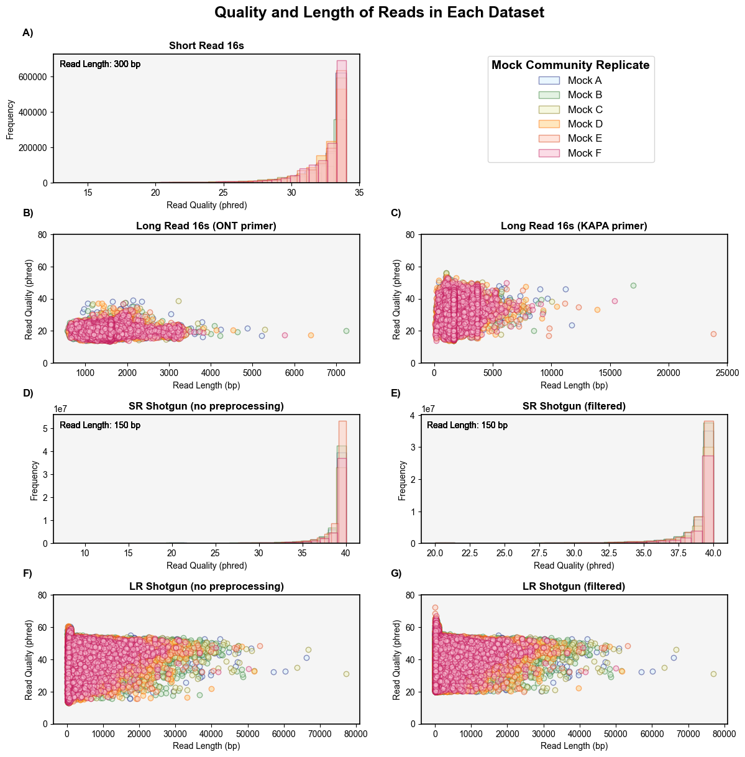

Appendix 4. Elbow Curve to determine the number of clusters for clustering algorithms

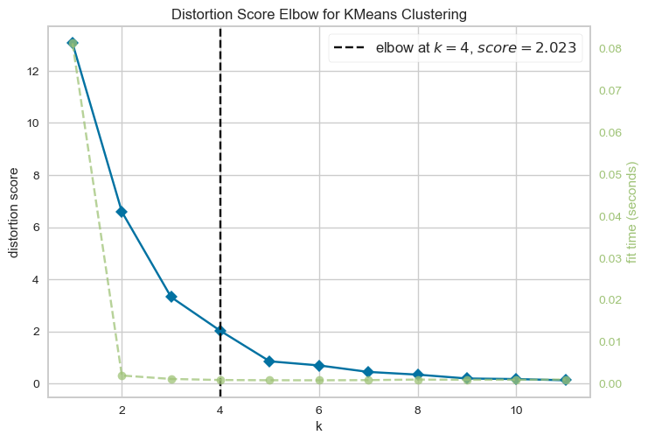

Appendix 5. Link to Github repository for all code

https://github.com/isabella-burdon/paper01_repository_cleanpipes

