Additional file 1. Figure S1. Muscle MRI results of patient 1 and patient 3.
(A) For patient 1, fatty infiltration was mainly present in bilateral posterior thigh (red arrows). (B) For patient 3, fatty infiltration was mainly present in bilateral posterior thigh (red arrows). FS: Fat Suppression

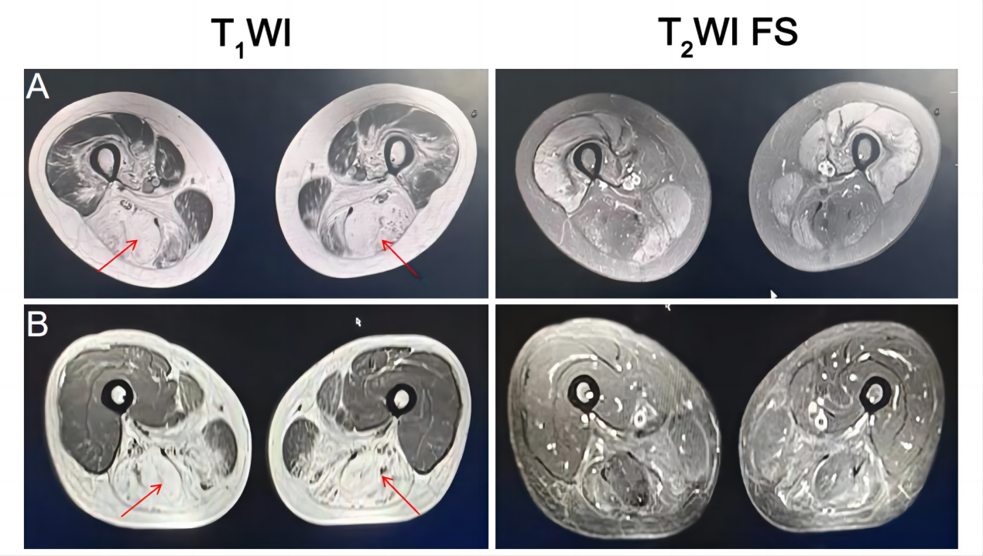

Additional file 2. Table S1. Characteristics of three patients with limb girdle muscular dystrophy 14.

 | Patient1 | Patient2 | Patient3
Gender/age(year) | Female/45 | Male/39 | Female/53
Onset age(year) | 25 | 21 | 43
Presenting  symptoms | Proximal lower limb weakness and difficulty in climbing stairs and squatting | Proximal lower limb weakness and wheelchair-bound | Proximal lower limb weakness and difficulty in squatting
Brain MRI | Not done | Normal | Normal
Mental retardation | Normal | Mild | Normal
Cardiac  evaluation | Normal | Dilated cardiomyopathy | Normal
Respiratory evaluation | Normal | Normal | Normal
Ocular involvement | Normal | Normal | Not done
Electromyogram | Myogenic change | Myogenic change | Myogenic change
Muscle MRI | Fatty infiltration in bilateral posterior thigh | Not done | Fatty infiltration in bilateral posterior thigh
CK (U/L) | 5624 | 1252 | 527
LDH (U/L) | 869.6 | 382.5 | 298.1
Muscle biopsy | Muscular  dystrophic change,  reduced aDG expression | Muscular  dystrophic change,  reduced aDG expression | Muscular  dystrophic change,  reduced aDG expression
POMT2  Mutation | c.1006+1G>A  c.295C>T  (p.R99C) | c.700_701insCT (p.V234Afs*8) c.1261C>T (p.R421W) | c.812C>T (p.S271L) c.170G>A (p.W57*)

