Supplemental Table
Diagnosis | Age | Sex | Ancestry | Li Response | Days Stable Li
Control | 56 | M | EUR | n/a | n/a
Control | 73 | M | EUR | n/a | n/a
Control | 38 | M | EUR | n/a | n/a
Bipolar | 57 | M | EUR | Responder | >730*
Bipolar | 65 | M | EUR | Responder | >730*
Bipolar | 69 | M | EUR | Non-Responder | 138
Bipolar | 22 | M | EUR | Non-Responder | 28
Bipolar | 54 | M | EUR | Non-Responder | 88

Table S1. Clinical Characteristics of NPC donors. Age refers to chronological age (years) at the time of skin biopsy. All donors were of European ancestry (EUR). Lithium response indicates responder or non-responder as defined by the ability to stabilize on lithium monotherapy in a prospective clinical trial. * indicates donor remained stable throughout entire duration of 2-year study. Due to the expected lack of therapeutic benefit and potential for causing side effects, controls were not exposed to lithium.

Supplemental Figures
Figure S1. Representative image of neural progenitor cells (NPC) generated from pluripotent stem cells (iPSCs). Nuclei are stained by DAPI (blue). NPC identity was verified by immunostaining and co-expression of the early cortical neural precursor markers NESTIN (green) and SOX-2 (red). As reported previously (Mishra et al 2021) we did not find any quantitative differences in NPCs grown from Control, Li-R and Li-NR. Scale bar = 50µm.

Figure S2. Lithium increases the amplitude of circadian rhythms in immortalized mouse hippocampal neurons and control neural progenitor cells. A) Immortalized mouse hippocampal neurons (IMHN) transfected with the Per2-luc reporter sustain circadian rhythms for >5 days. Adding lithium to the cell culture media had concentration-dependent effects on the rhythms and significantly increased amplitude at 10mM (p<0.05, indicated by *). Data were analyzed using one-way ANOVA (n=6 /condition). Below appears a representative IMHN circadian rhythm measured using Per2-luc measured simultaneously over 5 days in the presence of lithium 10mM (blue) or vehicle (black) illustrating the increase in amplitude. NPCs from B) control (n=3), C) lithium-responders (Li-R, n =2) and D) lithium non-responders (Li-NR, n=3) were transfected with the Per2-luc reporter sustain circadian rhythms for >5 days. Adding lithium to the cell culture media significantly increased amplitude at 1 mM only in the control cells (p<0.05, indicated by *). Data were analyzed using T-test for each group. Data indicate 2-3 technical replicates from each individual donor.

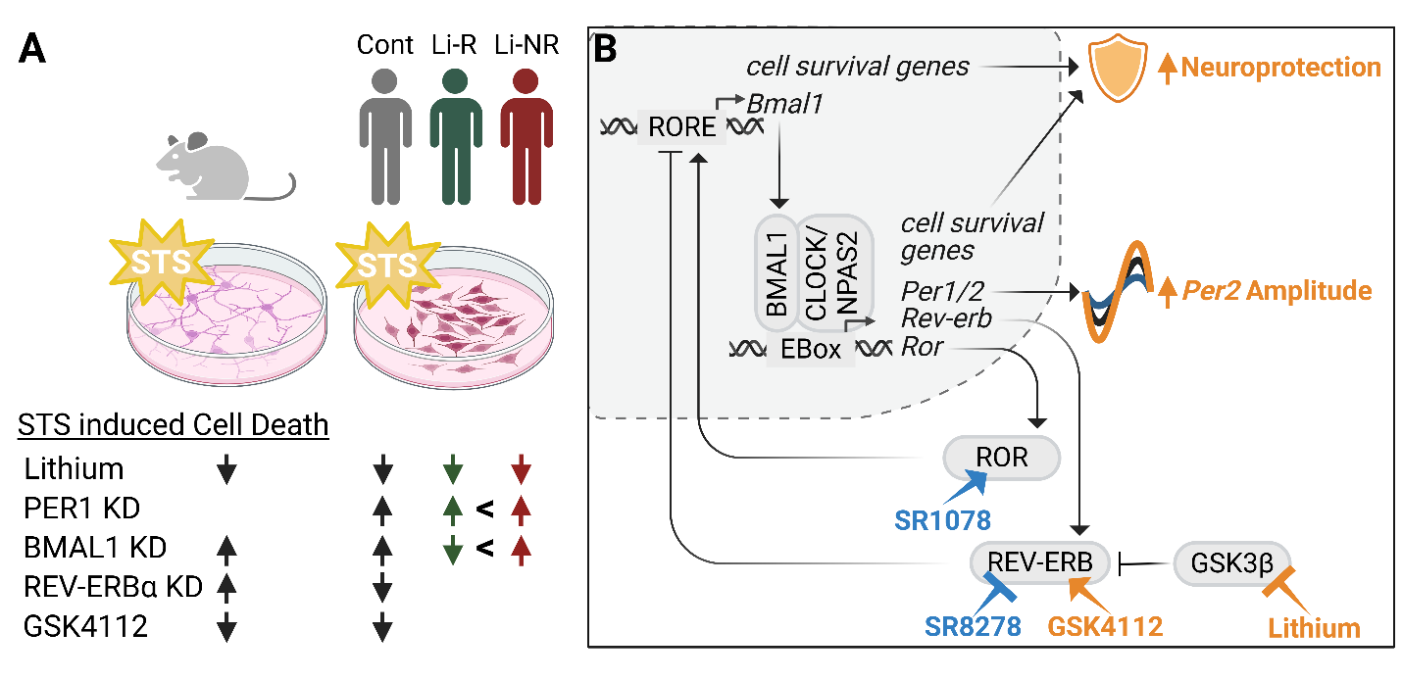
Figure S3. Summary and synthesis of experimental results. A) Mouse immortalized hippocampal neurons and neuronal progenitor cells from control (Cont), lithium responder (Li-R), lithium non-responder (Li-NR) donors with bipolar I disorder were treated with staurosporine (STS) to induce apoptosis. Summary of experiments in which selected clock genes (Bmal1, Per1, Rev-Erbα) were knocked down (KD) using siRNA to identify roles in cell death (arrows indicate increase/decrease). Lithium, and drugs that target ROR and REV-ERB nuclear receptors were also examined. In IMHN, lithium and GSK4112 (orange) had shared effects on promoting neuroprotection and amplitude boosting of circadian rhythms. In NPCs, GSK4112 was only neuroprotective in control samples, but not in Li-R/Li-NR. SR1078 and SR 8278 (blue) decreased amplitude but were not studies in cell death assays. B) A simplified diagram of the molecular circadian clock mechanism is shown. E-Box and RORE elements in DNA promote rhythmic transcription of clock genes (Bmal1, Per1/2, Rev-Erbα, ROR) and rhythmic cell survival genes. Dotted lines indicate cell nucleus. Arrows indicate activation/stimulation. Vertical bars indicate inhibition/blocking. Capital letters indicate proteins. Italics indicate genes. Mouse gene nomenclature has been used, but the circadian gene network is conserved in humans and similarly applies to NPC results.

