Supplementary information
Towards a sustainable waste to eco-friendly grease pathway: A biorefinery proposal for the silk and food industries
Dutra, R. C; Couto, G. O; Péres, E. U. X; Oliveira, J. S; Ghesti, G. F; and Suarez, P. A. Z.
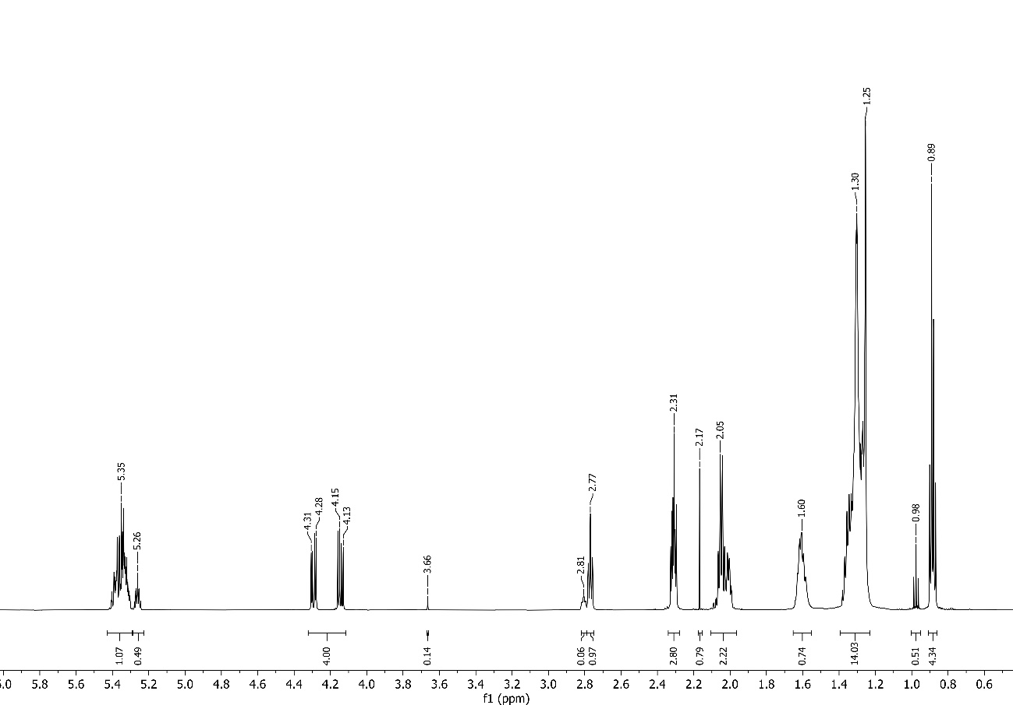
S-Fig. 1. ¹H NMR spectra for SO (Soy Oil) in CDCl₃.

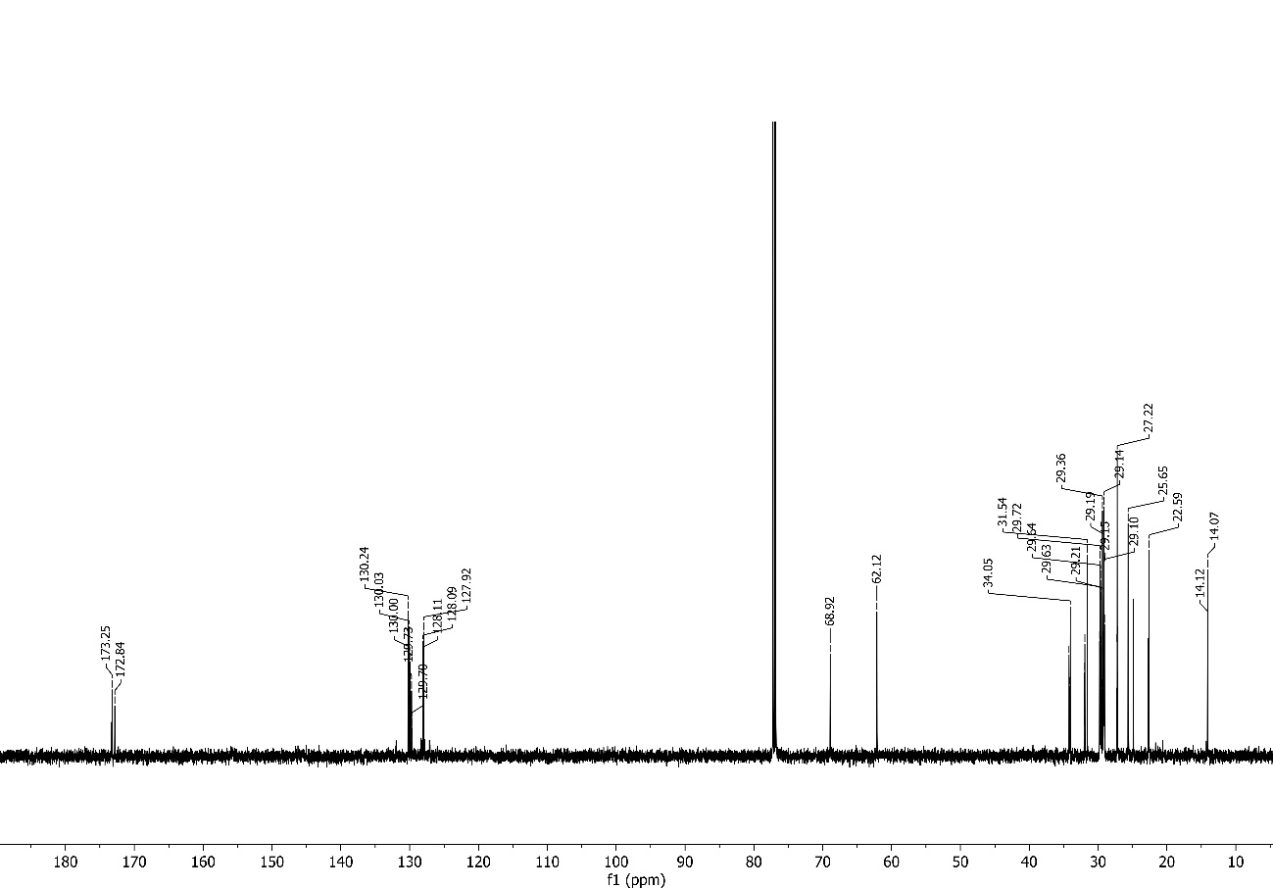
S-Fig. 2. ¹³C NMR spectra for SO (Soy Oil) in CDCl₃.
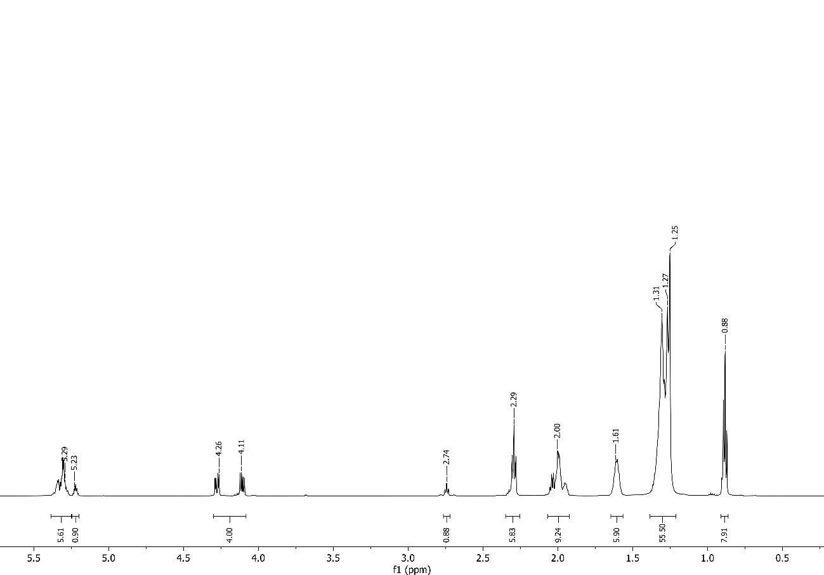
S-Fig. 3. ¹H NMR spectra for WCO (Waste Cooking Oil) in CDCl₃.

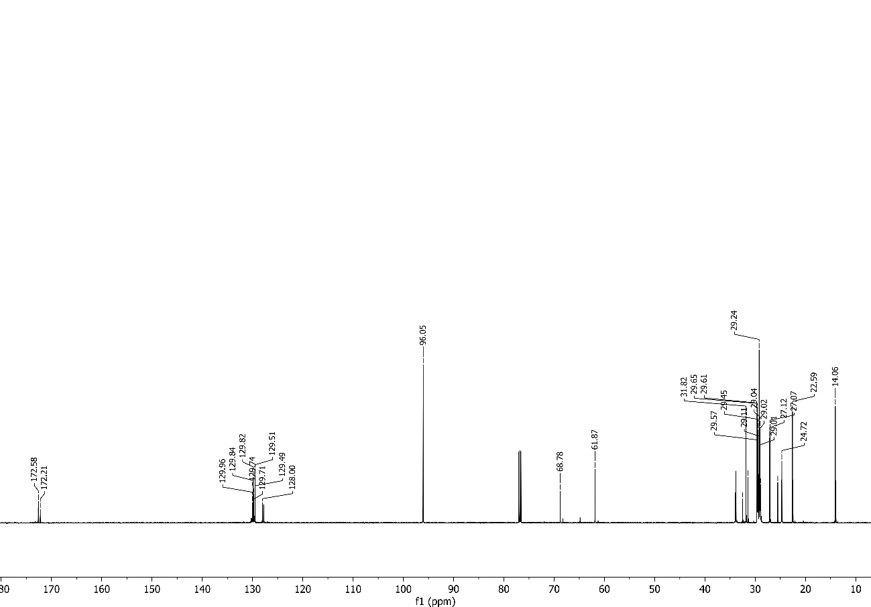
S-Fig. 4. ¹³C NMR spectra for WCO (Waste Cooking Oil) in CDCl₃.
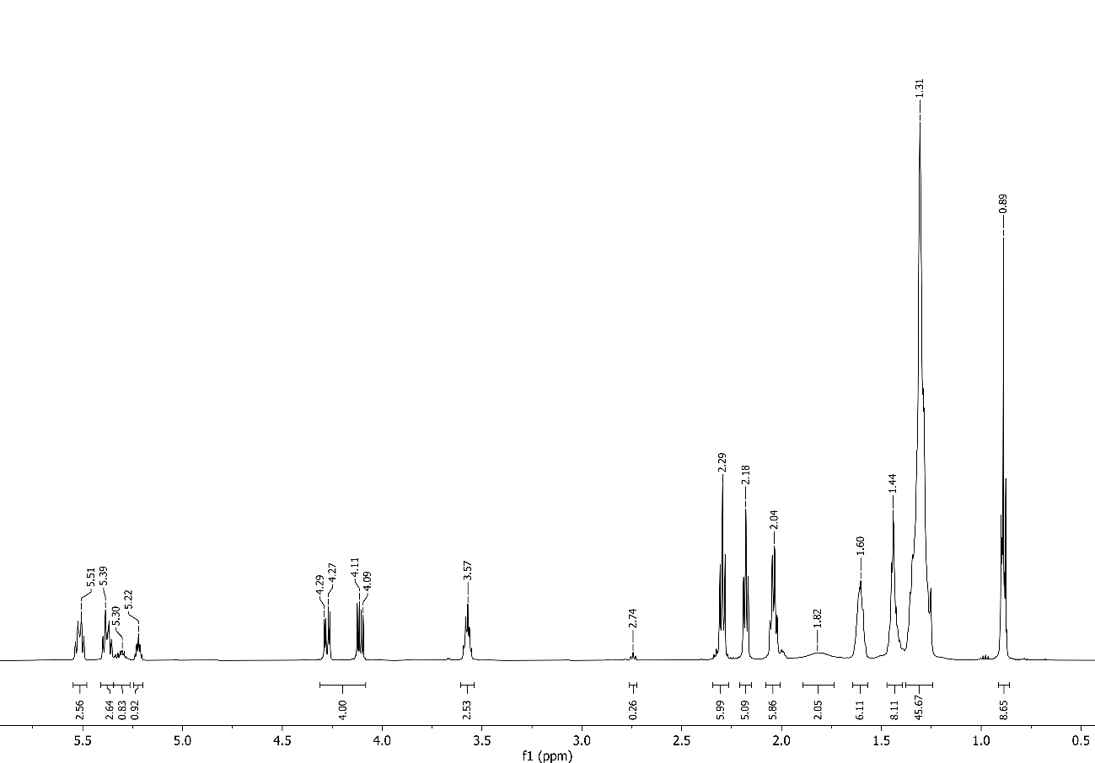
S-Fig. 5. ¹H NMR spectra for RO (Ricin Oil) in CDCl₃.

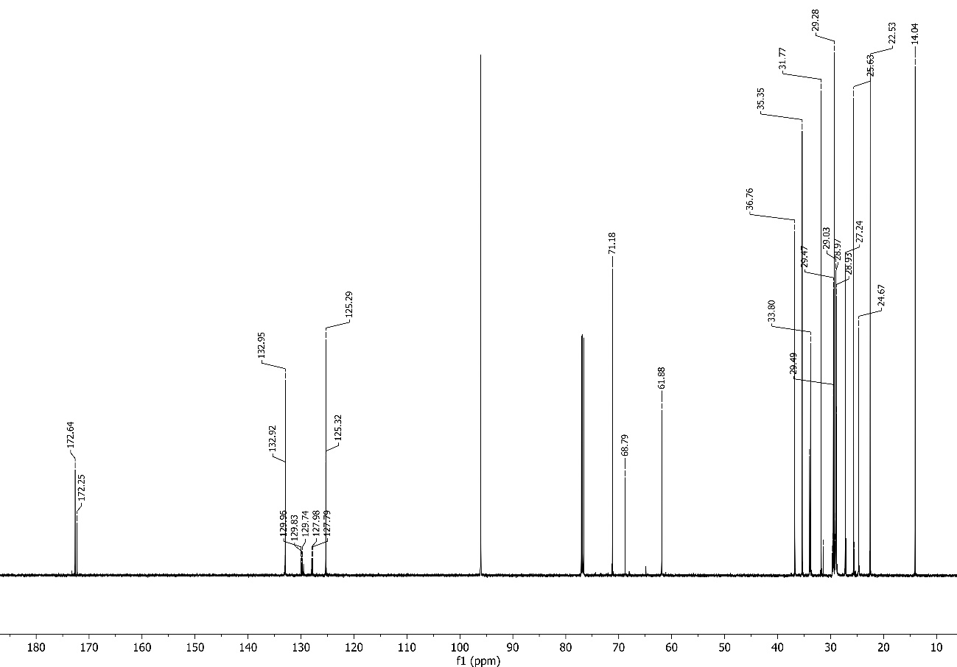
S-Fig. 6. ¹³C NMR spectra for RO (Ricin Oil) in CDCl₃.
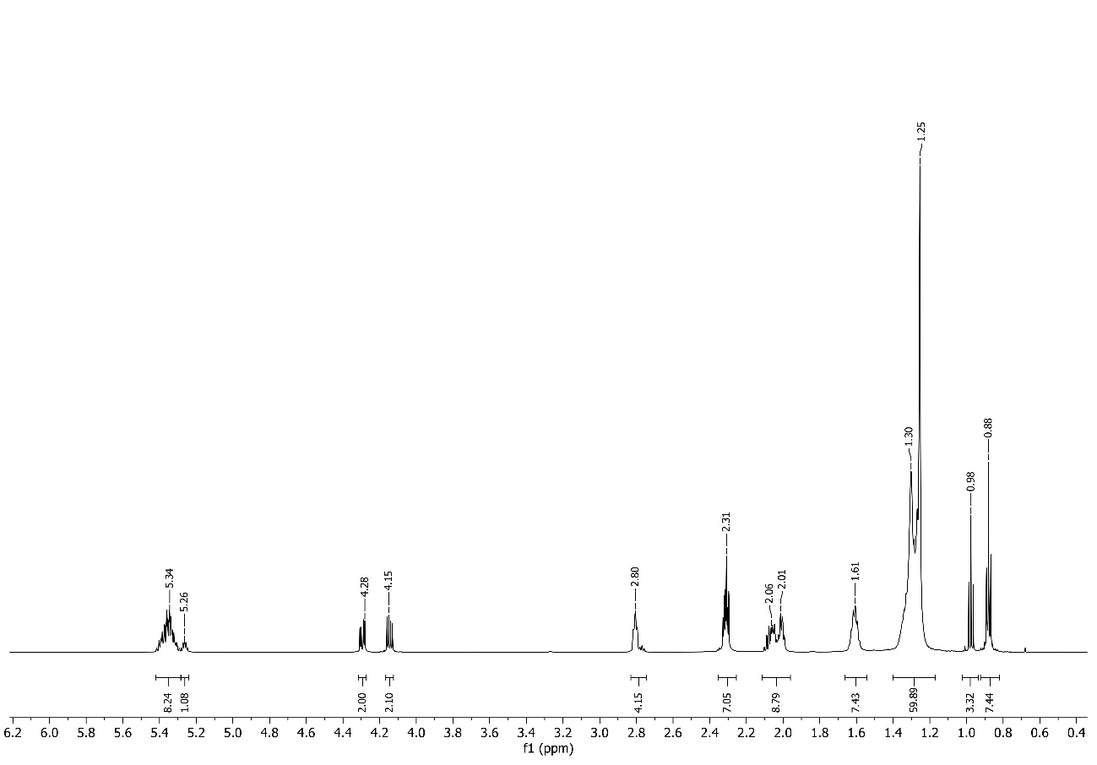
S-Fig. 7. ¹H NMR spectra for SPO (Silkworm Pupae Oil) in CDCl₃.

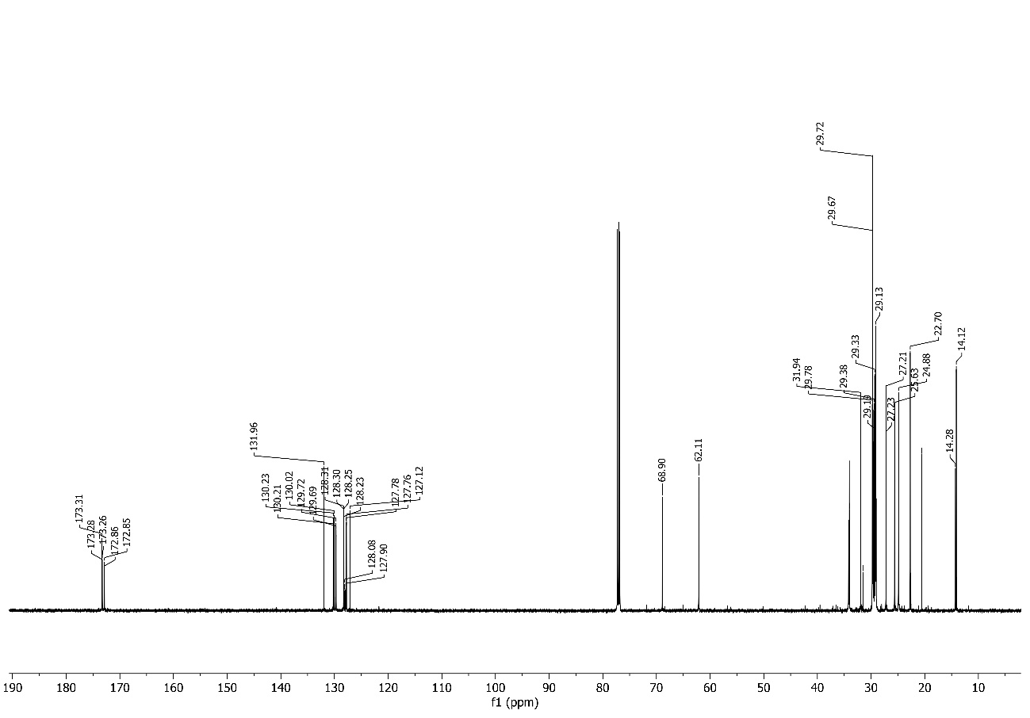
S-Fig. 8. ¹³C NMR spectra for SPO (Silkworm Pupae Oil) in CDCl₃.
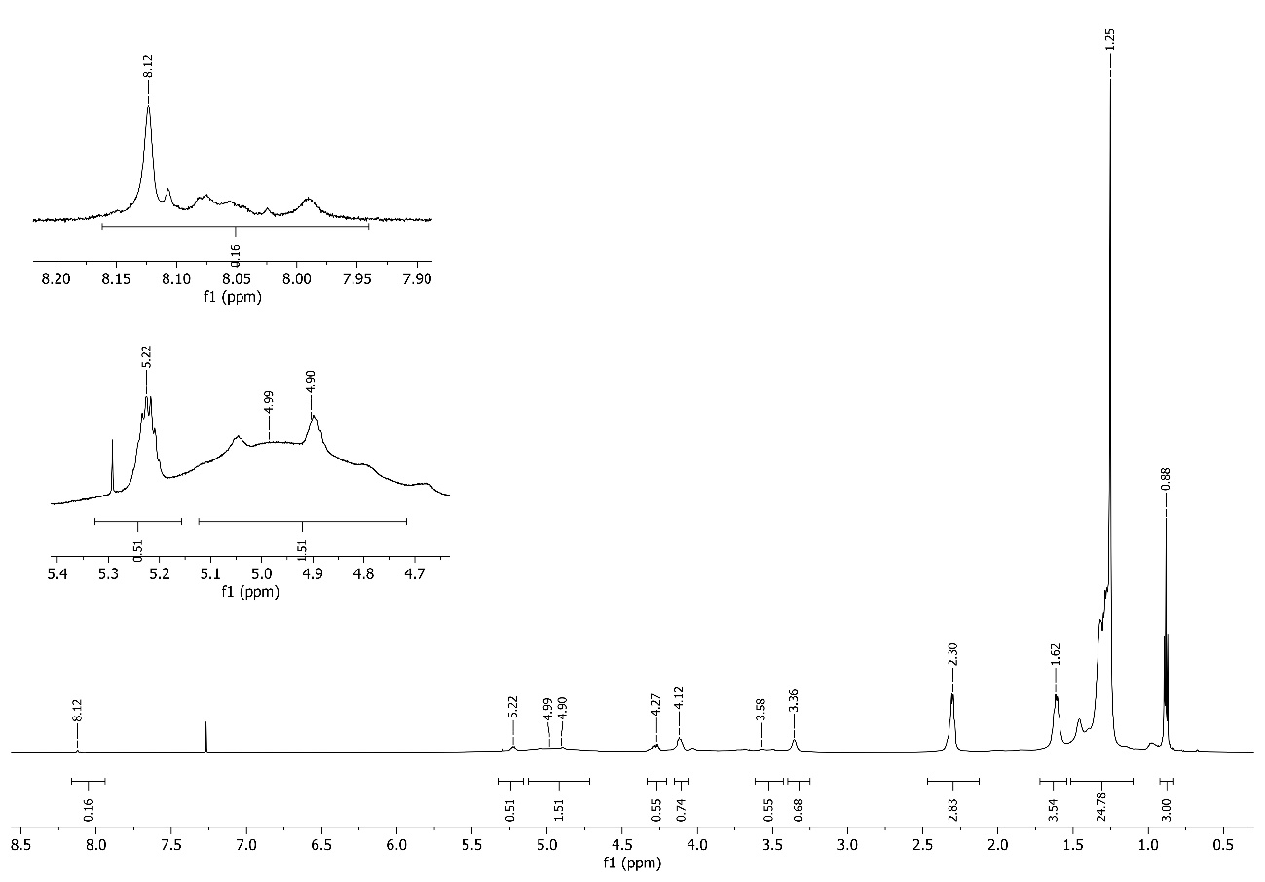
S-Fig. 9. ¹H NMR spectra for SPP (Silkworm Pupae Polyol) in CDCl₃.

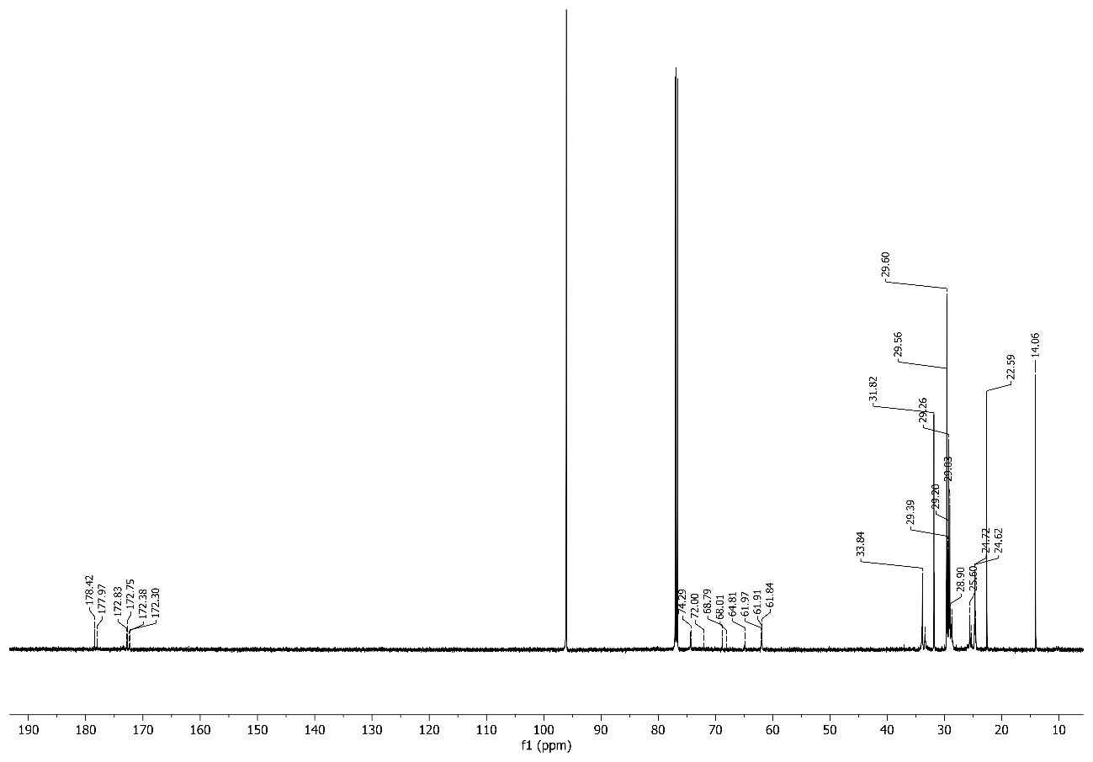
S-Fig. 10. ¹³C NMR spectra for SPP (Silkworm Pupae Polyol) in CDCl₃.

