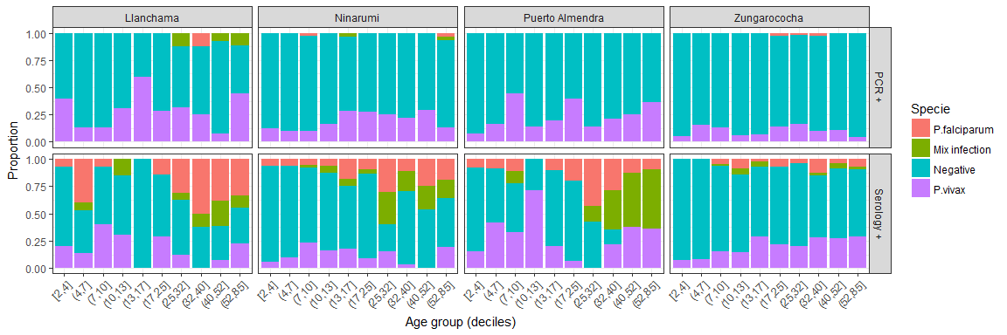
Supplementary information

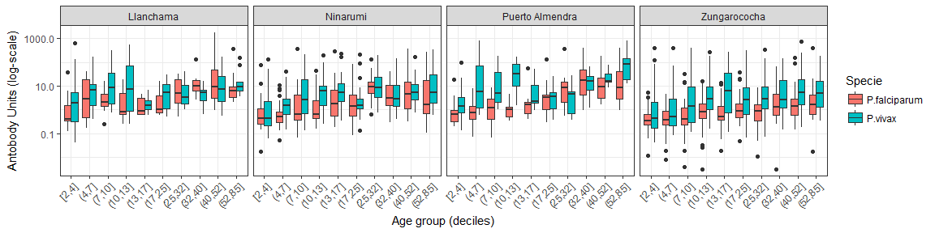

Figure S1 Anti-Plasmodium IgG antibody intensity in four rural communities in Zungarococha, Iquitos. Anti-PvMSP1-119kDa and anti-PfMSP1-119kDa ELISA. Vertical lines show the cut-off values for each protein defined by the mixture models.

