Table 1. Representative top-scoring tetrapeptides with their molecular properties and docking
scores
Rank | Structure | Sequence | Mol Wt | FRED Chemguass4 docking score
1 | 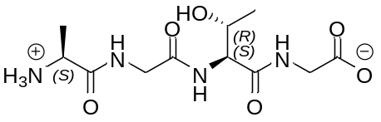  1 | Ala-Gly-Thr-Gly | 304.30 | -15.99
2 | 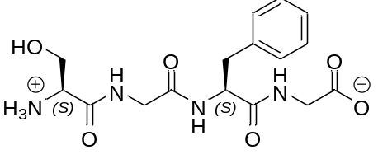  2 | Ser-Gly-Phe-Gly | 366.37 | -15.66
3 | 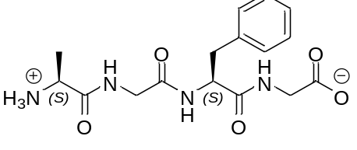  3 | Ala-Gly-Phe-Gly | 350.37 | -15.65
4 | 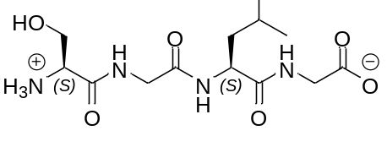  4 | Ser-Gly-Leu-Gly | 332.35 | -15.54
5 | 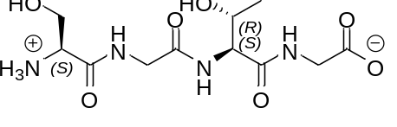  5 | Ser-Gly-Thr-Gly | 3 | -15.51
6 | 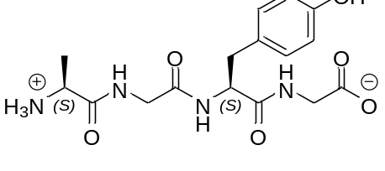  6 | Ala-Gly-Tyr-Gly | 366.37 | -15.42
7 | 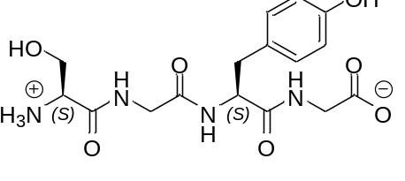  7 | Ser-Gly-Tyr-Gly | 383.37 | -15.20
8 | 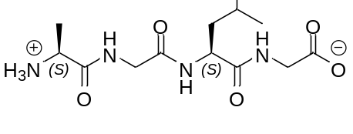  8 | Ala-Gly-Leu-Gly | 316.35 | -15.15
9 | 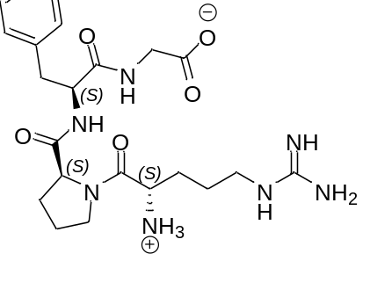  9 | Arg-Pro-Phe-Gly | 475.55 | -15.09
10 | 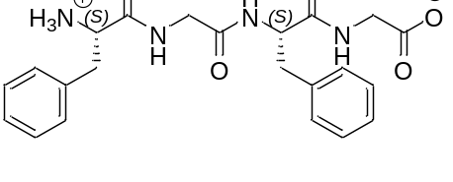  10 | Phe-Gly-Phe-Gly | 426.47 | -15.07

Table 2. Calculated/predicted molecular, physicochemical and pharmacokinetic properties of top-five hits from pharmacophore screening
Pharmacophore Screening Hit | HDon | HAcc | QP  logP_{o/w} | Violation of Lipinski’s rule | QP  logS | QP  logHERG | QP  P_{Caco} | QP  P_{MDCK} | QP  LogK_{hsa} | %  Human Oral Absorption
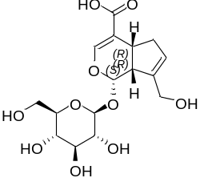  Geniposidic acid (11)  [27741-01-1]  Mol. Formula: C₁₆H₂₂O₁₀  Mol. Wt.: 374.34 | 6 | 10 | -1.826 | 1 | -1.494 | -1.92 | 3.77 | 1.511 | -1.307 | 13.611
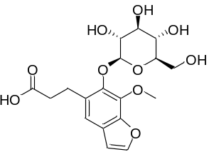  ZINC39010597 (12)  Mol. Formula: C₁₈H₂₂O₁₀  Mol Wt.: 398.36 | 5 | 10 | -0.003 | 0 | -1.916 | -2.591 | 11.86 | 5.217 | -1.036 | 46.159
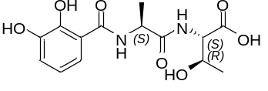  ZINC2356677764 (13)  Mol. Formula: C₁₄H₁₈N₂O₇  Mol. Wt.: 326.31 | 6 | 7 | -1.826 | 1 | -1.494 | -1.92 | 3.77 | 1.511 | -1.307 | 13.611
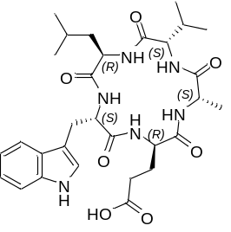  WS-7338A (14)  Mol. Formula: C₃₀H₄₂N₆O₇  Mol. Wt.: 598.70 | 7 | 7 | 1.714 | 2 | -5.955 | 0.779 | 84.21 | 130.2 | -0.604 | 32.567
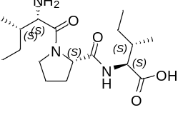  Diprotin A (15)  Mol. Formula: C₁₇H₃₂N₃O₄  Mol. Wt.: 341.44 | 3 | 5 | -1.307 | 0 | -1.13 | 0 | 8.249 | 9.97 | -0.973 | 35.693

Table 4. Docking scores and the binding free energy estimates of the five hits from direct docking
of the phytochemicals library in the susbtrate-binding site of PLpro (PDB ID 6WX4)
Direct docking Hit | Mol Formula (Mol Wt; Violation Ro5ª) | LibDock score | Binding energy (kcal/mol)
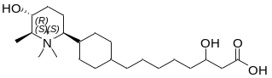  16 | C₂₂H₄₂NO₄  (384.58; 0) | 121.95 | -303.147
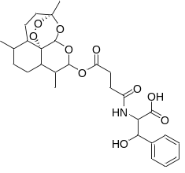  17 | C₂₈H₃₇NO₁₀  (547.60; 2) | 167.571 | -302.907
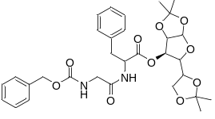  18 | C₃₁H₃₈N₂O₁₀  (598.65; 2) | 158.378 | -293.926
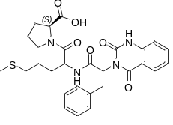  19 | C₂₈H₃₂N₄O₆S  (552.65; 1) | 158.066 | -290.98
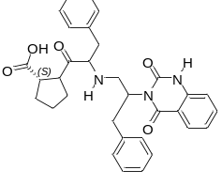  20 | C₃₂H₃₃N₃O₅  (539.63; 1) | 161.205 | -290.173
ªRo5: Lipinski’s Rule of five; one violation is permitted.

