Supplementary material
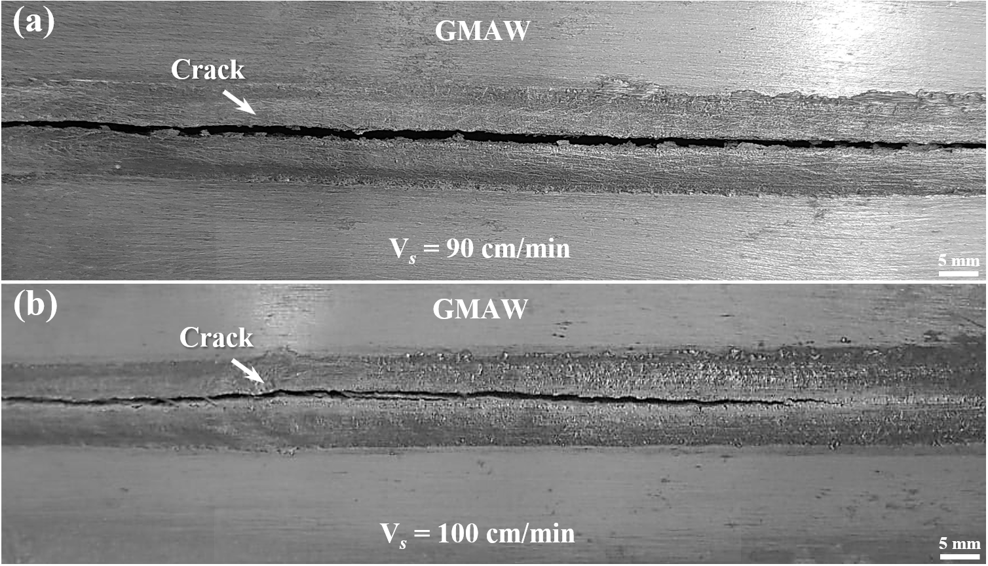
S 1 The bead profiles of the welds performed at travel speeds of 90 cm/min and 100 cm/min are shown in (a) and (b), respectively, with visible cracks in both for the P-GMAW process.
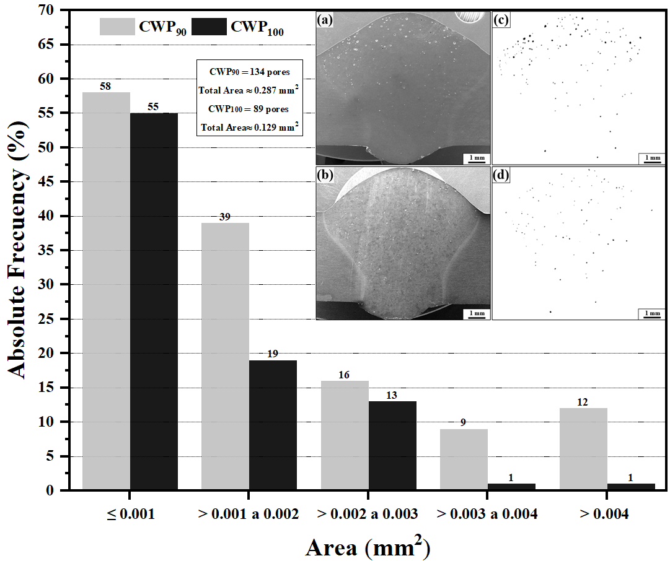
S 2 Absolute frequencies of porosity areas for each welding condition are presented, accompanied by the regions subjected to analysis. SEM-SE micrographs of the cross-sections of CWP₉₀ and CWP₁₀₀ joints are shown in (a) and (b), respectively. In addition, binarized images of CWP₉₀ (c) and CWP₁₀₀ (d) are also provided.

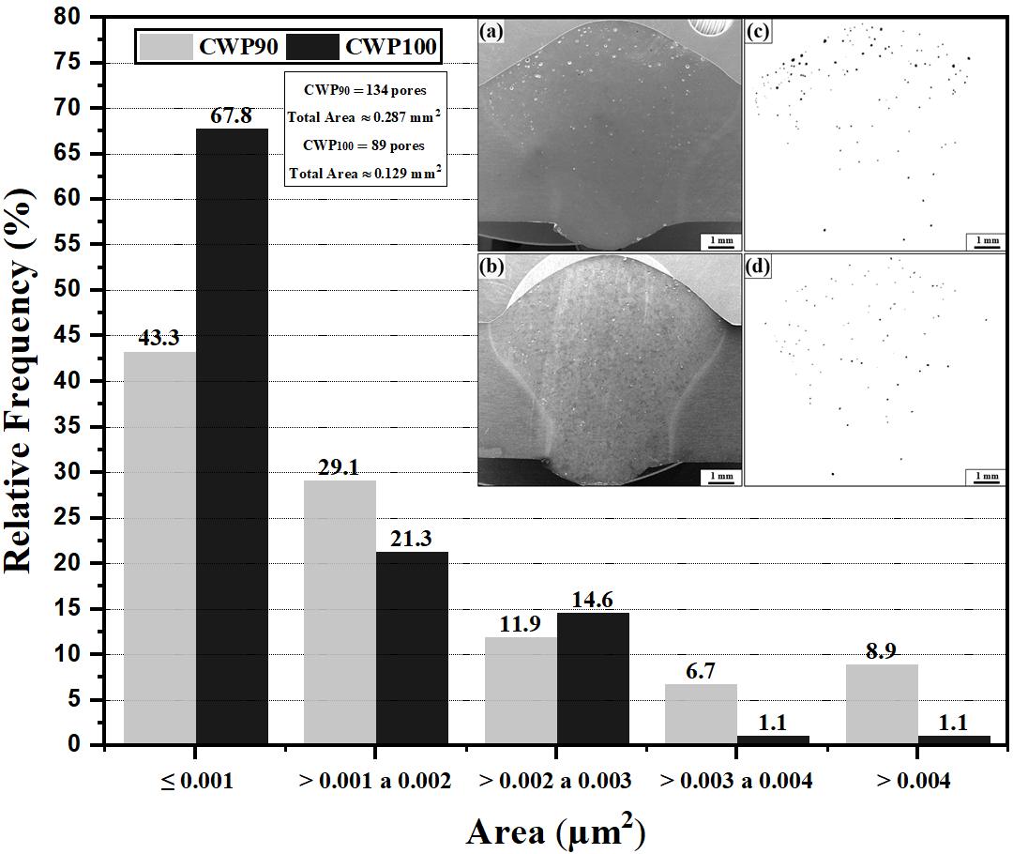
S 3 Relative frequencies of porosity areas for each welding condition are presented, accompanied by the regions subjected to analysis. SEM-SE micrographs of the cross-sections of CWP₉₀ and CWP₁₀₀ joints are shown in (a) and (b), respectively. In addition, binarized images of CWP₉₀ (c) and CWP₁₀₀ (d) are also provided.
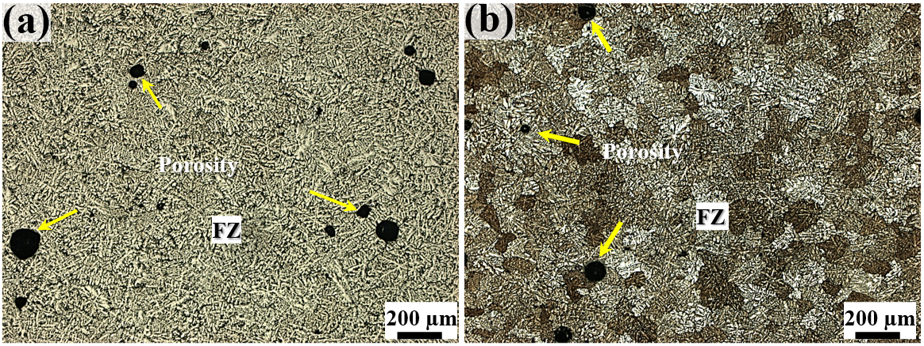
S 4 Micrographs of cross-sections of the top region of the Fusion Zone for the CWP₉₀ (a) and CWP₁₀₀ (b), with a magnification of 200x.

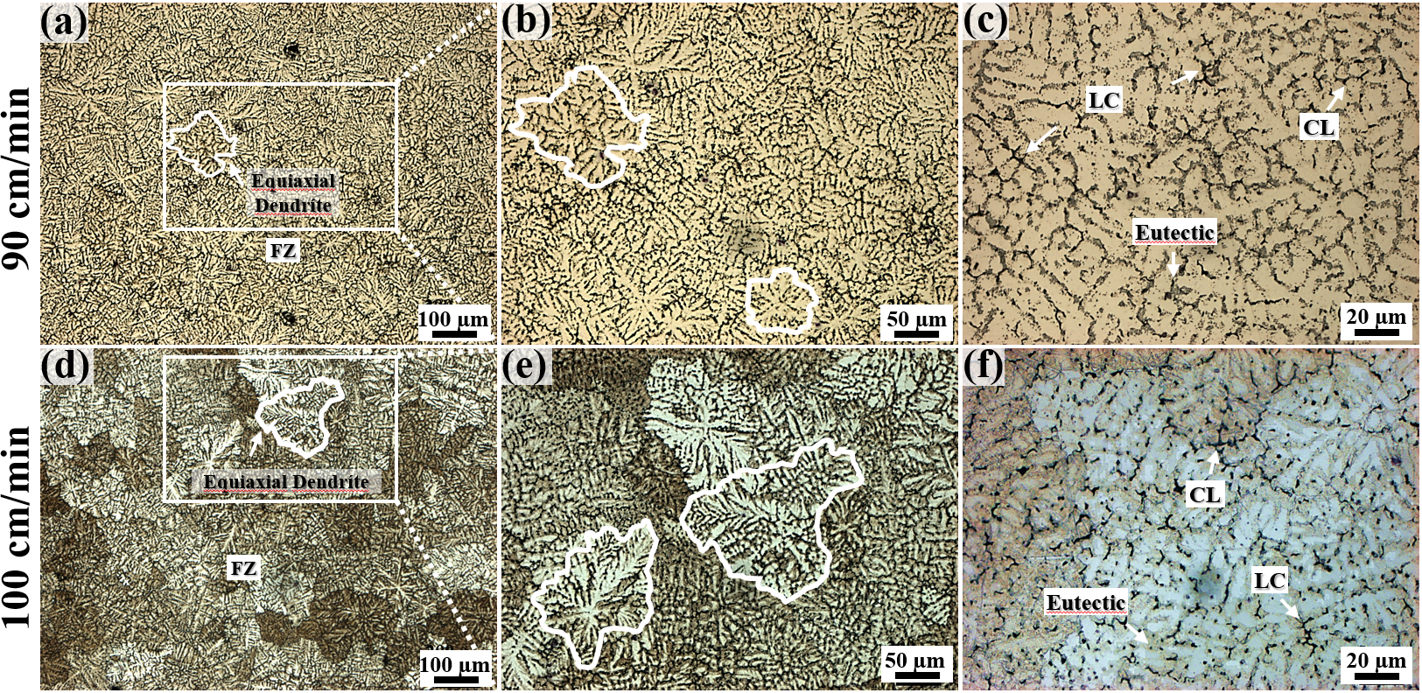
S 5 Micrographs of cross-sections of the central region of the Fusion Zone for the CWP₉₀ (a, b, c) and CWP₁₀₀ (d, e, f), with a magnification of 100x, 200x, and 500x.
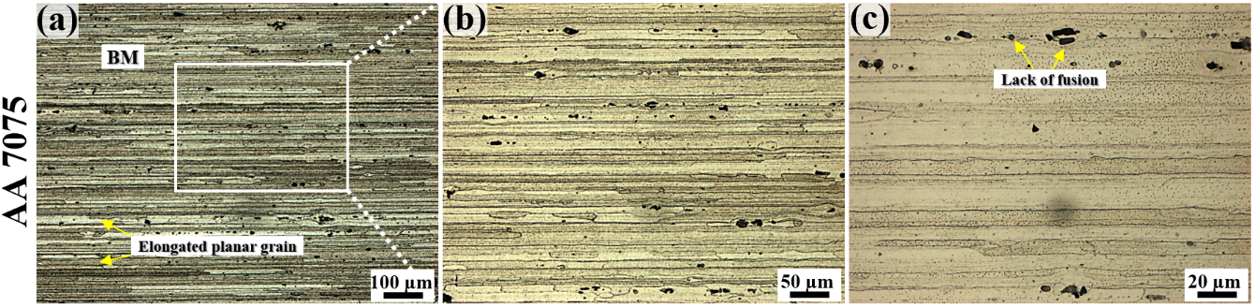
S 6 Micrographs of cross-sections of the as-received base metal with a magnification of 100x, 200x, and 500x.

ST 1 - EDS results for the weld metal region for both experimental conditions, chemical composition (% wt.)
Cold Wire-GMAW-20% (90 cm/min)
Point # | Al | Zn | Cu | Mg | Cr | Mn | Fe | Si
1 | 78.00 | 8.70 | 4.90 | 7.90 | 0.20 | 0.10 | 0.10 | 0.20
2 | 93.80 | 2.80 | 0.40 | 2.40 | 0.20 | 0.30 | 0.10 | 0.10
3 | 79.30 | 8.00 | 4.50 | 7.70 | 0.20 | 0.20 | – | 0.20
4 | 75.40 | 8.90 | 5.50 | 8.70 | 1.00 | 0.40 | – | 0.10
5 | 85.60 | 5.90 | 2.50 | 5.20 | – | 0.10 | 0.40 | 0.10
Cold Wire-GMAW-20% (100 cm/min)
1 | 94.00 | 3.10 | 0.40 | 2.00 | 0.20 | – | – | 0.10
2 | 82.50 | 7.60 | 4.30 | 5.10 | 0.20 | 0.20 | 0.10 | –
3 | 70.80 | 12.20 | 6.80 | 9.50 | 0.10 | 0.20 | 0.30 | 0.10
4 | 78.10 | 9.10 | 4.80 | 7.10 | 0.20 | 0.20 | 0.20 | 0.10
5 | 79.30 | 8.90 | 4.60 | 7.00 | – | 0.10 | – | 0.10

ST 2 - EDS results for the partially melted zone for both experimental conditions, chemical composition (% wt.)
Cold Wire-GMAW-20% (90 cm/min)
Point # | Al | Zn | Cu | Mg | Cr | Mn | Fe | Si
1 | 90.20 | 5.80 | 1.10 | 2.40 | 0.10 | 0.10 | – | –
2 | 85.90 | 7.20 | 3.60 | 4.00 | 0.20 | – | – | 0.10
3 | 45.90 | 23.00 | 13.10 | 18.80 | 0.10 | 0.10 | 0.10 | 2.00
4 | 57.60 | 13.60 | 17.00 | 10.90 | 0.30 | 0.10 | – | 0.40
5 | 63.10 | 15.60 | 9.70 | 11.00 | 0.20 | – | – | 0.30
Cold Wire-GMAW-20% (100 cm/min)
1 | 67.90 | 2.80 | 7.40 | 1.10 | 4.10 | 1.20 | 14.50 | 0.90
2 | 84.50 | 7.5 | 4.10 | 3.40 | 0.40 | 0.30 | 0.20 | 0.10
3 | 89.00 | 5.80 | 2.00 | 2.80 | 0.10 | 0.10 | – | 0.20
4 | 69.30 | 4.90 | 6.00 | 12.00 | 0.30 | 0.80 | 17.40 | 0.10
5 | 54.00 | 22.30 | 14.10 | 14.40 | – | 0.10 | – | 0.10

