Supplementary materials to Understanding Emotional Flexibility in Autism: The Social Factor Matters
Table of Contents
Supplementary materials to Understanding Emotional Flexibility in Autism: The Social Factor Matters 4
1 Pretests 4
1.1 Participants 4
1.2 Material and stimuli 4
1.3 Procedure 6
1.4 Analyses 7
1.5 Results 7
1.5.1 Pretest 1. 7
1.5.2 Pretest 2. 8
1.5.3 Final control. 9
2 Main experiment 10
2.1 Analyses on images without context 10
2.2 Table for analyses of the images with context 13
3 Correlational analyses 17

Adeline Lacroix¹, Yoann Bennetot-deveria¹, Monica Baciu¹, Frédéric Dutheil², Valentin Magnon², Marie Gomot³, & Martial Mermillod¹
¹ Univ. Grenoble Alpes , Univ. Savoie Mont Blanc, CNRS, LPNC, 38000 Grenoble, France.
² Université Clermont Auvergne, CNRS, LaPSCo, CHU Clermont-Ferrand, WittyFit, F-63000 Clermont-Ferrand, France.
³ UMR 1253 iBrain, Université de Tours, Inserm, Tours, France.

Author note
Adeline Lacroix ORCID ID: https://orcid.org/0000-0001-6990-5949
Correspondence concerning this article should be addressed to Adeline Lacroix, Laboratoire de Psychologie et NeuroCognition, Univ. Grenoble Alpes, 1251 avenue centrale, Grenoble, France. E-mail: adeline.lacroix@univ-grenoble-alpes.fr

Supplementary materials to Understanding Emotional Flexibility in Autism: The Social Factor Matters

1 Pretests
We conducted two pretests to validate the images used as stimuli in the Emotional Shifting Task -2 (EST-2) (see Method section of the manuscript). The pretests aimed to categorize pairs of images, within or without context, according to their emotional valence (positive or negative), their social or non-social nature, and the context of the image, which may or may not be congruent in emotional valence with the same image without context.

1.1 Participants
Twenty-four participants (17 males and 7 females), aged between 19 and 27 years old (M = 22 years), completed the first pretest questionnaire. Additionally, 22 volunteer participants (16 males and 6 females), aged between 18 and 33 years old (M = 24 years), completed the second pretest questionnaire. All participants declared that they had no uncorrected visual impairment, psychiatric, neurological, or neurodevelopmental disorders. Participants were recruited through our personal networks, some likely took part in both pretests. Pretest participants were excluded from participating in the main experiment due to their familiarity with the stimuli.

1.2 Material and stimuli
To design our stimuli, we initially searched for images with emotional content that could be cropped to remove their original context. The goal was to create pairs of stimuli, each consisting of an image without context and the same image within its original context. Stimuli were chosen from established and validated image databases, such as the Natural Disasters Picture System (Merlhiot et al., 2018), the International Affective Picture System (Lang, Bradley & Cuthbert, 2008), the Geneva Affective Picture Database (Dan-Glauser & Scherer, 2011), the Nencki Affective Picture System (Marchewka et al., 2014), and the Open Affective Standardized Image Set (Kurdi et al., 2017). Additionally, images were sourced from online image banks with copyright-free images. We aimed to select images varied in emotional valence, social content, and context congruence, to have a diverse set of validated stimuli for each condition.
Subsequently, we processed these images using RawTherapee 5.8 software. The images were cropped to isolate their emotional content from the surrounding context. The cropped images were resized to 350 pixels wide while maintaining the original scale. The full images, including their context, were resized to 500 pixels wide, also preserving the original scale. These dimensions were chosen to facilitate display on the Psytoolkit platform and to ensure consistent image resolutions. Most images were resized to a lower resolution than the original. However, for images of lower quality, resizing sometimes increased the number of pixels. In such cases, the software utilized an algorithm called Lanczos to enhance rendering.
We conducted an initial pretest with 118 image pairs followed by a subsequent pretest with 68 new image pairs. Each image pair comprised a cropped image without context and the same image with context. If the context was congruent, these pairs maintained their emotional valence, transitioning from positive-to-positive or negative-to-negative. However, certain pairs could elicit a change in emotional valence if the context was incongruent with the valence of the context-free image. In such cases, the emotional transition could be from positive-to-negative or negative-to-positive. Any image involving humans at least partially was classified as a social stimulus. Pairs of social stimuli were designed to feature social content in both the image within context and the image without context

1.3 Procedure
Both pretests were administered online via the Psytoolkit platform (Stoet, 2010, 2017), allowing for completely anonymous completion of tasks or questionnaires. After providing consent and meeting the inclusion criteria, participants were provided with a brief explanation of valence and arousal. Then, participants were instructed to rate the valence and arousal of emotions for each image presented individually. They were asked to assess emotional valence using a scale ranging from 0 to 100, with 0 indicating the most negative emotions on the left and 100 indicating the most positive ones on the right. Similarly, they were asked to rate the arousal of emotions using an identical scale, with 0 representing the lowest intensities on the left and 100 representing the highest intensities on the right. Notably, the numerical values (0 to 100) were not visible to participants; instead, they interacted with the scales by moving a cursor with the mouse. They were assured that there were no correct or incorrect responses, and that their personal feelings were the only criteria for evaluation.
Each image was presented alongside both scales. All images without context were presented before the images within context. The presentation order of images was randomized, except for the final image without context and the initial image with context, which remained consistent for all participants. This approach allowed participants to evaluate the emotional content of cropped images independently of their context, while ensuring that no pair of stimuli was presented simultaneously. Upon completing the evaluation of all stimuli, participants were prompted to briefly define the concepts of emotional valence and arousal to confirm their understanding of the instructions.

1.4 Analyses
The stimuli were categorized based on their valence: if the average valence of an image was less than 50, it was considered negative; conversely, if the average valence was greater than 50, it was considered positive.
For pairs with an incongruent context, we conducted t-tests to verify if the valence of the image without context significantly differed from the valence of the image with context. We excluded pairs where the t-tests showed insignificant differences.
In addition to this initial control, we excluded pairs in which one of the images had a valence between 48.5 and 51.5. We chose this threshold as a compromise to remove images with the most ambiguous valence, while retaining an adequate number of images in each condition. This threshold was applied to all images, regardless of condition.
Finally, we ran a linear mixed model to check if our stimuli were not significantly different in arousal. We included the social nature (social vs non social), the valence (negative vs. positive) and the context (with context vs. without context) as fixed effects and the stimuli as a random effect.

1.5 Results

1.5.1 Pretest 1.
Out of the 118 pairs of images tested (totaling 236 stimuli), 15 pairs were excluded due to a non-statistically significant result from the test assessing the incongruence in valence between the images with and without context. The remaining images were categorized as follows: 20 negative-to-negative pairs in the non-social condition, 26 negative-to-negative pairs in the social condition, 14 positive-to-positive pairs in the non-social condition, 13 positive-to-positive pairs in the social condition, 2 negative-to-positive pairs in the non-social condition, 6 negative-to-positive pairs in the social condition, 14 positive-to-negative pairs in the non-social condition, and 8 positive-to-negative pairs in the social condition.
Originally, the aim was to validate a minimum of 10 pairs of stimuli for each condition. Consequently, we decided to conduct a second pretest to complete the negative-to-positive in both conditions, as well as the positive-to-negative in the social condition.

1.5.2 Pretest 2.
In the second pretest, 68 new pairs of images were tested, totaling 136 stimuli, of which 11 pairs could not be categorized. The remaining images were categorized as follows: 5 negative-to-negative pairs in the non-social condition, 14 negative-to-negative pairs in the social condition, 8 positive-to-positive pairs in the non-social condition, 7 positive-to-positive pairs in the social condition, 7 negative-to-positive pairs in the non-social condition, 6 negative-to-positive pairs in the social condition, 7 positive-to-negative pairs in the non-social condition, and 3 positive-to-negative pairs in the social condition.
We then aggregated the validated stimuli from both pretests for each condition. The condition with negative-to-positive social pairs included only nine pairs, making it the condition with the fewest validated stimulus pairs. Consequently, we selected nine stimulus pairs for each condition from the validated ones. To do so, we prioritized the least ambiguous stimuli based on valence (those with the most extreme emotional valences), while also avoiding stimuli with similar content. Ultimately, a total of 72 pairs of stimuli were selected for the EST-2 (see Figure 1.A of the manuscript for examples of stimuli).
Some of the negative stimuli had valences between 45 and 58.5, and some of the positive stimuli had valences between 51.5 and 55, which could be considered ambiguous. However, these 12 stimuli (out of 144) were all involved in image pairs with an emotional shift. This means that their associated pairs evoked a significantly different valence (negative to positive or positive to negative). For example, the closest mean valence to 50 was 51.8, corresponding to an image presented with context, whereas the same image without context had a mean valence of 32. On the other hand, all the stimuli in pairs with no emotional shift had either very positive valences (with a minimum of 59) or very negative valences (with a maximum of 43).

1.5.3 Final control.
The results of the model showed that arousal was stronger for negative than positive emotions ($β$ = -7.05, 95% CI [-10.04, -4.05], p <0.001). In addition, arousal was stronger for images within context than for images without context ($β$ = 5.81, 95% CI [3.18, 8.44], p <0.001). However, the difference in arousal between social and non-social stimuli was not significant ($β$ = -3.32, 95% CI [-6.98, 0.34], p = 0.075) and there was no significant interaction effect. The Figure 1 represent the observed data in each condition.
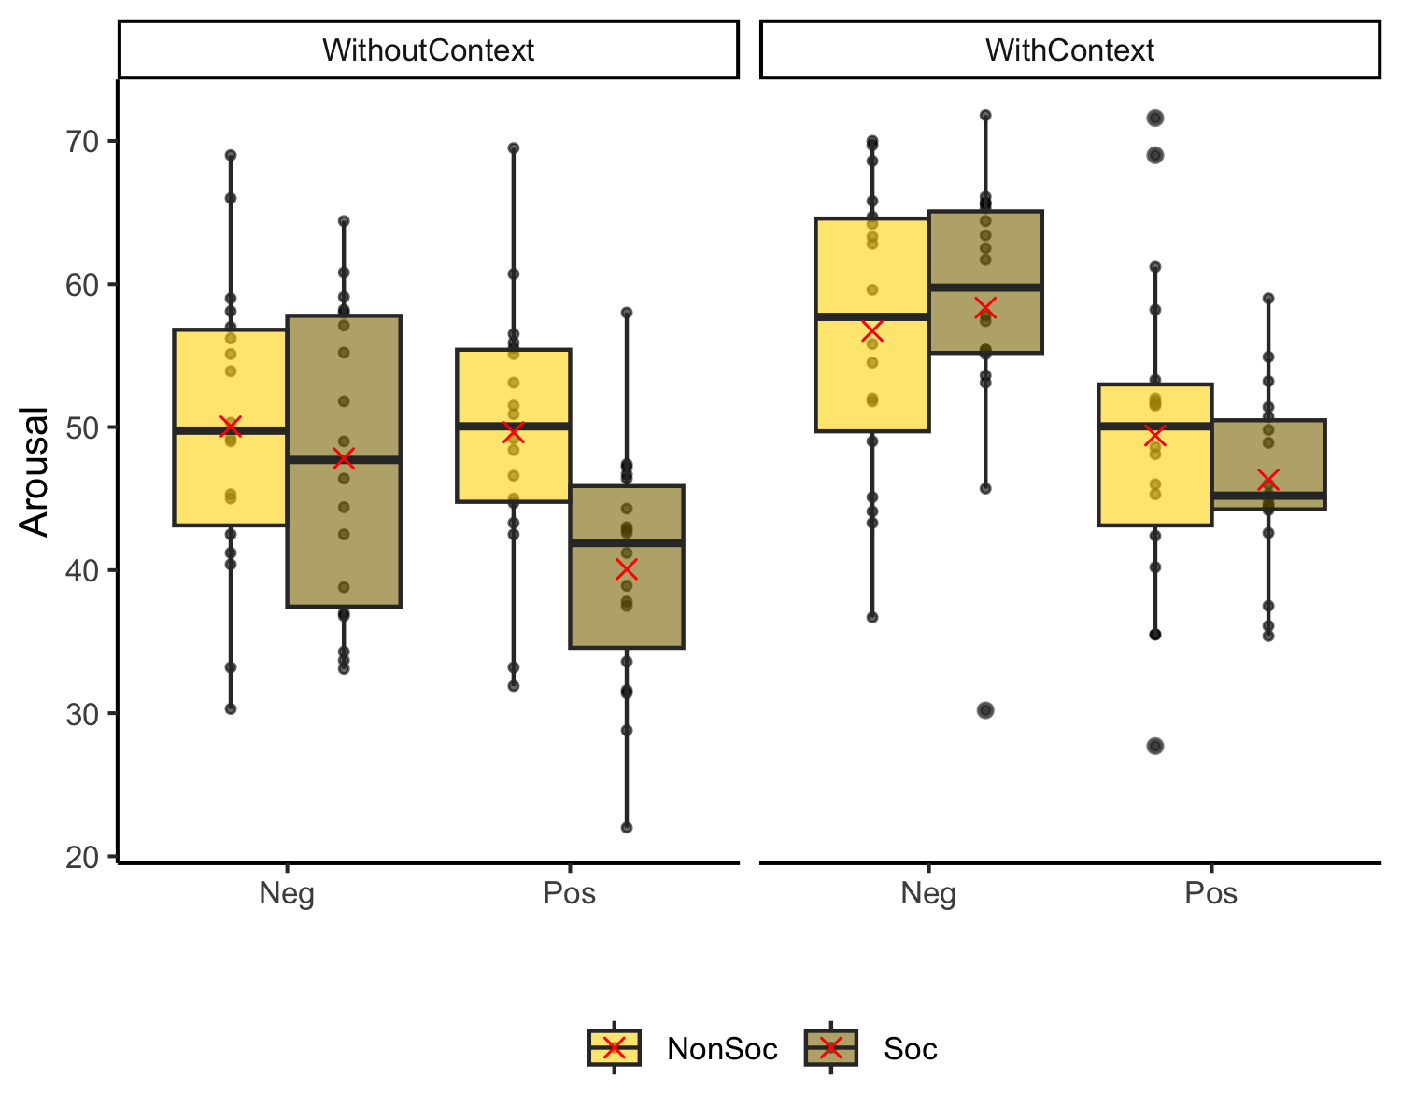
Figure 1: Observed arousal in each condition. The box plots represent the observed median arousal for our stimuli, with the interquartile range, the individual data points and the mean with the red cross, for each condition. WithContext= stimuli within context; WithoutContext= stimuli without context; NonSoc = non-social stimuli; Soc = social stimuli; Neg = negative stimuli; Pos = positive stimuli.

2 Main experiment

2.1 Analyses on images without context
Table 1:
Fixed effect estimates from CR analysis for the simple emotion condition of the EST. Results in the table represent the slope (b) with its standard error (SE) and 95% confidence interval as well as the z statistic (z) and the p-value (p) for each predictor.
Predictors | b | SE | z | p | Lower | Upper
Intercept | 2.47 | 0.15 | 16.42 | <0.001 | 2.18 | 2.77
Group | 0.34 | 0.10 | 3.37 | 0.001 | 0.14 | 0.53
Sex | 0.12 | 0.09 | 1.32 | 0.187 | -0.06 | 0.30
Social | -0.13 | 0.26 | -0.50 | 0.618 | -0.63 | 0.38
Emotion | 0.58 | 0.26 | 2.26 | 0.024 | 0.08 | 1.09
Psy/Neuro Diag | 0.04 | 0.15 | 0.28 | 0.782 | -0.25 | 0.33
NeuroDev Diag | 0.09 | 0.13 | 0.74 | 0.459 | -0.15 | 0.34
Group x Sex | -0.29 | 0.18 | -1.60 | 0.109 | -0.64 | 0.06
Group x Social | 0.10 | 0.10 | 0.97 | 0.333 | -0.10 | 0.29
Sex x Social | 0.05 | 0.10 | 0.49 | 0.621 | -0.15 | 0.24
Group x Emotion | 0.35 | 0.10 | 3.42 | 0.001 | 0.15 | 0.55
Social x Emotion | -0.49 | 0.51 | -0.96 | 0.339 | -1.50 | 0.52
Sex x Emotion | -0.35 | 0.10 | -3.47 | 0.001 | -0.55 | -0.15
Group x Sex x Social | -0.01 | 0.20 | -0.03 | 0.974 | -0.40 | 0.38
Group x Sex x Emotion | -0.27 | 0.20 | -1.30 | 0.192 | -0.66 | 0.13
Analyses of valence accuracy on the picture without context showed fewer correct responses for autistic than NA individuals ($β$ = 0.34, 95% CI [0.14, 0.53], p 0.001) and for negative than positive stimuli ($β$ = 0.58, 95% CI [0.08, 1.09], p 0.024). We also observed an interaction between group and emotion ($β$ = 0.35, 95% CI [0.15, 0.55], p 0.001), indicating a reduced difference in accuracy between positive and negative stimuli in autism compared to NA. Finaly, there was an interaction between sex and emotion ($β$ = -0.35, 95% CI [-0.55, -0.15], p 0.001), indicating a reduced difference in accuracy between positive and negative stimuli in males compared to females. Interaction are reprsented in the Figure 2.
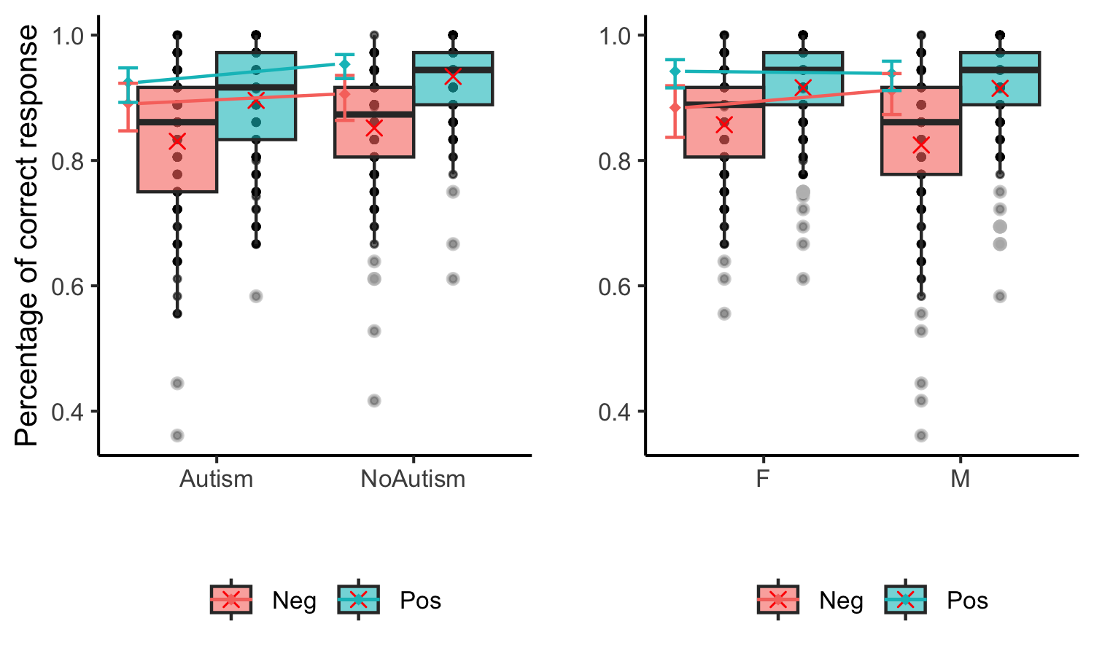
Figure 2: Interaction between Group, sex and the social content on correct responses. The box plot represent the obserevd median correct response rate (CR) for the emotion recognition with context, with the interquartile range and individual data points for each condition, and the red cross represent the observed mean. In addition, the coloured points represent the estimated marginal means with their 95% CI.

2.2 Table for analyses of the images with context

Table 2:
Fixed effect estimates from CR analysis for emotion recognition with context on the EST. Results in the table represent the slope (b) with its standard error (SE) and 95% confidence interval as well as the z statistic (z) and the p-value (p) for each predictor.
Predictors | b | SE | z | p | Lower | Upper
Intercept | 2.59 | 0.16 | 16.20 | <0.001 | 2.28 | 2.91
Group | 0.30 | 0.12 | 2.49 | 0.013 | 0.06 | 0.54
Shift | -2.90 | 0.28 | -10.20 | <0.001 | -3.45 | -2.34
Sex | 0.16 | 0.11 | 1.46 | 0.144 | -0.05 | 0.38
Social | -0.66 | 0.27 | -2.42 | 0.016 | -1.20 | -0.13
Emotion | -0.06 | 0.28 | -0.21 | 0.831 | -0.61 | 0.49
NeuroDev Diag | 0.12 | 0.13 | 0.88 | 0.378 | -0.15 | 0.38
Psy/Neuro Diag | 0.33 | 0.16 | 2.15 | 0.032 | 0.03 | 0.64
Group x Shift | 0.06 | 0.22 | 0.25 | 0.801 | -0.38 | 0.49
Group x Sex | -0.19 | 0.20 | -0.96 | 0.335 | -0.59 | 0.20
Shift x Sex | -0.25 | 0.21 | -1.15 | 0.25 | -0.66 | 0.17
Group x Social | 0.32 | 0.17 | 1.91 | 0.056 | -0.01 | 0.66
Shift x Social | -0.25 | 0.55 | -0.45 | 0.651 | -1.32 | 0.82
Sex x Social | -0.23 | 0.16 | -1.42 | 0.155 | -0.55 | 0.09
Group x Emotion | 0.36 | 0.18 | 1.94 | 0.052 | 0.00 | 0.72
Social x Emotion | 0.33 | 0.55 | 0.61 | 0.544 | -0.74 | 1.40
Sex x Emotion | -0.10 | 0.18 | -0.57 | 0.572 | -0.45 | 0.25
Shift x Emotion | -0.73 | 0.55 | -1.34 | 0.18 | -1.81 | 0.34
Group x Shift x Sex | 0.15 | 0.39 | 0.38 | 0.704 | -0.62 | 0.92
Group x Shift x Social | -0.06 | 0.33 | -0.19 | 0.852 | -0.72 | 0.59
Group x Sex x Social | 0.61 | 0.28 | 2.19 | 0.029 | 0.06 | 1.15
Shift x Sex x Social | 0.31 | 0.32 | 0.98 | 0.327 | -0.31 | 0.94
Group x Sex x Emotion | -0.01 | 0.30 | -0.02 | 0.981 | -0.60 | 0.59
Group x Shift x Sex x Emotion | 0.82 | 0.54 | 1.52 | 0.13 | -0.24 | 1.87

Table 3:
Fixed effect estimates from RT analysis for emotion recognition with context in the EST. Results in the table represent the slope (b) with its standard error (SE) and 95% confidence interval as well as the z statistic (z) and the p-value (p) for each predictor.
Predictors | b | SE | z | p | Lower | Upper
Intercept | 1,610.33 | 12.29 | 131.01 | <0.001 | 1,586.24 | 1,634.42
Group | -89.61 | 10.55 | -8.49 | <0.001 | -110.28 | -68.93
Shift | 157.63 | 10.38 | 15.18 | <0.001 | 137.28 | 177.97
Sex | 19.16 | 8.88 | 2.16 | 0.031 | 1.75 | 36.57
Social | 61.16 | 25.28 | 2.42 | 0.016 | 11.60 | 110.71
Emotion | -66.14 | 9.63 | -6.87 | <0.001 | -85.01 | -47.26
NeuroDev Diag | -1.19 | 9.28 | -0.13 | 0.898 | -19.38 | 17.01
Psy/Neuro Diag | -44.41 | 11.53 | -3.85 | <0.001 | -67.02 | -21.81
Group x Shift | -26.97 | 8.43 | -3.20 | 0.001 | -43.49 | -10.44
Group x Sex | 16.20 | 10.43 | 1.55 | 0.12 | -4.24 | 36.64
Shift x Sex | 33.76 | 10.75 | 3.14 | 0.002 | 12.69 | 54.83
Group x Social | -54.81 | 9.55 | -5.74 | <0.001 | -73.53 | -36.09
Shift x Social | 102.73 | 9.10 | 11.28 | <0.001 | 84.89 | 120.58
Sex x Social | 11.24 | 8.98 | 1.25 | 0.21 | -6.35 | 28.84
Group x Emotion | -27.96 | 11.10 | -2.52 | 0.012 | -49.70 | -6.21
Social x Emotion | 0.56 | 8.85 | 0.06 | 0.949 | -16.78 | 17.90
Sex x Emotion | 18.31 | 10.53 | 1.74 | 0.082 | -2.32 | 38.94
Shift x Emotion | 7.97 | 8.33 | 0.96 | 0.339 | -8.36 | 24.31
Group x Shift x Sex | 55.80 | 8.82 | 6.33 | <0.001 | 38.52 | 73.08
Group x Shift x Social | -41.83 | 8.74 | -4.79 | <0.001 | -58.97 | -24.70
Group x Sex x Social | -0.92 | 10.32 | -0.09 | 0.929 | -21.14 | 19.30
Shift x Sex x Social | -0.51 | 8.92 | -0.06 | 0.955 | -17.98 | 16.97
Group x Sex x Emotion | 24.35 | 12.40 | 1.96 | 0.05 | 0.04 | 48.66
Group x Shift x Sex x Emotion | 14.13 | 11.53 | 1.23 | 0.22 | -8.47 | 36.73

3 Correlational analyses
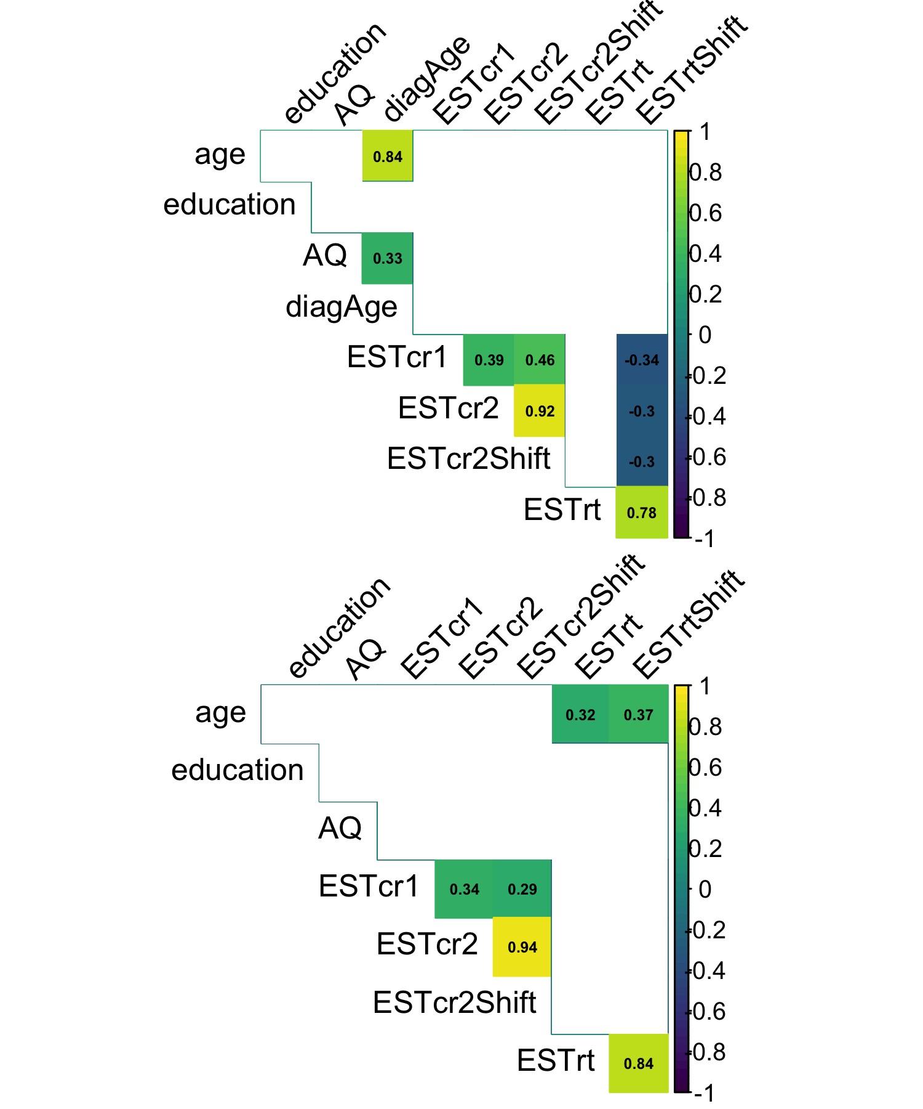
Figure 3: Correlation coefficient between demographic data and behavioral performances to the EST for autistic participants (top) and non-autistic participants (bottom). Significant correlations are coloured. EST = Emotionnal Shifting, cr = correct responses, 1 = without context, 2 = with context, rt = Response Time, Shift = shift condition only, AQ = Autism Quotient, diagAge = age at diagnosis.
Correlational analyses can be seen on Figure 3. While increased accuracy correlates with decreased response time in the shift condition in autism (r = -0.30, p = 0.026), this phenomenon is not observed in non-autistic individuals. Additionally, age significantly increases response time in non-autistic individuals r = 0.37, p = <0.001) but not in those with autism.
Interestingly, an increase in diagnostic age is associated with higher AQ (Autism Quotient) scores in autism (r = 0.84, p = <0.001), which may seem counterintuitive as higher autistic traits might be expected to lead to an earlier diagnosis. However, it could indicate that individuals with a later diagnosis possess a better understanding and awareness of their symptoms.

