Supplementary Results
Drolet experiment replication results

Table S1. Echocardiographic results at 12 weeks of intervention
 | Controls (n=6) | Experimentals (n=6) | P Value*
Aortic Valve Area (cm²) | 0.34±0.04 | 0.31±0.02 | 0.310
Values are mean±sd, *Mann-Whitney U test

Table S2. Serum Vitamin D2 levels by LC-MS/MS at 12 weeks of intervention
 | Controls (n=6) | Experimentals (n=6) | P Value*
Vitamin D2 | <LOD* | <LOD* | N/A
*LOD instrument: 12,8 ng/ml. LOD method: 19,1 ng/ml

Novel Protocol results

Table S3: Levels of serum and aortic valve tissue Vitamin D metabolites
Serum | 2 weeks |  |  | 7 weeks
Serum | Control Animals (n=6) | Experimental animals  (n=6) | p | Control animals (n=6) | Experimental  animals  (n=6) | p
D2 | <13 | 91.8 | 0.021 | <13 | 100 | <0.001
25-OH D2 | <7 | 794 | 0.023 | <7 | 660 | <0.001
1.25-(OH)2 D2 | <20 | <20 | n/a | <20 | <20 | n/a
D3 | <4.1 | <4.1 | n/a | <4.1 | <4.1 | n/a
25-(OH) D3 | <6.7 | 9.69 | 0.006 | <6.7 | <6.7 | n/a
1.25-(OH)2 D3 | <26 | 36.1 | 0.054 | <26 | 50.7 | 0.04
Aortic valve | - |  |  | 7 weeks
Aortic valve |  |  |  | Control animals  (n=4) | Experimental animals  (n=6) | p
D2 |  |  |  | < 1.8 # | < 1.8 # | n/a
25-OH D2 |  |  |  | <0.24 # | 34.98±9.8 | 0.008*
1.25-(OH)2 D2 |  |  |  | <0.74 # | <0.74 # | n/a
D3 |  |  |  | 16.95±7.9 | 33.3±15.5 | 0.199*
25-(OH)2 D3 |  |  |  | 9.9±3.83 | 5.76±9.5 | 0.187*
1.25-(OH)2 D3 |  |  |  | 352±625 | <0.43 # | 0.068*
*p value from Kruskal-Wallis test. # values below instrumental LOD value (the LOD value was used for calculations were applicable). N/A non-applicable

Table S4. Echocardiographic measurements
 | 2 weeks |  |  | 4 weeks |  |  | 7 weeks |  |  | Pooled  Controls  (n=15) | P value among weeks
 | Controls (n=5) | Experim.  (n=7) | P / P against pooled controls | Controls (n=7) | Experim.  (n=5) | P / P against pooled controls | Controls (n=3) | Experim.  (n=12) | P / P against pooled controls | Pooled  Controls  (n=15) | P value among weeks
Vmax | 81.1±5.6 | 95.8±2.1 | 0.252/  0.869 | 99.4±5.9 | 105.1±7.9 | 0.366/  0.05 | 94.4±3.8 | 116.9±18.8 | 0.005/  <0.001 | 92.3±11.5 | <0.001
Mean Gradient | 1.31±0.1 | 1.61±0.1 | 0.247/  0.327 | 1.43±0.1 | 1.71±0.3 | 0.231/  0.144 | 1.50±0.1 | 2.27±0.86 | 0.047/  <0.001 | 1.41±0.3 | 0.001
AVA | 0.56±0.1 | 0.42±0.1 | 0.037/  0.054 | 0.47±0.1 | 0.33±0.1 | 0.012/  0.002 | 0.47±0.1 | 0.33±0.1 | 0.032/  <0.001 | 0.52±0.1 | <0.001
P value obtained from Kruskal-Wallis 1-way ANOVA for all comparisons

Table S5: Serum biochemical analyses
 | 2 weeks |  |  | 4 weeks |  |  | 7 weeks
 | Controls (n=6) | Experim. (n=5) | P& value | Controls  (n=6) | Experim.(n=6) | P& value | Controls  (n=6) | Experim.(n=6) | P& value | Pooled  Controls  (n=18) | P value among weeks%
Glucose* (mg/dl) | 255.7±40.5 | 220.4±77.5 | 0.356/0.641 | 236.7±36.9 | 231.1±49.65 | 0.827/0.941 | 205.3±55.6 | 149.17±55.61 | 0.070/0.001 | 232.6±42.2 | 0.074
Total cholesterol# (mg/dl) | 45.1±12.7 | 349.1±4183.8 | 0.029/<0.001 | 43.7±7.5 | 669.3±231.9 | 0.008/<0.001 | 65.2±44.2 | 769.3±210.9 | 0.003/<0.001 | 52.2±28.4 | <0.001
LDL (mg/dl)# | 7.1±5.6 | 324.1±181.7 | 0.005/<0.001 | 7.7±5.4 | 623±223.2 | <0.001 | 27.1±38.3 | 736.7±198.9 | 0.004/<0.001 | 15.1±24.5 | <0.001
HDL* (mg/dl) | 20.7±8.8 | 18.4±4.2 | 0.612/0.242 | 24.8±4.4 | 27.1±4.6 | 0.429/0.139 | 21.5±7.23 | 19.1±5.33 | 0.511/0.293 | 22.3±6.9 | 0.014
Triglycerides# (mg/dl) | 60.5±10.6 | 34.1±12.4 | 0.298/0.013 | 56.1±14.5 | 92.3±53.3 | 0.446/0.032 | 71.8±24.6 | 68.5±41.9 | 0.684/0.297 | 62.7±18.9 | 0.020
Urea# (mg/dl) | 38.8±2.9 | 37.2±8.1 | 0.351/0.417 | 51.8±7.5 | 45.3±14.6 | 0.008/0.431 | 35.1±3.1 | 52.3±33.7 | 0.135/0.977 | 41.9±8.7 | 0.511
Creatinine# (mg/dl) | 1.2±0.2 | 1.4±0.3 | 0.353/0.018 | 1.1±0.1 | 1.7±0.5 | 0.039/0.007 | 1.1±0.2 | 1.3±0.3 | 0.095/0.006 | 1.1±0.2 | 0.013
Na* | 145.7±6.2 | 141.2±7.1 | 0.295/0.364 | 148.7±9.2 | 139.5±14.2 | 0.214/0.254 | 140.83±9.04 | 122.67±11.38 | 0.013/<0.001 | 145.1±8.5 | 0.030
K* | 4.3±0.5 | 4±0.07 | 0.221/0.094 | 4.5±0.37 | 4.1±0.7 | 0.226/0.334 | 4.2±0.47 | 3.85±0.97 | 0.412/0.091 | 4.4±0.4 | 0.814
Ca* | 13.1±0.8 | 13.2±0.7 | 0.794/0.633 | 13.4±1.1 | 14.6±1.5 | 0.130/0.044 | 12.43±0.87 | 13.48±2.41 | 0.339/0.440 | 12.9±0.9 | 0.365
Mg* | 2.8±0.3 | 2.7±0.3 | 0.724/0.328 | 2.3±0.2 | 2.8±0.4 | 0.416/0.184 | 2.4±0.46 | 2.65±0.74 | 0.499/0.506 | 2.5±0.4 | 0.946
SGOT# (mg/dl) | 12.1±4.2 | 15.2±5.8 | 0.483/0.563 | 22.5±10.7 | 25.5±15.1 | 0.036/0.130 | 13.1±2.9 | 16.1±10.7 | 0.386/0.482 | 17.2±8.8 | 0.253
SGPT# (mg/dl) | 33.5±2.1 | 30.2±9.8 | 0.483/0.176 | 23.8±4.5 | 63.7±27.8 | 0.002/0.021 | 29.2±7.6 | 34.1±14.4 | 0.785/0.156 | 27.4±6.5 | 0.051
g-GT# | 7.5±2.1 | 8.4±3.5 | 0.329/0.960 | 6.7±2.1 | 7.8±3.9 | 0.426/0.909 | 7.1±2.8 | 9.1±5.6 | 0.982/0.982 | 6.9±2.3 | 0.978
Hs-troponin-T# | 0.45±0.3 | 5.2±1.1 | 0.197/<0.001 | 0.61±0.2 | 19.2±16.1 | 0.004/<0.001 | 0.7±0.4 | 93.4±163.1 | 0.001/<0.001 | 0.63±0.3 | <0.001
Parathormone# | 21.9±7.1 | 6.9±4.6 | 0.089/<0.001 | 28.7±18.7 | 4.8±3.1 | 0.010/<0.001 | 28.9±13.3 | 10.4±10.5 | 0.024/<0.001 | 26.5±13.4 | <0.001
Values are mean±SD *=variables with normal distribution. # =variables with deviation from normal distribution. &= p value from t-test or Kruskal-Wallis test as appropriate. %= p value from ANOVA or Kruskal-Wallis test as appropriate

Throughout the intervention, experimental animals suffered from gradual weight loss, and mild arterial pressure increase. Beyond four weeks, animals demonstrated reduced appetite for the high-fat diet, reflected in a reduction in cholesterol and glucose levels, along with a parathormone increase, pointing towards a relative drop in the vitamin D2 serum levels.

 | 2 weeks |  |  | 4 weeks |  |  | 7 weeks
 | Controls (n=8) | Experim. (n=9) | P value | Controls  (n=6) | Experim.(n=6) | P value | Controls  (n=8) | Experim.(n=10) | P value | Pooled  Controls  (n=22) | P value among weeks%
Baseline weight (kg) | 4.21±0.3 | 4.44±0.4 | 0.005/0.002 | 4.3±0.3 | 4.1±0.2 | 0.004/<0.001 | 4.3±0.3 | 4.6±0.3 | 0.001/<0.001 | 4.29±0.3 | <0.001%
Final weight (kg) | 4.5±0.3 | 4.3±0.5 | 0.005/0.002 | 4.6±0.3 | 3.7±0.2 | 0.004/<0.001 | 4.7±0.3 | 3.8±0.6 | 0.001/<0.001 | 4.62±0.5 | <0.001%
Systolic BP&  (mmHg) |  | 76.5±10.1 | 0.63# | - | - | - |  | 91.3±8.5 | 0.057# | 77.3±10.7 | 0.081%
Diastolic BP& (mmHg) |  | 60.1±3.6 | 0.99# | - | - | - |  | 72.1±12.7 | 0.057# | 59.1±2.1 | 0.066%
Mean BP&  (mmHg) |  | 67.1±4.5 | 0.63# | - | - | - |  | 80.7±11.3 | 0.057# | 66.1±5.6 | 0.028%
P values calculated with t-test, #: p value calculated with Mann-Whitney test, %: p value calculated with Kruskal-Wallis test, &: pooled controls n=4, experimentals at 2 and 7 weeks, n=8.
Table S6. Rabbit weight and arterial pressure measurements

Table S7. Quantification of calcification activity with 18F-NaF microPET and γ-counting
 | Pooled Control animals  (n=5) | Experimental Animals
 | Pooled Control animals  (n=5) | 2 weeks |  | 4 weeks | 7 weeks
 | Pooled Control animals  (n=5) | (n=5) | P* | (n=1) | (n=4) | P* | P among groups#
SUV max | 1.19±0.33 | 1.23±0.37 | 0.940 | 4.43 | 6.69±1.11 | 0.011 | 0.018
SUVmean | 0.03±0.01 | 0.02±0.01 | 0.878 | 0.08 | 0.10±0.06 | 0.014 | 0.017
SUV S.D. | 0.08±0.04 | 0.1±0.04 | 0.704 | 0.57 | 0.52±0.17 | 0.007 | 0.016
Volume$ | 2.57±2.8 | 2.87±1.8 | & | 3.71 | 3.1±2.2 | & | 0.593
g-counts | 19816.5±5442.4 | 16546.1±8773.6 | 0.564 | - | 109226.1±22663.2 | 0.037^ | 0.024@
p values obtained from Kruskal-Wallis test. *: versus pooled controls. #: among all groups (Kruskal-Wallis one-way ANOVA). &: not performed as the overall test does not show significant differences across subgroups. $: VOI sphere volume. # p value obtained with ROC test. AUC=0.375. ^ p value obtained with ROC test. AUC=1. @ p value obtained with Spearman’s rho test for correlation between SUVmax and γ-counts. correlation coefficient = 0.636)

Table S8. Interpretation of FT-IR vibrations
Band position (cm⁻¹) | Assignment
2930 | ν_{asym}(CH₂) lipids and carbohydrates, ν(CH₂) nucleic acids
2850 | ν_{sym}(CH₃) lipids, ν(CH₂) nucleic acids
1740 | ν(CO) lipids, ν(CO) nucleic acids
1650 | v(C=O) and v(C ̶ N) and δ(N ̶ H) proteins (Amide I), v(C=O)  nucleic acids (DNA); δ(N ̶ H) nucleic acids (RNA)
1540 | δ(N=H) and v(C=N) proteins (Amide II)
1460 | v₃(CO²⁻₃) inorganic ions
1240 | γ(CH₂) lipids, ν(C-O-C) carbohydrates, δ_{s}(NH) and ν(C-N) proteins (Amide III), ν_{asym}(PO₂⁻) phosphorylated proteins, ν_{asym}(PO₂⁻) nucleic acids, υ_{as}(SO₃⁻) in glycosaminoglycans
1085 | PO³⁻₄ inorganic ions. SiO²⁻₄ inorganic  ions

Analysis of inorganic residues via Raman spectroscopy

Raman spectra from the precipitated samples confirmed the presence of hydroxyapatite in the 7- and 4-week experimental samples, as a relatively intense Raman band appeared at 960 cm⁻¹, with a gradual longitudinal increase in its intensity. Even at the 2-week stage, a weak signal at this frequency suggested the presence of hydroxyapatite (Extended Data, Figure 1). Notably, the proline band at 855 cm⁻¹, corresponding mainly to proline in collagen, appeared at all the different stages of CAVD.
Figure S1. Raman spectroscopy analysis
Fig S1. Raman spectra obtained from precipitated samples at various stages of CAVD show bands of cell residues as increased intensity of the hydroxyapatite band at 960 cm⁻¹. Sulfate anion narrow band at 982 cm⁻¹ is due to neutralization of the homogenization buffer solution that is included in samples preparation. Representative spectra, of at least 5 measurements per sample, of at least 2 samples per group.

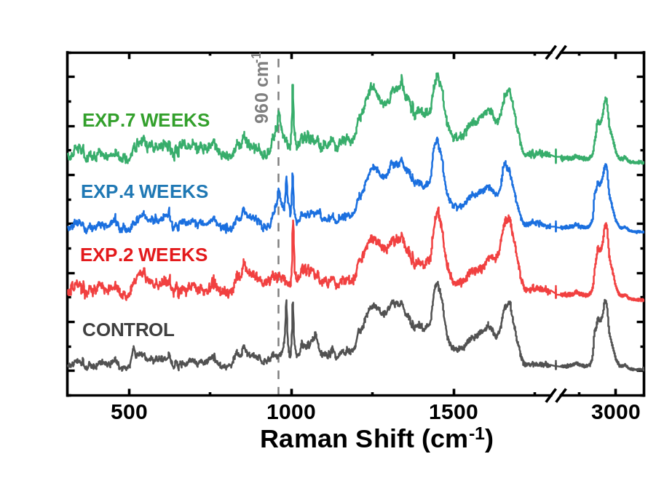

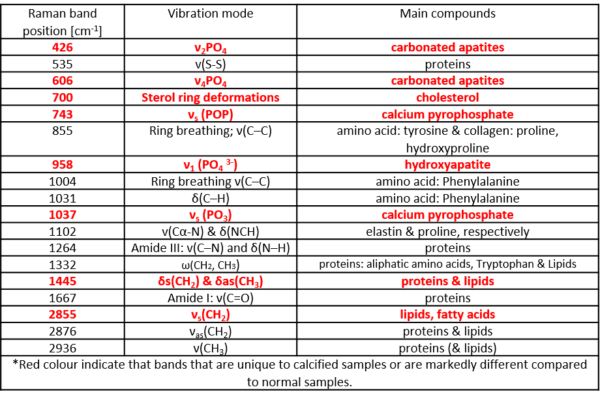
Interpretation of Raman vibrations
Figure S2. Representative echocardiographic images of the rabbit aortic valve
 | Control | Experimental
2 weeks | 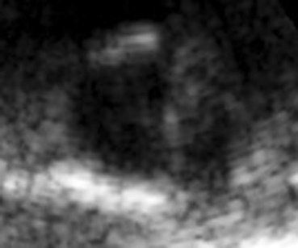 | 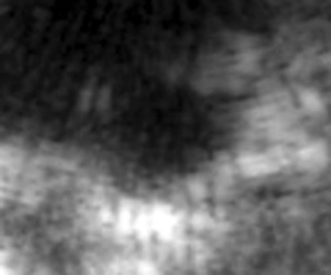
7 weeks | 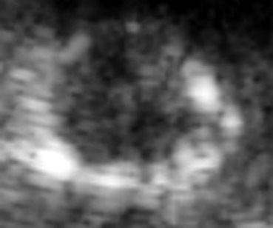 | 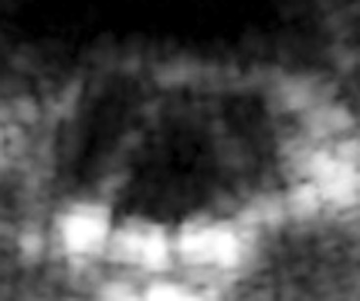

Figure S3. Representative microCT and microPET fusion imaging

 | CT image | microPET fusion 1 | microPET fusion 2
Control animal cusp | 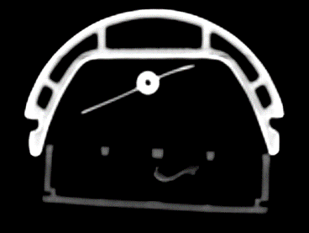 | 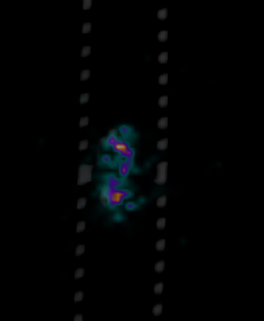 | 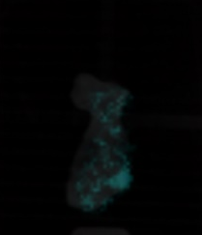
Experimental animal cusp – 2 weeks | 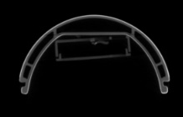 |  | 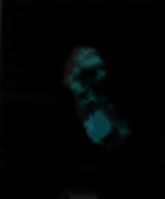
Experimental animal cusp – 4 weeks | 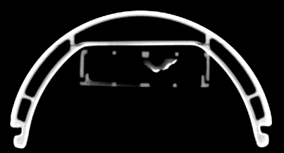 | 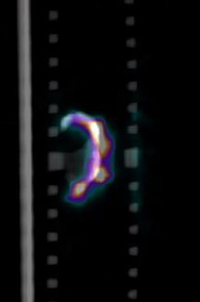 | 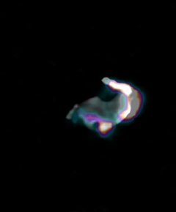
Experimental animal cusp – 7 weeks | 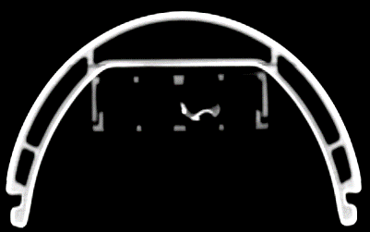 | 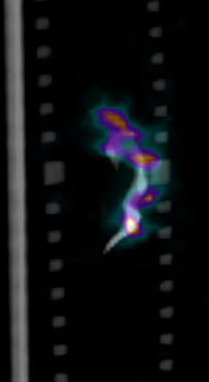 | 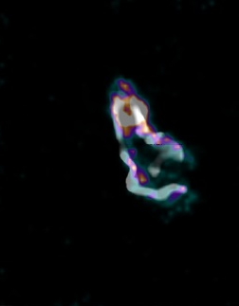
microPET images are fusion images of [¹⁸F]-NaF activity, up to the 75% of SUVmax and CT.

Figure S4. Immunofluorescence image of an aortic valve section at 7 weeks stained against RUNX2 (green), and WGA (red), blue = DAPI.

Figure S5. Immunohistochemistry brightfield image of an aortic valve section at 7 weeks stained against osteopontin.

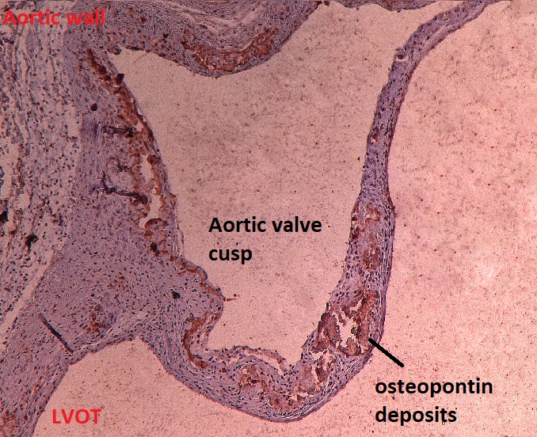

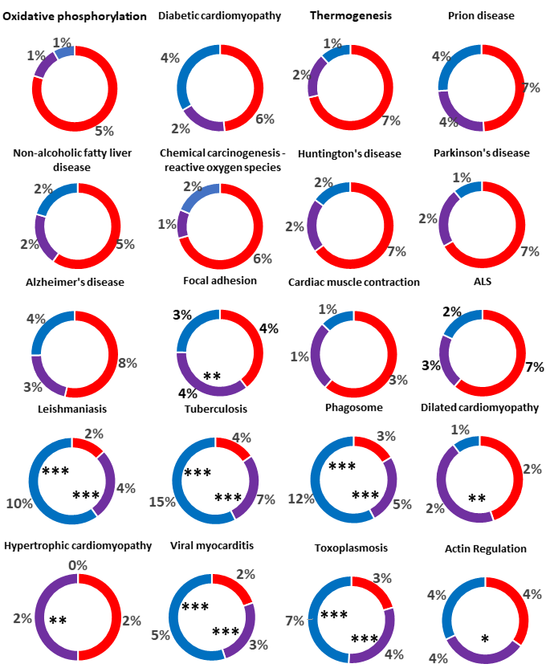
Figure S6 (1 out of 3). Longitudinal mRNA KEGG patwhay coverage plots. Significant pathways (FDR < 0.05) sorted by FDR in the analysis 7 versus 2 weeks. Percentages denotes coverage of the reference pathway’s genes. Red colour: 7 versus 2 weeks, Purple: 7 weeks versus controls, Blue: 4 weeks versus controls. All red pathways are significant in the 7 versus 2 weeks comparison. For the rest *** denotes FDR<0.001, ** FDR<0.01

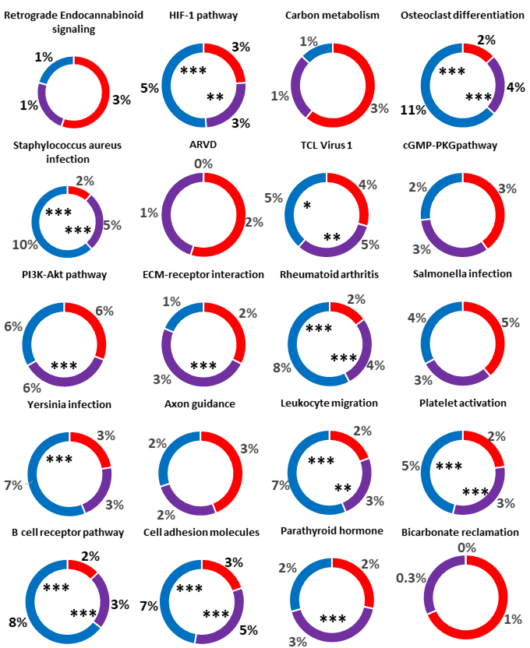
Figure S6 (2 out of 3)
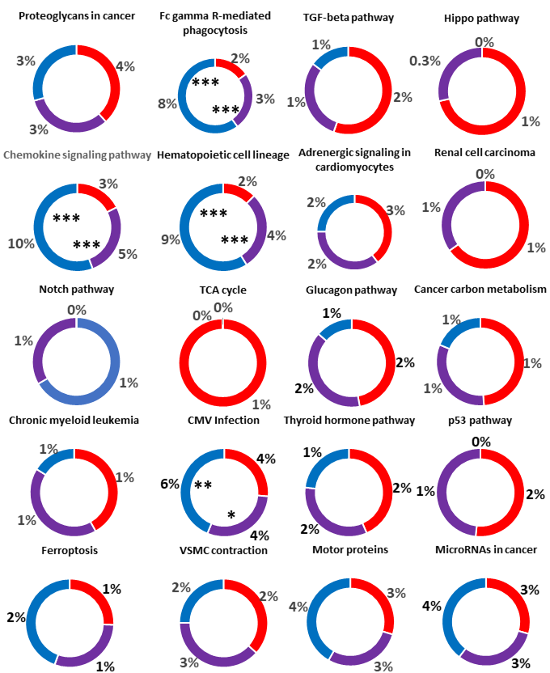
Figure S6 (3 out of 3).
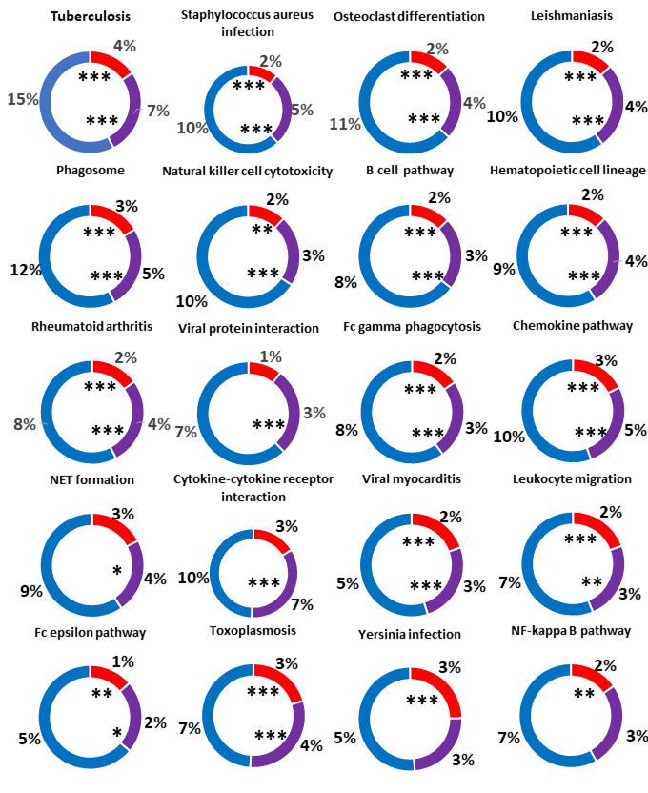
Figure S7 (1 out of 2). Longitudinal mRNA KEGG patwhay coverage plots. Significant pathways (FDR < 0.05) sorted by FDR in the analysis 4 weeks versus controls. Percentages denotes coverage of the reference pathway’s genes. Red colour: 7 versus 2 weeks, Purple: 7 weeks versus controls, Blue: 4 weeks versus controls. All red pathways are significant in the 4 weeks versus controls comparison. For the rest *** denotes FDR<0.001, ** FDR<0.01, * FDR<0.05
Figure S7 (2 out of 2).
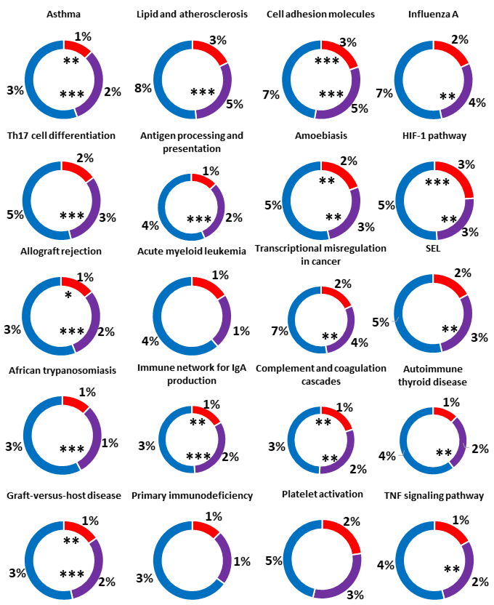
Table S9. MicroRNA differential expression results

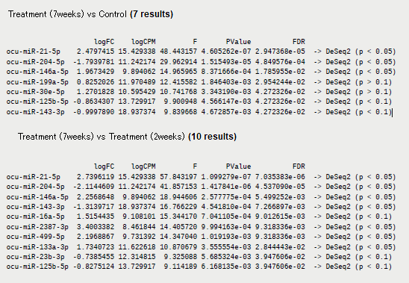
Table S10. Selected mRNA expression (1 of 3)

 | 2 weeks DE |  | 4 weeks DE |  | 7 weeks DE |  | 7 vs 2 weeks DE
Gene | Log2Fold | FDR | Log2Fold | FDR | Log2Fold | FDR | Log2Fold | FDR
Inflammation
IL10RA | 0.05 | 0.974 | 2.286 | 0.019 | 2.427 | 0.007 | 2.378 | 0.002
IL1R1 | -0.111 | 0.87 | 0.37 | 0.547 | 0.696 | 0.062 | 0.808 | 0.016
IL6R | 0.142 | 0.882 | 1.381 | 0.035 | 1.267 | 0.025 | 1.124 | 0.017
TNFRSF1B | -0.241 | 0.665 | 0.92 | 0.038 | 1.273 | 0.006 | 1.515 | <0,001
CXCR1 | 0.228 | 0.885 | 1.911 | 0.065 | 2.167 | 0.019 | 1.928 | 0.012
CXCR2 | -0.006 | 0.998 | 0.625 | 0.71 | 2.125 | 0.023 | 2.132 | 0.008
CXCL14 | -1.105 | 0.573 | 2.147 | 0.116 | 3.896 | 0.006 | 5.001 | <0,001
C1R | -0.179 | 0.859 | 1.092 | 0.124 | 1.171 | 0.046 | 1.351 | 0.011
C3AR1 | 0.3 | 0.741 | 2.085 | 0.019 | 1.851 | 0.007 | 1.551 | 0.004
C5AR1 | -0.336 | 0.771 | 2.445 | 0.019 | 2.448 | 0.006 | 2.784 | 0.001
DNA damage response
PPRC1 | 0.546 | 0.14 | 0.247 | 0.657 | -0.176 | 0.566 | -0.722 | 0.01
PARPBP | 0.112 | 0.948 | 1.235 | 0.262 | 1.429 | 0.079 | 1.317 | 0.052
RAD51 | 0.751 | 0.488 | 1.917 | 0.045 | 0.941 | 0.019 | 1.23 | 0.052
PERM1 | -2.783 | 0.094 | -0.92 | 0.681 | -0.109 | 0.94 | 2.674 | 0.021
Hypoxia
HIGD1B | -1.289 | 0.13 | 1.923 | 0.677 | 0.866 | 0.18 | 2.155 | 0.003
HILPDA | 0.044 | 0.943 | 0.291 | 0.57 | 0.631 | 0.044 | 0.588 | 0.026
HIF3A | -0.576 | 0.583 | -0.037 | 0.987 | 0.862 | 0.218 | 1.438 | 0.026
Mechanotransduction
YAP1 | 0.328 | 0.545 | -0.083 | 0.931 | -0.402 | 0.28 | -0.732 | 0.029
NOTCH2 | 0.178 | 0.596 | -0.209 | 0.596 | -0.46 | 0.049 | -0.638 | 0.005
MAPK1 | 0.459 | 0.145 | -0.092 | 0.878 | -0.356 | 0.158 | -0.815 | 0.003
MAPK4 | 0.876 | 0.176 | -0.257 | 0.822 | -1.421 | 0.017 | -2.298 | <0,001
DDR2 | 0.462 | 0.282 | -0.275 | 0.664 | -0.71 | 0.047 | -1.172 | 0.002
EndMT
TGFB2 | 0.352 | 0.349 | -0.569 | 0.124 | -0.992 | 0.007 | -1.344 | <0,001
ACTA2 | 0.803 | 0.198 | -0.355 | 0.717 | -1.135 | 0.036 | -1.938 | 0.001
PECAM1 | -0.241 | 0.759 | 0.024 | 0.987 | 0.921 | 0.058 | 1.162 | 0.01
CDH2 | -1.961 | 0.105 | -0.538 | 0.776 | -0.053 | 0.964 | 1.908 | 0.025
MMP13 | 1.839 | 0.571 | 3.43 | 0.179 | 6.752 | 0.006 | 4.912 | 0.003
Fibrotic-related
TAGLN | 0.23 | 0.689 | -0.143 | 0.903 | -0.426 | 0.3557 | -0.989 | 0.02
PLA2G7 | -0.336 | 0.682 | 0.775 | 0.277 | 0.926 | 0.077 | 1.262 | 0.01
PRG4 | 0.971 | 0.369 | 2.715 | 0.019 | 2.892 | 0.007 | 1.921 | 0.013
PCOLCE2 | 0.384 | 0.237 | -0.199 | 0.685 | -0.71 | 0.016 | -1.095 | <0,001
SERPINA3 | 2.595 | 0.207 | 4.131 | 0.043 | 5.105 | 0.009 | 2.509 | 0.032
Table S10. Selected mRNA expression (2 of 3)

 | 2 weeks DE |  | 4 weeks DE |  | 7 weeks DE |  | 7 vs 2 weeks DE
Gene | Log2Fold | FDR | Log2Fold | FDR | Log2Fold | FDR | Log2Fold | FDR
Osteogenic-related
RUNX2 | -0.796 | 0.386 | -0.04 | 0.984 | 0.737 | 0.268 | 1.533 | 0.015
SPP1 | 1.312 | 0.106 | 1.304 | 0.103 | 2.0185 | 0.009 | 0.706 | 0.175
CORO1A | 0.219 | 0.858 | 2.593 | 0.019 | 2.508 | 0.006 | 2.289 | 0.002
HCLS1 | 0.094 | 0.949 | 2.516 | 0.019 | 2.408 | 0.008 | 2.314 | 0.003
LCP1 | -0.108 | 0.948 | 2.749 | 0.019 | 3.162 | 0.006 | 3.27 | 0.001
VWF | -0.109 | 0.927 | 0.147 | 0.921 | 1.338 | 0.038 | 1.445 | 0.012
CD74 | -0.25 | 0.875 | 2.271 | 0.043 | 2.597 | 0.013 | 2.847 | 0.003
COL6A3 | -0.035 | 0.977 | 0.938 | 0.259 | 0.987 | 0.104 | 1.021 | 0.05
CD79A | -0.712 | 0.617 | 2.023 | 0.058 | 2.754 | 0.008 | 3.466 | 0.001
VIC-type related
ALPL | 0.053 | 0.968 | 1.183 | 0.141 | 1.384 | 0.038 | 1.331 | 0.020
ANPEP | -0.078 | 0.955 | 0.888 | 0.373 | 0.071 | 0.931 | 0.149 | 0.812
BGLAP | 0.011 | 0.995 | -1.196 | 0.277 | -2.523 | 0.012 | -2.534 | 0.004
CD34 | -0.380 | 0.400 | -0.247 | 0.707 | -0.130 | 0.721 | 0.250 | 0.380
CD44 | 0.394 | 0.419 | 0.522 | 0.313 | 0.298 | 0.409 | -0.096 | 0.774
CD59 | -0.555 | 0.322 | -0.215 | 0.822 | 0.161 | 0.732 | 0.716 | 0.057
COL8A1 | 0.501 | 0.579 | 0.479 | 0.680 | 1.055 | 0.090 | 0.554 | 0.275
CTHRC1 | 0.279 | 0.911 | 0.830 | 0.752 | 1.240 | 0.332 | 0.961 | 0.369
DES | -1.759 | 0.132 | -0.303 | 0.892 | 0.982 | 0.281 | 2.741 | 0.005
ELN | 1.873 | 0.071 | 0.343 | 0.797 | -0.202 | 0.766 | -2.075 | 0.003
ENG | -0.213 | 0.772 | 0.282 | 0.749 | 1.001 | 0.032 | 1.214 | 0.005
FKBP5 | -0.156 | 0.930 | 0.045 | 0.988 | 0.991 | 0.263 | 1.147 | 0.126
GFAP | 0.370 | 0.751 | 0.785 | 0.486 | 0.923 | 0.185 | 0.553 | 0.341
ID4 | 0.157 | 0.830 | 0.231 | 0.798 | -0.190 | 0.666 | -0.348 | 0.320
ITGB1 | 0.775 | 0.114 | -0.166 | 0.846 | -0.600 | 0.119 | -1.374 | 0.002
MAOA | -0.064 | 0.938 | 0.248 | 0.767 | 0.109 | 0.808 | 0.173 | 0.624
MEOX1 | 0.660 | 0.217 | 0.026 | 0.984 | -0.033 | 0.952 | -0.693 | 0.061
NT5E | 0.550 | 0.371 | 0.141 | 0.905 | -0.376 | 0.421 | -0.926 | 0.028
PLXNA2 | 0.223 | 0.696 | 0.501 | 0.323 | 0.545 | 0.124 | 0.323 | 0.272
RPS6 | -0.197 | 0.680 | 0.012 | 0.991 | 0.044 | 0.900 | 0.241 | 0.338
SORL1 | 0.224 | 0.778 | 0.464 | 0.559 | 0.531 | 0.245 | 0.307 | 0.432
SPP1 | 1.312 | 0.106 | 1.304 | 0.103 | 2.019 | 0.009 | 0.706 | 0.175
TGFBR2 | 0.541 | 0.689 | 0.150 | 0.947 | -0.180 | 0.854 | -0.721 | 0.307
THY1 | -0.362 | 0.448 | -0.118 | 0.891 | -0.405 | 0.242 | -0.043 | 0.899
TMTC1 | 0.132 | 0.915 | -0.501 | 0.677 | -0.655 | 0.298 | -0.787 | 0.137
VIM | 0.440 | 0.262 | 0.035 | 0.968 | -0.455 | 0.141 | -0.896 | 0.005

Table S10. Selected mRNA expression (3 of 3)

 | 2 weeks DE |  | 4 weeks DE |  | 7 weeks DE |  | 7 vs 2 weeks DE
Gene | Log2Fold | FDR | Log2Fold | FDR | Log2Fold | FDR | Log2Fold | FDR
ROS related
NOS2 | -0.610 | 0.348 | 1.390 | 0.027 | 2.225 | 0.003 | 2.836 | 0.000
NOX4 | 0.632 | 0.183 | 0.120 | 0.901 | -0.065 | 0.884 | -0.697 | 0.039
MAOB | 0.116 | 0.805 | -0.059 | 0.932 | -0.630 | 0.031 | -0.746 | 0.006
SOD3 | 0.207 | 0.755 | -0.309 | 0.681 | -0.840 | 0.045 | -1.047 | 0.007
DDAH2 | 0.251 | 0.597 | -0.277 | 0.638 | -0.448 | 0.157 | -0.699 | 0.017
GSTO1 | -0.428 | 0.242 | 0.123 | 0.851 | 0.319 | 0.270 | 0.747 | 0.009
COX6C | -1.230 | 0.099 | -0.409 | 0.712 | 0.250 | 0.678 | 1.480 | 0.008
NDUFA4L2 | -0.926 | 0.206 | 0.934 | 0.225 | 2.016 | 0.007 | 2.943 | 0.000
SDHD | -0.722 | 0.249 | -0.372 | 0.648 | 0.278 | 0.588 | 1.000 | 0.026
G-Glutamyl Putrescine & Orntihine related
GCLC | 0.014 | 0.987 | -0.152 | 0.872 | -0.117 | 0.796 | -0.131 | 0.720
TGM2 | -0.414 | 0.310 | 0.094 | 0.907 | 0.206 | 0.524 | 0.620 | 0.029
TGM3 | -0.526 | 0.671 | -0.582 | 0.699 | -0.955 | 0.237 | -0.429 | 0.544
F13A1 | -0.118 | 0.913 | 0.799 | 0.310 | 1.087 | 0.059 | 1.206 | 0.018
EPB42 | -0.196 | 0.927 | 0.172 | 0.950 | 1.757 | 0.083 | 1.953 | 0.029
AZIN2 | -0.110 | 0.810 | 0.104 | 0.942 | 0.744 | 0.173 | 0.910 | 0.056
CGAS | -0.323 | 0.804 | 1.409 | 0.118 | 1.788 | 0.023 | 2.111 | 0.004
Mevalonate related
MVK | 0.024 | 0.978 | 0.281 | 0.742 | -0.123 | 0.798 | -0.147 | 0.703
PMVK | -0.419 | 0.398 | -0.052 | 0.958 | 0.029 | 0.951 | 0.448 | 0.149
MVD | 3.280 | 0.895 | -0.065 | 0.958 | -0.243 | 0.611 | -0.358 | 0.351
Phospholipids related
PLA2G7 | -0.336 | 0.683 | 0.775 | 0.277 | 0.926 | 0.078 | 1.262 | 0.011
CDS2 | 0.746 | 0.085 | -0.467 | 0.307 | -0.941 | 0.013 | -1.687 | 0.000
PIK3R5 | -0.108 | 0.943 | 1.987 | 0.034 | 2.083 | 0.013 | 2.191 | 0.004
PIK3CB | -0.351 | 0.290 | 0.121 | 0.834 | 0.263 | 0.307 | 0.615 | 0.013
PIK3C2A | 0.285 | 0.586 | -0.138 | 0.866 | -0.374 | 0.288 | -0.659 | 0.035
PIK3CG | -0.372 | 0.786 | 1.344 | 0.192 | 1.572 | 0.055 | 1.944 | 0.011
Other
POU2F2 | 0.061 | 0.971 | 2.315 | 0.021 | 2.926 | 0.006 | 2.865 | 0.001

Table S11. Differentially Expressed proteins at 7 weeks of intervention. sorted by p value (p<0.05)
Symbol | Log2_Ratio.CasevsControl | MW_p_CasevsControl
Downregulated
CLIC6 | -1.0065 | 0.0043
PFKP | -1.0419 | 0.0043
CKB | -1.1836 | 0.0043
PPIA | -1.1837 | 0.0043
PPP1CB | -1.1988 | 0.0043
PRKG1 | -1.5640 | 0.0043
MYLK | -1.8668 | 0.0043
CACNA2D1 | -2.6840 | 0.0043
SERPINA6 | Only in Control | 0.0055
ACTA2 | -0.6391 | 0.0087
PYGM | -1.0656 | 0.0087
MYH11 | -1.1161 | 0.0087
AKR1C5 | -1.2574 | 0.0087
TES | -1.4682 | 0.0087
CAMK2D | -1.7453 | 0.0087
BCHE | Only in Control | 0.0169
GOT2 | -0.7542 | 0.0173
ANXA11 | -0.7745 | 0.0173
MYL1 | -0.7876 | 0.0173
SLMAP | -0.9480 | 0.0173
SOD3 | -1.0740 | 0.0173
DAG1 | -1.5656 | 0.0173
FKBP1A | -1.2811 | 0.0222
GYG1 | -2.5640 | 0.0277
PEBP1 | -0.6668 | 0.0303
OGN | -0.6891 | 0.0303
ATP2A1 | -0.7226 | 0.0303
CAPZA2 | -0.7638 | 0.0303
ABCC2 | -1.1391 | 0.0303
RYR2 | -1.6111 | 0.0303
ADCY5 | -0.9587 | 0.0353
NOS1 | Only in Control | 0.0446
CACNB1 | Only in Control | 0.0446
ACAP2 | Only in Control | 0.0446
SLC4A9 | Only in Control | 0.0446
Upregulated
APOB | Only in Case | 0.0039
APOD | Only in Case | 0.0039
B2M | Only in Case | 0.0039
YBX1 | Only in Case | 0.0039
HMGCR | Only in Case | 0.0039
KV04_RABIT | 5.5196 | 0.0043
APOE | 3.6582 | 0.0043
AHSG | 2.7453 | 0.0043
CLU | 2.4471 | 0.0043
SSR1 | 2.2230 | 0.0043
FN1 | 2.0014 | 0.0043
TF | 1.7693 | 0.0043
VTN | 1.6111 | 0.0043
LGALS3 | 1.4909 | 0.0043
IGHG_RABIT | 1.2642 | 0.0043
CES2 | 1.1001 | 0.0043
SERPIND1 | 0.9266 | 0.0043
COL12A1 | 7.1493 | 0.0055
CD14 | 5.2943 | 0.0055
F10 | 5.1820 | 0.0055
MGP | 3.0269 | 0.0067
RAD51 | 2.8516 | 0.0067
ITIH3 | 4.0478 | 0.0075
CST3 | 2.1065 | 0.0075
SLC12A4 | 1.9814 | 0.0075
C3 | 1.6024 | 0.0087
HRG | 1.4172 | 0.0087
PON1 | 0.9140 | 0.0087
ATP1B3 | 3.7293 | 0.0097
ETF1 | 3.0381 | 0.0097
RBP4 | 2.4601 | 0.0116
ANXA8 | 2.3337 | 0.0116
C8B | Only in Case | 0.0150
ATP6V1D | Only in Case | 0.0150
H13_RABIT | Only in Case | 0.0150
FTL | 1.4277 | 0.0173
TGFBI | 1.3366 | 0.0173
KAC4_RABIT | 0.9396 | 0.0173
FTH1 | 2.1101 | 0.0222
MMP2 | 5.2075 | 0.0285
PRKCG | 4.4827 | 0.0285
FGB | 1.1888 | 0.0303
GC | 0.7751 | 0.0303
P4HB | 0.6405 | 0.0303
MYH4 | 3.9807 | 0.0444
TIMP1 | 3.6753 | 0.0444
KV13_RABIT | 3.2784 | 0.0444
FLNB | 2.6759 | 0.0444
RNF207 | 5.8055 | 0.0465
CD63 | 3.1077 | 0.0465
SORL1 | Only in Case | 0.0476
SPARC | Only in Case | 0.0484
C8G | Only in Case | 0.0484
CRYBA2 | Only in Case | 0.0484
KV05_RABIT | Only in Case | 0.0484
JCHAIN | Only in Case | 0.0484
T5 | Only in Case | 0.0484
SLC9A3 | Only in Case | 0.0484
CYP2J1 | Only in Case | 0.0484
CYP2A10 | Only in Case | 0.0484

Table S12. Top differentially expressed tissue metabolites at 7 weeks of intervention.
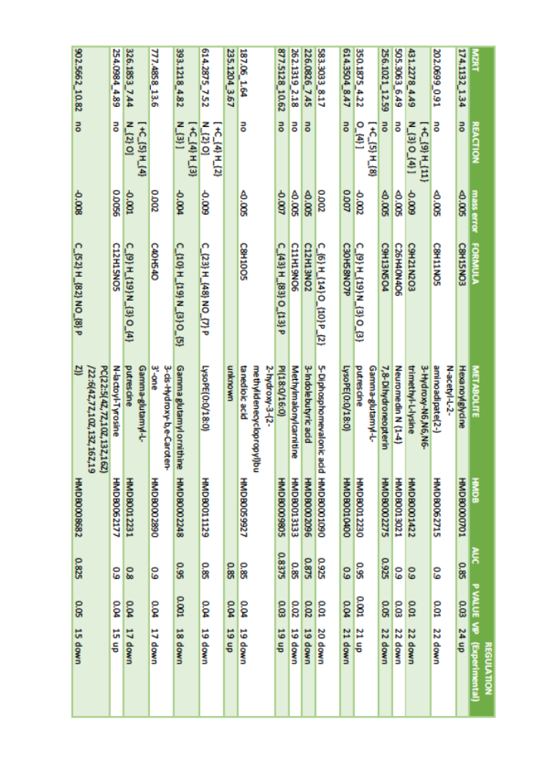

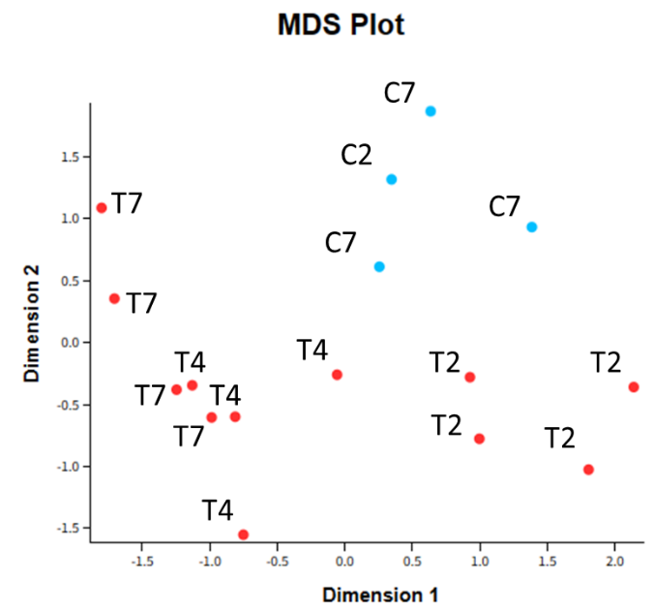
mRNA diferrential expression discrimation among groups

Number of differentially expressed genes per group

microRNA differential expression heatmap at 7 weeks
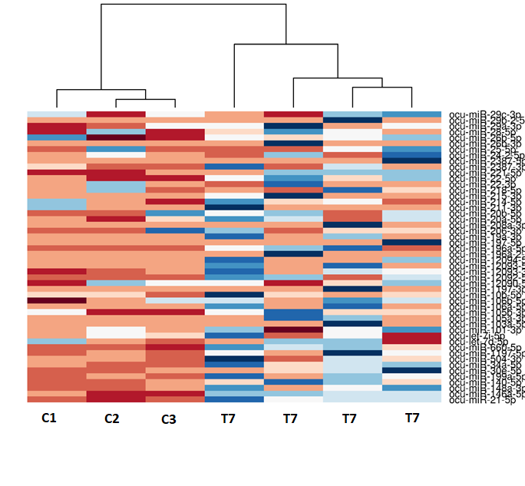

Proteomics differential expression discrimination among groups and heatmap
Discrimination among valve stenosis and control valves by proteomic analysis.

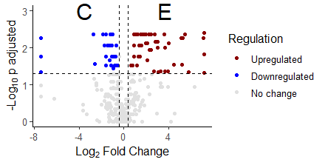
Volcano plot and heatmap of differential expressed proteins at the 0.05 significance level.
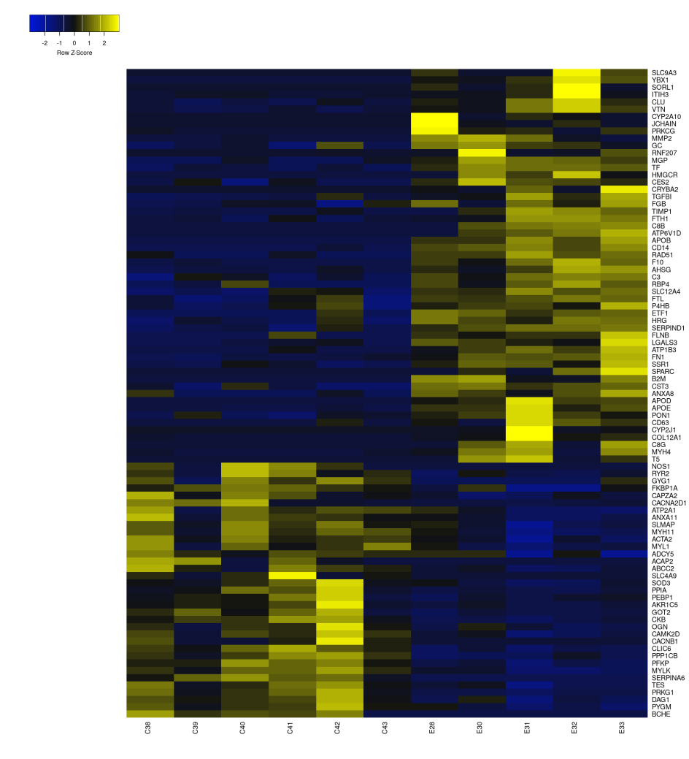

Metabolomics differential expression discrimination among groups and heatmap

Discrimination among experimental and control valves by metabolomic analysis.

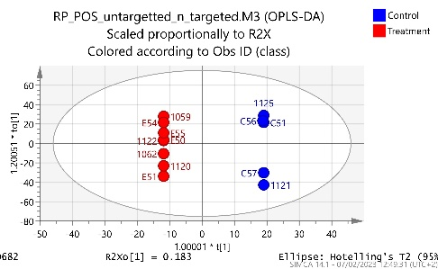

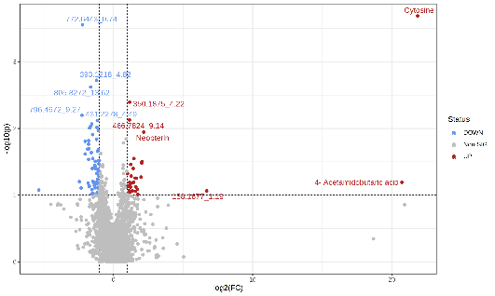
Volcano plot and heatmap of differential expressed metabolites.
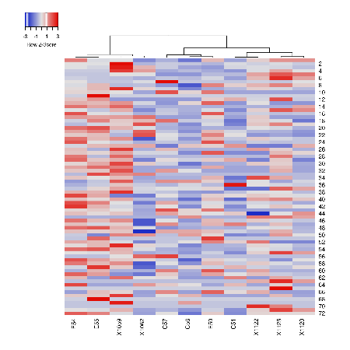

Heart transplantation recipients demographics and primary disease

Patient | Age | Gender | Indication for heart transplantation
1 | 57 | M | Dilated cardiomyopathy - advanced heart failure
2 | 56 | M | Dilated cardiomyopathy - advanced heart failure
3 | 54 | M | Dilated cardiomyopathy - advanced heart failure
4 | 49 | M | Ischemic cardiomyopathy - advanced heart failure
5 | 36 | M | Hypertrophic cardiomyopathy - advanced heart failure
6 | 59 | M | Ischemic cardiomyopathy - advanced heart failure
7 | 45 | M | Dilated cardiomyopathy - advanced heart failure
8 | 53 | M | Dilated cardiomyopathy - advanced heart failure
9 | 54 | M | Dilated cardiomyopathy - advanced heart failure
10 | 42 | F | Dilated cardiomyopathy - advanced heart failure

CAVS cohort descriptives (n=17)
Variable | Value
Clinical history and medications
Age (years) | 69.2±10.4
Gender (male) | 76.5%
Hypertension | 88.2%
Diabetes Mellitus | 35.3%
Current smoking | 23.5%
Ex smoking | 64.7%
Dyslipidemia | 70.6%
Coronary heart disease | 35.3%
Stage III or IV chronic kidney disease | 17.6%
Peripheral artery disease | 41.2%
Antihypertensives | 76.5%
Antilipidemics | 70.6%
Antidiabetics | 29.4%
Insulin | 11.8%
Antiarrhythmics | 41.2%
Antiplatelets | 58.8%
Echocardiography
Ejection Fraction | 50.5±11.7%
Regional wall abnormalities | 23.5%
Aortic Vmax (m/sec) | 4±0.7
Aortic meanGradient (mmHg) | 40.2±4.5
Aortic peakGradient (mmHg) | 62.5±18.6
Aortic Valve Area (cm²) | 0.8±0.2
Pulmonary pressure (mmHg) | 52.5±16.5
Blood tests
White blood cells (10³/μl) | 7.9±2.2
Red blood cells (10³/μl) | 4.6±0.6
Hemoglobin (g/dl) | 12.9±1.3
MCV (fL) | 88.4±6.9
MCH (pg) | 28.2±3.1
MHCH (g/dL) | 32.1±1.1
RDW (%) | 15.7±1.7
PLT (10³/μl) | 261.6±76.6
MPV (fL) | 10.3±0.9
Neutrophils (10³/μl) | 0.6±0.09
Lymphocytes (10³/μl) | 0.2±0.07
Monocytes (10³/μl) | 0.1±0.02
Eosinophils (10³/μl) | 0.01±0.01
Baseophils (10³/μl) | 0.01±0.004
TSH (μIUs/ml) | 2.2±0.9
FT3 (pmol/l) | 2.2±0.9
FT4 (pmol/l) | 2.9±3.2
Glucose (mg/dL) | 114.9±42.4
Urea (mg/dL) | 52.3±29.5
Creatinine (mg/dL) | 1.3±0.5
Total cholesterol (mg/dL) | 164.5±36.8
HDL (mg/dL) | 41.7±11.1
LDL (mg/dL) | 96.7±34.1
Triglycerides (mg/dL) | 129.8±52.2
Uric acid (mg/dL) | 6.9±1.9
Potassium (mg/dL) | 4.5±0.7
Sodium (mg/dL) | 138.4±4.6
Calcium (mg/dL) | 9.0±0.3
SGOT (U/L) | 27.5±19.1
SGPT (U/L) | 77.9±21.4
g-GT (U/L) | 48.3±25
Alkaline Phosphatase (IU/L) | 65.6±24.5
Total bilirubin (mg/dL) | 0.6±0.3

Experimental procedures

Animal handling
Animal Experimentation was carried out in accordance with the National Legislation for the protection of animals used for reaserch purposes (P.D. 56/2013) in harmonization to the European Directive 2010/63. The study was conducted by implementing ethical principles of reduction and refinement of procedures paying particular attention to minimize any distress. The use of animals was approved by the Project Evaluation Committee and Veterinary Service of the Prefecture of Athens (Approval No: 792323/04-12-2019). A total of 73 animals were used, of these 12 at the Drolet replication experiment, 3 for the dose escalation experiment, and 58 for the main experiment, divided in two groups: A (n=36) and B (n=22) to facilitate respective methods implementation. New Zealand male rabbits (aged 5 months, importantly weighting > 4 kg) were purchased from Trompetas farm (Megara, Greece, EL02RAB01), were individually caged in a room with controlled temperature, humidity, light cycle, and fed ad libitum. After one week of acclimation, animals were randomly assigned 1:1 to experimental and control groups and introduced to the dietary intervention. Control animals received normal chow (Diet N. 54, Viozokat, Katerini, Greece, S.M. Table 1), whereas experimentals were fed on baseline chow supplemented by the manufacturer (Viozokat) with 1% cholesterol (C8503, Sigma-Aldrich).
Formulation of Diet N. 54
Chemical formulation | %
Total nitrogen | 16
Total fat | 3
Total fibers | 16
Crude ash | 10
Humidity | 12
Ca | 1,4
Phosphate | 0,65
Sodium | 0,24
Added ingredients per kg
Vitamin A (retinol, 3a672a) | 8000 I.U.
Vitamin D3 (cholecalciferol, 3a671) | 800 I.U.
Vitamin E (acid a-tocopherol, 3a700) | 80 mg
Vitamin K3 (menadione, 3a711) | 2 mg
Vitamin B1 (thiamin, 3a821) | 1,6 mg
Vitamin B2 (riboflavin) | 4 mg
Vitamin B6 (pyridoxine, 3a831) | 2,4 mg
Vitamin B12 (cyanocobalamin) | 12 mcg
Niasin (nicotinic acid, 3a314) | 35 mg
Pantothenic acid (3a841) | 16 mg
Folic acid (3a316) | 2 mg
Biotin (3a880) | 400 mcg
Choline (3a890) | 400 mg
Manganese: Mn(II)Oxide (3b502) | 64 mg
Zinc: ZnOxide (3b603) | 80 mg
Iron: Fe(II)Sulphate (3b103) | 60 mg
Copper: CuSO₄5H₂0 (3b405) | 8 mg
Iodine: Ca-Iodate (3b203) | 1,5 mg
Selenium: Na-Selenite (3b802) | 0,2 mg

Animals were weighed at baseline and every 3 days. Vitamin D2 (ergocalciferol, Α2089, PanReac-AppliChem) stock solution was prepared weekly in olive oil with sonication (frequency 100% for 20-30 sec), aliquoted, and stored at -20 C. Experimental animals received 3500 I.U.s Vitamin D2 per kg per day, given every 3 days in flavored biscuits (Keks Mit Biss crunchy cracker, Bunny Nature), the caregiver ensured complete consumption of each biscuit.
For anesthesia, a weight-adjusted intramuscular dose of 1:1 mixture of ketamine (20 mg/kg) - xylazine (1 mg/kg) was used (Ketamidor 100 mg/ml, richter pharma AG - Rompun 20 mg/ml, Bayer Animal Health).
Arterial pressure was measured intraarterially using a dedicated pressure transducer. For arterial pressure measurements, after complete anesthesia was induced, a dedicated pressure transucer was connected directly to a 21-gauge arterial catheter inserted in the central auricular artery, and to a digital monitor. After equilibration, the arterial waveform was collected for 30 seconds and the mean systolic and diastolic arterial pressure was measured.

Echocardiography

Echocardiography was performed at 2, 4 and 7 weeks post treatment, using a weight-adjusted intramuscular dose of 1:1 mixture of ketamine (20 mg/kg) - xylazine (1 mg/kg). Animals were anesthetized and placed in the supine position on a warming pad. The chest was shaved and ECG limb electrodes were placed. Echocardiographic experiments were performed using the Vivid7 ultrasound system (M3S transducer). Images were analyzed using Echopac PC SW 3.1.3 software (General Electric Healthcare).
The aortic valve was imaged in the short-axis view to assess leaflet morphology and in the parasternal long-axis view to measure the left ventricular outflow tract diameter. The peak and mean aortic valve flow velocities and aortic transvalvular gradients were determined by continuous-wave Doppler echocardiography. The aortic valve area (AVA) was measured by the standard continuity equation, as currently recommended in the literature. Echocardiographic experiments were performed throughout the protocol by the same investigator who was kept blind regarding to experiment groups in order to minimize the intra- and inter-assay variability.

Sacrifice was done using a weight-adjusted lethal pentobarbital dose (Exagon 400 mg/ml, richter pharma AG) given in the marginal ear vein, after induction of anesthesia. At sacrifice heart was accessed via mid-sternotomy, ascending aorta was cut before the aortic arch and carefully longitudinally dissected towards the aortic valve. The heart-aorta was transferred en-block in a clean glass beaker, thoroughly washed with normal saline with 100 Units/ml heparine (Heparine, Leo), and transferred in a glass benchtop. The glass benchtop and all surgical instruments were thoroughly treated against RNAses using detergent (9037, RNAse-OFF, Takara Bio), cleaned with water for injection and dried with clean paper towels.

Tissue handling

The aortic valve was carefully dissected with scissors under inspection with surgical magnifying glasses from the aorto-ventricular junction up to the sinotubular junction, and the aortic cusps with their valve tips were separated. The ostia of the coronary arteries were included, whereas most of the surrounding fibrofatty tissue and the proximal part of the coronary arteries were excised. A small part of periaortic fat, was included in the specimen. The care was given to complete the tissue preparation quickly (up to 10 minutes), to preserve RNA. The right coronary cusp (corresponding to the right coronary artery, RCC) was washed in normal saline and immediately immersed in RNAlater solution (AM7021, Invitrogen), transferred at 4 C overnight, and then stored at – 80 C. The left coronary cusp (corresponding to the left coronary artery, LCC) was snap-frozen in liquid nitrogen in a 2 ml polypropylene tube. The non-coronary cusp (NCC) was immersed in fresh 4% PBS buffered-formalin solution in a histology cassette overnight at 4 C, in a platform shaker, then thoroughly washed in PBS, transferred in 70% ethanol, and embedded in paraffin. Alternatively, the LCC was snap-frozen in liquid nitrogen or fixed for TEM analysis, the RCC embedded in OCT compound (4583, Tissue-Tek, Sakura) and then frozen in liquid nitrogen in an isopentane bath, and the NCC was formalin-fixed overnight then stored at 4 C in 70% ethanol and prepared for SEM analysis with critical point drying (CPD). For every technique, the same cusp was used, from 2 groups of animals.

The distribution of aortic valve tissue specimens is as follows:

Cusp | Animal group | Preparation | Technique
RCC | A | RNAlater | RNA extraction
LCC | A | snap-freeze in LN | Protein extraction
NCC | A | FFPE | Histology-Immunohistochemistry
LCC | B | snap-freeze in LN | Metabolite extraction
LCC | B | OsO₄ fixation -resin embedding | Transmition electron microscopy
RCC | B | Frozen in OCT | Immunofluorescence, IR-mapping, Ramman
NCC | B | Formalin - Ethanol Fixation | ex vivo microPET/CT, CPD - SEM, IR spot

Ex vivo microPET/CT imaging and γ-counting

For [¹⁸F]-NaF ex vivo microPET experiments, animals were anesthetized as previously, a 21-gauge catheter was secured in the marginal ear vein, and an [¹⁸F]-NaF dose of 30 MBq/kg was infused. After 45 minutes, animals were sacrificed, one aortic valve cusp was dried using a clean paper towel, weighed, and immediately transferred in a histology cassette for imaging.
The NCC was imaged with Mediso nanoScan PET/CT scanner, using the Four-Mouse imaging chamber, acquisition was done for 20 minutes, with slice thickness 0.40 mm. DICOM images were analyzed using Syngo.via clinical software (Siemens Healthineers), using the VOI tool. For internal control of the ex-vivo microPET-derived SUVmax measurements, some cusps were immediately transferred in radioimmunoassay polystyrene tubes in PBS, to a Cobra II automatic gamma counter (Canberra, Packard, Downers Grove, IL, USA), to measure the radioactivity of each excised sample. All measurements were corrected for background and radioactive decay. Furthermore, for reasons of direct correlation between the results of the PET scan and the gamma-counting, these measurements were also converted to the actual time of the PET scan for each animal.

Sample preparation for proteomics analysis
Tissue specimens were homogenized in lysis buffer consisting of 0.1 M Tris-HCl pH 7.6 supplemented with 4% SDS and 0.1 M DTE. Homogenization was performed with the bullet blender homogenizer (Next Advance). Afterwards, samples were centrifuged at 14.000g for 10min RT and the supernatant was kept in clean tubes.

Metabolites extraction
Frozen aortic valve cusps were thawed and mechanically disrupted following the same procedure as for proteomics, using as a buffer a 2:2:1 methanol:acetone:H₂O solution, and the homogenate was used for targeted and untargeted LC-MS/MS.

Histology
Formalin-fixed, paraffin embedded (FFPE) blocks were cut using a microtome into 10-μm thin sections on polylysine-coated glass slides. Slides were briefly heated at 60 C, incubated in xylene for 5 minutes twice, then gradually rehydrated with series of ethanol (100% to 50%), then washed twice in PBS.
For Von Kossa staining, rehydrated sections were treated in 2% silver nitrate in a glass coplin jar placed directly in front of a 60 W lamp and the sunlight, for 1 hour. Slides were washed several times in distilled water, and then post-fixed with 2.5% sodium thiosulphate for 5 minutes, washed in distilled water, counterstained with TMD-green for 1-2 minutes, washed in distilled water and then dehydrated following a reverse process as previously described, incubated in clear xylene and mounted with mounting medium (ROTI Histokitt, Carl Roth).
For Masson’s Trichrome staining, rehydrated sections were first stained with Hematoxyline Harris for 1 minute, washed with distilled water, stained with Red of Mallory for 5-7 minutes, washed with distilled water, stained with 1% molybdophosphoric acid for 2 minutes, followed by methyl blue for 1-2 minutes, washed in distilled water, rehydrated in ethanol, then incubated for 2 minutes with acidified ethanol, incubated in Xylene and mounted as previously.

Immunohistochemistry and immunofluorescence studies
For immunohistochemistry, deparaffinized and rehydrated paraffin tissue sections mounted on polylysine-coated slides, washed in 0.1% PBS-Tween 20, incubated in 10 mM Tris (pH 9), 5 mM EDTA, and 0.05% Tween 20 in a jar inside a glass beaker with bowling water (T >95°C) for 30 minutes and then allowed to cool at RT. The slides were then washed in 0.1% PBS-Tween 20 for 2 minutes, then blocked with 50 mg/ml bovine serum albumin (BSA) in 0.1% PBS-Tween 20 overnight at 4°C, washed with 0.1% PBS-Tween 20, incubated in peroxidase blocking buffer with 10 μl/ml H2O2 for 10 minutes, and washed in 0.1% PBS-Tween 20. Then, the sections were incubated with the primary antibody in 20 mg/ml BSA in 0.1% PBS-Tween 20 in a humidified chamber at 4°C for >3 hours, washed with 0.1% PBS-Tween 20, and incubated with 1:1000 HRP-conjugated secondary antibody in 20 mg/ml BSA in 0.1% PBS-Tween 20 at RT for 1 hour. The slides were then washed three times in 0.1% PBS-Tween 20, and the sections were incubated with DAB in a humidified chamber for <5 minutes, washed in distilled water, counterstained with hematoxylin, washed, rehydrated, incubated in xylene, and mounted as previously described. Slides were then examined under a light microscope.
For immunofluorescence, OCT-embedded blocks were cut into 14-μm thin sections using a cryotome, mounted on electrically charged glass slides, washed three times in PBS for 5 minutes, fixed in 1:1 methanol/acetone solution at -20°C for 15 minutes, washed in PBS twice, blocked with 50 mg/ml BSA in 0.1% PBS-Tween 20 overnight, incubated with the primary antibody in 5 mg/ml BSA in 0.1% PBS-Tween 20 for >3 hours at 4°C in a humidified chamber, washed twice in 0.1% PBS-Tween 20, incubated with the secondary antibody 1:1000 in 5 mg/ml BSA in 0.1% PBS-Tween 20 for 1 hour at RT, washed in 0.1% PBS-Tween 20 twice, stained with DAPI 1:3000 for 2 minutes, mounted in antifade medium and sealed with nail polish. Fluorescent dye-labeled sections were examined using a confocal microscope (Leica TCS SP5 on a DMI6000 inverted microscope).

Epoxy resin embedding
Tissue specimens were cut into 1X1 mm pieces and fixed overnight in 2.5% freshly prepared glutaraldehyde in 0.1 M phosphate buffer (PB) at 4 C. Fixation buffer was washed five times for 5 minutes in 0.1 M PB. Tissue was post-fixed in 1% OsO4 in 0.1 M PB for 1 hour at 4 C. Tissue was gradually dehydrated with a series of ethanol solutions (30% to 100%) for 5 minutes each at RT and then treated with 100% propylene oxide (PO) resin solution for 2x5 minutes, followed by gradual infiltration by resin solution of gradually increasing concentrations (2:1, then 1:1, then 1:2), every step for 30 minutes – 1 hour, then left overnight in 100% resin in a rotator at RT. A final change in pure resin followed; tissue was embedded in dedicated molds and left to polymerize for 24 hours at 60 C.

RNA extraction
Aortic valve cusps were thawed, cleaned from excessive RNAlater and homogenized using sterile pestle and mortar freezed by liquid nitrogen. Homogenate powder was further homogenized in polypropylene tubes with steel blade homogenizer in TRI Reagent (T9424, Sigma-Aldrich), repeated twice (in the supernatant), RNA was purified with phenol-chloroform and preicipitated with 2-propanol and ethanol, and treated with DNAse I. Rna quality and concentration was analyzed with Nanodrop. For animal microRNA analysis, the same samples were used. For human microRNA analysis valve specimen were homogenized as previously in TRI Reagent and then transferred to NucleSpin miRNA tubes (740971.50, Macherey-Nagel) for smallRNA purification, following the manufacturer's protocols.

RNA bioinformatic analysis flowchart
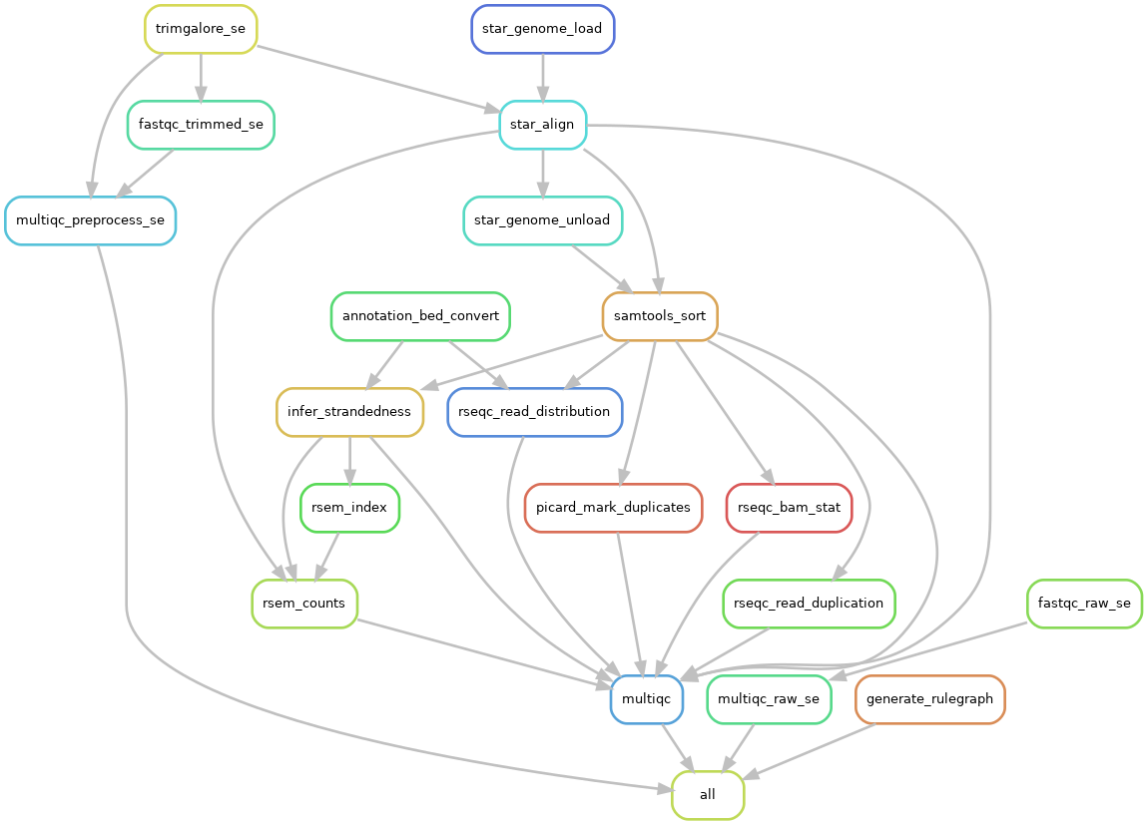

Primers for human miRNA validation
U6 primers
F: 5´-ATTGCAACGATACAGAGAAGATT-3´
R: 5´-GGAACGCTTCACGAATTTG-3´

mir21 primers
F: 5-'CCACTGTCTAGCACGACACTAA-3´
R: 5´-CACTGTCTAGCACGACACTAATCAACATCA-3´

mir146a
F: 5'-TAACCGAATCTTGCCATACGCA-3'
R: 5'-CGGAGTCTGAGAACTGAATTCCA-3'

miR204
F 5′-GCGGCGGTTCCCTTTGTCATCCT-3’
R 5′- GTGCAGGGTCCGAGGT-3’

Proteomics analysis detailes
Protein concentration was determined with Bradfrod assay. Protease inhibitors (Roche) were added at a final concentration of 3.6% and samples were stored at -80°C until further use. Samples were processed with the GeLC-MS method as previously described (REF: Methods Mol Biol. 2018;1788:165-175). Briefly, 10 μg of each sample was analyzed in 12% SDS-PAGE. Electrophoresis was stopped when samples just entered the separating gel. Gels were stained with Fast Gene Q coomassie colloidal blue overnight. Excess of stain was washed with water. Each band was excised from the gel and further sliced to small pieces (1-2mm). Gel pieces were destained with 40% Acetonitrile, 50mM NH4HCO3 and then reduced with 10mM DTE in 100mM NH4HCO3 for 20min RT. After reduction, samples were alkylated with 54mM Iodoacetamide in 100mM NH4HCO3 for 20min RT in the dark. Samples were then washed with 100mM NH4HCO3 for 20 min, RT, followed by another wash with 40% Acetonitrile, 50mM NH4HCO3 for 20min, RT and a final wash with ultrapure water under the same conditions was performed. Gel pieces were dried in a centrifugal vacuum concentrator (speed vac) and trypsinized overnight in the dark, RT, by adding 600ng of trypsin per sample (trypsin stock solution: 10ng/μL in 10mM NH4HCO3, pH 8.5). Peptides were extracted after incubation with the following buffers: 50mM NH4HCO3 for 15min, RT followed by two incubations with 10% Formic Acid, Acetonitrile (1:1) for 15 min, RT. Peptides were eluted in a final volume of 600μL and filtered with PVDF filers (Merck Millipore) before dried in a centrifugal vacuum concentrator (speed vac). Dried peptides were reconstituted in mobile phase A buffer (0.1% formic acid, pH 3) and processed with LC-MS/MS analysis.

List of Antibodies and kits Used in histology studies

Antibody | Code | Clone | Host | Technique | Secondary antibody | Source
RANKL | MBS725358 |  |  | Competitive sandwich ELISA |  | MyBiosource
IL1-beta | ER5RB |  |  | Competitive sandwich ELISA |  | Invitrogen
Osteopontin | SC21742 | AKm2A1 | mouse | IHC, IF | Goat anti-mouse-488 | Santa Cruz Bio
Desmin | SC271677 | B-7 | mouse | IF | Goat anti-mouse-488 | Santa Cruz Bio
Vimentin | V4630 | Polyclonal | goat | IF | Donkey anti-goat 594 | Sigma-Aldrich
H+L IgG – Alexa Fluor 633 | A21070 | Polyclonal | goat | IF | - | Invitrogen
TGF-beta-1 | MA5-16949 | TB21 | mouse | IF | Goat anti-mouse-488 | Invitrogen
CD8 | NB100-64021 | 12.C7 | mouse | IF | Goat anti-mouse-488 | Novus Biologicals
TNAP | TRA-2-49 | TRA-2-49/6E | mouse | IF | Goat anti-mouse-488 | Stemcell
Wheat Germ Agglutinin (WGA) | W11262 | - | - | IF | - | Invitrogen
Complement 3 (C3) | SC28294 | B9 | mouse | IF | Goat anti-mouse-488 | Santa Cruz Bio
RUNX2 | SC-390351 | F2 | Mouse | IF | Goat anti-mouse-488 | Santa Cruz Bio

