SUPPLEMENT TO:

Vaccine Effectiveness Of Bivalent HPV Vaccination Against Genital HPV Of A Catch-Up Campaign And 12 Years Routine Vaccination For Girls-Only: A Biennial Repeated Cross-Sectional Study
Johannes MA Kusters^{1,2}, Maarten F Schim van der Loeff^{2,3}, Birgit HB van Benthem¹, Audrey J King¹, PASSYON study group, Hester E de Melker¹, Titia Heijman³ , Janneke CM Heijne³

¹Centre for Infectious Diseases Control, National Institute for Public Health and the Environment, Bilthoven, the Netherlands; ²Institute for Immunology and Infectious Diseases (AII), Amsterdam UMC, Amsterdam, the Netherlands; ³Department of Infectious Diseases, Public Health Service of Amsterdam, Amsterdam, the Netherlands
Supplementary table 1: Characteristics of the female study population of the PASSYON study, by eligibility for analysis based on availability of self-reported vaccination status and genital swabs, the Netherlands, 2011-2021
 |  | Eligible for inclusion in study¹
Variable | Total | No | Yes | p-value
 | n (%) or  median (IQR) | n (%) or  median (IQR) | n (%) or  median (IQR)
Total | 5,006 | 518 | 4,488
Study round |  |  |  | <0·001
2011 | 68 (1·4) | 7 (1·4) | 61 (1·4)
2013 | 353 (7·1) | 28 (5·4) | 325 (7·2)
2015 | 777 (15·5) | 76 (14·7) | 701 (15·6)
2017 | 1,215 (24·3) | 93 (18·0) | 1,122 (25·0)
2019 | 1,256 (25·1) | 141 (27·2) | 1,115 (24·8)
2021 | 1,337 (26·7) | 173 (33·4) | 1,164 (25·9)
Age (year) | 21 (19, 22) | 21 (19, 22) | 21 (19, 22) | 0·62
Age (year) |  |  |  | 0·57
16-18 | 722 (14·4) | 67 (12·9) | 655 (14·6)
19-21 | 2,649 (52·9) | 276 (53·3) | 2,373 (52·9)
22-24 | 1,635 (32·7) | 175 (33·8) | 1,460 (32·5)
Migration background |  |  |  | <0·001
None (Dutch) | 3,882 (77·9) | 360 (70·0) | 3,522 (78·8)
Migrant | 314 (6·3) | 57 (11·1) | 257 (5·7)
Child of migrant | 789 (15·8) | 97 (18·9) | 692 (15·5)
Missing | 21 | 4 | 17
Education² |  |  |  | <0·001
(Pre)university | 3,793 (76·0) | 351 (69·0) | 3,442 (76·8)
Other | 1,200 (24·0) | 158 (31·0) | 1,042 (23·2)
Missing | 13 | 9 | 4
Age sexual debut (years) | 16 (15, 17) | 16 (15, 17) | 16 (15, 17) | 0·47
Age sexual debut (years) |  |  |  | 0·62
≤14 | 634 (13·0) | 53 (11·5) | 581 (13·1)
15-16 | 2,319 (47·5) | 221 (48·0) | 2,098 (47·4)
≥17 | 1,931 (39·5) | 186 (40·4) | 1,745 (39·4)
Missing | 122 | 58 | 64
No. sex partners lifetime | 7 (4, 12) | 7 (4, 12) | 7 (4, 11) | 0·67
No. sex partners lifetime |  |  |  | 0·88
0-4 | 1,369 (27·9) | 128 (27·2) | 1,241 (27·9)
5-9 | 1,779 (36·2) | 169 (35·9) | 1,610 (36·2)
≥10 | 1,766 (35·9) | 174 (36·9) | 1,592 (35·8)
Missing | 92 | 47 | 45
No. sex partners preceding 6 mos. | 2 (1, 4) | 2 (1, 4) | 2 (1, 4) | 0·38
No. sex partners preceding 6 mos. |  |  |  | 0·05
0-1 | 1,341 (26·8) | 152 (29·6) | 1,189 (26·5)
2-3 | 3,246 (64·9) | 309 (60·2) | 2,937 (65·5)
≥4 | 411 (8·2) | 52 (10·1) | 359 (8·0)
Missing | 8 | 5 | 3
History of STI |  |  |  | 0·09
No | 2,470 (49·9) | 231 (46·9) | 2,239 (50·2)
Yes | 1,503 (30·3) | 171 (34·7) | 1,332 (29·9)
Never tested | 981 (19·8) | 91 (18·5) | 890 (20·0)
Missing | 52 | 25 | 27
Current Ct infection³ |  |  |  | 0·95
Negative | 4,102 (82·6) | 420 (82·8) | 3,682 (82·6)
Positive | 862 (17·4) | 87 (17·2) | 775 (17·4)
Not tested/missing | 41 | 10 | 31
Current Ng infection³ |  |  |  | 0·90
Negative | 4,865 (99·0) | 498 (98·8) | 4,367 (99·0)
Positive | 51 (1·0) | 6 (1·2) | 45 (1·0)
Not tested/missing | 89 | 13 | 76
Note: Eligibility for inclusions was based on availability of self-reported vaccination status and providing a genital swab. 422 women did not report vaccination status, 96 did not provide a genital swab, and 18 provided neither. P-value based on a chi-squared test for the categorical variables and Wilcoxon rank-sum test for the continuous variables, due to their non normal distributed nature.
Abbreviations: Ct Chlamydia trachomatis; Ng Neisseria gonorrhoeae; hrHPV high-risk HPV; HPV human papilloma virus; IQR interquartile range; SHC sexual health clinic; STI sexually transmitted infection.
1: Women were eligible when both self-reported HPV vaccination status and genital swab were available.
2: (Pre)university is defined as higher general secondary education, pre-university education, university for applied sciences and university. Other is defined as all other levels of education.
3: Diagnosis at the same visit to the SHC at which the participant was included in this study.

Supplementary table 2: Crude and propensity score stratification adjusted vaccine effectiveness against type-specific and grouped genital HPV DNA-positivity for female participants from the PASSYON study, the Netherlands, 2011-2021
 | Overall VE
 | Crude |  | PS stratification adjusted
 | VE % | (CI) | VE % | (CI)
High-risk genotypes
HPV-16 | 92.7 | (88.9, 95.4) | 93.5 | (89.8, 95.9)
HPV-18 | 88.5 | (82.0, 93.0) | 89.5 | (83.0, 93.6)
HPV-31 | 63.4 | (54.0, 71.1) | 63.9 | (54.1, 71.6)
HPV-33 | 46.1 | (25.9, 60.7) | 51.5 | (32.6, 65.0)
HPV-35 | 49.9 | (26.1, 66.1) | 48.5 | (23.0, 65.5)
HPV-39 | -7.7 | (-32.7, 12.1) | -10.3 | (-36.3, 10.8)
HPV-45 | 79.4 | (65.7, 88.1) | 79.6 | (64.7, 88.2)
HPV-51 | -10.8 | (-24.3, 0.9) | -10.9 | (-24.6, 1.2)
HPV-52 | 19.5 | (8.2, 29.3) | 18.0 | (6.2, 28.4)
HPV-56 | -22.8 | (-48.0, -2.5) | -18.9 | (-43.7, 1.6)
HPV-58 | 24.5 | (0.0, 42.6) | 31.4 | (8.7, 48.5)
HPV-59 | -44.6 | (-94.5, -8.9) | -42.6 | (-92.9, -5.4)
Low-risk genotypes
HPV-6 | -5.9 | (-24.9, 9.9) | -5.3 | (-24.4, 10.9)
HPV-11 | 15.1 | (-25.1, 41.7) | 12.3 | (-30.2, 40.9)
Grouped
2vHPV ¹ | 91.2 | (87.9, 93.7) | 92.1 | (88.9, 94.4)
Crosstypes 1 ² | 59.7 | (51.6, 66.5) | 61.8 | (53.7, 68.4)
Crosstypes 2 ³ | 31.9 | (25.2, 38) | 32.4 | (25.6, 38.7)
9vhrHPV ⁴ | 21.6 | (16.3, 26.5) | 28.7 | (22.9, 34.1)
hrHPV ⁵ | 12.4 | (7.6, 16.9) | 12.8 | (7.9, 17.5)
Abbreviations: CI confidence interval; HPV human papillomavirus; PS propensity score; VE vaccine effectiveness.
1: DNA-positive for at least one of HPV-16/18.
2: DNA-positive for at least one of HPV-31/33/45.
3: DNA-positive for at least one of HPV-31/33/35/45/52/58.
4: DNA positive for at least one of HPV-16/18/31/33/45/52/58.
5: DNA-positive for at least one of HPV-16/18/31/33/35/39/45/51/52/56/58/59.
Supplementary table 3: Vaccine effectiveness against genital HPV-16, HPV-18 and grouped HPV DNA-positivity for female participants from the PASSYON study, by having been eligible for catch-up or routine HPV vaccination, the Netherlands, 2011-2021
 | Eligibility for HPV vaccination
 | Catch-up |  | Routine
 | VE % | (CI) | VE % | (CI) | p-value
Type-specific
HPV-16 | 92·1 | (86·6, 95·4) | 94·9 | (87·8, 97·8) | 0·54
HPV-18 | 92·2 | (84·1, 96·2) | 86·8 | (74·0, 93·3) | 0·37
Grouped
2vHPV ¹ | 92·2 | (87·9, 94·9) | 91·8 | (86·0, 95·2) | 0·84
Crosstypes 1 ² | 53·9 | (41·2, 63·9) | 68·1 | (56·9, 76·4) | 0·09
Crosstypes 2 ³ | 33·7 | (24·7, 41·6) | 30·6 | (19·5, 40·2) | 0·56
9vhrHPV ⁴ | 27·3 | (19·7, 34·1) | 29·3 | (20·0, 37·5) | 0·65
hrHPV ⁵ | 13·8 | (7·7, 19·5) | 11·8 | (4·0, 19·0) | 0·44
Note: Eligible for catch-up had been women from birth cohort 1993-1996, and for routine vaccination birth cohort ≥1997. VE estimates are adjusted with propensity score stratification. P-values are based on adding an interaction term in the multivariable logistic regression adjusted with propensity score stratification.
Abbreviations: CI confidence interval; HPV human papillomavirus; VE vaccine effectiveness.
1: DNA-positive for at least one of HPV-16/18.
2: DNA-positive for at least one of HPV-31/33/45.
3: DNA-positive for at least one of HPV-31/33/35/45/52/58.
4: DNA positive for at least one of HPV-16/18/31/33/45/52/58.
5: DNA-positive for at least one of HPV-16/18/31/33/35/39/45/51/52/56/58/59.

Supplementary table 4: Vaccine effectiveness against genital HPV-16, HPV-18 and grouped HPV DNA-positivity for female participants from birth cohort 1993-1996 (catch-up cohort) from the PASSYON study, by having been sexually active before or in the same year as having been eligible for HPV vaccination, the Netherlands, 2011-2021
 | Sexually active before or in the same year as having been eligible for HPV vaccination
 | No |  | (Potentially) yes
 | VE % | (CI) | VE % | (CI) | p-value
Type-specific
HPV-16 | 94·6 | (88·6, 97·4) | 86·0 | (69·3, 93·6) | 0·11
HPV-18 | 94·4 | (85·5, 97·9) | 91·1 | (71·5, 97·2) | 0·47
Grouped
2vHPV ¹ | 94·5 | (89·9, 97·0) | 87·5 | (76·1, 93·4) | 0·07
Crosstypes 1 ² | 57·9 | (43·7, 68·6) | 44·2 | (11·0, 64·9) | 0·39
Crosstypes 2 ³ | 37·0 | (26·9, 45·8) | 21·5 | (-1·1, 39·0) | 0·20
9vhrHPV ⁴ | 25·9 | (16·6, 34·2) | 32·7 | (18·9, 44·3) | 0·27
hrHPV ⁵ | 13·3 | (5·9, 20·1) | 16·6 | (4·8, 26·9) | 0·65
Note: Having been sexually active before or in the same year as having been eligible for HPV vaccination was based on self-reported age at sexual debut and the age women had been eligible for vaccination based on their year of birth. VE estimates are adjusted with propensity score stratification. P-values are based on adding an interaction term in the multivariable logistic regression adjusted with propensity score stratification.
Abbreviations: CI confidence interval; HPV human papillomavirus; VE vaccine effectiveness.
1: DNA-positive for at least one of HPV-16/18.
2: DNA-positive for at least one of HPV-31/33/45.
3: DNA-positive for at least one of HPV-31/33/35/45/52/58.
4: DNA positive for at least one of HPV-16/18/31/33/45/52/58.
5: DNA-positive for at least one of HPV-16/18/31/33/35/39/45/51/52/56/58/59.

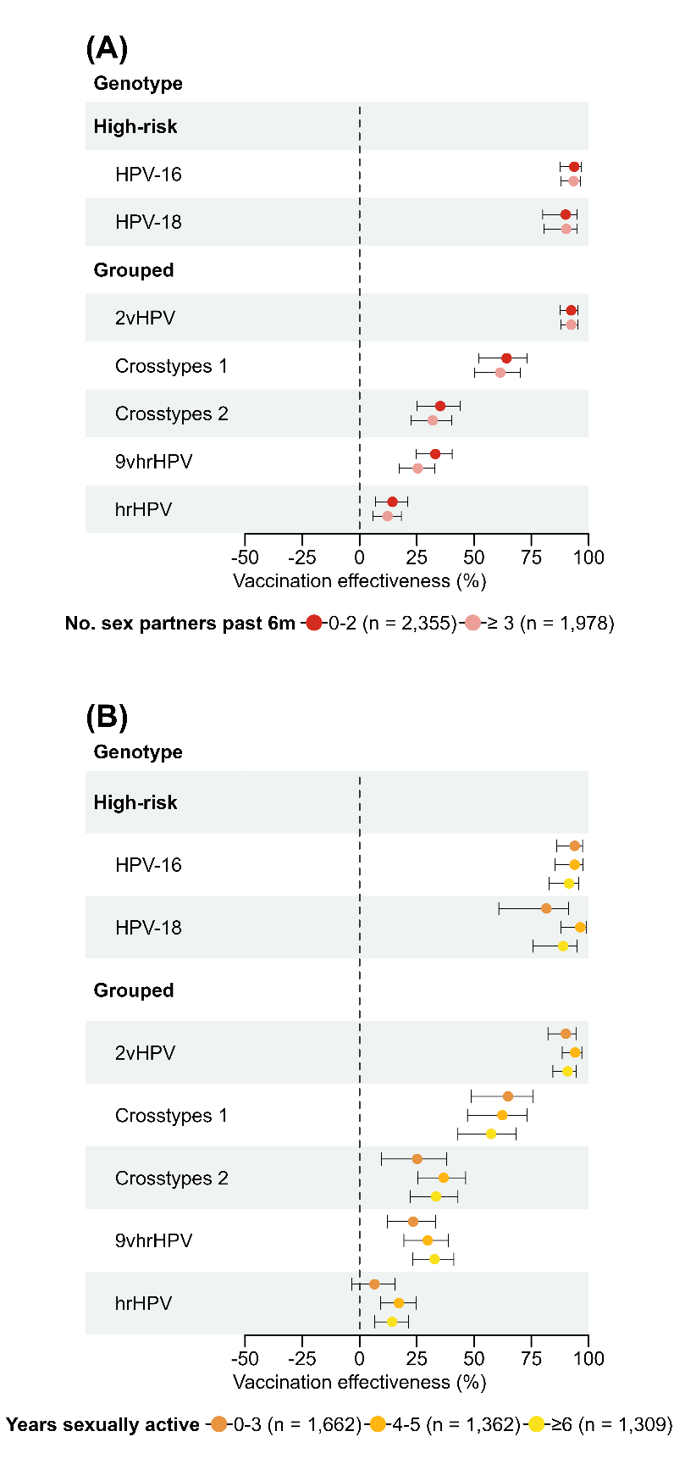
Supplementary figure 1: Stratified analyses of type-specific and grouped vaccine effectiveness of the bivalent HPV vaccine against genital HPV DNA-positivity, by sexual behaviour, for female participants in the PASSYON study, the Netherlands, 2011-2021.
Footnote: Panel A presents stratified VE analyses by number of sexual partners in the preceding 6 months. Panel B presents stratified analyses by years sexually active. Years sexually active is obtained by self-reported age minus self-reported age at sexual debut. 2vHPV is DNA-positive for at least one of HPV-16/18; crosstypes 1 is DNA-positive for at least one of HPV-31/33/45; crosstypes 2 is DNA-positive for at least one of HPV-31/33/35/45/52/58; 9vhrHPV is DNA positive for at least one of HPV-16/18/31/33/45/52/58; hrHPV is DNA-positive for at least one of 16/18/31/33/35/39/45/51/52/56/58/59.
Abbreviations: 2vHPV bivalent HPV; 9vhrHPV nonavalent high-risk HPV; HPV human papillomavirus; hrHPV high-risk HPV; VE vaccine effectiveness.
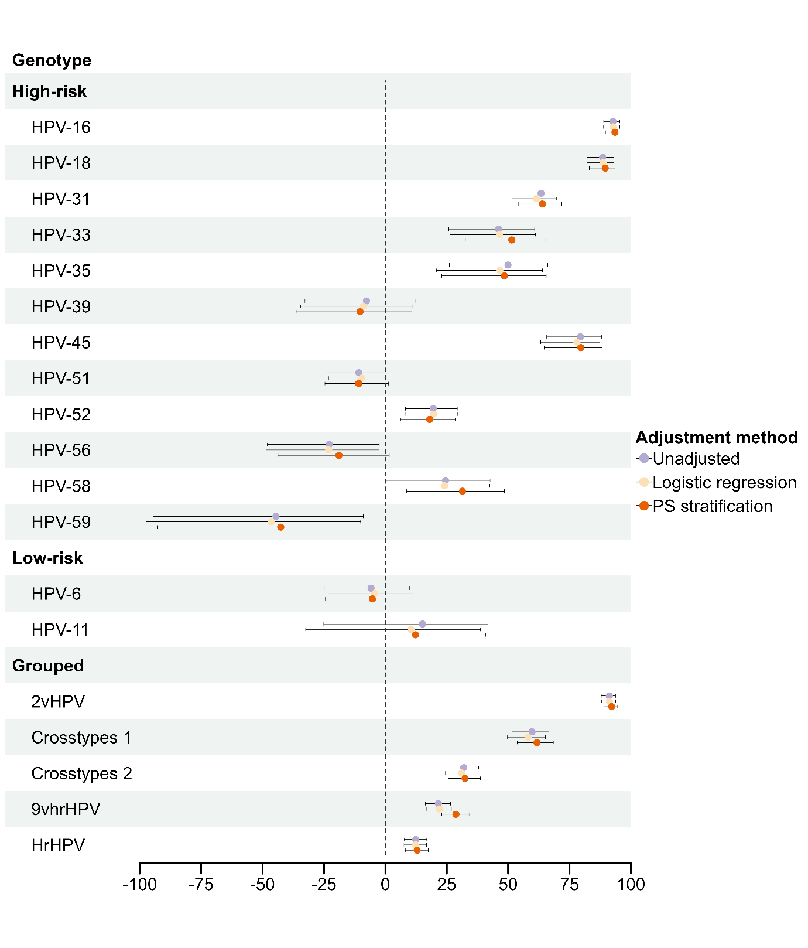
Supplementary figure 2: Type-specific and grouped vaccine effectiveness of the bivalent HPV vaccine against genital HPV DNA-positivity for female participants who had been eligible for HPV vaccination and included in the PASSYON study, the Netherlands, 2011-2021. Comparison of crude VE, VE adjusted using logistic regression, and VE adjusted using propensity score stratification.
Footnote: 2vHPV is DNA-positive for at least one of HPV-16/18; crosstypes 1 is DNA-positive for at least one of HPV-31/33/45; crosstypes 2 is DNA-positive for at least one of HPV-31/33/35/45/52/58; 9vhrHPV is DNA positive for at least one of HPV-16/18/31/33/45/52/58; hrHPV is DNA-positive for at least one of 16/18/31/33/35/39/45/51/52/56/58/59.
Abbreviations: 2vHPV bivalent HPV; 9vhrHPV nonavalent high-risk HPV; CI confidence interval; HPV human papillomavirus; hrHPV high-risk HPV; PS propensity score; VE vaccine effectiveness.

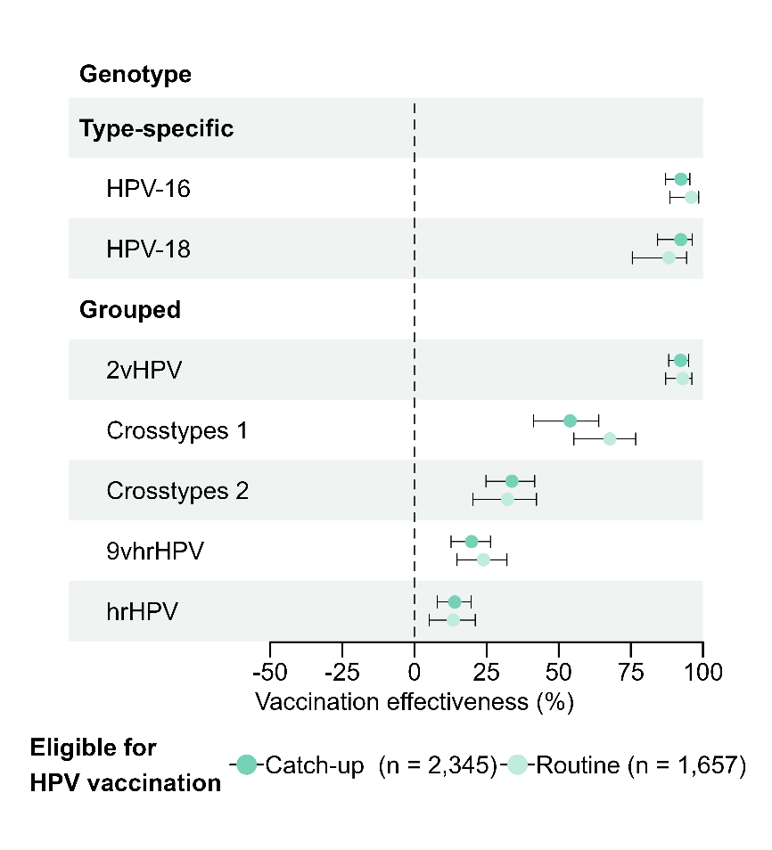
Supplementary figure 3: Type-specific and grouped vaccine effectiveness of the bivalent HPV vaccine against genital HPV DNA-positivity for female participants who had been eligible for HPV vaccination within the catch-up campaign for ages 13-16 years and for those who had been eligible for routine vaccination at age 12 years. Analysis restricted to birth cohorts 1993-2000, who were all eligible for three-dose vaccination schedule. PASSYON study, the Netherlands, 2011-2021.
Footnote: Figure presents stratified VE analyses by birth cohort, where birth cohort 1993-1996 had been eligible for 3 doses within the catch-up campaign and birth cohort ≥1997 for 3 doses within routine vaccination.
2vHPV is DNA-positive for at least one of HPV-16/18; crosstypes 1 is DNA-positive for at least one of HPV-31/33/45; crosstypes 2 is DNA-positive for at least one of HPV-31/33/35/45/52/58; 9vhrHPV is DNA positive for at least one of HPV-16/18/31/33/45/52/58; hrHPV is DNA-positive for at least one of 16/18/31/33/35/39/45/51/52/56/58/59.
Abbreviations: 2vHPV bivalent HPV; 9vhrHPV nonavalent high-risk HPV; HPV human papillomavirus; hrHPV high-risk HPV; VE vaccine effectiveness.

