Agricultural intensification affects communities of plants and arthropods in field borders and their potential to engender biological control
Alan V. Saldanha^{ab}, Rayana M.R. Carvalho^{ab}, Carolina F.M. Machado^{b}, João Paulo Souza^{c}, Lessando M. Gontijo^{b*}

ªDepartment of Entomology and Acarology, University of São Paulo, Esalq, Piracicaba, SP 13418-900, Brazil

^{b}Graduate Program: Management and Conservation of Natural and Agricultural Ecosystems, Federal University of Viçosa – Florestal Campus, Florestal, MG 35690-000, Brazil.

^{c}Department of Ecology, Federal University of Viçosa, Viçosa Campus, Viçosa, MG, 36570-000, Brazil

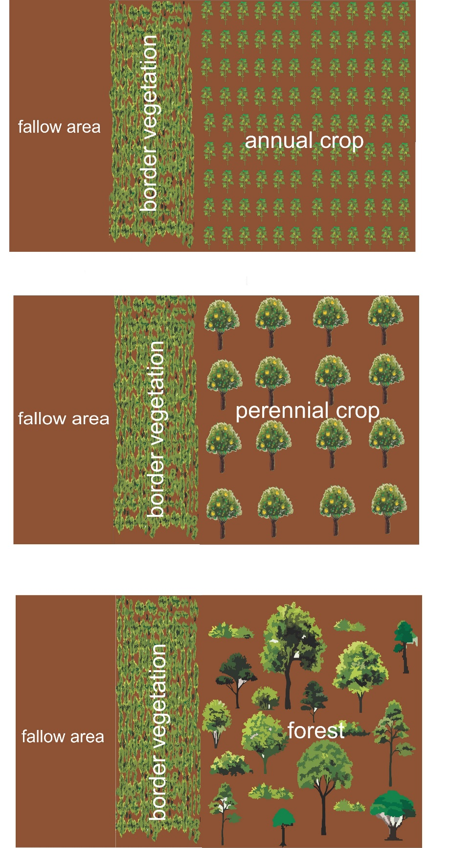
Fig. S1. Schematic illustration of the experimental design. Three types of spontaneous field borders were investigated in each season (summer, winter, spring). The selected borders were next to (i) annual crop, (ii) perennial crop, or (iii) forest area.

Fig. S2. Abundances of aphids (i), thrips (ii), and whiteflies (iii) in relation to border location (annual crop, perennial crop, forest area) and to season (summer, winter, spring). Bar values followed by distinct letters within each season differ statistically at p-value <0.05 (emmeans pairwise-comparisons).
herbivores

Fig. S3. Non-metric Multi-dimensional Scaling (NMDS) for testing and visualizing the community structure of all herbivores occurring next to either forest, perennial or annual crop areas during three seasons (summer, winter and spring). The closer two points are (by shape or color), the more similar the corresponding samples are. The stress value for this analysis was 0.19 (good ordination fit: stress <0.2).

predators
Fig. S4. Non-metric Multi-dimensional Scaling (NMDS) for testing and visualizing the community structure of all predators occurring next to either forest, perennial or annual crop areas during three seasons (summer, winter and spring). The closer two points are (by shape or color), the more similar the corresponding samples are. The stress value for this analysis was 0.18 (good ordination fit: stress <0.2).

parasitoids
Fig. S5. Non-metric Multi-dimensional Scaling (NMDS) for testing and visualizing the community structure of all parasitoid morphospecies occurring next to either forest, perennial or annual crop areas during three seasons (summer, winter and spring). The closer two points are (by shape or color), the more similar the corresponding samples are. The stress value for this analysis was 0.16 (good ordination fit: stress <0.2).

Table S1. Supplementary information on the actual length and width considered in the field borders selected for the current study.
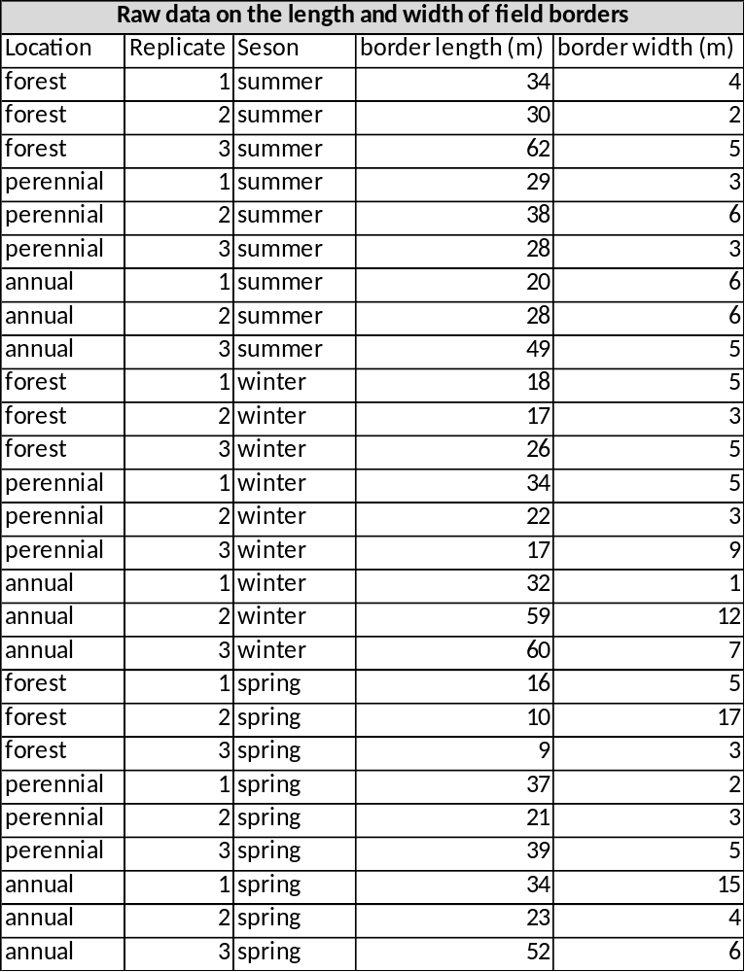

Table S2. Abundance of herbivores collected in sticky traps and pitfalls, grouped by season (summer, winter and spring) and border location (forest, perennial and annual crop areas).
Herbivores | Summer |  |  | Winter |  |  | Spring
Herbivores | Forest | Perennial | Annual | Forest | Perennial | Annual | Forest | Perennial | Annual
Aphids | 48 | 113 | 176 | 56 | 113 | 187 | 29 | 59 | 119
Bemisia spp | 0 | 173 | 480 | 70 | 35 | 27 | 24 | 60 | 51
Roaches | 4 | 0 | 0 | 2 | 1 | 4 | 4 | 1 | 0
Termites | 0 | 1 | 0 | 1 | 1 | 0 | 18 | 23 | 540
Leafhoppers | 115 | 137 | 67 | 92 | 79 | 200 | 82 | 77 | 137
Leaf beetles | 48 | 126 | 123 | 46 | 50 | 41 | 219 | 116 | 150
Diptera | 347 | 571 | 1497 | 231 | 226 | 839 | 845 | 769 | 1230
Lepidoptera | 1 | 2 | 7 | 4 | 16 | 18 | 30 | 4 | 5
Orthoptera | 48 | 52 | 22 | 11 | 1 | 0 | 17 | 1 | 3
Stink bugs | 5 | 22 | 20 | 3 | 14 | 45 | 11 | 12 | 22
Thysanoptera | 34 | 141 | 194 | 87 | 137 | 692 | 204 | 306 | 249
Grand total | 650 | 1338 | 2586 | 603 | 673 | 2053 | 1483 | 1428 | 2506

Table S3. Abundance of natural enemies (predators and parasitoid morphospecies), collected in sticky traps and pitfalls, grouped by season (summer, winter and spring) and border location (forest, perennial and annual crop areas).
Predators and Parasitoids | Summer |  |  | Winter |  |  | Spring
Predators and Parasitoids | Forest | Perennial | Annual | Forest | Perennial | Annual | Forest | Perennial | Annual
Carabidae | 1 | 6 | 4 | 0 | 0 | 1 | 9 | 3 | 21
Chrysopidae | 0 | 0 | 0 | 0 | 1 | 271 | 0 | 0 | 0
Coccinellidae | 0 | 3 | 3 | 0 | 1 | 121 | 3 | 11 | 4
Dolichopodidae | 14 | 51 | 58 | 3 | 4 | 47 | 82 | 24 | 32
Dermaptera | 2 | 2 | 1 | 0 | 0 | 0 | 0 | 0 | 0
Parasitoids | 199 | 95 | 249 | 460 | 208 | 357 | 369 | 158 | 279
Predator bug | 4 | 0 | 1 | 0 | 0 | 18 | 0 | 0 | 1
Spiders | 16 | 192 | 8 | 11 | 6 | 11 | 22 | 12 | 20
Staphylinidae | 26 | 40 | 24 | 31 | 28 | 21 | 11 | 2 | 10
Syrphidae | 2 | 0 | 7 | 0 | 0 | 4 | 0 | 1 | 1
Vespidae | 2 | 4 | 3 | 2 | 4 | 2 | 26 | 29 | 23
Grand total | 266 | 393 | 358 | 507 | 252 | 853 | 522 | 240 | 391

Table S4. Plant species/specimens found in field borders next to forest, perennial or annual crop areas during three seasons (summer, winter and spring). It also presents the species of aphids reported in the literature† to occur on some of these plant species. (Su. = summer, Wi. = winter, Spr. = spring).
Plant species | Forest |  |  | Perennial |  |  | Annual |  |  | Aphid species reported to occur
Plant species | Su. | Wi. | Spr. | Su. | Wi. | Spr. | Su. | Wi. | Spr. | Aphid species reported to occur
Acanthospermum australe (Loefl.) Kuntze | X |  |  | X |  |  | X | X | X
Acanthospermum hispidum DC. |  |  |  | X |  |  | X | X
Acromia aculeata (Jacq.)Lood. | X
Ageratum conyzoides L. |  |  |  |  |  |  |  | X
Alchornea sp. |  | X | X
Alternanthera tenella Colla. |  |  |  | X |  | X | X
Amaranthus deflexus L. |  |  |  | X |  | X |  |  |  | Aphis gossypii occurring in Amaranthus sp.²
Amaranthus hybridus L. |  |  |  | X | X |  | X |  |  | A. gossypii occurring in Amaranthus sp.²
Amaranthus retroflexus L. |  |  |  |  |  |  |  | X |  | A. gossypii occurring in Amaranthus sp.²
Asteraceae sp 1 |  |  |  | X
Asteraceae sp 2 |  | X | X
Asteraceae sp 3 |  | X
Asteraceae sp 4 |  | X
Asteraceae sp 5 |  | X
Asteraceae sp 6 |  |  |  |  | X
Asteraceae sp 7 | X
Asteraceae sp 8 | X
Baccharis dracunculifolia DC. | X | X |  |  | X |  |  |  |  | Aphis craccivora, A. gossypii and Aphis spiraecola¹
Bambusoideae | X |  | X
Bidens pilosa L. | X | X |  | X | X |  | X | X | X | Aphis coreopsidis¹; A. gossypii²
Bidens subalternans DC. |  |  |  |  |  | X
Bignoniaceae sp 1 |  | X | X
Bignoniaceae sp 2 |  | X | X
Blainvillea biaristata DC. |  |  |  |  |  |  |  | X
Blainvillea rhomboidea Cass. |  |  |  |  |  |  |  | X
Brachiaria decumbens Stapf | X | X | X | X | X | X | X | X | X | Hysteroneura setariae occurring in Brachiaria sp.¹
Brachiaria plantaginea (Link) Hitchc |  |  |  |  |  | X |  |  |  | H. setariae occurring in Brachiaria sp.¹
Buddleja stachyoides Cham. &Schltdl. |  | X
Celtis sp. |  | X | X
Cenchrus echinatus L. |  |  |  |  | X | X | X | X
Chamaecrista nictitans L. | X |  |  |  |  |  | X
Chamaesyce hirta L. |  | X |  | X |  | X | X |  |  | Occurrence reported but species not identified ²
Chamaesyce hyssopifolia L. | X | X | X | X | X |  |  |  |  | Occurrence reported but species not identified ²
Chamaesyce prostrata (Aiton) Small. |  |  |  |  |  |  | X
Chaptalia nutans (L.) Polak. | X
Chromolaena laevigata (Lam.) R.M.King & H.Rob | X |  | X
Commelina benghalensis L. | X |  |  | X | X | X | X | X | X | A. gossypii ²; A. gossypii, Brevicoryne  brassicae and Myzys persicae ³
Convolvulaceae |  | X | X
Conyza canadensis (L.) Cronquist | X | X |  | X |  |  | X | X | X
Copaifera langsdorffii Desf | X | X | X |  |  |  |  |  |  | A. craccivora and A. gossypii ¹
Coronopus didymus (L.) Smith |  |  |  | X |  |  |  | X
Crotalaria incana L. |  | X |  |  | X |  |  | X
Crotalaria indica L. | X |  |  |  |  |  | X
Croton glandulosus L. |  |  |  |  |  |  |  |  | X
Cupania vernalis Camb. |  | X
Cuphea carthagenensis (Jacq.) J.F.Macbr |  |  |  |  |  | X
Cynodon dactylon (L.) Pers. |  |  |  | X |  | X | X
Cyperus esculentus L. |  |  |  | X | X | X |  | X | X
Cyperus rotundus L. |  |  |  |  |  | X |  |  | X
Desmodium incanum (Sw.) DC. | X |  |  | X | X | X |  |  |  | Picturaphis vignaphyllus ¹
Desmodium tortuosum (Sw.) DC. |  |  |  |  |  |  |  |  | X
Desmodium uncinatum (Jacq.) DC. |  |  |  | X |  |  |  |  |  | P. vignaphyllus ¹
Digitaria horizontalis Willd. | X |  |  | X
Digitaria insularis (L.) Fedde |  |  |  |  |  |  |  | X
Eleusine indica (L.) Gaertn | X |  |  | X | X | X | X | X | X | A. gossypii ³
Emilia coccinea (Sims) G. Don |  |  |  |  | X |  |  | X |  | Occurrence reported but species not identified ²
Emilia fosbergii Nicolson | X |  | X | X | X | X |  | X | X | A. gossypii ³
Enterolobium spp. |  | X
Eragrotis pilosa (L.) P. Beauv |  |  |  | X
Euphorbia heterophylla L. | X | X |  | X | X |  | X | X
Fabaceae sp 1 | X | X | X
Fabaceae sp 2 | X | X | X
Fabaceae sp 3 |  | X | X
Fabaceae sp 4 |  | X | X
Fabaceae sp 5 | X
Galinsoga quadriradiata Ruiz & Pav. |  |  |  |  |  |  | X | X | X
Gaya guerkeana K. Schum |  |  |  |  |  |  |  |  | X
Glycine wightii Wight & Arn. | X |  |  |  |  | X |  | X | X
Gochnatia polymorpha Cabrera |  | X
Herissantia crispa (L.) Brizicky | X
Ipomea nil (L.) Roth | X |  |  | X |  | X |  | X | X
Ipomoea indivisa (Vell.) Hallier F. | X |  |  |  |  |  | X | X
Ipomoea quamoclit L. | X |  |  |  |  |  |  | X
Ipomoea ramosissima (Poir) Choisy | X |  |  | X |  |  | X
Ipomoea triloba L. | X |  |  |  |  |  | X |  | X
Jaegeria hirta (Lag.) Less. |  |  |  |  |  | X
Lantana Camara L. | X |  |  |  |  |  |  |  |  | Aphis spiraecola reported in Lantana sp. ¹
Lauraceae sp 1 | X
Lauraceae sp 2 | X | X | X
Leonotis nepetifolia (L.) R. Br. |  |  |  |  | X
Lepidium virginicum L. |  |  |  |  |  |  |  | X
Macroptilium lathyroides (L.) Urb. |  |  |  | X
Malvaceae |  |  | X
Manettia cordifolia Mart. |  | X | X
Marsypianthes chamaedrys (Vahl) Kuntze. |  |  |  | X | X |  | X | X | X
Melastomataceae |  | X
Merremia cissoides (Lam.) Hallier f. |  |  |  |  |  |  |  |  | X
Mitracarpus hirtus (L.) DC. |  |  |  |  | X | X
Morphospecies 1 to 10 | X |  | X
Morphospecies 11 to 22 |  | X
Morphospecies 23 to 26 |  | X | X
Morphospecies 27 to 30 |  |  |  |  | X
Morphospecies 31 to 37 | X
Morphospecies 38 |  |  |  |  |  |  |  | X
Morphospecies 39 to 42 |  |  |  |  |  |  |  |  | X
Morphospecies 43 to 46 |  |  | X
Morphospecies 47 |  | X |  |  | X
Morphospecies 48 |  | X | X |  | X
Myracrodun Urundeuva Allemão. | X
Myrtaceae sp 1 |  | X | X
Myrtaceae sp 2 |  | X
Nicandra physalodes (L.) Gaertn. |  |  |  |  |  |  |  | X
Orchidaceae |  |  |  |  |  |  |  | X
Panicum maximum Jacq. | X | X | X | X | X |  | X | X | X
Parthenium hysterophorus L. |  |  |  | X | X | X |  | X
Paspalum notatum Flüggé |  |  |  | X | X | X
Poaceae sp 1 |  | X
Poaceae sp 2 |  |  |  | X | X | X |  |  | X
Poaceae sp 3 |  |  |  | X
Poaceae sp 4 |  |  |  | X
Porophyllum ruderale (Jacq.) Cass. |  |  |  |  |  |  |  |  | X
Portulaca oleracea L. |  |  | X | X | X | X | X | X | X
Pyrostegia venusta (Ker Gawl.) Miers | X |  | X |  | X
Qualea grandiflora Mart. |  | X
Raphanaus raphanistrum L. |  |  |  |  |  |  | X | X | X
Rhynchelytrum repens (Willd.) C. E. Hunbb. | X |  | X |  |  |  | X | X | X
Richardia brasiliensis Gomes | X |  |  | X |  | X | X | X | X
Richardia grandiflora (Cham. & Schldtdl.) Steud. |  | X |  | X |  |  | X
Ricinus communis L. |  |  |  |  |  |  |  | X
Rubiaceae | X
Rubus sellowii Cham. & Schlitdl. |  | X
Schinopsis brasiliensis Engl. |  | X | X
Senna obtusifolia (L.) Irwin & Barneby. |  |  |  |  |  |  | X
Sida cordifolia L. |  | X | X |  | X | X | X | X |  | Aphis gossypii occurring in Sida sp.¹
Sida glaziovii K. Schum. | X | X | X | X | X | X | X | X | X | Aphis gossypii occurring in Sida sp.¹
Sida rhombifolia L. | X | X |  | X |  |  | X |  |  | Aphis gossypii occurring in Sida sp.¹
Sida urens L. |  |  |  |  | X |  |  |  |  | Aphis gossypii occurring in Sida sp.¹
Siegesbeckia orientalis L. |  |  |  | X |  |  | X
Siparuna Guianensis Aubl. |  | X |  |  |  |  |  |  |  | Lizerius tuberculatus and Toxoptera aurantii ¹
Smilax brasiliensis Spreng. | X | X
Solanum americanum Mill. | X |  |  | X |  |  |  | X |  | Aphis solanella, A. spiraecola and Uroleucon gravicornis¹; Aphis fabae ²
Solanum asperolanatum Ruiz & Pav. |  |  |  |  |  |  |  |  | X | A. solanella, A. spiraecola occurring Solanum sp. ¹
Soliva pterosperma (Juss.) Less. |  |  |  |  |  |  |  | X
Sonchus oleraceus L. |  |  |  |  |  |  | X | X
Spermacoce latifolia Aubl. | X |  |  |  |  |  | X |  | X
Stylosanthes guianensis (Aubl.) Sw. |  |  |  |  |  |  |  | X
Synedrellopsis grisebachii Hieron. & Kuntze |  |  |  | X |  |  |  |  | X
Talium paniculatum (Jacq.) Gaertn. |  | X
Tridax procumbens L. |  | X | X | X | X | X | X | X | X
Urticaceae |  | X
Vernonia platensis Spreng. Less. |  |  |  |  |  |  |  | X |  | T. aurantiioccurring Vernonia sp. ¹
Vernonia sp. |  | X |  |  |  |  |  |  |  | T. aurantiioccurring Vernonia sp. ¹
Veronica polyanthes Less. | X | X |  | X |  |  |  |  |  | A. spiraecola occurring in V. polyanthes, T. aurantii occurring in Vernonia sp. ¹
Waltheria indica L. |  |  |  |  | X | X
Wissadula subpeltata (Kuntze) R. E. Fr. | X | X | X |  |  |  |  | X
Zanthoxylum sp. | X |  | X |  |  |  |  |  |  | T. aurantii and Toxoptera citricidus occurring in Z. rhoifolium ¹
Zanthoxylum rhoifolium Lam. |  | X | X |  |  |  |  |  |  | T. aurantii and T. citricidus¹
Zoysia japonica Steud. |  |  |  | X
†Articles reporting the occurrence of aphids on plants:
¹ CUNHA, Suzan Beatriz Zambon da. Afídeos e suas interações biológicas em áreas de vegetação natural e agrícolas: exemplo de sucesso nas invasões biológicas. 2017. Tese (Doutorado em Ecologia e Recursos Naturais) – Universidade Federal de São Carlos, São Carlos, 2017.
² LIMA, R. C. A.; PANCIEIRI, G. N.; ROCHA, M. A. M.; PAULA, A. COUTO, A. O. F.; MARTINS, D. S. Ocorrência de plantas hospedeiras de afídeos em sistemas de produção integrada e convencional de mamão no polo de fruticultura de Linhares-ES. Papaya Brasil, p. 535-538, 2003.
³ Barbosa JPF, Silva JE, Silva DJ, Pinheiro RA, Leite RA, Santana LS, Souza TA, Barros RP. Registro da associação entre afídeos (Hemiptera: Aphididae) e plantas daninhas em cultivo orgânico e convencional de hortaliças. Revista Craibeiras de Agroecologia 2020;5(1):81-95.

