Supporting Information

For

Mechanical-Chemical Coupled Synthesis for Long-Range Ordered Perovskites

Hong Liu^{1#}, Haodong Wu^{2#}, Zezhu Zhou^{1,6}, Lizhi Ren^{1,3}, Yi Yang¹, Aiping Zhang¹, Jin Qian^{3,4}, Shashank Priya^{2,5}, Bed Poudel², Dong Yang⁶*, Kai Wang^{2,3,4}*, Congcong Wu¹*

¹ Key Laboratory for the Green Preparation and Application of Functional Materials, Hubei Key Laboratory of Polymer Materials, School of Materials Science and Engineering, Hubei University, Wuhan 430062, China
² Department of Materials Science and Engineering, Pennsylvania State University, University Park, PA 16802, United States
³ Huanjiang Laboratory, Zhuji 311800, China
⁴ School of Aeronautics and Astronautics, Zhejiang University, Hangzhou 310027, China
⁵ Chemical Engineering and Materials Science, University of Minnesota, Minneapolis, MN 55455, United States
⁶ Key Laboratory of Photoelectric Conversion and Utilization of Solar Energy, Dalian National Laboratory for Clean Energy, Dalian Institute of Chemical Physics, Dalian 116023, China

#Equal contribution
Correspondence:
DY (dongyang@dicp.ac.cn); KW (kaikaiwang@zju.edu.cn or kaiwang@psu.edu); CW (ccwu@hubu.edu.cn)
This file includes:
Supplementary Notes 1 to 4
Supplementary Figures 1 to 24
Supplementary Tables 1 to 6
Supplementary References

Table of Contents
Supplementary Notes 1-4 4
Supplementary Figures 1-24 9
Supplementary Tables 1-6 33
Supplementary References 41

Supplementary Notes 1-4
Supplementary Note 1.
Using the Fluo Time 300 "Easy Tau" spectrometer, a 485 nm pulsed laser is employed to detect time-resolved photoluminescence (TRPL) of various perovskite thin film samples (deposited on glass). TRPL spectra can be fitted by using the biexponential function¹,
$f\left(t\right)=A_{1}\exp\left(\frac{-t}{τ_{1}}\right)+A_{2}\exp\left(\frac{-t}{τ_{2}}\right)+B$ (S1)
where A₁ and A₂ represent the decay amplitude of fast and slow decay process, respectively. $τ_{1}$ and $τ_{2}$ are the corresponding decay lifetime components. The fast decay component $τ_{1}$ is associated with carrier recombination at the surface defect in perovskite films, while the slow decay component is related to the bulk recombination². The average carrier lifetime ($τ_{ave}$) can be calculated by the equation:
$τ_{ave}=\frac{∑A_{i}τ_{ⅈ}^{2}}{∑A_{i}τ_{i}}$ (S2)
The B-ACN film shows a longer $τ_{ave}$ of 218.9 ns with $τ_{1}$ of 261.6 ns and $τ_{2}$ of 85 ns, respectively, compared to a $τ_{ave}$ of 55.2 ns from the control perovskite and a $τ_{ave}$ of 105.5 ns from the S-ACN film (detailed results can be found in Supplementary Table 1). Hence, the B-ACN effectively reduces surface and bulk defects, effectively suppressing non-radiative recombination.

Supplementary Note 2.
In order to elucidate the material’s electrical behavior, the conductivity ($σ$) of perovskite layers can be calculated through the following equation³,
$σ=\frac{d}{AR}$ (S3)
where $d$ is the perovskite layer thickness ($d$ is of ca. 900 nm, determined from cross sectional SEM images of Supplementary Fig. 11a); A is the active area of the electrode ($A$ is of ca. 0.06 cm⁻²). And $R$ is the film’s resistance of the perovskite film which is obtained by calculating the reciprocal of the slope of the I-V curve ($\frac{∆x}{∆y}$). The I-V curves are tested within the range of -1.5V to 1.5V, with a scan rate of 500mV/s measured by the electrochemical workstation (IM6; Zennium).
From Fig. 4 c, the resistances of B-ACN, S-ACN, and control are calculated to be 20.00 Ω, 25.51 Ω, and 27.96 Ω, respectively. Based on this, the conductivity of B-ACN is 7.5$×$10⁻⁵ S/cm, which is higher than that of S-ACN of 5.88$×$10⁻⁵ S/cm and control of 5.36$×$10⁻⁵ S/cm, respectively. Therefore, it can be seen that the synthesis strategy of B-ACN effectively enhances the charge transfer efficiency of perovskite films.

Supplementary Note 3.
The space charge-limited current (SCLC) measurement is used to quantify the trap density and charge carrier mobility of B-ACN, S-ACN and control perovskite films. Electron-only devices with a device structure of FTO/TiO₂/Perovskite/PCBM/Ag are prepared and tested by Keithley 2400 source meter within the range of -50 mV to 2 V. The active area of the electrode is defined as 0.06 cm² by shadow mask. Subsequently, the measured J-V curves were plotted in log-log scale. There are mainly three characteristic regions in the J-V curve: (1) In the low-bias region, the current density exhibits a linear dependence on the applied voltage ($J∝V^{n}$, n=1), indicating a typical ohmic response (named as the “Ohmic region”); (2) With increasing bias voltage, the current density increases nonlinearly, which corresponds to the trap-filling by injected charge carriers, which is named as the “trap-filling limit (TFL) region”; (3) In the region of higher bias voltage, the J-V curve exhibits a linear relationship again ($J∝V^{n}$, n=2), which is named as the “Child region”.
Trap density ($n_{t}$) can be calculated through the following equation^{4,5},
$V_{TFL}=\frac{ⅇn_{t}L^{2}}{2εε_{0}}$ (S4)
where $V_{TFL}$ is the trap-filling voltage⁶; $ⅇ$ is the elementary charge ($ⅇ$ ca. 1.6$×$10⁻¹⁹ C); the $ε_{0}$ is the vacuum permittivity ($ε_{0}$ ca. 8.85$×$10⁻¹² F/m) and $ε$ is the relative permittivity of perovskite ($ε$=32); $L$ is the perovskite layer thickness ($L$ ca. 900 nm, determined from cross sectional SEM images of Supplementary Fig. 11a). It can be easily obtained the $V_{TFL}$ of different perovskite thin films, where the $V_{TFL}$ for B-ACN is 0.16 V, for S-ACN is 0.18 V, and for the control is 0.28 V, respectively. Further calculation results indicate that the B-ACN film has a lower trap density (0.69×10¹⁵ cm⁻³), significantly lower than that of the control (1.22×10¹⁵ cm⁻³) and S-ACN film (0.78×10¹⁵ cm⁻³). The synthesis strategy of B-ACN can effectively reduce the trap density of the perovskite thin film, benefiting from its enhancement of the crystalline quality and long-range order of the perovskite thin film.

Supplementary Note 4.
The charge carrier mobility ($μ$) can be calculated through the equation ⁴,
$\begin{aligned}J=\frac{9}{8}μεε_{0}\frac{V^{2}}{L^{3}}\#\end{aligned}$ (S5)
where $V$ is the applied bias voltage, $J$ is the corresponding current density; the $ε_{0}$ is the vacuum permittivity ($ε_{0}$ ca. 8.85$×$10⁻¹² F/m) and $ε$ is the relative permittivity of perovskite ($ε$=32); $L$ is the perovskite layer thickness ($L$ ca. 900 nm, determined from cross-sectional SEM images of Supplementary Fig. 11a).
To calculate the charge carrier mobility, we obtain the applied bias voltage and corresponding current density in the Child region of the J-V curve (details are described in Supplementary Note 3). Further calculation reveals that the charge carrier mobility of the B-ACN film is approximately 1.723×10⁻³ cm² V⁻¹s⁻¹, which is 1.5 times that of the control film ($μ$=1.138×10⁻³ cm² V⁻¹s⁻¹) and 1.4 times that of the S-ACN film ($μ$=1.207×10⁻³ cm² V⁻¹s⁻¹).

Supplementary Figures 1-24
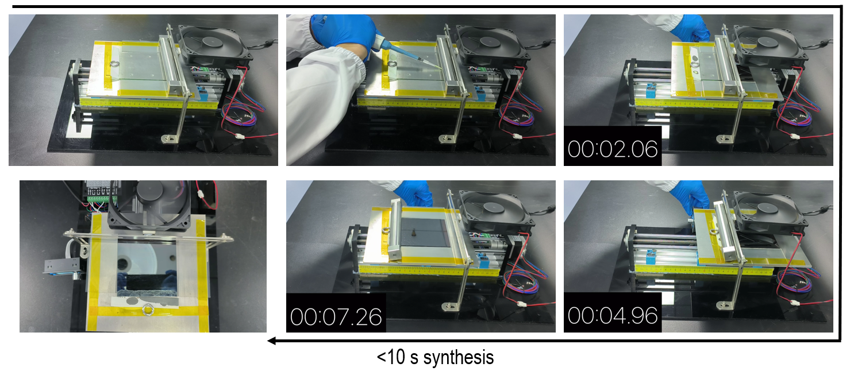
Supplementary Fig. 1 Rapid synthesis strategy. Illustration of the rapid synthesis for the fabrication of large-area perovskite polycrystalline films. (Screenshots from Supplementary Video 1)

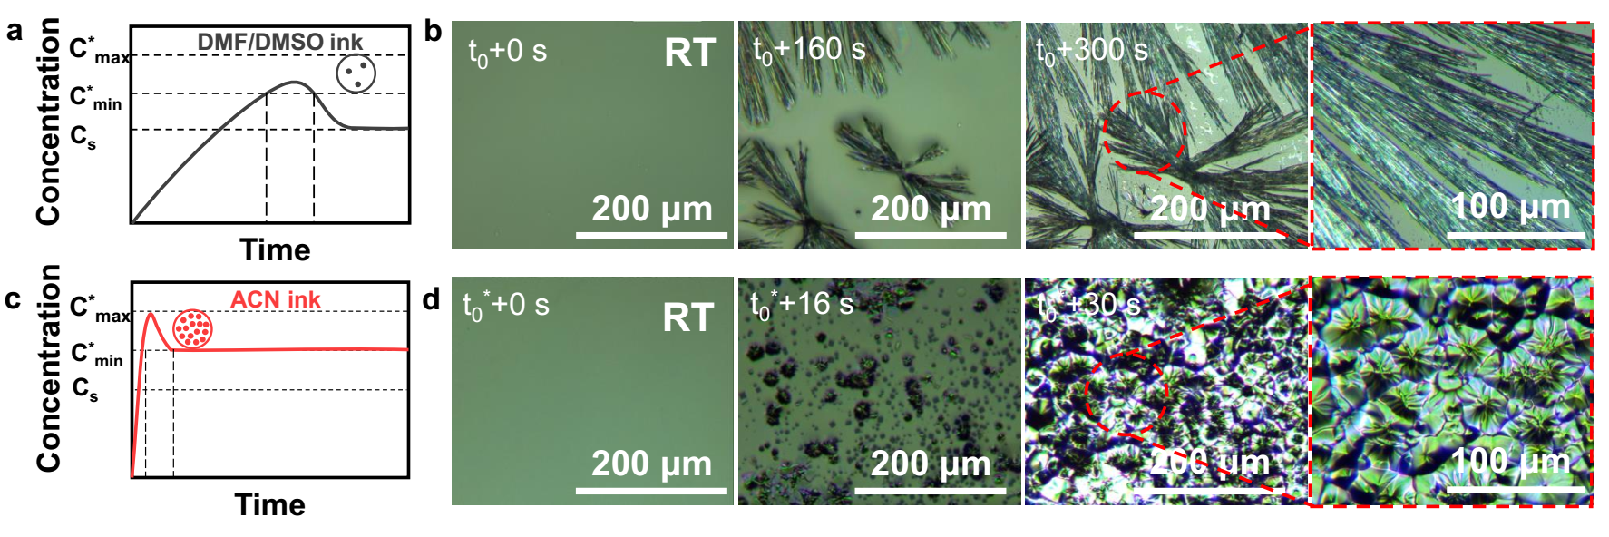
Supplementary Fig. 2 Nucleation and crystal growth from different perovskite inks. Classical LaMer model of a and c to illustration of different nucleation and perovskite crystal growth behavior under different inks. b and d, In situ observation of perovskite precursor film morphology evolutions over time with polarizing microscope, through natural spreading the different inks, at room temperature (RT). (Screenshots from Supplementary Video 2)

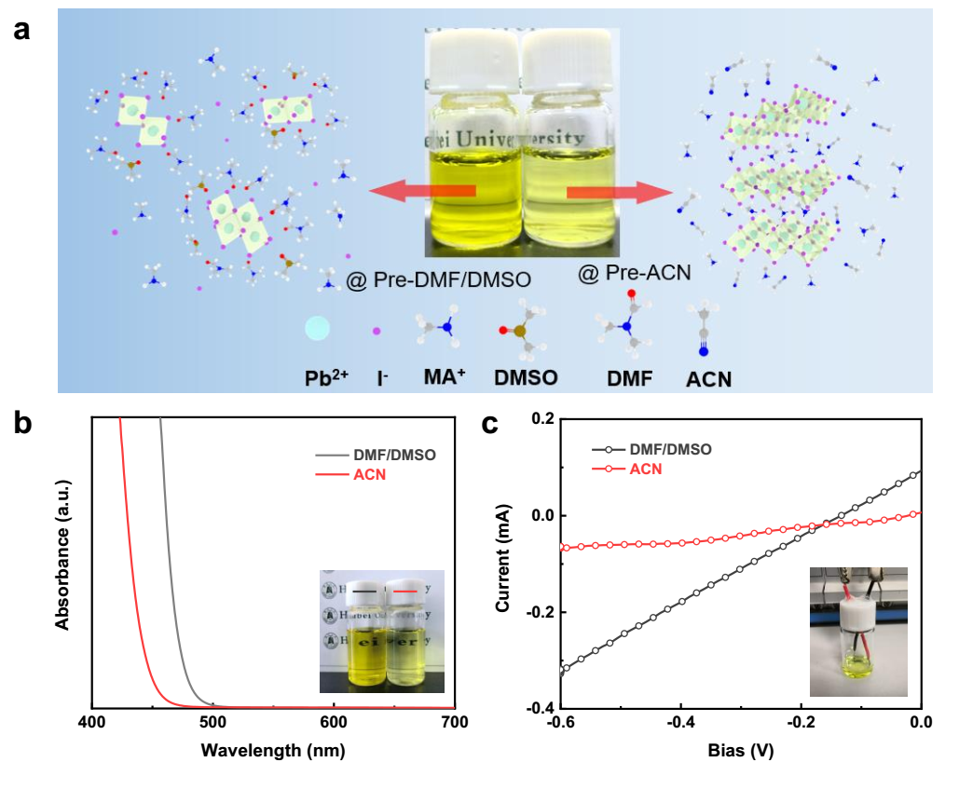
Supplementary Fig. 3 Cluster distribution state in different inks. a, Photograph and schematic showing the structure of different inks. b, UV-vis absorption spectrum of different inks. c, Current-voltage (I-V) curves of different inks.

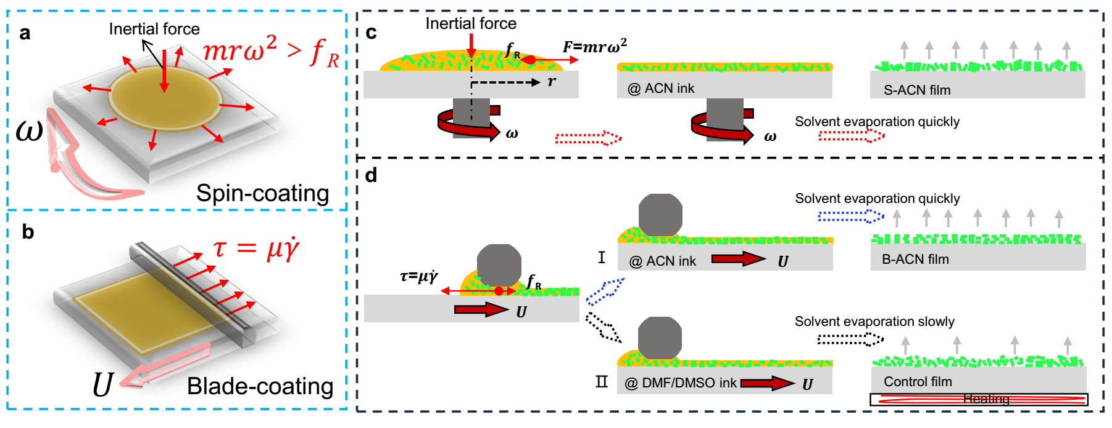
Supplementary Fig. 4 Diagram of the force and growth of colloidal clusters by different methods. a-b, 3D schematic of the force analysis by spin coating and blade coating. c-d, synthesis of different perovskite films by (c) spin coating ACN ink, and (d) blade coating with different inks: (Ⅰ) ACN ink and (Ⅱ) DMF/DMSO ink.

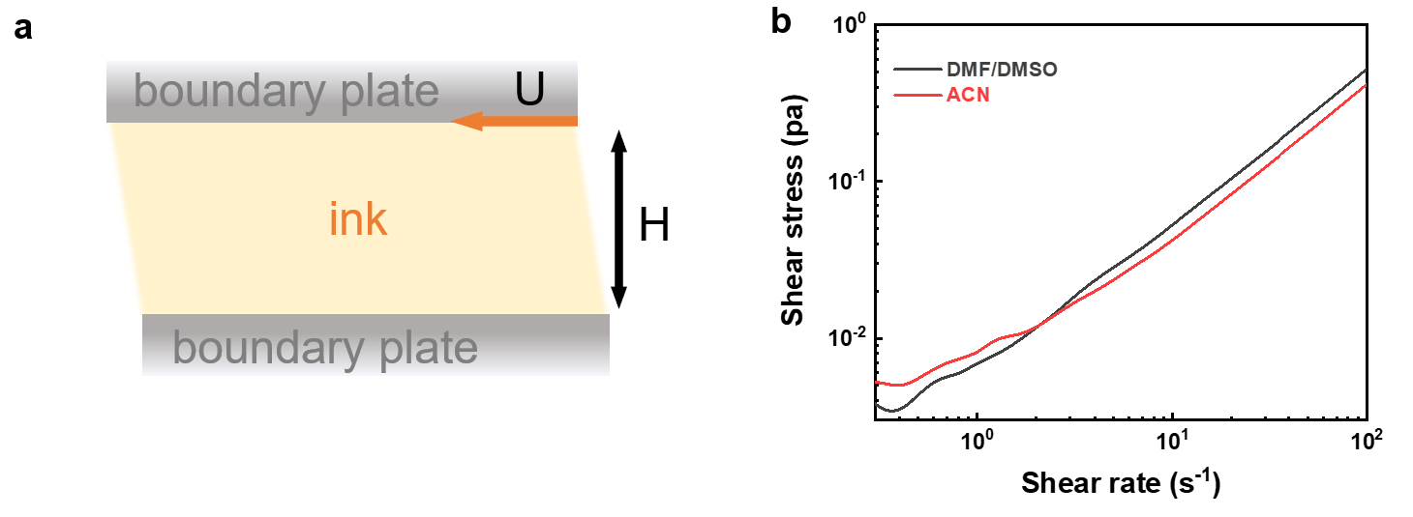
Supplementary Fig. 5 Shear stress between parallel plates. a, Schematic diagram of the narrow gap between two parallel plates. b, The shear stress as a function of shear rate of different inks.

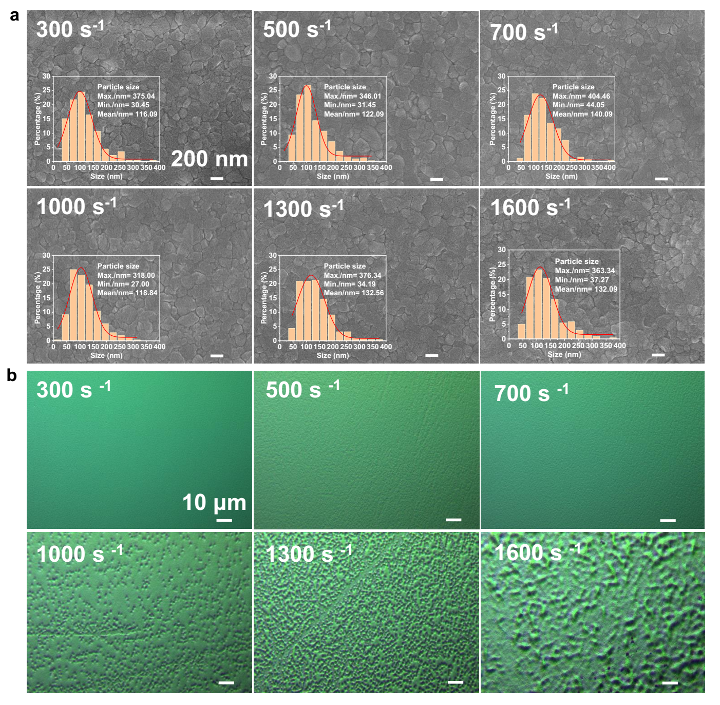
Supplementary Fig. 6 Surface morphology of perovskite thin films. a, Surface SEM images of B-ACN films fabricated at different shear rates (scale bars, 200 nm), inset: corresponding surface particle size distribution. b, Polarization microscope images of B-ACN films fabricated at different shear rates, (scale bars, 10 μm).

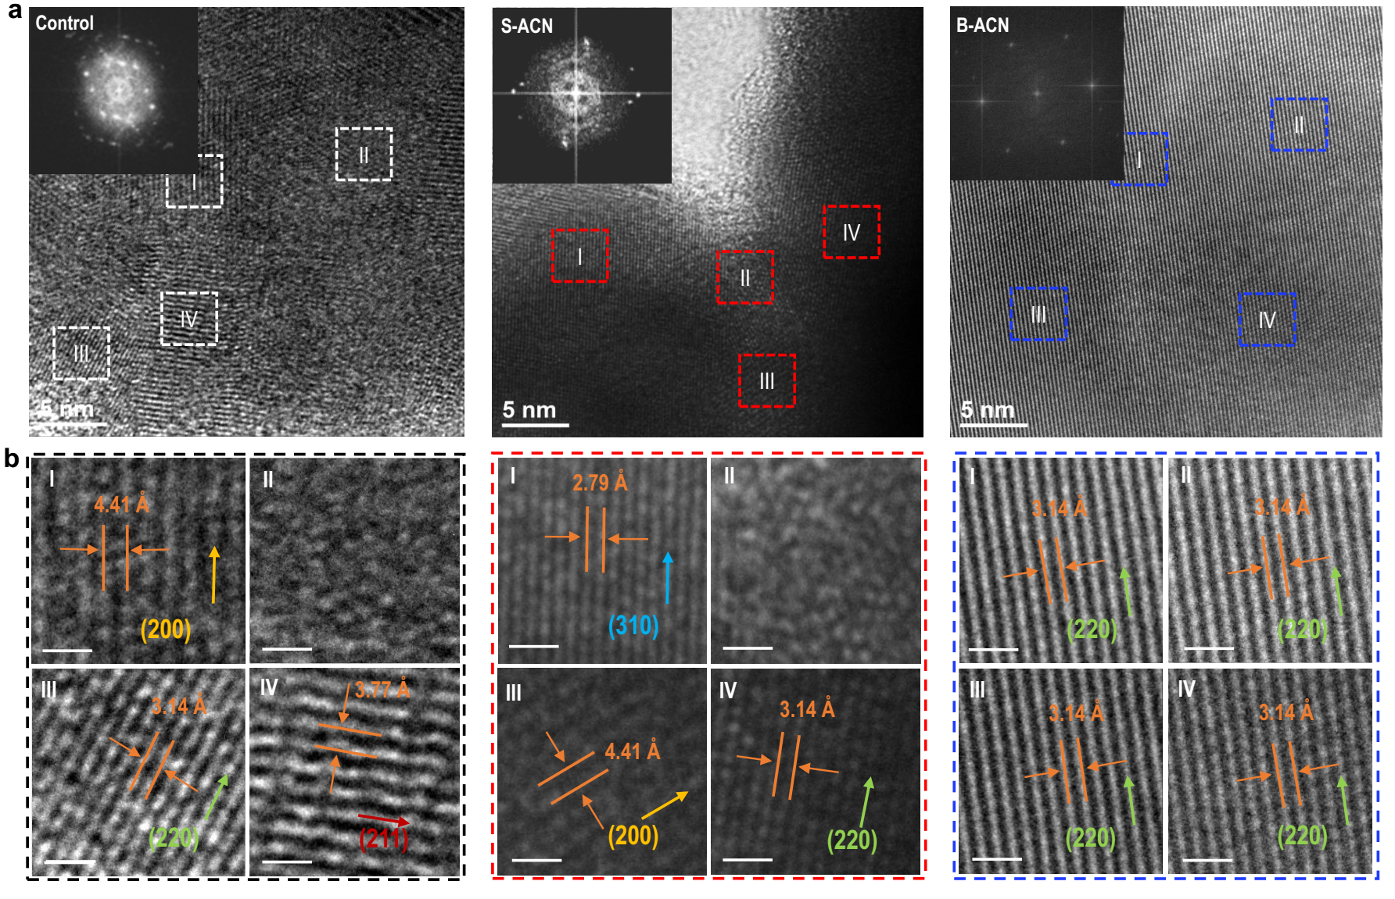
Supplementary Fig. 7 Microstructural lattice orientation of perovskite thin films. a, HRTEM images and the corresponding FFT patterns from three different perovskite films. b, (Ⅰ to Ⅳ) Four representative magnified HRTEM images of the squared area selected in (a) and the corresponding FFT pattern, (scale bars, 1 nm).

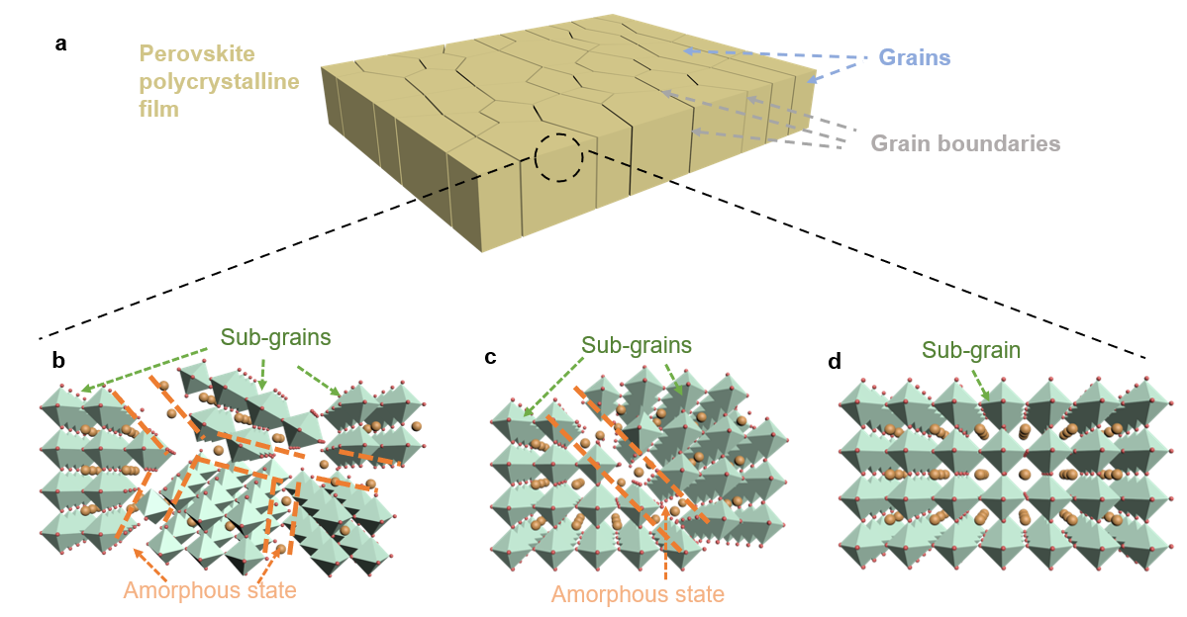
Supplementary Fig. 8 Crystal stacking forms. a, Schematic illustration of the grains and grain boundaries. b-d, Illustration of the sub-grains and amorphous state area in different perovskite polycrystalline films, (b) Control, (c) S-ACN, and (d) B-ACN.

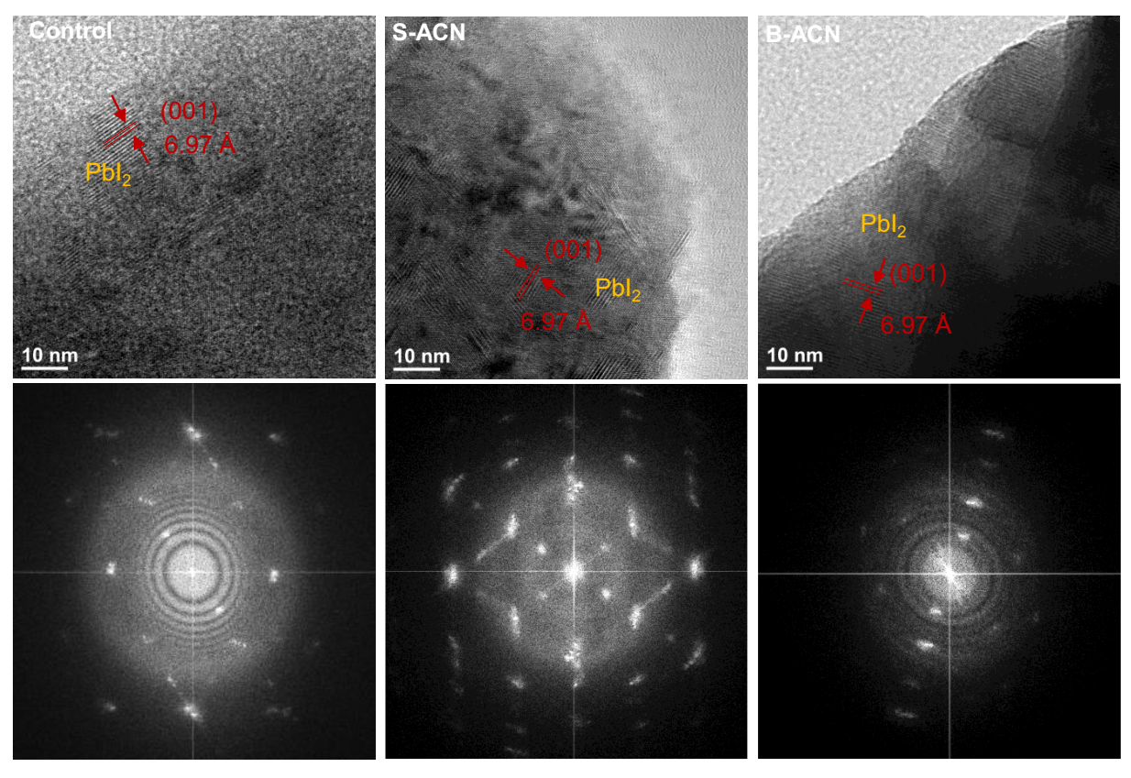
Supplementary Fig. 9 Analysis on microstructure and orientation. HRTEM images and corresponding FFT patterns of Control, S-ACN, and B-ACN perovskite films in a wider range area.

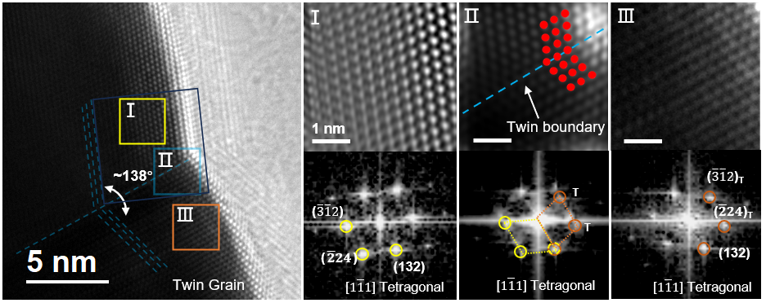
Supplementary Fig. 10 Analysis on microstructure. Representative HRTEM image of B-ACN perovskite film shows the twin grain. Right: Localized magnification images (Ⅰ, Ⅱ, and Ⅲ) and the corresponding FFT patterns.

Supplementary Fig. 11 Investigation on microstructure of perovskite thin films. a The surface and cross-sectional SEM images of different perovskite thin films. b The cross-sectional SEM images of different perovskite thin films on larger glass substrates (5$×$5 cm²). Partial needle vacancies are circled by white circles, and the white dashed lines indicate the surface smoothness of the films.

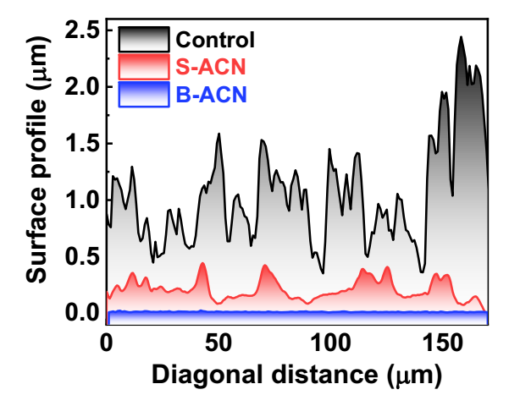
Supplementary Fig. 12 Comparison of the surface roughness of different perovskite thin films. The height distribution along with the diagonal from the AFM images in Figure 3a.

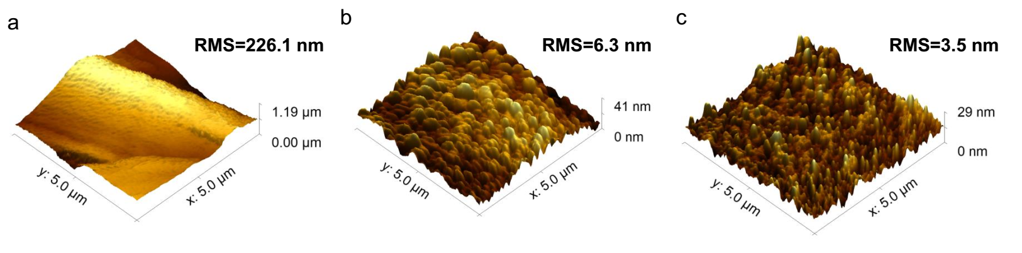
Supplementary Fig. 13 Investigation on the surface roughness. The representative AFM images at a smaller scale (a) Control, (b) S-ACN, and (c) B-ACN perovskite films, range 5$×$5 μm².

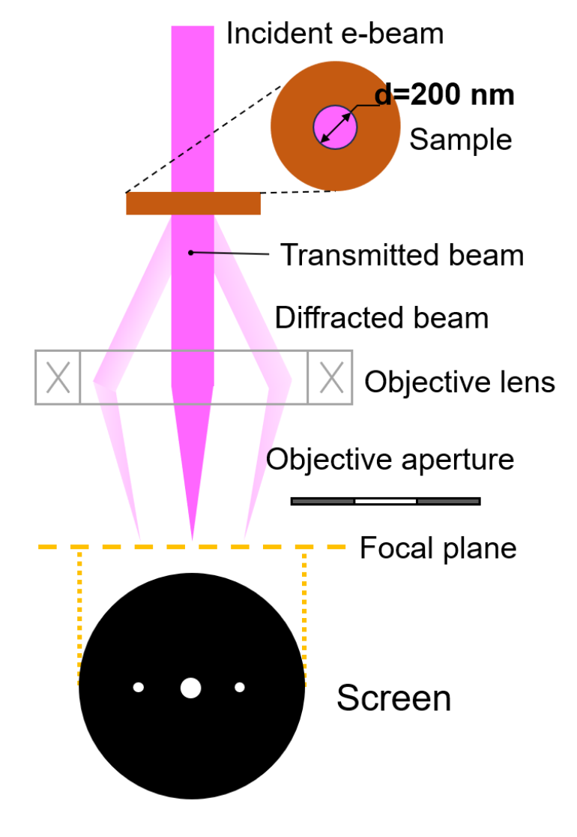
Supplementary Fig. 14 Schematic illustration of the working principle of the SAED. The detection range is a circular area with a diameter of approximately 200 nm in the sample.

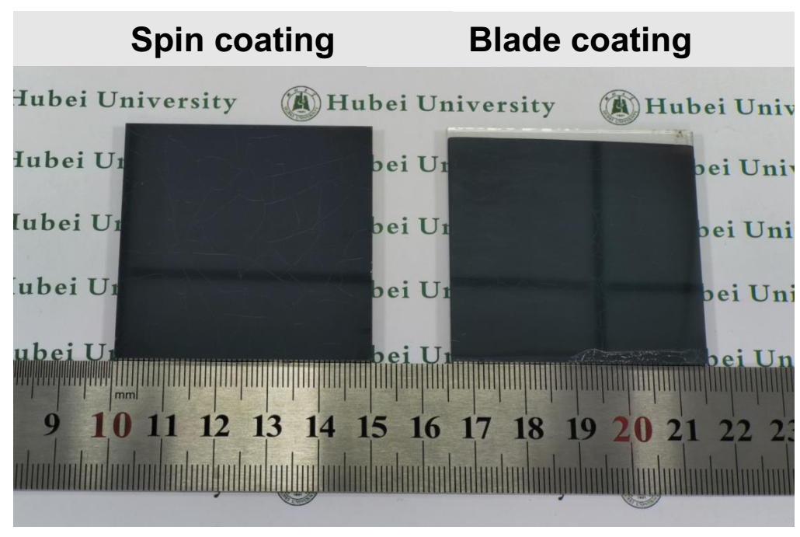
Supplementary Fig. 15 Macroscopic surface of perovskite thin films. Photographs show a mirror-like perovskite film on 5×5 cm² substrate made by spin-coating and blade-coating using ACN ink (note that the black lines on the films correspond to the reflection of the ceiling).

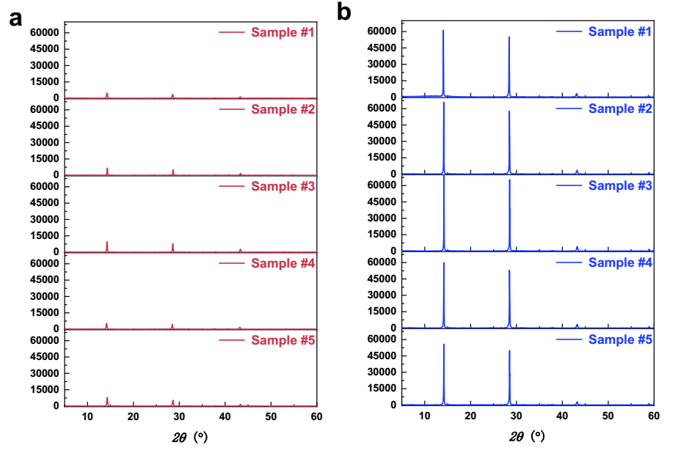
Supplementary Fig. 16 XRD patterns of two types of perovskite thin films at five different regions along the diagonal direction. a-b, (a) S-ACN, (b) B-ACN.

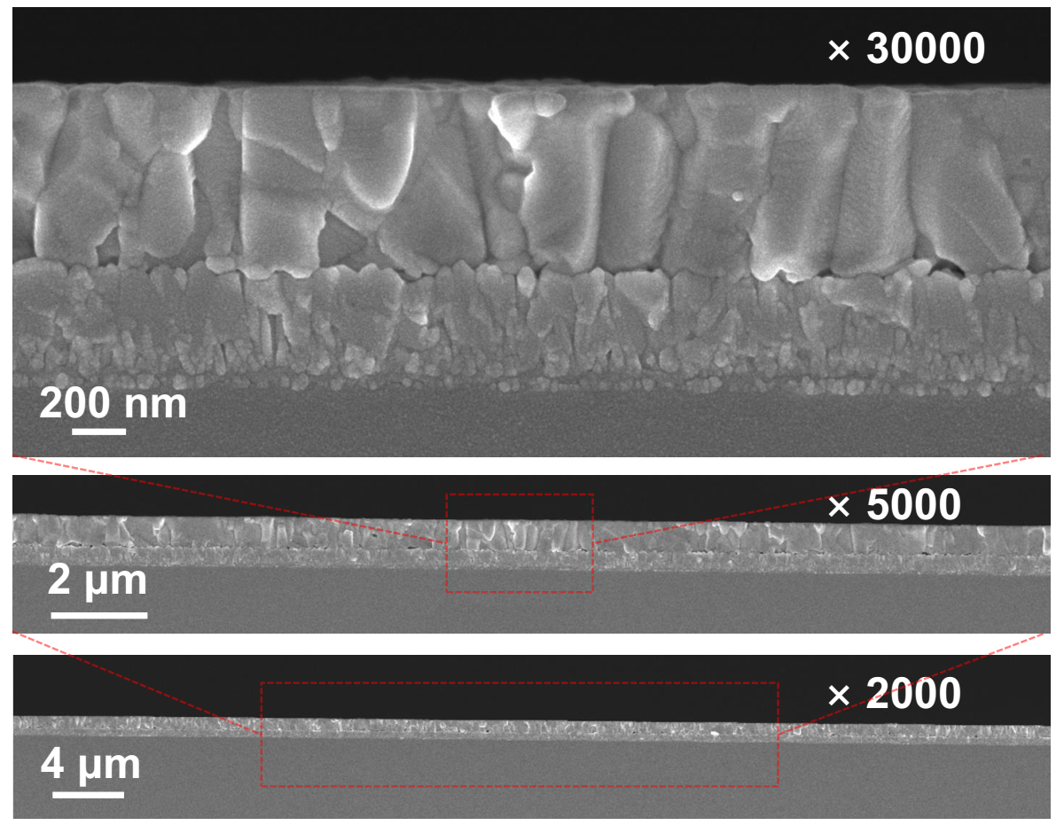
Supplementary Fig. 17 Investigation on microstructure. Cross-sectional SEM images of B-ACN perovskite film at different zoom-in scales.

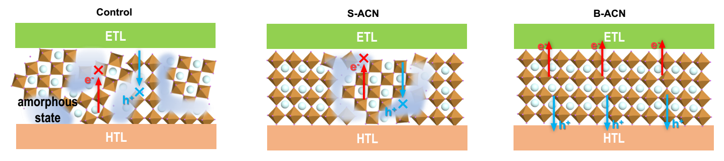
Supplementary Fig. 18 The influence of crystal orientation and amorphous distribution on charge transport. Schematic illustration of the carrier transport routes of different films in the corresponding devices.

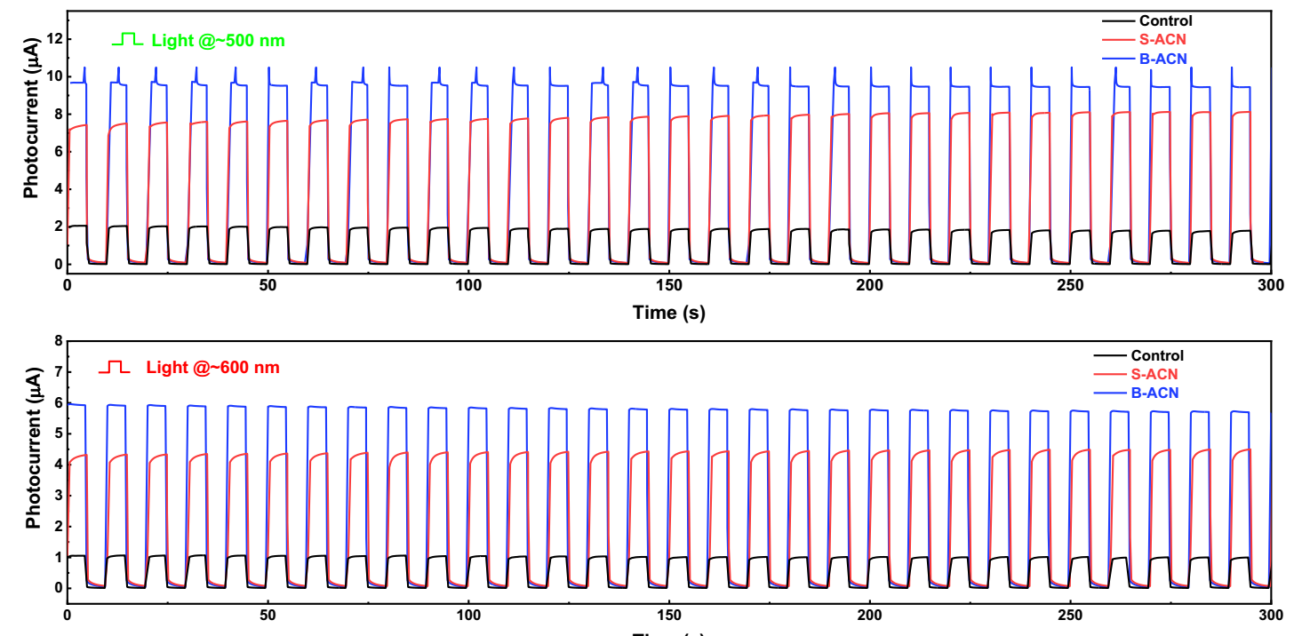
Supplementary Fig. 19 Comparison of the photocurrent response of the devices. Long-term photocurrent response under light of different wavelength of 500 nm and 600 nm.

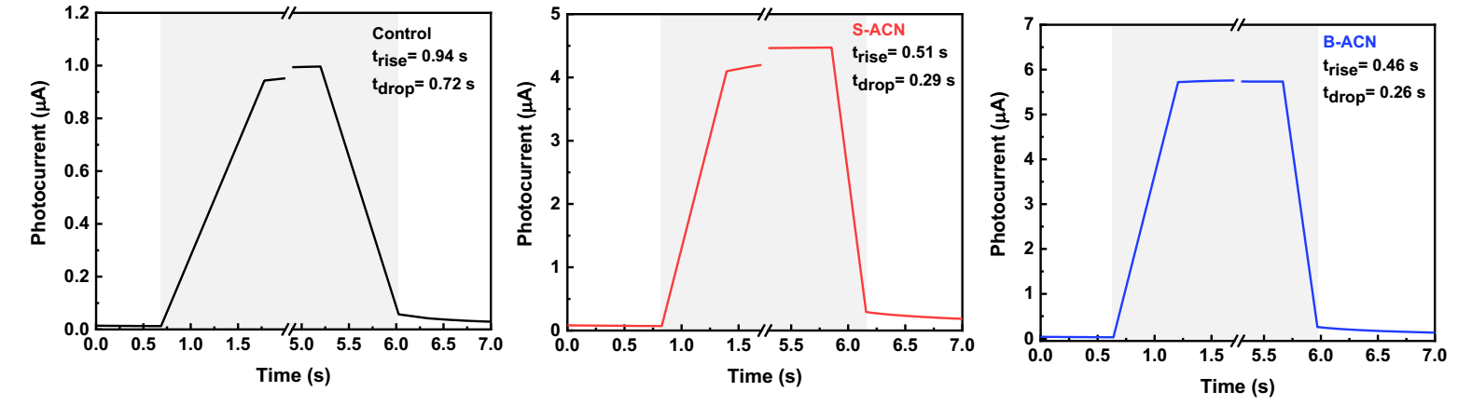
Supplementary Fig. 20 Analysis on photocurrent response. The time-resolved photocurrent response of the devices under the 600 nm light.

Supplementary Fig. 21 Photovoltaic performance of B-ACN. a J-V curves of the B-ACN device under reverse and forward scans. b The corresponding EQE spectra.

Supplementary Fig. 22 Fabrication of perovskite solar module. The process of module laser scribing is demonstrated.

Supplementary Fig. 23 Perovskite solar module demonstration. Front-side view photo of the 10×10 cm² PSM, and optical microscopy image of the P1, P2 and P3 laser scribing line for module fabrication.

Supplementary Fig. 24 Photovoltaic performance of different PSMs. J-V curves of different champion PSMs.

Supplementary Tables 1-6
Supplementary Table 1. Results of TRPL of the control, S-CAN and B-ACN perovskite films.

Samples | Control | S-ACN | B-ACN
$A_{1}$ (kCnts/Chnl) | 0.34 | 0.29 | 0.377
$τ_{1}$ (ns) | 68.3 | 135 | 261.6
$A_{2}$(kCnts/Chnl) | 0.48 | 0.53 | 0.368
$τ_{2}$ (ns) | 39 | 78 | 85
$τ_{ave}$ (ns) | 55.2 | 105.5 | 218.9

Supplementary Table 2. Comparison of transient photocurrent parameters of perovskite devices.

Light | Samples | $$t_{rise}$$  (s) | $$t_{drop}$$  (s) | $$v_{rise}$$  ($μ$A/s) | $$v_{drop}$$  ($μ$A/s) | $$I_{max}$$  ($μ$A)
400 nm | Control | 0.51 | 0.50 | 2.87 | 2.92 | 1.83
400 nm | S-ACN | 0.50 | 0.27 | 5.92 | 10.96 | 3.65
400 nm | B-ACN | 0.66 | 0.25 | 9.96 | 26.30 | 8.24
500 nm | Control | 0.5 | 0.46 | 2.77 | 3.01 | 1.73
500 nm | S-ACN | 0.7 | 0.29 | 9.28 | 22.4 | 8.12
500 nm | B-ACN | 0.41 | 0.24 | 18.52 | 31.63 | 9.49
600 nm | Control | 0.94 | 0.72 | 0.85 | 1.11 | 0.99
600 nm | S-ACN | 0.51 | 0.29 | 7.08 | 12.45 | 4.46
600 nm | B-ACN | 0.46 | 0.26 | 10.14 | 17.94 | 5.74

Supplementary Table 3. The main optoelectronic properties of perovskite thin films prepared by different synthesis strategies.

 | control | S-ACN | B-ACN
$τ_{ave}$ (ns) | 55.2 | 105.5 | 218.9
$σ$ (S/cm) | 5.36$×$10⁻⁵ | 5.88$×$10⁻⁵ | 7.50$×$10⁻⁵
$μ$(cm²V⁻¹s⁻¹) | 1.138$×$10⁻³ | 1.207$×$10⁻³ | 1.723$×$10⁻³
$n_{t}$(cm⁻³) | 1.22$×$10¹⁵ | 7.87$×$10¹⁴ | 6.99$×$10¹⁴
$t_{rise}$(s) | 0.94 | 0.51 | 0.46
$t_{drop}$(s) | 0.72 | 0.29 | 0.26

Supplementary Table 4. The main optoelectronic properties of perovskite thin films prepared by different synthesis strategies (normalization).

 | control | S-ACN | B-ACN
$$τ_{ave}$$ | 0.252169941 | 0.481955231 | 1
$$σ$$ | 0.714666667 | 0.784 | 1
$$μ$$ | 0.660475914 | 0.70052234 | 1
1/$n_{t}$ | 0.571708912 | 0.8888888 | 1
1/$t_{rise}$ | 0.489361702 | 0.901960784 | 1
1/$t_{drop}$ | 0.361111111 | 0.896551724 | 1

Supplementary Table 5. Photovoltaic parameters derived from the J-V of 10$×$10 cm² perovskite modules prepared by different synthesis strategies.

 | Device number | V_{OC}  (V) | JSC  (mA cm⁻²) | FF  (%) | PCE  (%) | A  (cm²)
B-ACN | 1 | 20.82 | 1.32 | 77.21 | 21.24 | 70.00
B-ACN | 2 | 20.52 | 1.34 | 75.46 | 20.76 | 70.00
B-ACN | 3 | 20.74 | 1.32 | 78.98 | 21.63 | 70.00
B-ACN | 4 | 20.59 | 1.31 | 76.44 | 20.62 | 70.00
B-ACN | 5 | 20.78 | 1.34 | 78.32 | 21.78 | 70.00
B-ACN | 6 | 20.82 | 1.33 | 77.20 | 21.44 | 70.00
B-ACN | 7 | 20.59 | 1.35 | 76.35 | 21.22 | 70.00
B-ACN | 8 | 20.22 | 1.31 | 77.65 | 20.49 | 70.00
B-ACN | 9 | 20.15 | 1.30 | 77.32 | 20.18 | 70.00
B-ACN | 10 | 20.09 | 1.29 | 76.12 | 19.70 | 70.00
S-ACN | 1 | 18.87 | 1.42 | 70.85 | 19.01 | 70.00
S-ACN | 2 | 18.86 | 1.32 | 63.10 | 15.72 | 70.00
S-ACN | 3 | 19.46 | 1.32 | 76.57 | 19.62 | 70.00
S-ACN | 4 | 18.53 | 1.30 | 59.24 | 14.31 | 70.00
S-ACN | 5 | 18.47 | 1.34 | 66.44 | 16.47 | 70.00
S-ACN | 6 | 18.45 | 1.32 | 62.41 | 15.19 | 70.00
S-ACN | 7 | 18.46 | 1.35 | 74.90 | 18.63 | 70.00
S-ACN | 8 | 17.99 | 1.35 | 61.34 | 14.87 | 70.00
S-ACN | 9 | 17.95 | 1.31 | 57.51 | 13.49 | 70.00
S-ACN | 10 | 17.90 | 1.30 | 55.46 | 12.91 | 70.00
control | 1 | 15.81 | 1.29 | 49.56 | 10.11 | 70.00
control | 2 | 15.95 | 1.37 | 63.09 | 13.77 | 70.00
control | 3 | 15.71 | 1.11 | 42.46 | 7.38 | 70.00
control | 4 | 16.31 | 1.31 | 68.01 | 14.53 | 70.00
control | 5 | 15.41 | 1.01 | 38.12 | 5.96 | 70.00
control | 6 | 15.84 | 1.29 | 62.37 | 12.76 | 70.00
control | 7 | 15.72 | 1.15 | 50.15 | 9.04 | 70.00
control | 8 | 15.71 | 1.11 | 42.46 | 7.38 | 70.00
control | 9 | 15.64 | 1.09 | 41.41 | 7.07 | 70.00
control | 10 | 15.86 | 1.11 | 54.64 | 9.64 | 70.00

Supplementary Table 6. Summary of PCE, coating method, area and perovskite composition from published literature to date.

Year | Institute | PCE (%) | Coating method | Area (cm²) | Ref
2018 | Swansea | 6.6 | Drop casting | 198 | ⁷
2019 | Uniroma | 13.4 | Spin-coating | 108 | ⁸
2019 | SKKU | 14.03 | Spin-coating | 100 | ⁹
2021 | WHUT | 19.54 | Slot-die coating | 65 | ¹⁰
2021 | UNC | 18.60 | Blade-coating | 60.8 | ¹¹
2022 | ERI@N | 16.22 | Slot-die coating | 57.5 | ¹²
2022 | KIER | 20.55 | Spin-coating | 64 | ¹³
2022 | OIST | 15.30 | Blade-coating | 205 | ¹⁴
2022 | Uniroma | 11.9 | Spin-coating | 192 | ¹⁵
2022 | SKKU | 18.27 | Spin-coating | 60.68 | ¹⁶
2022 | XMU | 19.90 | Blade-coating | 54 | ¹⁷
2023 | NWPU | 17.71 | Blade-coating | 56 | ¹⁸
2023 | UTOLEDO | 20.15 | Blade-coating | 81 | ¹⁹
2024 | PSU | 20.14 | Spin-coating | 70 | ²⁰
2024 | CCSFU | 18.73 | Slot-die coating | 171.5 | ²¹
2024 | HUST | 18.2 | Drop casting | 57.5 | ²²
2024 | UNC | 19.6 | Blade-coating | 84 | ²³
2024 | UNC | 19.21 | Blade-coating | 108 | ²³
2024 | This work | 21.78 | Blade-coating | 70 | n.a.

Supplementary References
1. Feng, J. et al. Record Efficiency Stable Flexible Perovskite Solar Cell Using Effective Additive Assistant Strategy. Adv. Mater. 30, 1–9 (2018).
2. Li, Y. et al. High-efficiency robust perovskite solar cells on ultrathin flexible substrates. Nat. Commun. 7, 10214 (2016).
3. Zheng, J. et al. Solution-Processed, Silver-Doped NiOx as Hole Transporting Layer for High-Efficiency Inverted Perovskite Solar Cells. ACS Appl. Energy Mater. 1, 561–570 (2018).
4. Peng, J., Chen, Y., Zheng, K., Pullerits, T. & Liang, Z. Insights into charge carrier dynamics in organo-metal halide perovskites: From neat films to solar cells. Chem. Soc. Rev. 46, 5714–5729 (2017).
5. Liu, K. et al. Zwitterionic-Surfactant-Assisted Room-Temperature Coating of Efficient Perovskite Solar Cells. Joule 4, 2404–2425 (2020).
6. Shi, D. et al. Low trap-state density and long carrier diffusion in organolead trihalide perovskite single crystals. Science (80-. ). 347, 519–522 (2015).
7. De Rossi, F. et al. All Printable Perovskite Solar Modules with 198 cm2 Active Area and Over 6% Efficiency. Adv. Mater. Technol. 3, 1–9 (2018).
8. Agresti, A. et al. Two-Dimensional Material Interface Engineering for Efficient Perovskite Large-Area Modules. ACS Energy Lett. 4, 1862–1871 (2019).
9. Han, G. S. et al. Spin-Coating Process for 10 cm × 10 cm Perovskite Solar Modules Enabled by Self-Assembly of SnO2 Nanocolloids. ACS Energy Lett. 4, 1845–1851 (2019).
10. Bu, T. et al. Lead halide–templated crystallization of methylamine-free perovskite for efficient photovoltaic modules. Science (80-. ). 372, 1327–1332 (2021).
11. Chen, S. et al. Stabilizing perovskite-substrate interfaces for high-performance perovskite modules. Science (80-. ). 373, 902–907 (2021).
12. Rana, P. J. S. et al. Alkali Additives Enable Efficient Large Area (>55 cm2) Slot-Die Coated Perovskite Solar Modules. Adv. Funct. Mater. 32, (2022).
13. Kim, M. et al. Conformal quantum dot-SnO2 layers as electron transporters for efficient perovskite solar cells. Science (80-. ). 375, 302–306 (2022).
14. Bu, T. et al. Modulating crystal growth of formamidinium–caesium perovskites for over 200 cm2 photovoltaic sub-modules. Nat. Energy 7, 528–536 (2022).
15. Castriotta, L. A. et al. Reducing Losses in Perovskite Large Area Solar Technology: Laser Design Optimization for Highly Efficient Modules and Minipanels. Adv. Energy Mater. 12, 2103420 (2022).
16. Zhu, J. et al. Defect Healing in FAPb(I1-xBrx)3 Perovskites: Multifunctional Fluorinated Sulfonate Surfactant Anchoring Enables >21% Modules with Improved Operation Stability. Adv. Energy Mater. 12, 2200632 (2022).
17. Feng, Q. et al. Governing PbI6 octahedral frameworks for high-stability perovskite solar modules. Energy Environ. Sci. 15, 4404–4413 (2022).
18. Chen, R. et al. Patch-healed grain boundary strategy to stabilize perovskite films for high-performance solar modules. Nano Energy 115, 108759 (2023).
19. Chung, J. et al. Engineering Perovskite Precursor Inks for Scalable Production of High-Efficiency Perovskite Photovoltaic Modules. Adv. Energy Mater. 13, 1–10 (2023).
20. Wu, H. et al. Down-selection of biomolecules to assemble “reverse micelle” with perovskites. Nat. Commun. 15, (2024).
21. Duan, L. et al. A‐D‐A Molecule–Bridge Interface for Efficient Perovskite Solar Cells and Modules. Adv. Mater. 2314098, 1–10 (2024).
22. Liu, J. et al. Electron injection and defect passivation for high-efficiency mesoporous perovskite solar cells. Science 383, 1198–1204 (2024).
23. Uddin, M. A. et al. Iodide manipulation using zinc additives for efficient perovskite solar minimodules. Nat. Commun. 15, 1–9 (2024).

