Supplementary
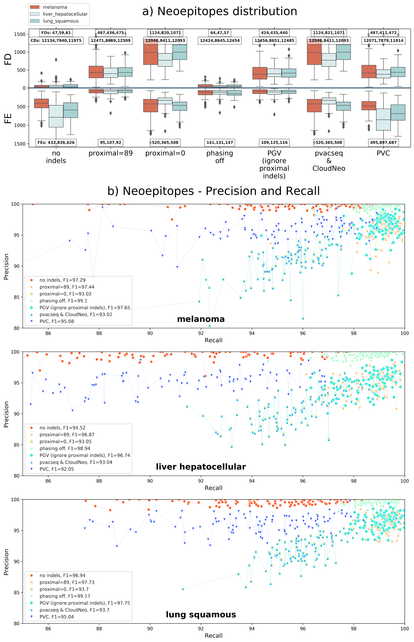
Figure S1: (a) Distribution of FDs, CDs, and FEs on neoepitopes across 100 samples of melanoma, hepatocellular carcinoma and lung squamous cancer, respectably, when some of the mutational events are switched off: all indels are ignored, the proximal area size of only 89 nucleotides as used in PVC, all proximal variants ignored (proximal=0), excluding variant phasing, the influence of indels around currently processed somatic variant (as excluded in PGV), pvacseq & CloudNeo (excluding phasing and proximal area equals 0) and PVC (no indels and proximal area of 89). Total numbers of FDs, FEs, and CDs are given in the boxes for each mutational event switch off and for each algorithm with its mutational events switched off. (b) Precision and recall scores on neoepitopes across 100 samples each of melanoma, hepatocellular carcinoma, and lung squamous cancer when the same mutational events are switched off. Mean f-scores (F1) across all samples when a mutational event is switched off are given in the figure’s legend. Neoepitopes (sizes 8, 9, 10, and 11 amino acids) are spawned from all neoantigen nests not contained in the wild type protein database.

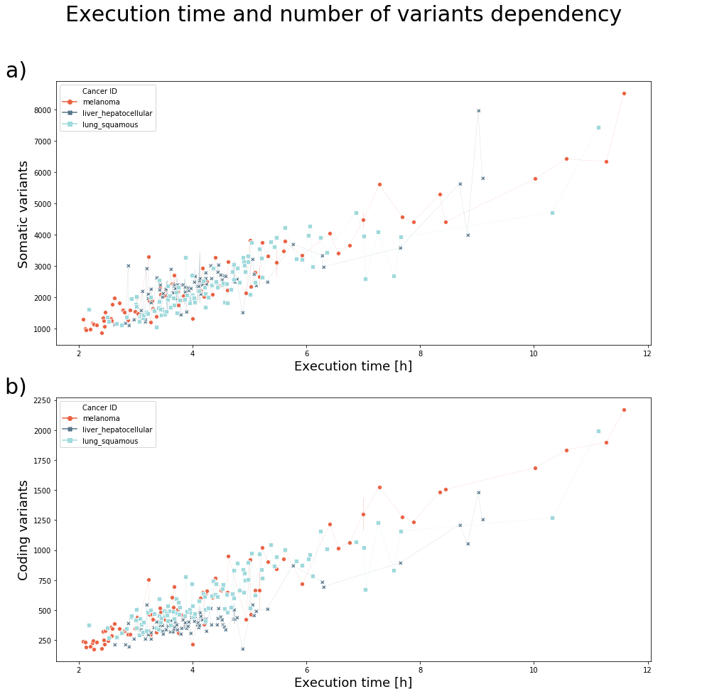
Figure S2: Distribution of INAEME execution times across 100 samples of melanoma, hepatocellular carcinoma and lung squamous cancer (total 300 samples). (a) Dependency of execution time and number of somatic variants detected in the sample. (b) Dependency of execution time and number of somatic variants that fall into gene coding regions.

