Nitrogen availability controls plant carbon storage with warming
Supplementary Material
Guiyao Zhou, Cesar Terrer, Bruce A. Hungate, Natasja van Gestel, Xuhui Zhou,
Kees Jan van Groenigen

Supplementary Figures

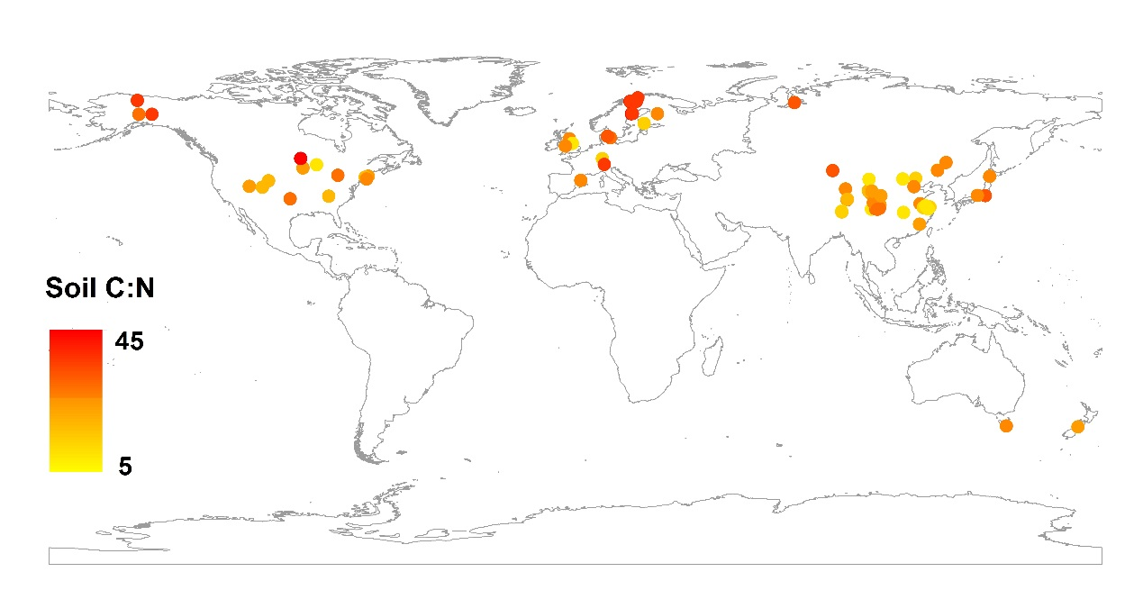
Figure S1. Geographical distribution of experimental sites included in our dataset. The colour of each data point indicates the soil C:N value at the corresponding site.

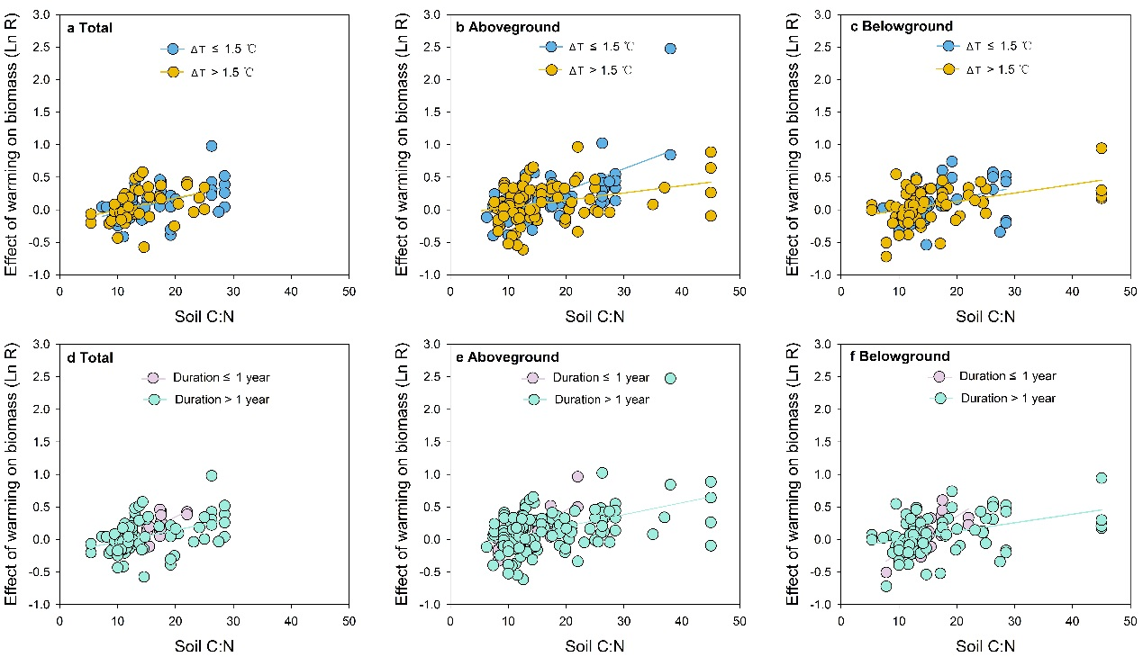

Figure S2. Relationships between soil C:N and the responses (LnR) of total biomass (TGB), aboveground biomass (AGB) and belowground biomass (BGB) to warming for various experimental conditions. Relationships between soil C:N and LnR of total biomass (A), aboveground biomass (B) and belowground biomass (C) for studies categorized by warming magnitude. Positive relationships between LnR of TGB were found for ΔT ≤ 1.5℃ (R² = 0.25, P < 0.001, n = 42) and ΔT˃1.5℃ (R² = 0.13, P = 0.02, n=42); for AGB for ΔT ≤ 1.5℃ (R² = 0.41, P < 0.001, n=70) and ΔT˃1.5℃ (R² = 0.11, P < 0.001, n=89); for BGB for ΔT ≤ 1.5℃ (R² = 0.12, P = 0.03, n = 38) and ΔT˃1.5℃ (R² = 0.18, P < 0.001, n=69). Relationships between soil C:N and LnR of total biomass (D), aboveground biomass (E) and belowground biomass (F) for studies categorized by experimental duration. Positive relationships for TGB were found for duration ≤ 1 year (R² = 0.34, P = 0.03, n = 14), and duration > 1 year (R² = 0.17, P < 0.001, n = 70); for AGB for duration ≤ 1 year (R² = 0.64, P < 0.001, n = 17) and duration > 1 year (R² = 0.20, P < 0.001, n = 142); for BGB for duration ≤ 1 year (R² = 0.45, P = 0.003, n = 17) and duration > 1 year (R² = 0.16, P < 0.001, n = 90).

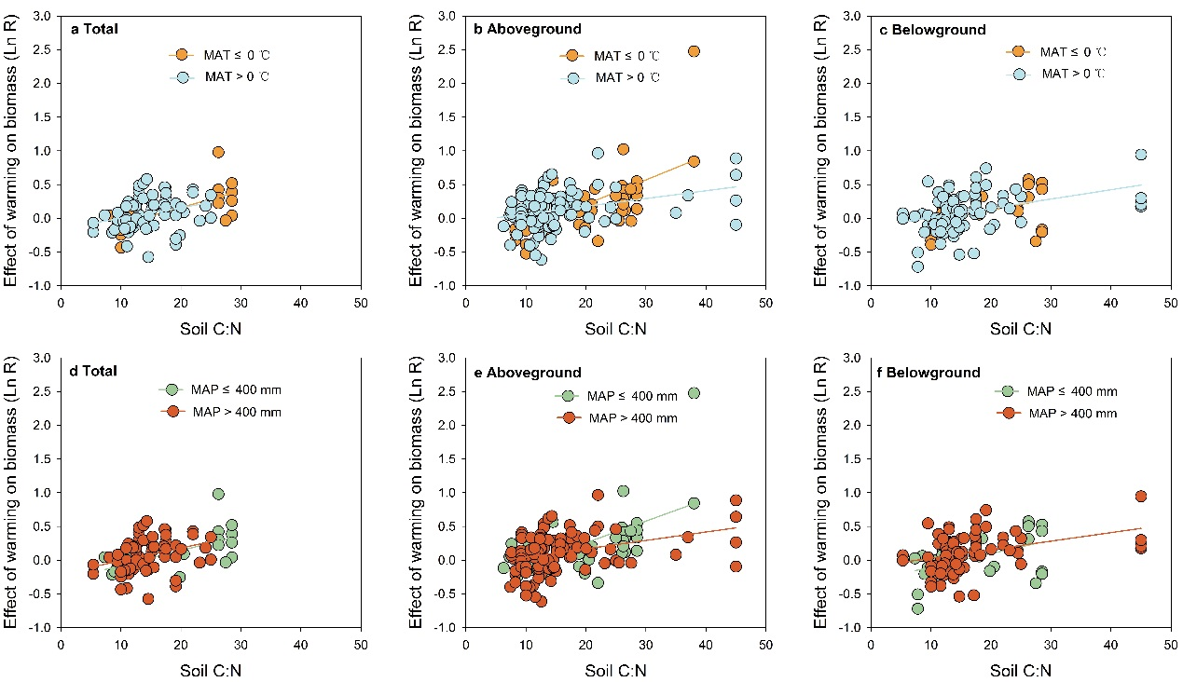Figure S3. Relationships between soil C:N and the responses (LnR) of total biomass (TGB), aboveground biomass (AGB) and belowground biomass (BGB) to warming for various climatic conditions. Relationships between soil C:N and LnR of total biomass (A), aboveground biomass (B) and belowground biomass (C) for studies categorized by MAT. Positive relationships for TGB were found for MAT ≤ 0℃ (R² = 0.44, P = 0.003, n = 18) and MAT > 0℃ (R² = 0.08, P < 0.019, n = 66), for AGB for MAT ≤ 0℃ (R² = 0.43, P < 0.001, n = 47) and MAT > 0℃ (R² = 0.11, P < 0.001, n = 112), for BGB for MAT ≤ 0℃ (R² = 0.20, P = 0.021, n = 26) and MAT > 0℃ (R² = 0.15, P < 0.001, n = 81). Relationships between soil C:N and LnR of total biomass (D), aboveground biomass (E) and belowground biomass (F) for studies categorized by MAP. Positive relationships for TGB were also found for MAP ≤ 400 mm (R² = 0.42, P = 0.002, n = 20) and MAP > 400 mm (R² = 0.11, P = 0.009, n=64); for AGB for MAP ≤ 400 mm (R² = 0.37, P < 0.001, n=42) and MAP > 400 mm (R² = 0.12, P < 0.001, n=117); for BGB for MAP ≤ 400 mm (R² = 0.25, P = 0.007, n = 28) and MAP > 400 mm (R² = 0.14, P < 0.001, n=79).

Supplementary Tables

Table S1 Overview of the predictors and corresponding study categories included in our model selection approach.

Predictor | Source | Categories
Soil C:N | Corresponding paper; SoilGrids | Continuous
MAP | Corresponding paper; Worldclim.org | Continuous
MAT | Corresponding paper; Worldclim.org | Continuous
Ecosystem type | Corresponding paper | Cropland; Desert; Forest; Grassland; Peatland; Shrubland; Salt marsh
Plant type | Corresponding paper | Herbaceous; Woody
Mycorrhizae type | Corresponding paper; Wang & Qiu (2006) | AM; ECM
Warming method | Corresponding paper | Passive warming; Cable; Infrared heater; Heated OTC/Greenhouse
Duration | Corresponding paper | Continuous
Nitrogen additions | Corresponding paper | Yes; No
Latitude | Corresponding paper | Continuous
ΔT | Corresponding paper | Continuous

Supplementary Notes S1
References Dataset
- Jarvi, P., Burton, A. (2013). Acclimation and soil moisture constrain sugar maple root respiration in experimentally warmed soil. Tree Physiology, 9, 949-959.
- Saleska S., Shaw M., Fischer, M., Dunne, J., Still, C., & Holman, M., Harte, J. (2002). Plant community composition mediates both large transient decline and predicted long-term recovery of soil carbon under climate warming. Global Biogeochemical Cycles, 16, 1055.doi:10.1029/2001GB001573.
- Zhang, T., Guo, R., Guo, J., Sun, W. (2015).Responses of Plant Community Composition and Biomass Production to Warming and Nitrogen Deposition in a Temperate Meadow Ecosystem. Plos One.DOI:10.1371/journal.pone.0123160.
- Björk, R., Majdi, H., Klemedtsson, L., Lewis-Jonsson, L.,Molaul U. (2007).Long-term warming effects on root morphology, root mass distribution, and microbial activity in two dry tundra plant communities in northern Sweden. New Phytologist, 176, 862-873.
- Rinnan, R., Michelsen, A., Jonasson, S. (2008). Effects of litter addition and warming on soil carbon, nutrient pools and microbial communities in a subarctic heath ecosystem.Applied Soil Ecology, 39, 271- 281.
- Graham, S., Hunt J., Millard, P., Mcseveny, T., Whitehead, D. (2014). Effects of soil warming and nitrogen addition on soil respiration in a new zealand tussock grassland. PLoS ONE, 9(3), e91204.
- Cowles, J., Wragg, P., Wright, A., Powers, J., Tilman, D. (2016). Shifting grassland plant community structure drives positive interactive effects of warming and diversity on aboveground net primary productivity. Global Change Biology, 22, 741-749.
- Li,Q., Huahua Bai, H., Liang, W., Xia, J., Wan, S., Van der Putten, W.(2013). Nitrogen Addition and Warming Independently Influence the Belowground Micro-Food Web in a Temperate Stepp. PLoS ONE 8(3): e60441. doi:10.1371/journal.pone.0060441.
- Lin, X., Zhang, Z., Wang, S., Hu, Y., Xu, G., Luo, C., Chang, X., Duan, J., Lin, Q., Xu, B., Wang, Y., Zhao, X., Xie, Z. (2011). Response of ecosystem respiration to warming and grazing during the growing seasons in the alpine meadow on the tibetan plateau. Agricultural & Forest Meteorology, 151, 792-802.
- Noh, N., Kuribayashi, M., Saitoh, T., Nakaji, T., Nakamura, M., Hiura, T., Muraoka, H. (2016). Responses of soil, heterotrophic, and autotrophic respiration to experimental open-field soil warming in a cool-temperate deciduous forest. Ecosystems, 19, 504-520.
- Xu, Z., Yin, H., Xiong, P., Wan, C., Liu, Q. (2012). Short-term responses of picea asperata seedlings of different ages grown in two contrasting forest ecosystems to experimental warming. Environmental and Experimental Botany, 77, 1-11.
- Wang, X., Dong, S., Gao, Q., Zhou, H., Liu, S., Su, X., Li, Y. (2014). Effects of short-term and long-term warming on soil nutrients, microbial biomass and enzyme activities in an alpine meadow on the Qinghai-Tibet Plateau of China. Soil Biology & Biochemistry, 76 ,140-142.
- Cheng, H., Ren, W., Ding, L., Liu, Z., Fang, C. (2013). Responses of a rice–wheat rotation agroecosystem to experimental warming. Ecological Research, 28, 959-967.
- Peng, F., You, Q., Xu, M. , Zhou, X., Xue, X. (2015). Effects of experimental warming on soil respiration and its components in an alpine meadow in the permafrost region of the qinghai-tibet plateau. European Journal of Soil Science, 66, 145-154.
- Yin, H., Xiao, J., Li, Y., Chen, Z., Cheng, X., Zhao, C., Liu, Q. (2013). Warming effects on root morphological and physiological traits: the potential consequences on soil c dynamics as altered root exudation. Agricultural and Forest Meteorology. 180, 287-296.
- Pendall, E., Osanai, Y., Williams, A., Hovenden, M. (2011). Soil carbon storage under simulated climate change is mediated by plant functional type. Global Change Biology, 17, 505-514.
- Yin, H., Liu Q., Lai, T. (2008). Warming effects on growth and physiology in the seedlings of the two conifers picea asperata and abies faxoniana under two contrasting light conditions. Ecological Research, 23, 459-469.
- Briones, M., Ostle, N., Mcnamara, N., Poskitt, J. (2009). Functional shifts of grassland soil communities in response to soil warming. Soil Biology & Biochemistry, 41, 315-322.
- Usami, T., Lee, J., Oikawa, T. (2010). Interactive effects of increased temperature and CO2 on the growth of quercus myrsinaefolia saplings. Plant Cell & Environment, 24, 1007-1019.
- Richardson, S., Press, M., Parsons, A., Hartley, S. (2002). How do nutrients and warming impact on plant communities and their insect herbivores? a 9-year study from a sub-arctic heath. Journal of Ecology, 90, 544-556.
- Clemmensen, K., Michelsen, A. (2006). Integrated long-term responses of an arctic-alpine willow and associated ectomycorrhizal fungi to an altered environment. Canadian Journal of Botany, 84, 831-843.
- Aerts, R., Cornelissen, J., Dorrepaal, E. (2006). Plant performance in a warmer world: general responses of plants from cold, northern biomes and the importance of winter and spring events. Plant Ecology, 182, 65-77.
- Jonasson, S., Michelsen, A., Schmidt I., Nielsen, E. (1999). Responses in microbes and plants to changed temperature, nutrient, and light regimes in the arctic. Ecology, 80, 1828-1843.
- Shi, F., Wu, N., Wu, Y. (2010). Responses of plant growth and substance allocation of three dominant plant species to experimental warming in an alpine grassland, Northwestern Sichuan, China. Chinese Journal of Plant Ecology, 34 ,488-497.
- Luo, Y., Sherry, R., Zhou, X., Wan, S. (2008). Terrestrial carbon-cycle feedback to climate warming: experimental evidence on plant regulation and impacts of biofuel feedstock harvest. GCB Bioenergy, 1, 62-74.
- Hartley, I., Heinemeyer, A., Evans, S., Ineson, P. (2010). The effect of soil warming on bulk soil vs. rhizosphere respiration. Global Change Biology, 13, 2654-2667.
- Xu, Z., Hu, T., Li, X., Zhang, Y., Xian, J., Wang, K. (2009). Short -term responses of grass community in clear -cutting land of sub -alpine regions to simulated global warming, Western Sichuan. Acta Ecologica Sinica, 29, 2899-2905. (In Chinese with English Abstract).
- Charles, H., Dukes, J. (2009). Effects of warming and altered precipitation on plant and nutrient dynamics of a New England salt marsh. Ecological Applications, 19, 1758-1773.
- Boelman, N., Stieglitz, M., Rueth, H., Sommerkorn, M., Griffin, K., Gamon, S. (2003). Response of NDVI, biomass, and ecosystem gas exchange to long-term warming and fertilization in wet sedge tundra. Oecologia, 135, 414-421.
- Hakala, K. (1998). Growth and yield potential of spring wheat in a simulated changed climate with increased CO₂ and higher temperature. European Journal of Agronomy, 9,41-52.
- Wang, J., Duan, B., Zhang, Y. (2012). Effects of experimental warming on growth, biomass allocation, and needle chemistry of abies faxoniana in even-aged monospecific stands. Plant Ecology, 213, 47-55.
- Liu, Y. (2013). Response of soil respiration and microbial community structure to soil warming and throughfall exclusion in warming-temperate oak (Quercus aliena Var. acuteserrata) forest. Ph.d Dissertation for Chinese Academy of Forestry. (In Chinese with English Abstract).
- Zhao, C. (2009). Response of two coniferous species seedlings to artificial warming and nitrogen fertilization in subalpine region of western Sichuan, China. Ph.d Dissertation for Sichuan Agricultural University. (In Chinese with English Abstract).
- Hoeppner, S., Dukes, J. (2012). Interactive responses of old-field plant growth and composition to warming and precipitation. Global Change Biology, 18, 1754-1768.
- Kostiainen, K., Kaakinen, S., Saranp, P., Sigurdsson, B., Lundqvist, S., Linder, S., Linder, S., Vapaavyori, E. (2009). Stem wood properties of mature norway spruce after 3 years of continuous exposure to elevated CO2 and temperature. Global Change Biology, 15, 368-379.
- Lambrecht, S., Loik, M., Inouye, D., Harte, J. (2007). Reproductive and physiological responses to simulated climate warming for four subalpine species. New Phytologist , 173, 121-134.
- Alster, C., Allison, S., Treseder, K. (2020). Carbon budgets for soil and plants respond to long-term warming in an alaskan boreal forest. Biogeochemistry, 150, 345-353.
- Malhotra, A., Brice, D., Childs, J., Graham, J., Hobbie, E., Stel, H., Feron, S., Hanson, P., Iversen, C. (2020). Peatland warming strongly increases fine-root growth. Proceedings of the National Academy of Sciences, 117, 17627-17634.
- Xu, M., Liu, M., Zhai, D., Xue, X., Peng, F., You, Q. (2015). Effects of experimental warming on the root biomass of an alpine meadow on the Qinghai-Tibetan Plateau, China. Acta Ecologica Sinica, 36, 6812-6822. (In Chinese with English Abstract).
- Kardol, P., Campany, C., Souza, L., Norby, Wwltzin, J., Classen, A. (2010). Climate change effects on plant biomass alter dominance patterns and community evenness in an experimental old-field ecosystem. Global Change Biology, 16, 2676-2687.
- Wang, B., Li, J., Wan, Y., Cai, W., Guo, C., You, S., Li, R., Qin, X., Gao, Q., Zhou, S., Liu, K., Wilkes, A., Li, Y. (2019). Variable effects of 2°C air warming on yield formation under elevated CO2 in a Chinese double rice cropping system. Agricultural and Forest Meteorology, 278, 107662.
- Mueller, K., Blumenthal, D., Pendall, E., Carrillo, Y., Dijkstra, F., Williams, D., Follett, R., Morgan, J. (2016). Impacts of warming and elevated CO2 on a semi-arid grassland are non-additive, shift with precipitation, and reverse over time. Ecology Letters, 19, 956-966.
- Sigurdsson, B., Medhurst, J., Wallin, G., Eggertsson, G., Linder, S. (2013). Growth of mature boreal norway spruce was not affected by elevated CO2 and/or air temperature unless nutrient availability was improved. Tree Physiology. 33, 1192-1205.
- Drebenstedt, I., Schmid, I., Poll, C., Marhan, S., Kahle, R., Kandeler, E., Högy, P. (2020). Effects of soil warming and altered precipitation patterns on photosynthesis, biomass production and yield of barley. Journal of Applied Botany and Food Quality 93, 44-53.
- Xu, X., Sherry, R., Niu, S., Zhou, J., Luo, Y. (2012). Long-term experimental warming decreased labile soil organic carbon in a tallgrass prairie. Plant & Soil, 361, 307-315.
- Ma, Z., Liu, H., Mi, Z., Zhang, Z., Wang, Y., Xu, W., Jiang, L., He, J. (2017). Climate warming reduces the temporal stability of plant community biomass production. Nature Communications,8:15378. DOI: 10.1038/ncomms15378.
- Dawes, M., Philipson, C., Fonti, P., Bebi, P., Hättenschwiler, S., Hagedorn, F., Rixen, C. (2015). Soil warming and CO2 enrichment induce biomass shifts in alpine tree line vegetation. Global Change Biology, 21, 2005-2021.
- Chen, J, Luo, Y., Xia, J., Shi, Z., Jiang, L., Niu, S., Zhou, X., Cao, J. (2016). Differential responses of ecosystem respiration components to experimental warming in a meadow grassland on the Tibetan plateau. Agricultural & Forest Meteorology, 220, 21-29.
- Ji, Y. (2017). Effects of altered precipitation, nitrogen addition and warming on plant community structure in an alpine meadow on the Tibetan plateau. Master thesis for Nanjing Agricultural University. (In Chinese with English Abstract).
- Ge Y., Wang, X., Yan, Y., Ganjurjav, Hu, G., Wang, Z., Li, Y., Shui, H., Yang, J., Gao, Q. (2019). Effects of warming and nitrogen addition on plant community structure and species diversity of alpine meadow in Northern Tibet. Ecology and Environmental Sciences, 28, 2185-2191. (In Chinese with English Abstract).
- Wu, Q. (2019). Long-term effects of warming and nitrogen addition on the stability of plant community in a desert steppe. Ph.d dissertation for Inner MongoliaAgricultural University.(In Chinese with English Abstract).
- Xiong, D., Yang, Z., Chen, G., Liu, X., Lin, W., Huang, J., Bowles, F., Lin, C., Xie, J., Li, Y., Yang, Y. (2018). Interactive effects of warming and nitrogen addition on fine root dynamics of a young subtropical plantation. Soil Biology and Biochemistry, 123, 180-189.
- Norby, R., Childs, J. (2018). SPRUCE: Sphagnum Productivity and Community Composition in the SPRUCE Experimental Plots. Oak Ridge National Laboratory, TES SFA, U.S. Department of Energy, Oak Ridge, Tennessee, U.S.A.
- Zong, N., Duan, C., Geng, S., Chai, X., Shi, P., He, Y. (2018). Effects of warming and nitrogen addition on community production and biomass allocation in an alpine meadow. Chinese journal of Applied Ecology, 29, 59-67
- Dong, W., Chen, J., Zhang, B., Tian, Y., Zhang, W. (2011). Responses of biomass growth and grain yield of midseason rice to the anticipated warming with FATI facility in east china. Field Crops Research, 123, 259-265.
- Wang, J., Liu, X., Zhang, X., Smith, P., Li, L., Filley, T., Cheng, K., Shen, M., He, Y., Pan, G. (2016). Size and variability of crop productivity both impacted by co2 enrichment and warming-a case study of 4 year field experiment in a Chinese paddy. Agriculture, Ecosystems & Environment. 221, 40-49.
- Gedan, K., Bertness, M. (2010). How will warming affect the salt marsh foundation species Spartina patens and its ecological role? Oecologia, 164, 479-487.
- Wang, W., Cai, C., Lam, S. K., Liu, G., & Zhu, J. (2018). Elevated CO2 cannot compensate for japonica grain yield losses under increasing air temperature because of the decrease in spikelet density. European Journal of Agronomy, 99, 21-29.
- Yang, K., Wang, G., Zhang, T., Tang, C., Huang, K., Zhao, X., Yang, X., Yang, Y. (2020). Response of root functional traits to experimental warming in the alpine meadow with different soil moisture in the permafrost region of the Qinghai-Tibet Plateau. Acta Ecologica Sinica, 40, 6362-6373. (In Chinese with English Abstract).
- Fang, C., Li, F., Pei, J., Ren,. J., Gong, Y., Yuan, Z., Ke, W., Zheng, Y., Bai, X., Ye, J. (2018). Impacts of warming and nitrogen addition on soil autotrophic and heterotrophic respiration in a semi-arid environment. Agricultural & Forest Meteorology. 248, 449-457.
- Hutchison, J., Henry, H. (2010). Additive effects of warming and increased nitrogen deposition in a temperate old field: plant productivity and the importance of winter. Ecosystems, 13, 661-672.
- Rasheed, M., Julkunen-Tiitto, R., Kivimäenpää, M., Riikonen, J., Kasurinen, A. (2020). Responses of soil-grown Scots pine seedlings to experimental warming, moderate nitrogen addition and bark herbivory in a three-year field experiment. Science of the Total Environment, 733, 139110.
- Zhao, J., Luo, T., Wei, H., Deng, Z., Li, X., Li, R., Tang, Y. (2019). Increased precipitation offsets the negative effect of warming on plant biomass and ecosystem respiration in a tibetan alpine steppe. Agricultural and Forest Meteorology, 15, 107761.
- Wen, J., Qin, R., Zhang, S., Yang, X., Xu, M. (2020). Effects of long-term warming on the aboveground biomass and species diversity in an alpine meadow on the Qinghai-Tibetan Plateau of China. J Arid Land. 12, 252-266.
- Yu, C., Wang, J., Shen, Z., Fu, G. (2019). Effects of experimental warming and increased precipitation on soil respiration in an alpine meadow in the northern tibetan plateau. Science of The Total Environment, 647, 1490-1497.
- Liu, J. (2019). Effects of Simulated Warming and Nitrogen Addition on Carbon Exchange in Alpine Wetland Ecosystem of Qinghai Lake. Master thesis for Qinghai Normal University. (In Chinese with English Abstract).
- Yu, H., Xu, Z., Zhou, G., & Shi, Y. (2020). Soil carbon release responses to long-term versus short-term climatic warming in an arid ecosystem. Biogeosciences, 17(3), 781-792.
- Li, C., Peng, F., Xue, X., You, Q., Lai, C., Zhang, W., & Cheng, Y. (2018). Productivity and quality of alpine grassland vary with soil water availability under experimental warming. Frontiers in plant science, 9, 1790.
- Cui, X. (2018). Effects of enhanced precipitation, temperature and nitrogen addition on nitrogen fate and plant stoichiometry in temperate desert ecosystems in Xinjiang. Phd dissertation for China Agricultural university. (In Chinese with English Abstract).
- Lim, H., Oren, R., Näsholm, T., Strömgren, M., Lundmark, T., Grip, H., Linder, S. Boreal forest biomass accumulation is not increased by two decades of soil warming. Nature Climate Change 9, 49-52 (2019).
- Ma, L., Zhang, Q., Zhang, Z., Guo, J., Yang, X., Zhou, B., Deng, Y., Wang, F., Yu, Y., Zhou, H. (2020). Effects of gradient warming on species diversity and biomass in Alpine meadows. Acta Agrestia Sinica, 28,1395-1402. (In Chinese with English Abstract).
- Li, D. D., Nan, H. W., Zhao, C. Z., Yin, C. Y., & Liu, Q. (2021). Effects of warming and fertilization interacting with intraspecific competition on fine root traits of Picea asperata. Journal of Plant Ecology, 14(1), 147-159.
- Yang, X. 2020. Influence of Arbuscular Mycorrhizal fungi on plant phenological characteristic and community stability under warming and nitrogen addition in Songen grassland. Phd disertation for Northeast Normal University. Changchun. (In Chinese with English Abstract).
- Liu, H., Lin, L., Wang, H., Zhang, Z., Shangguan, Z., Feng, X., & He, J. S. (2020). Simulating warmer and drier climate increases root production but decreases root decomposition in an alpine grassland on the Tibetan plateau. Plant and Soil 458, 59-73.
- Cao, J., Lin, T. C., Yang, Z., Zheng, Y., Xie, L., Xiong, D., & Yang, Y. (2020). Warming exerts a stronger effect than nitrogen addition on the soil arbuscular mycorrhizal fungal community in a young subtropical Cunninghamia lanceolata plantation. Geoderma, 367, 114273.
- Biasi, C., Meyer, H., Rusalimova, O., Hämmerle, R., Kaiser, C., Baranyi, C., ... & Richter, A. (2008). Initial effects of experimental warming on carbon exchange rates, plant growth and microbial dynamics of a lichen-rich dwarf shrub tundra in Siberia. Plant and Soil, 307(1), 191-205.
- Salmon, V. G., Soucy, P., Mauritz, M., Celis, G., Natali, S. M., Mack, M. C., & Schuur, E. A. (2016). Nitrogen availability increases in a tundra ecosystem during five years of experimental permafrost thaw. Global Change Biology, 22(5), 1927-1941.
- Gill, R. A. (2014). The influence of 3-years of warming and N-deposition on ecosystem dynamics is small compared to past land use in subalpine meadows. Plant and soil, 374(1), 197-210.
- Yoshitake, S., Tabei, N., Mizuno, Y., Yoshida, H., Sekine, Y., Tatsumura, M., & Koizumi, H. (2015). Soil microbial response to experimental warming in cool temperate semi-natural grassland in Japan. Ecological Research, 30(2), 235-245.
- Ylänne, H., Kaarlejärvi, E., Väisänen, M., Männistö, M. K., Ahonen, S. H., Olofsson, J., & Stark, S. (2020). Removal of grazers alters the response of tundra soil carbon to warming and enhanced nitrogen availability. Ecological Monographs, 90(1), e01396
- Fu, W., Zhang, X., Zhao, J., Du, S., Hou, M. (2017) Effects of experimental warming on soil respiration during growing period in cropland in the black soil region of Northeast China. Chinese Journal of Ecology 36, 601-608.
- Sardans, J., Peñuelas, J., Estiarte, M., & Prieto, P. (2008). Warming and drought alter C and N concentration, allocation and accumulation in a Mediterranean shrubland. Global Change Biology, 14(10), 2304-2316.
- Holmstrup, M., Sørensen, J. G., Schmidt, I. K., Nielsen, P. L., Mason, S., Tietema, A., ... & Ehlers, B. K. (2013). Soil microarthropods are only weakly impacted after 13 years of repeated drought treatment in wet and dry heathland soils. Soil Biology and Biochemistry, 66, 110-118.
- Andresen, L. C., Michelsen, A., Ambus, P., & Beier, C. (2010). Belowground heathland responses after 2 years of combined warming, elevated CO₂ and summer drought. Biogeochemistry, 101(1), 27-42.
- Gorissen, A., Tietema, A., Joosten, N. N., Estiarte, M., Penuelas, J., Sowerby, A., ... & Beier, C. (2004). Climate change affects carbon allocation to the soil in shrublands. Ecosystems, 7(6), 650-661.
- Fang, S., Cammarano, D., Zhou, G., Tan, K., & Ren, S. (2015). Effects of increased day and night temperature with supplemental infrared heating on winter wheat growth in North China. European Journal of Agronomy, 64, 67-77.

Note: Jasper Ridge warming data were provided through personal communication with Bruce Hungate.

