Atomic perspective on plasticity mechanism of ionic-covalent systems from machine learning molecular dynamics simulations (Supplementary Information)

Guanlin Yang^{l,‡}, Hexiang Peng^{1,‡}, Jian Huang², Hongjian Chen¹, Shifang Xiao^{3,}*, Wangyu Hu^{1,}*

¹College of Materials Science and Engineering, Hunan University, Changsha 410082, China
²Materials Genome Institute, Shanghai University, Shanghai 200444, China
³School of Physics and Electronics, Hunan University, Changsha 410082, China

‡Contribute equally
*Corresponding Author: shifangxiao@hnu.edu.cn, wyuhu@hnu.edu.cn

Modulus calculation
Various crystal systems correspond to different stiffness matrices. We derive the modulus (bulk modulus, shear modulus and Young’s modulus) of monoclinic Ag₂S based on calculations of elastic constants from first principles or molecular dynamics and employ the Voigt-Reuss-Hill approximation. The moduli satisfy the expression:
$$E=\frac{9BG}{3B+G} (S1)$$

Surface energy calculation
For surface energies of {100} and {001}, the positions with the largest layer distance are cut to build slabs and the bulk structures with the same number of atoms are taken as a reference, based on which the surface energy can be described by
$$γ=\left(E_{slab}^{N}-\frac{1}{3}NE_{bulk}\right)/2A (S2)$$
where $E_{slab}^{N}$, $E_{bulk}$ and $A$ are the total energy of the relaxed slab containing N atoms, bulk energy per Ag₂S unit and the exposed surface area of the slab.

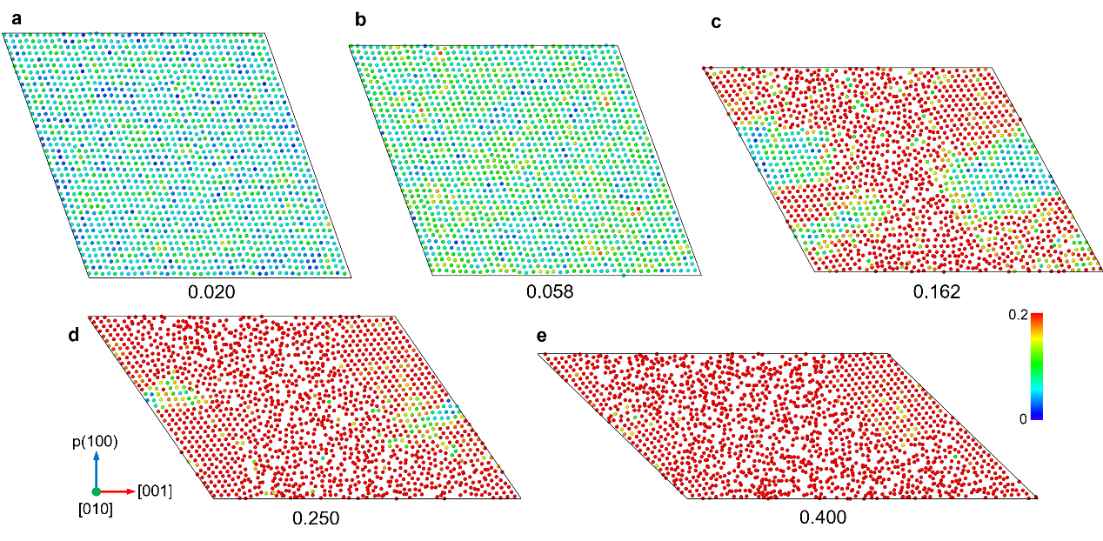
Fig. S1 The single-layer atomic slice (S-framework, longitudinal cross-section) during the MD uniaxial compression process. Each figure is colored with the atomic shear strain and labeled with corresponding compressive strain values, describing the points A~E in the stress-strain curve in Fig. 3.

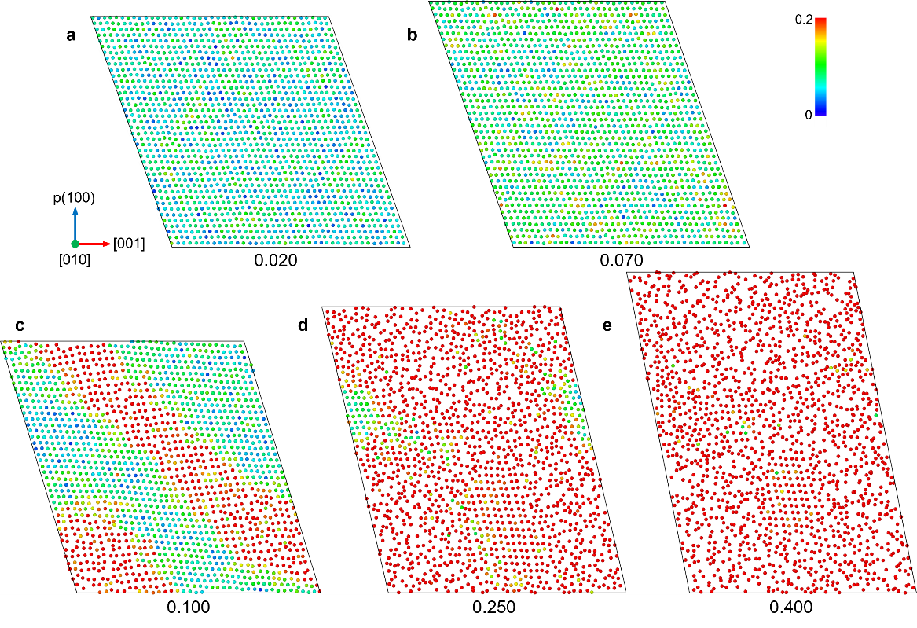
Fig. S2 The single-layer atomic slice (S-framework, longitudinal cross-section) during the MD uniaxial tension process. Each figure is colored with the atomic shear strain and labeled with corresponding compressive strain values, describing the points Aʹ~Eʹ in the stress-strain curve in Fig. 3.

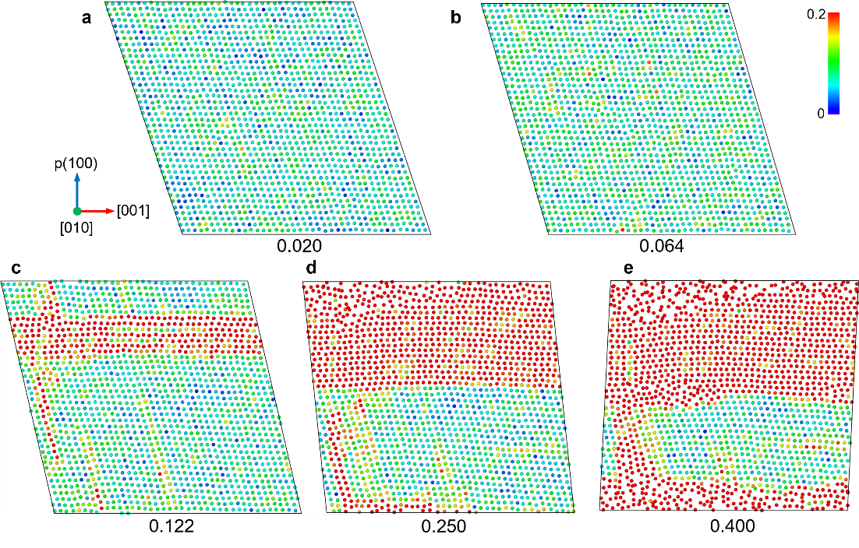
Fig. S3 The single-layer atomic slice (S-framework, longitudinal cross-section) during the MD shear process along the (100)[001] direction. Each figure is colored with atomic shear strains and labeled with corresponding shear strain values, depicting points A~E in the stress-strain curve in Fig. 4.

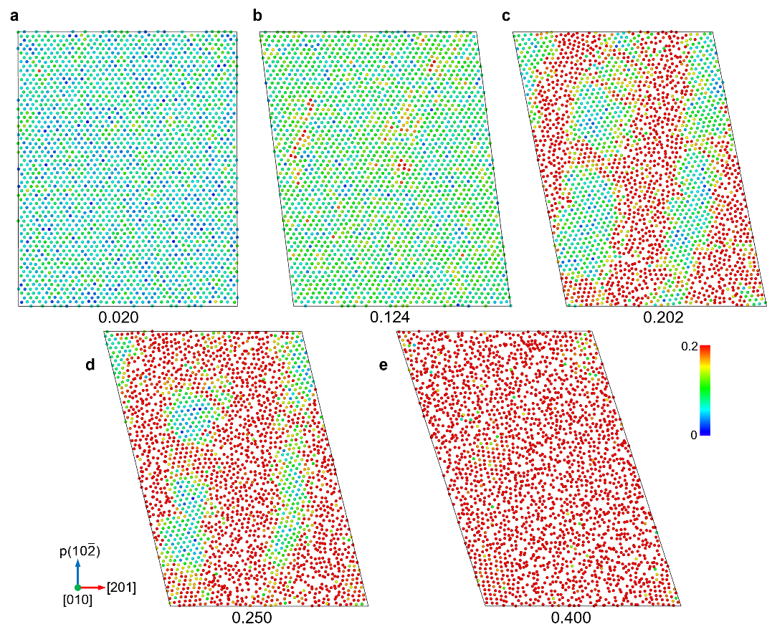
Fig. S4 The single-layer atomic slice (S-framework, longitudinal cross-section) during the MD shear process along the (10$\overline{2}$)[201] direction. Each figure is colored with atomic shear strains and labeled with corresponding shear strain values, depicting points Aʹ~Eʹ in the stress-strain curve in Fig. 4.

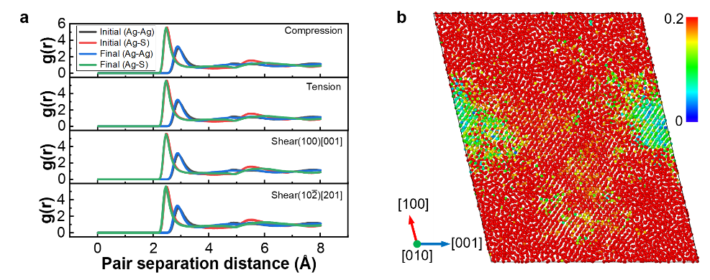
Fig. S5 Structural alterations of the sample under strain. a The radial distribution function (RDF) of Ag-Ag and Ag-S before and after compression, tension, and shear. b The thick slice (more than 20 Å in thickness) of atomic structure under tensile strain of 0.250.

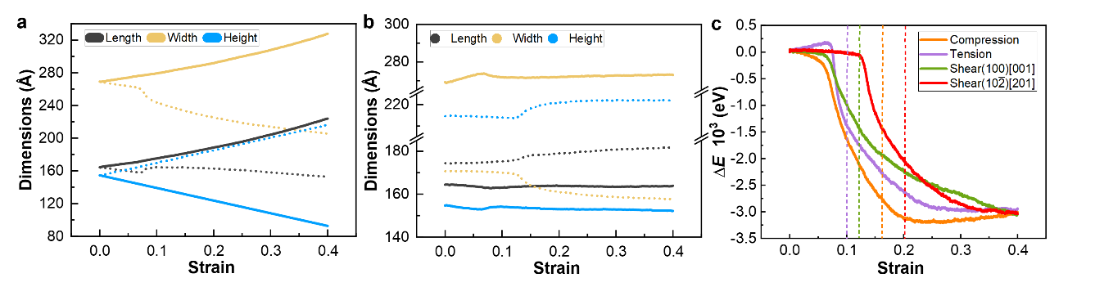
Fig. S6 The variations in box dimensions and total energies of samples during uniaxial compression, uniaxial tension, and shear deformation. The solid and dotted lines in a correspond respectively to the compression and tension processes, while the solid and dotted lines in b correspond to the shear processes along (100)[001] and (10$\overline{2}$)[201]. Dashed lines in c indicate the strain at point C or Cʹ.
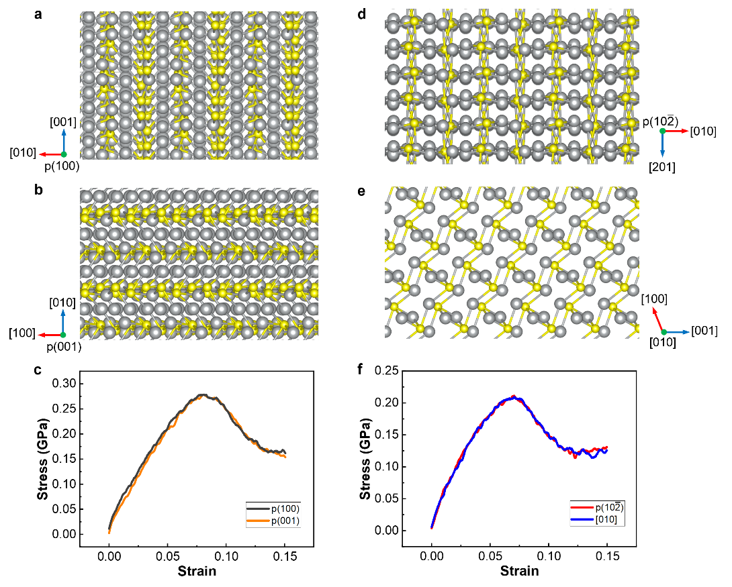
Fig. S7 The atomic arrangement of α-Ag₂S and corresponding stress-strain curve of compression along the directions perpendicular to (100), (001), (10$\overline{2}$) and along [010]. The arrangement is depicted from the perspectives indicated by p(100), p(001), p(10$\overline{2}$) and b in Fig. 2. The stress-strain curve was obtained at a higher strain rate of 0.001/ps.

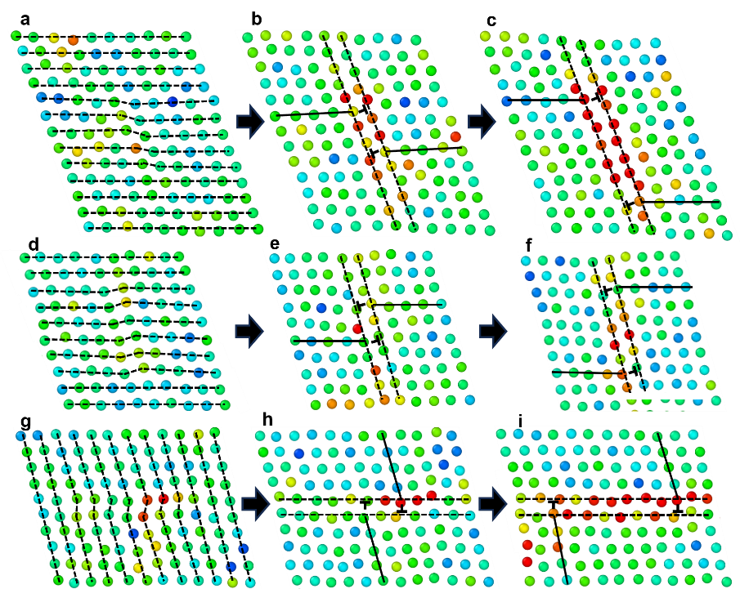
Fig. S8 The microstructural evolution of S-framework during the softening stage of compression (a-c) along p(100) and shear (d-f and g-i) along (100)[001]. Dashed lines are employed to facilitate the identification of atomic arrangements, while solid lines indicate the positions of extra half-atomic planes (determined by the arrangement of atoms on either side rather than by the position of a single atom).
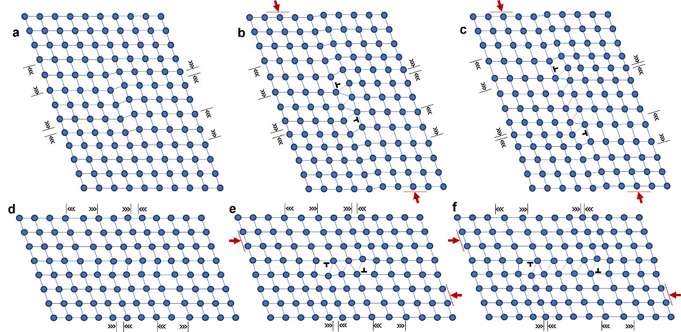
Fig. S9 The schematic diagram, corresponding to Fig. S8d-i, depicting the nucleation and motion of edge dislocations during shear deformation along (100)[001]. The labeling employed aligns with the notation utilized in Fig. 6 of the text.

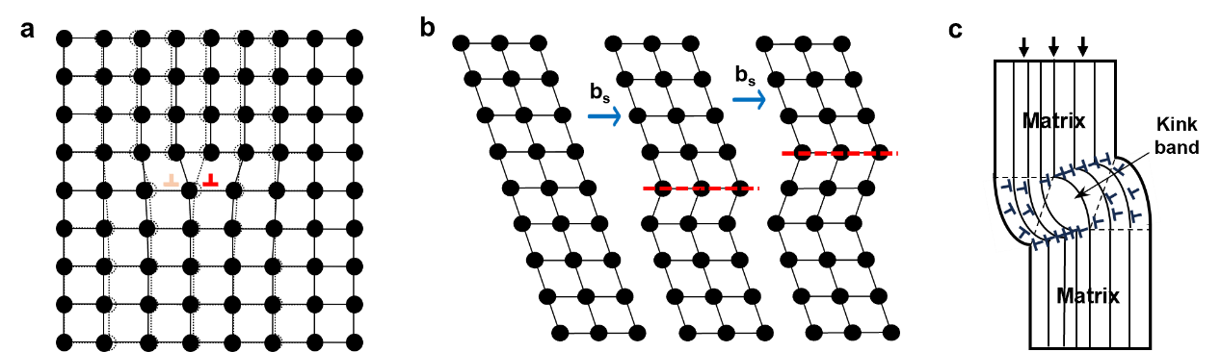
Fig. S10 Schematic of some common mechanisms for plastic deformation in metals: a Dislocation slip; b Twinning mechanism; c Kink deformation.

