Supplementary Information for:
How does a phosphorus reduction affect microcystin concentrations? Evidence from field observations
Charlotte Schampera ^{1, *}, Julian Merder², Thomas Niemeyer ¹, Julia Pries ¹, Ferdi L. Hellweger ^{1, **}

Affiliation:
¹ Water Quality Engineering,
Technical University of Berlin, Germany
Sekr. KF 4
Straße des 17. Juni 135
10623 Berlin / Germany

² Department of Global Ecology,
Carnegie Institution for Science
260 Panama St
94305 Stanford, CA / USA

*Corresponding author
Charlotte Schampera
Water Quality Engineering
Technical University of Berlin
Sekr. KF 4
Straße des 17. Juni 135
10623 Berlin / Germany
email: schampera@tu-berlin.de

**Corresponding author
Ferdi L. Hellweger
Water Quality Engineering
Technical University of Berlin
Sekr. KF 4
Straße des 17. Juni 135
10623 Berlin / Germany
phone: +49 (0)30 314-25847
email: ferdi.hellweger@tu-berlin.de

Material and Methods

Literature review on laboratory studies
Studies investigating the effect of varying nitrogen concentration or irradiance on MC quota were catalogued by Hellweger et al. ¹. Abbreviations in figure 1 of the main paper are consistent with that study and indicate the letter of authors’ initial and year (e.g. WO75 is Watanabe and Oishi, 1975) ². The two-fold change (i.e. logarithm to the base of two - log2 of ratio) of lowest to highest value (above zero) was calculated. In cases of time-series data, only the last data point was considered. In cases of other altered conditions (e.g. varying phosphorus concentrations, temperatures, etc.) or various strains investigated, the average of all measurements was used (i.e. each point corresponds to one study and are potentially the average of several individual experiments). For light conditions, environmentally relevant ranges of irradiances were included (i.e. if several high light intensities were measured, irradiances below 200 µmol photons/m²/s were used).

Literature review on field data
A strategic literature review on long-term data of cyanotoxins in lakes with phosphorus reduction ³ was performed using the web-based search platforms “GoogleScholar”, “Web of Science” and “Google Search”. The combination of “Lake name” and “cyanotoxin/cyanobacteria/microcystin” was applied. Furthermore, references of ³ were audited. Lakes were grouped in the categories “no data”, “single data points” and “long-term data” (i.e. > 3 data points in one blooming season).

Analysis National Lakes Assessment
The NLA survey from the Environmental Protection Agency (EPA) is conducted in the United States of America to strategically sample lakes, reservoirs and ponds for common limnological data including measurements from 11037 lakes in the years 2007, 2012 2017, and 2022. For methodology of sampling and analyses refer to the Field and Lab Manual (link: Manuals Used in the National Aquatic Resource Surveys | US EPA). Data were extracted from the website (link: Data from the National Aquatic Resource Surveys | US EPA) and processed with Phyton, R.Studio and Excel. Data were analyzed using two different approaches:

- Time-series analysis
The lakes were matched from one sampling year to the other using the common identifier “COM_ID” for the time-series analysis. The dataset was filtered for lakes with detectable concentrations of MCs within two sampling events. For all parameters, the change among sampling years was calculated for each lake using a two-fold change (log2). Hereby, data show proportional change of a parameter rather than absolute change. For instance, in 2007 a microcystin (MC) concentration of 0.3 and in 2012 of 0.66 was measured in Cedar Creek Reservoir 9-A. The fold change is 1.14 (i.e. $\log_{2}(\frac{0.66}{0.3})$), and the parameter has more than doubled. Correlation analyses were performed for changes in TP concentrations and changes in the parameters chlorophyll a (Chl a), dissolved inorganic nitrogen (DIN), turbidity, MC per biomass (MC/Chl a) and MC concentration. Spearman rank correlation tests were performed in R.Studio (R4.3.2) with the dplyr package ⁴.

- Comprehensive Analysis
For the comprehensive analysis, all data including non-detects of MC concentrations were used. Generalized Additive Models (GAMs) were fitted to each response variable using smoothing splines to allow for non-linear effects between log TN and log TP, resulting in models of the following form:
$g(E(Y)) = f1(\log{TN})+f2(\log{TP})$
where E(⋅) denotes the expected value, g(.) the log link function, f1(.) the effect term of log TN, f1(.) the effect term of log TP. We used a Tweedie distribution for DIN, turbidity, and the MC/Chla ratio as conditional distribution using the “R” package “mgcv” ⁵. For MC we employed the method of Merder et al 2023 using the “R” package “gamlss” ⁶ to fit a zero-adjusted lognormal distribution. We did this due to the distinct detection limit of 0.1µg/L. We tested if each model could be simplified by exchanging a smoothing function with a simpler term and found that for MC concentration the linear term of the transformation 1/logTP performed best, using the Bayesian Information Criterion (BIC) ⁷. Given models are fit with a log link, their combined effect is multiplicative rather than additive when back-transformed to the original scale, leading to an interaction-like effect without an explicit interaction term being included in the model. Predictions were generated on a grid of log TN and log TP values to visualize and capture the joint effects of these predictors on each response variable. For models with the conditional Tweedie distribution, predictions represent the mean, while for the MC model predictions represent the median MC concentration. In addition to the median, we also predicted the 0.95 MC quantile to illustrate how expected extreme concentrations would look like under changing TN and TP concentrations (fig. S4).

Results and Discussion

Additional time-series analyses
In fig. S1, the time-series analysis including all time pairs is shown. A change in TP concentrations correlate positively with biomass (i.e. Chl a, fig. S1 A) and is not significantly correlated with available nitrogen (i.e. DIN, fig. S1 B1). With reduced phosphorus and biomass, also turbidity decreases (fig. S1 B2) but MC per biomass increases (fig. S1 C). No change in MC concentrations with decreasing TP concentration is evident (fig. S1 D solid) although biomass was decreasing (dashed line).
In figure S2, the results of the time-series analysis of the subset with a dual reduction of TN and TP concentrations are depicted. Here, changes in TP concentration correlate positively with changes in biomass (fig. S2 A), DIN (fig. S2 B1), turbidity (fig. S2 B2) and MC concentrations (S2 D, solid line). Only MC per biomass increases with reduced TP concentration (fig. S2 C) which is also visible in the steeper slope of the dashed line, representing changes in biomass than the solid, representing changes in MC concentration in fig. S2 D. Hence, biomass and MC concentrations do not change proportionally.
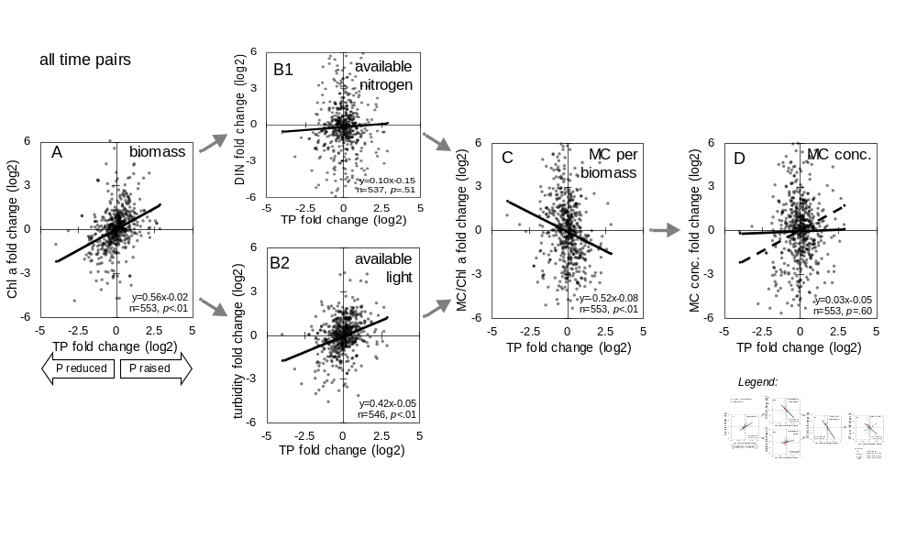
Fig. S1: Time series analysis over all time pairs, Data (dots) and their regression lines are shown for the National Lakes Assessment (NLA) survey depicted as change between sampling times. Each point represents the fold change (log2 of ratio) of one parameter for different sampling times in the same lake. Note, that a few data points are out of figure scaling. A phosphorus-only reduction would move a lake from right to left on the x-axis. Spearman rank correlation tests were performed.

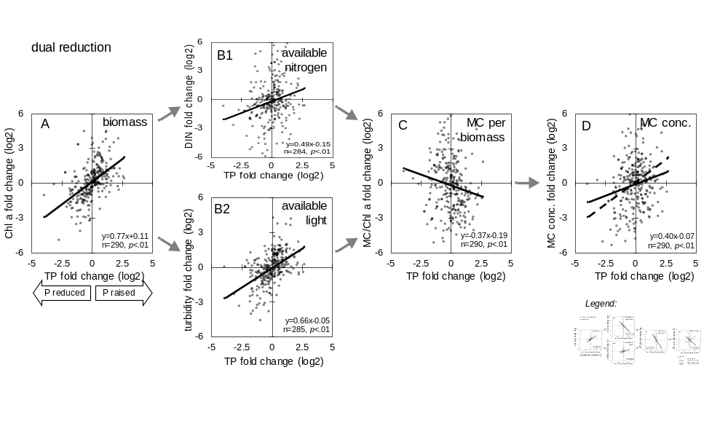
Fig. S2: Time series analysis of the subset with dual reduction of total nitrogen and total phosphorus. See figure caption S1.

Model data comparison of GAMS
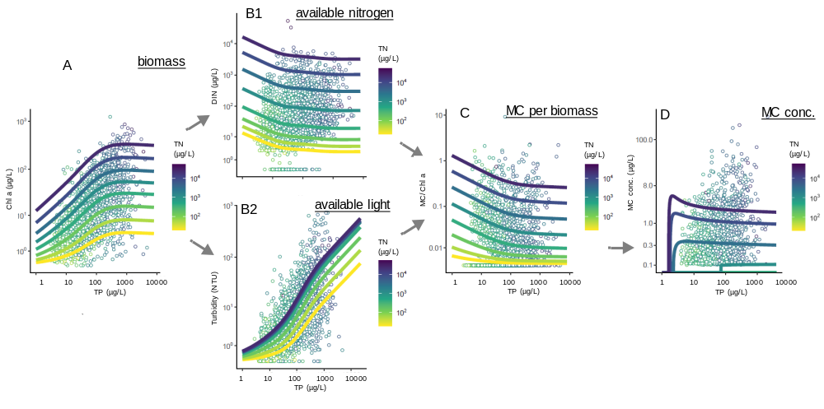
Fig. S3: Comprehensive analyses across lakes shows that lower phosphorus is associated with higher MC concentration. Generalized Additive Model predictions (lines) and field data (symbols) are shown against TP concentration. Color-code indicate TN concentrations. A phosphorus-only reduction would move a lake from right to left on the x-axis. A reduction in total phosphorus (TP) results in a decrease of Chlorophyll a (Chl a, panel A), an increase in dissolved inorganic nitrogen (DIN, panel B1), a decrease in turbidity (panel B2) and an increase in MC/Chl a (panel C) and MC concentrations (panel D). Arrows depict causal reasoning. Note that the original data does not necessarily need to follow the predicted pattern, as in the original data TN and TP are correlated r=0.77 while predictions show the marginal effect of TP.

Additional comprehensive analyses
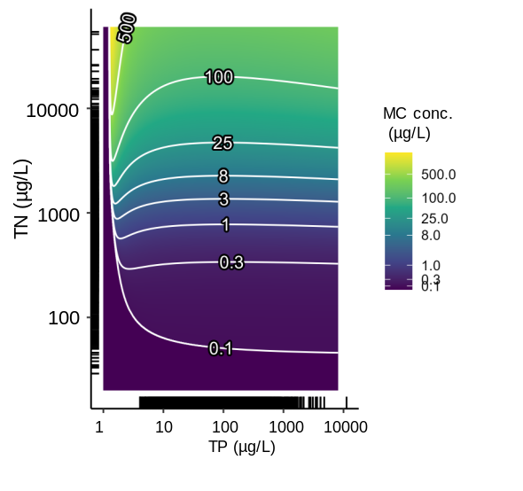
Fig. S4: Prediction of 0.95 MC quantile illustrating expected extreme concentrations. Generalized Additive Model predictions are generated on a grid of log TN and log TP values. A phosphorus-only reduction would move a lake from right to left on the x-axis, and a dual reduction would move a lake toward the lower left corner. A reduction in total phosphorus (TP) MC concentrations.
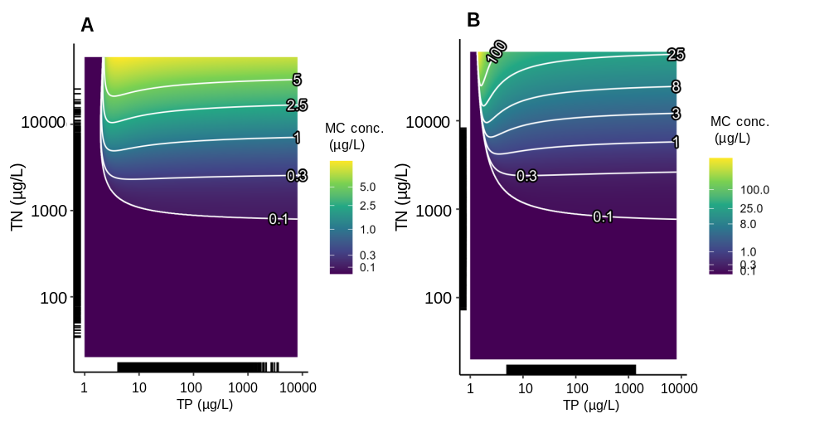
Fig. S5: Prediction of MC concentration without 0.1% (A) and 1% (B) of extreme TP and TN values.
See figure caption S4.
Reference
1. Hellweger, F. L. et al. Models predict planned phosphorus load reduction will make Lake Erie more toxic. Science (1979) 376, 1001–1005 (2022).
2. Watanabe, M. F. & Oishi, S. Effects of Environmental Factors on Toxicity of a Cyanobacterium (Microcystis Aeruginosa) under Culture Conditions. APPLIED AND ENVIRONMENTAL MICROBIOLOGY vol. 49 https://journals.asm.org/journal/aem (1985).
3. Schindler, D. W., Carpenter, S. R., Chapra, S. C., Hecky, R. E. & Orihel, D. M. Reducing phosphorus to curb lake eutrophication is a success. Environ Sci Technol 50, 8923–8929 (2016).
4. Wickham, H., François, R., Henry, L., Müller, K. & Vaughan, D. dplyr: A Grammar of Data Manipulation. Preprint at https://dplyr.tidyverse.org (2023).
5. Wood, S. N. Generalized Additive Models: An Introduction with R. (CRC Press, A Chapman & Hall Book, 2017).
6. Rigby, R. A. & Stasinopoulos, D. M. Generalized Additive Models for Location, Scale and Shape. Appl. Statist vol. 54 (2005).
7. Schwarz, G. Estimating the Dimension of a Model. Source: The Annals of Statistics vol. 6 (1978).

