Supplementary Information

Regulating the Connectivity of Hydrogen Bonding Networks on Pt for Alkaline Hydrogen Oxidation

Wei Liu#, Zhensheng Mi#, Fengyuan Wei#, Kangjie Lyu, Peng Li*, Gongwei Wang, Shengli Chen, Li Xiao*, Lin Zhuang*

College of Chemistry and Molecular Sciences, Hubei Key Lab of Electrochemical Power Sources, Wuhan University, Wuhan 430072, China
E-mails: peng.li@whu.edu.cn, chem.lily@whu.edu.cn, lzhuang@whu.edu.cn

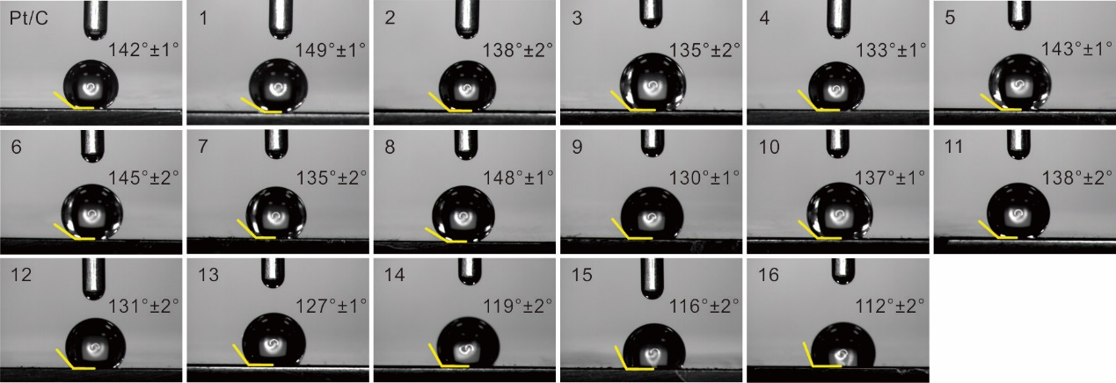
Figure S1. Contact angles (CA) of all Pt/C-x. The standard deviation for CA was obtained from six independent measurements.

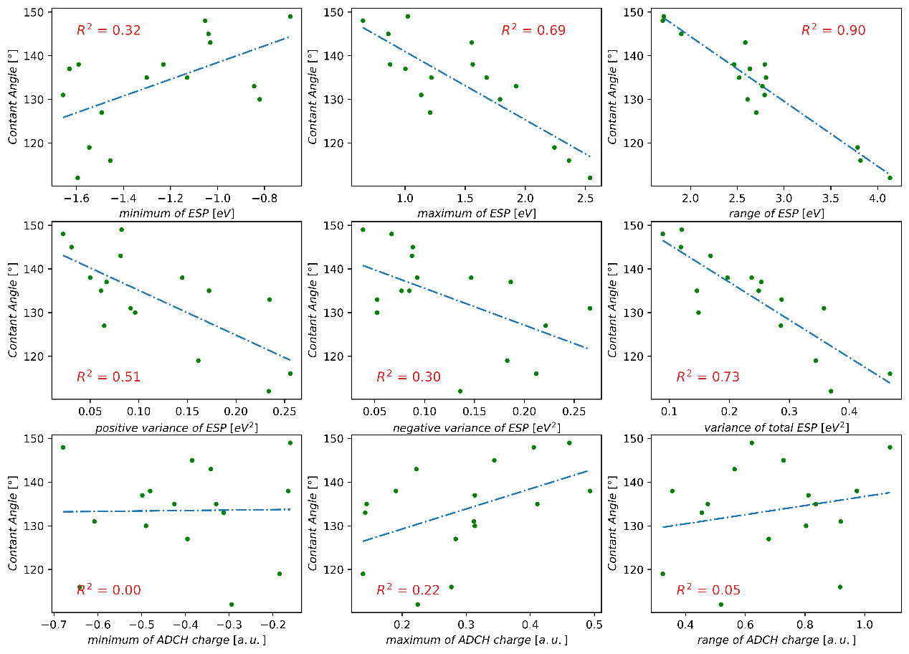
Figure S2. The correlation between the CA and 9 characteristics of the organic molecules, including maximum/minimum of ESP and the range of ESP, variance of positive and negative part of ESP and variance of total ESP, maximum/minimum of ADCH charge and the range of ADCH. The coefficient of determination (R²) of each correlation was also included.

Table S1. The theoretical calculation results of 9 characteristics of the organic molecules.
 |  | Minimum electrostatic potential (eV) | Maximum electrostatic  potential (eV) | Range  of  electrostatic potential (eV) | Minimum  ADCH  charge (a.u.) | Maximum  ADCH  charge (a.u.) | Range of  ADCH potential (a.u.) | Variance  of negative  part  of ESP (eV²) | Variance  of positive  part  of ESP (eV²) | Variance of  total ESP (eV²)
(1) | Benzotrifluoride | -0.690 | 1.023 | 1.714 | -0.161 | 0.461 | 0.622 | 0.880 | 1.897 | 2.778
(2) | aniline | -1.231 | 1.563 | 2.793 | -0.165 | 0.190 | 0.355 | 2.134 | 3.335 | 5.469
(3) | 4-Fluoroaniline | -1.129 | 1.678 | 2.807 | -0.330 | 0.145 | 0.474 | 1.770 | 3.969 | 5.739
(4) | 4-(trifluoromethyl)aniline | -0.844 | 1.923 | 2.768 | -0.313 | 0.142 | 0.455 | 1.206 | 5.408 | 6.614
(5) | N-methylaniline | -1.030 | 1.555 | 2.585 | -0.342 | 0.222 | 0.564 | 2.012 | 1.875 | 3.887
(6) | N,N dimethylaniline | -1.038 | 0.862 | 1.900 | -0.384 | 0.344 | 0.728 | 2.035 | 0.711 | 2.745
(7) | benzylamine | -1.301 | 1.219 | 2.520 | -0.425 | 0.411 | 0.836 | 1.953 | 1.411 | 3.364
(8) | N,N Dimethylbenzylamine | -1.052 | 0.651 | 1.703 | -0.679 | 0.406 | 1.085 | 1.541 | 0.509 | 2.050
(9) | Diphenylamine | -0.821 | 1.789 | 2.610 | -0.490 | 0.313 | 0.803 | 1.208 | 2.217 | 3.425
(10) | pyridine | -1.630 | 1.004 | 2.633 | -0.498 | 0.313 | 0.812 | 4.297 | 1.539 | 5.836
(11) | lutidine | -1.590 | 0.876 | 2.467 | -0.480 | 0.493 | 0.974 | 3.383 | 1.153 | 4.536
(12) | Acetylpyridine | -1.657 | 1.134 | 2.791 | -0.608 | 0.312 | 0.920 | 6.132 | 2.114 | 8.246
(13) | Diacetylpyridine | -1.981 | 1.236 | 2.703 | -0.395 | 0.283 | 0.679 | 5.106 | 1.485 | 6.591
(14) | Benzoic acid | -1.455 | 2.098 | 3.787 | -0.185 | 0.139 | 0.324 | 4.217 | 3.715 | 7.932
(15) | Potassium phthalate | -1.591 | 2.207 | 3.818 | -0.641 | 0.277 | 0.918 | 4.887 | 5.898 | 10.786
(16) | Dopamine | -1.804 | 2.495 | 4.133 | -0.294 | 0.224 | 0.519 | 3.130 | 5.389 | 8.519
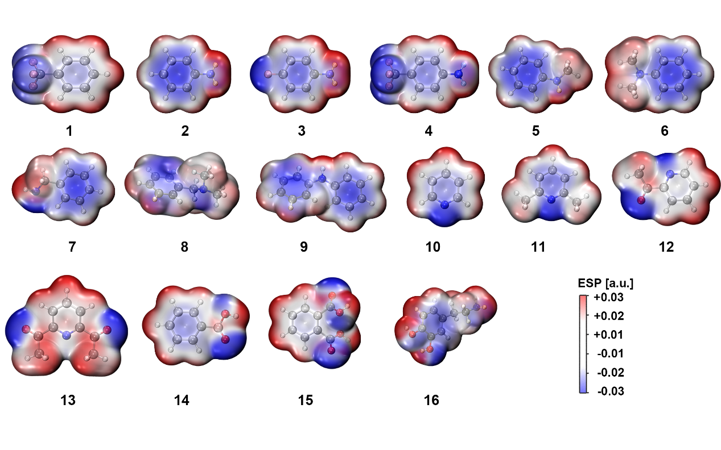
Figure S3. The Electrostatic potential projected on the molecule surface (isosurface of electronic density with value of 0.001 a.u.) for all molecules.

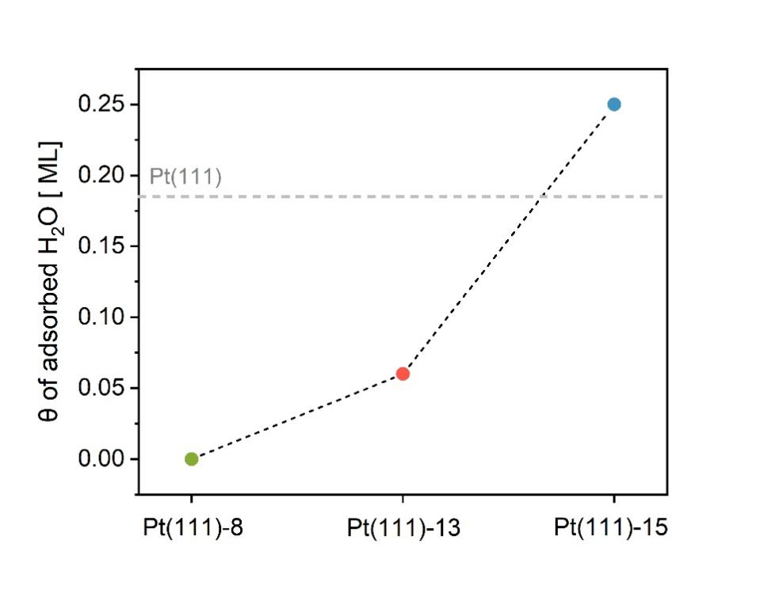
Figure S4. Statistical coverages of the chemisorbed water molecules at three representative Pt(111)-x/water interfaces.

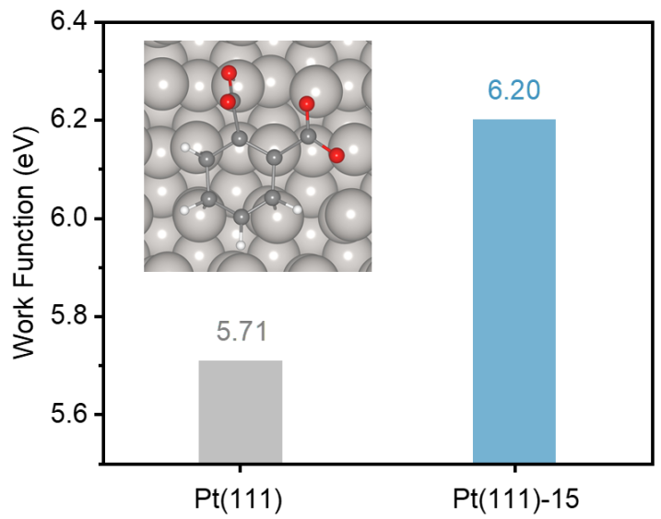
Figure S5. The calculated work functions of Pt(111) and Pt(111)-15 surfaces in vacuum.

Figure S5 clearly shows that the molecule 15 with fairly high ESP_{range} can significantly increase the work function of Pt electrode, thus resulting in the higher PZC value compared to the bare Pt(111)/water interface (Fig. 2a in the main text).

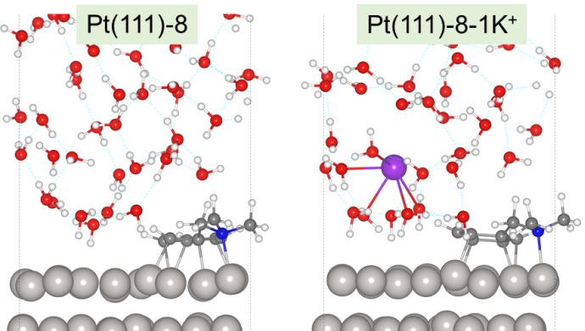
Figure S6. Representative snapshots of the Pt(111)-8/water interfaces with surface charge densities of 0.0 μC/cm² and -14.6 μC/cm². The Pt, O, H, C, N and K atoms are colored in silver, red, white, grey, blue and purple, respectively.

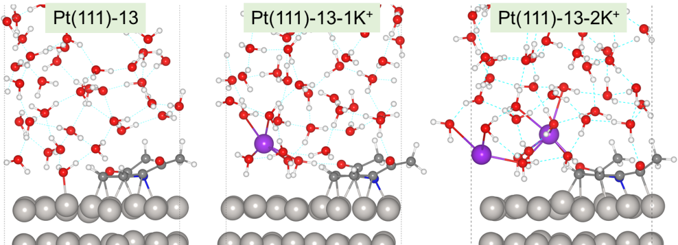
Figure S7. Representative snapshots of the Pt(111)-13/water interfaces with surface charge densities of 0.0 μC/cm², -14.6 μC/cm² and -29.2 μC/cm². The Pt, O, H, C, N and K atoms are colored in silver, red, white, grey, blue and purple, respectively.

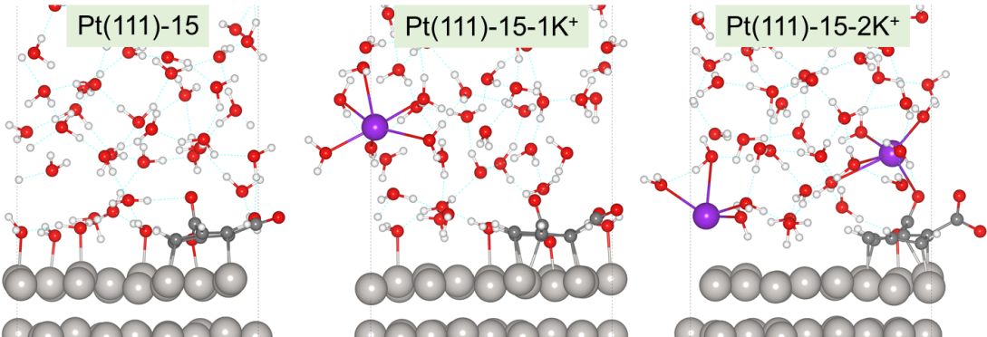
Figure S8. Representative snapshots of the Pt(111)-15/water interfaces with surface charge densities of 0.0 μC/cm², -14.6 μC/cm² and -29.2 μC/cm². The Pt, O, H, C, N and K atoms are colored in silver, red, white, grey, blue and purple, respectively.

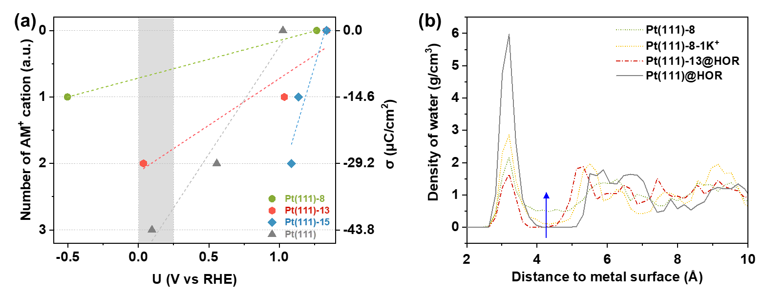
Figure S9. (a) The change trend of electrode potential (U) referenced to the reversible hydrogen electrode (RHE) with the number of introduced alkali metal (AM⁺) cation (namely the negative charge density on electrode surface) for different systems. The light grey shaded area represents the experimental HOR potential range in alkaline electrolyte. (b) Density distribution profiles of water at different interfaces.

As shown in Figure S9a (converted from Figure 2b in the main text), when introducing three alkali metal (AM⁺) cations into the unmodified Pt(111)/water interface and two AM⁺ cations into Pt(111)-13/water interfaces, the electrode potentials (U vs RHE) can be adjusted into the experimental alkaline HOR potential range (light grey shaded area). By contrast, it can be seen that driving the electrode potential of Pt(111)-8/water interface to lie within the experimental potential range only requires less than one AM⁺ cation. This implies that the AM⁺ concentration in EDL will be much lower at Pt(111)-8/water interface under alkaline HOR conditions, thus leading to an excellent connectivity of interfacial water and hydrogen bond networks. Figure S9b can provide clear support for this scenario, which shows that the water densities within the gap zones at both Pt(111)-8/water interfaces containing zero and one K⁺ are distinctly higher, compared to the Pt(111)/water and Pt(111)-13/water interfaces at the alkaline HOR potentials. In addition, for the Pt(111)-15/water interface, it can be easily expected that a large number of AM⁺ cations need to be introduced to bring the electrode potential to the experimental alkaline HOR potential range, thereby leading to very serious crowding of AM⁺ cation in the EDL and very poor connectivity of interfacial water and hydrogen bonding networks.

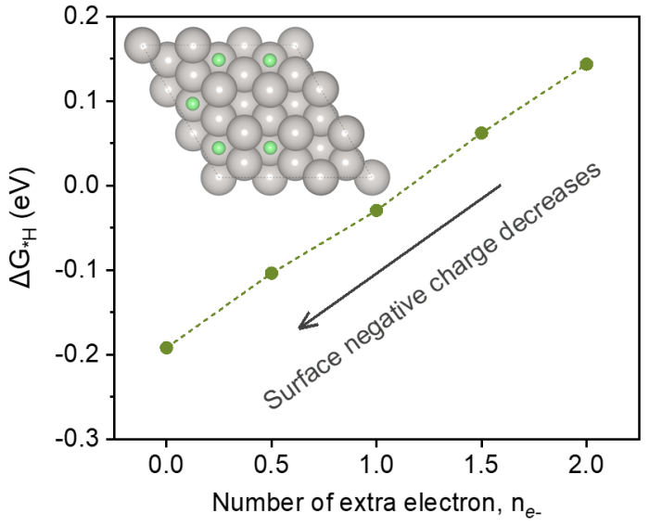
Figure S10. Change trend of the adsorption free energy of *H (∆G_{*H}) on Pt(111) with the surface negative charge density. The *H atoms are colored in green, and the coverage is 0.556 ML (monolayer).

The ∆G_{*H} was calculated according to the following equation,
$$∆G_{∗H}=\frac{1}{5}[E_{∗H}−E_{∗}+5 \left({ZPE}_{∗H}−{TS}_{∗H}\right)−\frac{5}{2} {(E}_{H_{2}}{+ZPE}_{H_{2}}−{TS}_{H_{2}})]$$
where the $E_{∗H}$, $E_{∗}$, $ZPE$ and $TS$ are the total energy of *H adsorbed Pt(111) surface, the total energy of bare Pt(111) surface, the zero point energy and vibrational entropy of various species, respectively.
Figure S10 clearly shows that the adsorption strength of *H intermediate on Pt(111) gradually increases with the surface negative charge decreasing. Therefore, it can be predicted that the fairly lower surface negative charge density at Pt(111)-8/water interface would possess much higher *H adsorption strength, which instead is detrimental to the HOR kinetics.

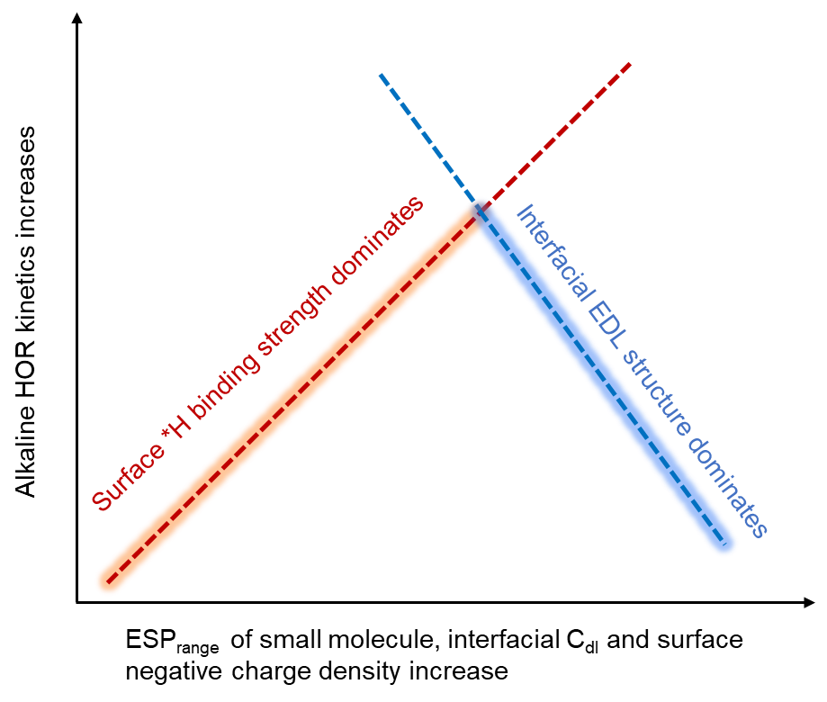
Figure S11. The predicted alkaline HOR kinetic volcano relation for the organic molecule modified Pt catalysts.

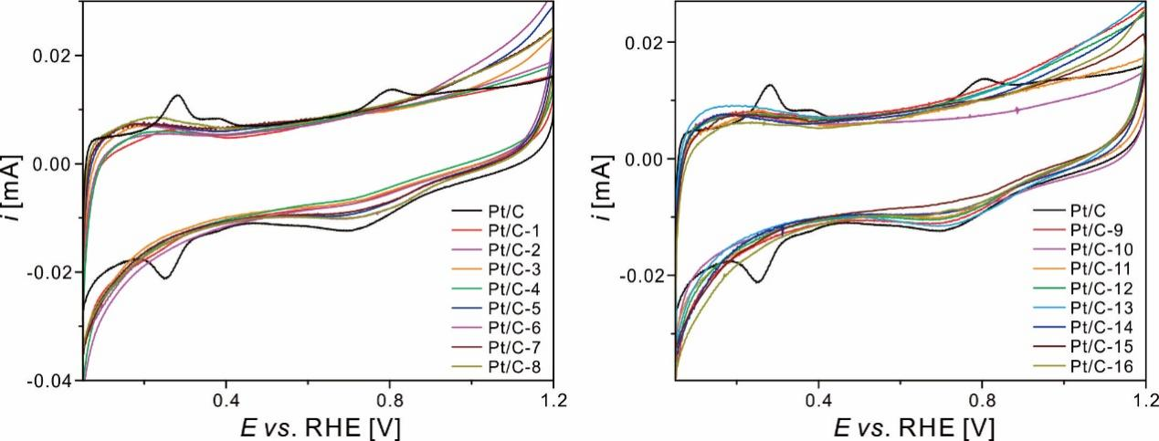
Figure S12. Cyclic voltammetry of Pt/C and Pt/C-x at 20 mV s⁻¹ in 0.1 M KOH solution.

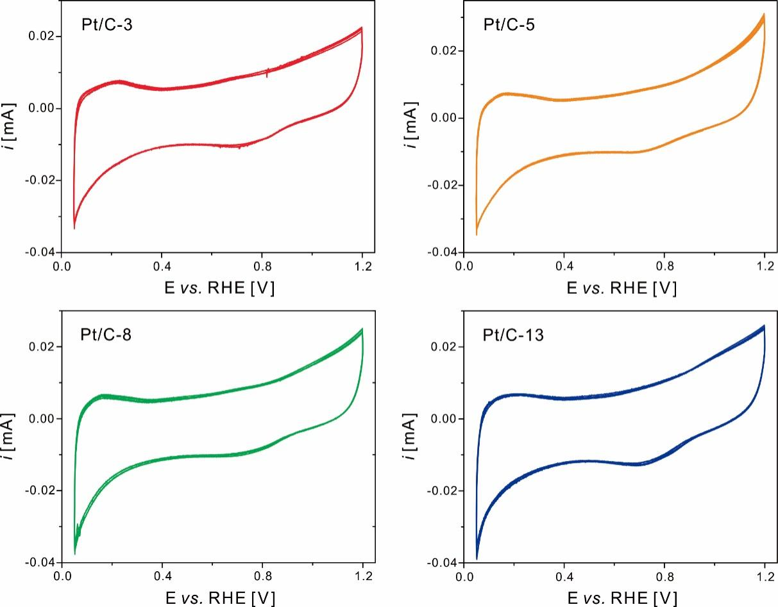
Figure S13. Representative cyclic voltammetry of Pt/C-x (x = 3, 5, 8 and 13) for four cycles at 20 mV s⁻¹ in 0.1 M KOH solution.

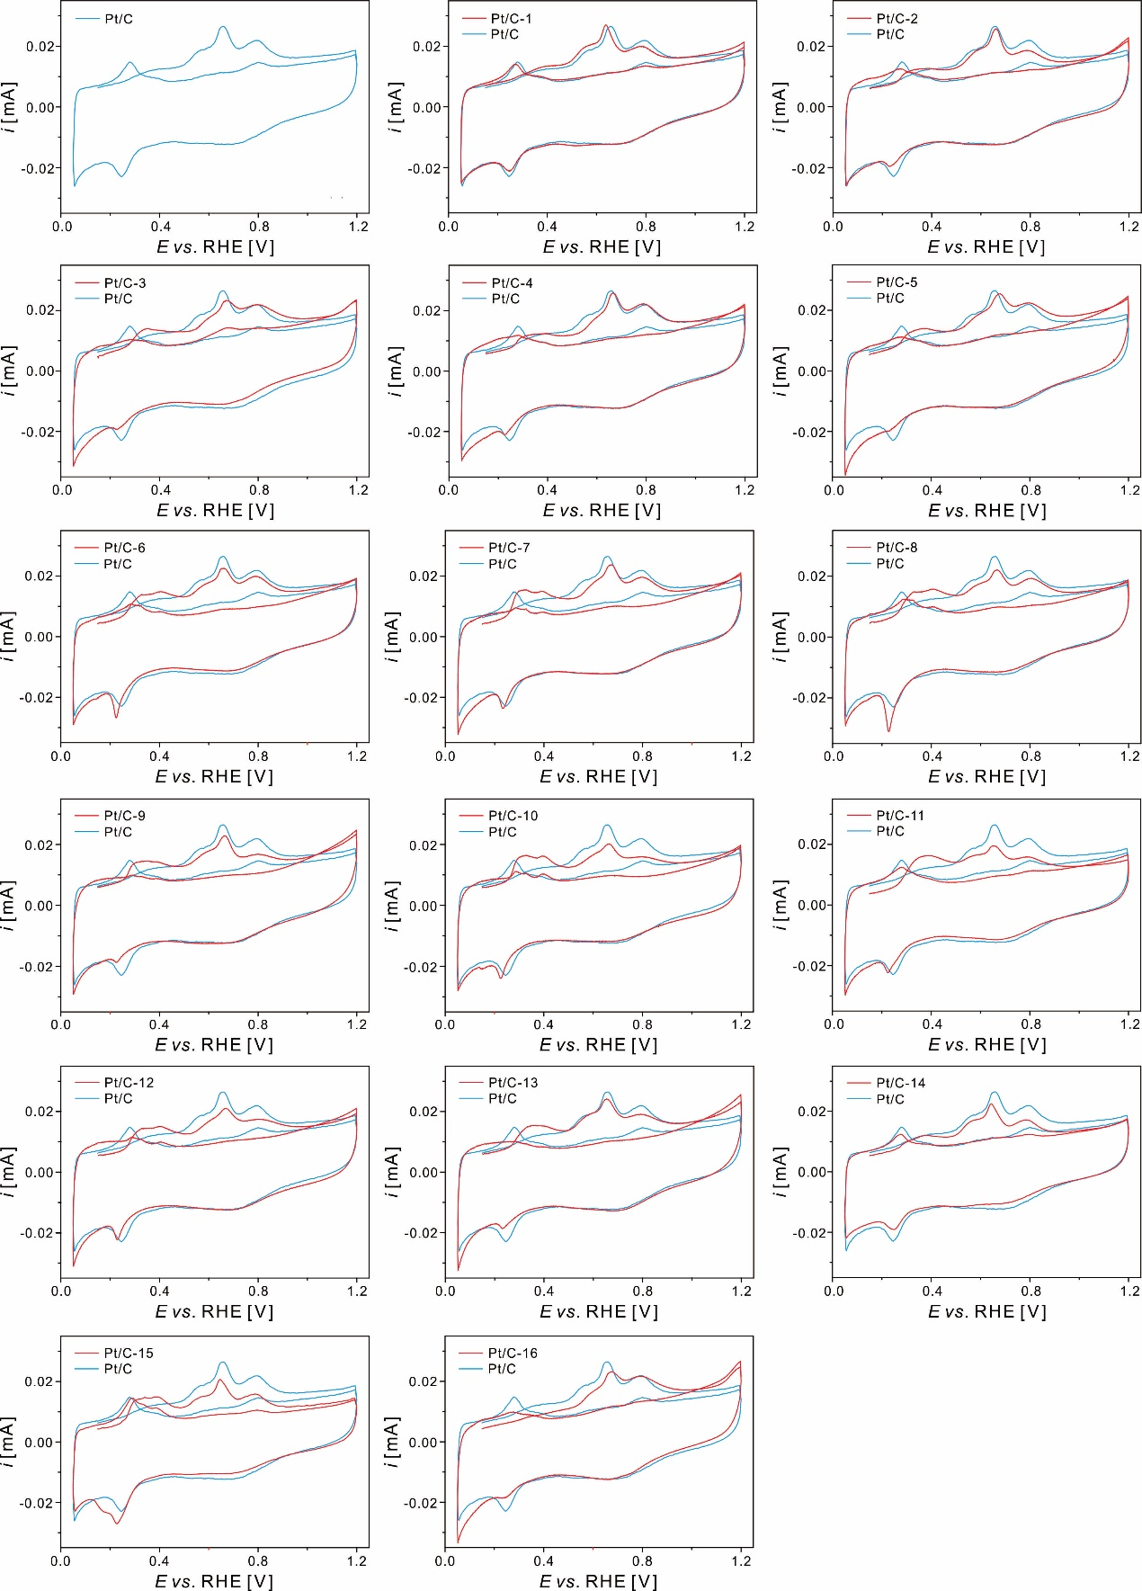
Figure S14. CO stripping curves of Pt/C and Pt/C-x at 20 mV s⁻¹ in 0.1 M KOH solution.

Table S2 The electrochemical surface areas (ECSA) of Pt/C and Pt/C-x obtained from CO stripping. The standard deviation of ECSA was obtained from three independent measurements.
Sample | ECSA / cm_{Pt}²
Pt/C | 0.81 ± 0.02
Pt/C-1 | 0.78 ± 0.04
Pt/C-2 | 0.67 ± 0.02
Pt/C-3 | 0.56 ± 0.03
Pt/C-4 | 0.73 ± 0.01
Pt/C-5 | 0.72 ± 0.04
Pt/C-6 | 0.80 ± 0.03
Pt/C-7 | 0.73 ± 0.04
Pt/C-8 | 0.79 ± 0.02
Pt/C-9 | 0.71 ± 0.02
Pt/C-10 | 0.78 ± 0.04
Pt/C-11 | 0.55 ± 0.02
Pt/C-12 | 0.68 ± 0.03
Pt/C-13 | 0.79 ± 0.03
Pt/C-14 | 0.61 ± 0.02
Pt/C-15 | 0.57 ± 0.02
Pt/C-16 | 0.55 ± 0.01

Table S3 The exchange current density (i₀) of Pt/C and Pt/C-x. The standard deviation of i₀ was obtained from three independent measurements.
Sample | i₀ / mA cm_{Pt}⁻²
Pt/C | 0.40 ± 0.02
Pt/C-1 | 0.38 ± 0.02
Pt/C-2 | 0.65 ± 0.01
Pt/C-3 | 0.63 ± 0.02
Pt/C-4 | 0.56 ± 0.03
Pt/C-5 | 0.60 ± 0.03
Pt/C-6 | 0.50 ± 0.04
Pt/C-7 | 0.57 ± 0.02
Pt/C-8 | 0.40 ± 0.01
Pt/C-9 | 0.63 ± 0.03
Pt/C-10 | 0.48 ± 0.04
Pt/C-11 | 0.53 ± 0.03
Pt/C-12 | 0.67 ± 0.02
Pt/C-13 | 0.81 ± 0.02
Pt/C-14 | 0.59 ± 0.03
Pt/C-15 | 0.54 ± 0.03
Pt/C-16 | 0.36 ± 0.01

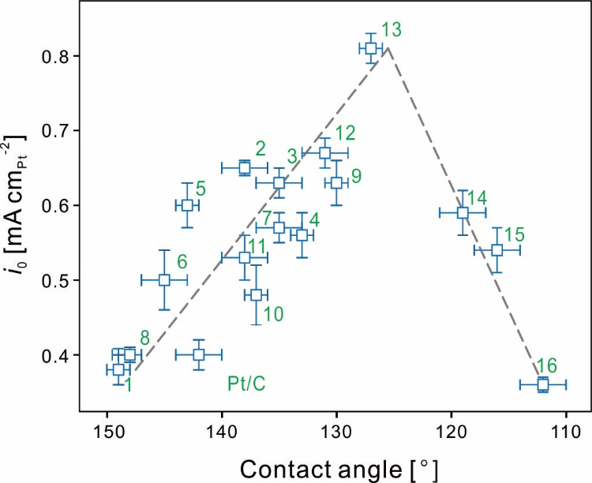
Figure S15. The volcano-type relationship between i_{0, HOR} and CA of Pt/C and Pt/C-x. The corresponding error bars for i_{0, HOR} were calculated from three independent experiments.

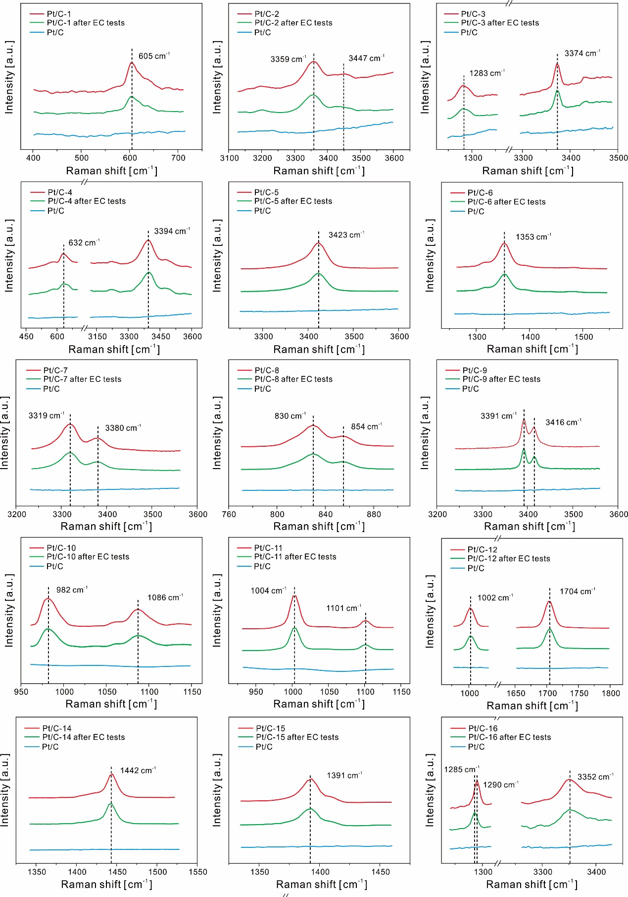
Figure S16. Raman spectra of characteristic groups of modified molecules for all Pt/C-x before and after RDE tests.

Table S4 The assignment of Raman peaks to characteristic groups of modified molecules.
Sample | Wavenumber / cm⁻¹ | Assignment
Pt/C-1 | 605 | C-F (CF₃) in-plane bending
Pt/C-2 | 3359  3447 | N-H (NH₂) symmetric stretching  N-H (NH₂) asymmetric stretching
Pt/C-3 | 1283  3374 | C-F stretching  N-H (NH₂) symmetric stretching
Pt/C-4 | 632  3394 | CF₃ in-plane bending  N-H (NH₂) symmetric stretching
Pt/C-5 | 3423 | N-H (ArNHR) stretching
Pt/C-6 | 1353 | C-N (ArNR₂) stretching
Pt/C-7 | 3319  3380 | N-H (NH₂) symmetric stretching  N-H (NH₂) asymmetric stretching
Pt/C-8 | 830  854 | C-N (R₃N) symmetric stretching  C-N (R₃N) asymmetric stretching
Pt/C-9 | 3391  3416 | N-H (Ar₂NH) symmetric stretching  N-H (Ar₂NH) asymmetric stretching
Pt/C-10 | 982  1086 | ring breathing of pyridine  triangular ring breathing of pyridine
Pt/C-11 | 1004  1101 | ring breathing of pyridine  triangular ring breathing of pyridine
Pt/C-12 | 1002  1704 | ring breathing of pyridine  C=O stretching
Pt/C-13 | 1004  1706 | ring breathing of pyridine  C=O stretching
Pt/C-14 | 1442 | C=O (COOK) stretching
Pt/C-15 | 1391 | C=O (COOK) stretching
Pt/C-16 | 1285  1290  3352 | C-O (ArOK) stretching  C-O (ArOH) stretching  N-H (NH₂) symmetric stretching

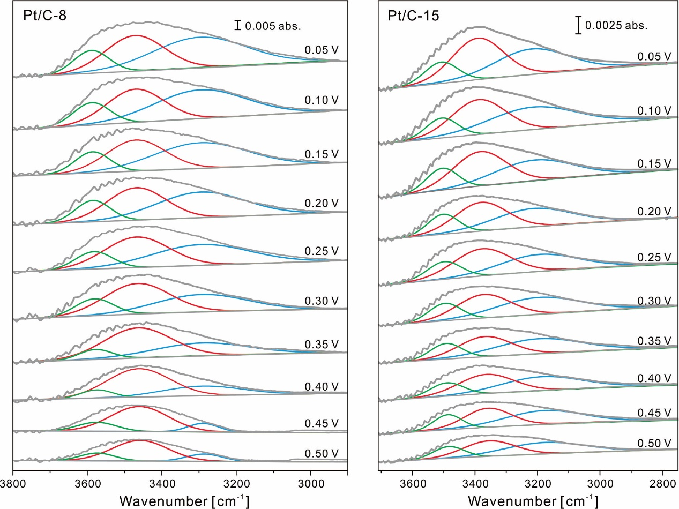
Figure S17. Spectra at the Pt/C-x (x = 8 and 15) electrode in Ar-saturated 0.1 M KOH calculated using the spectra at 0.55 V as the reference. These spectra are fitted with three Gaussian curves (blue, red and green, respectively).

