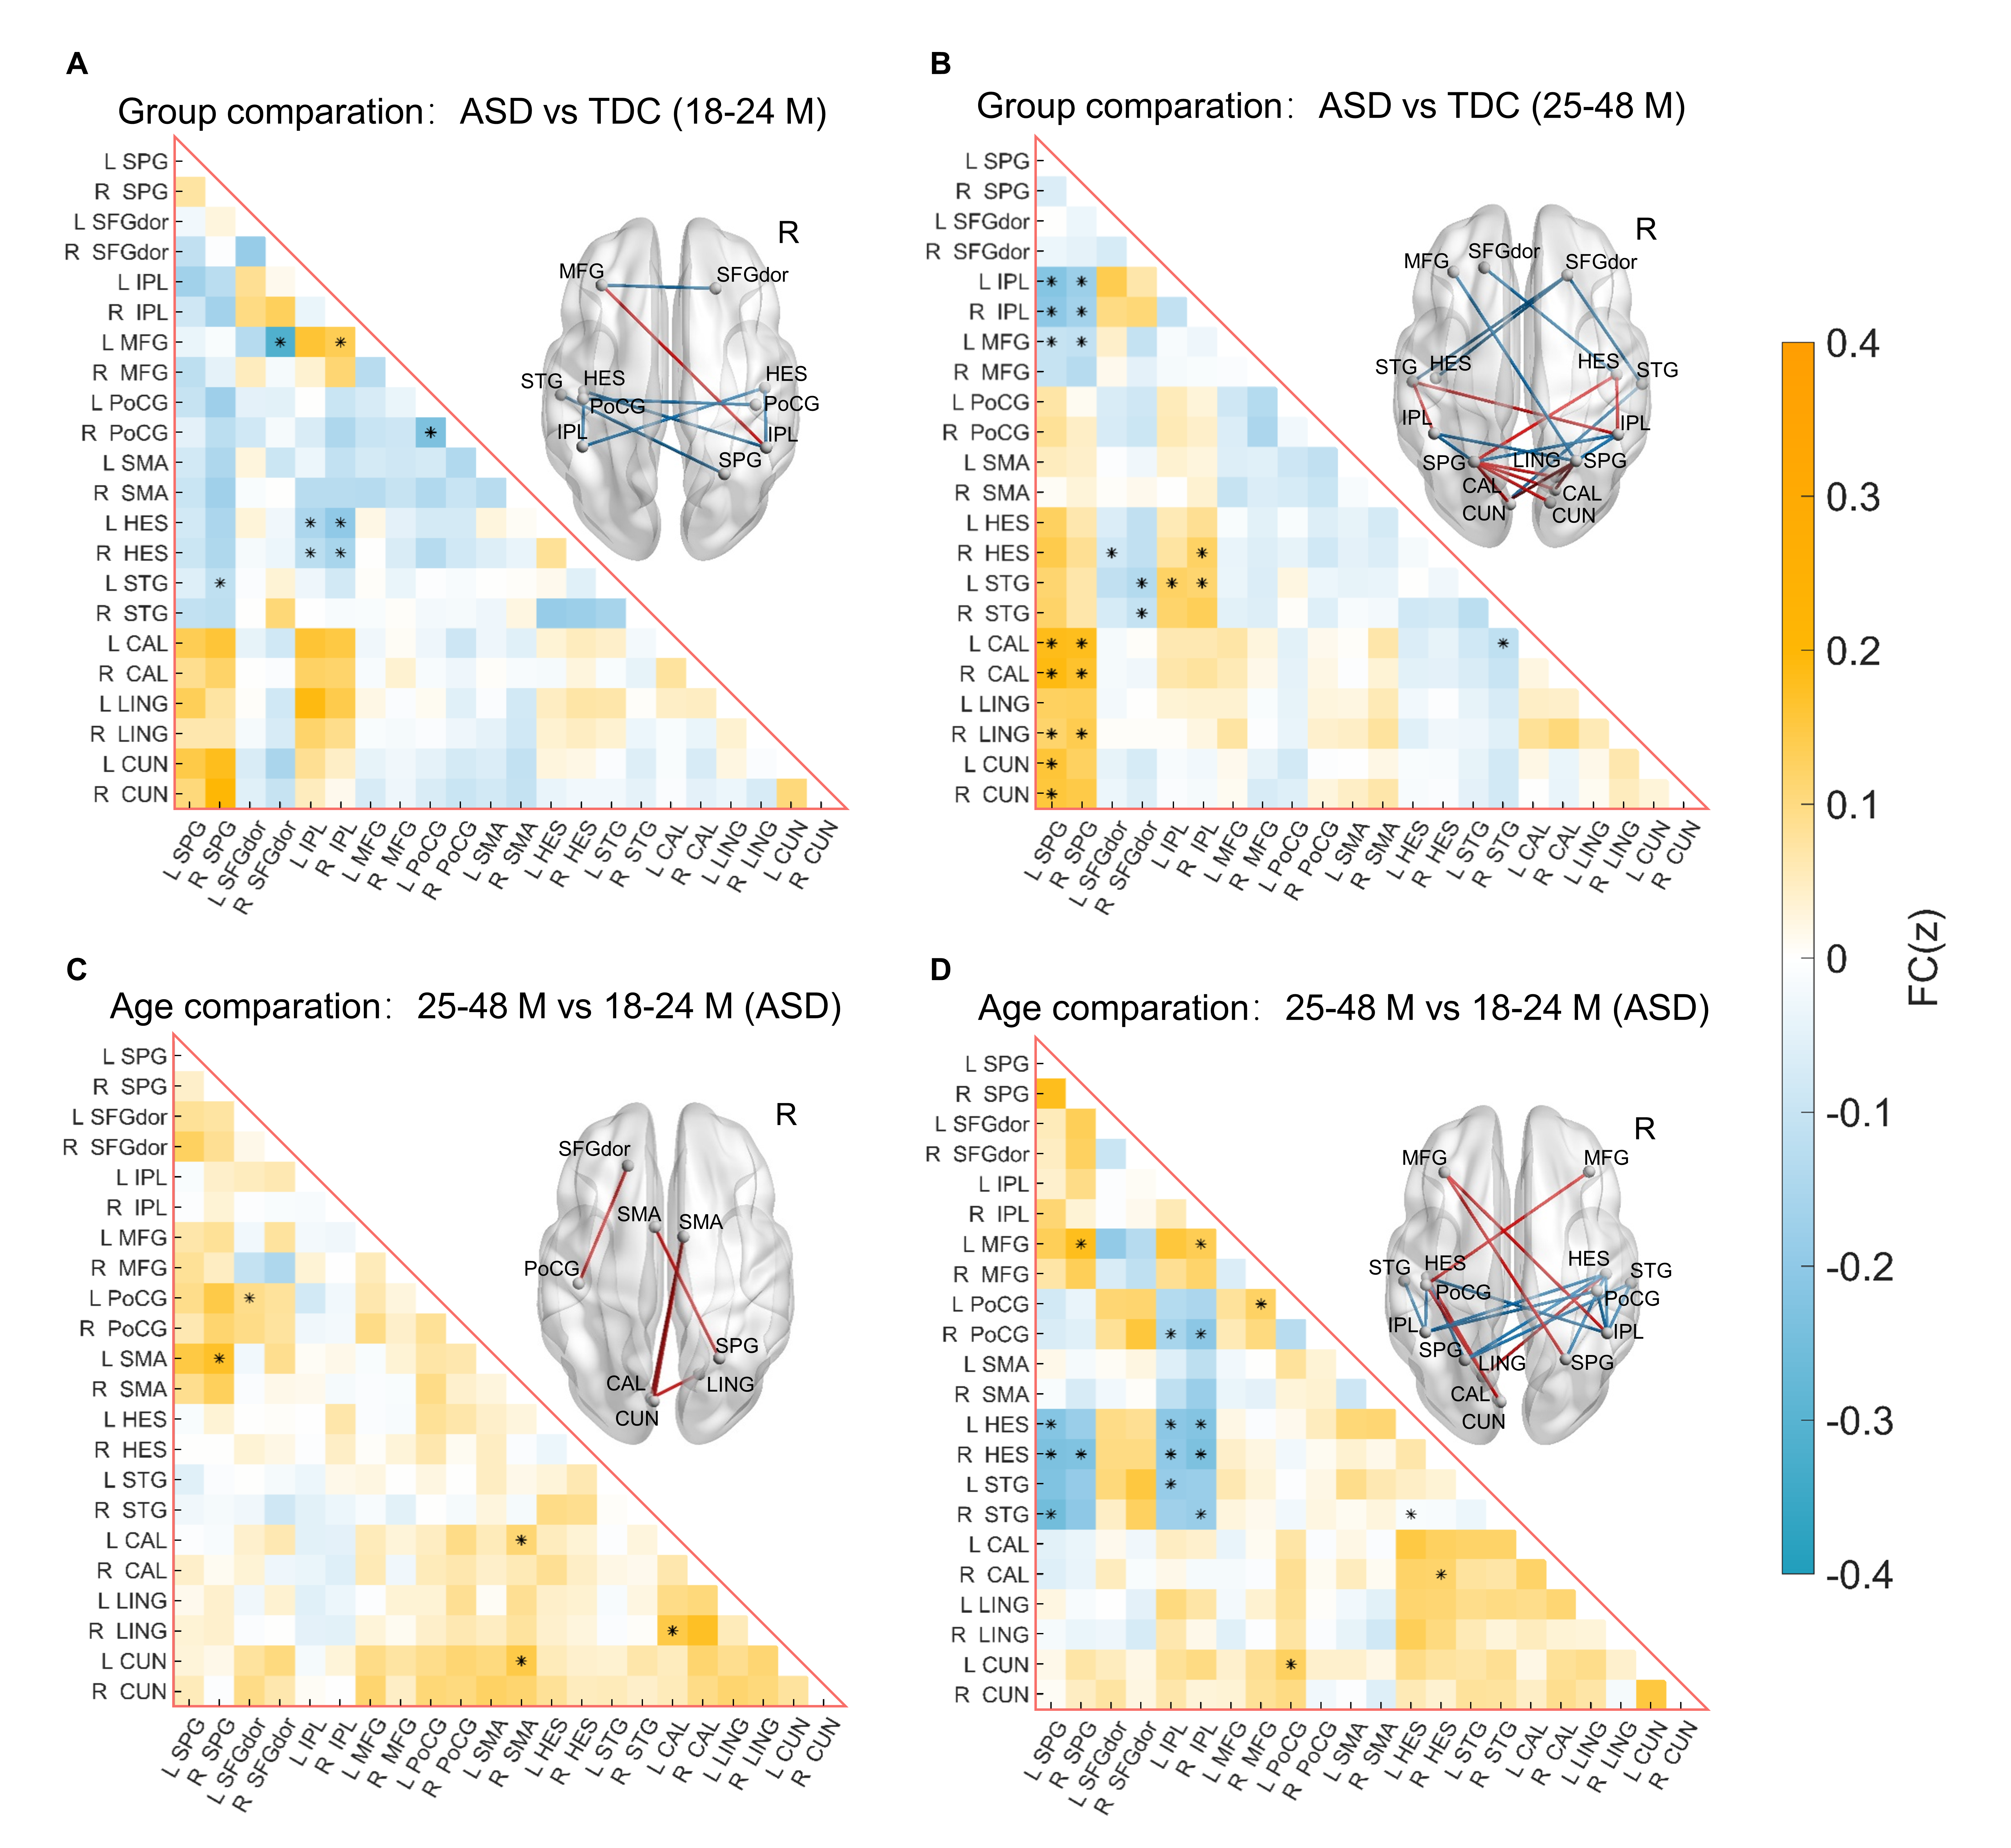
Figure S1. Functional connectivity (FC) between non-self-related brain regions
(A) The matrix diagram of FC represents the FC differences (Fisher z) of the ASD group minus the TDC group for 18-24 months. (B) The FC differences of the ASD group minus the TDC group for 25-48 months. (C) The FC differences of the 25-48 months group minus the 18-24 months group for ASD. (D) The FC differences of the 25-48 months group minus the 18-24 months group for TDC. The FC maps indicate Fisher z values ranging from -0.4 to 0.4 (blue to orange). Adjacent to the matrix diagram, on the right, is the connectivity map of brain regions. The red line indicated an increase in ASD compared to TDC (A, B), and the blue line represents a decrease in the 25-48 months group compared the 18-24 months group (C, D). *：p<0.05(FDR corrected).

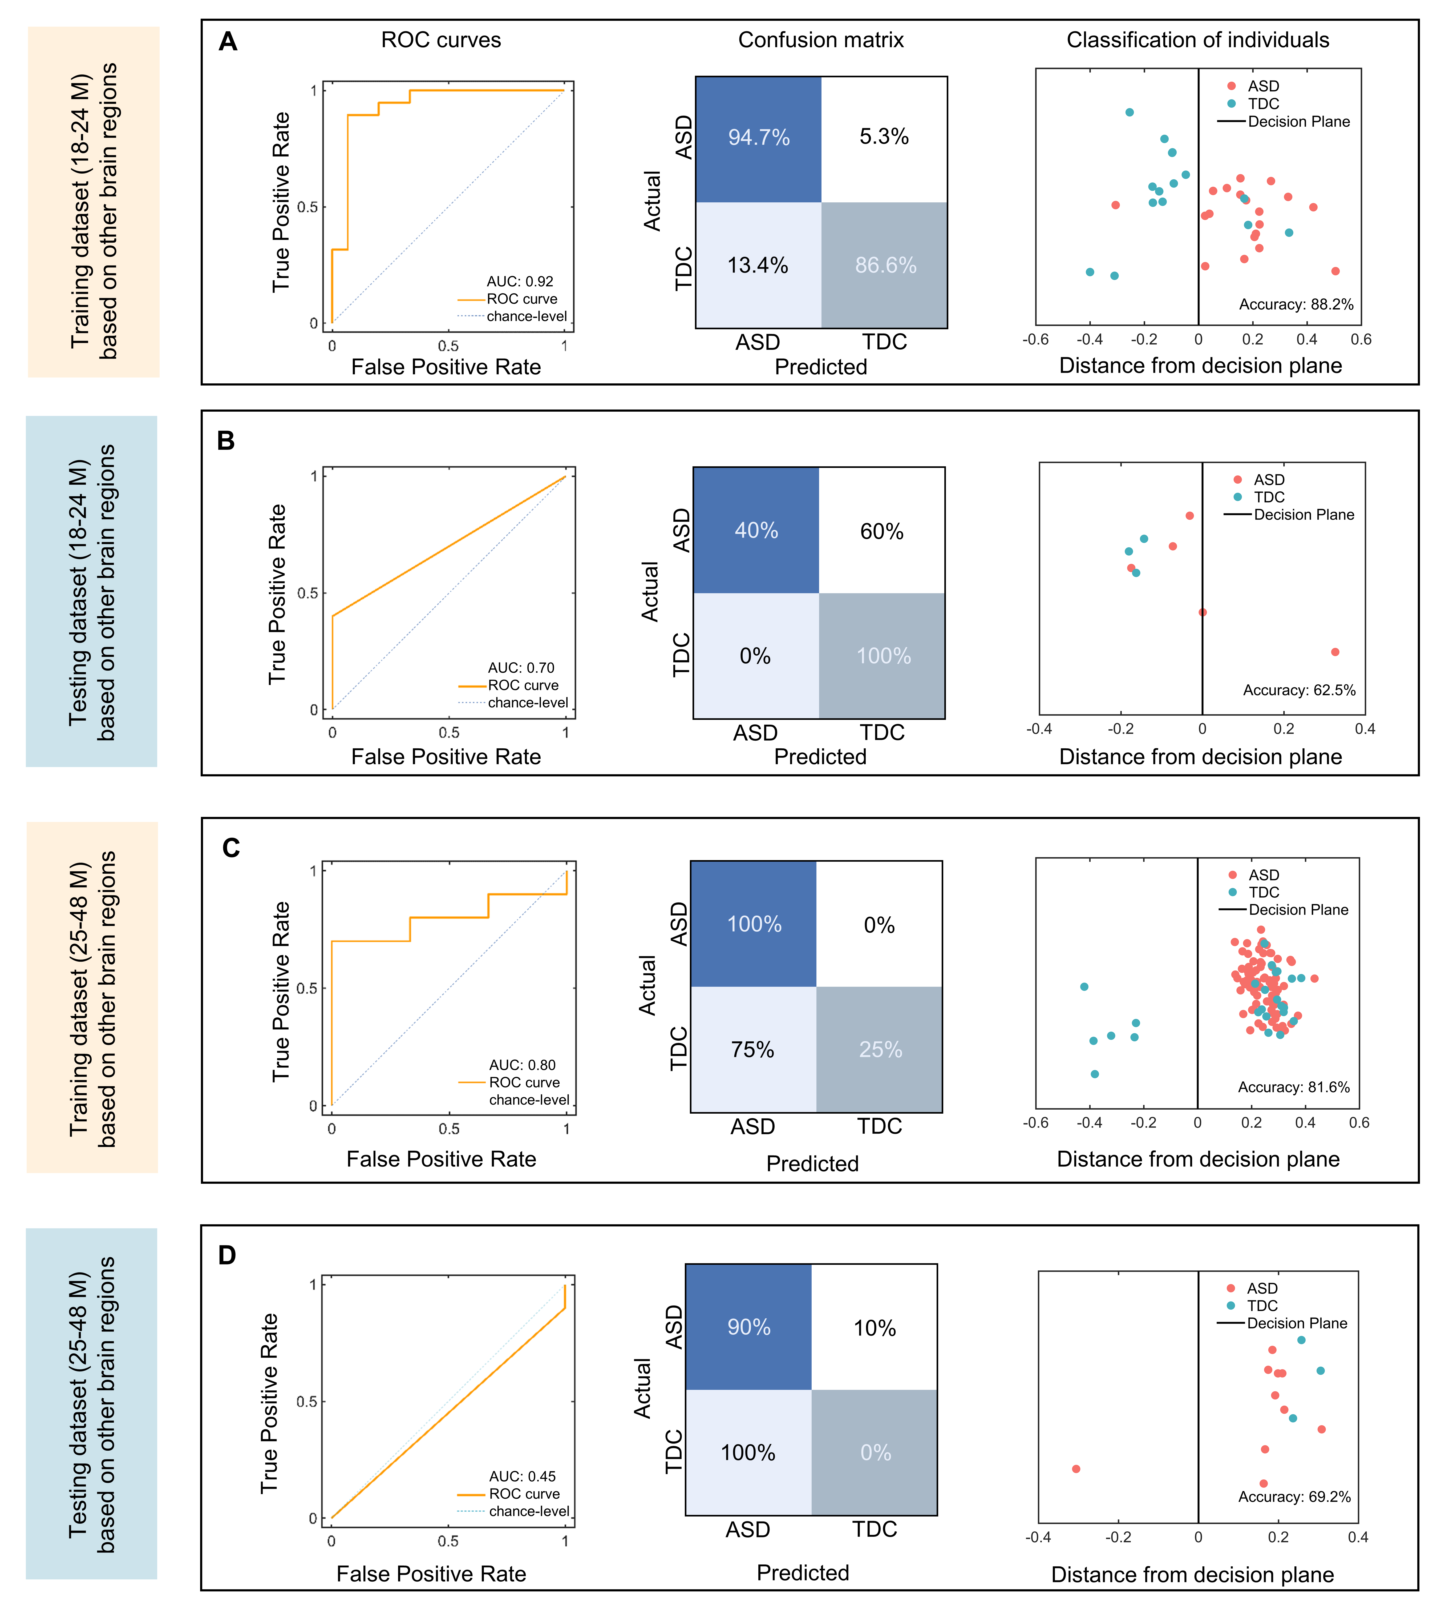
Figure S2. The SVM model discriminates ASD and TDC at two ages
(A) The SVM model which elected important functional brain regions as features (B) The SVM model for testing dataset (18-24 months). (C) The SVM model for training dataset (25-48 months). (D) The SVM model for testing dataset (25-48 months) The ROC curves directly reflected the classification performance of SVM model. The confusion matrix represents the sensitivity and specificity of the SVM model respectively. On the right side of the confusion matrix is the classification of the SVM model. The red point represents ASD data, and the blue point represents TDC data. Points on the left of the decision plane are identified as ASD by the SVM model, and those on the right are identified as TDC. The testing data is independent data with the same collection and processing. ROC: receiver operating characteristic; AUC: area under curve.

Table S1. Abnormal functional connectivity of self-networks in ASD
Brain regions | Functional connectivity
18-24 Months | ASD > TDC | ASD < TDC
Exteroceptive-self
L.TPJ | L.mPFC | —
R.TPJ | L.mPFC, R. L.mPFC | —
25-48 Months
Exteroceptive-self
L.TPJ | R.PMC | —
R.TPJ | L.mPFC, R. L.mPFC | —
Mental-self
L.ACC | L.PCC | —
R.ACC | L.PCC | —
Brain regions are the core brain regions of self-network, and the functional connectivity (FC) means abnormal FC between the brain regions of self-network. L.means left hemisphere; R.means right hemispher; abbreviations of the brain regions: TPJ: temporo-parietal junction; mPFC: medial prefrontal cortex; ACC: anterior cingulate cortex; PMC: premotor cortex; PCC: posterior cingulate cortex.

Table S2. Functional connectivity of self-networks in age group comparison
Brain regions | Functional connectivity
ASD  Interoceptive-self | 25-48 Months > 18-24 Months | 25-48 Months < 18-24 Months
L.Thal | — | R.Thal
TDC
Interoceptive-self
L.Insula | — | L.TPJ
Mental-self
R.ACC | — | L.PCC
L.means left hemisphere; R.means right hemispher; abbreviations of the brain regions: Thla: thalamus; INS: Insula; TPJ: temporo-parietal junction; ACC: anterior cingulate cortex; PCC: posterior cingulate cortex

