Probabilistic deployment pathways of scaling up distributed green hydrogen systems for urban residential communities in North America

Supplementary Note 1. Modelling multi-source uncertainties

Fig.S1. shows the flowchart of quantifying uncertainties layer by layer from the household level to the community level and then superimposes them to quantify compound impacts. The data structure of each process is designed to clearly represent the outcomes of each processing step. At the household level (Process a and b), we first developed climate-human uncertainty scenario pools and then derived household energy scenario pools that were simulated based on individual benchmark archetypes using the EnergyPlus engine. In climate-human uncertainty scenario pools, each typical climate scenario with occurrence possibility is associated with all uncertain human scenarios to address the uncertain relationship between weather and human behavior. This ensures that all calculated energy scenarios within each weather scenario were equally plausible for the subsequent clustering process. At the community level (Process c and d), we first utilized the defined household scale to cluster community energy scenarios from obtained household energy scenario pools. Then, we labeled these community energy scenarios based on the prosumer scale. These clustering and labeling processes do not change the data structures, as they contain only combined and categorized data. Finally, the synthesized community energy scenario pools contain combined uncertain information from the household and community levels.
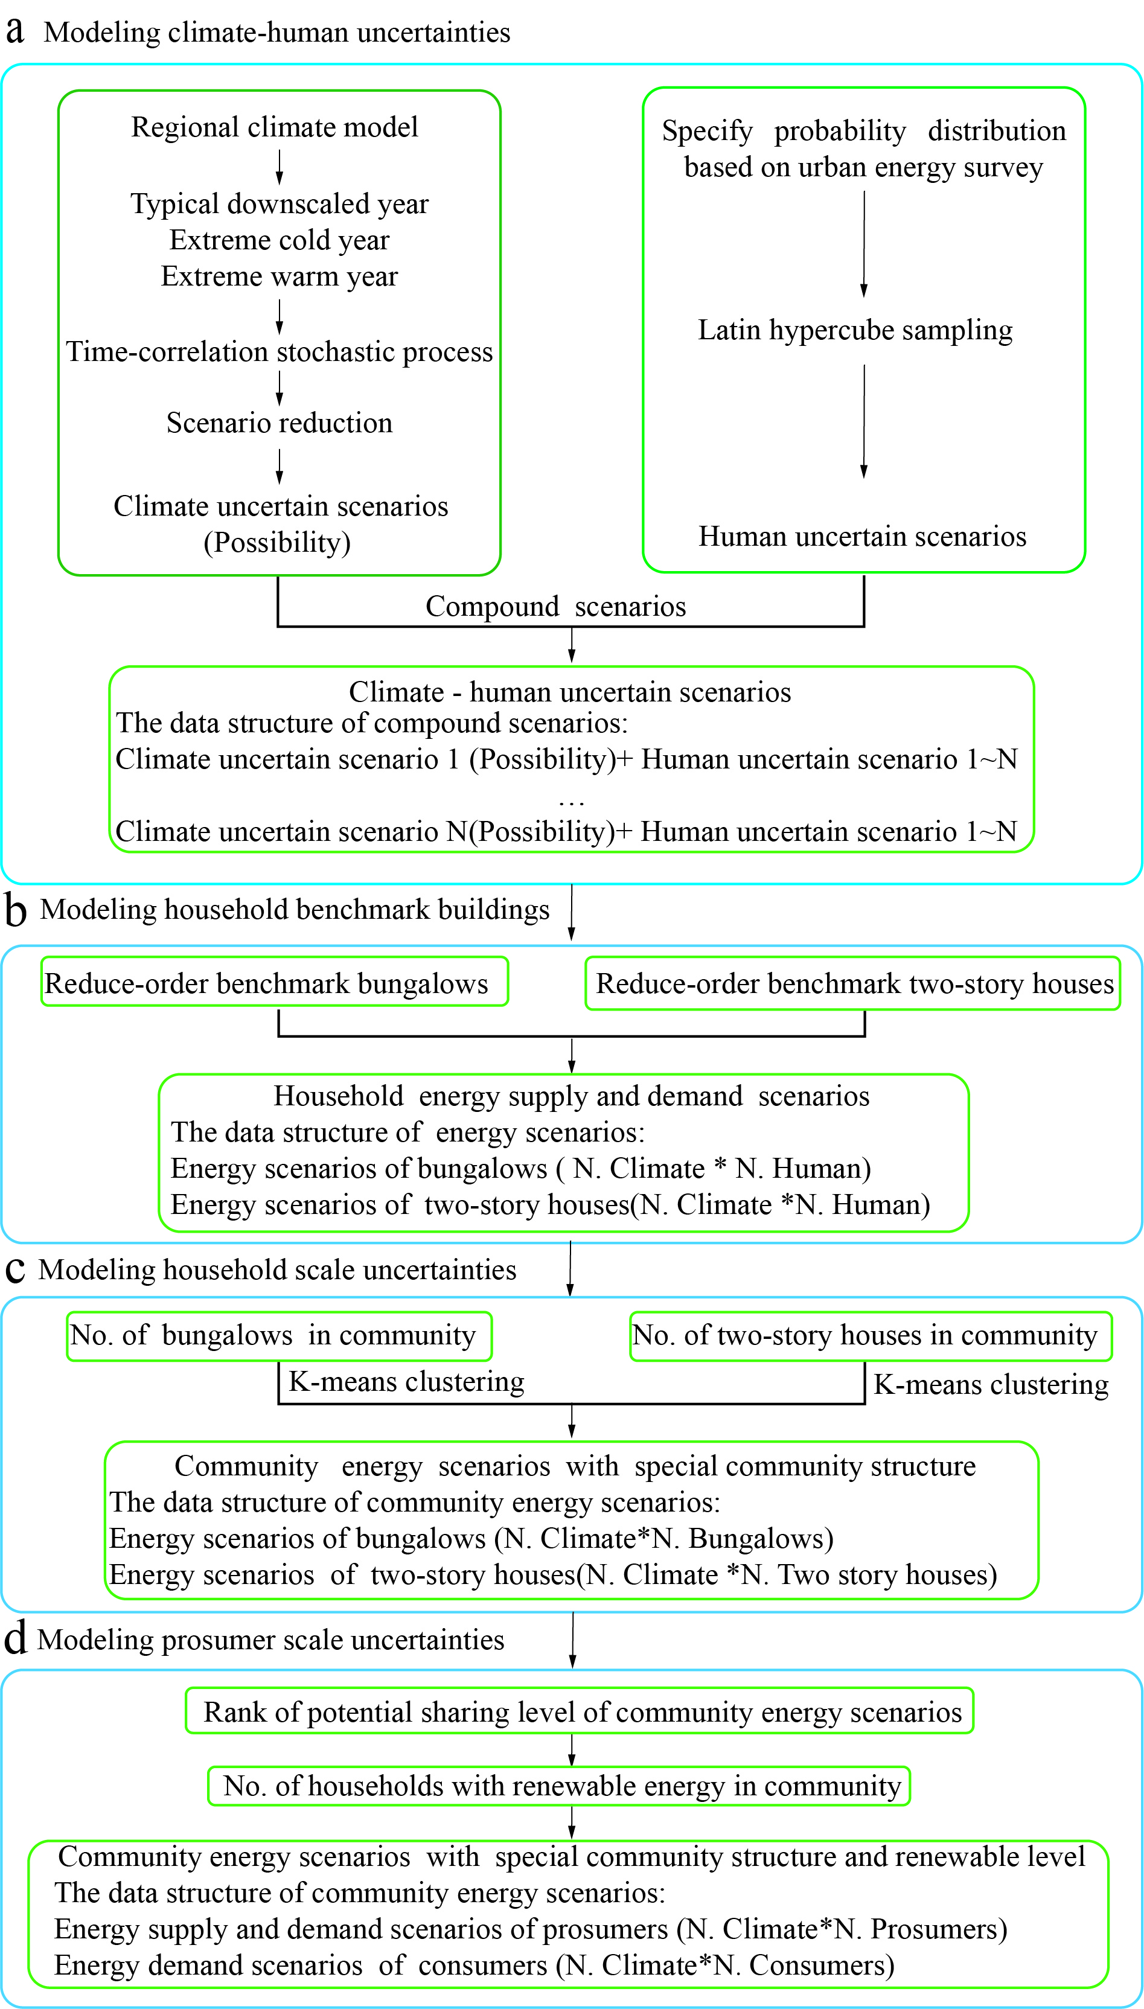
Fig.S1. Flowchart of quantifying uncertainties layer by layer from household level to community level. Climate uncertain scenario 1 + human uncertain scenario 1~N represents each climate scenario corresponding to 1~N human scenarios. No. denotes number. N. Climate *N. Human, N. Climate*N. Bungalows, N. Climate*N. Two story houses, N. Climate*N. Prosumers, and N. Climate*N. Consumers represent the total number of scenarios in each data structure, in which Climate, Human, Bungalows, two-story houses, prosumers, and consumers denote the component data role for each scenario.

Supplementary Note 2. Modelling future climate uncertainty

Given the constraints inherent in Global Climate Models (GCM)¹, researchers have devised both statistical^{2,3} and dynamical downscaling methodologies⁴ rooted in GCMs to generate future weather data conducive to dynamic building simulations. Nevertheless, these approaches encounter obstacles in effectively synthesizing extensive and representative weather data to elucidate the uncertainty surrounding climate patterns and extreme weather events at special future climatic periods. While morphing downscaling proves to be resource-efficient, it lacks precision during extreme weather events, coherence across meteorological parameters, and transparency regarding the impacts of climate change⁵. Conversely, dynamical downscaling addresses these challenges but necessitates substantial computational resources⁶. Thus, these methods are seldom integrated into stochastic energy system optimization to strengthen resilience and stability.

To address these challenges, we proposed a method based on time-related Monte Carlo methods to synthesize an arbitrary number of weather scenarios which account for potential typical and extreme weather information. Specifically, the method generates a set of weighted sums for weather indices based on climate characters and morphs extreme weather data using predicted weights to produce a set of future weather data. We noticed that monthly average dry bulb temperatures in RCMs maintain a strong time correlation and season characteristics although extreme weather events cause short-term intense temperature fluctuation. In addition, climate change mainly influences temperature and rainfall, while its impact on wind and solar radiation is relatively weaker.⁷ Thus, the dry bulb temperature was selected as the primary weather index to generate numerous stochastic weather scenarios, effectively reducing synthesizing time while preserving key weather features.

As shown in Fig.S2, our method involved four successive processes. We first generated hourly resolution typical downscaled year (TDY), extreme cold year (ECY), and extreme warm year (EWY) weather data from 20-year Canadian Regional Climate Model version 4 (CanRCM4-LE) data following the bias-corrected steps outlined by Gaur. et al⁸. Next, we extracted the monthly temperature data from TDY, EWY, and ECY to define the feature and boundary conditions of future monthly weather data. Following this, we derived random monthly temperature data based on the assumption that TDY, EWY, and ECY follow the multivariate normal distribution. Subsequently, we calculated the weight coefficients of EWY and ECY in new temperature data. Note that the sum of weight coefficients of EWY and ECY is equal to 1, which means that meteorological parameters tend to align with EWY or ECY as a certain weight coefficient of EWY or ECY approaches 1. Finally, we mapped the derived weather data, such as temperature and solar radiation, from monthly into hourly resolution by summing the monthly weights of the hourly resolution EWY and ECY.

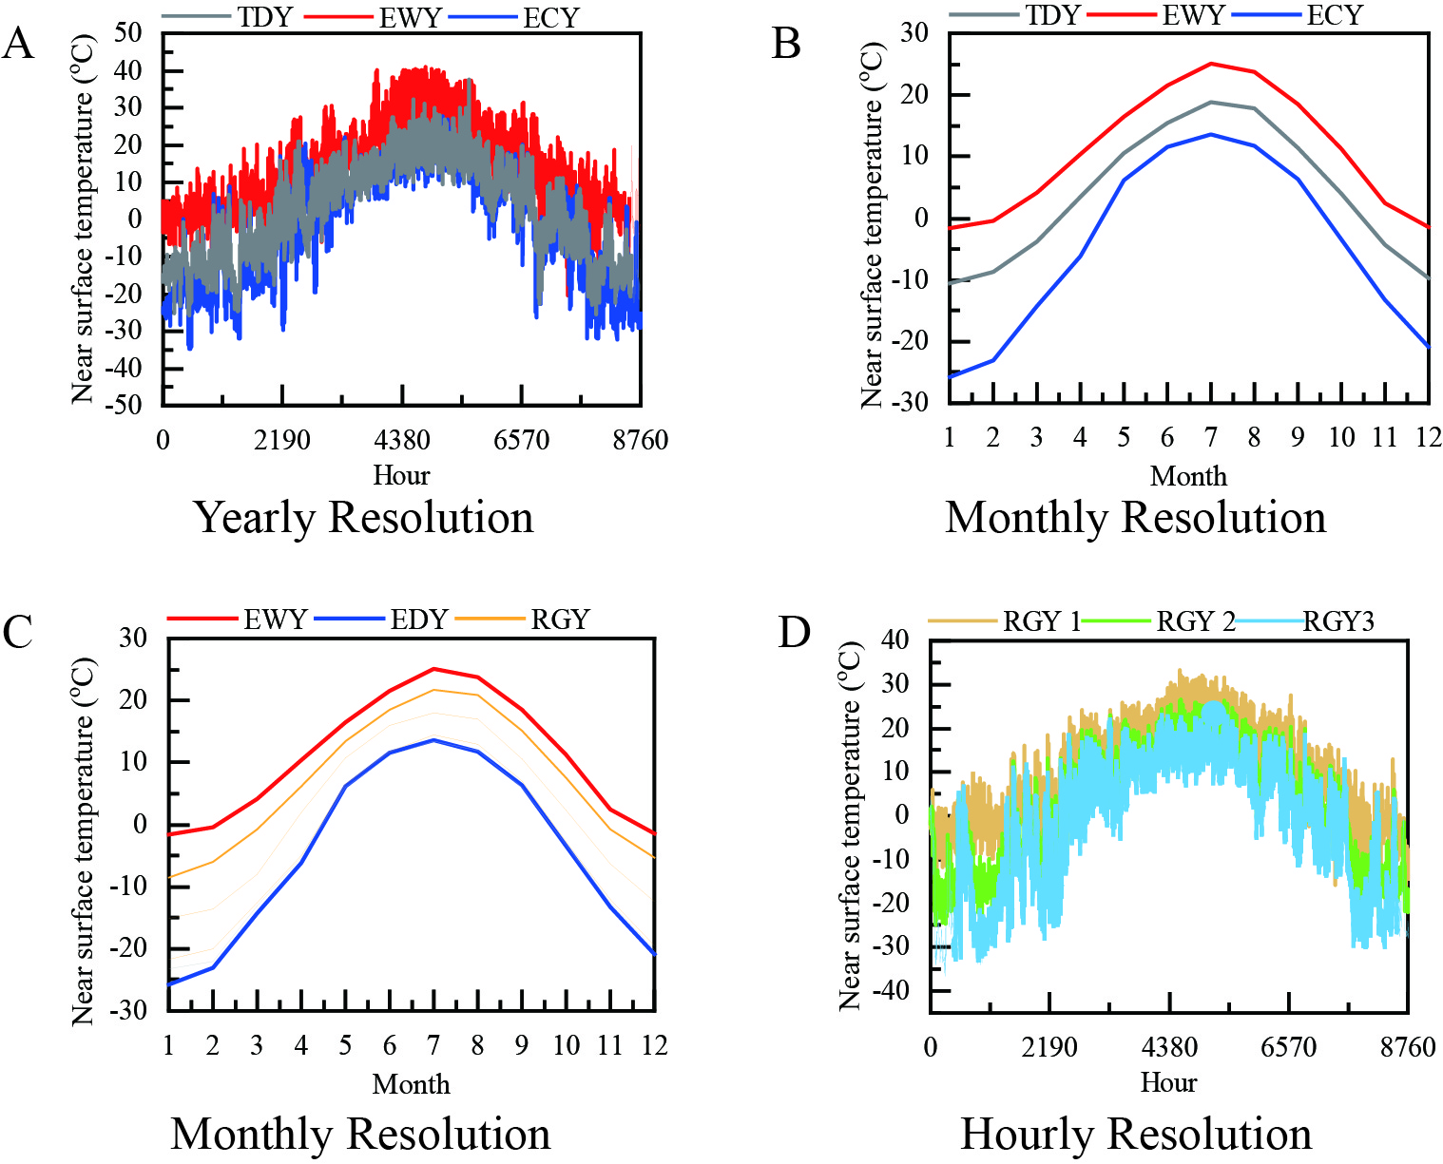
Fig.S2. Flowchart of weather data synthesis method. The method for synthesizing an hourly resolution random generation year (RGY) from TDY, EWY, and ECY. To provide a clear illustration of the synthesizing process in stages A to D, the 2030~2050 period of Edmonton was selected.

Supplementary Note 3. Modelling human behavior uncertainty

Supplementary Table 1 summarizes the uncertain operation factors and plausible ranges that affect the energy performance of building energy systems. These factors are derived from the urban census, the residential energy use survey, building codes and standards, and related research articles.

Supplementary Table 1. Uncertain operational factors and their plausible ranges for a residential household.
Classification | Variable | unit | Range
Internal Load | Occupants | persons | [1,6]^{9,10}
Internal Load | Lighting capacity | W/m² | [1,3]¹¹
Internal Load | Equipment capacity | W/m² | [5,20]¹²
HVAC | Ventilation rate | bedrooms | One occupant per room
HVAC | Infiltration | h⁻¹ | [0.05, 0.15]¹³
HVAC | Heating thermostat setting | ºC | [18,24)¹¹
HVAC | Cooling thermostat setting | ºC | (24,28]¹¹

Supplementary Note 4. Modelling regional household benchmark buildings

As shown in Fig.S3, to implement dynamic building simulations, we initially constructed building information modelling (BIM), and integrated building energy modelling (BEM) into BIM. The entire process of generating prototype building models using BIM and simulating dynamic building energy using BEM is based on approaches established by the U.S. Department of Energy ¹⁴.

The BIM outlines the regional building archetypes for subsequent energy analysis by identifying five structure parameters: building typologies, floors, external walls, roofs, and windows. The predominant building typologies of single-detached residential houses in North American urban centers are firstly determined as bungalows and two-story houses¹⁵. Following this, the other four structure parameters related to selected building typologies are identified based on regional building stock data and building standards. Conditional floor areas are averaged based on the state or provincial building stock data^{16,10}. Meanwhile, the aspect ratio of the external wall is set as the golden ratio for optimal thermal performance and aesthetics, given the absence of specific aspect ratios in city statistical data. The roof slope of gable roofs in the attic is defined as 6:12, reflecting the prevalence of asphalt shingles in North America¹⁷. Lastly, the window-to-wall ratio of window area is set at 27%, in accordance with the National Energy Code of Canada¹⁸.

The BEM is to implement physics-based dynamic simulation for building energy production and demand utilizing the building models built in BIM, which require the identification of four parts and their parameters: envelope construction, internal load, HVAC systems, and renewable energy systems¹⁹. Notably, the generated weather data, as described in Supplementary Note 2, serves as the input for the BEM process. The U-value and Solar Heat Gain Coefficient (SHGC) of the envelope construction are set to the allowed maximum allowable value in the ASHRAE standard for enhanced system robustness due to their low values indicating superior insulating performance, considering the influence of rooftop renewable energy systems²⁰. Internal loads mainly arise from people, electric lighting, and electrical appliances, each of which is highly related to people and their behavior. Thus, these terms within the internal loads are defined as uncertainty parameters. Similarly, the ventilation rate and heating and cooling thermostat settings associated with HVAC systems are categorized as uncertainty parameters. The range of uncertainty parameters is shown in Supplementary Note 3. Furthermore, the calculation of internal loads and HVAC systems also depends on operating schedules. In this study, a simplified operating schedule is defined by assuming that occupants are away from home between 8:00 and 17:00 on weekdays while they are staying home during weekends and holidays. All load operations are assumed to be intermittent, with usage at 80% when occupants are home and reduced to 10% when they are away. Additionally, the HVAC systems provide heating from October to May and cooling for the remaining months of the year to optimize energy costs. For the appropriate HVAC equipment, opting for heat pumps in households equipped with green hydrogen systems offers advantages in terms of safety, energy efficiency, and application prospects. On the one hand, hydrogen-powered gas boilers present challenges such as flashback and knock issues, requiring additional safety measures²¹. On the other hand, hydrogen-powered heat pumps not only provide space cooling for warmer weather conditions²², but are nearly six times more energy-efficient than gas boilers²³. Rooftop photovoltaic systems are installed in parallel on the attic as renewable energy systems, covering 98% of the inclined roof surface while maintaining a 0.1 m gap between the panels and the roof, adhering to guidelines from the National Renewable Energy Laboratory (NREL)²⁴. The energy production of renewable energy systems is calculated using the standard one-diode model due to its higher accuracy for widely used mono-Si and poly-Si PV modules and reduced dependence on the measured PV dataset²⁵.

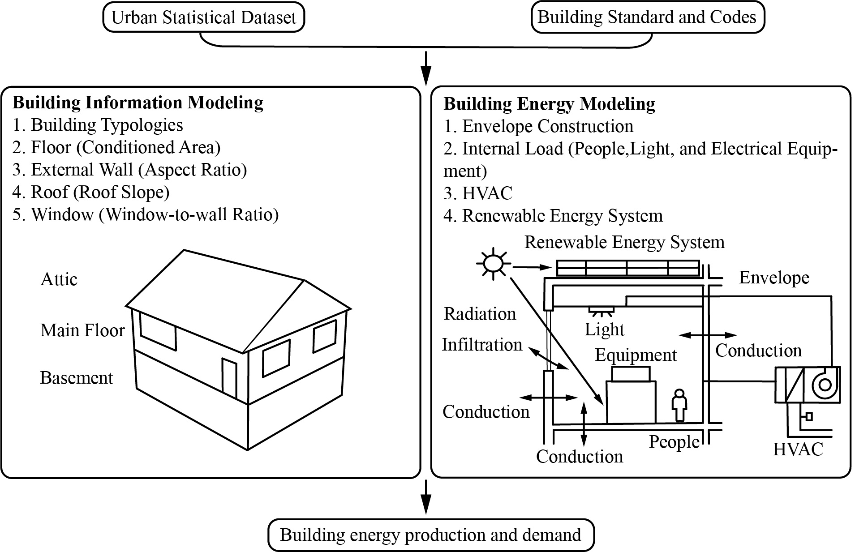
Fig.S3. A generation approach of regional individual benchmark model for 7 climate zone cities. BIM requires the identification of five parts along with their respective parameters: building typologies, floors, external walls, roofs, and windows. BEM needs to identify four parts along with their parameters: internal load, envelope construction, HVAC systems, and renewable energy systems.

Supplementary Note 5. Modelling system deployment pathways

We elaborate on energy dispatch strategies utilizing a two-stage logical framework across three system deployment pathways. Each deployment path features the same energy flow structure but differs in energy sharing structure, as shown in Fig. S4A~S4C.

As shown in Fig.S4A, household distributed programs describe prosumer-owned system deployment pathways that specify each prosumer as an energy trade entity with an independent energy system and a three-layer trade path. Each prosumer can determine his own trading energy using independent energy systems in the intra-household layer. These prosumers are organized into separate buyers and sellers and then transferred trading energy to the intra-community layer. The energy trade is initially executed among prosumers utilizing community trading prices, as outlined in the first layer. Subsequently, the remaining energy from the first layer is distributed to consumers situated in the second layer, also utilizing community trading prices. Finally, power grid covers any additional unbalanced energy with local purchase and sale prices of electricity. Notably, the design of the first layer aims to safeguard the interests of prosumers.

As shown in Fig.S4B, household centralized programs describe grouped prosumer-owned system deployment pathways which combine all prosumers as energy trade entities with a centralized energy system and a two-layer trade path. All community prosumers engage in freely exchanging energy and collaboratively identify trading energy. All prosumers acted as one buyer or seller trade energy in the intra-community layer. As outlined in the first layer, energy trading is first implemented with consumers using community trading prices. Subsequently, power grid eliminates the additional unbalanced energy with local purchase and sale prices of electricity.

As shown in Fig.S4C, community centralized programs describe community-owned system deployment pathways that coordinate all community households as energy trade entities with a centralized energy system and one-layer trade path. All community prosumers and consumers can freely exchange energy, and the remaining energy is traded with the power grid with local purchase and sale prices of electricity.
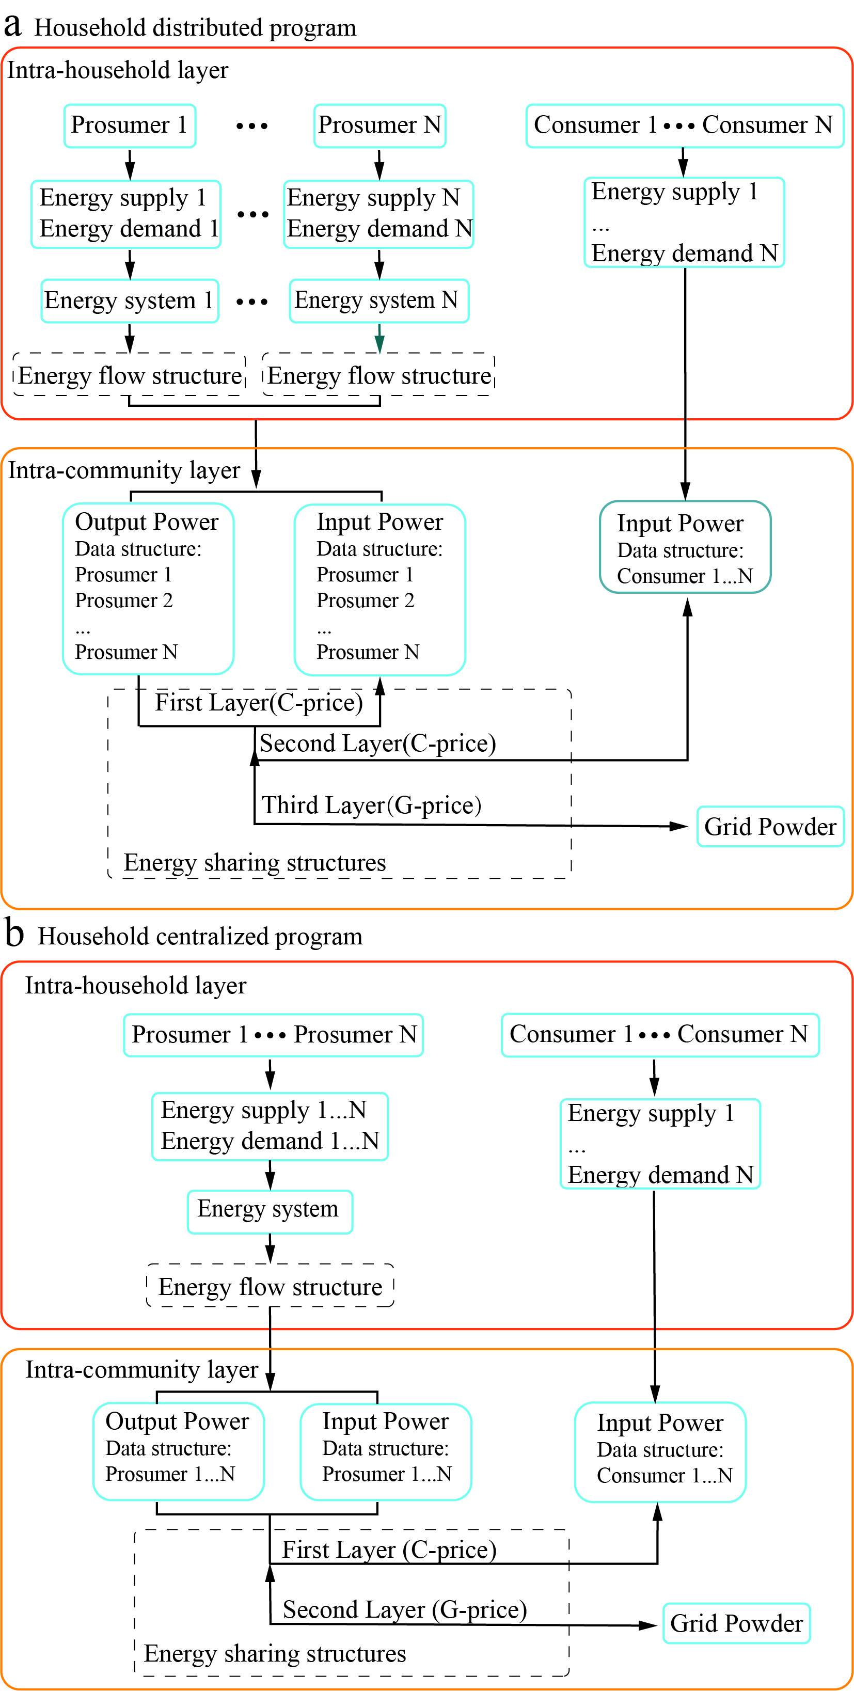
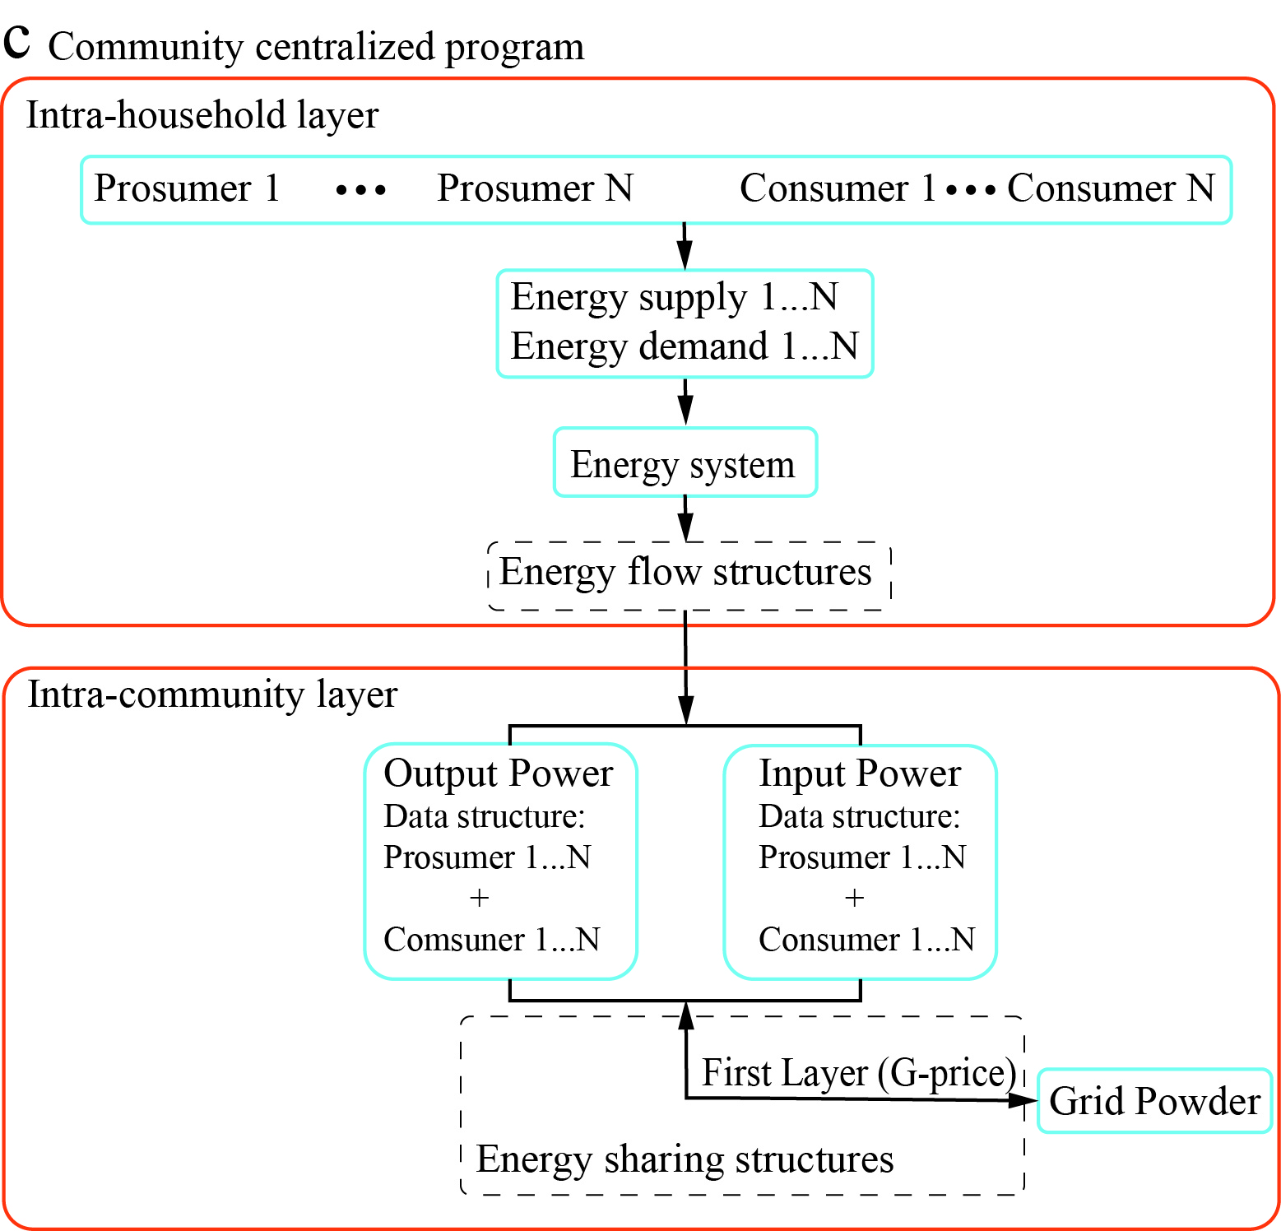
Fig.S4. Three types of system deployment pathways in urban communities. Energy supply N, Energy demand N, Prosumer N, denote the denote the separate energy variables; Energy supply 1…N, Energy demand 1…N Prosumer 1…N and Consumer 1…N denote the consolidated energy variables.

As shown in Fig.S5, energy flow structure details energy distribution with each set of system modules. Energy flow structure identifies twelve operating states based on physical constraints of system components, encompassing energy flow balance, energy storage prioritization, and energy storage boundary. The energy flow structure includes two main branches: positive net energy and negative net energy. The energy supply exceeds the energy demand in the positive net energy branch, represented by the first six operation states. States 1 and 2 provide storage options for surplus energy, with the battery module and the community being the boundary choices, respectively. The hydrogen module comes into play for surplus energy beyond these scenarios, as depicted in states 3 to 6 of subroutine A. Interactions among these states involve both the hydrogen module and the community in states 4 to 6. Conversely, the last six operation states pertain to the negative net energy branch, where the energy supply falls short of the energy demand. States 7 and 8 describe situations where energy deficiencies are remedied by the battery module and the community served as boundary choices. Subroutine B outlines operation states 9 to 12, highlighting the role of the hydrogen module in alleviating energy shortages.

The formulation of energy flow structure in intra-household layer needs to account for the physical constraints of system component. First, energy flow balance needs to be maintained within green hydrogen systems, as shown in Eq. (1). Notably, to simplify the energy analysis, energy required for hydrogenation and dehydrogenation in the LOHC process is added to the electrolyzer and fuel cell as additional energy, respectively.
 | $$P_{s,t,EP}+P_{s,t,fc}+P_{s,t,bpdch}+P_{s,t,combuy}=P_{s,t,ED}+P_{s,t,ele}+P_{s,t,bpch}+P_{s,t,comsell},$$  $$∀s∈N_{s},∀t∈T$$ | (1)
where, P_{s,t,EP} , P_{s,t,ED} P_{s,t,fc} , P_{s,t,ele}, P_{s,t,bpdch}, P_{s,t,bpch}, P_{s,t,combuy}, and P_{s,t,comsell} and denote the power related to energy production, demand, fuel cell, electrolyzer, battery discharge, battery charge, and community buying and community selling respectively, at time t in scenario s.
The energy exchange of battery package is constrained by its rated power and capacity, as shown in Eqs. (2) and (3). The C-rate, which is described as a measure of the discharge rate relative to its maximum capacity, is set at 0.3C for battery packages within the green hydrogen systems. In addition, to minimize degradation, the capacity of the battery packages is limited to between 10% and 90%²⁶.
 | $${0≤P}_{s,t,bpdch},P_{s,t,bpch}≤P_{s,BP}, ∀s∈N_{s},∀t∈T$$ | (2)
 | $${{SOC}_{s,min}≤{SOC}_{s,t+1,BP}={SOC}_{s,t,BP}+η}_{bpch}P_{s,t,bpch}-\frac{P_{s,t,bpdch}}{η_{bpdch}}≤{SOC}_{s,max},$$ | (3)
 | $$∀ sϵN_{s},∀t∈T$$ | (3)
where, SOC_{s,t,BP} and SOC_{s,t+1,BP} denote the energy stored in the battery package at time t and t+1, respectively, in scenario s; η_{bpch} and η_{bpdch} denote the charging and discharging efficiencies of the battery package; SOC_{s},_{min} and SOC_{s},_{max} are the minimum and maximum storage capacities of the battery package in scenario s (10% and 90% of E_{s,BP}); and P_{s,BP} denotes the maximum power output of the battery package in scenario s.
The hydrogen module requires coordinated operation among its various components to facilitate the generation, storage, and release of hydrogen, with LOHC serving as the energy carrier. Thus, the rated power of the electrolyzer and fuel cell is constrained by Eq. (4), while the rated capacity of the LOHC tank is constrained by Eq. (5). Due to the hydrogenation and dehydrogenation processes of LOHC are adjuncts to the electrolyzer and fuel cell operations, the energy consumption of the LOHC process is described as additional efficiency term added to the efficiencies of the electrolyzer and fuel cell, as shown in Eq. (5).
 | $$0≤P_{s,t,ele}≤P_{s,Ele},∀s∈N_{s},∀t∈T$$  $$0≤P_{s,t,fc}≤P_{s,FC},∀s∈N_{s},∀t∈T$$ | (4)
 | $${LOH}_{s,min}≤{LOH}_{s,t+1,H_{2}}={LOH}_{s,t,H_{2}}+\frac{P_{s,t,ele}}{η_{ele}+η_{LOHCs}}-\frac{P_{s,t,fc}}{η_{fc}-η_{LOHCr}}≤{LOH}_{s,max},$$  $$∀s∈N_{s},∀t∈T$$ | (5)
where, LOH_{s,t,H2} and LOH_{s,t+1,H2} denote the amount of energy stored in the hydrogen module at time t and t+1 in scenario s; η_{ele} and η_{fc} denote the efficiencies of the eletrolyze and fuel cell; η_{LOHCs} and η_{LOHCr} denote the efficiencies of the LOHC hydrogenation unit and LOHC dehydrogenation unit; LOH_{s},_{min} and LOH_{s},_{max} denote the minimum and maximum storage capacities of the LOHC tank in scenario s (10% and 90% of L_{HS}); P_{s},_{FC} and P_{s},_{Ele} denote the maximum power outputs of the fuel cell and eletrolyzer in scenario s, respectively.
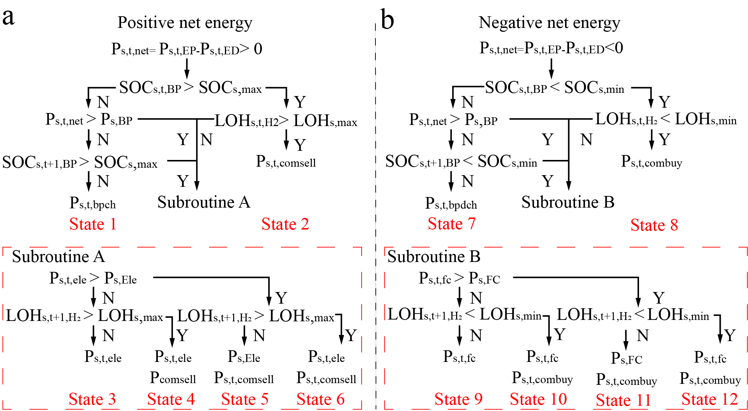
Fig.S5. Energy flow structure in intra-household layers. It employs a capacity priority strategy. Specifically, the energy system first assesses whether it fills the rated capacity of that component and then compares whether the transferred power exceeds the rated power of a system component.

Supplementary Note 6. Outline of green hydrogen systems in urban communities

As shown in Fig.S6, green hydrogen systems designed for residential communities comprise PV panel modules for energy supply, along with battery and hydrogen modules for energy storage. Coordinating energy flows within communities’ energy systems is guided by energy dispatching strategies based on pre-designed system deployment pathways. In terms of energy supply, we chose roof-top PV panel modules to minimize sitting ordinance challenges and prevent interference with building structure functions. This selection avoids contracts with small urban wind turbines that demand sufficient land areas and necessary average wind speeds^{27,28}. In terms of energy storage, we selected liquid organic hydrogen carriers (LOHC) and lithium-ion batteries as storage mediums. LOHC, being non-corrosive and non-toxic, can store hydrogen in liquid form in standard tanks at ambient conditions²⁹. Unlike current dominating densified storage technologies, which operate under high pressures or low temperatures and pose considerable safety risks without proper public training. This approach effectively mitigates hydrogen storage risk³⁰. Additionally, hydrogen absorption and release from LOHC can be fully managed by controlling the catalyst in hydrogenation and dehydrogenation reactions, further minimizing hydrogen leakage risk³¹. Lithium-ion battery packages have higher energy density which significantly reduces the required space, compared with other types of batteries.
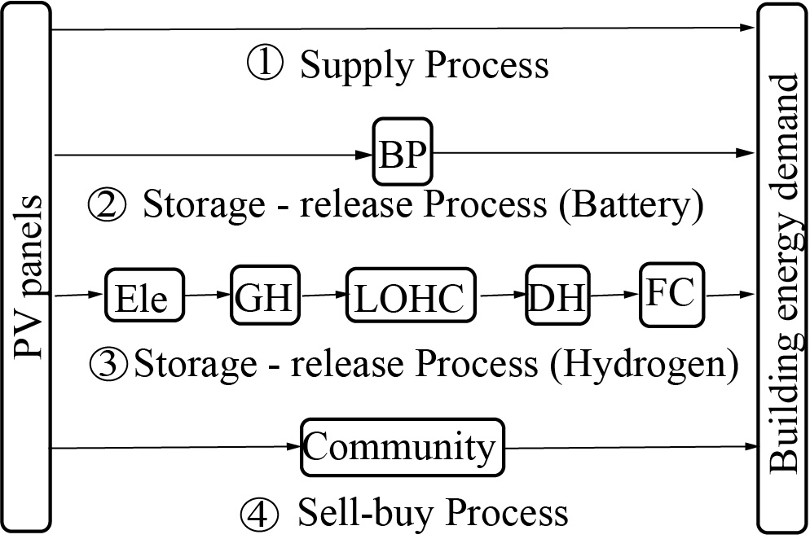
Fig.S6. Green hydrogen systems in residential sectors. Energy production modules are photovoltaic panels (PV panels). Energy storge modules include battery modules (BP) and the hydrogen utilization modules, including an electrolyzer (Ele), hydrogenation reactor (GH), hydrogen storage modules (LOHC), fuel cell (FC), and dehydrogenation reactor (DH). The numbers (1-4) represent energy transmission paths, with corresponding color lines representing different energy sources. (1) represents direct supply process of renewable energy. (2) represents storage-release process of surplus renewable energy using battery modules. (3) represents storage-release process of surplus renewable energy using hydrogen modules. (4) represents sell-buy process from community.

Supplementary Note 7. Formulating objective functions

Each part of LCC is computed in Eq.6~10. The initial investment cost, as shown in Eq. (6), encompasses costs associated with PV panels, battery packages, and hydrogen utilization module. The cost of PV panels is a deterministic part, while the costs of battery packages and the hydrogen utilization module vary based on the system configuration.
 | $$C_{s,inv}=C_{PV,inv}+C_{s,Eleinv}+C_{s,LOHCinv}+C_{s,FCinv }+C_{s,BPinv}$$  $$=f_{PV}A_{PV}+f_{Ele}P_{s,Ele}+f_{LOHCg}P_{s,LOHCg}{+f}_{tank}L_{s,HS}+f_{LOHCd}P_{s, LOHCd}+f_{FC}P_{s,FC}+f_{BP}E_{s,BP}$$ | (6)
where, C_{s,inv} is the investment cost ; C_{PV},_{inv}, C_{s},_{Eleinv}, C _{s},_{LOHCinv}, C _{s},_{FCinv,} and C _{s},_{BPinv} denote the investment costs of PV system, electrolyzer, LOHC unit, fuel cell, battery package, respectively; f_{PV}, f_{ele}, f_{LOHCg}, f_{tank}, f_{LOHCd}, f_{fc}, and f_{BP} denote cost factors of PV panels electrolyzer, LOHC hydrogenation unit, hydrogen tank ,LOHC dehydrogenation unit, fuel cell, and battery package, respectively; A_{PV} is the area of PV panels; P_{Ele}, P_{LOHCg}, P_{LOHCd}, and P_{FC} denote the rated powers of the electrolyzer, LOHC hydrogenation unit, LOHC dehydrogenation unit, and fuel cell; L_{s},_{HS} and E_{s},_{BP} denote the rated capacities of the hydrogen storage tank and battery package in scenario s, respectively.
The operation and maintenance costs are assumed to relate to the initial investment cost, as shown in Eq. (7).
 | $$C_{s,om}=\sum_{c∈PV, Ele,FC, BP,LOHC }{{α_{c}C}_{s,inv}}$$ | (7)
where, C_{s,om} is the operation and maintenance cost; α_{c} denotes the ratios of maintenance costs for each component.
The value of initial investment costs and operation and maintenance costs can be converted into the annual value based on capital recovery factor (CRF), as shown in Eq. (8).
 | $$CRF\left(r,Y\right)=\frac{r{(1+r)}^{Y}}{{(1+r)}^{Y}-1}$$ | (8)
where, r is the interest rate (5.8%/year); Y is the lifespan of each component in green energy systems, referenced from literature 32.
The carbon tax is calculated based on the emissions resulting from the purchased power from the electrical grid. Notably, in the study area of this paper, carbon tax policy is implemented in Canada, not in the United States. This calculation assumes that not all power obtained from the grid is generated through renewable energy sources, as shown in Eq. (9).
 | $$C_{n,s,t,tax}={λC}_{cpp}P_{n,s,t,gridbuy}$$ | (9)
where, λ is the electricity consumption intensity, referenced from literature 32; C_{cpp} is the price of carbon pollution per unit of carbon emitted, referenced from literature 32.

The community trade cost relates to energy sharing structures, including community trade with community price and grid trade with local purchase and sale prices of electricity. Due to different layer forms in three system deployment pathways, we counted the trade cost of community participation using hierarchical computation. Eq. (10) indicates shows the generalized form.
 | $$C_{n,s,t, community}=β_{comtrade}P_{n,s,t,comtrade}+β_{gridbuy}P_{n,s,t,cgridbuy}-β_{gridsell}P_{n,s,t,gridsell}$$ | (10)
where, β_{comtrade} denote the per unit trade price within community; β_{gridbuy} and β_{gridsell} denote the per unit trade price with power grid; P_{n},_{s,t,comtrade}, P_{n,s,t,gridbuy} , and P_{n,s,t,gridsell} denote the amount of electricity traded within community, the amount of electricity purchased from the grid and amount of electricity sold to the grid at time t in scenario s for system n.

Supplementary Table 2 shows the technical and economic parameters of components in green hydrogen systems for system design optimization. This study ignores changes in technical and economic parameters brought by future technological developments.

Supplementary Table 2. Technical and economic parameters of components in green hydrogen systems
Component | Technical parameters | Economic parameters
Component | Technical parameters | Installation cost | O&M ratio (Initial Cost)
PV³³ | η_{ref} = 0.22, PR=0.75 | 425 CA$/m² | 2%
PEM Electrolyzer³⁴ | η^{Ely} = 5.0kWh/Nm³ H₂ | 710 CA$/kW | 2%
LOHC hydrogenation unit³⁵ | η^{store}=0.06kWh/ Nm³ H₂ | 3033 CA$ /unit (Fix)  1087 CA$/ kW | 1%
LOHC dehydrogenation unit³⁵ | η^{release}= 0.8 kWh/ Nm³ H₂, | 1628 CA$/unit  (Fix)  584CA$/ kW | 1%
LOHC storage unit³⁴ | LoH^{HS,min}=0.1, LoH^{HS,max}=0.95 | 6.5 CA$/Nm³ | 2%
PEMFC (Including auxiliary devices)³⁶ | η^{FC}= 1.65 kWh/Nm³ H₂ | 3200CA$/kW | 5%
Lithium-ion Battery ³⁷ | η ^{Bat,ch} =0.9, η^{Bat,dch}=0.9, SoC^{BS,min}=0.1, SoC^{BS,max}=0.95 | 205 CA$/kWh | 1%

References
1. Alizadeh, O. Advances and challenges in climate modeling. Clim. Change 170, 26 (2022). https://doi.org/10.1007/s10584-021-03298-4.
2. Belcher, S. E., Hacker, J. N., and Powell, D. S. (2005). Constructing design weather data for future climates. Building services engineering research and technology, 26(1), 49-61.
3. Yassaghi, H., Mostafavi, N. & Hoque, S. Evaluation of current and future hourly weather data intended for building designs: A Philadelphia case study. Energy and Buildings 199, 491-511 (2019). https://doi.org/10.1016/j.enbuild.2019.07.016.
4. Xu, Z. F., Han, Y., Tam, C. Y., Yang, Z. L. & Fu, C. B. Bias-corrected CMIP6 global dataset for dynamical downscaling of the historical and future climate (1979-2100). Sci. Data 8, 11 (2021). https://doi.org/10.1038/s41597-021-01079-3.
5. Eames, M., Kershaw, T. & Coley, D. A comparison of future weather created from morphed observed weather and created by a weather generator. Building and Environment 56, 252-264 (2012). https://doi.org/10.1016/j.buildenv.2012.03.006.
6. Xu, Z. F., Han, Y., Tam, C. Y., Yang, Z. L. & Fu, C. B. Bias-corrected CMIP6 global dataset for dynamical downscaling of the historical and future climate (1979-2100). Sci. Data 8, 11 (2021). https://doi.org/10.1038/s41597-021-01079-3.
7. Nik, V. M. Making energy simulation easier for future climate - Synthesizing typical and extreme weather data sets out of regional climate models (RCMs). Applied Energy 177, 204-226 (2016). https://doi.org/10.1016/j.apenergy.2016.05.107.
8. Gaur, A. & Lacasse, M. Climate Data to Support the Adaptation of Buildings to Climate Change in Canada. Data 7, 22 (2022). https://doi.org/10.3390/data7040042.
9. Structural and geographic characteristics of U.S. homes by housing unit type 2020. Energy information Administration， https://www.eia.gov/consumption/residential/data/2020/hc/pdf/HC%202.1.pdf.
10. 2019 Survey of Household Energy Use (SHEU-2019) Data Tables. Natural Resources Canada，https://oee.nrcan.gc.ca/corporate/statistics/neud/dpa/showTable.cfm?type=SH&sector=aaa&juris=ca&year=2019&rn=2&page=1.
11. Perera, A. T. D., Khayatian, F., Eggimann, S., Orehounig, K. & Halgamuge, S. Quantifying the climate and human-system-driven uncertainties in energy planning by using GANs. Applied Energy 328, 12 (2022). https://doi.org/10.1016/j.apenergy.2022.120169.
12. List of the Power Consumption of Typical Household Appliances. https://www.daftlogic.com/information-appliance-power-consumption.htm.
13. Persily, A., Musser, A. & Emmerich, S. J. Modeled infiltration rate distributions for U.S. housing. Indoor Air 20, 473-485 (2010). https://doi.org/10.1111/j.1600-0668.2010.00669.x.
14. Salcido V.R., Y. Chen, & Y. Xie. Energy Savings Analysis: 2021 IECC for Residential Buildings. Pacific Northwest National Laboratory, https://www.energycodes.gov/sites/default/files/2022-09/2021_IECC_Commercial_Analysis_Final_2022_09_02.pdf.
15. Reyna, Janet, Eric Wilson, Andrew Parker, Aven Satre-Meloy, Amy Egerter, Carlo Bianchi, Marlena Praprost, Andrew Speake, et al. 2022. U.S. Building Stock Characterization Study: A National Typology for Decarbonizing U.S. Buildings.
16. New Single-family Homes in 2022. U.S. CENSUS BUREAU， https://www.census.gov/construction/chars/interactive/index.html.
17. Standard pitch of roof in degrees, ratio & fraction for house. CivilSir. https://civilsir.com/standard-pitch-of-roof-in-degrees-ratio-fraction-for-house/.
18. National Energy Code of Canada for Building: 2020. National Research Council Canada, https://nrc.canada.ca/en/certifications-evaluations-standards/codes-canada/help-using-accessing-codes/contact-codes-canada.
19. Xiong, J. et al. Predicting the response of heating and cooling demands of residential buildings with various thermal performances in China to climate change. Energy 269, 16 (2023). https://doi.org/10.1016/j.energy.2023.126789.
20. 2021 ASHRAE HANDBOOK FUNDAMENTALS. ASHRAE, https://www.ashrae.org/technical-resources/ashrae-handbook/description-2021-ashrae-handbook-fundamentals.
21. Levinsky, H. Why can't we just burn hydrogen? Challenges when changing fuels in an existing infrastructure. Progress in Energy and Combustion Science 84 (2021). https://doi.org/10.1016/j.pecs.2021.100907.
22. Berardi, U. & Jafarpur, P. Assessing the impact of climate change on building heating and cooling energy demand in Canada. Renew. Sust. Energ. Rev. 121, 12 (2020). https://doi.org/10.1016/j.rser.2019.109681.
23. Knosala, K. et al. The role of hydrogen in German residential buildings. Energy and Buildings 276 (2022). https://doi.org/10.1016/j.enbuild.2022.112480.
24. Gagnon, P., Margolis, R., Melius, J., Phillips, C. & Elmore, R. Rooftop solar photovoltaic technical potential in the United States: A detailed assessment. National Renewable Energy Lab (NREL), https://www.nrel.gov/docs/fy16osti/65298.pdf.
25. Wang, M., Peng, J. Q., Luo, Y. M., Shen, Z. C. & Yang, H. X. Comparison of different simplistic prediction models for forecasting PV power output: Assessment with experimental measurements. Energy 224, 13 (2021). https://doi.org/10.1016/j.energy.2021.120162.
26. Mulleriyawage, U. G. K. & Shen, W. X. Optimally sizing of battery energy storage capacity by operational optimization of residential PV-Battery systems: An Australian household case study. Renewable Energy 160, 852-864 (2020). https://doi.org/10.1016/j.renene.2020.07.022.
27. Akrofi, M. M. & Okitasari, M. Integrating solar energy considerations into urban planning for low carbon cities: A systematic review of the state-of-the-art. Urban Governance 2, 157-172 (2022). https://doi.org/10.1016/j.ugj.2022.04.002
28. Anup, K. C., Whale, J. & Urmee, T. Urban wind conditions and small wind turbines in the built environment: A review. Renewable Energy 131, 268-283 (2019). https://doi.org/10.1016/j.renene.2018.07.050.
29. Preuster, P., Alekseev, A. & Wasserscheid, P. in Annual Review of Chemical and Biomolecular Engineering, Vol 8 Vol. 8 Annual Review of Chemical and Biomolecular Engineering (ed J. M. Prausnitz) 445-471 (Annual Reviews, 2017).
30. Modisha, P. M., Ouma, C. N. M., Garidzirai, R., Wasserscheid, P. & Bessarabov, D. The Prospect of Hydrogen Storage Using Liquid Organic Hydrogen Carriers. Energy Fuels 33, 2778-2796 (2019). https://doi.org/10.1021/acs.energyfuels.9b00296.
31. Andersson, J. & Grönkvist, S. Large-scale storage of hydrogen. International Journal of Hydrogen Energy 44, 11901-11919 (2019). https://doi.org/10.1016/j.ijhydene.2019.03.063.
32. Wu, Y. & Zhong, L. X. An integrated energy analysis framework for evaluating the application of hydrogen-based energy storage systems in achieving net zero energy buildings and cities in Canada. Energy Conversion and Management 286, 16 (2023). https://doi.org/10.1016/j.enconman.2023.117066.
33. Liu, J., Cao, S., Chen, X., Yang, H. & Peng, J. Energy planning of renewable applications in high-rise residential buildings integrating battery and hydrogen vehicle storage. Applied Energy 281 (2021). https://doi.org/10.1016/j.apenergy.2020.116038.
34. Reuss, M. et al. Seasonal storage and alternative carriers: A flexible hydrogen supply chain model. Applied Energy 200, 290-302 (2017). https://doi.org/10.1016/j.apenergy.2017.05.050.
35. Knosala, K. et al. Hybrid Hydrogen Home Storage for Decentralized Energy Autonomy. International Journal of Hydrogen Energy 46, 21748-21763 (2021). https://doi.org/10.1016/j.ijhydene.2021.04.036.
36. Chen, X. et al. Multi-criteria assessment and optimization study on 5 kW PEMFC based residential CCHP system. Energy Conversion and Management 160, 384-395 (2018). https://doi.org/10.1016/j.enconman.2018.01.050.
37. Lithium-ion Battery Pack Prices Rise for First Time to an Average of $151/kWh. BloombergNEF, https://about.bnef.com/blog/lithium-ion-battery-pack-prices-rise-for-first-time-to-an-average-of-151-kwh/.

