Supplementary Information: Hydrogen Storage Materials Could Hit Requirements for GW-Scale Seasonal Storage and Green Steel

Hanna Breunig^{*1}, Fabian Rosner^{**1}, Syed Saqline¹, Dionissius Papdias², Eleyna Grant³, Kriston Brooks⁴, Thomas Autrey⁴, Rajesh Ahluwalia², Jennifer King³, Steve Hammond³

¹Lawrence Berkeley National Laboratory, Berkeley, CA 94720, United States
²Argonne National Laboratory, Lemont, IL 60439, United States
³National Renewable Energy Laboratory, Golden, CO 80401, United States
⁴Pacific Northwest National Laboratory, Richland, WA 99354, United States
* Corresponding authors
** Co-first author

Contents
List of Supplementary Tables 2
List of Supplementary Figures 2
Note 1: Scaling factors and capital costs. 3
Note 2: Carbon intensity of consumables and first fills. 5
Note 3: Storage facility scaling equation. 6
Note 4: Alternative storage technologies 8
Note 5: Hydrogen Safety Panel interview summary. 10
Note 6: Additional results. 13
References 17

List of Supplementary Tables
Table S1 | Capital components for the hydrogenation, dehydrogenation, and storage systems with scaling factors. Capital cost (CAPEX) from ASPENPlus and exponent from Woods (2007)¹ unless noted otherwise. 4
Table S2 | Life-cycle greenhouse gas emission factors (EF). NG: natural gas 5
Table S3 | Cost breakdown of TOL/MCH storage system across four key design capacity parameters. Example user inputs are presented in the first four rows. The ranges are not intended to capture all combinations of equipment size and operation, nor to suggest there are locations with both capacities and storage sizes at the min. and max. range. T: metric tonne. TPD: tonnes per day. 6

List of Supplementary Figures
Figure S1 | Distribution of error from scaling equation. Distribution of error in LCOS resulting from applying the storage facility scaling equation. Error reflects the net change compared with the LCOS derived from the approach described in Note 1. 7
Figure S2 | Performance of TOL/MCH storage for exemplary location in Texas. Storage system is fixed at 200 TPD dehydrogenation capacity, and maximum storage of 3,000 tonnes, for a steel end user. 7
Figure S3 | Capital cost for cryogenic storage and liquefaction plants. 8
Figure S4 | Levelized cost of delivered hydrogen for above and belowground storage technologies. Results presented for a case where H₂ is produced at $1/kg-H₂, the storage facility is scaled to ~3,000 tonnes H₂. GH2: 100 bar compressed gas; LH2: cryogenic liquid where boiloff at 3% per day is utilized; LRC: lined rock caverns at 150 bar compression. 10
Figure S5 | Mean capacity of the hydrogenation facility and dehydrogenation facility. Results presented for the median value of 20 locations with the lowest, median, and highest levelized cost of storage. 13
Figure S6 | Breakdown of levelized cost of storage. Breakdown by capital and operating costs for 20 representative locations near the lowest, median, and highest cost identified in the national sweep. 14
Figure S7 | Hourly tank fill level profile in equivalents of stored H₂. Results presented for two example locations with the lowest, median and highest levelized cost of storage. 14
Figure S8 | Production cost (LCOH) of H₂ from wind and solar generation powering 1 GW electrolyzer systems. Data generated using the GreenHEART model. 15
Figure S9 | Locations with hydrogenation capacity greater than or equal to 200 TPD. 16

Note 1: Scaling factors and capital costs.
The toluene (TOL)/methylcyclohexane (MCH) storage system is modeled in ASPENPlus at the system capacity described in the manuscript for the case location in Southwest Texas, and is the cost reference for this study. The total plant operating capacity and any necessary spare trains are gathered at the equipment level, and used to calculate capital costs. Capital costs are acquired from various references, primarily ASPENPlus and Rules of Thumb in Engineering Practice by Donald R. Woods.¹ A scaling approach is used to calculate the system size and subsequent capital costs for the hydrogenation, dehydrogenation, and liquid storage systems. Scaling factors are adopted at the equipment level, noted in Table S1. Our analysis uses a scaling approach based on the operating capacity in equipment specific units to get bare module costs. Once scaled, total plant cost is estimated by accounting for engineering, procurement, and contractor services and fees, process contingency, and project contingency. Maintenance factors are assigned at the equipment level as a fraction of equipment total plant cost. Balance of plant including piping, instrumentation, electrical, site development and buildings are taken as a percentage of major equipment cost for the hydrogenation and dehydrogenation facilties and scaled using a Lang Factor. This approach was used to model every location in the nation-sweep. An alternative, faster approach is presented in Note 3.

Table S1 | Capital components for the hydrogenation, dehydrogenation, and storage systems with scaling factors. Capital cost (CAPEX) from ASPENPlus and exponent from Woods (2007)¹ unless noted otherwise.
Process Unit | Process Unit Scaling Basis | Scaling Exponent | Comments
Major Equipment Cost
Hydrogenation System
TOL Feed Pump | Power, kW | 0.79 | centrifugal pump AVS
TOL Circulation Pump | Power, kW | 0.79 | centrifugal pump AVS
MCH to Storage Pump | Power, kW | 0.79 | centrifugal pump AVS
H₂ Recycle Compressor | Power, kW | 0.9 | centrifugal compressor
Flare Air Blower | Power, kW | 0.61 | centrifugal blower
Hydrogenation Reactor | Catalyst Volume, m³ | 0.68 | CAPEX¹ and exponent from Multi tubular reactor
TOL Condenser | Heat Exchange, kW | 0.39 | air cooled exchanger
H₂ Preheater | Heat Exchange, kW | 0.71 | shell tube exchanger
MCH Condenser | Heat Exchange, kW | 0.39 | air cooled exchanger
Flash Gas Condenser | Heat Exchange, kW | 0.71 | shell tube exchanger
TOL Steam Drum | Height (T-T) x Diameter^{1.5} | 0.81 | CAPEX¹ and exponent from Drum Sizing
MCH HP KO Drum | Height (T-T) x Diameter^{1.5} | 0.81 | CAPEX¹ and exponent from Drum Sizing
MCH LP Flash Drum | Height (T-T) x Diameter^{1.5} | 0.81 | CAPEX¹ and exponent from Drum Sizing
Flashgas KO Drum | Height (T-T) x Diameter^{1.5} | 0.81 | CAPEX¹ and exponent from Drum Sizing
Flare | Gas Flow, m³/s | 0.6 | exponent guessed
Startup Heat System | Hydrogenation Capacity | 0.79 | CAPEX¹ and exponent from Dowtherm Furnace
Dehydrogenation System
MCH Feed Pump | Power, kW | 0.79 | centrifugal pump AVS
TOL to Storage Pump | Power, kW | 0.79 | centrifugal pump AVS
BFW Pump | Power, kW | 0.79 | centrifugal pump AVS
H₂ Compressor | Power, kW | 0.9 | centrifugal compressor
Boiler Air Blower | Power, kW | 0.61 | centrifugal blower
Refrigeration Cycle | Cooling Duty, kW | 0.77 | CAPEX¹ and exponent from Refrigeration Package Unit
Steam Boiler | Heat Absorbed, MW | 0.59 | CAPEX¹ and exponent from Box Furnace Field Erected
Steam Drum | Height (T-T) x Diameter^{1.5} | 0.81 | CAPEX¹ and exponent from Drum Sizing
Hydrogenation Reactor | Catalyst Volume, m³ | 0.68 | CAPEX¹ and exponent from Multi tubular reactor
MCH Preheater | Heat Exchange, kW | 0.71 | shell tube exchanger
H₂ Cryo Cool | Heat Exchange, kW | 0.71 | shell tube exchanger
TOL Condenser 1 | Heat Exchange, kW | 0.39 | air cooled exchanger
TOL Condenser 2 | Heat Exchange, kW | 0.39 | air cooled exchanger
Cryo H₂ Drum | Height (T-T) x Diameter^{1.5} | 0.81 | CAPEX¹ and exponent from Drum Sizing
LP TOL Flash Drum | Height (T-T) x Diameter^{1.5} | 0.81 | CAPEX¹ and exponent from Drum Sizing
MCH KO Drum UpSt of Comp | Height (T-T) x Diameter^{1.5} | 0.81 | CAPEX¹ and exponent from Drum Sizing
Storage System
MCH Storage Tank | Tank Volume, m³ | 0.63
TOL Storage Tank | Tank Volume, m³ | 0.63

Note 2: Carbon intensity of consumables and first fills.
We estimate direct and indirect life-cycle greenhouse gas emissions associated with material and energy flows of the TOL/MCH storage system using emission factors as described in Table S2. Emission factors are derived from EcoInvent 3.10 in OpenLCA unless noted otherwise, and conversion of greenhouse gas emissions to climate change is conducted using ReCiPe 2016 Midpoint E characterization factors. We assume the storage system is not run on the renewable generation facility, and therefore assume ERCOT electricity grid. We assume nickel is produced from nickel sulfate. Values for the carbon intensity of catalysts are uncertain and supply chain dependent. Wind-sourced H₂ production is modeled assuming 0.66 kg-CO₂e /kg-H₂-produced.

Table S2 | Life-cycle greenhouse gas emission factors (EF). NG: natural gas
Flow | EF | Unit | Comments
TOL | 1.8135 | kg-CO2e/kg | EcoInvent: BTX production, from pyrolysis gas, average| toluene, liquid | Cutoff, S - RoW
NG | 16.5 | g-CO₂e/MJ | cradle to gate production emissions;² direct emissions from ASPENPlus
Nickel | 7.00518 | kg-CO₂e /kg | EcoInvent: nickel sulfate production| nickel sulfate| cutoff, S -GLO
Platinum | 66586.2 | kg-CO₂e/kg | EcoInvent: market for platinum| platinum| cutoff, S -GLO
Wind hydrogen | 0.66 | kg-CO₂e /kg-H₂-produced | assuming 60 kWh/kg including balance of plant for electrolytic production of hydrogen
Wind electricity | 11 | kg-CO₂e/MWh | NREL LCA Harmonization study³
ERCOT electricity | 358.792 | kg-CO₂e/MWh | Environmental Protection Agency Clean Power Plant target for Texas ISO for the year 2030⁴

Note 3: Storage facility scaling equation.
We present an alternative to the equipment level scaling approach presented in Note 1 whereby one equation can be used to calculated the levelized cost of storage (LCOS). The user simply inputs values for hydrogenation capacity, dehydrogenation capacity, annual storage and maximum storage capacity as shown in Table S3. Cost components are aggregated to overnight capital costs, fixed and variable operating costs.

Table S3 | Cost breakdown of TOL/MCH storage system across four key design capacity parameters. Example user inputs are presented in the first four rows. The ranges are not intended to capture all combinations of equipment size and operation, nor to suggest there are locations with both capacities and storage sizes at the min. and max. range. T: metric tonne. TPD: tonnes per day.
Hydrogenation Capacity (TPD) | 80 | 112 | 144 | 176 | 208 | 240 | 272 | 304 | 336 | 368 | 400
Dehydrogenation Capacity (TPD) | 80 | 112 | 144 | 176 | 208 | 240 | 272 | 304 | 336 | 368 | 400
Annual Storage (T) | 15,000 | 17,500 | 20,000 | 22,500 | 25,000 | 27,500 | 30,000 | 32,500 | 35,000 | 37,500 | 40,000
Maximum Storage (T) | 1,000 | 2,900 | 4,800 | 6,700 | 8,600 | 10,500 | 12,400 | 14,300 | 16,200 | 18,100 | 20,000
Overnight Capital Cost, $ | 125,018,316 | 195,582,127 | 262,794,985 | 328,088,498 | 392,039,451 | 454,968,392 | 517,079,648 | 578,514,388 | 639,375,591 | 699,741,410 | 759,672,982
Hydrogenation Capacity | 20,511,891 | 25,979,842 | 31,150,735 | 36,116,607 | 40,929,348 | 45,621,729 | 50,216,060 | 54,728,374 | 59,170,662 | 63,552,186 | 67,880,279
Dehydrogenation Capacity | 77,634,403 | 99,855,800 | 120,796,032 | 140,830,533 | 160,176,222 | 178,972,691 | 197,316,431 | 215,277,651 | 232,909,449 | 250,253,211 | 267,341,985
Annual Storage | 154,584.78 | 180,348.91 | 206,113.03 | 231,877.16 | 257,641.29 | 283,405.42 | 309,169.55 | 334,933.68 | 360,697.81 | 386,461.94 | 412,226.07
Maximum Storage | 26,717,437 | 69,566,137 | 110,642,106 | 150,909,481 | 190,676,239 | 230,090,567 | 269,237,987 | 308,173,430 | 346,934,782 | 385,549,551 | 424,038,491
Fix Operating Cost, $ | 4,622,049 | 5,487,962 | 6,265,739 | 6,993,501 | 7,686,425 | 8,352,895 | 8,998,231 | 9,626,103 | 10,239,180 | 10,839,488 | 11,428,607
Hydrogenation Capacity | 1,514,452 | 1,646,583 | 1,771,400 | 1,891,165 | 2,007,158 | 2,120,185 | 2,230,794 | 2,339,381 | 2,446,241 | 2,551,602 | 2,655,645
Dehydrogenation Capacity | 2,891,946 | 3,419,623 | 3,915,000 | 4,387,547 | 4,842,731 | 5,284,074 | 5,714,006 | 6,134,298 | 6,546,288 | 6,951,020 | 7,349,325
Annual Storage | 0 | 0 | 0 | 0 | 0 | 0 | 0 | 0 | 0 | 0 | 0
Maximum Storage | 215,651 | 421,756 | 579,339 | 714,789 | 836,536 | 948,636 | 1,053,431 | 1,152,424 | 1,246,651 | 1,336,866 | 1,423,638
Variable Operating Cost, $ | 6,941,258 | 8,329,396 | 9,668,922 | 10,981,306 | 12,274,926 | 13,554,358 | 14,822,490 | 16,081,301 | 17,332,229 | 18,576,360 | 19,814,542
Hydrogenation Capacity | 234,637 | 298,141 | 358,082 | 415,563 | 471,205 | 525,400 | 578,416 | 630,444 | 681,628 | 732,081 | 781,888
Dehydrogenation Capacity | 934,960 | 1,197,481 | 1,443,514 | 1,677,895 | 1,903,418 | 2,121,879 | 2,334,519 | 2,542,242 | 2,745,731 | 2,945,517 | 3,142,025
Annual Storage | 5,644,711 | 6,585,496 | 7,526,281 | 8,467,066 | 9,407,852 | 10,348,637 | 11,289,422 | 12,230,207 | 13,170,992 | 14,111,777 | 15,052,562
Maximum Storage | 126,949 | 248,279 | 341,045 | 420,781 | 492,451 | 558,443 | 620,133 | 678,408 | 733,878 | 786,986 | 838,066
Levelized Cost (TEA model, Note 1) | 1.36 | 1.59 | 1.73 | 1.84 | 1.91 | 1.97 | 2.02 | 2.06 | 2.09 | 2.11 | 2.13
Levelized Cost (Equation 6) | 1.44 | 1.60 | 1.72 | 1.82 | 1.89 | 1.96 | 2.01 | 2.05 | 2.09 | 2.12 | 2.15
Error | 4.93% | 0.83% | -0.64% | -1.12% | -1.15% | -0.97% | -0.68% | -0.33% | 0.05% | 0.43% | 0.81%

Figure S1 | Distribution of error from scaling equation. Distribution of error in LCOS resulting from applying the storage facility scaling equation. Error reflects the net change compared with the LCOS derived from the approach described in Note 1.
Using the scaling equation, we see that the LCOS increases with hydrogenation capacity (x-axis) and decreases with the fraction of produced hydrogen entering storage (e.g. 10%, 25%, 50%) while weighted LCOH is relatively unaffected by hydrogenation capacity and increases with fraction of produced hydrogen stored.

Figure S2 | Performance of TOL/MCH storage for exemplary location in Texas. Storage system is fixed at 200 TPD dehydrogenation capacity, and maximum storage of 3,000 tonnes, for a steel end user.

Note 4: Alternative storage technologies
Once H₂ is produced, the conventional H₂ liquefaction process follows the following three steps: compression, cooling and expansion. First, the H₂ is cooled to below its inversion temperature, 80 K, which employs the Claude cycle with a liquid nitrogen bath and a heat exchanger. Subsequently, the H₂ is further cooled and ultimately liquefied to 20 K through the Joule-Thomson expansion process.

Liquefaction is a capital and energy demanding process. The total cost of H₂ liquefaction plant facilities in current markets, likely including steam methane reforming (SMR), is estimated to range from $50 million to $800 million for capacities ranging from 6,000 kg/day to 200,000 kg/day, respectively. The energy demand for liquefaction of the biggest plants is ~10-12 kWh/kg-H₂ (a third of the lower heating value of H₂). Using the Hydrogen Delivery Scenario Analysis Model (HDSAM),⁵ we evaluated the capital cost for liquefaction plant as function of size as well as cryogenic storage (based on spherical vessels). Figure S3 below shows the capital costs for cryogenic storage and liquefaction plants.

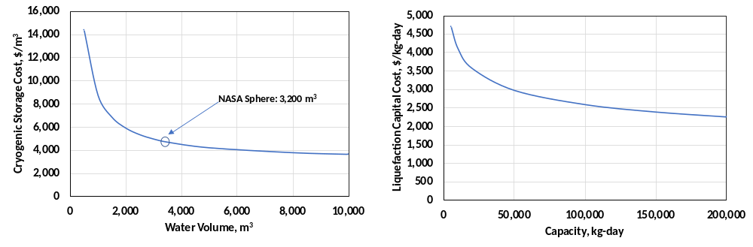
Figure S3 | Capital cost for cryogenic storage and liquefaction plants.

HDSAM assumes that the single largest unit train of the liquefier can be scaled up to 200,000 kg/day. No plant has been built so far at such high capacity. However, we find the cost per capacity decreases by 14% from 50,000 to 100,000 kg/day, but only by 8% from 100,000 to 150,000 kg/day. Similarly, the cost of H₂ storage shows economy of size as the cost per volume of storage decreases with increasing water volume capacity. HDSAM assumes that the largest tank capacity is 10,000 m³. This is a reasonable approximation, as the balance of plant components (piping, vaporizer, pump) only represent 2% of the total storage cost at large capacities. Furthermore, larger tanks would not necessarily provide any cost benefit as the cost levels off above 4,000 m³.

Similar to what was found for the storage size of the TOL/MCH hydrogenation system, the liquefaction plant increases from 320 tonnes/day (TPD) at 100% wind to 600 TPD at 100% solar. The storage demand however decreases as solar displaces wind from 6,500 tonnes at 100% wind and reaches a minimum of 3,000 tonnes at 30% wind and 70% solar. Storage demand starts to increase again as solar completely displaces wind. The total capital cost remains flat from 50% to 100% wind fraction. This is because the levelized cost of the liquid storage system decreases with increasing solar, but the cost of the liquefier increases as solar displaces wind. The cost sharply increases upon a further reduction in wind fraction as the predominant cost is due to the liquefaction plant.

The technoeconomic analysis of storing large amounts of H₂ in underground pipes, salt caverns and LRC is described in detail in a recently published work.⁶ In brief, underground pipes start with the production of API 5L Grade X 52 pipes at the mill which are electrical resisted welded. The diameter of the pipes (24”, schedule 60) were chosen based on cost optimization. For this scenario, a 24” pipe schedule 60 can store H₂ at a maximum pressure of 100 bar. Pipes are radiographically inspected and cut into segments of 12 m. An external coating of polyurethane is applied for corrosion prevention and the pipes are shipped to the staging facility. Site preparation costs include expenses for land acquisition, site clearing, grubbing and disposal of debris and excavation and backfilling of the pipe network. The pipes are covered by 1.2 m of soil, and pipe strings are spaced 80 cm apart as necessary clearance for welding. Before backfilling, individual pipe segments are arc resistant welded and radiographically inspected. Once the pipe network is complete, a final hydraulic pressure testing for all pipe strings is conducted to ensure that there are no leaks. After backfilling, aboveground facilities are included in the site preparation costs, which consist of compressor, valves and pipes connecting the storage facility to an adjacent H₂ production facility.

Salt caverns are especially suitable for H₂ storage in extensive quantities, but are geographically limited to a few locations; favorable locations in the U.S. are found in the Gulf Coast and the Northeast.^{7,8} Meeting geological requirements, the underground cavern can be created using a process known as solution mining or leaching. After drilling to a desired depth, an annular pipe is fitted through the borehole and lowered to the middle of the cavity. To form the salt cavern, fresh water is pumped through the inner tubing to the bottom of the borehole. The water dissolves the salt and saturated brine is removed through the other pipe, leaving an area of free space. Brine is assumed to be disposed in Class II wells. In absence of Class II wells, the brine is likely to be disposed in waste treatment plants. This is a costly option, and depending on the distance, this may limit site availability further. Upon completion of the cavern structure, a final debrining process is required, which essentially uses gas pressure to displace the brine contained in the cavern at the completion of solution mining. In this study, we assume the cavern is placed 765 m below ground, requiring a gas pressure of 120 bar to prevent creep of the cavern walls. Aboveground facilities are constructed in a similar fashion as the underground pipes, discussed earlier.

Where salt formations are not available, rock caverns can provide more possibilities close to H₂ production facilities.⁷ It should be noted that LRC require a competent rock, deep underground with rock mass rating (RMR) above 50 for high pressure storage (>100 bar). This requirement will further limit the applicability of site location. The core cost features of this type of storage system consist of three parts: a) excavation of the underground facility including access tunnels and the cavern enclosure, b) installation of the liner and concrete surrounding the liner and the cavern forming the storage facility and c) the aboveground facilities including compressor, pipes and valves. Excavation is performed by conventional mining operations i.e. drill-and-blast operations. Shafts connecting to the lower and upper part of the dome are excavated and supported with grouted rebar as to minimize groundwater leaking. The caverns are excavated as hemispherical cylinders and reinforced with rock bolting and concrete. A steel liner is then installed which contains the gas whereas the sealing layers transmit the pressure load to the surrounding rock. The lining consists of 15-mm thick mild steel sheets which are welded together to form the inner vessel of the dome. The concrete layer (2-m thick), reinforced with a rebar lattice, distributes the pressure load to the surrounding rock. A drainage arrangement of perforated pipes is also mounted around the cavern before the concrete is poured as to remove water accumulating in the lining section. We assume that the cavern is located 150 m below the surface and assume an RMR value to the rock of 50, which limits the maximum storage pressure to 150 bar.

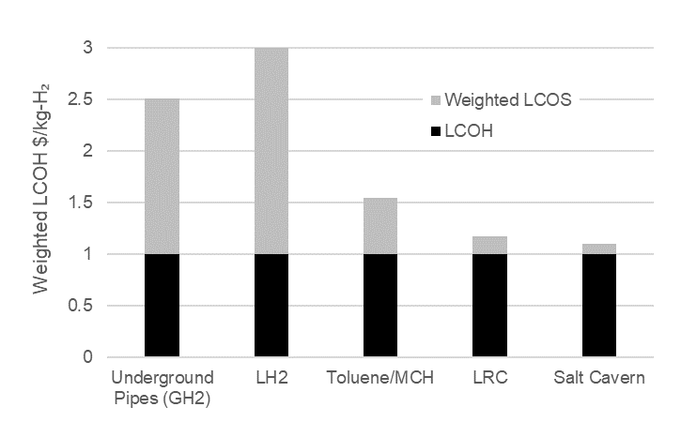
Figure S4 | Levelized cost of delivered hydrogen for above and belowground storage technologies. Results presented for a case where H₂ is produced at $1/kg-H₂, the storage facility is scaled to ~3,000 tonnes H₂. GH2: 100 bar compressed gas; LH2: cryogenic liquid where boiloff at 3% per day is utilized; LRC: lined rock caverns at 150 bar compression.

Note 5: Hydrogen Safety Panel interview summary.
Here we present the results of our comprehensive analysis of safety and technology risk of the proposed renewable H₂ generation and storage systems. Recognizing the importance of safety planning, the United States (US) Pacific Northwest National Laboratory (PNNL) Hydrogen Safety Panel (HSP) was formed by the US Department of Energy (DOE) to assemble a broad cross-section of expertise from the industrial, government, and academic sectors to help ensure the success of the program. For this study, we held two meetings with members of the HSP to evaluate safety of the proposed technology and its anticipated application.
In these meetings, a range of issues were identified relative to the use of H₂, oxygen, and H₂ carriers in large-scale industry applications, specifically the iron and steelmaking industry. Safety issues were associated with the design and operation of the electrolyzers as well as storage of the H₂ and carriers. For example, firewater and its management will require notable siting considerations. At the same time, these firewater issues are not new and similar designs have been developed for petrochemical plants. These design concepts will help guide the design of a H₂ carrier facility. In considering the design of a H₂-based DRI process, the HSP noted that the instrumentation required for a facility using H₂ (e.g. explosion proof electronics) may be challenging to implement in a retrofitted existing process. This may limit deployment to new iron and steelmaking facilities without policy intervention.
Compressed gas components
NFPA 55 describes the storage requirements for H₂.²¹ Although H₂ storage materials will be used to store the bulk of the H₂ used in the ironmaking process, storage of some H₂ ballast will most likely be required to maintain process continuity. This standard has the most stringent requirements with storing larger than 5000 scf or 141.6 m³ of H₂ (~ 13 kg H₂). At the required 140 kg H₂/min feedstock flow rate designated by the project (200 TPD), these standards will apply to the steel process. Requirements include a stand-off distance of 4.6 m from the H₂ storage container to any above ground storage of flammable or combustible liquids (H₂ carrier) except if systems are available to prevent accumulation in the event of a tank failure. Furthermore, piping should also have a separation distance based on the pressure in the pipe and what is being exposed (persons, buildings, flammable gases, etc). The standard considers 2” ID pipes as “large.” For these pipes, if they are at high pressures (50-103 bar), they require separation distances up to 30 m. Separation distances required for H₂ storage may play a key role in safely designing a H₂-based ironmaking facility.
TOL/MCH safety and land footprint
The HSP noted the need to consider the total footprint of the H₂ carrier tanks and their stand-off distance. The HSP indicated that NFPA 30 code requires spatial separation of Class 1 flammable liquid of at least 15.2 m (50 ft) and dikes around tank.²² The concern is that the size of the tanks and their required stand-off will be larger than is acceptable in an industrial area where land is at a premium. Calculations were performed to estimate the size of the tanks and determine the acreage required for storage of MCH and TOL. Gasoline/diesel tanks with internal volume of 15.6 million liters like that constructed in Phoenix, AZ by CalJet were assumed.²³ For the volumes MCH and TOL required for the 200 TPD case study system, we estimate that seven tanks would be required. Using a stand-off distance of 15.2 m the total footprint required for the tanks would be 13,759 m² (3.4 acres). NFPA requirements may be more complicated than simply a 15.2 m stand-off depending upon the tank and secondary containment design. NFPA 30 for example states that for Class I and II tanks the stand-off should be 1/6 * sum of adjacent tank diameters. In the case of the 15.6-million-liter tanks with a 31.7 m diameter, they would be surrounded by four tanks resulting in a 21.3 m stand-off. Furthermore, NFPA 30 requires dikes or other means of controlling spillage from the tank. This design requirement states that “secondary containment shall be designed to withstand the hydrostatic head resulting from a leak from the primary tank of a maximum amount of liquid that can be stored in the primary tank”.²² The design can vary, but it is generally 100% of the volume of the largest container for bulk storage.
In addition to separation from other tanks, Class I tanks require a standoff from the public and any buildings. For the tanks suggested, this distance could be between ½ the diameter of the tank to as much as 53.3 m, depending upon the tank design and its safety systems.
In contrast to the large separation distance required for Class 1 flammable liquids such as TOL and MCH, NFPA states that for Class IIIB, such as alternative material dibenzyltoluene (DBT), separation distances of no more than 0.9 m between tanks are required as long as the tank is not next to a Class I or II material. This would be the case if an alternative H₂ carrier such as DBT were used instead. Additionally, the tank can be as close as 4.6 ft from the public or a building. These smaller stand-off distances could make a significant difference in the total space required for the H₂ carrier system and ultimately the cost of the system.
Emissions and controls
Additional areas of note for the storage of H₂ carriers are the H₂ gas that is soluble and may come out of the liquid and into the tank head space during normal ambient temperature swings and the vaporization of the H₂ carrier itself. The H₂ release could occur due to daily or seasonal temperature changes or during the depressurization after hydrogenation. To address these suggestions, the solubility of H₂ at 34 and -15.6 °C was calculated and the mass of H₂ determined per tank.²⁴ For TOL this change in temperature results in 31.4 kg/tank (assuming the tank size of 15.6 million L described above) coming out of solution and into the tank headspace. Alternatively, a pressure change from 10 to 1 bar due to depressurization after hydrogenation results in approximately 1,050 kg/tank coming out of solution and into the tank headspace. This volume is more significant and may require special designed process to address. MCH and TOL have a vapor pressure at normal ambient temperatures. As a result, gas vapors must be dealt with during storage. Fortunately, floating lid tanks already address the issues of vapors in the petrochemical industry. This would include emission controls and vapor recovery systems as well as required electrical and wiring issues around the tanks. As the design is developed, the regulations associated with volatile organic compounds (VOCs) must be addressed.
The carrier vapor issues associated with MCH and TOL would be mitigated with DBT and heavier H₂ carriers. The emission controls for a Class IIIB combustible liquid would be greatly reduced. Furthermore, Class I, II and IIIA liquids require emergency venting using a device to relieve excessive pressure while Class IIIB tanks do not require venting. These measures may reduce the cost of the tank system.
Fire water and controls
The need for fire water was a significant concern for the HSP. While the flow rate, total volume, storage requirements and the specific design of the fire water system varies by jurisdiction, some general guidelines can be provided.
The constraints on fire water system design are provided in NFPA 30 and describe the flow rates as a function of tank surface area.²² The fire water volume is controlled by the duration of the firefighting required. Where the fire water is going after it is used is also an issue since such carriers as TOL cannot be allowed into the ground water. It must be captured and contained either using berms, a dry pond or large holding basin. One source had flow rates of between 0.379 and 1.895 liters per minute (LPM) for between 4-6 hours as determined by the fire hazards analysis.²⁵ Similar volumetric flows were mandated elsewhere.²⁶ These were 0.758-1.137 LPM for cooling and 0.1.137-1.895 LPM for fire suppression. It also specified the fire water flow rate for flammable liquids and high-pressure flammable gases of 15,160-37,900 LPM. This would apply for H₂ and TOL/MCH. In contrast, the fire water flow rate requirements for combustible liquids such as DBT were specified lower (11,370-18,950 LPM).
At this point these values should be considered as general guidelines. Before a fire water system can be designed, the location of the process must be known to apply the appropriate fire code permitting requirements as each jurisdiction may have their own (state, county, province).
Quantity limits
Based on the amount of hazardous chemical in the inventory (tank and process) the H₂ carrier plant design may be required to conform to the Process Safety Management regulations from OSHA/EPA.²⁷ These are very stringent regulations for specific named chemicals that exceed a specific mass threshold require additional safety controls that the iron industry may not be accustomed to. For the case of H₂, the limit is 4.54 tonnes (10,000 lbs) of on-site for H₂. These regulations apply to specific chemicals on the list of regulated materials. If not on the list, these additional safety requirements do not apply. In the case of TOL, MCH, and DBT are not included on the list. As a result, these additional constraints do not apply to the H₂ carrier process. However, with the 4.54 tonnes limit, the ballast tanks required for transients with a 200 TPD process cannot exceed 30 minutes of operating time before the OSHA/EPA requirements for H₂ apply. Most likely they will.

Note 6: Additional results.

Each location has a unique renewable profile affecting design parameters of the TOL/MCH storage system. However, certain trends can be derived through evaluation of locations with low, median, and high LCOS, beyond the wind to solar ratio variations conducted for the case location. Fig. S5 show the average capacity for hydrogenation and dehydrogenation for 20 sites in the low, median, and high LCOS regions, while Fig. S6 show cost breakdowns. Fig. S7 presents the tank fill levels for two representative locations within the low, median, and high LCOS ranges, similar to the format presented in Fig. 1 in the manuscript.

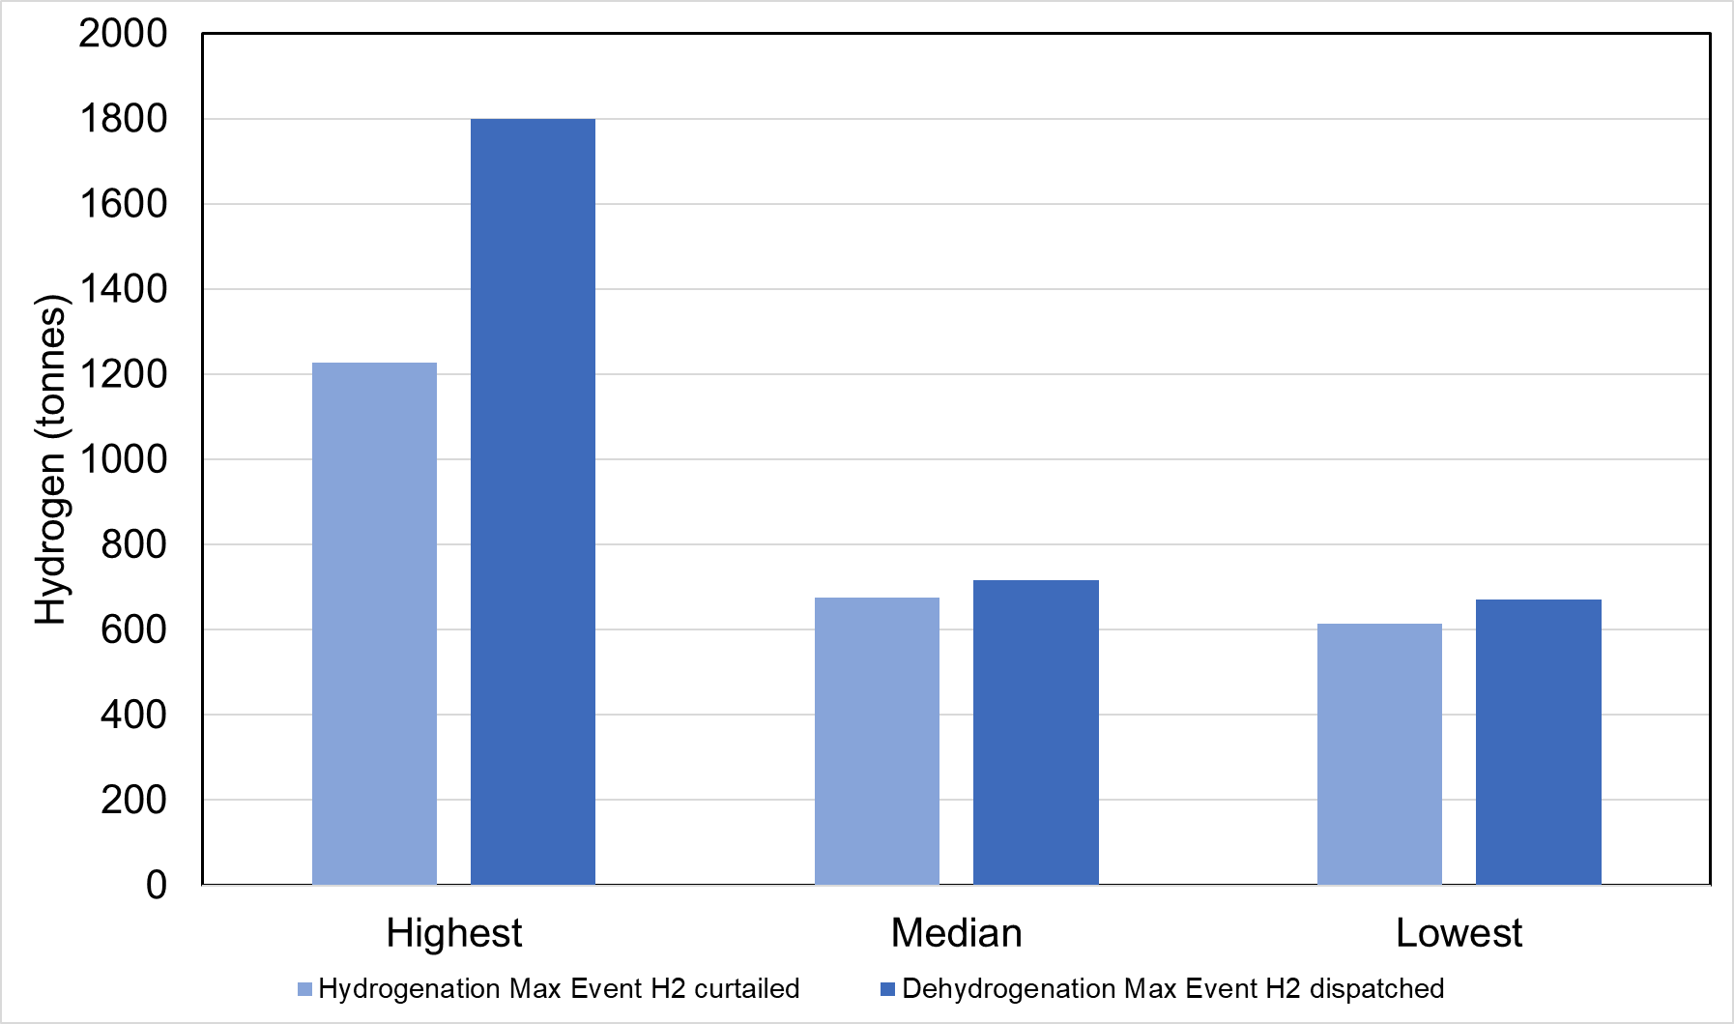
Figure S5 | Mean capacity of the hydrogenation facility and dehydrogenation facility. Results presented for the median value of 20 locations with the lowest, median, and highest levelized cost of storage.
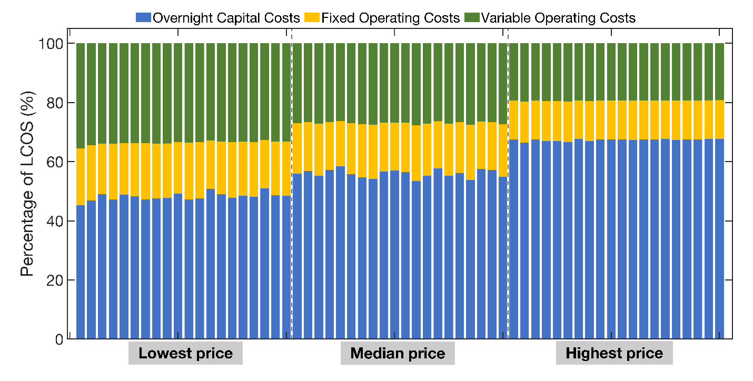
Figure S6 | Breakdown of levelized cost of storage. Breakdown by capital and operating costs for 20 representative locations near the lowest, median, and highest cost identified in the national sweep.
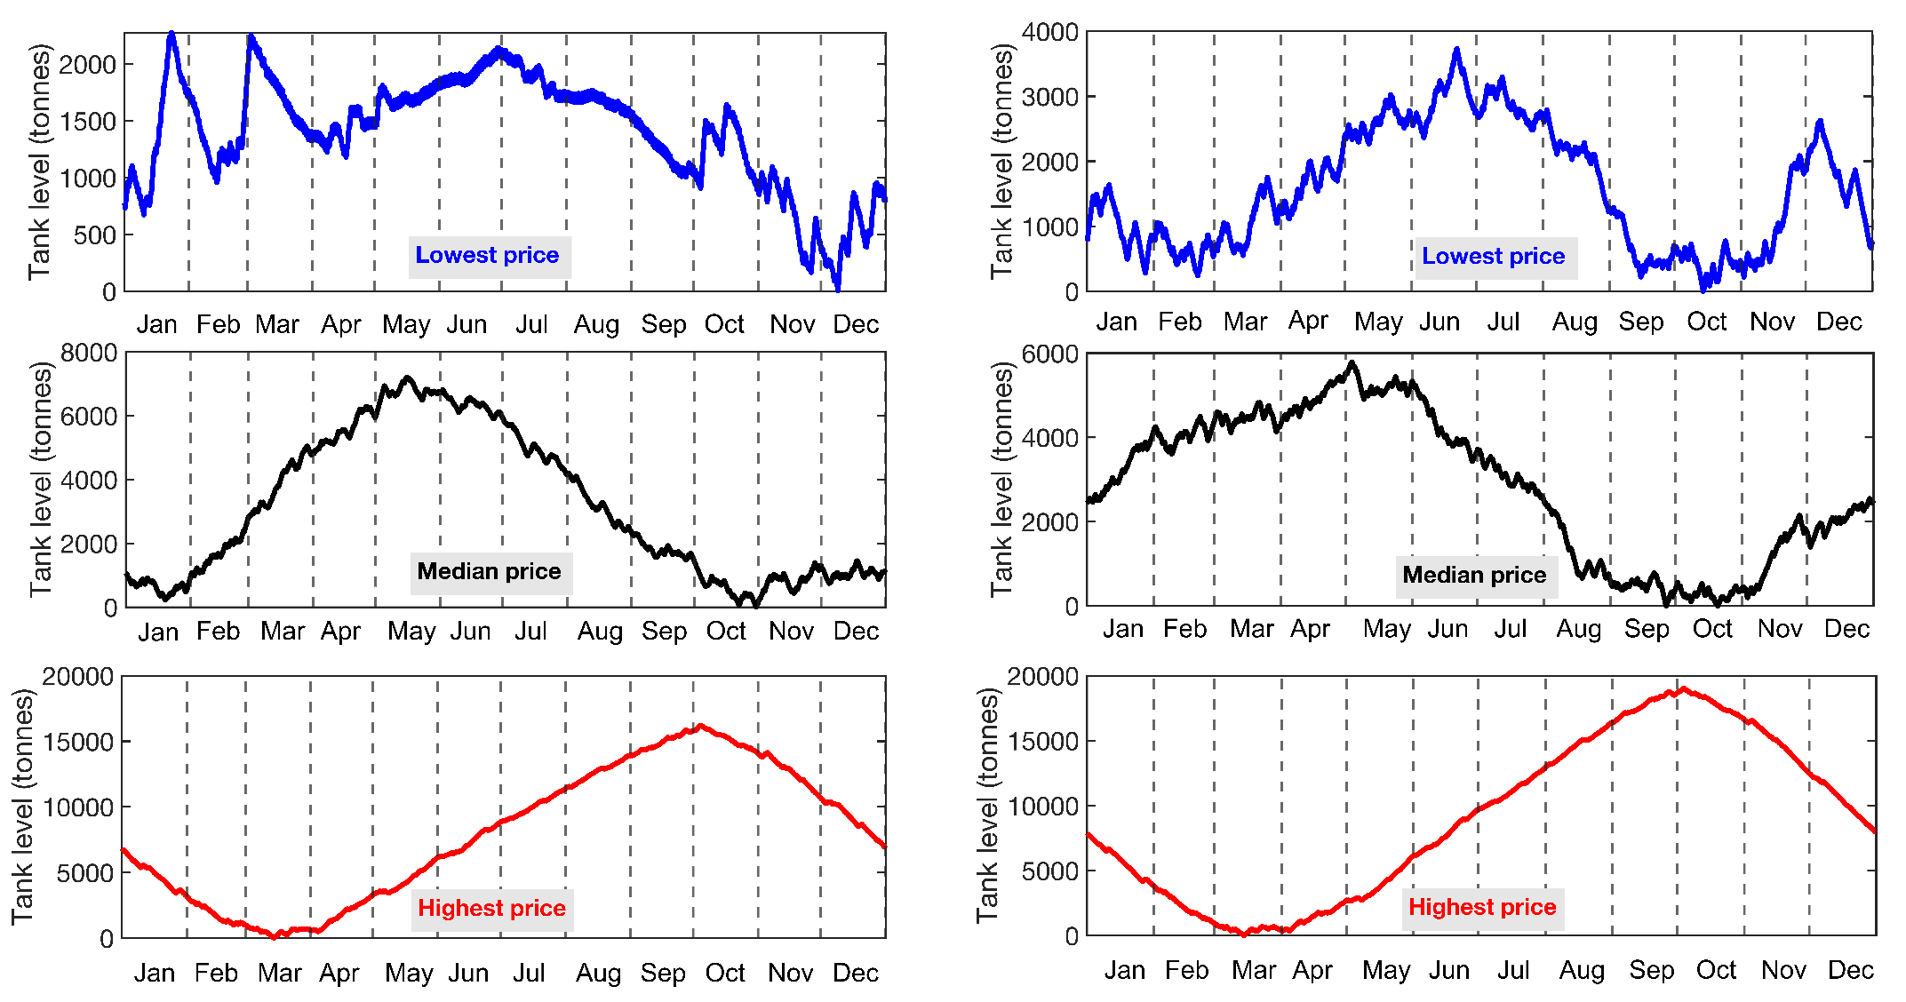
Figure S7 | Hourly tank fill level profile in equivalents of stored H₂. Results presented for two example locations with the lowest, median and highest levelized cost of storage.
The GreenHEART model⁷ was used to derive hourly renewable profiles, electrolyzer operation and the LCOH based on least-cost electricity generation from wind and solar in the contiguous US (Fig. S8).
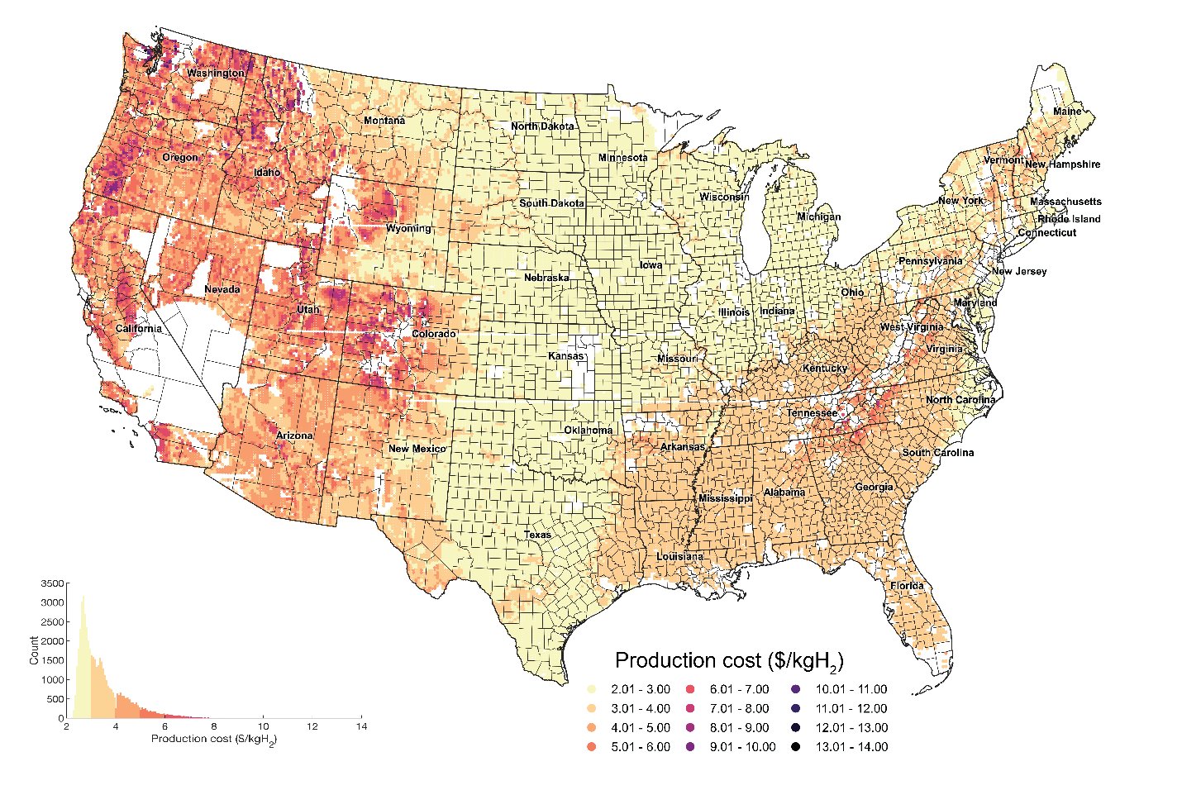
Figure S8 | Production cost (LCOH) of H₂ from wind and solar generation powering 1 GW electrolyzer systems. Data generated using the GreenHEART model.
Dehydrogenation capacity tends to be much higher than 200 TPD for the 1-GW-scale electrolyzer facilities (Fig. 6 in the manuscript). As the nameplate capacity of the electrolyzers is set to 449 TPD, a median capacity factor of 56% is achieved for the electrolyzers thanks to the storage system. As plotted in Fig. S9, the frequency of large hydrogenation capacities is much less, with a tendency towards capacities below 200 TPD in locations with favorable wind and solar resources. This reflects the limited difference between the nameplate capacity of the electrolyzer, and the annual average hydrogen produced. It is thus logical that this map is the inverse of the dehydrogenation facility, as a high annual average hydrogen production leads to a high dehydrogenation capacity.
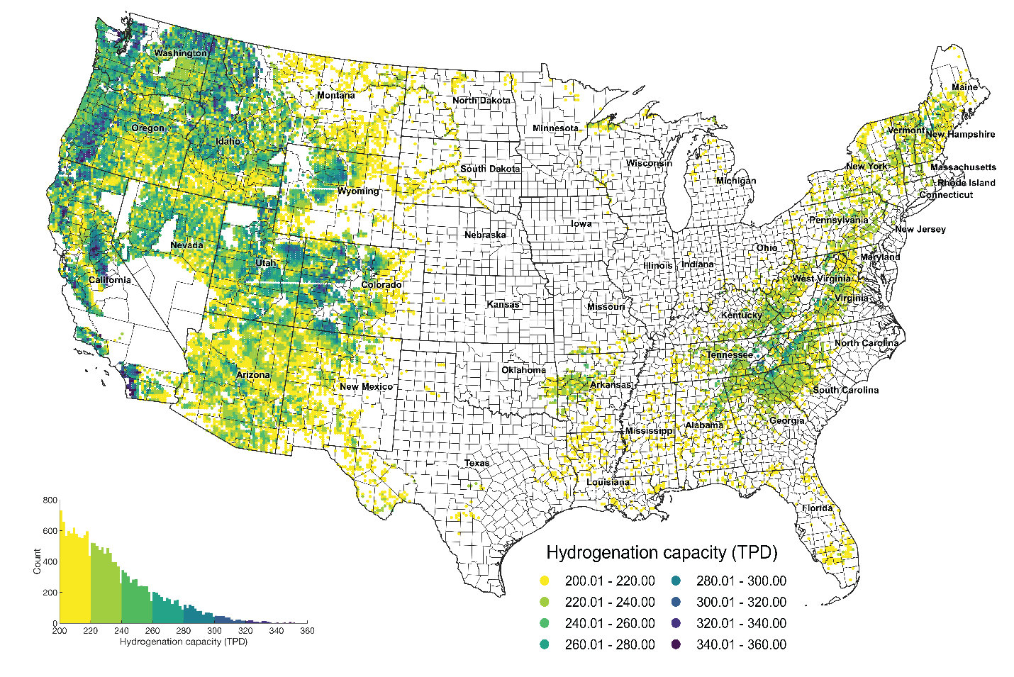
Figure S9 | Locations with hydrogenation capacity greater than or equal to 200 TPD.

References
1. Woods, D. R. Rules of Thumb in Engineering Practice. Rules Thumb Eng. Pract. 1–458 (2007) doi:10.1002/9783527611119.
2. Skone, T. J. Life Cycle Greenhouse Gas Emissions: Natural Gas and Power Production. in 2015 EIA Energy Conference 19 (2015).
3. Nicholson, S. & Heath, G. Life Cycle Emissions Factors for Electricity Generation Technologies. Natl. Renew. Energy Lab. 1–4 (2021).
4. ERCOT. ERCOT Analysis of the Impacts of the Clean Power Plan. http://www.ercot.com/content/news/presentations/2015/ERCOT_Analysis_of_the_Impacts_of_the_Clean_Power_Plan-Final_.pdf (2014).
5. Argonne National Laboratory. Hydrogen Delivery Scenario Analysis Model (HDSAM).
6. Papadias, D. D. & Ahluwalia, R. K. Bulk storage of hydrogen. Int. J. Hydrogen Energy 46, 34527–34541 (2021).
7. Reznicek, E. P. et al. Techno-Economic Analysis of Low-Carbon Hydrogen Production Pathways for Decarbonizing Steel and Ammonia Production. Joule (2024).
8. Andersson, J. & Grönkvist, S. Large-scale storage of hydrogen. Int. J. Hydrogen Energy 44, 11901–11919 (2019).

