Table of Contents:
Supplementary Figure 1 | Lattice structural analysis of a 20-nm freestanding HZO membrane along off-normal directions.
Supplementary Figure 2 | HR-TEM observation on 20-nm freestanding HZO.
Supplementary Figure 3 | Schematic of the experimental setup for grazing-incident XLD measurements.
Supplementary Figure 4 | Thickness-dependent XAS and XLS spectra for freestanding HZO membranes.
Supplementary Figure 5 | Thickness-dependent cKPFM curves as a function of reading voltages for freestanding HZO membranes.
Supplementary Figure 6 | Temperature-dependent dielectric response as a function of applied frequency.
Supplementary Figure 7 | Cross-sectional HR-TEM images of HZO-gated MoS₂ FET.
Supplementary Figure 8 | Elemental distributions in HZO-gated MoS₂ FET device.
Supplementary Figure 9 | Electrical properties of the dual-gate MoS₂ FET.
Supplementary Figure 10 | Dynamic characterizations of the MoS₂ FETs.
Supplementary Figure 11 | Current fluctuations for the SiO₂-gated FET.
Supplementary Figure 12 | Model of the current fluctuations.
Supplementary Figure 13 | Electrical properties of a conventional p-type FET.
Supplementary Figure 14 | Electrical properties of the n-type MoS₂ FET for inverter.
Supplementary Figure 15 | Demonstration of gate logic circuits.
Supplementary Table 1 | Detailed information of 32 MoS₂ FETs with freestanding HZO as top-gate dielectric.
Supplementary Reference 1 | References for Figure 3i.
Supplementary Reference 2 | References for Figure 4g.

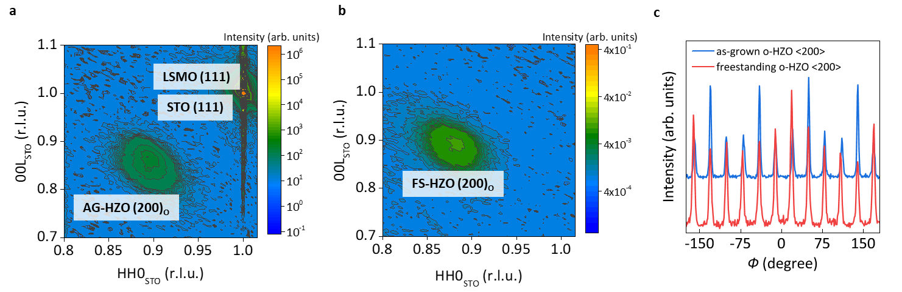
Supplementary Figure 1 | Lattice structural analysis of a 20-nm freestanding HZO membrane along off-normal directions. a, The reciprocal space mappings performed along the (200) reflection of the as-grown HZO thin film and b, FS-HZO membrane, respectively. We observed the FS-HZO o-phase (200) reflection around the STO (111) point in reciprocal space, with coordinates normalized by the STO lattice parameters (where 1 reciprocal lattice unit (r.l.u.) equals 2π/a_STO), predominantly aligned along the [111] direction of STO. This suggests that the orientation of the ferroelectric o-phase in the freestanding HZO remains consistent with that of the as-grown HZO. The symmetry of the o-phase HZO in both as-grown HZO thin film and FS-HZO membrane was further elucidated through an azimuthal scan along the (200) reflection, as shown in c. The 360-degree azimuthal scans along the o-phase HZO <200> both reveal two sets of six-fold lattice symmetry, suggesting the presence of a twin structure.

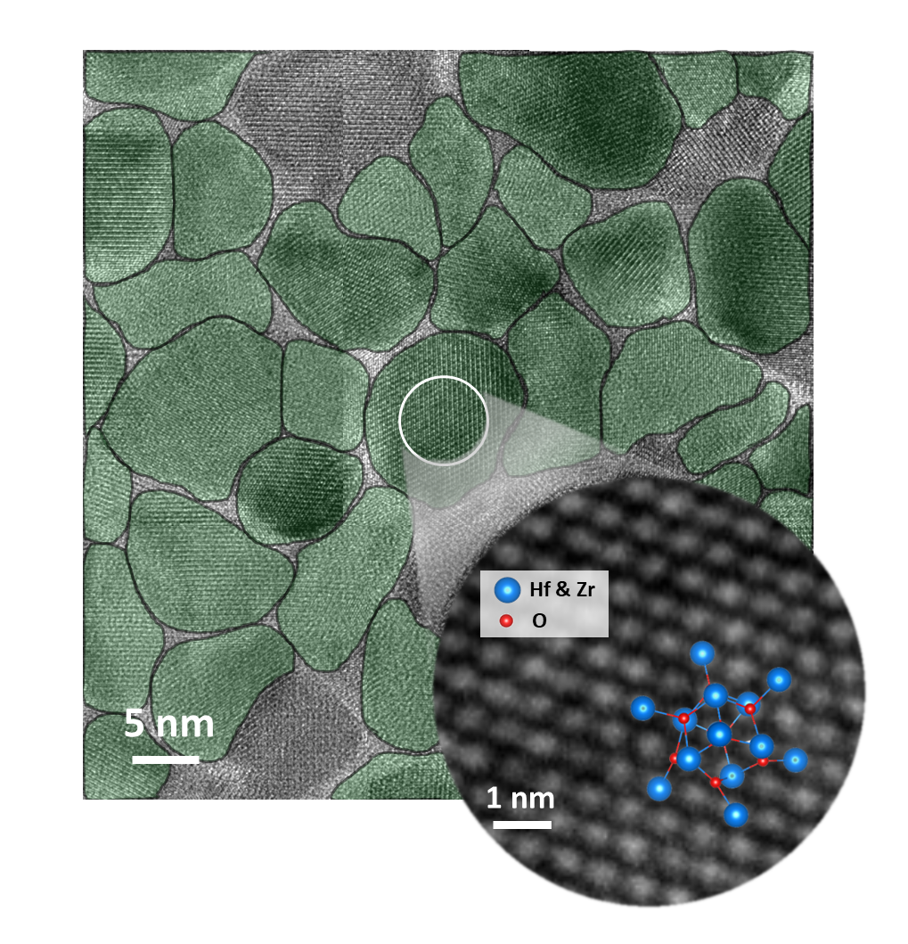
Supplementary Figure 2 | HR-TEM observation on 20-nm freestanding HZO. HR-TEM image unveils a mosaic-like pattern of HZO grains. The ferroelectric o-phase predominates the lattice volume of the 20-nm freestanding HZO, with an average grain size of approximately 10 nm. The green-filled grains represent their respective out-of-plane crystalline orientation along the o-[111] axis, while the absence of color in certain regions indicates unresolved orientation, likely due to off-axis observation or low crystallinity. Inset, an enlarged atomic image of the o-phase (111) is shown, alongside the corresponding lattice model, which clearly illustrates the hexagonal shape of the unit cell.

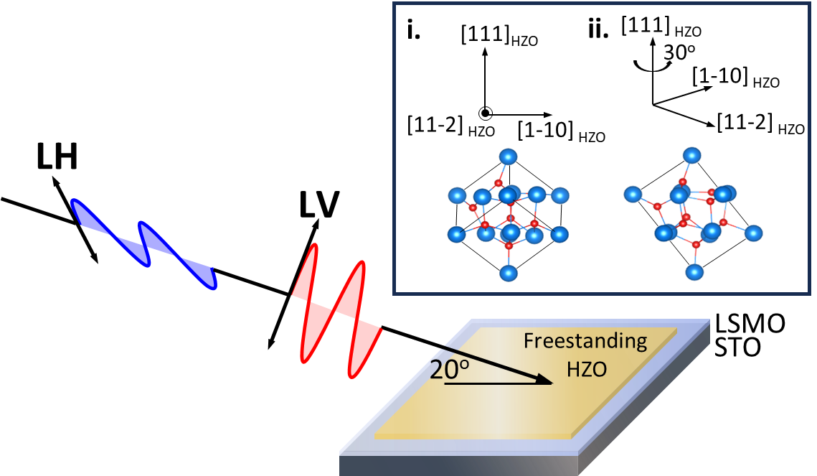
Supplementary Figure 3 | Schematic of the experimental setup for grazing-incident XLD measurements. X-rays with photon energy near the oxygen K-edge are incident onto freestanding HZO membranes at an angle of 20 degrees to the sample surface. The linearly polarized beam is indicated by LV and LH, representing electric fields along the out-of-plane and in-plane directions, respectively. Two types of HZO lattice structures (i. and ii.) in twin configurations with corresponding coordinates are depicted within the black frame, where a 30-degree twist along the [111] HZO axis is identified by azimuthal XRD scan.

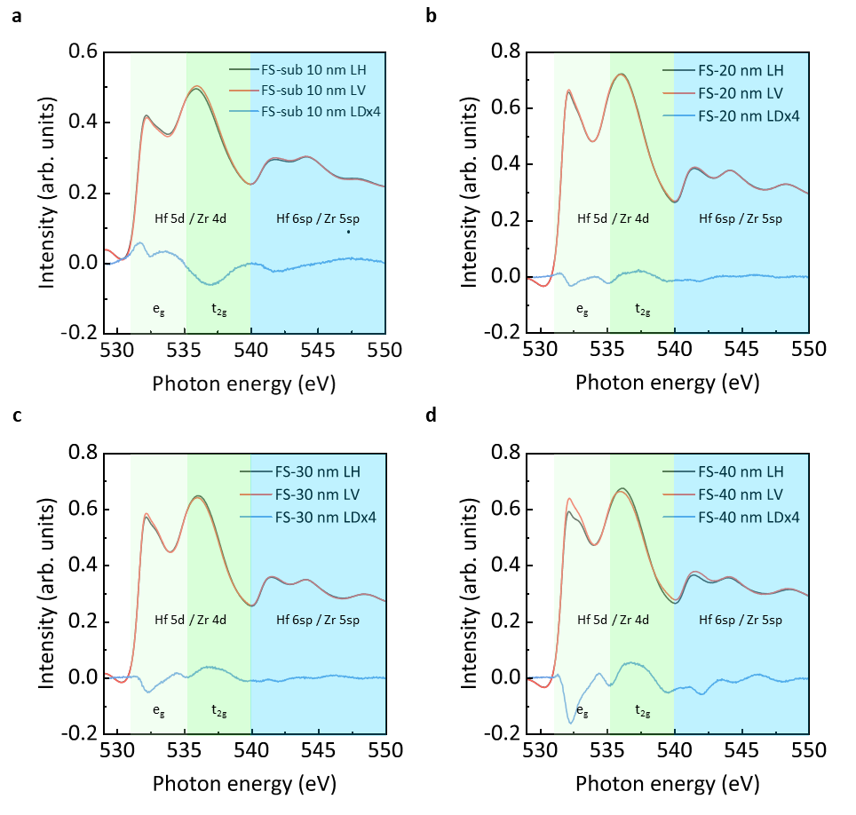
Supplementary Figure 4 | Thickness-dependent XAS and XLS spectra for freestanding HZO membranes. a-d, the XLD spectra and corresponding XAS spectra of sub-10, 20, 30, and 40-nm freestanding HZO, respectively. As the thickness increases, there is a gradual transition in the integral under the XLD curves, shifting from positive to negative values, accompanied by an escalation in XLD intensity. These observations suggest a modification in the orbital occupation within the e_{g} band, transitioning from ${\text{d}}_{{\text{3z}}^{\text{2}}\text{-}{\text{r}}^{\text{2}}}$ to ${\text{d}}_{{\text{x}}^{\text{2}}\text{-}{\text{y}}^{\text{2}}}$, indicating an increase in the out-of-plane (OOP) to in-plane (IP) anisotropy as the m-phase ratio rises.
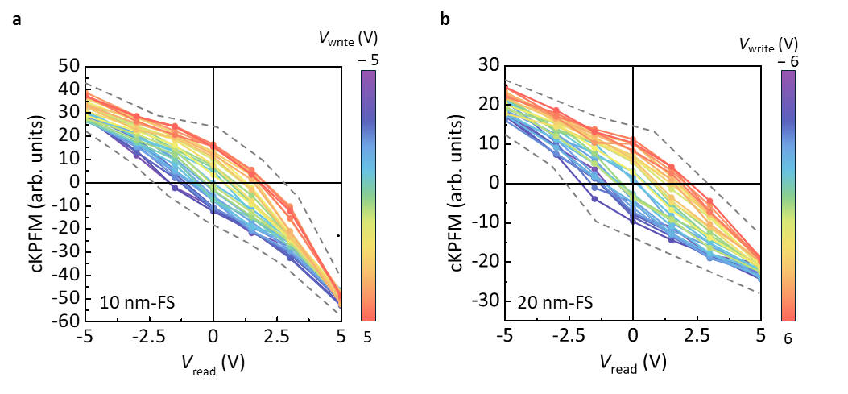
Supplementary Figure 5 | Thickness-dependent cKPFM curves as a function of reading voltages for freestanding HZO membranes. a, and b, cKPFM plots for 10- and 20-nm freestanding HZO, respectively. In these plots, the residual offset at 0 V is attributed to the permanent dipole moments resulting from spontaneous ferroelectric polarization. The presence of ferroelectricity in 10- and 20-nm freestanding HZO is evidenced by the nonlinear behavior observed in the cKPFM curves, which vary as a function of read voltage after a series of voltage pulses.
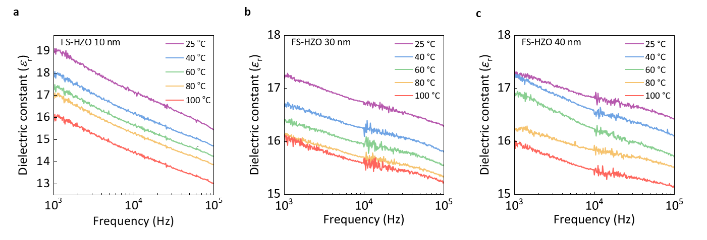
Supplementary Figure 6 | Temperature-dependent dielectric response as a function of applied frequency. a-c, Dielectric constant variation with driving frequency at different temperature points for a, 10-, b, 30-, and c, 40-nm freestanding HZO membranes. The dielectric constants of various thicknesses decrease by less than 10% as temperature rises. This trend aligns with prior research indicating differing dielectric constants across HZO's structural phases, with the o-phase demonstrating a higher dielectric constant than the m-phase. Consequently, the 10- and 20-nm freestanding HZO membranes, which contain a significant proportion of the o-phase, demonstrate outstanding dielectric performance.

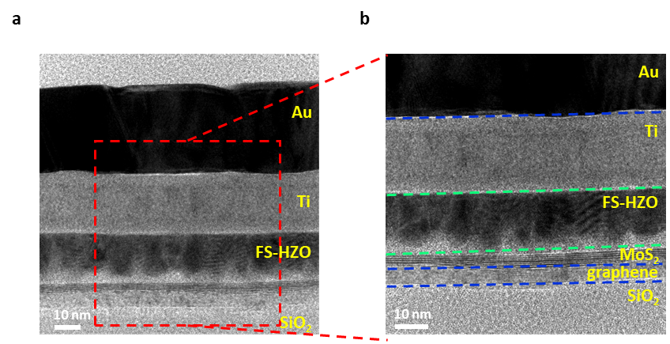
Supplementary Figure 7 | Cross-sectional HR-TEM images of HZO-gated MoS₂ FET. a, Low-magnification and b, high-magnification detailed cross-section images of the device.

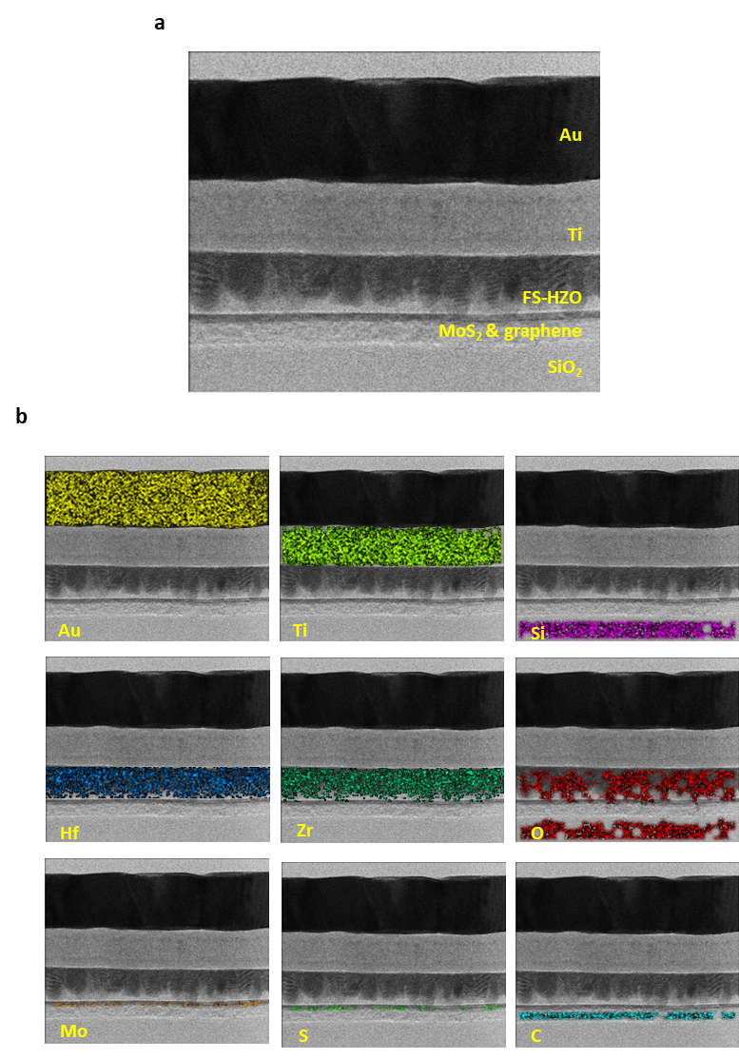
Supplementary Figure 8 | Elemental distribution in HZO-MoS₂ FET device. a, STEM dark-field image of the cross-sectional structure of an HZO-MoS₂ FET device. b, Spatial distribution of various elements revealed by energy-dispersive X-ray spectroscopy (EDS) mapping within each layer.
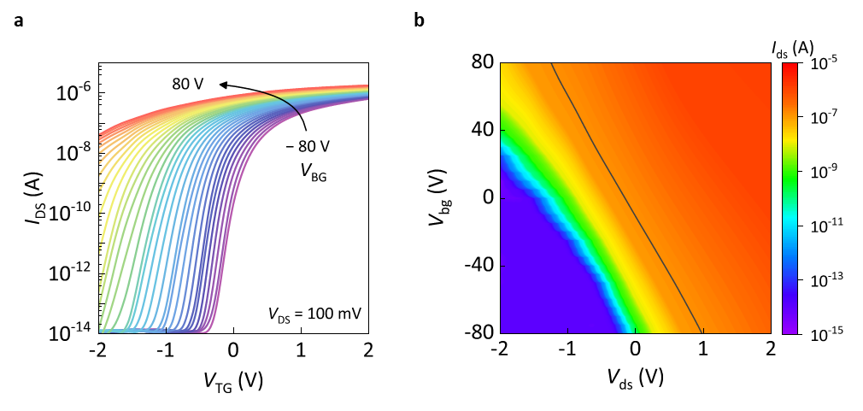
Supplementary Figure 9 | Electrical properties of the dual-gate MoS₂ FET. a, I_{DS}-V_{TG} transfer curves of the device with V_{BG} set at different values at a V_{DS} of 100 mV. b, I_{DS} current mapping of the dual-gate FET as a function of V_{BG} and V_{TG}. The solid line highlights the position of the I_{DS}= 200 nA.
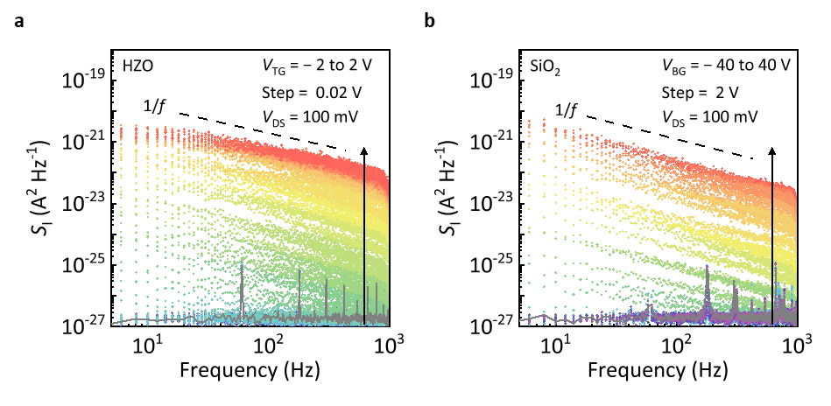
Supplementary Figure 10 | Dynamic characterizations of the MoS₂ FETs. Power spectral density (S_{I}) of current fluctuations depending on the frequency of the a, HZO- and b, SiO₂-gated FETs. The V_{DS} value is set as100 mV. The dashed lines show the ideal 1/f trend as a guide for the eyes.
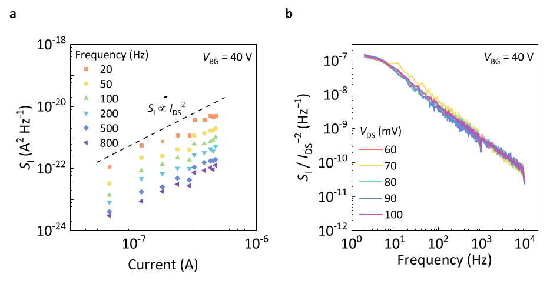
Supplementary Figure 11 | Current fluctuations for the SiO₂-gated FET. a, S_{I} as a function of I_{DS} at various frequencies. The dashed line shows that S_{I} is proportional to 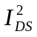. b, Normalized S_{I} as a function of frequency at different V_{DS} values.
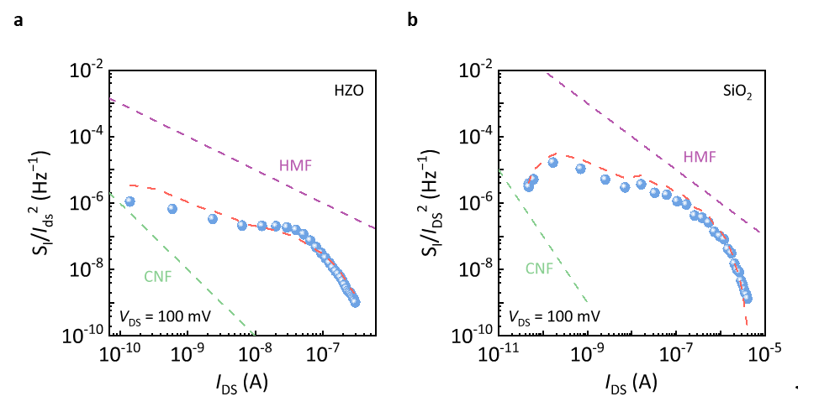
Supplementary Figure 12 | Model of the current fluctuations. Normalized S_{I} as a function of I_{DS} for a, the HZO- and b, SiO₂-gated FETs. The CNF and HFM models are offered for comparison.
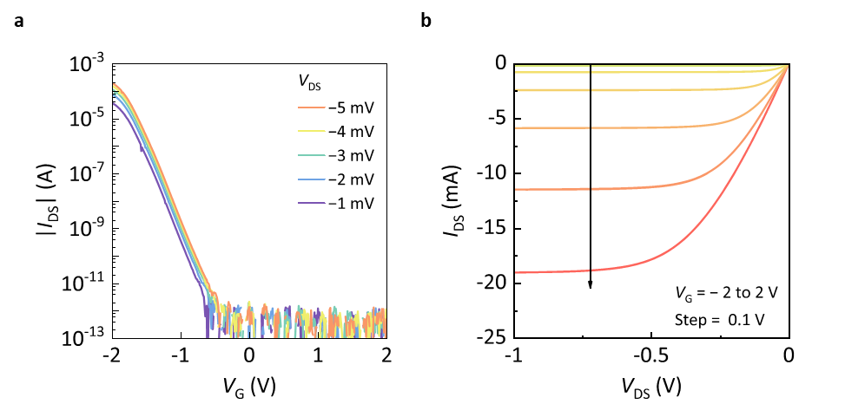
Supplementary Figure 13 | Electrical properties of a conventional p-type FET. a, Transfer, and b, output characteristics of a conventional p-type FET. (ZVP4424GTA, Diodes Incorporated)
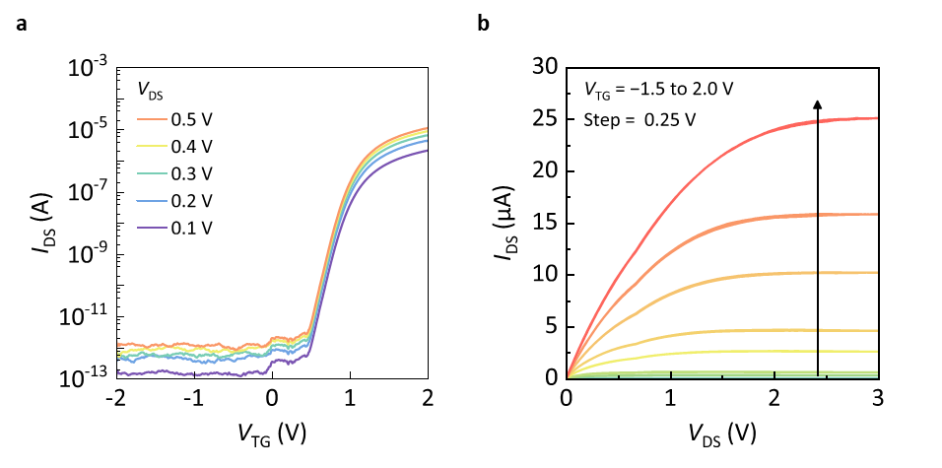
Supplementary Figure 14 | Electrical properties of the n-type MoS₂ FET for inverter. a, Transfer, and b, output characteristics of n-type MoS₂ FET (V_{BG}= －40 V; V_{TG}= ±2 V)
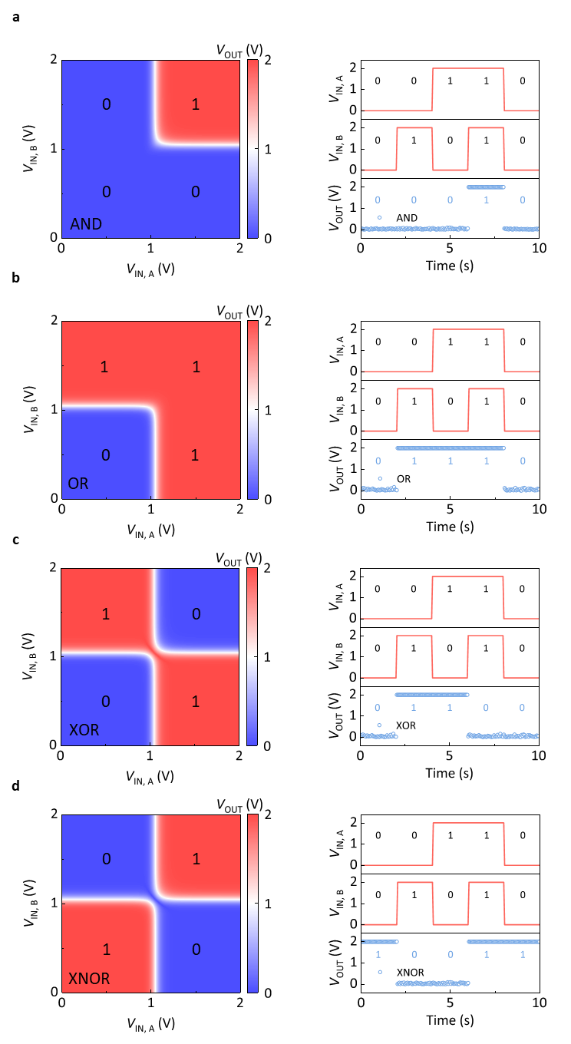
Supplementary Figure 15 | Demonstration of gate logic circuits. a-d, V_{OUT} results and the corresponding waveforms at V_{DD} = 2 V as functions of V_{IN,} _{A} and V_{IN,} _{B}, shown for AND, OR, XOR, and XNOR logic circuits.
Supplementary Table 1 | Detailed information of 32 MoS₂ FETs with freestanding HZO as top-gate dielectric.
Device Number | Length (µm) | Width (µm) | SS (mV/dec) | On/off | Mobility (cm² V⁻¹ s⁻¹)
1 | 4.3 | 3.4 | 50.12 | 4.99×10⁸ | 5.57
2 | 7.0 | 4.9 | 50.83 | 1.92×10⁹ | 5.62
3 | 6.2 | 3.3 | 52.58 | 4.99×10⁸ | 5.54
4 | 1.4 | 1.5 | 47.27 | 4.03×10⁷ | 5.80
5 | 2.9 | 4.1 | 53.50 | 1.53×10⁸ | 6.64
6 | 6.3 | 5.7 | 53.51 | 3.44×10⁷ | 9.33
7 | 4.0 | 0.8 | 50.37 | 5.22×10⁶ | 2.69
8 | 2.3 | 1.5 | 61.42 | 2.20×10⁷ | 7.17
9 | 2.0 | 3.6 | 54.78 | 6.55×10⁷ | 0.32
10 | 4.0 | 2.3 | 54.32 | 1.44×10⁸ | 5.37
11 | 4.8 | 2.0 | 47.99 | 1.98×10⁸ | 22.21
12 | 5.5 | 1.8 | 53.39 | 2.43×10⁸ | 10.03
13 | 5.0 | 2.8 | 52.54 | 1.61×10⁸ | 11.70
14 | 7.8 | 1.8 | 52.49 | 1.10×10⁸ | 7.32
15 | 3.0 | 1.0 | 68.78 | 3.92×10⁹ | 19.64
16 | 7.8 | 1.8 | 63.28 | 9.41×10⁸ | 38.97
17 | 3.1 | 1.9 | 55.43 | 6.82×10⁸ | 4.62
18 | 4.3 | 3.4 | 55.27 | 5.76×10⁷ | 3.69
19 | 1.6 | 4.4 | 50.43 | 4.79×10⁷ | 5.32
20 | 5.3 | 5.6 | 53.51 | 6.04×10⁷ | 10.26
21 | 5.6 | 1.8 | 52.40 | 4.08×10⁷ | 13.23
22 | 5.2 | 5.2 | 47.82 | 1.33×10⁹ | 20.42
23 | 5.1 | 3.9 | 55.46 | 5.94×10⁸ | 5.91
24 | 3.4 | 1.0 | 49.45 | 2.70×10⁸ | 13.63
25 | 2.3 | 4.6 | 51.59 | 3.21×10⁷ | 17.25
26 | 5.9 | 1.4 | 49.72 | 9.40×10⁵ | 10.67
27 | 2.3 | 5.7 | 64.36 | 3.85×10⁷ | 10.34
28 | 6.0 | 1.3 | 47.48 | 2.09×10⁶ | 10.40
29 | 5.3 | 1.7 | 51.43 | 6.53×10⁸ | 15.85
30 | 6.8 | 6.6 | 52.16 | 8.84×10⁸ | 17.03
31 | 6.1 | 2.2 | 56.08 | 7.06×10⁷ | 19.74
32 | 3.3 | 3.5 | 50.53 | 1.54×10⁸ | 7.07
Supplementary Reference 1 | References for Figure 3i.
- Single-layer MoS₂ transistors, Nat. Nanotechnol. 6, 147–150 (2011).
- Integration of high‐κ oxide on MoS₂ by using ozone pretreatment for high‐performance MoS₂ top‐gated transistor with thickness‐dependent carrier scattering investigation, Small 11, 5932–5938 (2015).
- Highly stable, dual-gated MoS₂ transistors encapsulated by hexagonal boron nitride with gate-controllable contact, resistance, and threshold voltage, ACS Nano 9, 7019–7026 (2015).
- Low sub-threshold swing realization with contacts of graphene/h-BN/MoS₂ heterostructures in MoS₂ transistors, Appl. Phys. Lett. 111 (2017).
- High‐performance wafer‐scale MoS₂ transistors toward practical application, Small 14, 1803465 (2018).
- MoS₂ transistors with 1-nanometer gate lengths, Science 354, 99–102 (2016).
- Graphene‐contacted ultrashort channel monolayer MoS₂ transistors, Adv. Mater. 29, 1702522 (2017).
- Sub-10 nm monolayer MoS₂ transistors using single-walled carbon nanotubes as an evaporating mask, ACS Appl. Mater. Interfaces 11, 11612–11617 (2019).
- Monolayer molybdenum disulfide transistors with single-atom-thick gates, Nano Lett. 11, 11612–11617 (2018).
- MoS₂ transistors with 1-nanometer gate lengths, Science 354, 99–102 (2016).
- Uniform and ultrathin high-κ gate dielectrics for two-dimensional electronic devices, Nat. Electron. 2, 563–571 (2019).
- Wafer-scale high-κ dielectrics for two-dimensional circuits via van der Waals integration. Nat. Commun. 14, 2340 (2023).
- Scalable integration of hybrid high-κ dielectric materials on two-dimensional semiconductors. Nat. Mater. 22, 1078–1084 (2023).
- van der Waals integration of high-κ perovskite oxides and two-dimensional semiconductors. Nat. Electron. 5, 233–240 (2022).
- A wafer-scale van der Waals dielectric made from an inorganic molecular crystal film. Nat. Electron. 4, 906–913 (2021).
- High-kappa perovskite membranes as insulators for two-dimensional transistors. Nature 605, 262–267 (2022).
Supplementary Reference 2 | References for Figure 4g.
- Low frequency noise characterization of 0.18 μm Si CMOS transistors, Microelectron. Reliab. 37, 1599–1602 (1997).
- MoS₂ Dual-Gate MOSFET With Atomic-Layer-Deposited Al₂O₃ as Top-Gate Dielectric, IEEE Electron Device Lett. 33, 546–548 (2012).
- Transferred large area single crystal MoS₂ field effect transistors, Appl. Phys. Lett. 107, 193503 (2015).
- Low-frequency noise in multilayer MoS₂ field-effect transistors: the effect of high-κ passivation, Nanoscale 6, 433–441 (2014).
- Thermally oxidized 2D TaS₂ as a high-κ gate dielectric for MoS₂ field-effect transistors, 2D Mater. 4, 031002 (2017).
- Effects of high-pressure annealing on the low-frequency noise characteristics in ferroelectric FET, IEEE Electron Device Lett. 43, 13–16 (2021).
- Ultrathin calcium fluoride insulators for two-dimensional field-effect transistors, Nat. Electron. 2, 230–235 (2019).
- Suppression of interfacial current fluctuation in MoTe2 transistors with different dielectrics, ACS Appl. Mater. Interfaces 8, 19092–19099 (2016).
- Low-frequency noise in layered ReS₂ field effect transistors on HfO₂ and its application for pH sensing, ACS Appl. Mater. Interfaces 10, 7248–7255 (2018).
- Statistical study of deep submicron dual-gated field-effect transistors on monolayer chemical vapor deposition molybdenum disulfide films, Nano Lett. 13, 2640–2646 (2013).
- Near-ideal subthreshold swing MoS₂ back-gate transistors with an optimized ultrathin HfO₂ dielectric layer, Nanotechnology 30, 095202 (2019).
- Uniform and ultrathin high-κ gate dielectrics for two-dimensional electronic devices, Nat. Electron. 2, 563–571 (2019).
- Impact and origin of interface states in MOS capacitor with monolayer MoS₂ and HfO₂ high-k dielectric, Sci. Rep. 7, 40669 (2017).

