Supporting Information
A novel Cu₉S₈ antibacterial based on magnetic chestnut shell biochar for the removal of sulfonamides in water environment: Differential adsorption and mechanism study
∗ Rui-peng Li^{a,1}, Zheng-rong Hu^{a,1}, Xing Wangª, Jun Chenª, Qing-qing Liu ª, Ying Zhaoª, Zhong-bao Zhao^{b}, Xu-lin Luª, Zhi-wei Zhangª∗
ª Chemical Engineering College, Hebei Normal University of Science and Technology, Qinhuangdao, 066600, China.
^{b} Hebei University of Environmental Engineering, Hebei Key Laboratory of Agroecological Safety., Qinhuangdao, 066100, China.
¹ These authors contributed equally to this work.

Text S1
1.35 g FeCl₃·6H₂O and 2.46 g CH₃COONa were dispersed in 40 mL ethylene glycol solution and stirred ultrasonically until completely dissolved. Then 2 g polyethylene glycol was weighed and further ultrasonic stirring is carried out. After the above solute was completely dissolved, 2.7 g BC was added and ultrasonic stirring continues until complete mixing was achieved. Subsequently, the obtained mixture was transferred to a 50 mL reactor with the hydrothermal temperature of 200 ℃ and the heating time of 8 h. After the reaction was completed, it was rinsed multiple times with deionized water and then rinsed once with anhydrous ethanol. The filtered sample was placed in a fume hood and dried naturally.
Text S2
The crystalline phase of Cu₉S₈, BC and Cu₉S₈/Fe₃O₄@BC were detected by the X-ray powder diffraction (XRD) pattern with the scanning speed of 8 °/min (Cu–Kα, operating conditions: 40 kV, 200 mA, range: 10–80 °). X-ray photoelectron spectroscopy (XPS) analyses were carried out using the Quantera SXM X-ray photoelectron spectrometer (Thermo Scientific Escalab 250Xi) equipped. The N₂ adsorption-desorption of Cu₉S₈ and Cu₉S₈/Fe₃O₄@BC were determined at 77.3 K with the surface area and porosity analyzer (Micromeritics, Tristar II 3020). The pore size distributions (PSDs) were derived with Barrett-Joyner-Halenda (BJH) method considering the large pore size from the N₂ desorption data. Elemental analyses for the Cu, S, Fe, O and C contents of the samples were conducted using the elemental analyzer (Octane Elect Super C5) with the thermal conductivity detector. Scanning electron microscopy (SEM) was performed using the SEM instrument from Hitachi (Regulus8100). Transmission electron microscopy (TEM, Tecnai G2 F20 S-Twin, USA) was used to examine the morphology of the materials. The magnetization of Cu₉S₈/Fe₃O₄@BC was tested by using the Vibrating Sample Magnetometer (VSM, Lake Shore 8600, USA). The zeta potential of Cu₉S₈ was measured by the zeta potentiometer (Malvern Zetasizer Nano ZS90).
Text S3
Prior to the inactivation experiments, all glassware and nutrient agar and saline solution (0.85%) were sterilized at 121 ℃ for 30 min to ensure sterility. In a typical disinfection experiment, S. aureus and E. coil were separately packed in 50ml conical bottles (initial concentration: 2.9×10⁷ colony-forming units CFU/mL) and 2 mg of antibacterial materials were added to it. During the disinfection process, at certain time intervals, the bacterial suspension (50 μL) was retrieved and evenly spread on agar plates, thus incubated at 37 ℃ for 24 h to evaluate the bacterial viability. For comparison, three parallel photocatalytic inactivation experiments were operated and the antibacterial data represented the average of these triplicates.
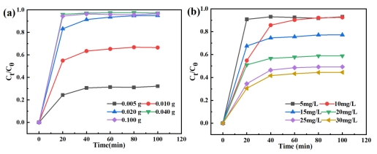
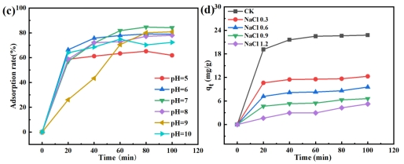
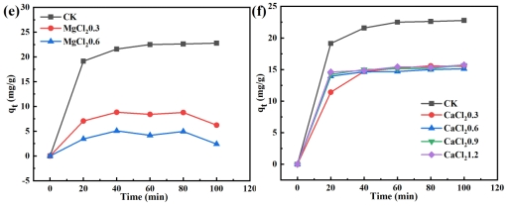
Fig. S1 Effects of (a) different Cu₉S₈ dosage on adsorption of SMZ, (b) different initial concentrations of SMZ on adsorption, (c) different pH values on the adsorption rate of Cu₉S₈ for SMZ in quartz tubes and NaCl (d), MgCl₂ (e) and CaCl₂ (f) on Cu₉S₈ adsorption of SMZ (dosage 0.02 g, concentration 10 mg/L).
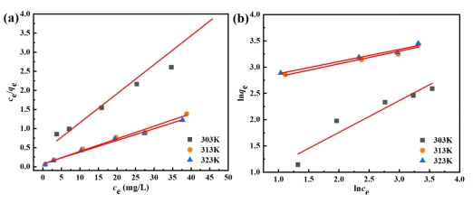
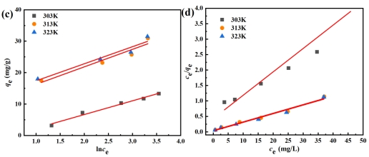
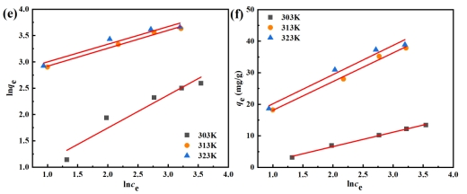
Fig. S2 Isotherms models describing the ST sorption: (a) Langmuir, (b) Freundlich and (c) Temkin models; isotherms models describing the SD sorption: (d) Langmuir, (e) Freundlich and (f) Temkin models.
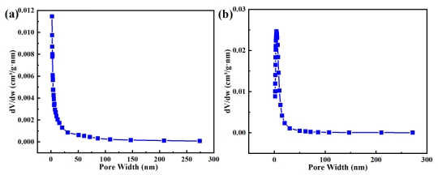
Fig. S3 Pore size distribution of (a) Cu₉S₈ and (b) Cu₉S₈/Fe₃O₄@BC.
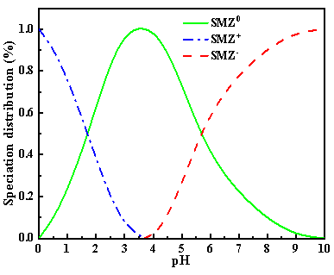
Fig. S4 The state of SMZ at different pH values.
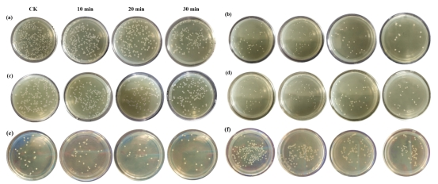
Fig.S5 Antibacterial properties of (a) BC, (c) Fe₃O₄, (f) Cu²⁺ for S. aureus and (b) BC, (d) Fe₃O₄ ,(e) Cu²⁺ for E. coil.
Table S1 Adsorption isotherm fitting parameters for the SMZ adsorption by Cu₉S₈
T(K) |  |  | 303 | 313 | 323
SMZ | Langmuir Model | q_{m}/( mg·g⁻¹ ) | 37.7644 | 43.6110 | 76.5111
SMZ | Langmuir Model | K_{L} | 0.1358 | 0.3906 | 0.3771
SMZ | Langmuir Model | R_{L} | 0.4241 | 0.2038 | 0.2096
SMZ | Langmuir Model | R² | 0.9876 | 0.9848 | 0.9893
SMZ | Feundlich Model | K_{F} | 6.9168 | 15.2648 | 29.2658
SMZ | Feundlich Model | 1/n | 0.4473 | 0.2979 | 0.2842
SMZ | Feundlich Model | R² | 0.9457 | 0.9847 | 0.9723
SMZ | Temkin Model | K_{T} | 1.4652 | 4.0129 | 4.9915
SMZ | Temkin Model | a | 7.9406 | 8.5679 | 14.7312
SMZ | Temkin Model | R² | 0.9863 | 0.9658 | 0.9174
SD | Langmuir Model | q_{m}/( mg·g⁻¹ ) | 13.2188 | 35.7398 | 35.7782
SD | Langmuir Model | K_{L} | 0.1764 | 0.6456 | 1.0390
SD | Langmuir Model | R_{L} | 0.3617 | 0.1341 | 0.0878
SD | Langmuir Model | R² | 0.9085 | 0.97853 | 0.97628
SD | Feundlich Model | K_{F} | 1.8691 | 13.1588 | 14.3611
SD | Feundlich Model | 1/n | 0.4939 | 0.3409 | 0.3554
SD | Feundlich Model | R² | 0.9216 | 0.9834 | 0.9073
SD | Temkin Model | K_{T} | 0.5747 | 2.6834 | 3.2331
SD | Temkin Model | a | 4.5535 | 9.1020 | 9.2644
SD | Temkin Model | R² | 0.9615 | 0.9884 | 0.9923
ST | Langmuir Model | q_{m}/( mg·g⁻¹ ) | 13.1458 | 30.2024 | 32.6477
ST | Langmuir Model | K_{L} | 0.1946 | 0.4858 | 0.4059
ST | Langmuir Model | R_{L} | 0.5139 | 0.2059 | 0.2464
ST | Langmuir Model | R² | 0.9378 | 0.9892 | 0.9859
ST | Feundlich Model | K_{F} | 1.7286 | 12.3940 | 14.0801
ST | Feundlich Model | 1/n | 0.6051 | 0.2425 | 0.2307
ST | Feundlich Model | R² | 0.9599 | 0.9516 | 0.8774
ST | Temkin Model | K_{T} | 0.6221 | 6.8212 | 9.0420
ST | Temkin Model | a | 4.3671 | 5.5703 | 5.4309
ST | Temkin Model | R² | 0.9185 | 0.8968 | 0.9789
Table S2 Adsorption thermodynamics parameters for the SMZ adsorption by Cu₉S₈
T (K) |  | 303 | 313 | 323
SMZ | ∆G (KJ·mol⁻¹) | -3347.39 | -3832.44 | -5464.43
SMZ | ∆H (KJ·mol⁻¹) | +28916.97
SMZ | ∆S (J·(mol·K)⁻¹) | +105.85
SD | ∆G (KJ·mol⁻¹) | -702.98 | -3314.47 | -3423.25
SD | ∆H (KJ·mol⁻¹) | +40092.03
SD | ∆S (J·(mol·K)⁻¹) | +136.01
ST | ∆G (KJ·mol⁻¹) | -689.03 | -2876.40 | -3177.36
ST | ∆H (KJ·mol⁻¹) | +36694.83
ST | ∆S (J·(mol·K)⁻¹) | +124.42
Table S3 Adsorption kinetic fitting parameters for the SMZ adsorption by Cu₉S₈
 |  | SMZ | SD | ST
pseudo-first-order | q_{e}/( mg·g⁻¹ ) | 23.1614 | 14.4154 | 16.1491
pseudo-first-order | q_{ec}/( mg·g⁻¹ ) | 24.0502 | 16.4276 | 15.3846
pseudo-first-order | k | 0.3159 | 0.1762 | 0.1183
pseudo-first-order | R² | 0.9853 | 0.9839 | 0.9792
pseudo-second-order | q_{e}/( mg·g⁻¹ ) | 24.3368 | 15.6031 | 17.0999
pseudo-second-order | q_{ec}/( mg·g⁻¹ ) | 24.0502 | 16.4276 | 15.3846
pseudo-second-order | k | 0.0586 | 0.0212 | 0.0075
pseudo-second-order | R² | 0.9996 | 0.9985 | 0.9930
Table S4 Desorption kinetic fitting parameters for the SMZ adsorption by Cu₉S₈
 |  | SMZ | SD | ST
pseudo-first-order | q_{e}/( mg·g⁻¹ ) | 15.3909 | 12.2784 | 10.5611
pseudo-first-order | q_{ec}/( mg·g⁻¹ ) | 16.6080 | 13.4327 | 11.7452
pseudo-first-order | k | 0.2285 | 0.2176 | 0.1010
pseudo-first-order | R² | 0.9598 | 0.9368 | 0.8784
pseudo-second-order | q_{e}/( mg·g⁻¹ ) | 16.8265 | 13.6874 | 12.1699
pseudo-second-order | q_{ec}/( mg·g⁻¹ ) | 16.6080 | 13.4327 | 11.7452
pseudo-second-order | k | 0.0215 | 0.0216 | 0.0115
pseudo-second-order | R² | 0.9974 | 0.9957 | 0.9859
Table S5 Study on antibacterial effects of different materials in references
Material | Dosage  (mg) | Time  (min) | Bacterial type | Inactivation rate (%) | References
CuBi₂O₄/Bi₂MoO₆ | 40 | 360 | E. coli | ＞99 | [Shi et al. 2020]
CdIn₂S₄/W₁₈O₄₉ | 20 | 120 | E. coli | ＞99 | [Yang et al. 2020]
MgTi₂O₅/g-C₃N₄ | 25 | 180 | E. coli | ＞99 | [Jiang et al. 2019]
Bi₄O₅I₂/AgI | 20 | 30 | E. coli | ＞99 | [Yang er al. 2019]
Agar/CuS NP | 50 | 420 | E. coli | ＞99 | [Roy et al. 2019]
Ti₃C₂T_{x}@CuS | 0.5 | 30 | E. coli | ＞99  ＞99 | [Li et al. 2021]
Ti₃C₂T_{x}@CuS | 0.5 | 30 | S.aureus | ＞99  ＞99 | [Li et al. 2021]
Cu₉S₈ | 2 | 20 | S.aureus  E. coli | ＞99 | Current
Cu₉S₈/Fe₃O₄@BC | 2 | 30 | S.aureus  E. coli | ＞99 | Current

∗ Corresponding authors: Dr. Zhang. Email: zhangzhiweia@163.com

