Supplementary materials
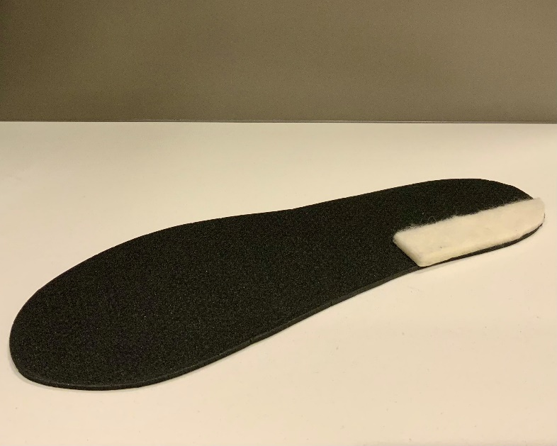
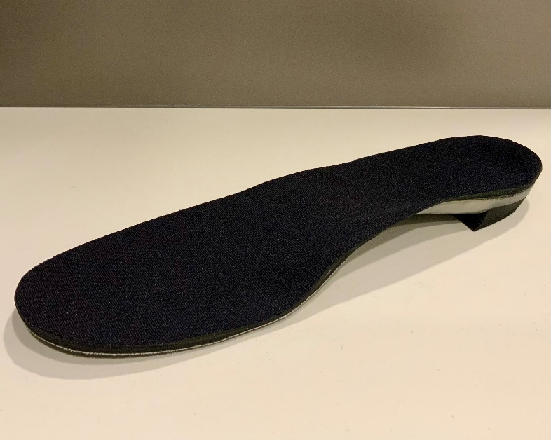
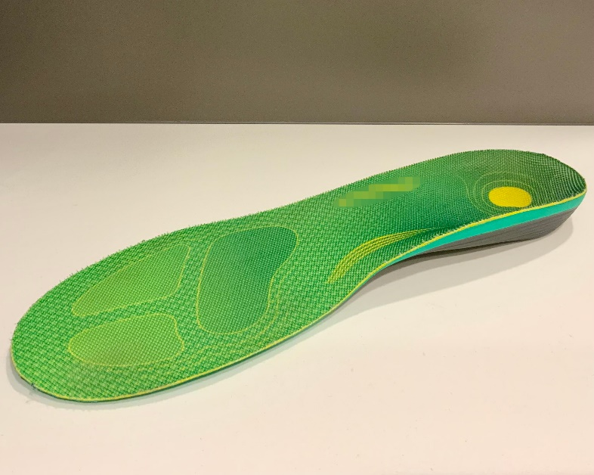
A
B
C
Supplementary material 1. Example of a common simple foot orthosis (A), prefabricated foot orthosis (B), and custom foot orthosis (C).

Supplementary material 2. Detailed description of the foot orthosis evaluated by the included studies
Study | Assessed conditions  FO type worn, corrective elements | FO customization method | FO specification  specification (material, hardness)
Andreasen et al. (2013) [49] | SG1: None  SG2: CFO, n/a | SG2: moulded and wedged individually | SG2: FO general (EVA, A35)
Baur et al. (2011) [50] | SG1: None  SG2: CFO, 3-mm FF lateral wedge and 25-mm arch support | SG2: Dynamic barefoot plantar pressure distribution | SG2: full-length FO with bowl-shaped heel (EVA, semi-rigid)
Boldt et al. (2013) [59] | SG:  1- None  2- SFO, 6° full-length medial wedge | None | 2- extrinsic wedge (EVA, A65), standardized shoe sock liner (n/m, n/m)
Bonacci et al. (2018) [51] | SG:  1- None  2- PFO, 6° medial wedge | 2- Optimal comfort: Heat molding, wedge, and/or heel raise | 2- 3/4 or full-length FO (EVA, A52-A75)
Dixon & McNally (2008) [71] | SG:  1- None  2- CFO, n/a | 2- Low, normal, or high arch based on dynamic arch index and medial wedge based on individual need | 2- full-length FO with a base layer (EVA, A60) and a top layer (EVA, A40)
Donoghue et al. (2008) [60] | SG:  1- None  2- CFO, medial wedge < 10° | n/m | 2- FO general (EVA, n/m)
Donoghue et al. (2008) [61] | SG:  1- None  2- CFO, medial wedge < 10° | 2- NWB neutral cast | 2- FO general (EVA, n/m)
Ferber et al. (2005) [72] | SG:  1- None  2- CFO, 4° RF intrinsic medial wedge  3- CFO, inverted | 2- NWB neutral cast  3- NWB neutral cast and inverted depending on foot morphology and symptoms | 2- shell with intrinsic FF wedge (graphite, n/m)  3- 15° or 25° inverted shell (graphite, n/m)
Hirschmüller et al. (2011) [52] | SG1: None  SG2: CFO, FF lateral wedge | SG2: Dynamic barefoot plantar pressure distribution | SG2: full-length FO with bowl-shaped heel (EVA, semi-rigid)
Lewinson et al. (2015) [53] | SG1: SFO, 6-mm full-length medial wedge  SG2: SFO, 3-mm full-length lateral wedge | SG1 and SG2: Foot size | SG1 and SG2: full-length insole (3-mm EVA, A60) and extrinsic wedge (EVA, A60)
MacLean et al. (2008) [62] | SG:  1- None  2- CFO, 5° RF intrinsic medial wedge | 2- NWB neutral cast and body weight | 2- shell with 18-mm deep heel cup (3-mm copolymer or polypropylene, semi-rigid), extrinsic RF stabilizer (EVA, n/m), full-length cover (EVA, n/m)
MacLean et al. (2009) [54] | SG:  With or without: CFO, 5° RF intrinsic medial wedge  1- Soft shoe midsole  2- Medium shoe midsole  3- Hard shoe midsole | SG: NWB neutral cast and body weight | CFO- shell with 18-mm deep heel cup (3-mm copolymer or polypropylene, semi-rigid), extrinsic RF stabilizer (EVA, n/m), full-length cover (EVA, n/m)  1- shoe midsole (n/m, C40)  2- shoe midsole (n/m, C55)  3- shoe midsole (n/m, C70)
MacLean et al. (2010) [73] | SG:  1- None  2- CFO, 5° RF intrinsic medial wedge | 2- NWB neutral cast and body weight | 2- shell with 18-mm deep heel cup (3-mm copolymer or polypropylene, semi-rigid), extrinsic RF stabilizer (EVA, n/m), full-length cover (EVA, n/m)
Mayer et al. (2007) [63] | SG1: None  SG2: CFO, FF lateral wedge, arch support | SG2: Dynamic barefoot plantar pressure distribution | SG2: full-length FO with bowl-shaped heel (EVA, semi-rigid)
Mills et al. (2012) [64] | SG1 and SG2:  1- PFO, n/m  2- PFO, n/m  3- PFO, n/m  4- sham/flat insole | None | SG1 and SG2:  1- full-length FO (EVA, A75)  2- full-length FO (EVA, A60)  3- full-length FO (EVA, A52)  4- 3-mm full length insole (EVA, A52)
Naderi et al. (2019) [55] | SG:  1- None  2- PFO, 25-mm peak-height arch support | None | 2- full-length FO with 15-mm deep heel cup (4-mm polypropylene, A50)
Naderi et al. (2022) [56] | SG1: sham/flat insole  SG2: PFO, 25-mm peak-height arch support | None | SG1: 3/4 insole (4-mm polypropylene, A50)  SG2: 3/4 FO with 15-mm deep heel cup (4-mm polypropylene, A50)
Nawoczenski et al. (1995) [65] | SG:  1- None  2- CFO, n/a | 2- NWB neutral cast and wedged individually | 2- shell (3-mm polypropylene, semi-rigid), cover (3-mm neoprene, A20)
Nawoczenski & Ludewig (1999) [74] | SG:  1- None  2- CFO, n/a | 2- NWB neutral cast and wedged individually | 2- shell with intrinsic FF wedge (3-mm polypropylene, semi-rigid), extrinsic RF wedge (n/m, n/m), cover (3-mm neoprene, n/m)
Orteza et al. (1992) [75] | SG:  1- None  2- CFO, n/a  3- sham/flat insole | 2- Molded to the neutral subtalar joint position and wedged individually | 2- shell with intrinsic RF wedge (3-mm Aquaplast, semi-rigid), extrinsic FF wedge (n/m, n/m), full-length cover (3-mm Plastazote, n/m)  3- full-length insole (3-mm Plastazote, n/m)
Rodrigues et al. (2013) [66] | SG:  1- None  2- SFO, 4° RF and FF medial wedges | None | 2- extrinsic wedges (rubber, n/m), New Balance insoles (n/m, n/m)
Shih et al. (2011) [67] | SG1: sham/flat insole  SG2: SFO, 5° RF medial wedge | SG1 and SG2: Foot size | SG1: full-length insole (2-mm Poron, n/m)  SG2: full-length insole (2-mm Poron, n/m) and extrinsic wedge (EVA, n/m)
Sinclair et al. (2018) [68] | SG:  1- None  2- PFO, n/a | SG: Heat molding to the longitudinal arch profile | SG: full-length FO (EVA, A30)
Sinclair & Butters (2021) [69] | SG:  1- None  2- PFO n/a | 2- Heat molding to the longitudinal arch profile | 2- full-length FO 6-mm deep heel cup (EVA, A30)
Stell & Buckley (1998) [76] | SG:  1- None  2- CFO, n/a  3- SFO, 5° RF wedge and arch support | 2- NWB neutral cast  3- Arch filled according to profile | 2- shell with intrinsic RF and FF wedges (EVA, high density)  3- full-length insole (1.5-mm EVA, n/m), extrinsic RF wedge (EVA, n/m) covered (1.5-mm Poron, n/m), filled arch support (Plastazote, n/m)
Van Lunen et al. (2011) [77] | SG:  1- None  2- PFO, 6° RF medial wedge | None | 2- 1/2 length FO with a 15-mm heel cup (n/m, n/m)
Williams III et al. (2003) [78] | SG:  1- None  2- CFO, 4° RF medial wedge  3- CFO, inverted | 2 and 3- impression n/m  2- wedged in FF individually  3- inversion according to calcaneal stance position | 2- shell with intrinsic FF wedge (graphite, n/m), extrinsic RF wedge (n/m, n/m)  3- 15° or 25° inverted shell (graphite, n/m)
Wyndow et al. (2013) [57] | SG:  1- None  2- PFO, n/a | None | 2- shell (polypropylene, semi-rigid), full-length cover (3-mm sponge, n/m)
Zhang et al. (2022) [58] | SG:  1- None  2- PFO, 4-mm medial FF wedge, 20-mm arch support  3- PFO, 2-mm medial FF wedge, 20-mm arch support  4- PFO, 20-mm arch support  5- PFO, 2-mm lateral FF wedge, 20-mm arch support  6- PFO, 4-mm lateral FF wedge, 20-mm arch support  7- PFO, 4-mm medial FF wedge, 24-mm arch support  8- PFO, 2-mm medial FF wedge, 24-mm arch support  9- PFO, 24-mm arch support  10- PFO, 2-mm lateral FF wedge, 24-mm arch support  11- PFO, 4-mm lateral FF wedge, 24-mm arch support | None | 2 to 11- 3/4 length shell with varying extrinsic FF wedges and arch support (4-mm 3D printed polyurethane, n/m), full-length cover (thin fabric, n/m)
Zhang & Vanwanseele (2023) [70] | SG:  1- None  2- PFO, 4-mm medial FF wedge, 20-mm arch support  3- PFO, 2-mm medial FF wedge, 20-mm arch support  4- PFO, 20-mm arch support  5- PFO, 2-mm lateral FF wedge, 20-mm arch support  6- PFO, 4-mm lateral FF wedge, 20-mm arch support  7- PFO, 4-mm medial FF wedge, 24-mm arch support  8- PFO, 2-mm medial FF wedge, 24-mm arch support  9- PFO, 24-mm arch support  10- PFO, 2-mm lateral FF wedge, 24-mm arch support  11- PFO, 4-mm lateral FF wedge, 24-mm arch support | None | 2 to 11- 3/4 length shell with varying extrinsic FF wedges and arch support (4-mm 3D printed polyurethane, n/m), full-length cover (thin fabric, n/m)
Abbreviations: CFO, custom foot orthosis; EVA, ethylene vinyl acetate; FF, forefoot; FO, foot orthosis; n/a, not applicable; n/m, not mentioned; NWB, non-weight bearing; PFO, prefabricated foot orthosis; RF, rearfoot; SG, symptomatic group; SFO, simple foot orthosis.

