Supplementary Material 1: PRO-ECO Intervention Details by Study ECEC Site

Loose parts implemented across all ECECs
- Milk crates
- Popsicle sticks
- Buttons
- Mason jar bangles
- Pillow cases
- Fabric
- Ribbons
- Shells
- Tactile objects
- Kitchen items
- Piping

Intervention components specific to each ECEC

Centre A
Built Environment Modifications
- Wooden deck tiles
- Wooden puzzle blocks
- Shade net with gourds, gourd chimes
- Ceramic planters and plantings
- Netting over play structure
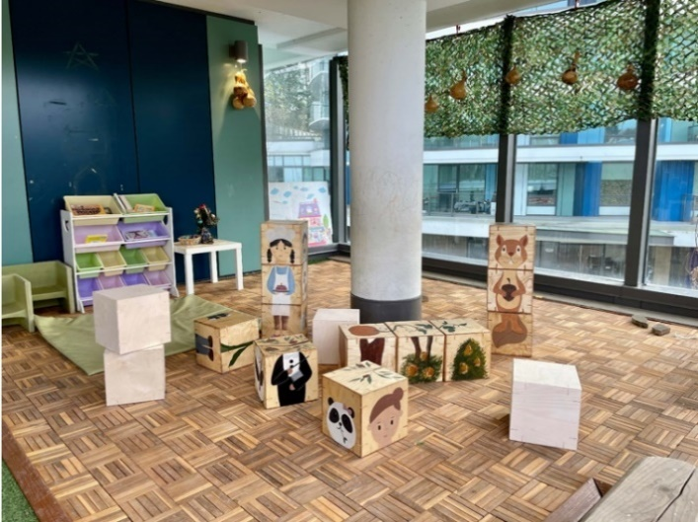
- Additional garden bed plantings and replacement of dead tree
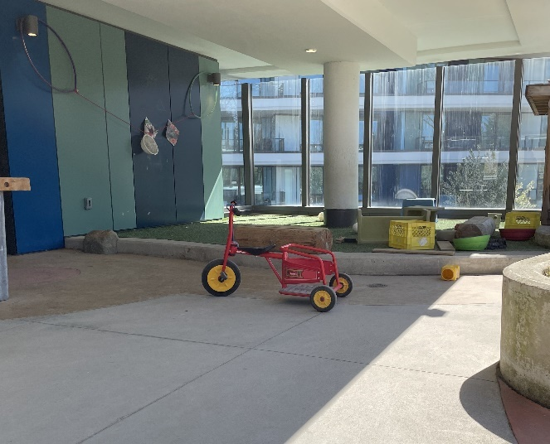
Figure 6: Centre A Open Space Pre-Intervention Figure 7: Centre A Open Space Post-Intervention
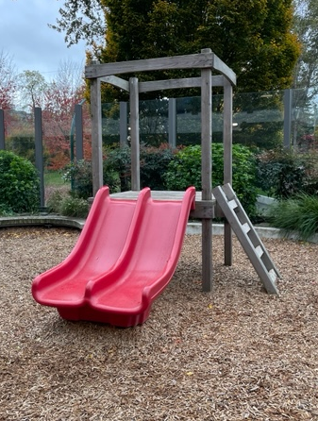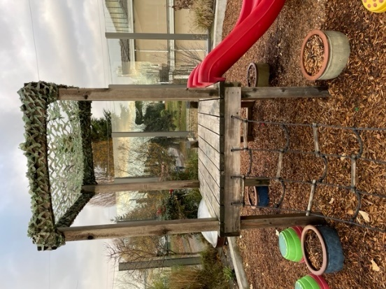
Figure 8: Centre A Play Structure Pre-Intervention Figure 9: Centre A Play Structure Post-Intervention

Centre B
Built Environment Modifications
- Shade sail
- Planter bags, planter boxes, plantings
- Expanded sandbox steps
- Rocking rainbows and water troughs with stands and wooden balls
- Water hoses and mulching
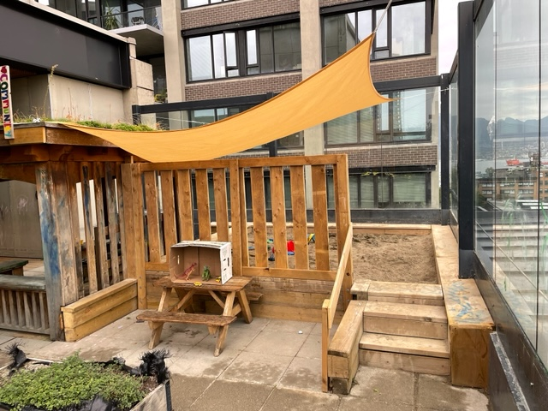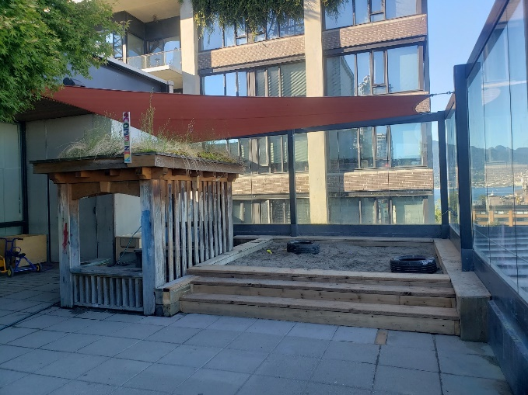
Figure 10: Centre B Sandbox Pre-Intervention Figure 11: Centre B Sandbox Post-Intervention
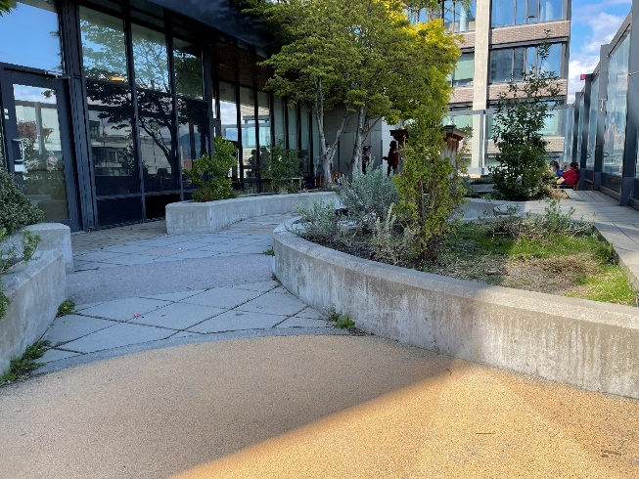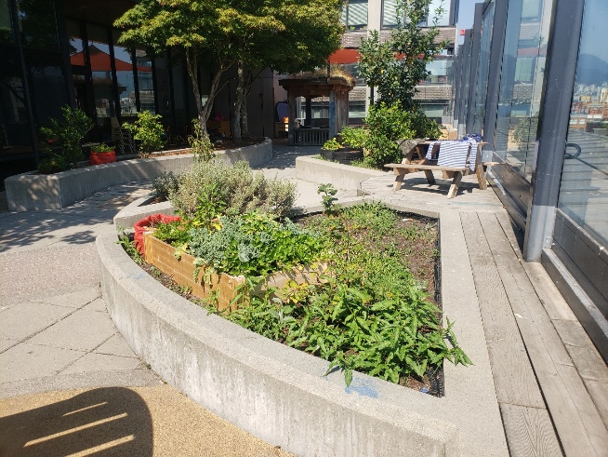
Figure 12: Centre B Gardening Pre-Intervention Figure 13: Centre B Gardening Post-Intervention

Centre C
Built Environment Modifications
- Shade sail
- Planter bags
- Ribbon arbor
- Wood climber
- Labyrinth (flagstones and grass)
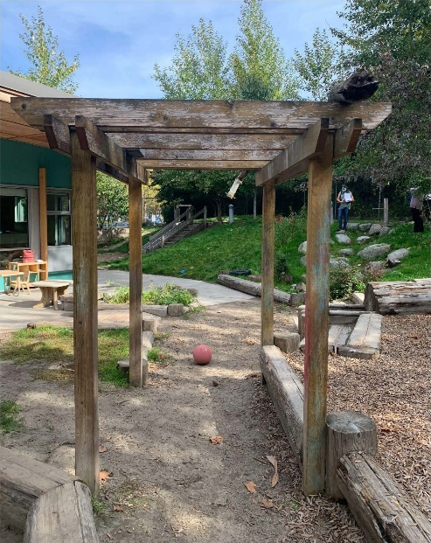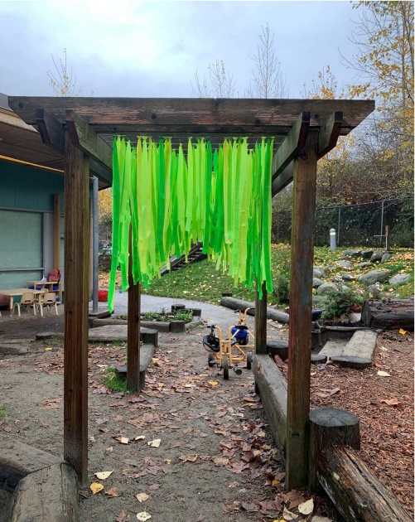
Figure 14: Centre C Awning Pre-Intervention Figure 15: Centre C Awning Post-Intervention
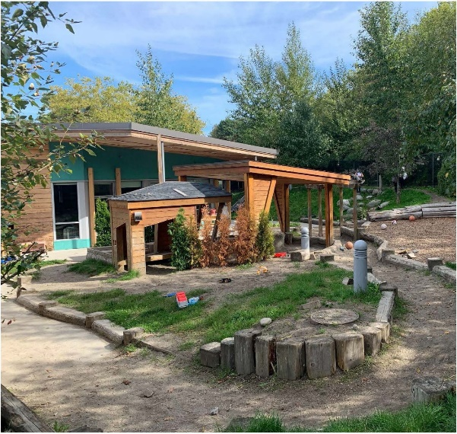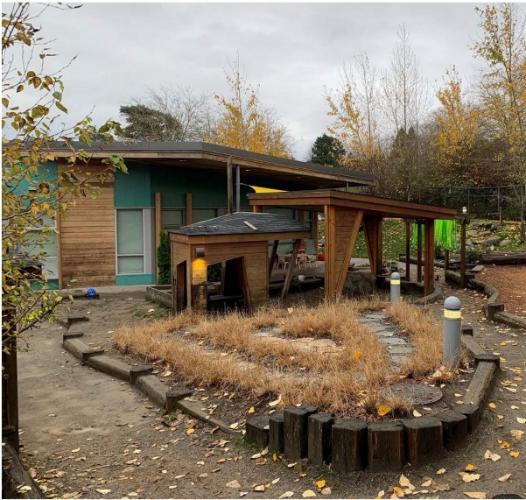
Figure 16: Centre C Raised Hill Pre-Intervention Figure 17: Centre C Raised Hill Post-Intervention
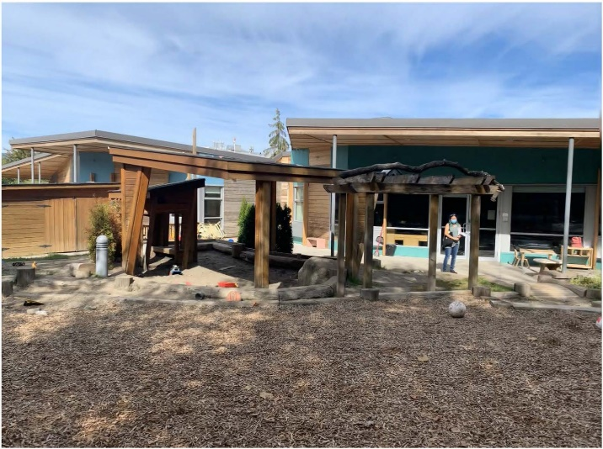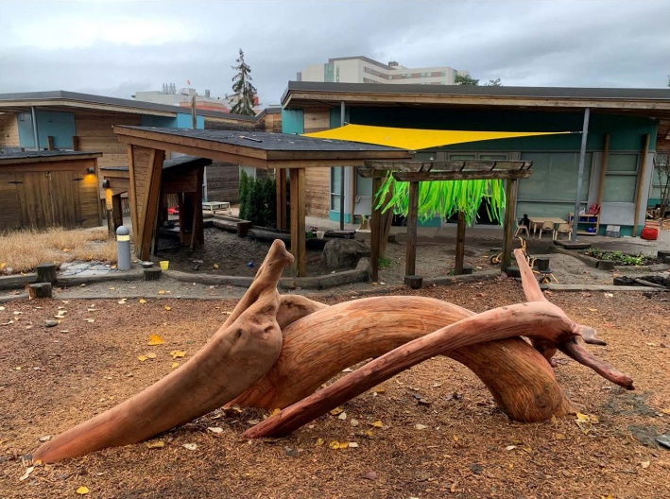
Figure 18: Centre C Open Space Pre-Intervention Figure 19: Centre C Open Space Post- Intervention

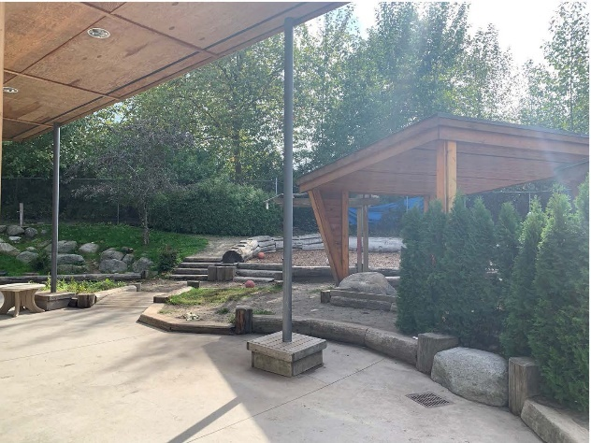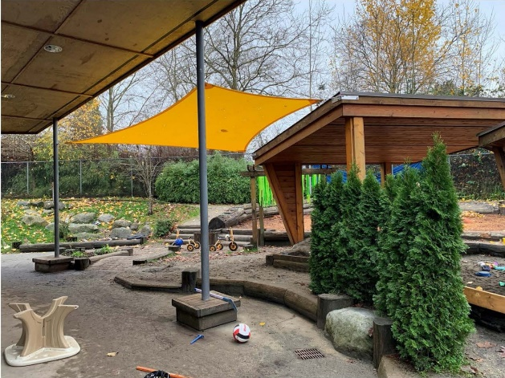
Figure 20: Centre C Covered Area Post-Intervention Figure 21: Centre C Covered Area Pre-Intervention

Centre D
Built Environment Modifications
- Plantings and tree cookies
- Water wall and rocky bamboo water area
- Shade sails and sandbox shade cover
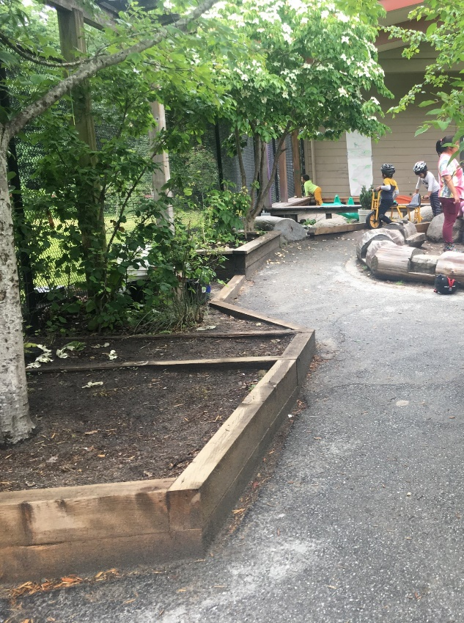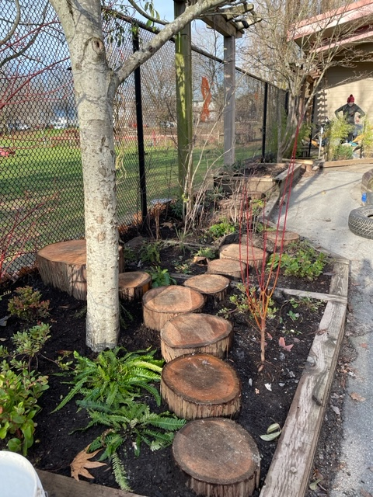
Figure 22: Centre D Gardening Area Post-Intervention Figure 23: Centre D Gardening Area Pre-Intervention

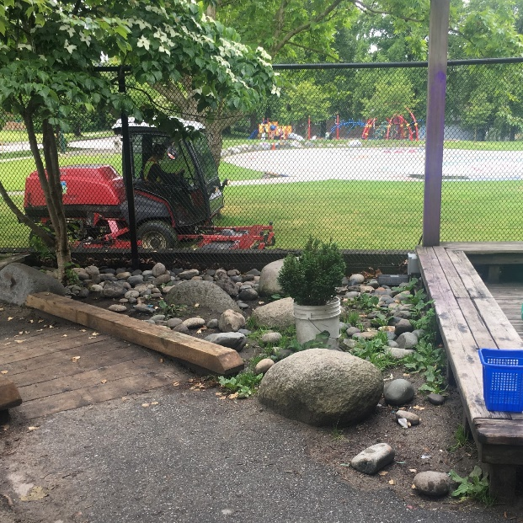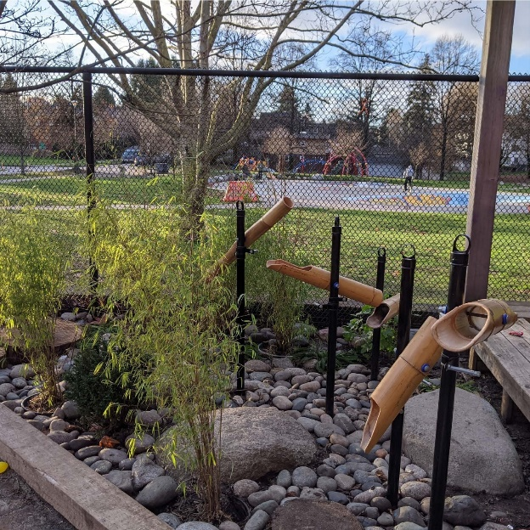
Figure 24: Centre D Rock Area Pre-Intervention Figure 25: Centre D Rock Area Post-Intervention
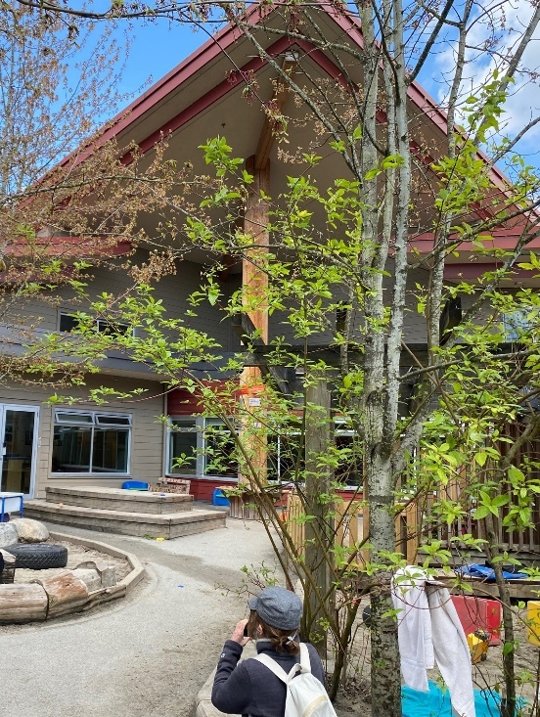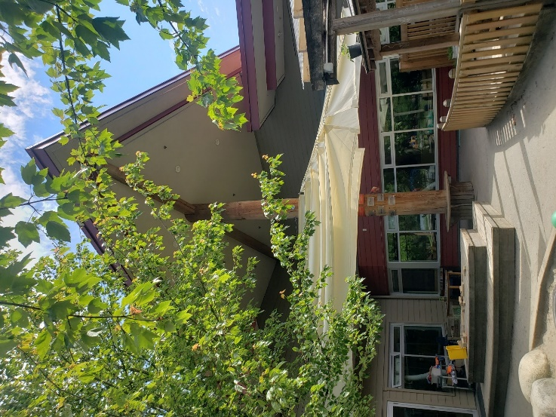
Figure 26: Centre D Covered Area Pre-Intervention Figure 27: Centre D Covered Area Post-Intervention

Centre E
Built Environment Modifications
- Shade sail
- Expanded fenced area
- Planter bags and plantings
- Hanging ribbon
- Water troughs with stands and wooden balls
- Water hose
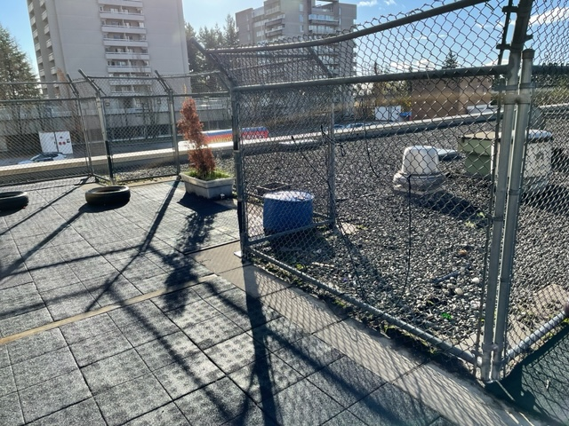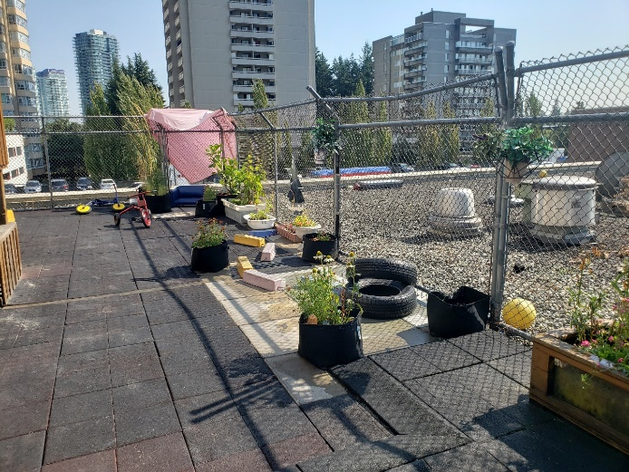
Figure 28: Centre E Fence Line Pre-Intervention Figure 29: Centre E Fence Line Post-Intervention
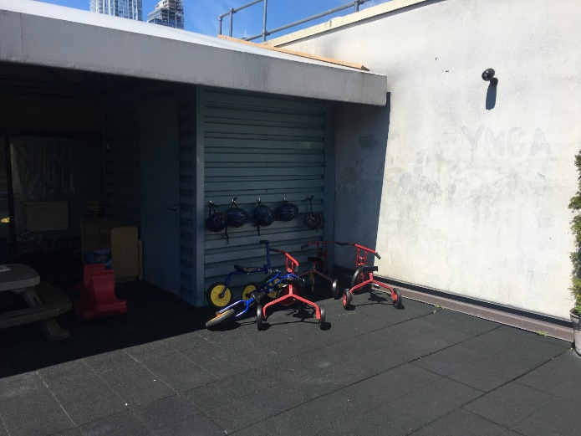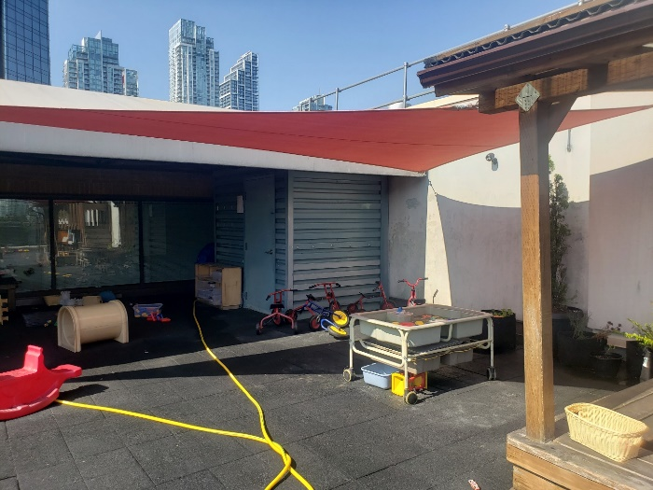
Figure 30: Centre E Corner Space Pre-Intervention Figure 31: Centre E Corner Space Post-Intervention

Centre F
Built Environment Modifications
- Plantings and planter bags
- Windsock fish
- Rocking rainbows and pickler arch and balance boards
- Water troughs with stands and wooden balls
- Water hose
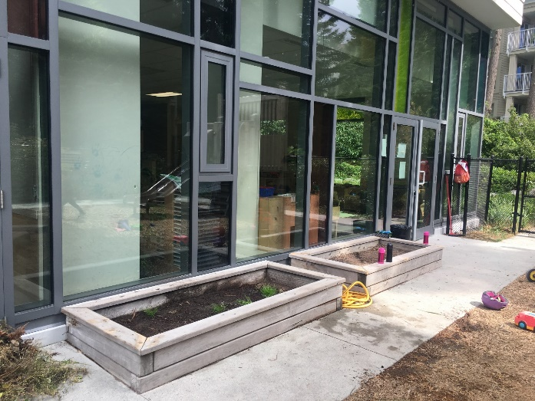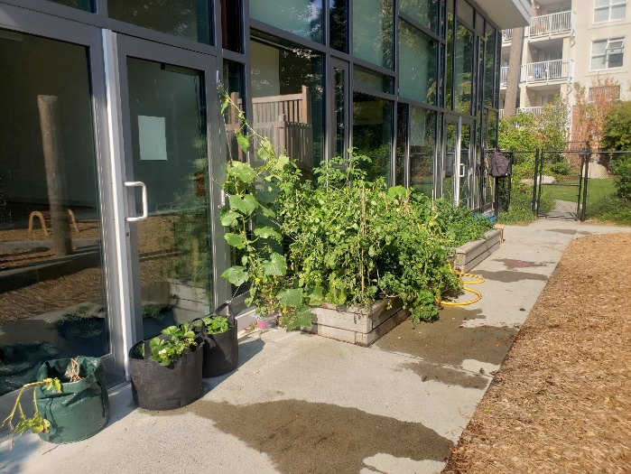
Figure 32: Centre F Gardening Area Pre-Intervention Figure 33: Centre F Gardening Area Post-Intervention
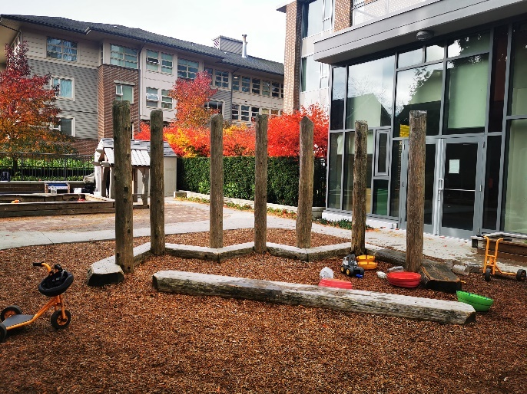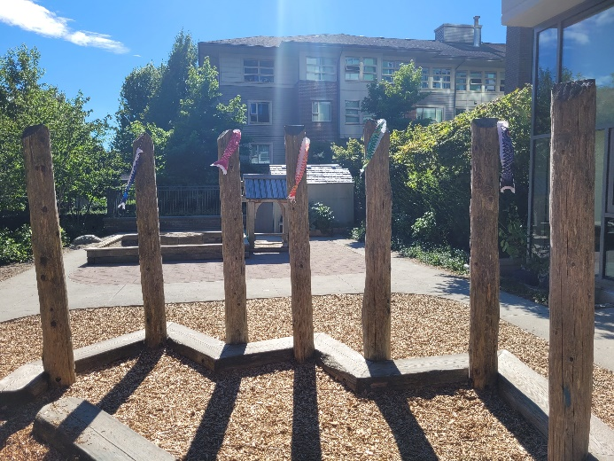
Figure 34: Centre F Wood Posts Pre-Intervention Figure 35: Centre F Wood Posts Post-Intervention
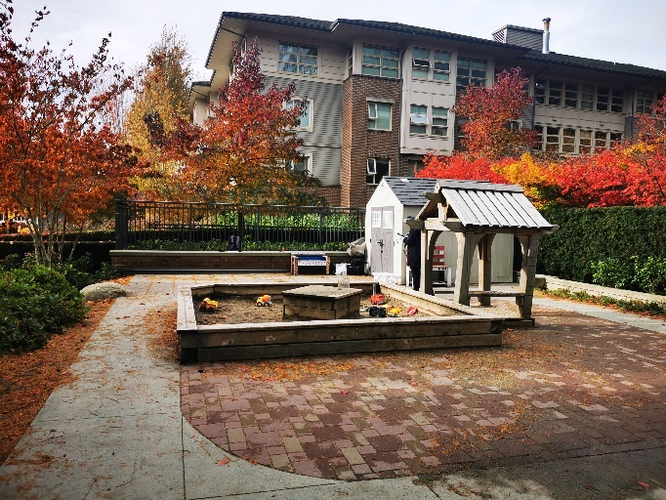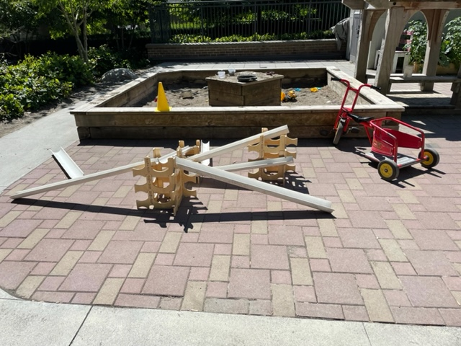
Figure 36: Centre F Open Space Pre-Intervention Figure 37: Centre F Open Space Post-Intervention

Centre G
Built Environment Modifications
- Fence banners and rainbow weaving
- Wind chimes
- Water pump, large wooden bucket and water troughs
- Grass corridor (plantings) with ferns and fairy pebbles
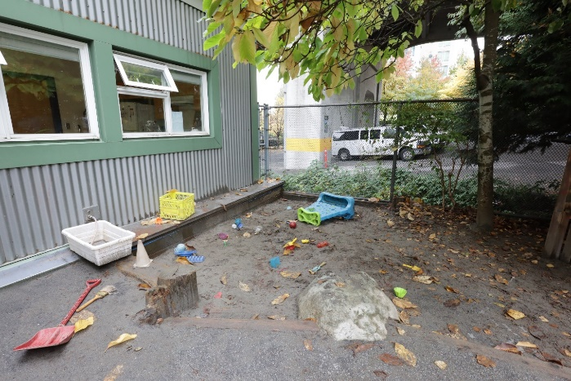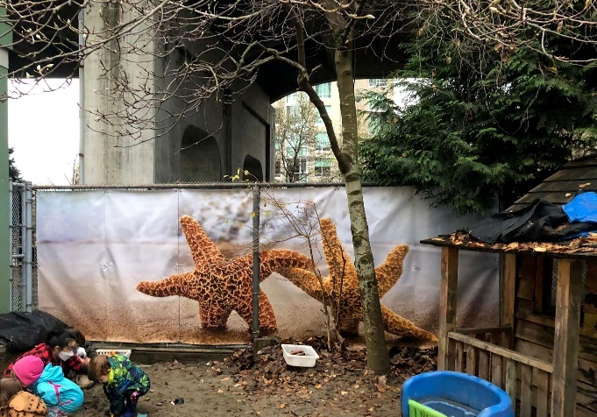
Figure 38: Centre G Sandbox Area Pre-Intervention Figure 39: Centre G Sandbox Area Post-Intervention
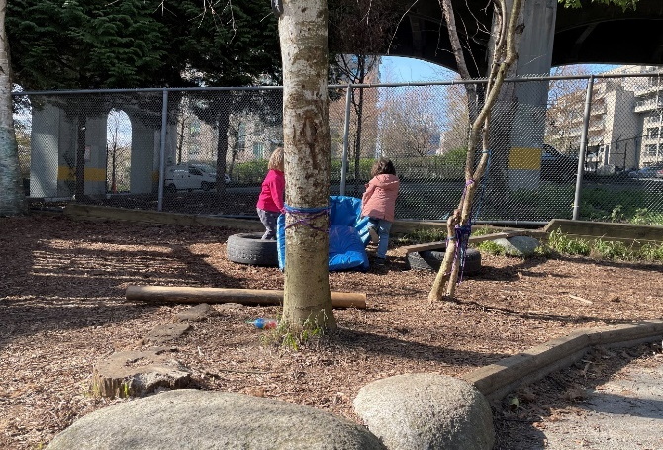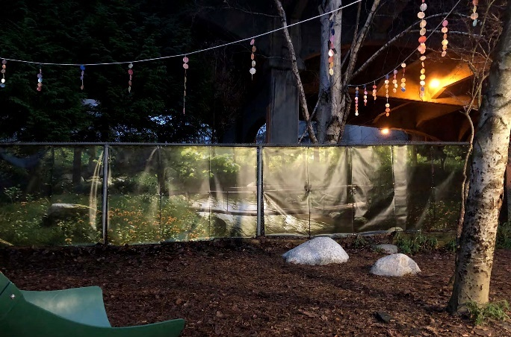
Figure 40: Centre G Open Area Pre-Intervention Figure 41: Centre G Open Area Post-Intervention
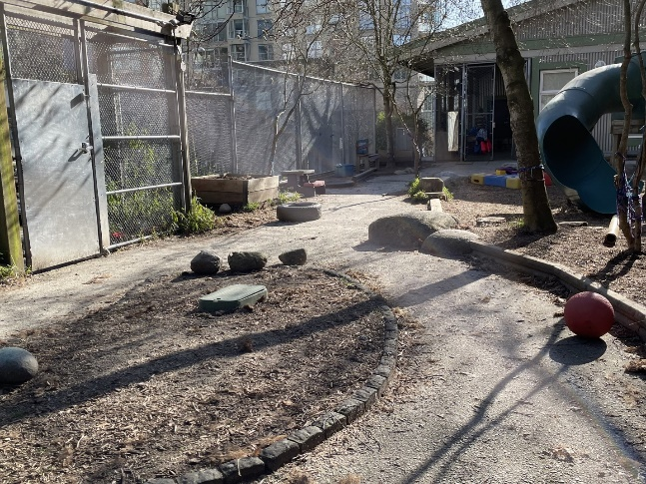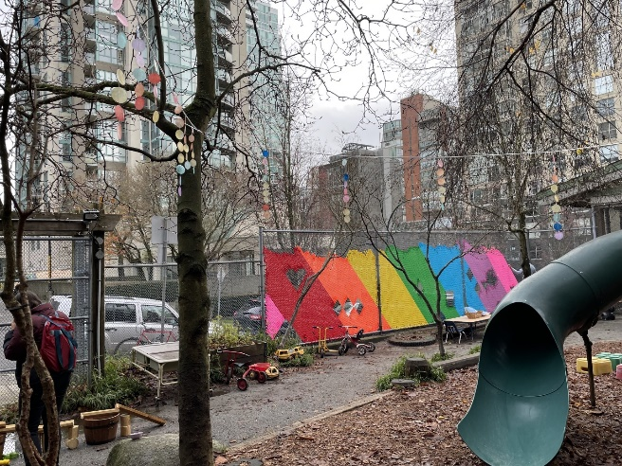
Figure 42: Centre G Outdoor Entrance Pre-Intervention Figure 43: Centre G Outdoor Entrance Post-Intervention

Centre H
Built Environment Modifications
- Labyrinth (pathway, rocks, tree)
- Planter bags and planter boxes with plantings
- Ribbon grids
- Shade sail
- Rocking rainbows, pickler arch and balance boards
- Water troughs with stands and wooden balls
- Hose and hose bib
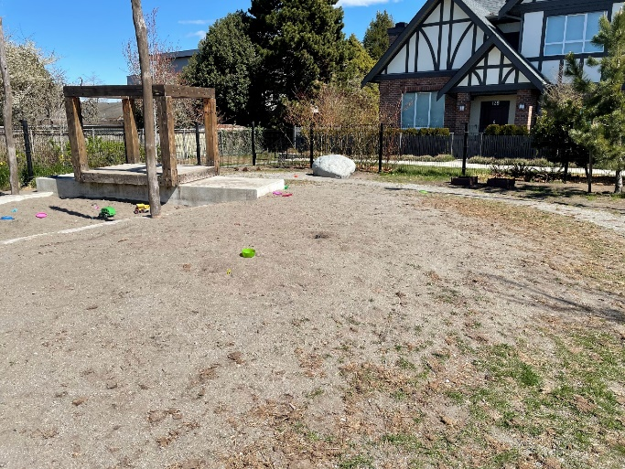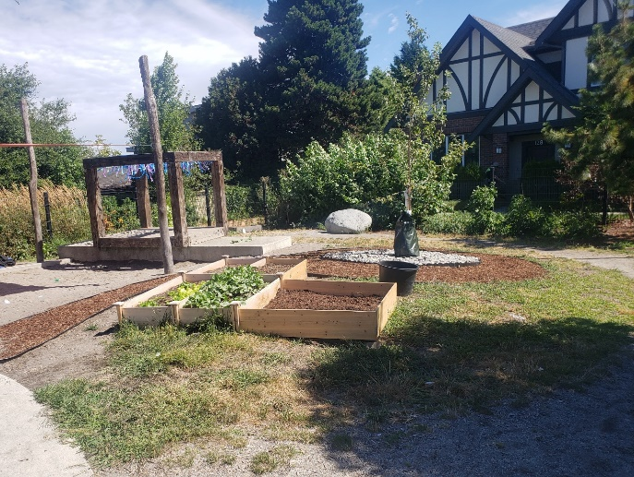
Figure 44: Centre H Open Space Pre-Intervention Figure 45: Centre H Open Space Post-Intervention
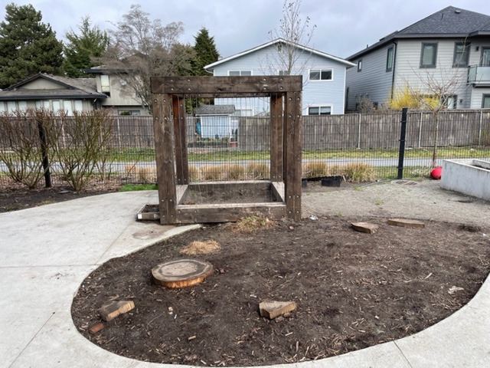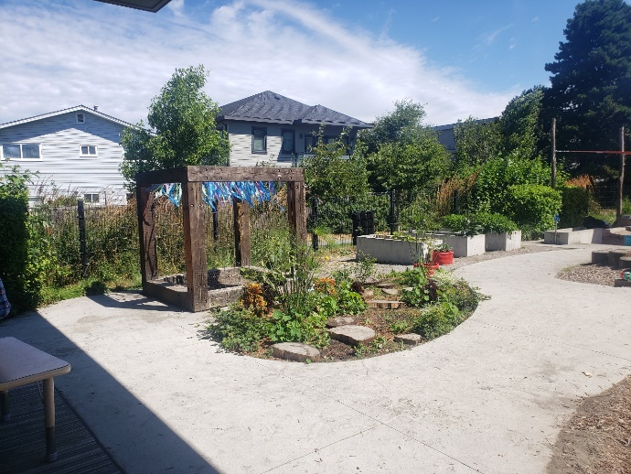
Figure 46: Centre H Garden Area Post-Intervention Figure 47: Centre H Garden Area Post-Intervention

