SUPPLEMENTARY MATERIAL
This supplementary information section contains background information on the modelling process (which is presented also in Chiaverini et al. 2023 where the models were originally published).
Data collection
Our models were built on extensive occurrence data we collected between 2007 and 2016 across Southeast Asia. We deployed camera trap grids in 37 landscapes across Southeast Asia, of which 15 were on the mainland, 15 in Borneo and 7 in Sumatra, yielding a sampling network of 2,928 camera trap stations (1,384 in mainland, 801 in Borneo and 743 in Sumatra). The total sampling effort produced 253,904 trap nights, of which 115,389 were in mainland, 77,687 in Borneo and 60,828 in Sumatra (Fig. 1; Tables S1-S3).
The surveys were primarily designed to sample mainland and Sunda clouded leopards (Neofelis nebulosa and Neofelis diardi, respectively), whose geographic ranges shaped the extents of the mainland and offshore study areas. However, the surveys also collected data for other members of the felids guilds. Specifically, on the mainland, we recorded clouded leopard, Asiatic golden cat (Catopuma temminckii), marbled cat (Pardofelis marmorata) and leopard cat (Prionailurus bengalensis) respectively at 235, 148, 116 and 345 stations. In Borneo, we recorded Sunda clouded leopard, Borneo bay cat (Catopuma badia), marbled cat and Sunda leopard cat (Prionailurus javanensis) respectively at 154, 25, 85 and 202 stations. In Sumatra, we recorded Sunda clouded leopard, Asiatic golden cat, marbled cat and Sunda leopard cat respectively at 101, 102, 39 and 23 stations (Tables S1-S3). All of these felid species are considered habitat specialist for evergreen forests, except leopard cat which is habitat generalist found in a wide variety of natural and man-made habitats (Pin et al. 2022; Rostro-Garcia et al. 2021).
Camera trap grids were deployed mainly in protected areas, and each consisted of approximately 80 camera trap stations placed 1.0-2.0km apart. For each station, a pair of camera traps was positioned at ~40cm above the ground, along forest trails, natural ridgelines and disused logging roads, allowing greater visibility to maximise felids’ detection success (Hearn et al. 2018; Macdonald et al. 2018; Macdonald et al. 2019).
Habitat covariates
To assess the relationships of the sampled felids with habitat factors, we selected two sets of covariates, one for the mainland and another for the Sunda Islands, reflecting the different habitats of the two regions. Covariates were chosen based on knowledge on felid ecology accrued from previous research in Southeast Asia (Hearn et al. 2018; Macdonald et al. 2018; Macdonald et al. 2019), and included landscape, anthropic, topographic and climatic factors (Tables S4-S5).
We calculated multiscale habitat condition metrics by using circular buffers with varying radii already demonstrated to be relevant for Southeast Asian biodiversity (Chiaverini et al. 2022; Macdonald et al. 2020): for the mainland, we used radii of 250m, 500m, 1km, 2km, 4km, 8km, 16km and 32km, while for the Sunda Islands we investigated radii of 250m, 500m, 1km, 2km, 4km, 6km, 8km and 10km, accounting for the different extents of the two regions. For each covariate, we calculated ecologically informative metrics in FRAGSTATS (McGarigal et al. 2012) and ArcMap v10.6.1 (ESRI 2018). Specifically, in FRAGSTATS we calculated the percentage of landscape (PLAND) for discrete layers, which measures, for each pixel, the percentage of the landscape within each circular buffer consisting of that landscape attribute. In ArcMap we calculated the focal mean (FM) for continuous layers across the same range of neighbourhood sizes. We then applied a multi-scale optimisation approach (sensu McGarigal et al. (2016)) using the methods described in Macdonald et al. (2018) and Macdonald et al. (2019) to produce predictive occurrence models for each species reflecting the multi-scale nature of the species-habitat relationships.
Modelling frameworks
In Chiaverini et al. (2023) we produced habitat suitability models for the sampled felids by applying two different algorithms and, for each of them, two data re-sampling techniques, resulting in four different modelling frameworks. Specifically, we produced habitat suitability models by applying generalised linear model (GLM) and random forest (RF) and, for each of them, we trained the models by bootstrapping or not the training data. The modelling frameworks described below have been applied independently for each species, for each study area, and they have been implemented in R v4.2.0.
GLM – Scales optimisation and covariates selection
We evaluated the most representative spatial scales by performing univariate GLMs, independently for each covariate at each scale (Hearn et al. 2018; Wasserman et al. 2012). Then, for each covariate, we retained the scale in which the univariate GLM presented the lowest Akaike Information Criterion (AIC). We trained the univariate GLMs with a subset of the original dataset, composed of a randomly selected 80% of the data, and used the remaining 20% for model validation. Then, we checked the scale-optimised covariates for multicollinearity by calculating Pearson’s correlation index between all covariates. When a covariates’ dyad was found to be highly correlated (i.e., |r|≥ 0.7), we discarded the covariate whose univariate GLM showed the lowest adjusted-R2 (Guisan and Zimmermann 2000).
GLM – Model training
Using the final set of standardised, uncorrelated, scale-optimised covariates as explanatory variables and the felids’ presence-absence data as response variables, we trained GLMs by applying two frameworks. For the first approach (hereafter non-bootstrapped GLM), we trained the models by using the same dataset used for the univariate GLMs, composed of 80% of the original dataset. We first conducted an all-subset GLM analysis using the MuMIn package (Bartoń 2013), and we then ranked the candidate models using AIC, retaining only those with ΔAIC≤ 2 (Burnham and Anderson 2002). Finally, by using the covariates’ coefficients averaged from the suite of competing models, we created a layer predicting the species’ habitat suitability.
For the second approach (hereafter bootstrapped GLM), we subsampled the original full dataset by randomly selecting 20% of the presence and of the absence data. We reiterated this selection 100 times with replacement, producing as many subsets as we used to train 100 independent GLMs by using the same framework described above for the non-bootstrapped GLM. We then produced the final habitat suitability layer by averaging the outcomes of the 100 iterations.
GLM – Model validation
We evaluated the performances of the non-bootstrapped GLM by calculating Area Under the ROC Curve (AUC) using the 20% of the data held-out from the training dataset, using the package PresenceAbsence (Freeman and Moisen 2007).
To evaluate the performances of the bootstrapped GLM, we calculated AUC independently for each of the 100 iterations, using the data held-out from the training datasets, composed of 80% of the presence and of the absence data. We then obtained the final AUC by averaging the AUC from each iteration.
RF – Scales optimisation and covariates selection
To investigate the most representative spatial scales with RF, we performed univariate RF independently for each covariate at each scale using the original full dataset and selecting, for each covariate, the scale whose univariate RF showed the lowest out-of-bag (OOB) error. To perform RF, we did not check for multicollinearity among scale-optimised covariates, since the algorithm is more robust to correlated explanatory variables than linear regression (Cutler et al. 2007). We implemented the analyses using the package randomForest (Liaw and Wiener 2002).
RF – Model training
We applied two modelling frameworks using the final set of scale-optimised covariates and the felid presence-absence data. For the first approach (hereafter non-bootstrapped RF), we trained the RF by using the same dataset used to train the non-bootstrapped GLM, composed of randomly selected 80% of the original dataset, and produced the species’ habitat suitability layers.
For the second approach (hereafter bootstrapped RF), we independently produced 100 subsets of the original full dataset by randomly sampling, with replacement, 20% of the presence and of the absence data. Then, for each subset, we trained RF and produced 100 habitat suitability layers, which we eventually averaged to obtain the final habitat suitability layer.
RF – Model validation
To evaluate the performances of the non-bootstrapped RF, we calculated AUC using the 20% of the hold-out data subset.
To evaluate the performances of the bootstrapped RF, for each of the 100 iterations we calculated AUC using the data held-out from the training dataset, composed of 80% of the presence and absence data. We then averaged the validation metrics from each iteration to calculate the final AUC.
Malhalanobis mask
Due to the diversity of environments encompassed within this region, we masked out the areas that were ecologically highly divergent from the sampled locations by producing Mahalanobis distance surfaces (Chiaverini et al. 2022), using the package dismo (Hijmans et al. 2017) in R v4.2.0 (R Core Team 2018). We calculated the Mahalanobis distances using the seven environmental factors that were found previously to be important predictors of felid species occurrence (Chiaverini et al. 2022): tree canopy cover (Hansen et al. 2013), protected areas (UNEP-WCMC and IUCN 2022), human footprint (WCS and CIESIN 2005), elevation (Jarvis et al. 2008), roughness (Evans et al. 2014), annual maximum temperature, annual minimum temperature and annual precipitation (PRISM Climate Group 2016) separately for mainland Southeast Asia, Borneo and Sumatra. The Mahalanobis surfaces were continuous layers of the multidimensional distances of each pixel across these regions where the camera traps were deployed. We excluded areas that were highly ecologically divergent from our sampled locations by applying thresholds for mainland Southeast Asia and for the Sunda Islands. Respectively, we used thresholds of the 40th and 20th percentile of the distribution of the multidimensional distances, accounting for the different extents of the mainland and offshore regions.
Scales optimisation and covariates selection
We tested four modelling frameworks for each species and chose the best one based on the AUC scores. In Tables S6-S8 we provided the comprehensive sets of representative scales selected for each felid species.
In mainland Southeast Asia, the scale optimisation revealed that most of the covariates had their strongest effects on felids at broad scales. With 42.2% of the covariates selected at 32km, the broadest assessed scale was the most selected one, followed by 16km (17.8% of the covariates) and 8km (13.3% of the covariates). The two smallest scales 250m and 500m were both selected for 8.9% of the covariates. Medium scales were the least selected ones, with 2km selected for 4.4% of the covariates, and 1km and 4km both selected for 2.2% of the covariates.
In Borneo, the scale optimisation revealed that felids selected fine and broad scales at similar rates. The two most selected scales were 500m and 8km, both selected for 20.4% of the covariates, followed by 250m (16.3% of the covariates), 2km (14.3% of the covariates) and 4km (12.2% of the covariates). The broadest assessed scale, 10km, was selected for 10.2% of the covariates, while 1km for 4.1% of the covariates and 6km for 2.0% of the covariates.
In Sumatra, most of the covariates were selected at fine and medium scales. The most selected scale was 250m, being the most representative scale for 26.8% of the covariates, followed by 4km (19.6% of the covariates) and 2km (12.5% of the covariates). Both 500m and 6km were selected for 10.7% of the covariates. Broad scaled were less representative, with 8km being selected for 8.9% of the covariates and 10km for 7.1% of the covariates. Finally, 1km was selected for 3.6% of the covariates.

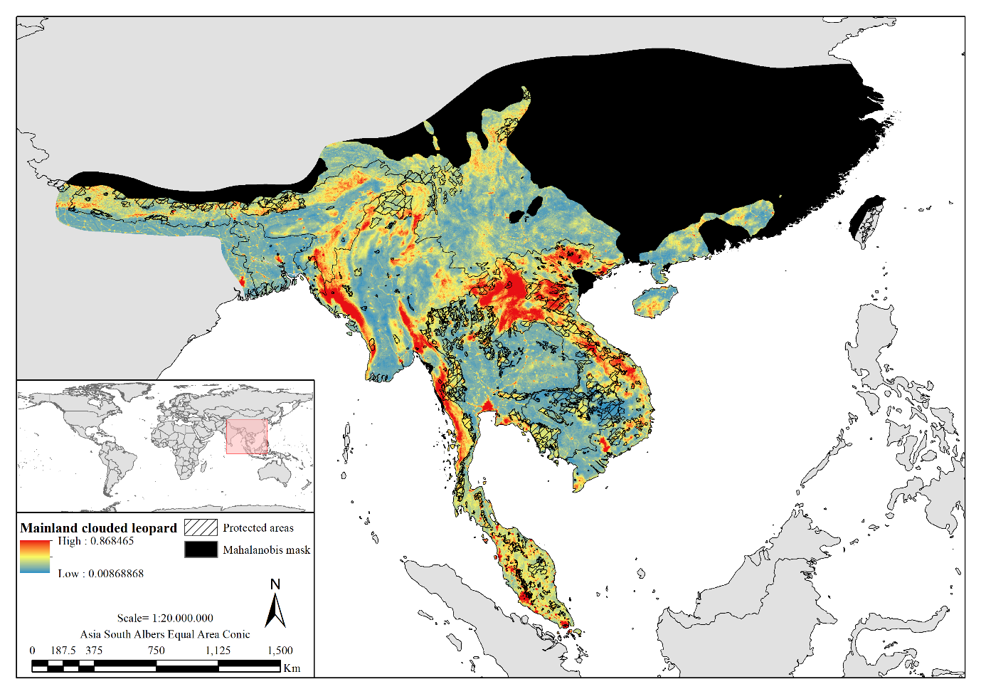
Fig. S1. Species distribution probability surface of clouded leopard in mainland Southeast Asia.

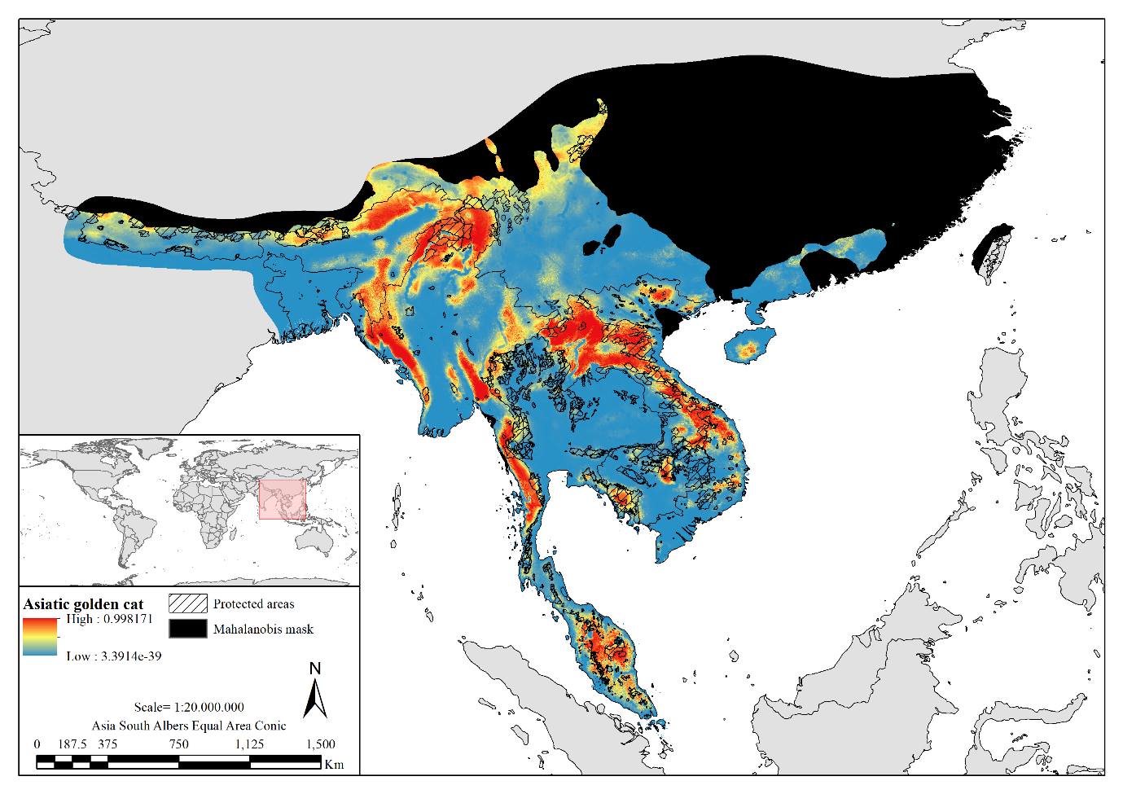
Fig. S2. Species distribution probability surface of Asiatic golden cat in mainland Southeast Asia.

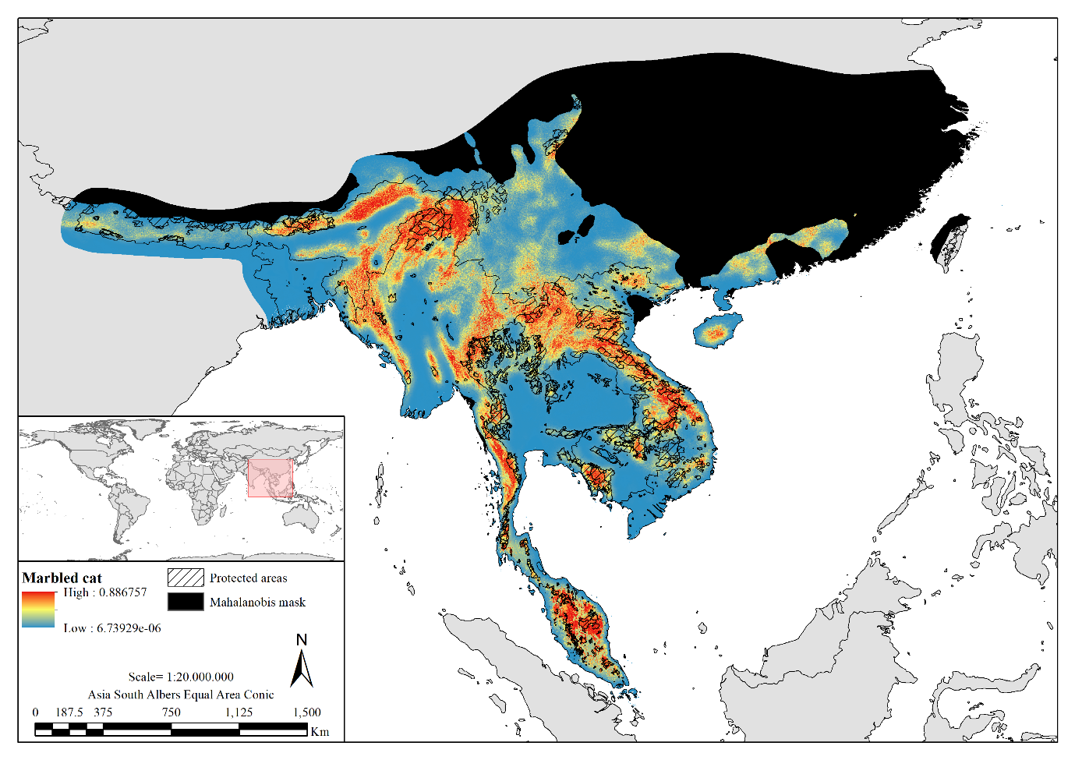
Fig. S3. Species distribution probability surface of marbled cat in mainland Southeast Asia.

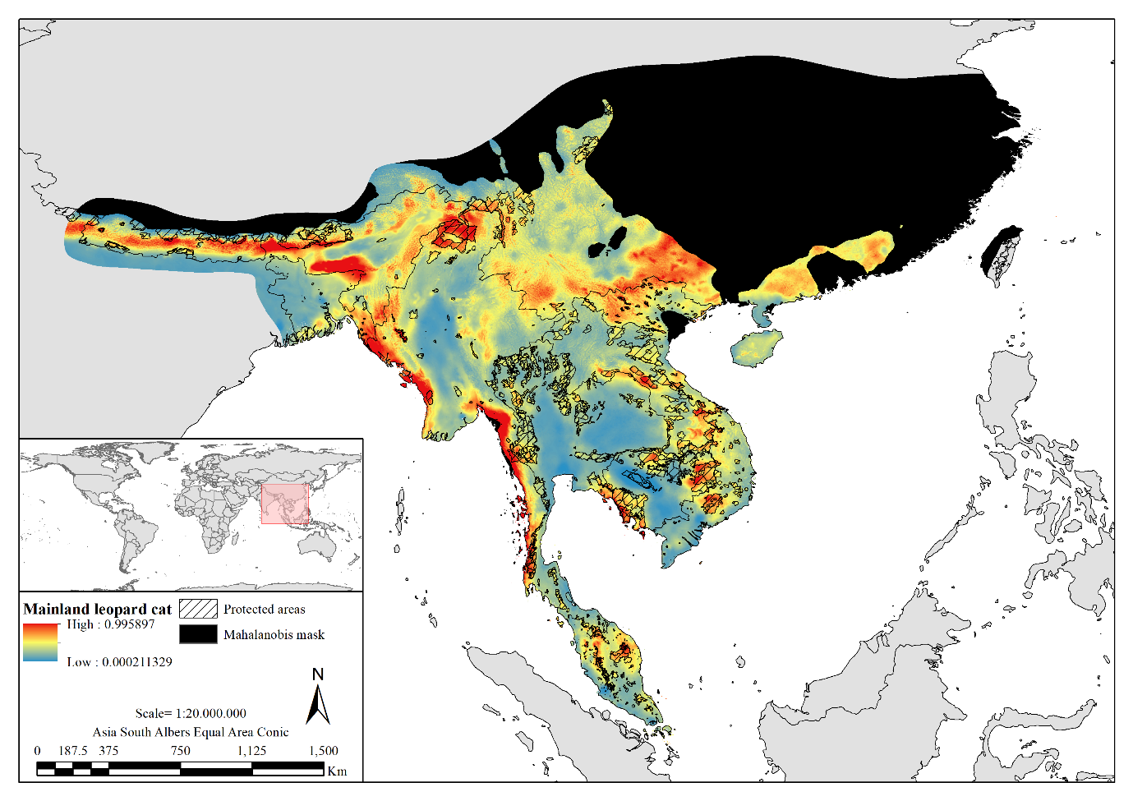
Fig. S4. Species distribution probability surface of leopard cat in mainland Southeast Asia.

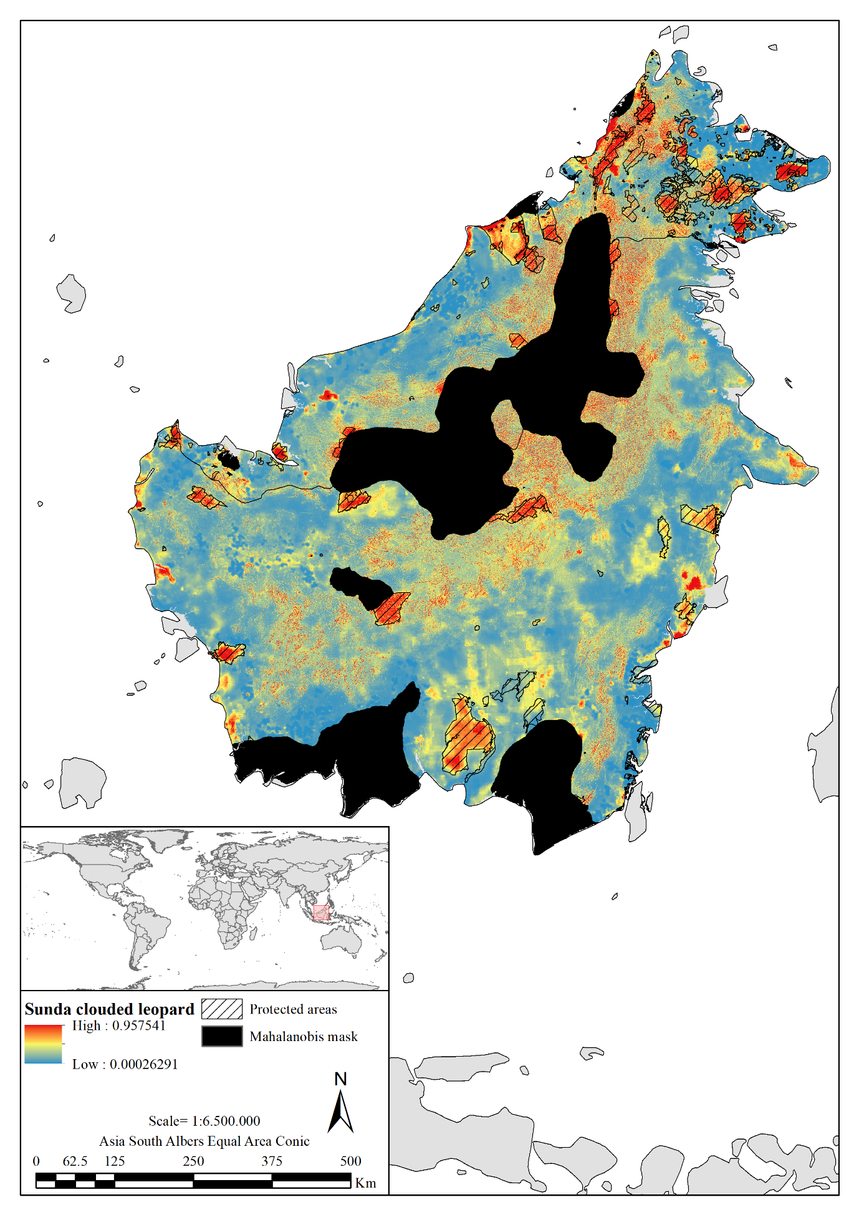
Fig. S5. Species distribution probability surface of Sunda clouded leopard in Borneo.

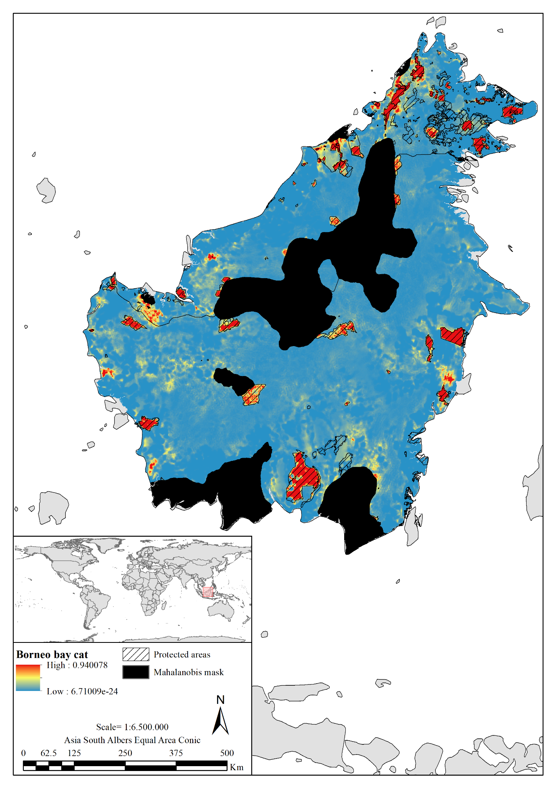
Fig. S6. Species distribution probability surface of Borneo bay cat in Borneo.

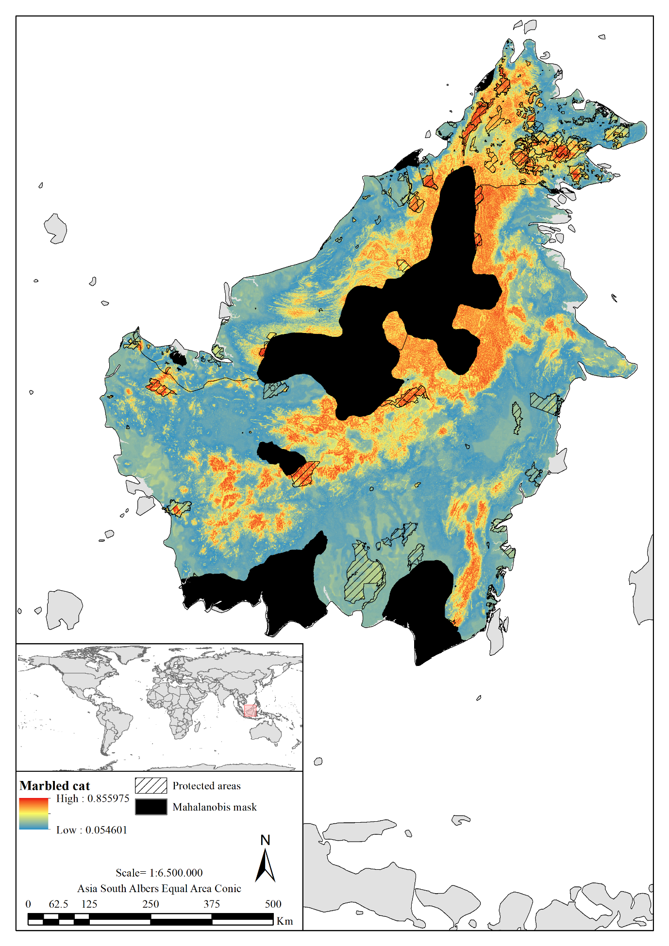
Fig. S7. Species distribution probability surface of marbled cat in Borneo.

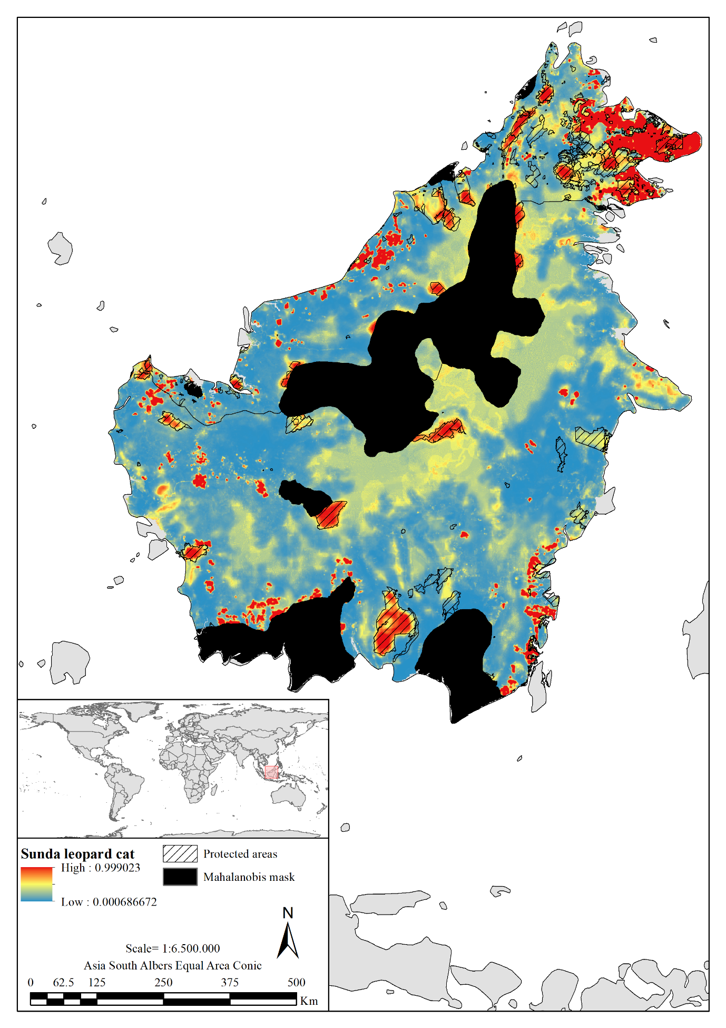
Fig. S8. Species distribution probability surface of Sunda leopard cat in Borneo.

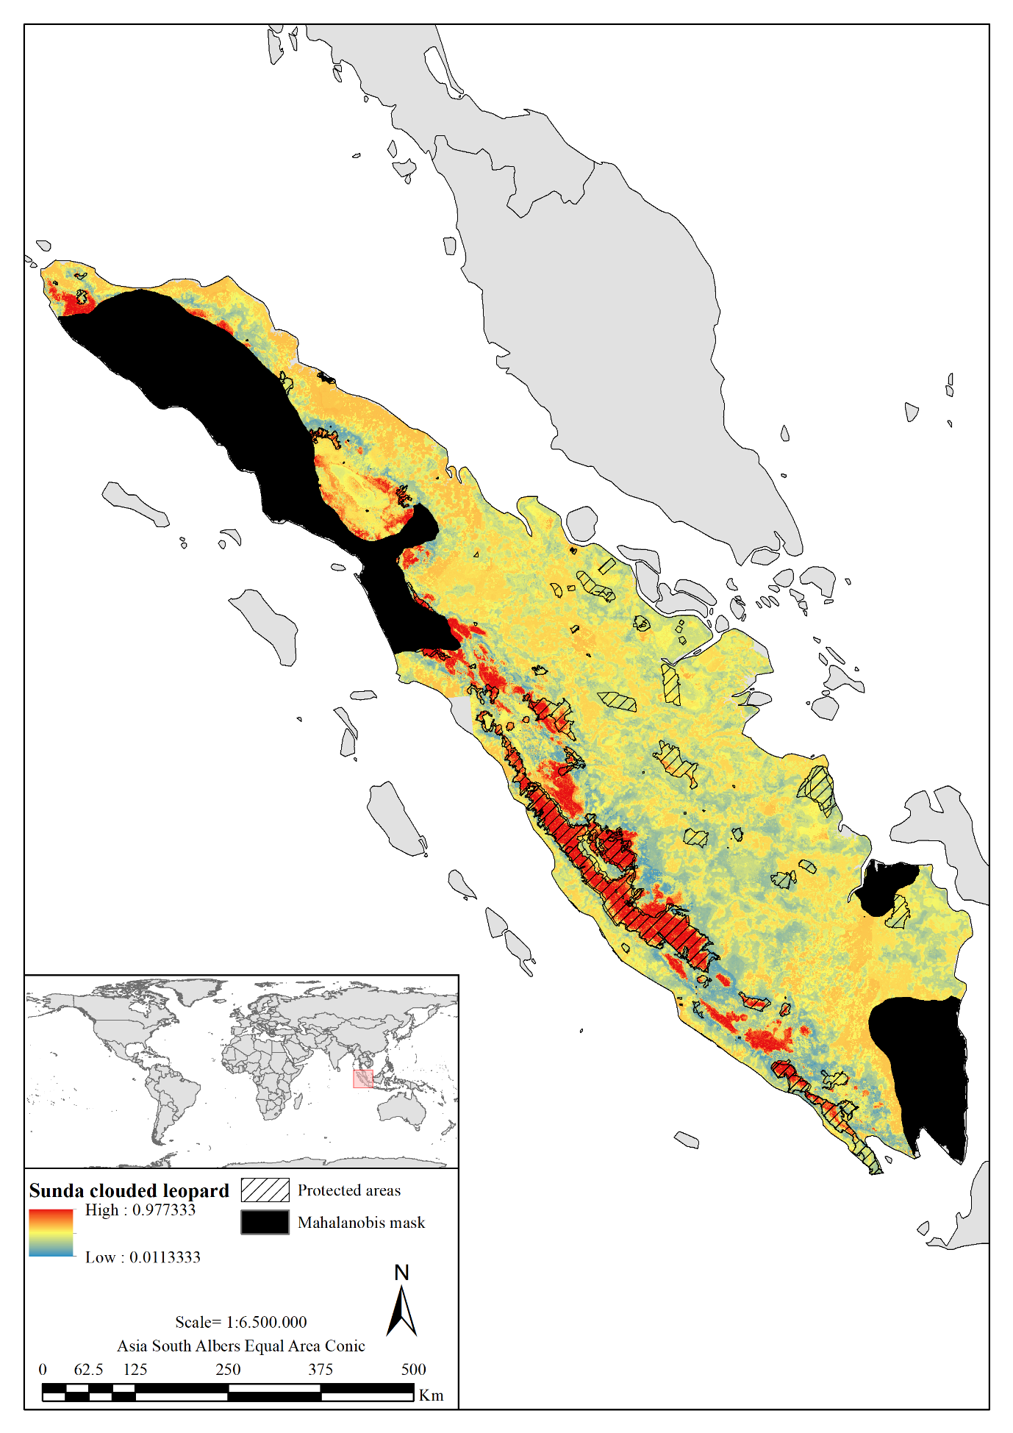
Fig. S9. Species distribution probability surface of Sunda clouded leopard in Sumatra.

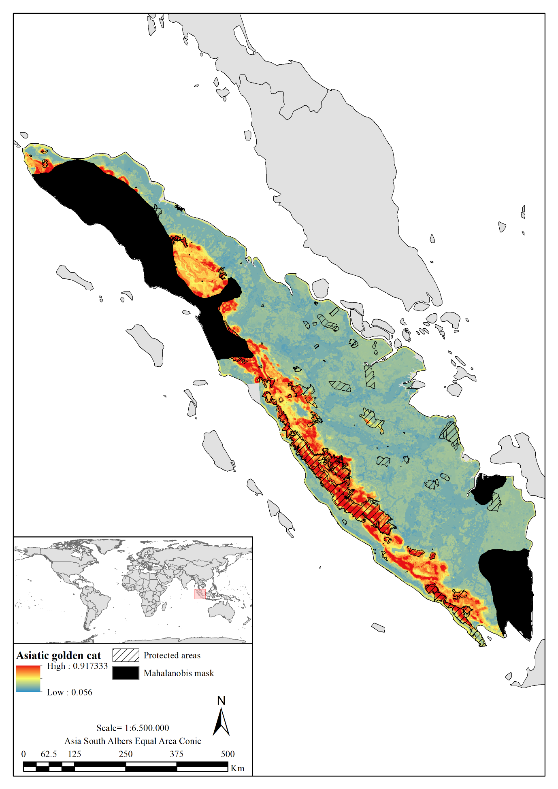
Fig. S10. Species distribution probability surface of Asiatic golden cat in Sumatra.

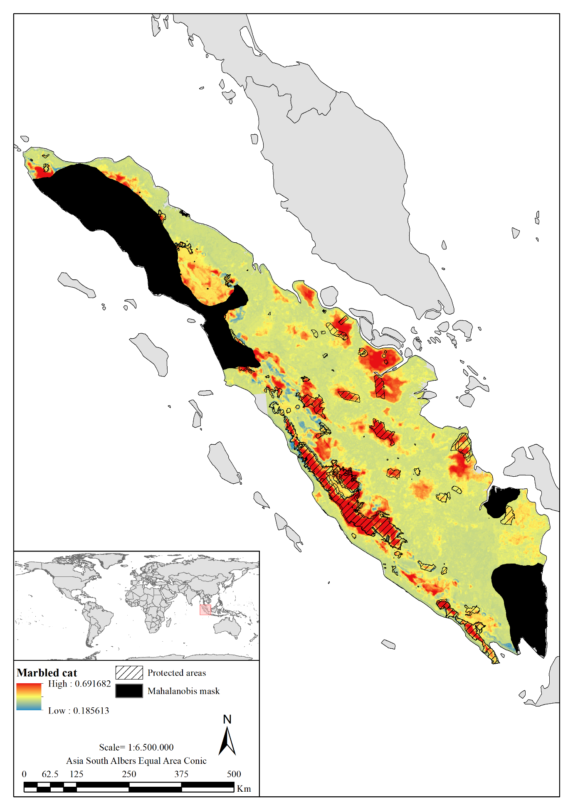
Fig. S11. Species distribution probability surface of marbled cat in Sumatra.

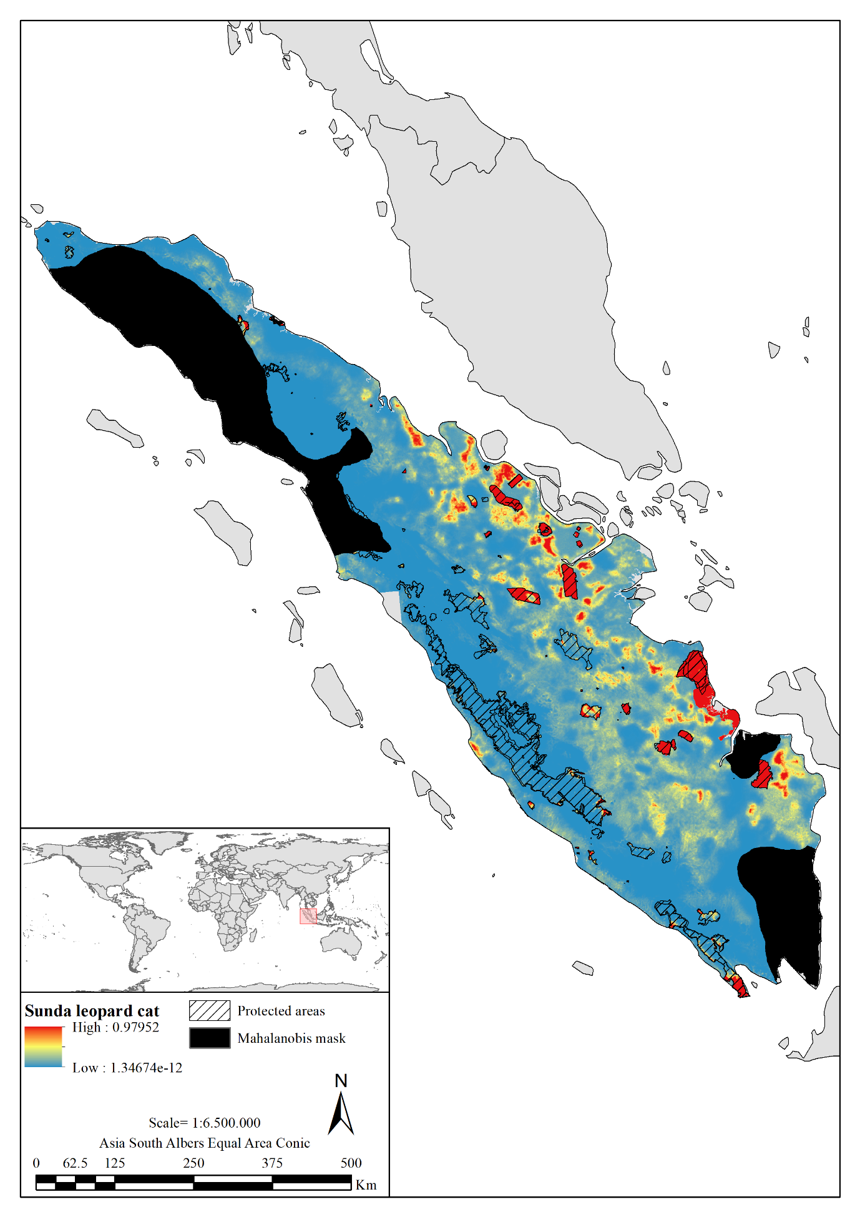
Fig. S12. Species distribution probability surface of Sunda leopard cat in Sumatra.

Table S1. Synoptic table showing country, number of camera trap stations and number of camera trap nights for each sampling location in mainland Southeast Asia. Additionally, we provided the number of detections for each sampled felid.
Country | Sampling location | Number of camera trap stations | Number of camera trap nights | Neofelis nebulosa detections | Catopuma temminckii detections | Pardofelis marmorata detections | Prionailurus bengalensis detections
Cambodia | Cardamom | 76 | 7,740 | 10 | 11 | 17 | 29
 | PPWS | 77 | 5,283 | 1 | 0 | 1 | 31
India | Dampa | 74 | 4,962 | 28 | 22 | 14 | 25
Laos | NPNV | 78 | 3,729 | 8 | 13 | 10 | 13
 | PD | 78 | 3,666 | 15 | 25 | 15 | 15
 | PS | 72 | 3,446 | 16 | 7 | 3 | 4
Malaysia (peninsular) | Ulu Muda Grid 1 | 76 | 9,251 | 10 | 0 | 10 | 39
 | Ulu Muda Grid 2 | 54 | 5,995 | 11 | 2 | 5 | 21
Myanmar | Htamanthi | 162 | 14,546 | 67 | 56 | 31 | 45
Nepal | Langtang NP | 83 | 7,105 | 7 | 0 | 0 | 37
Thailand | Dong Yai Wildlife Sanctuary | 58 | 2,709 | 3 | 0 | 0 | 3
 | Khao Yai National Park | 67 | 6,266 | 10 | 2 | 1 | 20
 | Pang Sida National Park | 163 | 17,750 | 24 | 5 | 3 | 28
 | Ta Phraya National Park | 56 | 4,636 | 5 | 0 | 1 | 8
 | Thap Lan National Park | 210 | 18,305 | 20 | 5 | 5 | 27
Total |  | 1,384 | 115,389 | 235 | 148 | 116 | 345

Table S2. Synoptic table showing country, number of camera trap stations and number of camera trap nights for each sampling location in Borneo. Additionally, we provided the number of detections for each sampled felid.
Country | Sampling location | Number of camera trap stations | Number of camera trap nights | Neofelis diardi detections | Catopuma badia detections | Pardofelis marmorata detections | Prionailurus javanensis detections
Indonesia (Kalimantan) | Bawan | 63 | 4,070 | 0 | 0 | 1 | 1
 | Belantikan | 51 | 3,846 | 2 | 0 | 0 | 3
 | Kutai | 52 | 3,269 | 1 | 2 | 1 | 0
 | Lesan | 73 | 10,057 | 1 | 0 | 1 | 1
 | Sungai Wain | 78 | 4,729 | 9 | 1 | 0 | 0
Malaysia (Sabah) | Crocker | 35 | 4,059 | 13 | 0 | 8 | 12
 | Danum Palm | 23 | 2,214 | 0 | 0 | 1 | 23
 | Danum Valley | 79 | 5,880 | 30 | 1 | 20 | 14
 | IJM | 33 | 1,855 | 0 | 0 | 0 | 26
 | Kinabatangan | 68 | 4,450 | 10 | 0 | 4 | 7
 | Malua | 38 | 3,867 | 7 | 2 | 3 | 32
 | Sepilok | 35 | 2,067 | 0 | 0 | 0 | 6
 | Tabin | 74 | 6,877 | 25 | 3 | 11 | 26
 | Tawau | 77 | 17,600 | 38 | 14 | 28 | 30
 | Ulu Segama | 22 | 2,847 | 18 | 2 | 7 | 21
Total |  | 801 | 77,687 | 154 | 25 | 85 | 202

Table S3. Synoptic table showing country, number of camera trap stations and number of camera trap nights for each sampling location in Sumatra. Additionally, we provided the number of detections for each sampled felid.
Country | Sampling location | Number of camera trap stations | Number of camera trap nights | Neofelis diardi detections | Catopuma temminckii detections | Pardofelis marmorata detections | Prionailurus javanensis detections
Indonesia (Sumatra) | Bungo | 79 | 8,405 | 18 | 14 | 7 | 1
 | Ipuh | 79 | 6,276 | 13 | 13 | 7 | 2
 | Kambang | 149 | 12,599 | 12 | 9 | 2 | 1
 | Linggau | 120 | 7,269 | 0 | 2 | 3 | 17
 | Muara Hemat | 164 | 13,466 | 18 | 24 | 3 | 1
 | RKE | 72 | 5,586 | 27 | 16 | 6 | 1
 | Sipurak | 80 | 7,227 | 13 | 24 | 11 | 0
Total |  | 743 | 60,828 | 101 | 102 | 39 | 23

Table S4. Preliminary set of covariates evaluated to model habitat suitability for felids sampled in mainland Southeast Asia.
Class | Covariate | Source | Metric
Landscape | Bare ground | ESA Land Cover CCI (2017) | PLAND
 | Croplands | ESA Land Cover CCI (2017) | PLAND
 | Mosaic areas | ESA Land Cover CCI (2017) | PLAND
 | Forested areas | ESA Land Cover CCI (2017) | PLAND
 | Shrublands and grasslands | ESA Land Cover CCI (2017) | PLAND
 | Permanent snow and ice | ESA Land Cover CCI (2017) | PLAND
 | Urban areas | ESA Land Cover CCI (2017) | PLAND
 | Water | ESA Land Cover CCI (2017) | PLAND
 | Non-forested areas (0-20%) | Hansen et al. (2013) | PLAND
 | Open forests (20-40%) | Hansen et al. (2013) | PLAND
 | Closed forests (>40%) | Hansen et al. (2013) | PLAND
Anthropic | Forest loss | Hansen et al. (2013) | FM
 | Human footprint | WCS and CIESIN (2005) | FM
 | Human population density | CIESIN and CIAT (2016) | FM
 | Protected areas | UNEP-WCMC and IUCN (2022) | PLAND
Topographic | Elevation | Jarvis et al. (2008) | FM
 | Compound Topographic Index | Jarvis et al. (2008); Evans et al. (2014) | FM
 | Slope position | Jarvis et al. (2008); Evans et al. (2014) | FM
Climatic | Mean annual precipitation | Fick and Hijmans (2017) | FM

Table S5. Preliminary set of covariates evaluated to model habitat suitability for felids sampled in Borneo and Sumatra.
Class | Covariate | Source | Metric
Landscape | Lowland forests | Miettinen et al. (2012) | PLAND
 | Lowland mosaic areas | Miettinen et al. (2012) | PLAND
 | Lower-montane forests | Miettinen et al. (2012) | PLAND
 | Lowland open areas | Miettinen et al. (2012) | PLAND
 | Mangroves | Miettinen et al. (2012) | PLAND
 | Montane mosaic areas | Miettinen et al. (2012) | PLAND
 | Montane open areas | Miettinen et al. (2012) | PLAND
 | Palm plantations | Miettinen et al. (2012) | PLAND
 | Peat swamp forests | Miettinen et al. (2012) | PLAND
 | Plantation and regrowth | Miettinen et al. (2012) | PLAND
 | Upper-montane forests | Miettinen et al. (2012) | PLAND
 | Urban areas | Miettinen et al. (2012) | PLAND
 | Water | Miettinen et al. (2012) | PLAND
 | Continuous tree canopy cover | Hansen et al. (2013) | FM
 | Non-forested areas (0-20%) | Hansen et al. (2013) | PLAND
 | Open forests (20-40%) | Hansen et al. (2013) | PLAND
 | Closed forests (>40%) | Hansen et al. (2013) | PLAND
Anthropic | Human footprint | WCS and CIESIN (2005) | FM
 | Human population density | CIESIN and CIAT (2016) | FM
 | Forest loss | Hansen et al. (2013) | PLAND
 | Protected areas | UNEP-WCMC and IUCN (2022) | PLAND
Topographic | Elevation | Jarvis et al. (2008) | FM
 | Roughness | Jarvis et al. (2008); Evans et al. (2014) | FM
 | Slope position | Jarvis et al. (2008); Evans et al. (2014) | FM
 | Compound topographic index | Jarvis et al. (2008); Evans et al. (2014) | FM

Table S6. Most representative spatial scales for felids sampled in mainland Southeast Asia, obtained by applying univariate GLM and univariate RF modelling frameworks.
 |  |  | GLM best scales (m) |  |  |  | RF best scales (m)
Class | Covariate | Metric | Neofelis nebulosa | Catopuma temminckii | Pardofelis marmorata | Prionailurus bengalensis | Neofelis nebulosa | Catopuma temminckii | Pardofelis marmorata | Prionailurus bengalensis
Landscape | Bare ground | PLAND | 32,000 | 32,000 | 32,000 | 32,000 | 32,000 | 32,000 | 16,000 | 32,000
 | Croplands | PLAND | 16,000 | 16,000 | 16,000 | 32,000 | 4,000 | 8,000 | 4,000 | 4,000
 | Mosaic areas | PLAND | 8,000 | 8,000 | 250 | 32,000 | 250 | 250 | 250 | 250
 | Forested areas | PLAND | 32,000 | 32,000 | 32,000 | 32,000 | 250 | 250 | 250 | 250
 | Shrublands and grasslands | PLAND | 16,000 | 32,000 | 1,000 | 2,000 | 250 | 250 | 250 | 250
 | Urban areas | PLAND | 32,000 | 32,000 | 32,000 | 16,000 | 16,000 | 16,000 | 16,000 | 16,000
 | Water | PLAND | 16,000 | 8,000 | 16,000 | 16,000 | 8,000 | 8,000 | 8,000 | 8,000
 | Non-forested areas | PLAND | 32,000 | 32,000 | 32,000 | 32,000 | 1,000 | 8,000 | 1,000 | 1,000
 | Open forests | PLAND | 16,000 | 32,000 | 32,000 | 32,000 | 500 | 4,000 | 500 | 500
 | Closed forests | PLAND | 16,000 | 32,000 | 32,000 | 32,000 | 500 | 500 | 500 | 250
Anthropic | Forest loss | FM | 500 | 500 | 16,000 | 8,000 | 500 | 500 | 250 | 250
 | Human footprint | FM | 500 | 500 | 1,000 | 32,000 | 250 | 250 | 250 | 250
 | Human population density | FM | 500 | 500 | 500 | 2,000 | 250 | 250 | 250 | 250
 | Protected areas | PLAND | 32,000 | 500 | 250 | 8,000 | 250 | 250 | 250 | 250
Topographic | Elevation | FM | 16,000 | 32,000 | 32,000 | 32,000 | 500 | 1,000 | 2,000 | 32,000
 | Compound topographic index | FM | 500 | 32,000 | 250 | 32,000 | 16,000 | 2,000 | 500 | 16,000
 | Slope position | FM | 8,000 | 8,000 | 250 | 4,000 | 1,000 | 1,000 | 250 | 16,000
Climatic | Mean annual precipitation | FM | 1,000 | 32,000 | 32,000 | 8,000 | 32,000 | 1,000 | 250 | 2,000

Table S7. Most representative spatial scales for felids sampled in Borneo, obtained by applying univariate GLM and univariate RF modelling frameworks.
 |  |  | GLM best scales (m) |  |  |  | RF best scales (m)
Class | Covariate | Metric | Neofelis diardi | Catopuma badia | Pardofelis marmorata | Prionailurus javanensis | Neofelis diardi | Catopuma badia | Pardofelis marmorata | Prionailurus javanensis
Landscape | Lowland forests | PLAND | 8,000 | 4,000 | 8,000 | 8,000 | 250 | 500 | 500 | 250
 | Lowland mosaic areas | PLAND | 8,000 | 8,000 | 8,000 | 8,000 | 250 | 500 | 500 | 250
 | Lower-montane forests | PLAND | 1,000 | 1,000 | 6,000 | 4,000 | 8,000 | 1,000 | 2,000 | 8,000
 | Lowland open areas | PLAND | 10,000 | 4,000 | 10,000 | 10,000 | 500 | 2,000 | 500 | 4,000
 | Mangroves | PLAND | 8,000 | 8,000 | NA⁑ | 6,000 | 4,000 | 4,000 | NA⁑ | 10,000
 | Montane mosaic areas | PLAND | NA* | NA* | NA* | NA* | NA* | NA* | NA* | NA*
 | Montane open areas | PLAND | NA* | NA* | NA* | NA* | NA* | NA* | NA* | NA*
 | Palm plantations | PLAND | 2,000 | 4,000 | 2,000 | 2,000 | 2,000 | 2,000 | 2,000 | 2,000
 | Plantation and regrowth | PLAND | 6,000 | 250 | 4,000 | 8,000 | 500 | 500 | 500 | 250
 | Upper-montane forests | PLAND | NA* | NA* | NA* | NA* | NA* | NA* | NA* | NA*
 | Water | PLAND | 10,000 | NA⁑ | 4,000 | 10,000 | 4,000 | NA⁑ | 4,000 | 4,000
 | Continuous tree canopy cover | FM | 6,000 | 2,000 | 6,000 | 1,000 | 6,000 | 250 | 4,000 | 1,000
 | Non-forested areas | PLAND | 6,000 | 4,000 | 8,000 | 1,000 | 500 | 1,000 | 500 | 1,000
 | Open forests | PLAND | 8,000 | 4,000 | 8,000 | 10,000 | 1,000 | 4,000 | 4,000 | 10,000
 | Closed forests | PLAND | 6,000 | 4,000 | 8,000 | 1,000 | 1,000 | 1,000 | 500 | 1,000
Anthropic | Human footprint | FM | 250 | 10,000 | 10,000 | 500 | 250 | 250 | 250 | 250
 | Human population density | FM | 6,000 | 250 | 10,000 | 250 | 500 | 4,000 | 2,000 | 4,000
 | Forest loss | PLAND | 8,000 | 4,000 | 10,000 | 8,000 | 500 | 2,000 | 500 | 500
 | Protected areas | PLAND | 8,000 | 4,000 | 8,000 | 10,000 | 250 | 1,000 | 500 | 1,000
Topographic | Elevation | FM | 250 | 250 | 250 | 10,000 | 10,000 | 8,000 | 8,000 | 10,000
 | Roughness | FM | 1,000 | 2,000 | 1,000 | 10,000 | 8,000 | 4,000 | 8,000 | 6,000
 | Slope position | FM | 250 | 8,000 | 250 | 250 | 250 | 6,000 | 250 | 10,000
 | Compound topographic index | FM | 500 | 2,000 | 500 | 10,000 | 1,000 | 2,000 | 1,000 | 6,000
* Covariates excluded from the models because occurring in <10% of camera trap stations.
⁑ Covariates excluded because the univariate models did not converge.

Table S8. Most representative spatial scales for felids sampled in Sumatra, obtained by applying univariate GLM and univariate RF modelling frameworks.
 |  |  | GLM best scales (m) |  |  |  | RF best scales (m)
Class | Covariate | Metric | Neofelis diardi | Catopuma temminckii | Pardofelis marmorata | Prionailurus javanensis | Neofelis diardi | Catopuma temminckii | Pardofelis marmorata | Prionailurus javanensis
Landscape | Lowland forests | PLAND | 4,000 | 6,000 | 500 | 6,000 | 500 | 500 | 500 | 500
 | Lowland mosaic areas | PLAND | 8,000 | 10,000 | 8,000 | 4,000 | 2,000 | 2,000 | 4,000 | 2,000
 | Lower-montane forests | PLAND | 250 | 6,000 | 2,000 | 500 | 250 | 250 | 500 | 500
 | Lowland open areas | PLAND | 6,000 | 10,000 | 6,000 | 4,000 | 4,000 | 4,000 | 6,000 | 6,000
 | Mangroves | PLAND | NA* | NA* | NA* | NA* | NA* | NA* | NA* | NA*
 | Montane mosaic areas | PLAND | 2,000 | 10,000 | 6,000 | 10,000 | 2,000 | 2,000 | 4,000 | 6,000
 | Montane open areas | PLAND | 8,000 | 8,000 | 8,000 | 10,000 | 6,000 | 10,000 | 6,000 | 8,000
 | Palm plantations | PLAND | 8,000 | 10,000 | 8,000 | NA⁑ | 8,000 | 8,000 | 8,000 | NA⁑
 | Plantation and regrowth | PLAND | 1,000 | 2,000 | 2,000 | 2,000 | 250 | 500 | 500 | 500
 | Upper-montane forests | PLAND | 6,000 | 10,000 | 10,000 | 10,000 | 4,000 | 4,000 | 4,000 | 4,000
 | Water | PLAND | NA* | NA* | NA* | NA* | NA* | NA* | NA* | NA*
 | Continuous tree canopy cover | FM | 500 | 1,000 | 6,000 | 2,000 | 500 | 2,000 | 6,000 | 6,000
 | Non-forested areas | PLAND | 2,000 | 4,000 | 6,000 | 10,000 | 2,000 | 500 | 2,000 | 2,000
 | Open forests | PLAND | 6,000 | 8,000 | 8,000 | 10,000 | 8,000 | 2,000 | 4,000 | 4,000
 | Closed forests | PLAND | 6,000 | 4,000 | 6,000 | 10,000 | 1,000 | 1,000 | 2,000 | 2,000
Anthropic | Human footprint | FM | 10,000 | 10,000 | 6,000 | 10,000 | 250 | 250 | 250 | 500
 | Human population density | FM | 500 | 1,000 | 10,000 | 10,000 | 250 | 250 | 250 | 250
 | Forest loss | PLAND | 6,000 | 4,000 | 4,000 | 4,000 | 500 | 1,000 | 1,000 | 1,000
 | Protected areas | PLAND | 4,000 | 10,000 | 250 | 250 | 250 | 500 | 250 | 250
Topographic | Elevation | FM | 250 | 8,000 | 4,000 | 250 | 4,000 | 4,000 | 8,000 | 2,000
 | Roughness | FM | 4,000 | 10,000 | 10,000 | 10,000 | 250 | 4,000 | 6,000 | 10,000
 | Slope position | FM | 8,000 | 250 | 1,000 | 2,000 | 250 | 250 | 1,000 | 4,000
 | Compound topographic index | FM | 500 | 250 | 1,000 | 250 | 250 | 8,000 | 6,000 | 2,000
* Covariates excluded from the models because occurring in <10% of camera trap stations.
⁑ Covariates excluded because the univariate models did not converge.

Table S9. Best scale and coefficient of the covariates included in the final model for clouded leopard in mainland Southeast Asia.
Covariate | Best scale (m) | Coefficient
Intercept | NA | -2.89
Camera trap nights | NA | 0.01
Slope position | 8,000 | 0.14
Compound topographic index | 500 | -0.30
Water | 16,000 | -0.06
Mosaic areas | 8,000 | -0.27
Shrublands and grasslands | 16,000 | 0.40
Protected areas | 32,000 | -0.10
Urban areas | 32,000 | 0.08
Forested areas | 32,000 | -0.13
Croplands | 16,000 | -0.21
Human footprint | 500 | 0.61
Closed forests | 16,000 | 0.82

Table S10. Best scale and coefficient of the covariates included in the final model for Asiatic golden cat in mainland Southeast Asia.
Covariate | Best scale (m) | Coefficient
Intercept | NA | -4.84
Camera trap nights | NA | 0.01
Slope position | 8,000 | 0.08
Protected areas | 500 | -0.23
Compound topographic index | 32,000 | -0.02
Shrublands and grasslands | 32,000 | 1.61
Water | 8,000 | -6.04
Forested areas | 32,000 | 1.43
Forest loss | 500 | 0.49
Urban areas | 32,000 | -0.47
Open forests | 32,000 | -0.69
Closed forests | 32,000 | 0.63

Table S11. Best scale and coefficient of the covariates included in the final model for marbled cat in mainland Southeast Asia.
Covariate | Best scale (m) | Coefficient
Intercept | NA | -3.75
Camera trap nights | NA | 0.00
Protected areas | 250 | -0.04
Slope position | 250 | 0.20
Shrublands and grasslands | 1,000 | -0.20
Compound topographic index | 250 | -0.20
Water | 16,000 | -0.31
Mosaic areas | 250 | -0.50
Forest loss | 16,000 | 0.08
Forested areas | 32,000 | 0.01
Urban areas | 32,000 | -0.31
Open forests | 32,000 | 0.32
Closed forests | 32,000 | 1.56

Table S12. Best scale and coefficient of the covariates included in the final model for leopard cat in mainland Southeast Asia.
Covariate | Best scale (m) | Coefficient
Intercept | NA | -2.43
Camera trap nights | NA | 0.01
Urban areas | 16,000 | -0.20
Protected areas | 8,000 | 0.20
Water | 16,000 | 0.15
Human population density | 2,000 | -0.01
Slope position | 4,000 | 0.14
Bare ground | 32,000 | -0.22
Open forests | 32,000 | 0.57
Shrublands and grasslands | 2,000 | -0.11
Compound topographic index | 32,000 | -0.73
Mosaic areas | 32,000 | 0.02
Forested areas | 32,000 | 0.16
Mean annual precipitation | 8,000 | 0.72
Croplands | 32,000 | 0.55

Table S13. Best scale and coefficient of the covariates included in the final model for Sunda clouded leopard in Borneo.
Covariate | Best scale (m) | Coefficient
Intercept | NA | -5.64
Camera trap nights | NA | 0.01
Human footprint | 250 | 0.68
Mangroves | 8,000 | -4.02
Palm plantations | 2,000 | -6.50
Plantation and regrowth | 6,000 | -0.58
Lowland open areas | 10,000 | -0.24
Slope position | 250 | 0.60
Protected areas | 8,000 | 0.35
Forest loss | 8,000 | -0.70
Elevation | 250 | -0.11
Compound topographic index | 500 | -0.31

Table S14. Best scale and coefficient of the covariates included in the final model for Borneo bay cat in Borneo.
Covariate | Best scale (m) | Coefficient
Intercept | NA | -6.19
Camera trap nights | NA | 0.01
Plantation and regrowth | 250 | 0.23
Human footprint | 10,000 | 0.96
Palm plantations | 4,000 | -1.08
Lowland mosaic areas | 8,000 | 0.35
Mangroves | 8,000 | -2.32
Slope position | 8,000 | -0.25
Continuous tree canopy cover | 2,000 | 0.40
Compound topographic index | 2,000 | 0.25
Forest loss | 4,000 | -2.09
Protected areas | 4,000 | 0.94

Table S15. Best scale and mean decrease accuracy of the covariates included in the final model for marbled cat in Borneo.
Covariate | Best scale (m) | Mean decrease accuracy
Camera trap nights | NA | 5.34
Closed forests | 500 | -0.17
Compound topographic index | 1,000 | 7.53
Elevation | 8,000 | 5.05
Human footprint | 250 | 3.54
Lowland forests | 500 | 0.73
Lowland mosaic areas | 500 | 0.89
Lower-montane forests | 2,000 | 0.21
Lowland open areas | 500 | -0.47
Forest loss | 500 | 0.64
Non-forested areas | 500 | -0.29
Open forests | 4,000 | 2.98
Palm plantations | 2,000 | -0.64
Human population density | 2,000 | 2.14
Plantation and regrowth | 500 | -0.08
Protected areas | 500 | 6.92
Roughness | 8,000 | 4.28
Slope position | 250 | 8.10
Continuous tree canopy cover | 4,000 | 4.39
Water | 4,000 | -0.60

Table S16. Best scale and coefficient of the covariates included in the final model for Sunda leopard cat in Borneo.
Covariate | Best scale (m) | Coefficient
Intercept | NA | -3.22
Camera trap nights | NA | 0.01
Slope position | 250 | 0.13
Human population density | 250 | -0.13
Closed forests | 1,000 | -0.38
Human footprint | 500 | 0.59
Open forests | 10,000 | -0.48
Forest loss | 8,000 | 0.51
Lowland open areas | 10,000 | -2.48
Palm plantations | 2,000 | 1.53
Protected areas | 10,000 | 0.70
Plantation and regrowth | 8,000 | -1.27

Table S17. Best scale and mean decrease accuracy of the covariates included in the final model for Sunda clouded leopard in Sumatra.
Covariate | Best scale (m) | Mean decrease accuracy
Camera trap nights | NA | 2.91
Compound topographic index | 250 | 1.49
Elevation | 4,000 | 12.85
Human footprint | 250 | 3.93
Lowland forests | 500 | 6.03
Lower-montane forests | 250 | 11.09
Lowland open areas | 4,000 | 1.41
Montane mosaic areas | 2,000 | 2.46
Non-forested areas | 2,000 | 4.97
Open forests | 8,000 | 10.45
Palm plantations | 8,000 | 7.48
Human population density | 250 | 3.34
Plantation and regrowth | 250 | 12.35
Roughness | 250 | 4.58
Slope position | 250 | 6.24
Continuous tree canopy cover | 500 | 12.08
Upper-montane forests | 4,000 | 3.77

Table S18. Best scale and mean decrease accuracy of the covariates included in the final model for Asiatic golden cat in Sumatra.
Covariate | Best scale (m) | Mean decrease accuracy
Camera trap nights | NA | 11.04
Compound topographic index | 8,000 | 4.54
Elevation | 4,000 | 15.00
Human footprint | 250 | 3.47
Human population density | 250 | 0.55
Roughness | 4,000 | 3.99
Continuous tree canopy cover | 2,000 | 4.80

Table S19. Best scale and mean decrease accuracy of the covariates included in the final model for marbled cat in Sumatra.
Covariate | Best scale (m) | Mean decrease accuracy
Camera trap nights | NA | 2.07
Closed forests | 2,000 | 0.45
Compound topographic index | 6,000 | 1.22
Elevation | 8,000 | 0.67
Human footprint | 250 | 0.65
Lowland forests | 500 | -0.53
Lowland mosaic areas | 4,000 | -0.08
Lower-montane forests | 500 | 0.76
Lowland open areas | 6,000 | 1.47
Forest loss | 1,000 | 0.61
Montane mosaic areas | 4,000 | 0.14
Montane open areas | 6,000 | 0.08
Non-forested areas | 2,000 | -0.16
Open forests | 4,000 | 1.32
Palm plantations | 8,000 | 0.91
Human population density | 250 | -0.31
Plantation and regrowth | 500 | 1.84
Protected areas | 250 | 1.06
Roughness | 6,000 | 0.34
Slope position | 1,000 | -0.53
Continuous tree canopy cover | 6,000 | 1.91
Upper-montane forests | 4,000 | 0.30

Table S20. Best scale and coefficient of the covariates included in the final model for Sunda leopard cat in Sumatra.
Covariate | Best scale (m) | Coefficient
Intercept | NA | -8.29
Camera trap nights | NA | 0.03
Lowland forests | 6,000 | -0.66
Lowland open areas | 4,000 | 0.24
Upper-montane forests | 10,000 | -0.22
Montane mosaic areas | 10,000 | 0.29
Protected areas | 250 | 1.43
Plantation and regrowth | 2,000 | 0.37
Non-forested areas | 10,000 | -1.47
Roughness | 10,000 | -0.67
Forest loss | 4,000 | 0.47
Lower-montane forests | 500 | -1.40
Slope position | 2,000 | -0.55
Compound topographic index | 250 | 0.30
Elevation | 250 | -2.60

