Supplementary appendix

Table S1. Cohort demographics of dataset stratified in two neurocardiovascular risk categories

 | Low neurocardiovascular risk  (n = 225) | Intermediate-high neurocardiovascular risk  (n = 266) | p value
Age (years) | 43.1 ± 15.3 | 60.3 ± 17.2 | < 0.001
Gender
Female | 135 (60%) | 103 (38.72%) | < 0.001
Male | 90 (40%) | 163 (61.28%) | < 0.001
2D images
OD | 205 (50.87%) | 207 (50.99%) | 0.08
OS | 198 (49.13%) | 199 (49.01%) | 0.1
3D volumes
OD | 189 (58.15%) | 197 (57.27%) | 0.07
OS | 136 (41.85%) | 147 (42.73%) | 0.05
CHA₂DS₂-VASc
0 | 54 | 0
1 | 171 | 0
2 | 0 | 121
3 | 0 | 83
4 | 0 | 39
5 | 0 | 20
6 | 0 | 3
7 | 0 | 0
8 | 0 | 0
9 | 0 | 0
Congestive Heart Failure | 1 (0.04 %) | 13 (5.64%) | < 0.001
Hypertension | 15 (6.67%) | 152 (57.52%) | < 0.001
Diabetes | 49 (21.78%) | 146 (54.89%) | < 0.001
Stroke | 0 (0%) | 19 (7.89%) | < 0.001
Vascular disease | 3 (1.33%) | 59 (23.31%) | < 0.001
BMI (kg/m²) | 26.31 ± 6.75 | 27.64 ± 5.64 | < 0.001
Obstructive sleep apnea syndrom | 54 (24%) | 53 (21.05%) | < 0.001
Smoking | 43 (19.11%) | 117 (45.86%) | < 0.001
Dyslipidemia | 64 (28.44%) | 140 (54.14%) | < 0.001
FAZ raw length (mm)
OD | 2.11094 ± 0.98535 | 2.59944 ± 2.75922 | < 0.001
OS | 2.50263 ± 5.48394 | 2.63453 ± 2.73034 | < 0.001
FAZ circularity (index)
OD | 0.71450 ± 0.10830 | 0.67579 ± 0.13228 | < 0.001
OS | 0.70890 ± 0.12058 | 0.67983 ± 0.13224 | < 0.001
FAZ raw size (mm²)
OD | 0.26217 ± 0.20212 | 0.37013 ± 0.62330 | < 0.001
OS | 0.36773 ± 1.42650 | 0.35169 ± 0.46060 | < 0.001
Superficial density average (mm⁻¹)
OD | 18.80578 ± 2.04037 | 18.15997 ± 2.29528 | < 0.001
OS | 19.22418 ± 2.22279 | 18.69722 ± 1.94740 | < 0.001
Deep density average (mm⁻¹)
OD | 11.66953 ± 4.15646 | 10.98035 ± 3.95363 | < 0.001
OS | 12.57253 ± 3.97667 | 10.64352 ± 4.28142 | < 0.001
Superficial density circle of 3 mm (mm⁻¹)
OD | 17.82831 ± 2.83015 | 17.12961 ± 2.73442 | < 0.001
OS | 18.21600 ± 2.86958 | 17.60500 ± 2.67419 | < 0.001
Deep density circle of 3 mm (mm⁻¹)
OD | 10.71253 ± 3.92655 | 9.91995 ± 3.71602 | < 0.001
OS | 11.52654 ± 3.81618 | 9.44172 ± 3.91438 | < 0.001
Superficial density circle of 6 mm (mm⁻¹)
OD | 18.85921 ± 2.21284 | 18.29860 ± 2.17277 | < 0.001
OS | 19.21006 ± 2.34993 | 18.66469 ± 1.07267 | < 0.001
Deep density circle of 6 mm (mm⁻¹)
OD | 11.75994 ± 4.17580 | 11.12017 ± 4.00451 | < 0.001
OS | 12.67029 ± 4.01169 | 10.64802 ± 4.28640 | < 0.001
Superficial perfusion average (index)
OD | 0.41452 ± 0.04166 | 0.40130 ± 0.05011 | < 0.001
OS | 0.42514 ± 0.04534 | 0.40962 ± 0.04782 | < 0.001
Deep perfusion average (index)
OD | 0.23240 ± 0.08449 | 0.21865 ± 0.08435 | < 0.001
OS | 0.25442 ± 0.08196 | 0.25745 ± 0.51454 | < 0.001
Superficial perfusion circle of 3 mm (index)
OD | 0.37463 ± 0.059532 | 0.35943 ± 0.06527 | < 0.001
OS | 0.38511 ± 0.05724 | 0.36545 ± 0.06367 | < 0.001
Deep perfusion circle of 3 mm (index)
OD | 0.21412 ± 0.08169 | 0.19650 ± 0.07975 | < 0.001
OS | 0.23171 ± 0.07995 | 0.21657 ± 0.31525 | < 0.001
Superficial perfusion circle of 6 mm (index)
OD | 0.41070 ± 0.05149 | 0.39776 ± 0.05232 | < 0.001
OS | 0.41989 ± 0.047530 | 0.40248 ± 0.05277 | < 0.001
Deep perfusion circle of 6 mm (index)
OD | 0.23489 ± 0.08484 | 0.22034 ± 0.08514 | < 0.001
OS | 0.25555 ± 0.08314 | 0.25617 ± 0.48568 | < 0.001
Descriptive results are presented as n (%) and mean ± standard deviation. Pearson’s chi-squared test was used to compare categorical variables and ANOVA test was used to compare the quantitative data.
BMI: Body Mass Index. FAZ: Fovea Avascular Zone.

Figure S1. Learning curves of model performance for the 5-fold cross validation according to microvascular plexuses

Vascular retinal layer | Superficial | Deep | Choriocapillaris
Fold 1 | 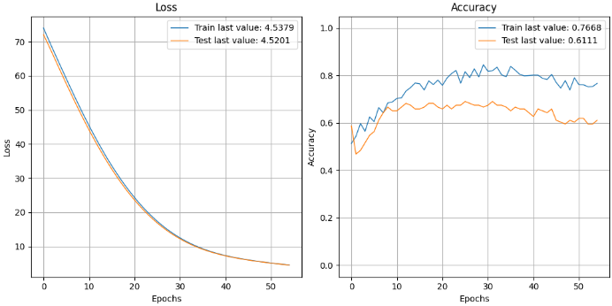 | 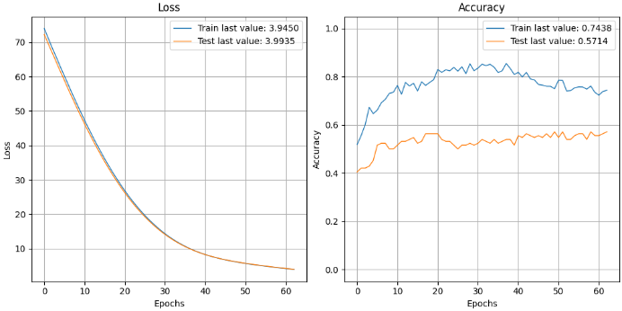 | 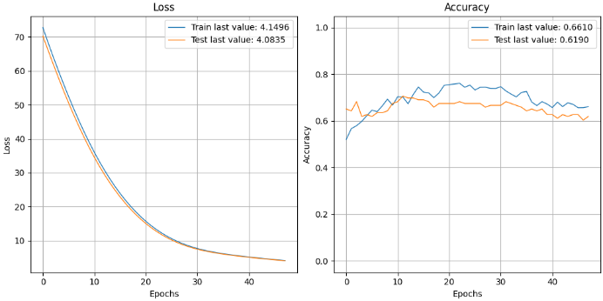
Fold 2 | 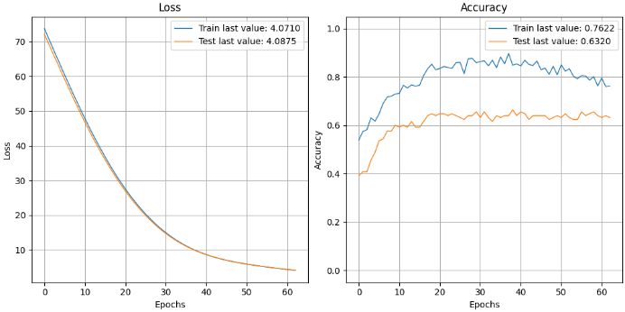 | 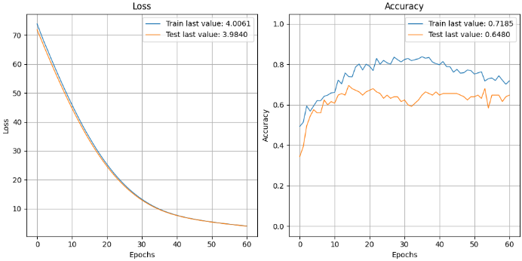 | 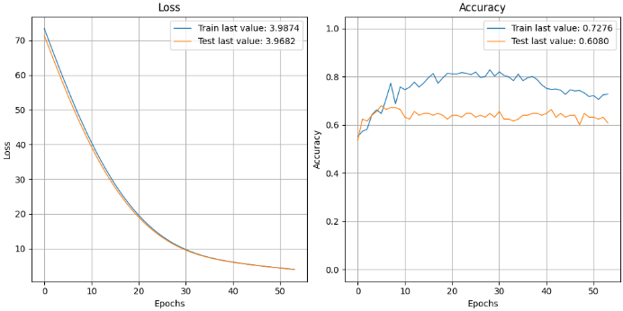
Fold 3 | 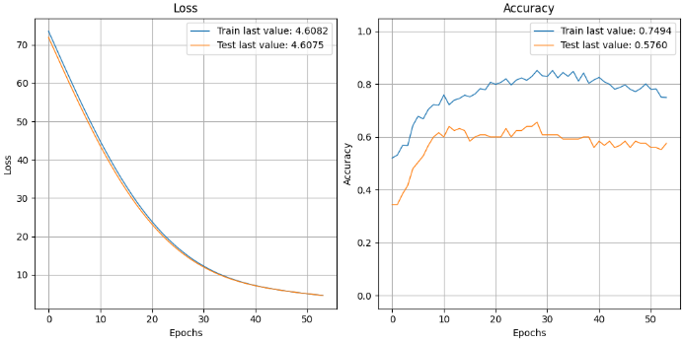 | 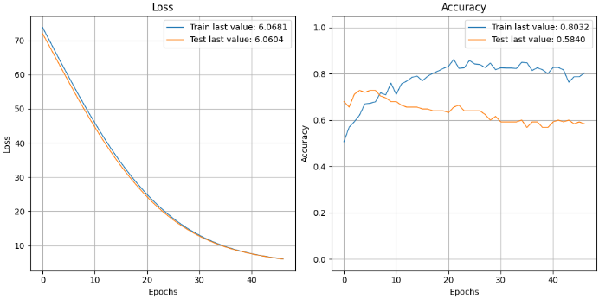 | 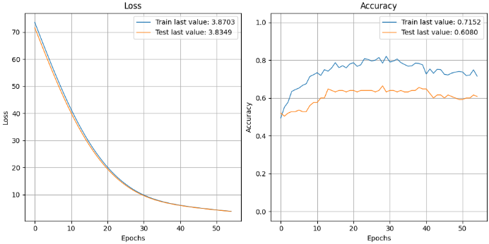
Fold 4 | 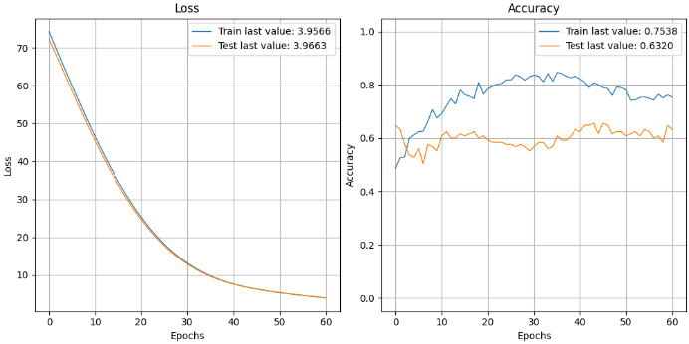 | 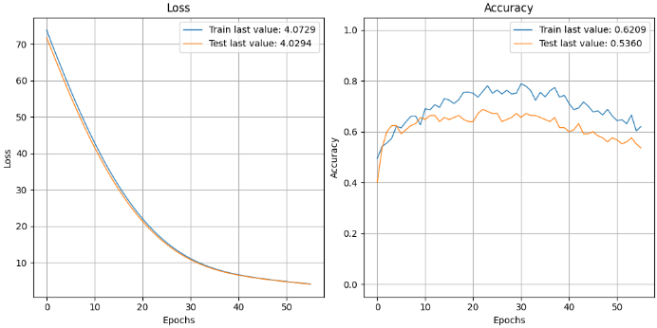 | 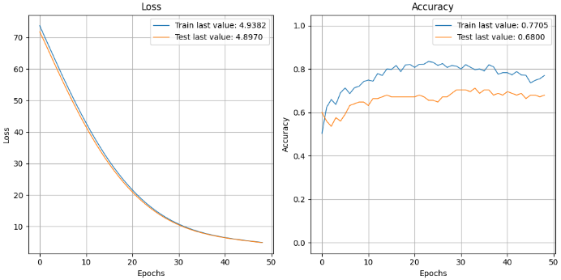
Fold 5 | 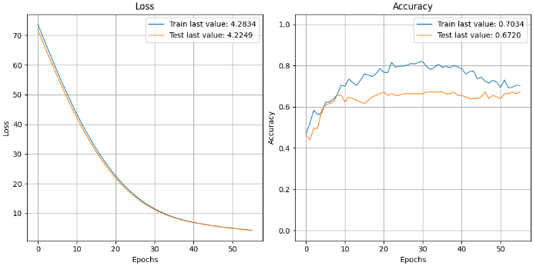 | 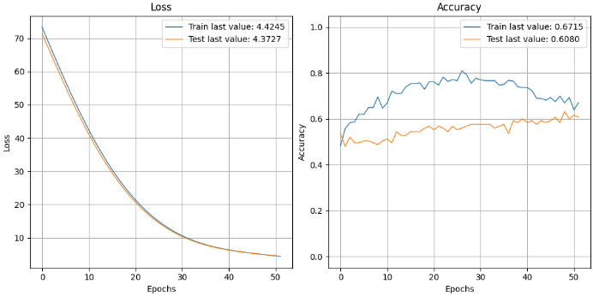 | 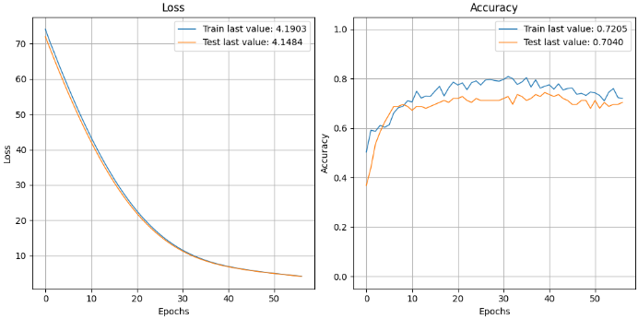

Figure S2. Deep learning classification results details

