Supplementary Materials for
A Penta-Component Mpox mRNA Vaccine Induced Protective Immunity in Naive and Simian Immunodeficiency Virus Infected Nonhuman Primates

Qing Ye^{1,}†, Dong Zhang^{2,}†, Rong-Rong Zhang^{1,}†, Qian Xu^{3,}†, Xing-Yao Huang^{1,}†, Baoying Huang^{4,}†, Meng-Xu Sun^{1,}†, Zhe Cong², Lin Zhu², Jianrong Ma², Na Li², Jingjing Zhang², Ting Chen², Jiahan Lu², Yongzhi Hou², Xiang Chen¹, Hai-Tao Liu¹, Chao Zhou¹, Mei Wu¹, Zheng-Jian Wang¹, Jiye Yin⁵, Ye-Feng Qiu⁶, Bo Ying⁷, Wen-Jie Tan^{4,}*, Jing Xue^{2,}*, Cheng-Feng Qin^{1,8,}*

*Correspondence: qincf@bmi.ac.cn (C.F.Q), xuejing@cnilas.org (J.X.), tanwj@ivdc.chinacdc.cn (W.J.T.)

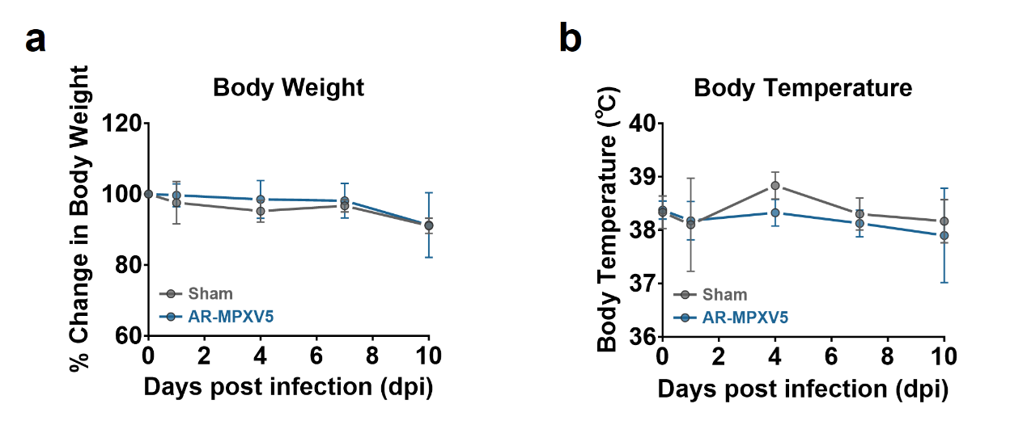
Supplementary Fig. 1 Changes of body weight (a) and body temperature (b) after MPXV challenge.

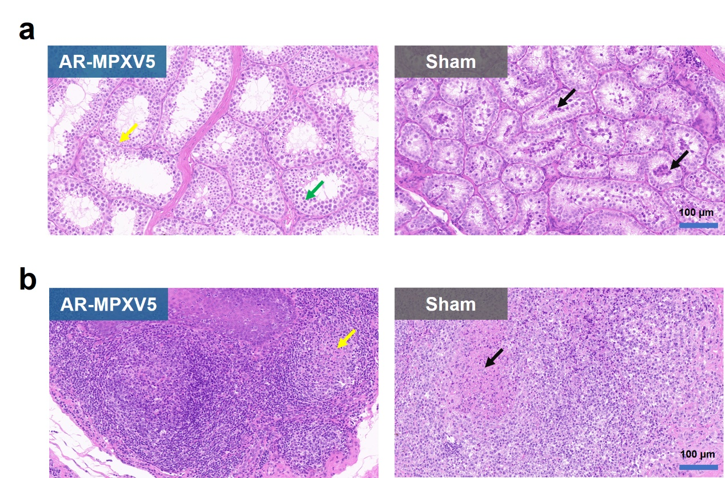
Supplementary Fig. 2 H&E staining of testis (a) and tonsil (b) from MPXV-infected macaques.

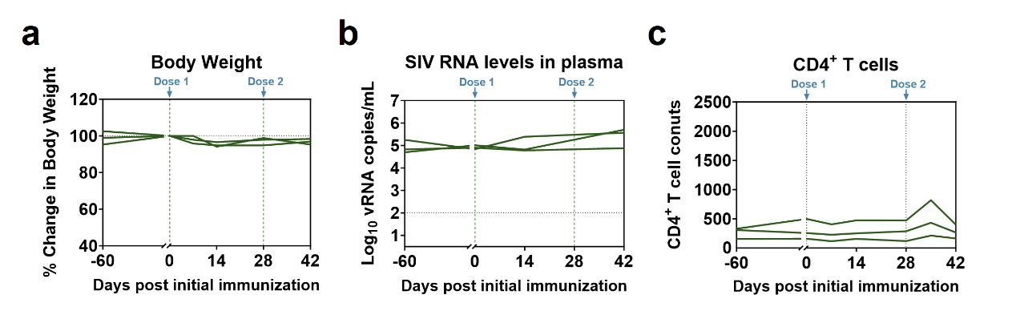
Supplementary Fig. 3 Changes of body weight, plasma viremia and CD4⁺ T cell counts in SIV-infected rhesus monkeys after AR-MPXV5 vaccination. Animals were immunized at 27, 43 and 49 months after SIV infection, respectively. a, Changes of body weight. b, SIV loads in plasma. c, CD4⁺ T cell counts.

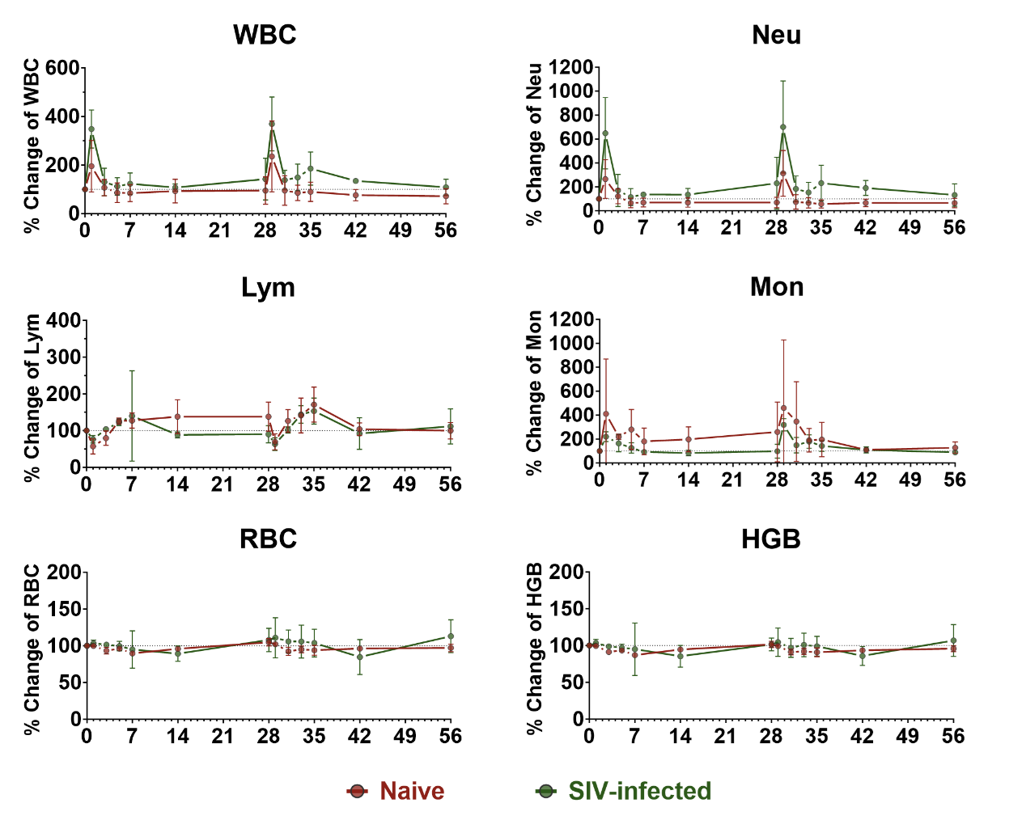
Supplementary Fig. 4 Hematological parameter alterations in naive and SIV-infected rhesus monkeys after vaccination. Hematological parameters were recorded and analyzed at 0, 1, 3, 5, 7 and 14 days after the prime and boost immunization. Changes in white blood cell (WBC) count, neutrophil (Neu) count, lymphocyte (Lym) count, monocyte (Mon) count, red blood cell (RBC) count and hemoglobin (HGB) are shown as mean ± SEM.

Parameter | Day0 |  |  | Day1 |  |  | Day3 |  |  | Day5 |  |  | Day7 |  |  | D14 |  |  | D28 |  |  | D29 |  |  | D31 |  |  | D33 |  |  | D35 |  |  | D42 |  |  | D56
Parameter | Mean | SE |  | Mean | SE |  | Mean | SE |  | Mean | SE |  | Mean | SE |  | Mean | SE |  | Mean | SE |  | Mean | SE |  | Mean | SE |  | Mean | SE |  | Mean | SE |  | Mean | SE |  | Mean | SE
WBC (10⁹/L) | 9.01 | 2.05 |  | 16.39 | 4.15 |  | 9.09 | 1.28 |  | 6.79 | 0.83 |  | 6.88 | 0.91 |  | 7.45 | 1.60 |  | 7.55 | 1.98 |  | 19.40 | 5.58 |  | 7.70 | 2.26 |  | 6.94 | 0.28 |  | 7.35 | 1.20 |  | 6.31 | 0.46 |  | 5.78 | 0.77
Neu (10⁹/L) | 6.22 | 2.34 |  | 14.05 | 3.97 |  | 6.52 | 1.60 |  | 2.99 | 0.40 |  | 3.42 | 0.67 |  | 3.49 | 0.80 |  | 3.36 | 0.86 |  | 16.06 | 4.26 |  | 3.64 | 1.45 |  | 2.98 | 0.39 |  | 2.77 | 0.67 |  | 3.47 | 0.70 |  | 3.09 | 0.69
Lym (10⁹/L) | 2.29 | 0.37 |  | 1.39 | 0.45 |  | 1.79 | 0.34 |  | 2.87 | 0.42 |  | 2.83 | 0.27 |  | 3.17 | 0.79 |  | 3.14 | 0.68 |  | 1.62 | 0.41 |  | 2.80 | 0.38 |  | 3.04 | 0.10 |  | 3.72 | 0.34 |  | 2.33 | 0.29 |  | 2.19 | 0.11
Mon (10⁹/L) | 0.28 | 0.08 |  | 0.73 | 0.24 |  | 0.60 | 0.16 |  | 0.62 | 0.01 |  | 0.40 | 0.03 |  | 0.45 | 0.04 |  | 0.51 | 0.13 |  | 0.79 | 0.33 |  | 0.67 | 0.15 |  | 0.45 | 0.11 |  | 0.42 | 0.06 |  | 0.29 | 0.08 |  | 0.31 | 0.04
RBC (10¹²/L) | 4.63 | 0.24 |  | 4.62 | 0.22 |  | 4.33 | 0.31 |  | 4.45 | 0.29 |  | 4.15 | 0.25 |  | 4.44 | 0.24 |  | 4.84 | 0.22 |  | 4.73 | 0.27 |  | 4.28 | 0.29 |  | 4.40 | 0.26 |  | 4.36 | 0.37 |  | 4.46 | 0.30 |  | 4.51 | 0.34
HGB (g/L) | 126.67 | 6.39 |  | 126.00 | 5.51 |  | 115.67 | 6.89 |  | 118.33 | 6.64 |  | 110.33 | 6.69 |  | 119.67 | 5.84 |  | 128.33 | 4.91 |  | 125.67 | 6.36 |  | 115.67 | 6.77 |  | 116.33 | 5.36 |  | 115.33 | 8.95 |  | 118.33 | 6.57 |  | 121.33 | 7.54
HCT (%) | 35.10 | 1.59 |  | 35.60 | 1.39 |  | 33.63 | 2.01 |  | 35.10 | 2.00 |  | 32.43 | 1.88 |  | 34.77 | 1.89 |  | 38.13 | 1.44 |  | 38.07 | 2.03 |  | 33.43 | 1.79 |  | 35.10 | 1.76 |  | 34.37 | 2.50 |  | 34.63 | 2.23 |  | 34.50 | 2.44
MCHC (g/L) | 360.00 | 1.73 |  | 354.33 | 3.84 |  | 344.00 | 1.58 |  | 336.67 | 1.20 |  | 339.33 | 3.18 |  | 344.67 | 1.76 |  | 337.00 | 1.00 |  | 331.00 | 1.15 |  | 346.00 | 1.73 |  | 332.33 | 1.45 |  | 335.67 | 1.67 |  | 341.67 | 2.60 |  | 352.33 | 2.73
PLT (10⁹/L) | 224.00 | 18.19 |  | 211.00 | 6.66 |  | 205.00 | 19.97 |  | 251.33 | 51.43 |  | 231.00 | 93.95 |  | 289.00 | 9.07 |  | 237.33 | 8.99 |  | 192.33 | 8.01 |  | 229.33 | 11.35 |  | 284.33 | 26.64 |  | 302.00 | 36.36 |  | 231.00 | 24.01 |  | 230.33 | 12.20
Eos (10⁹/L) | 0.20 | 0.09 |  | 0.12 | 0.06 |  | 0.12 | 0.04 |  | 0.23 | 0.11 |  | 0.20 | 0.08 |  | 0.31 | 0.20 |  | 0.50 | 0.41 |  | 0.77 | 0.71 |  | 0.55 | 0.30 |  | 0.42 | 0.20 |  | 0.41 | 0.16 |  | 0.21 | 0.04 |  | 0.19 | 0.11
Bas (10⁹/L) | 0.02 | 0.01 |  | 0.09 | 0.06 |  | 0.07 | 0.02 |  | 0.07 | 0.01 |  | 0.04 | 0.01 |  | 0.03 | 0.01 |  | 0.03 | 0.01 |  | 0.17 | 0.13 |  | 0.04 | 0.02 |  | 0.05 | 0.02 |  | 0.03 | 0.01 |  | 0.02 | 0.00 |  | 0.01 | 0.00
MCV (fL) | 75.83 | 0.95 |  | 77.07 | 1.20 |  | 77.80 | 1.02 |  | 78.90 | 1.17 |  | 78.10 | 0.85 |  | 78.27 | 1.18 |  | 78.73 | 0.99 |  | 80.50 | 1.05 |  | 78.23 | 1.51 |  | 79.83 | 0.89 |  | 78.97 | 1.62 |  | 77.73 | 1.05 |  | 76.67 | 0.87
MCH (pg) | 27.30 | 0.31 |  | 27.30 | 0.60 |  | 26.77 | 0.46 |  | 26.60 | 0.47 |  | 26.50 | 0.06 |  | 27.00 | 0.44 |  | 26.57 | 0.37 |  | 26.67 | 0.43 |  | 27.07 | 0.52 |  | 26.53 | 0.39 |  | 26.53 | 0.49 |  | 26.53 | 0.41 |  | 27.00 | 0.47
RDW-CV (%) | 11.67 | 0.09 |  | 11.70 | 0.12 |  | 11.70 | 0.10 |  | 11.63 | 0.09 |  | 11.87 | 0.22 |  | 12.00 | 0.35 |  | 11.67 | 0.33 |  | 11.73 | 0.23 |  | 11.93 | 0.20 |  | 11.63 | 0.23 |  | 11.87 | 0.37 |  | 11.80 | 0.32 |  | 12.00 | 0.29
MPV (fL) | 10.97 | 0.48 |  | 11.13 | 0.50 |  | 11.13 | 0.29 |  | 10.40 | 0.35 |  | 10.43 | 0.34 |  | 10.97 | 0.32 |  | 11.10 | 0.70 |  | 10.77 | 0.57 |  | 11.63 | 0.69 |  | 10.67 | 0.35 |  | 10.60 | 0.35 |  | 11.33 | 0.15 |  | 11.27 | 0.26
Supplementary Table 1 Hematological parameters in naive rhesus monkeys after vaccination.

Supplementary Table 2 Hematological parameters in SIV-infected rhesus monkeys after vaccination.

Parameter | Day0 |  |  | Day1 |  |  | Day3 |  |  | Day5 |  |  | Day7 |  |  | D14 |  |  | D28 |  |  | D29 |  |  | D31 |  |  | D33 |  |  | D35 |  |  | D42 |  |  | D56
Parameter | Mean | SE |  | Mean | SE |  | Mean | SE |  | Mean | SE |  | Mean | SE |  | Mean | SE |  | Mean | SE |  | Mean | SE |  | Mean | SE |  | Mean | SE |  | Mean | SE |  | Mean | SE |  | Mean | SE
WBC (10⁹/L) | 3.25 | 0.47 |  | 11.47 | 2.31 |  | 4.25 | 1.15 |  | 3.77 | 0.98 |  | 3.85 | 0.61 |  | 3.51 | 0.59 |  | 4.82 | 1.77 |  | 11.88 | 2.27 |  | 4.45 | 0.83 |  | 5.08 | 1.54 |  | 6.26 | 1.77 |  | 3.80 | 0.36 |  | 3.46 | 0.62
Neu (10⁹/L) | 1.57 | 0.27 |  | 9.68 | 1.93 |  | 2.37 | 0.76 |  | 1.71 | 0.51 |  | 2.11 | 0.31 |  | 2.00 | 0.24 |  | 3.25 | 1.38 |  | 10.12 | 1.93 |  | 2.59 | 0.51 |  | 2.50 | 1.07 |  | 3.40 | 0.94 |  | 2.43 | 0.34 |  | 1.86 | 0.51
Lym (10⁹/L) | 1.37 | 0.33 |  | 1.07 | 0.31 |  | 1.42 | 0.35 |  | 1.68 | 0.43 |  | 1.45 | 0.35 |  | 1.22 | 0.31 |  | 1.29 | 0.41 |  | 0.88 | 0.29 |  | 1.41 | 0.38 |  | 2.03 | 0.61 |  | 2.21 | 0.70 |  | 0.97 | 0.10 |  | 1.34 | 0.11
Mon (10⁹/L) | 0.23 | 0.02 |  | 0.49 | 0.01 |  | 0.36 | 0.08 |  | 0.27 | 0.03 |  | 0.20 | 0.01 |  | 0.18 | 0.02 |  | 0.21 | 0.07 |  | 0.72 | 0.09 |  | 0.32 | 0.05 |  | 0.39 | 0.03 |  | 0.31 | 0.03 |  | 0.27 | 0.07 |  | 0.20 | 0.01
RBC (10¹²/L) | 4.09 | 0.37 |  | 4.21 | 0.28 |  | 4.16 | 0.45 |  | 4.05 | 0.22 |  | 3.77 | 0.26 |  | 3.68 | 0.54 |  | 4.35 | 0.17 |  | 4.42 | 0.24 |  | 4.27 | 0.15 |  | 4.23 | 0.15 |  | 4.17 | 0.13 |  | 3.37 | 0.15 |  | 4.54 | 0.24
HGB (g/L) | 101.67 | 12.24 |  | 104.33 | 9.91 |  | 100.33 | 11.41 |  | 98.00 | 9.29 |  | 91.67 | 9.49 |  | 88.67 | 17.68 |  | 102.00 | 7.81 |  | 103.67 | 3.18 |  | 96.67 | 4.84 |  | 100.33 | 3.76 |  | 98.67 | 4.67 |  | 84.00 | 9.00 |  | 105.67 | 2.73
HCT (%) | 29.80 | 3.09 |  | 30.60 | 2.41 |  | 30.77 | 3.72 |  | 29.67 | 2.19 |  | 27.13 | 2.42 |  | 26.37 | 4.78 |  | 31.53 | 1.70 |  | 31.53 | 0.48 |  | 30.80 | 1.54 |  | 31.07 | 0.57 |  | 29.90 | 0.89 |  | 23.60 | 0.10 |  | 32.47 | 1.09
MCHC (g/L) | 340.33 | 6.77 |  | 339.33 | 6.23 |  | 325.67 | 5.55 |  | 328.33 | 9.21 |  | 337.33 | 6.17 |  | 334.00 | 10.58 |  | 323.33 | 9.82 |  | 329.00 | 9.87 |  | 313.67 | 8.84 |  | 323.00 | 6.81 |  | 328.67 | 7.42 |  | 356.00 | 36.00 |  | 326.33 | 7.45
PLT (10⁹/L) | 318.00 | 58.52 |  | 310.00 | 49.64 |  | 375.33 | 61.66 |  | 443.00 | 69.51 |  | 437.67 | 67.59 |  | 423.00 | 82.71 |  | 317.67 | 66.31 |  | 275.00 | 63.29 |  | 356.67 | 71.27 |  | 412.00 | 59.01 |  | 440.67 | 59.47 |  | 376.00 | 1.00 |  | 373.67 | 82.60
Eos (10⁹/L) | 0.08 | 0.03 |  | 0.20 | 0.08 |  | 0.08 | 0.06 |  | 0.10 | 0.04 |  | 0.08 | 0.04 |  | 0.10 | 0.05 |  | 0.06 | 0.04 |  | 0.12 | 0.06 |  | 0.10 | 0.04 |  | 0.14 | 0.07 |  | 0.33 | 0.25 |  | 0.10 | 0.02 |  | 0.06 | 0.02
Bas (10⁹/L) | 0.01 | 0.01 |  | 0.02 | 0.01 |  | 0.02 | 0.01 |  | 0.01 | 0.01 |  | 0.01 | 0.00 |  | 0.01 | 0.00 |  | 0.01 | 0.00 |  | 0.03 | 0.01 |  | 0.02 | 0.00 |  | 0.02 | 0.00 |  | 0.02 | 0.00 |  | 0.03 | 0.01 |  | 0.00 | 0.00
MCV (fL) | 72.63 | 1.23 |  | 72.60 | 1.22 |  | 73.80 | 1.70 |  | 73.17 | 1.69 |  | 71.77 | 1.74 |  | 70.60 | 3.20 |  | 72.47 | 3.00 |  | 71.60 | 2.90 |  | 72.23 | 3.11 |  | 73.57 | 3.26 |  | 71.87 | 2.92 |  | 70.25 | 3.25 |  | 71.70 | 1.63
MCH (pg) | 24.73 | 0.93 |  | 24.67 | 0.83 |  | 24.03 | 0.86 |  | 24.07 | 1.19 |  | 24.27 | 1.03 |  | 23.63 | 1.78 |  | 23.47 | 1.65 |  | 23.60 | 1.63 |  | 22.70 | 1.39 |  | 23.80 | 1.53 |  | 23.67 | 1.51 |  | 25.10 | 3.70 |  | 23.40 | 1.04
RDW-CV (%) | 12.57 | 0.86 |  | 12.77 | 0.94 |  | 12.57 | 0.94 |  | 12.97 | 1.18 |  | 13.17 | 1.29 |  | 14.10 | 2.35 |  | 14.40 | 2.75 |  | 15.07 | 3.32 |  | 14.60 | 2.76 |  | 14.47 | 2.67 |  | 14.93 | 2.89 |  | 16.35 | 4.75 |  | 14.97 | 2.32
MPV (fL) | 10.03 | 0.45 |  | 10.00 | 0.50 |  | 9.97 | 0.47 |  | 9.60 | 0.42 |  | 9.37 | 0.38 |  | 9.67 | 0.70 |  | 9.73 | 0.73 |  | 10.43 | 0.93 |  | 10.10 | 0.47 |  | 9.87 | 0.46 |  | 9.53 | 0.56 |  | 9.45 | 0.05 |  | 9.13 | 0.45

