Supplementary Figures and Tables
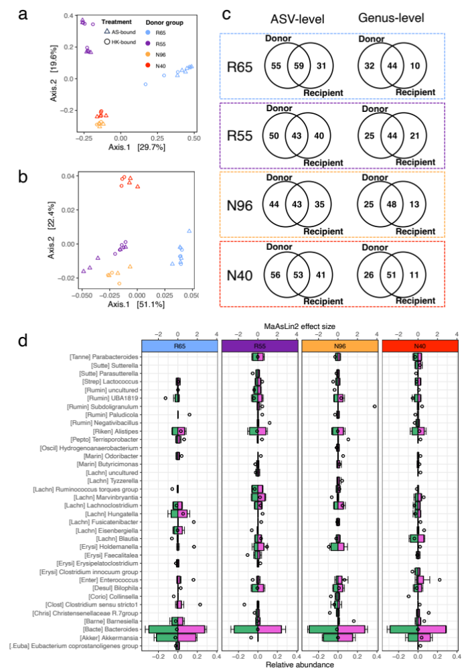
Figure S1. Bacterial community beta diversity and colonization of donor microbiota in recipient mice prior to Anaerobutyricum soehngenii or heat-killed culture treatment. Principal coordinate analysis of unweighted (a) and weighted (b) UniFrac distances of 16S rRNA gene sequencing profiles of feces collected eight weeks after colonization immediately prior to initializing treatment with Anaerobutyricum soehngenii (AS) or heat-killed culture (HK). At the time of feces collection, all mice were housed in the same cage (n = 9-10 per cage) but had been randomly assigned to go to the AS treatment group (AS-bound) or the HK treatment group (HK-bound). c, Venn-diagram comparisons of amplicon sequence variants (ASVs; left) and genera (right) detected above 0.05% relative abundance in human donor fecal inocula versus recipient mouse feces prior to AS/HK treatment. d, Six weeks after treatment, differential abundance analysis was performed on cecal bacterial community profiles using MaAsLin2. Differential-abundance effect sizes are shown (top axis, dots) for genus-level features between treatments within each donor group. The position of the dot relative to the origin represents the direction and magnitude of the effect (left of origin = higher abundance in AS-treated mice; right of origin = higher abundance in HK-treated mice). The significance of the effect size is indicated by a solid dot (P < 0.05) or an open dot (P > 0.05). Relative abundances (bottom axis) of each genus are indicated by the horizontal bars (green = abundance in AS group, pink = abundance in HK group). The first five letters of the family name for each genus are shown in brackets (see Table S3 for the full name).

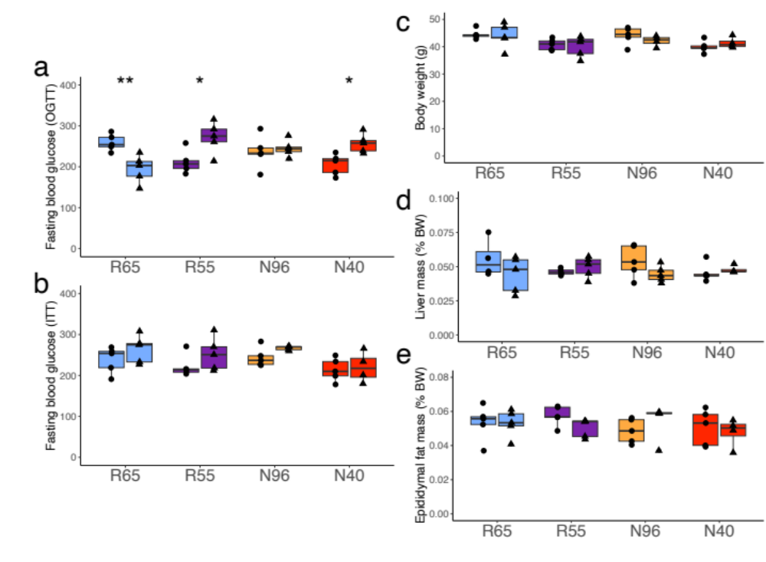
Figure S2. The effect of Anaerobutyricum soehngenii (AS) or heat-killed AS (HK) on fasting blood glucose and body composition in gnotobiotic mice. Fasting blood glucose levels at the start (0 minutes) of the oGTT (a) and the ITT (b) one week later, mice were colonized with fecal microbiota from different human donors (R65, R55, N96, N40) and treated with either live AS (circles) or HK (triangles). Measurements of body weight (c), liver mass (d), and epididymal fat mass (e) collected upon sacrifice, one week after ITT. Comparisons of means were conducted using Student’s T-test between treatment groups within each donor group. Significance is indicated by * (P < 0.05), ** (P < 0.01). n = 4-5/group.

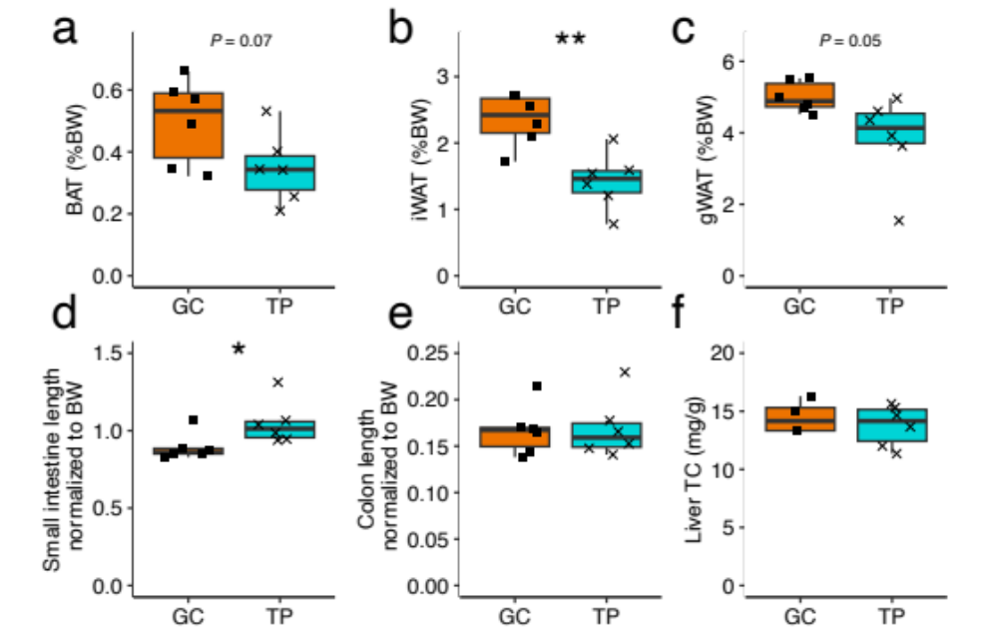
Figure S3. The effect of tripropionin on adipose deposits, intestinal length and liver cholesterol content of conventionally raised mice. Conventionally-raised male mice were treated with either tripropionin (TP) diet or glycerol control (GC) diet for 13 weeks (n=6/group) a-c, weight of brown adipose tissue (BAT), inguinal white adipose tissue (iWAT) and gonadal white adipose tissue (gWAT) expressed as a percentage of body weight. d-e, length of the small intestine and colon in cm normalized to body weight. f, Liver total cholesterol (TC) (n = 4-6/group). Significance is indicated by * (P < 0.05), ** (P < 0.01).

Supplementary Table S1. Spearman correlation rho (ρ) coefficients, P-values, and adjusted P-values (fdr) of cecal SCFA levels vs AUCs for oGTT and ITT within each donor group.
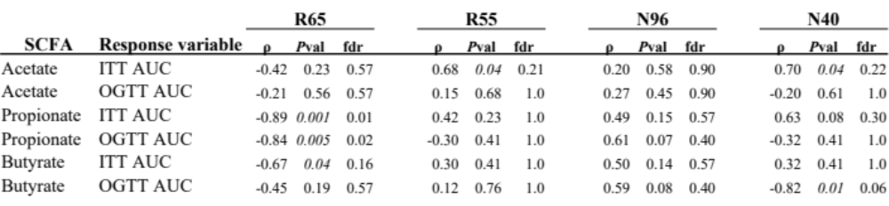

Supplementary Table S2. Composition of diets. All diets were irradiated and vacuum-packed.
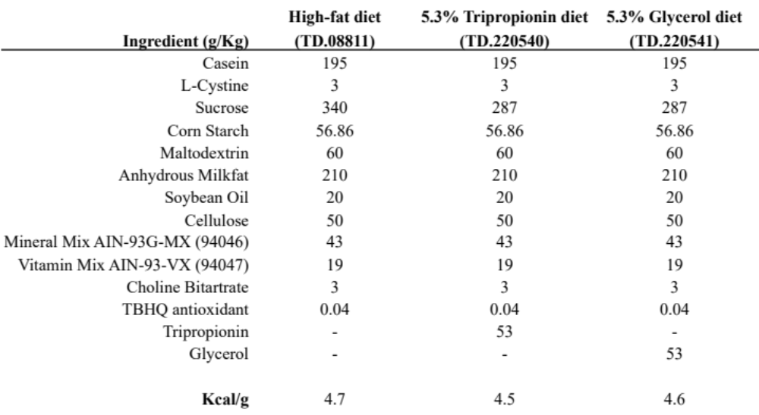

Supplemental Table S3. List of family-level abbreviations of bacterial classifications used in Figure 2.
