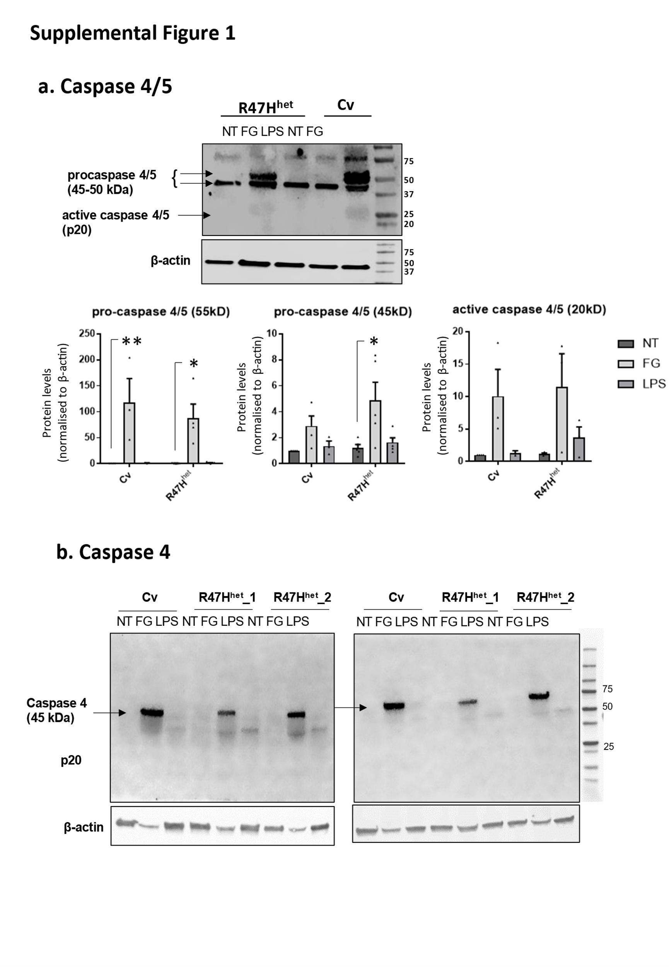
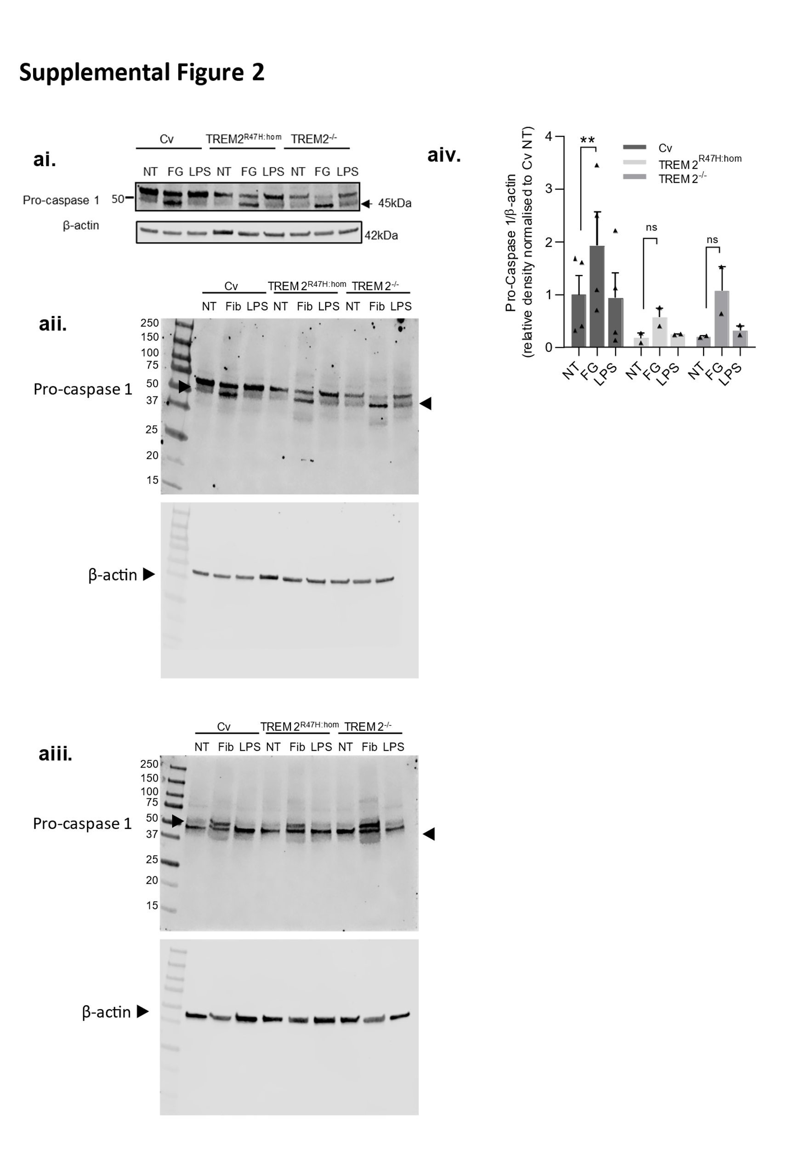
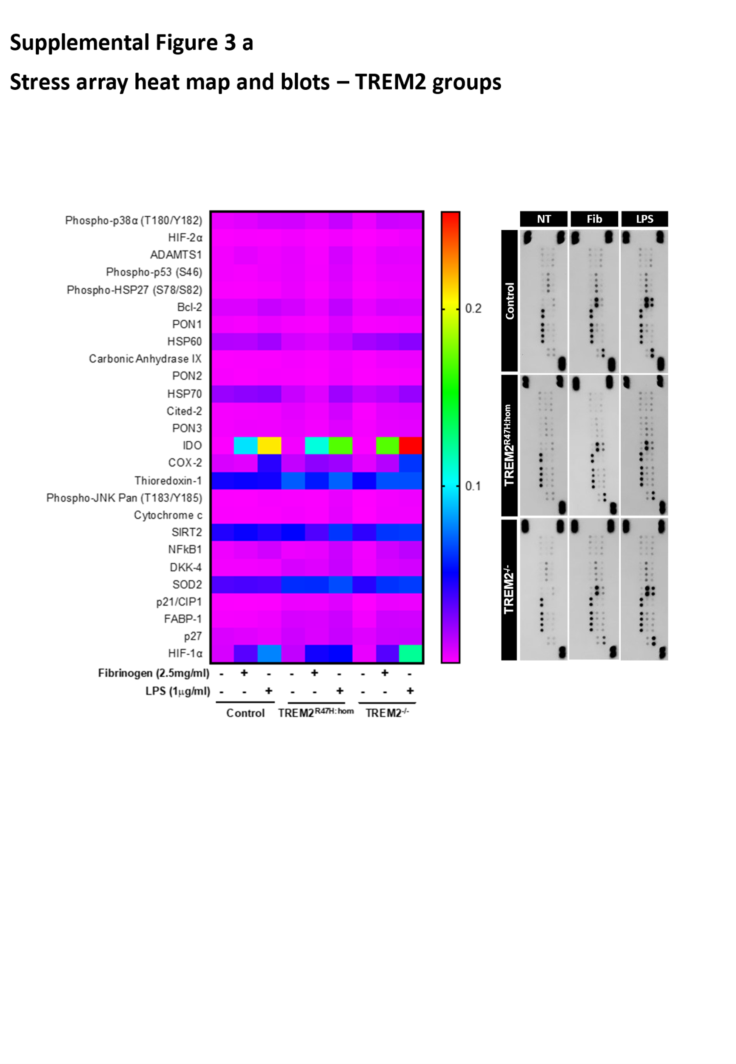
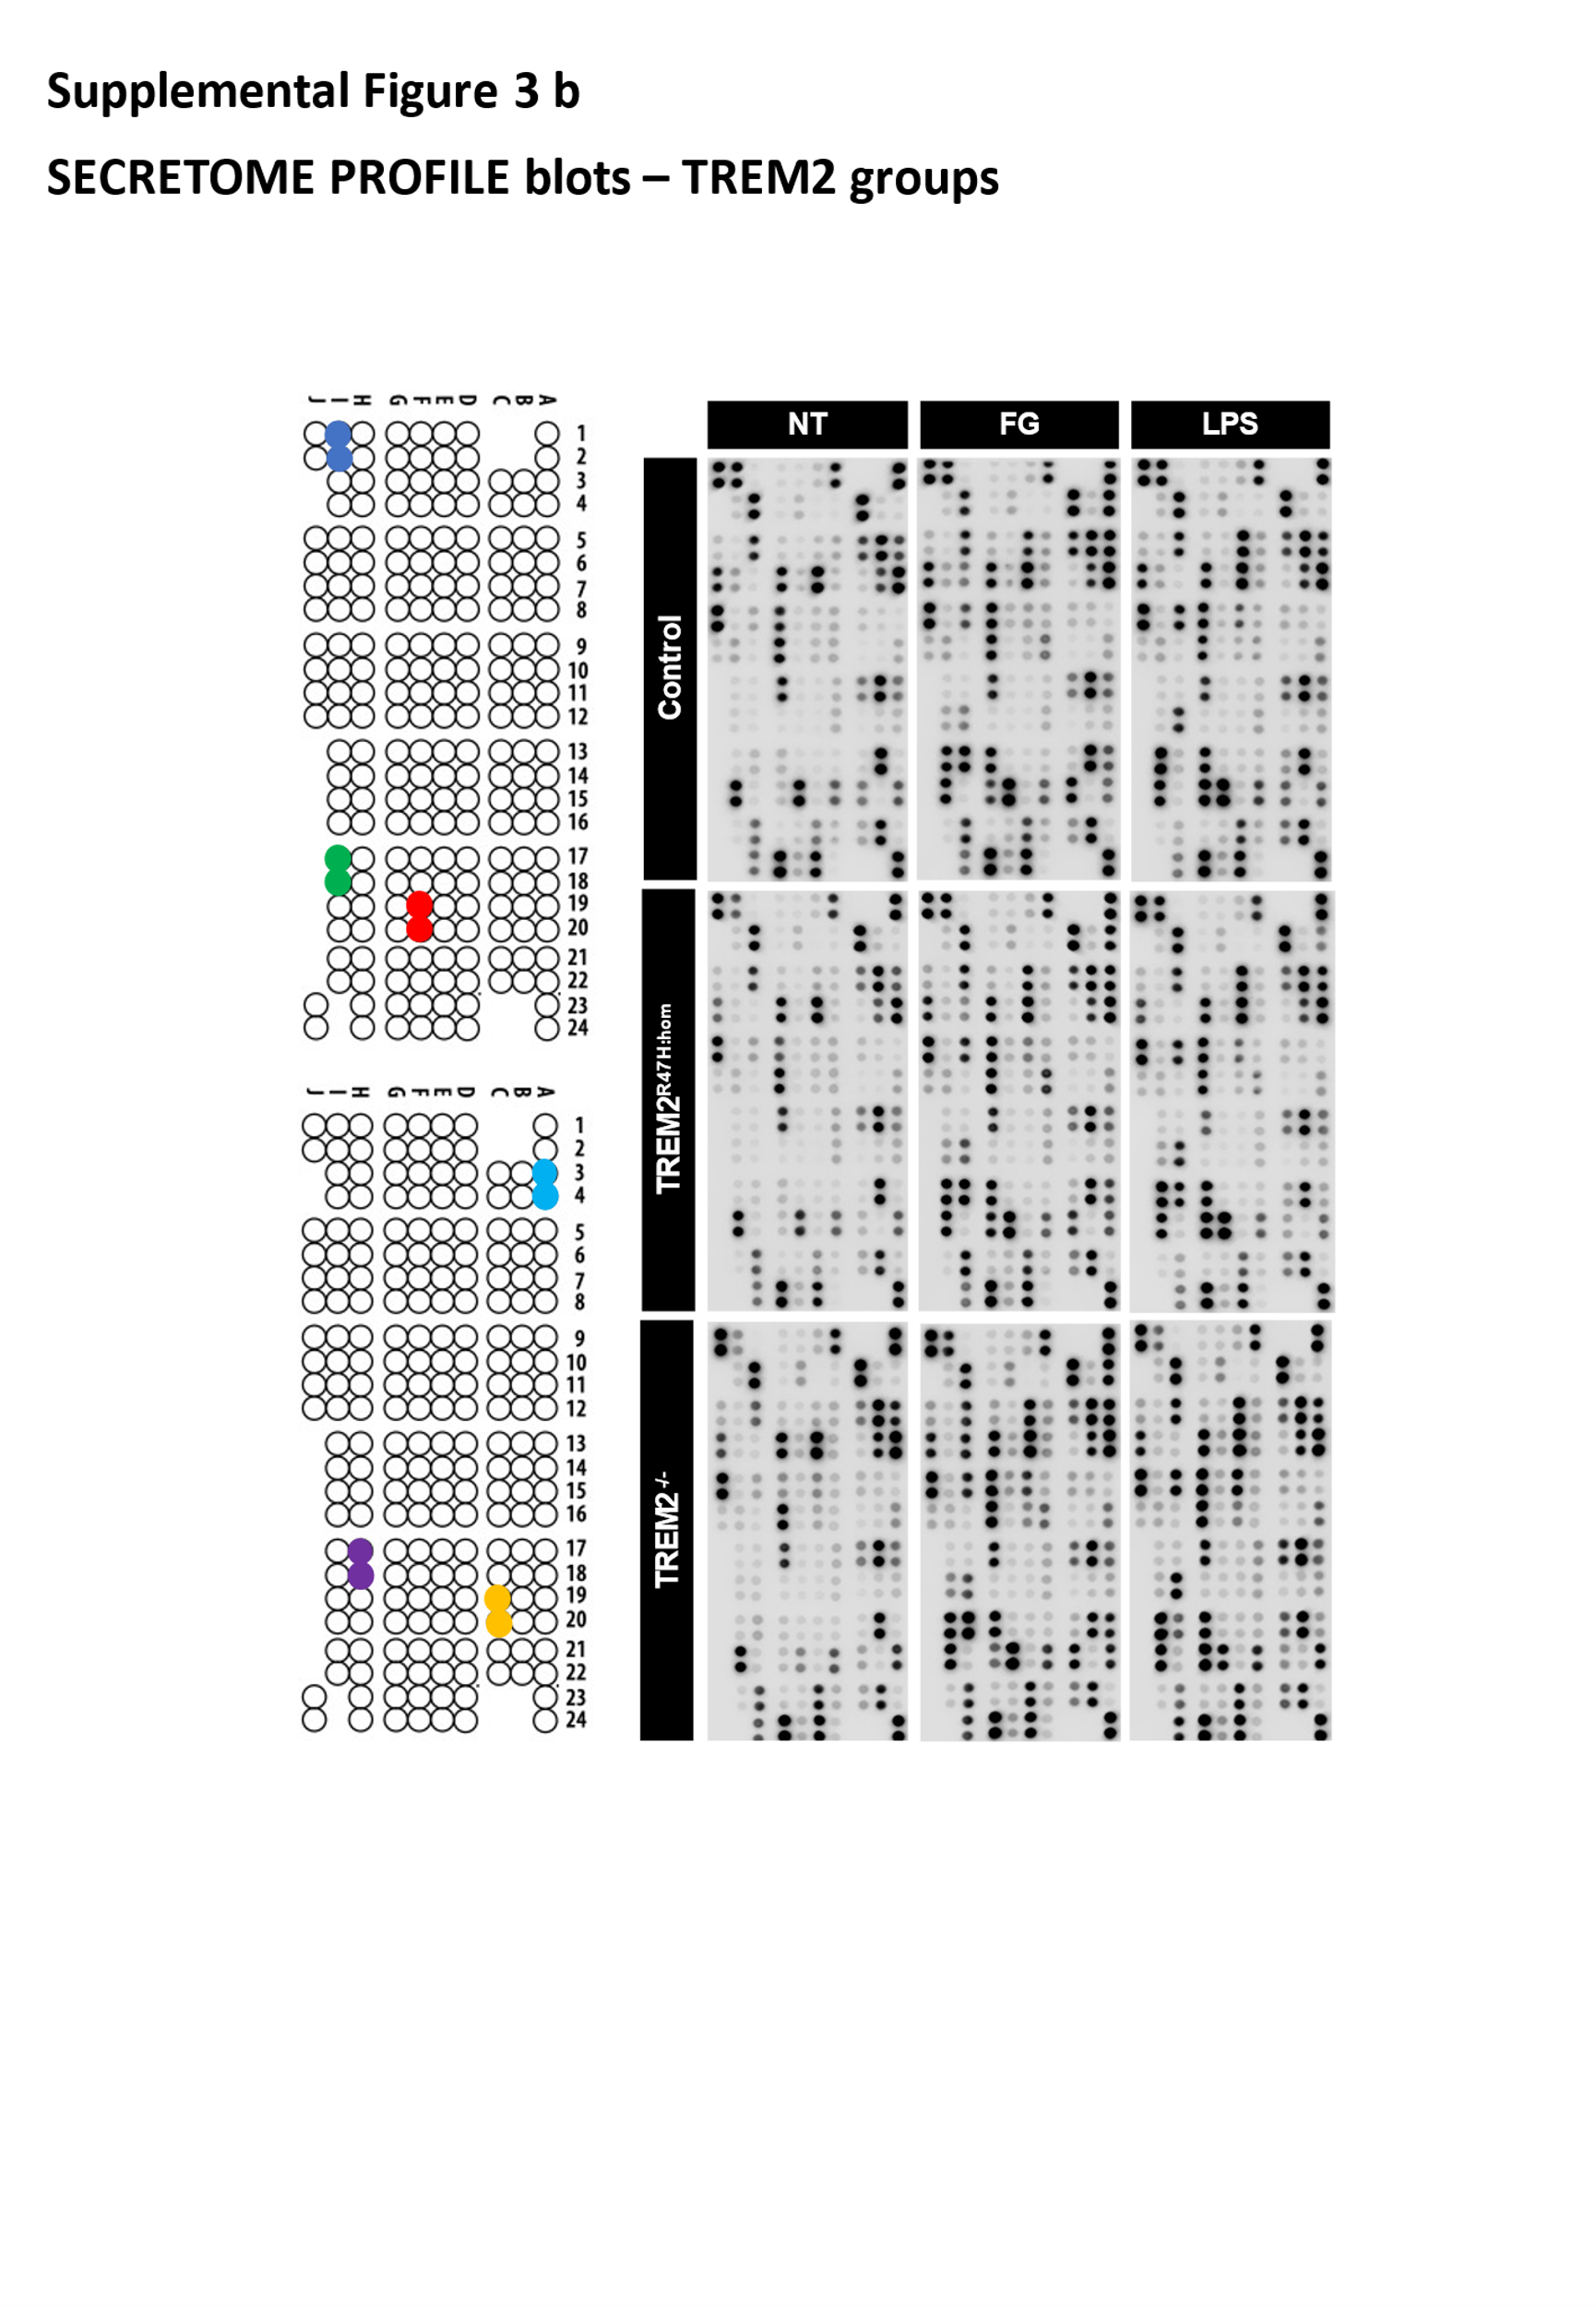
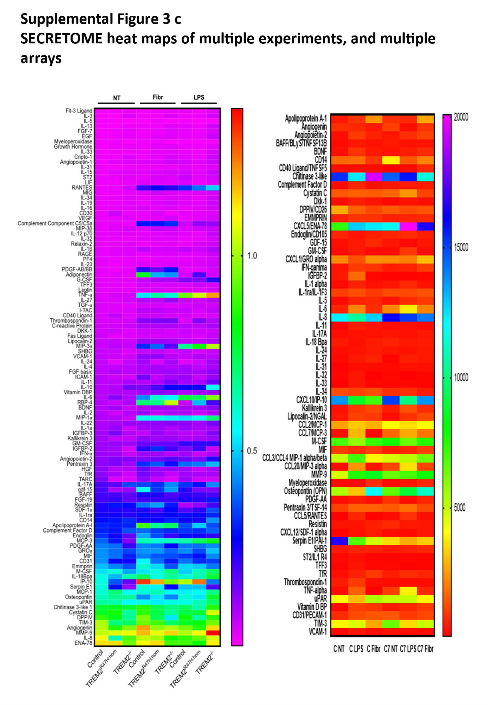
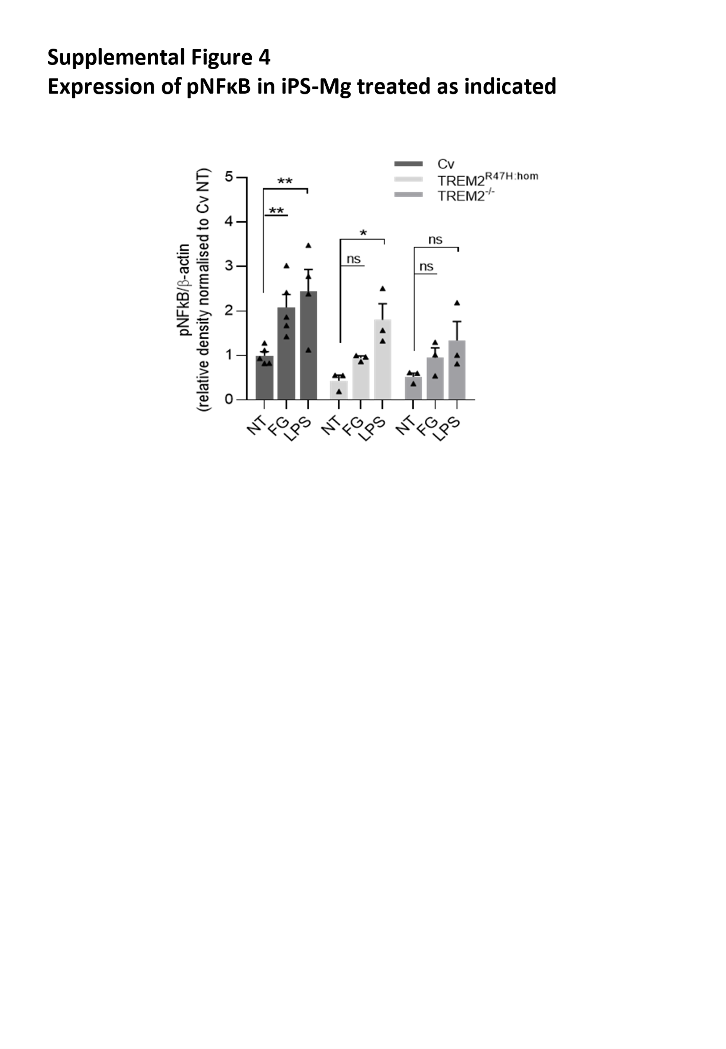
Supplementary Figure 1
Additional data for the expression of Caspase 4/5 (a.), and Caspase 4 (b.) in human iPS-microglia expressing TREM2 common variant and hypomorphic variants.

Supplementary Figure 2
Representative blot (a.) of Caspase-1 (total procaspase-1, at 50 kDa and 45 kDa) in human iPS-microglia expressing TREM2 common variant and hypomorphic variants, at basal (NT) or following 24 stimulation with 2.5 mg/ml FG or 100 ng/ml LPS. Densitometric analysis of 2 blots for caspase-1 expression relative to actin (b.)

Supplementary Figure 3a, 3b and 3c
Proteome stress array blots and heat arrays (3a) and Secretome array blots from multiple experiments and heat arrays from multiple experiments with different arrays (3b, 3c).

Supplementary Figure 4
Western blot analysis of pNFκB expression in iPS-Mg following stimulation with fibrinogen (FG, 2.5mg/ml), LPS (100 ng/ml), or non-treated (NT) for 24 h in TREM2 Cv, R47H^{hom} or TREM2^{-/-} iPS-Mg. Data are the mean of 3 blots from 3 independent cultures normalized to β-actin, +/- SEM, two-way ANOVA, * ρ<0.05, **ρ<0.01.

